USAGE OF THUNDERBIRD

A Map visualization software created for SOCIALEE by Kush Pandya(Summer Intern).



# 

# **How to REPORT a Bug**

Sometimes the software may not behave as it should in that case for a query or a bug please use the following ways to report/resolve it:-

1. Contact Kush Pandya - Ph.no - (a) 9913515325

(b) 6354144590

1. Email - [kpandya7@gmail.com](mailto:kpandya7@gmail.com),[1705701@kiit.ac.in](mailto:1705701@kiit.ac.in)
2. Report it on GITHUB - [https://github.com/kushjayankpandya/ThunderBird/issues](mailto:https:/github.com/kushjayankpandya/ThunderBird/issues)

NOTE:- Only Socialee employees will only be allowed to report through Call or and Email all other users are requested use GitHub for reporting it.

# **HOW TO INSTALL**

1. Download the executable software for Socialee from this link:- <https://drive.google.com/drive/folders/1GShwnUkwHLaeDMs7gNUKI0OGdqAR_6LW?usp=sharing>

Size - 215 MB

1. Store the folder at the place where you like to store.
2. Now to get the executable file please Follow the specific order. ThunderBird >> dist >>thunderbird
3. Now search for “thunderbird.exe” and create a shortcut for it. Just click on the shortcut and rename it to your accordance,the software will start working.

# **HOW TO USE IT**

This is a Specialized tool for visualisation of Facebook **Page** Insights Geographically. You are to use CSV format **ONLY**.

## **Step 1.**

## Get the csv file for particular Date Range you want to the visualisation for select page data and remember only csv format with legacy layout.

## 

## **Step 2.**

Now save the file to the appropriate folder. The output of the software will be created in the same folder.And remember to turn on your net.

## **Step 3.**

Now open the software and produced with the 2 screens.

A console and a GUI(Graphical User Interface).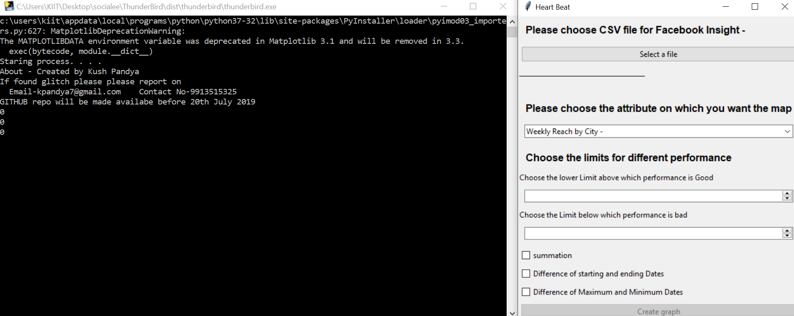

## 

## 

## **Step 4.**

Select a file and the chosen file will be shown as a heading and “create graph” button will be enabled. 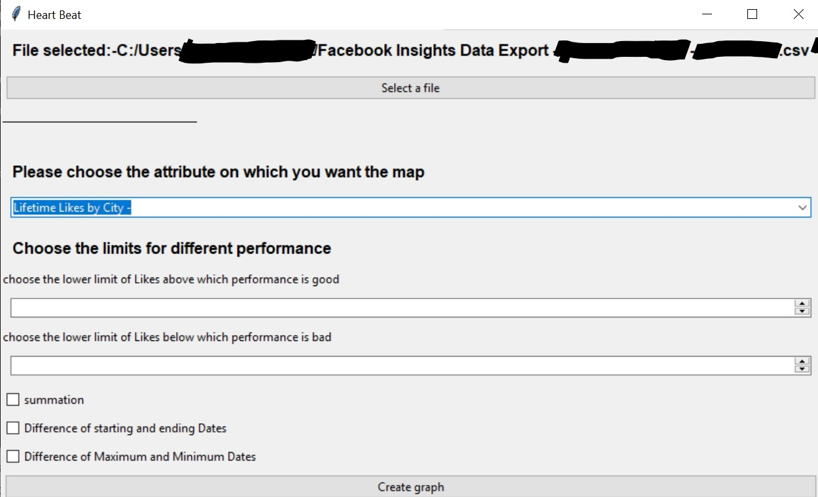

## **Step 5.**

Choose the appropriate attribute its lower limit and upper limit(Its significance is explained in the next section).

Then Choose a particular field i.e Summation, Difference of Starting and Ending date,Difference of Maximum and Minimum Dates.

## **Step 5.**

Create graph!

# **UNDERSTANDING OUTPUT**

* You would be getting 3 HTML file. For each selection in the same folder as the input file.
* It's better to use a single checkbox at a time So you can set different limits for different attributes.
* Now the 3 Html files will be saved in a folder with format “Analysis {input file name} {time stamp}”.
* Each Html file will be form “{performance index} {checkbox chosen} {input file name} .html”

## ***Understanding each performance index***

1. Excellent performance(Excellent_perfor):- This are all the values limit above which performance is good.(First limit box in GUI)
2. Badly performance(Badly_perfor):- This are all the values below the limit below which performance is bad.(Second limit box in GUI)
3. Medium performance(Medium_perfor):-This are between the above(1&2).

## ***Output of Each map.***

In each map you will be provided with a heatmap.A colored circle and a pop up marker. In a dynamic Google map.

* Use magnification and heatmap to find different places.
* Use circle for magnitude.
* If you want additional information use pop up marker by taking your cursor to that point on the map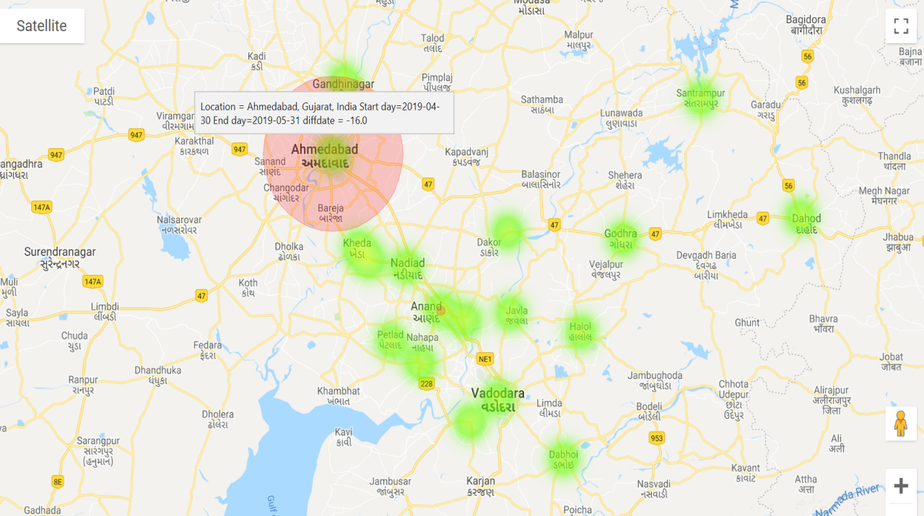

Created by :- Kush Pandya