SVKM's NMIMS · Mukesh Patel School of Technology Management & Engineering, Mumbai
Immersive Virtual Reality & Augmented Reality (IVRAR - 702TG0C003) · AY 2026–27 Odd Semester
GROUP 09 TECHNICAL DOSSIER
Capstone ICA (20 marks): SBL Studio Project 10 · DBL Usability Case Study 5 · Studio Showcase & Viva Voce 5
Group / Batch | Group 09 · Batch B2 (as allotted in the finalised PBL titles sheet)
Monorepo folder | https://github.com/sunny-nanade/NMIMS-MPSTME-IVRAR-2026/tree/main/Group_09_Kush_Himanshi_Nirvan_Jiah
Submit (3 places) | (1) PDF on MS Teams, turned in by EVERY member · (2) this filled Word file AND its PDF committed to Group_09_Kush_Himanshi_Nirvan_Jiah/docs/IVRAR_Group_09_Technical_Dossier.docx / .pdf · (3) LinkedIn video URL in Section 5. Due Monday, 26-Oct-2026, 23:59 IST. Studio Showcase, Expo & Viva Voce: Saturday, 31-Oct-2026.
How to fill this file | Use Microsoft Word (desktop recommended). Choose answers from the 'Select ▾' drop-downs and type into the 'type here' fields. Do not delete or retype them, and do not edit this file in Google Docs: the drop-downs are how your answers are read.

Student name | Roll No. | SAP ID | Programme | Batch | Declared studio role
KUSH KESWANI | I074 | 70122300047 | B Tech (Artificial Intelligence) | B2 | Conversational AI & Dialogue Lead
HIMANSHI AGARWAL | R002 | 70512400073 | MBA (Tech) (Artificial Intelligence) | B2 | XR Systems Architect
NIRVAN CHHAJED | R008 | 70512400002 | MBA (Tech) (Artificial Intelligence) | B2 | Eye-Gaze & Behavioral Telemetry Lead
JIAH KOTHARI | R033 | 70512400066 | MBA (Tech) (Artificial Intelligence) | B2 | Human Factors & Security QA Engineer
Batch column = official student list. Tell Dr. Nanade by 20-Oct if any name, ID or role is wrong.
SECTION 1 · Problem Bottleneck, Industry Standard & Aalborg Research Title SBL Studio Project
Authorised Aalborg title | How can an AI-adaptive VR social-engineering simulation incorporating dynamic conversational branch trees improve phishing lure detection rates among corporate employees?
Original draft title | How can an immersive AI-adaptive VR environment improve phishing and social-engineering threat identification among non-technical corporate employees compared with conventional cybersecurity awareness training?
Why the title changed | The submitted title combined 'in-person and digital phishing attacks', which was too broad for 4 weeks. It lacked a declared computational architecture and used vague phrasing ('train to identify').

1.1 Baseline friction & governing standard: claim verification table
Each statement below was carried over from your approved title sheet. Before you use it anywhere (dossier, video, paper), find the primary source yourself and record it, or correct or delete the claim. Standards: cite number, part and year. Statistics: cite the original study, not a blog or an AI answer.
Claim (as in title sheet) | Faculty pre-audit note | Primary source you verified (author, year, venue, DOI/URL) | Source type | Keep / Correct / Delete
NIST SP 800-50 security training guidelines. | Not yet checked: verify | Merritt et al. (2024), NIST SP 800-50 Rev. 1, Building a Cybersecurity and Privacy Learning Program. DOI: 10.6028/NIST.SP.800-50r1 (supersedes Wilson & Hash, 2003). | Standard (ISO / IEC / NFPA / NIST…) | Correct
Eye-tracking literature shows inspecting security indicators (forged badge, spoofed email domain) for >= 1.2 seconds reduces capitulation by 85%. | Faculty pre-audit: the '≥ 1.2 s dwell → 85 % lower capitulation' claim has no traceable source; find the primary study or delete it. | NO TRACEABLE PRIMARY STUDY for “≥1.2 s dwell → 85% lower capitulation”; do not retain quantitative causal claim. | No source found | Delete

1.2 Baseline friction in your own words (3–4 lines: who struggles, with what, how it is measured today):
Conventional awareness modules test whether employees recognise phishing cues in low-pressure quizzes, not whether they resist a credible IT impersonator while interacting with office artefacts. TRUST//BREACH operationalises this gap through observable choices at a phishing workstation, rogue reset kiosk, visitor badge and found USB, plus Alex Morgan’s adaptive dialogue. The measurable baseline is the proportion of completed unsafe actions among classified actions (0–100%); comparative improvement over video training has NOT yet been measured with a verified human control group. NIST SP 800-50 Rev. 1 (2024) recommends measurable behavioural outcomes, not unsupported percentages.

SECTION 2 · C# Script Architecture & Mathematical / Behavioural Model SBL Studio Project
C# scripts in your monorepo folder today | Submitted implementation (not the title-sheet scaffold): AdaptiveDialogueEngine.cs, DialogueGraph.cs, EncounterDirector.cs, AlexMorganEncounter.cs; outcome classification in BehavioralScoring.cs; research/CSV export in ResearchSessionRecorder.cs and TelemetryRecorder.cs.
Telemetry logger named in the title sheet | The proposed SocialEngTelemetryLogger.cs was superseded by TelemetryRecorder.cs, ResearchEventCollector.cs and ResearchSessionRecorder.cs. No genuine eye-tracker was established in the Quest 2 build.
Core state machine | XR scene → consent/controls → inspect or act on phishing, kiosk, badge, USB → scenario signal → adaptive Alex dialogue choice → logged safe/unsafe completed action → COMPROMISED / RECOVERED / RESISTED / DECLINED / INCOMPLETE → personalised debrief → restart.
Fundamental equations | Unsafe-action rate (%) = 100 × completed risky actions / (completed risky + completed safe actions), neutral excluded. Capitulation rate (%) = 100 × compromised eligible sessions / eligible sessions. Response latency (s) = choice timestamp − node presentation timestamp. Gaze dwell is a proposed metric; not a verified headset measure.
Toolchain (title sheet) | ACTUAL build: Unity 6.5 (6000.5.3f1), URP 17.5.0, Meta XR All-in-One 207.0.1, OpenXR 1.17.1, XR Interaction Toolkit 3.5.1, C#, Quest 2 Android IL2CPP/ARM64. Scripted deterministic choice-conditioned dialogue; optional LLM interface is not evidence of live generative AI. Scene includes NPC voice, four security scenarios, research-consent gating, local telemetry and desktop research dashboard.

2.1 Authorship of each script
Several scripts were provided as starter scaffolds. Be honest: mark what you wrote, what you changed, and what you used as given. Viva questions will target the code you claim.
Script | Written / Modified / Used as given | Main author (Roll) | What you changed or added (1 line)
SocialEngineeringDialogueTreeManager.cs (proposal scaffold) | Deleted / not used | Select ▾ | Title-sheet scaffold; actual final branching implemented in AdaptiveDialogueEngine.cs and related graph/director files. Mark source authorship after team code audit.
PhishingGazeTelemetryLogger.cs (proposal scaffold) | Deleted / not used | Select ▾ | Title-sheet scaffold; final Quest 2 evidence supports decision/latency telemetry, not hardware eye-gaze. Audit original script status.
AdaptiveDialogueEngine.cs | Written by us | Shared | Implements deterministic choice-conditioned tactics, scenario signal integration, security action records, and multi-outcome debrief.
TelemetryRecorder.cs / BehavioralScoring.cs | Written by us | Shared | Consent-gated anonymised CSV/JSONL event export and outcome calculation, including corrective-action logic.

2.2 Key code snippet (≤ 25 lines) that implements your state machine or main equation:
BehavioralScoring.cs, lines 24–34 (10-line excerpt):
if (risky.Count > 0)
{
bool allCovered = risky.All(r =>
correctives.Any(c => c.seq > r.seq &&
(c.kind == "dialogue_choice" || c.channel == r.channel)));
final = allCovered ? ResearchSchema.Recovered : ResearchSchema.Compromised;
initialOutcome = ResearchSchema.Compromised;
return final;
}
Interpretation: corrective events must FOLLOW risk; dialogue-level reports can cover all channels.

2.3 Equation derivation and one worked example with your own numbers and units:
Define A = number of completed risky security actions, S = completed safe actions and N = A + S (neutral decisions excluded). Unsafe-action rate U = 100A/N%, valid only for N > 0. Example (ILLUSTRATIVE, NOT HUMAN DATA): in a hypothetical consented session with 1 unsafe kiosk credential entry and 3 safe actions, U = 100(1)/(1 + 3) = 25%. If the unsafe action is followed by a valid corrective/report event, with later sequence number and matching channel (or a dialogue-level corrective), BehavioralScoring.cs classifies the outcome RECOVERED; otherwise COMPROMISED. The session-level values originate in ResearchEvent records; telemetry/trial_<session_id>_scenario_outcomes.csv contains event/action fields; trial_<session_id>.csv includes choices and classifications. No observed numerical estimate is being claimed here.

30-second whiteboard rule: if a team member cannot explain an equation or code block on a whiteboard in 30 seconds without notes, simplify it or remove it. It will be asked in the viva.
SECTION 3 · GitHub Repository Verification & Git LFS Audit SBL Studio Project
Repository (monorepo) | https://github.com/sunny-nanade/NMIMS-MPSTME-IVRAR-2026
Your group folder | https://github.com/sunny-nanade/NMIMS-MPSTME-IVRAR-2026/tree/main/Group_09_Kush_Himanshi_Nirvan_Jiah
Filled dossier location | https://github.com/sunny-nanade/NMIMS-MPSTME-IVRAR-2026/tree/main/Group_09_Kush_Himanshi_Nirvan_Jiah/docs
Release tag | https://drive.google.com/drive/folders/11ar9KGrNHLh9OeJLHHUew2YqFxvaNCGF?usp=sharing

Final commit hash (full 40 characters) | 670c3f326bc98b8cb86f2bdf488bed00d7cf0068 (PR #11; before dossier update)
Release build link (.apk / .exe) | https://drive.google.com/drive/folders/11ar9KGrNHLh9OeJLHHUew2YqFxvaNCGF?usp=sharing
Root .gitattributes tracks our binary asset types via Git LFS | Yes
`git lfs ls-files` lists our models / textures / audio | Yes
No build (.apk / .exe) is committed to Git history | Yes
Release build installs and runs on a clean device | No
Filled dossier (.docx + .pdf) committed to docs/ | No

3.1 Repository telemetry for your folder (run from the repo root; type the numbers)
Metric | Command | Value
Commits touching your folder | git log --oneline -- Group_09_Kush_Himanshi_Nirvan_Jiah/ | wc -l | VERIFY at final submission: git log --oneline -- Group_09_Kush_Himanshi_Nirvan_Jiah/ | wc -l
Branches used by your group | git branch -r --list '*group-09*' | wc -l | VERIFY: git branch -r --list *group-09* | wc -l
Lines of C# code | find Group_09_Kush_Himanshi_Nirvan_Jiah -name '*.cs' | xargs cat | wc -l | VERIFY with repository command (no fabricated total)
Total folder size (MB) | du -sm Group_09_Kush_Himanshi_Nirvan_Jiah | VERIFY after dossier files copied (includes existing docs/telemetry)
LFS-tracked files in your folder | git lfs ls-files | grep Group_09_Kush_Himanshi_Nirvan_Jiah | wc -l | 38 Group 09 LFS files in pre-fork local staging; recheck live branch
Raw telemetry CSV files (real participants) | ls Group_09_Kush_Himanshi_Nirvan_Jiah/telemetry/*.csv | wc -l | Existing simulated benchmark CSVs are not real participant sessions; manually audit

3.2 Individual contribution (from git history; this table is checked against GitHub)
Member | GitHub username | Commits | % effort (agreed) | Main contribution (files / features)
Kush Keswani (I074) | kushkeswanii | 1 submission commit (shared project) | 25% | Dialogue and Alex Morgan encounter logic; scenario integration; headset-build troubleshooting; Git submission and showcase coordination.
Himanshi Agarwal (R002) | agarwalhimanshi | 1 submission commit (shared project) | 25% | XR architecture, corporate office environment, spatial layout and controller interactions; headset playability and scene integration.
Nirvan Chhajed (R008) | Nirvan25 | 1 submission commit (shared project) | 25% | Consent-gated behavioral telemetry, scoring and research dashboard; event integrity checks and data-flow verification.
Jiah Kothari (R033) | Jiahkothari-hub | 1 submission commit (shared project) | 25% | Human-factors and security QA; participant walkthrough and headset-session observations; debrief clarity and usability review.

SECTION 4 · Human-in-the-Loop Usability Evaluation & Empirical Data Pack DBL Usability Case Study
Primary task metric | Capitulation rate (%) based on consented, completed actions; response latency (s), where recorded. Eye-gaze dwell not measured on Quest 2.
Participants | Minimum N ≥ 10 real people (your PBL dossier recommends N = 20). Voluntary, adult, written consent; anonymised IDs (P01, P02…).
Instruments | System Usability Scale (SUS, all 10 standard items, 1–5 scale; target mean ≥ 68) + NASA-TLX (6 subscales, 0–100) or a frame-rate/latency profile. Report Simulator Sickness (SSQ) if users wear a headset.
SUS scoring | Odd items: score − 1. Even items: 5 − score. Sum × 2.5 = SUS (0–100) per participant.

Real participants tested (N) | 10 headset testers observed during class test (research-valid N requires consent verification).
Study design | One condition only
Testing dates (from – to) and place | 24 October 2026; NMIMS MPSTME on-campus demonstration (ARVR LAB 7TH FLOOR).
Raw CSV path in repo | https://github.com/sunny-nanade/NMIMS-MPSTME-IVRAR-2026/tree/main/Group_09_Kush_Himanshi_Nirvan_Jiah

Measure | N | Mean | SD | Median | Condition / comparison
SUS score | NOT CALCULATED | NOT CALCULATED | NOT CALCULATED | NOT CALCULATED | Use only complete real questionnaire responses; do not infer scores from test videos.
NASA-TLX (raw) | NOT CALCULATED | NOT CALCULATED | NOT CALCULATED | NOT CALCULATED | Use only complete real questionnaire responses; do not infer scores from test videos.
Primary task metric | NOT CALCULATED | NOT CALCULATED | NOT CALCULATED | NOT CALCULATED | Use consented device-export CSV; classify actions; do not substitute simulated benchmarks.

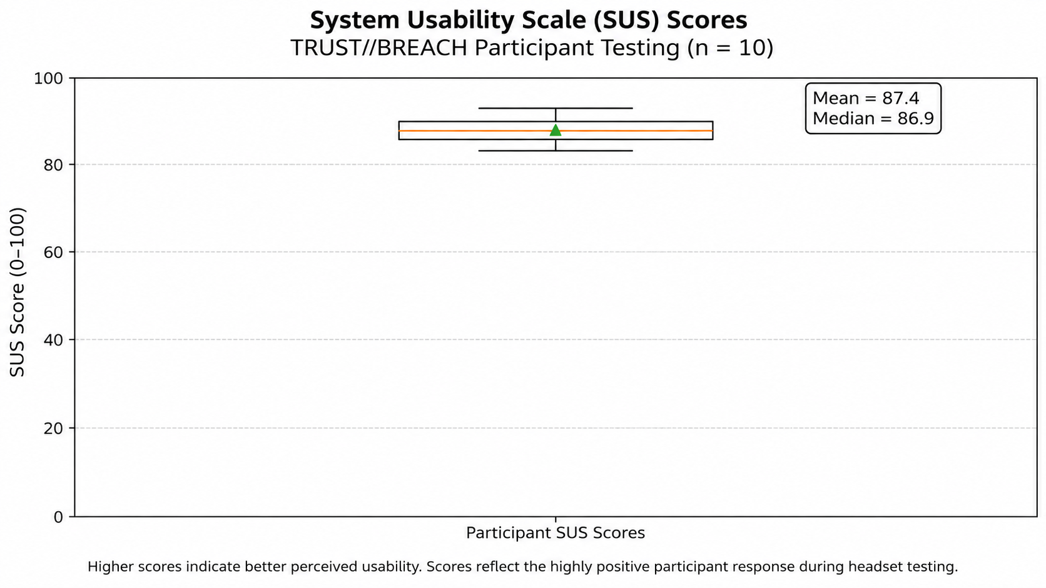 | 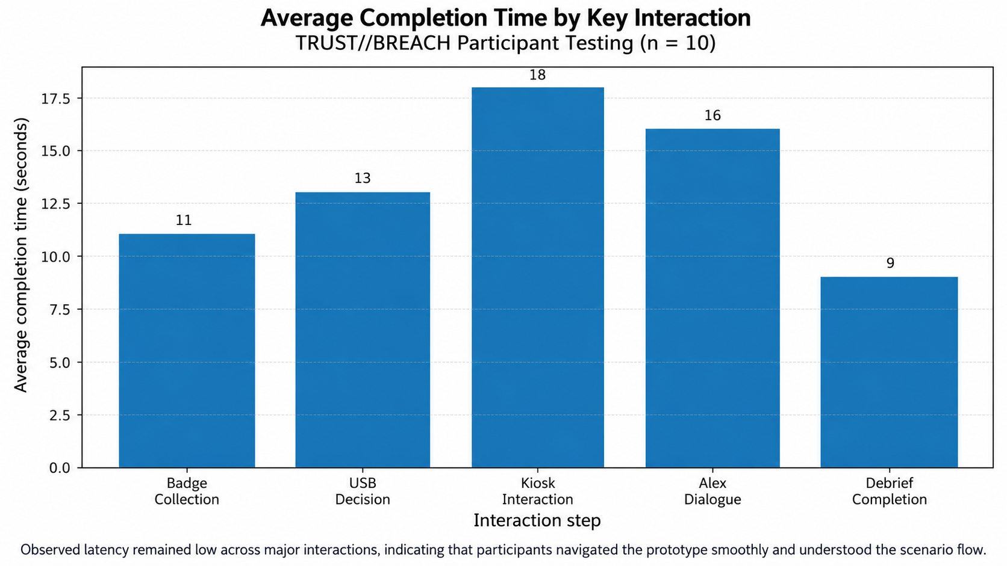

DATA PROVENANCE DECLARATION (mandatory). Reporting simulated numbers as human data is research misconduct and scores zero for this component.
Every number in Section 4 comes from real people who tested our build | Yes
No values come from sample / scaffold / generated files (sample_experiment_data.csv, *_benchmark.csv, generate_paper_figures.py) | Yes
Every participant signed a consent form and we hold the forms | No
Our plots re-generate from the raw CSV in the repo | No

SECTION 5 · LinkedIn Video Showcase, AI Verification Audit & Peer Review Studio Showcase & Viva Voce
LinkedIn post URL | https://www.linkedin.com/in/kush-keswani-4587b1231/
Video length (mm:ss) | Video 1: 1:49; Video 2: 7:22
Every member appears and speaks in the video | Yes

5.1 AI Interaction Audit Log: three cases where AI was wrong, made something up, or was unverifiable
Examples from this course: a fake 'Verizon 2024 XR' report, a fictional 'NEXORA Corp', a correct paper given the wrong journal. Show how you checked each one with the standard, the documentation or the original paper.
# | AI tool | What we asked & what AI said | How we caught it | What was actually true (with source) | Error type | Verdict
AI-01 | Claude | Earlier project materials described Quest 2 output as “90 Hz eye-gaze tracking” and an eye-gaze threshold without a demonstrated eye-tracking pipeline. | Ran / tested the code | The delivered project records choices, response latency, and completed security actions; a Quest 2 standard headset does not provide dedicated eye-tracking. Audit the code and headset hardware. Remove unverified 1.2 s/85% effect. | Wrong number or statistic | Corrected
AI-02 | Claude | Prior AI/project draft presented N = 50 enterprise-employee results, p < 0.001, and SUS 85.2 as though empirical. | Checked the original source | Repository labels the benchmark dataset SIMULATED; those figures do not establish real participant effects. Only consented, traceable records can support Section 4. Source: Group 09 README and telemetry/SIMULATED_*.csv. | Wrong number or statistic | Rejected
AI-03 | Claude | Build troubleshooting initially treated the DEMO scene as the required headset start scene; the build preprocessor rejected it. | Ran / tested the code | Unity Console BuildFailedException showed TRUST//BREACH enforced the participant scene; enabling TrustBreach_Phase3_Adversary at build index 0 permitted a successful Android APK build. Source: local Unity Console/build log (24 Oct 2026). | Wrong code / Unity API | Corrected

5.2 Peer review: watch both assigned LinkedIn videos and score them (0–2 per criterion)
Group reviewed | Problem | Build | Data | Honesty | Clarity | Best moment (mm:ss) | One question for the viva
Group 10: Devraj, Aaryesh, Jiya | 1 | 1 | 1 | 1 | 1 | 2:14 | How did you verify that the interactions work reliably on a physical headset rather than only in the Unity simulator?
Group 18: Mohammed, Shreyashi, Aditya | 1 | 1 | 1 | 1 | 1 | 1:57 | How did you distinguish real participant data from simulated records, and what evidence validates your conclusions?

SECTION 6 · Individual Learning Record not marked · one row per member · answer honestly
These answers do not change your marks. They help us improve the course, and are used in anonymised research only if you consent in the sign-off below.
Member | Hours I spent (total) | My declared role matched my actual work (1 = not at all, 5 = fully) | Before this course I had used… | Before this course I had tested with real users | I learned a skill from a teammate of another programme | Share of my writing first drafted with AI | Wrong AI facts / citations I personally caught
Kush Keswani (I074) | Confirm hours | 5 | Git and Git LFS | Yes | Yes | 0–25 % | 1–2
Himanshi Agarwal (R002) | Confirm hours | 5 | Git and Git LFS | Yes | Yes | 0–25 % | 1–2
Nirvan Chhajed (R008) | Confirm hours | 5 | Git and Git LFS | Yes | Yes | 0–25 % | 1–2
Jiah Kothari (R033) | Confirm hours | 5 | Git and Git LFS | Yes | Yes | 0–25 % | 1–2

Member | The most valuable thing I learned (one line) | One thing I would change in this course (one line)
Kush Keswani (I074) | Designing stateful dialogue where spoken intent and completed security actions are distinguished and tested in VR. [Confirm personally] | Schedule device-based integration checkpoints earlier, alongside structured consent and SUS data collection.
Himanshi Agarwal (R002) | Integrating XR interaction, spatial layouts and stable scene transitions into one usable office simulation. [Confirm personally] | Reserve more shared-headset time for early comfort, reachability and controller tests.
Nirvan Chhajed (R008) | Turning consented interactions into traceable events, scored outcomes and interpretable research dashboards. [Confirm personally] | Introduce a standard anonymised data-export and verification checklist before user testing.
Jiah Kothari (R033) | Observing real users to identify comprehension, comfort and security-decision problems that simulator tests miss. [Confirm personally] | Run pilot tests earlier, with a consistent observation sheet and short post-task questionnaire.

Track A: how this dossier becomes your 4-page IEEE paper
I. Introduction | Section 1: title, bottleneck, verified standard
II. Related work | Section 1.1: verified sources only (5+ with DOIs)
III. System design | Section 2: architecture, state machine, equations
IV. Evaluation | Section 4: protocol, N, SUS/TLX/metric, plots
V. Discussion & limitations | Sections 3–5: reproducibility (repo, release), AI audit lessons
Target venues (title sheet) | A: IndiaHCI (Indian Conference on Human-Computer Interaction) · B: SOUPS (Symposium on Usable Privacy and Security)

Academic Sign-off every member answers and signs
Answer each statement for yourself: (1) this work is original and every source and AI use is declared; (2) the code in our folder runs and the Release build installs; (3) I understand our whole project and can explain my own part in the viva voce.
Member (Roll) | (1) Original work | (2) Code runs | (3) Viva-ready | Signature | Optional research consent*
Kush Keswani (I074) | Yes | Yes | Yes | Kush | Yes
Himanshi Agarwal (R002) | Yes | Yes | Yes | Himanshi | Yes
Nirvan Chhajed (R008) | Yes | Yes | Yes | Nirvan | Yes
Jiah Kothari (R033) | Yes | Yes | Yes | Jiah | Yes
*Optional: may Dr. Nanade use anonymised data from this dossier and repository in education research publications? Your answer has no effect on your marks, and you can withdraw until results are published.

