IP Model Automation — Project Overview
From hardware design documents (DLDs) to validated SimPy performance models and unit tests
This document answers three questions, in order:
- What does this system do for me? (Part 1)
- How do I generate a model and unit tests from my DLD? (Part 2)
- What actually happens in the background? (Part 3)
Current project status is in Part 4. The exact CLI command reference lives in the repository README. The diagrams in this document are also available as standalone SVG files in docs/diagrams/.

Part 1 — What this system does for you

The one-sentence version
You write a design document for your hardware IP block; this system turns it into a runnable performance model (Python/SimPy) and a unit test suite — with automated checks at every step so nothing is invented or lost along the way.
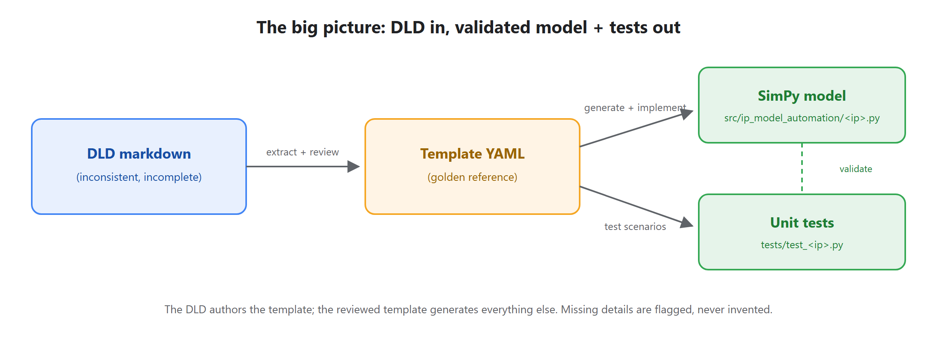
Figure 1 — The big picture: DLD in, validated model + tests out.

What goes in, what comes out
You provide: a DLD (Design-Level Document) — an ordinary markdown (or Word) file describing your IP block: what it does, its interfaces, its internal state machines (FSMs), and how many cycles each operation takes. Examples live in dlds/ — e.g. timer_ip_dld.md.
You get back:
Output | What it is | Where it lands
SimPy model | A Python simulation of your IP: every FSM runs as a concurrent process, every delay comes from your DLD's timing table. You can run traffic through it and measure latency, throughput, backpressure. | src/ip_model_automation/<ip>.py
Unit tests | Tests that check the model's functional behavior and its timing against what the DLD stated. | tests/test_<ip>.py
Gaps report | A checklist of everything your DLD didn't say (missing timing, unclear behavior, open items) — so you know exactly what to clarify instead of discovering it later. | reports/<ip>.gaps.md
Readable spec | A clean, browsable HTML/Markdown rendering of the normalized spec extracted from your DLD — handy for reviews. | reports/template_docs/

Why would I want a SimPy model?
Long before RTL exists, a transaction-level delay model lets you answer questions like:
- What's the end-to-end latency of a DMA descriptor under load?
- Where does backpressure build up when the completion queue is slow?
- Is the arbitration policy fair across tenants at high occupancy?
The repo includes a ready-made experiments layer (tools/run_experiments.py) that sweeps a model parameter against a fixed workload and produces CSV and markdown result tables.

The core promise: nothing is invented
DLDs are written by humans, so they vary in format and always omit something. This system never guesses. Anything the DLD doesn't state is flagged in the gaps report and marked TODO_REVIEW for a human (or an LLM under a strict contract) to resolve — using only what the DLD actually says. Automated gates block progress until every marker is resolved. That's what makes the generated model trustworthy.

Part 2 — How to go from a DLD to a model + tests

The short version (fully automated)
Drop your DLD into dlds/ and run the pipeline:
copy my_ip_dld.md dlds\
python tools\auto_ip_pipeline.py
The pipeline detects the new document and drives everything: extraction, review prompts, gate checks, model scaffolding, implementation prompts, unit tests, and a final repo-wide validation. Two steps in the middle need judgment (reviewing the extracted spec, and implementing model behavior) — for those the pipeline either:
- writes a ready-to-send prompt to reports/agent_requests/ and pauses, telling you which IP is awaiting which step (you or an LLM complete it, then re-run), or
- runs unattended if you give it an LLM command — it pipes the prompt in, validates the result, and retries with the failure log if validation fails:
python tools\auto_ip_pipeline.py --agent-cmd "claude -p --permission-mode acceptEdits"
When the pipeline reports green, you have a validated model in src/ip_model_automation/ and passing tests in tests/.

The step-by-step version (manual, so you see each stage)
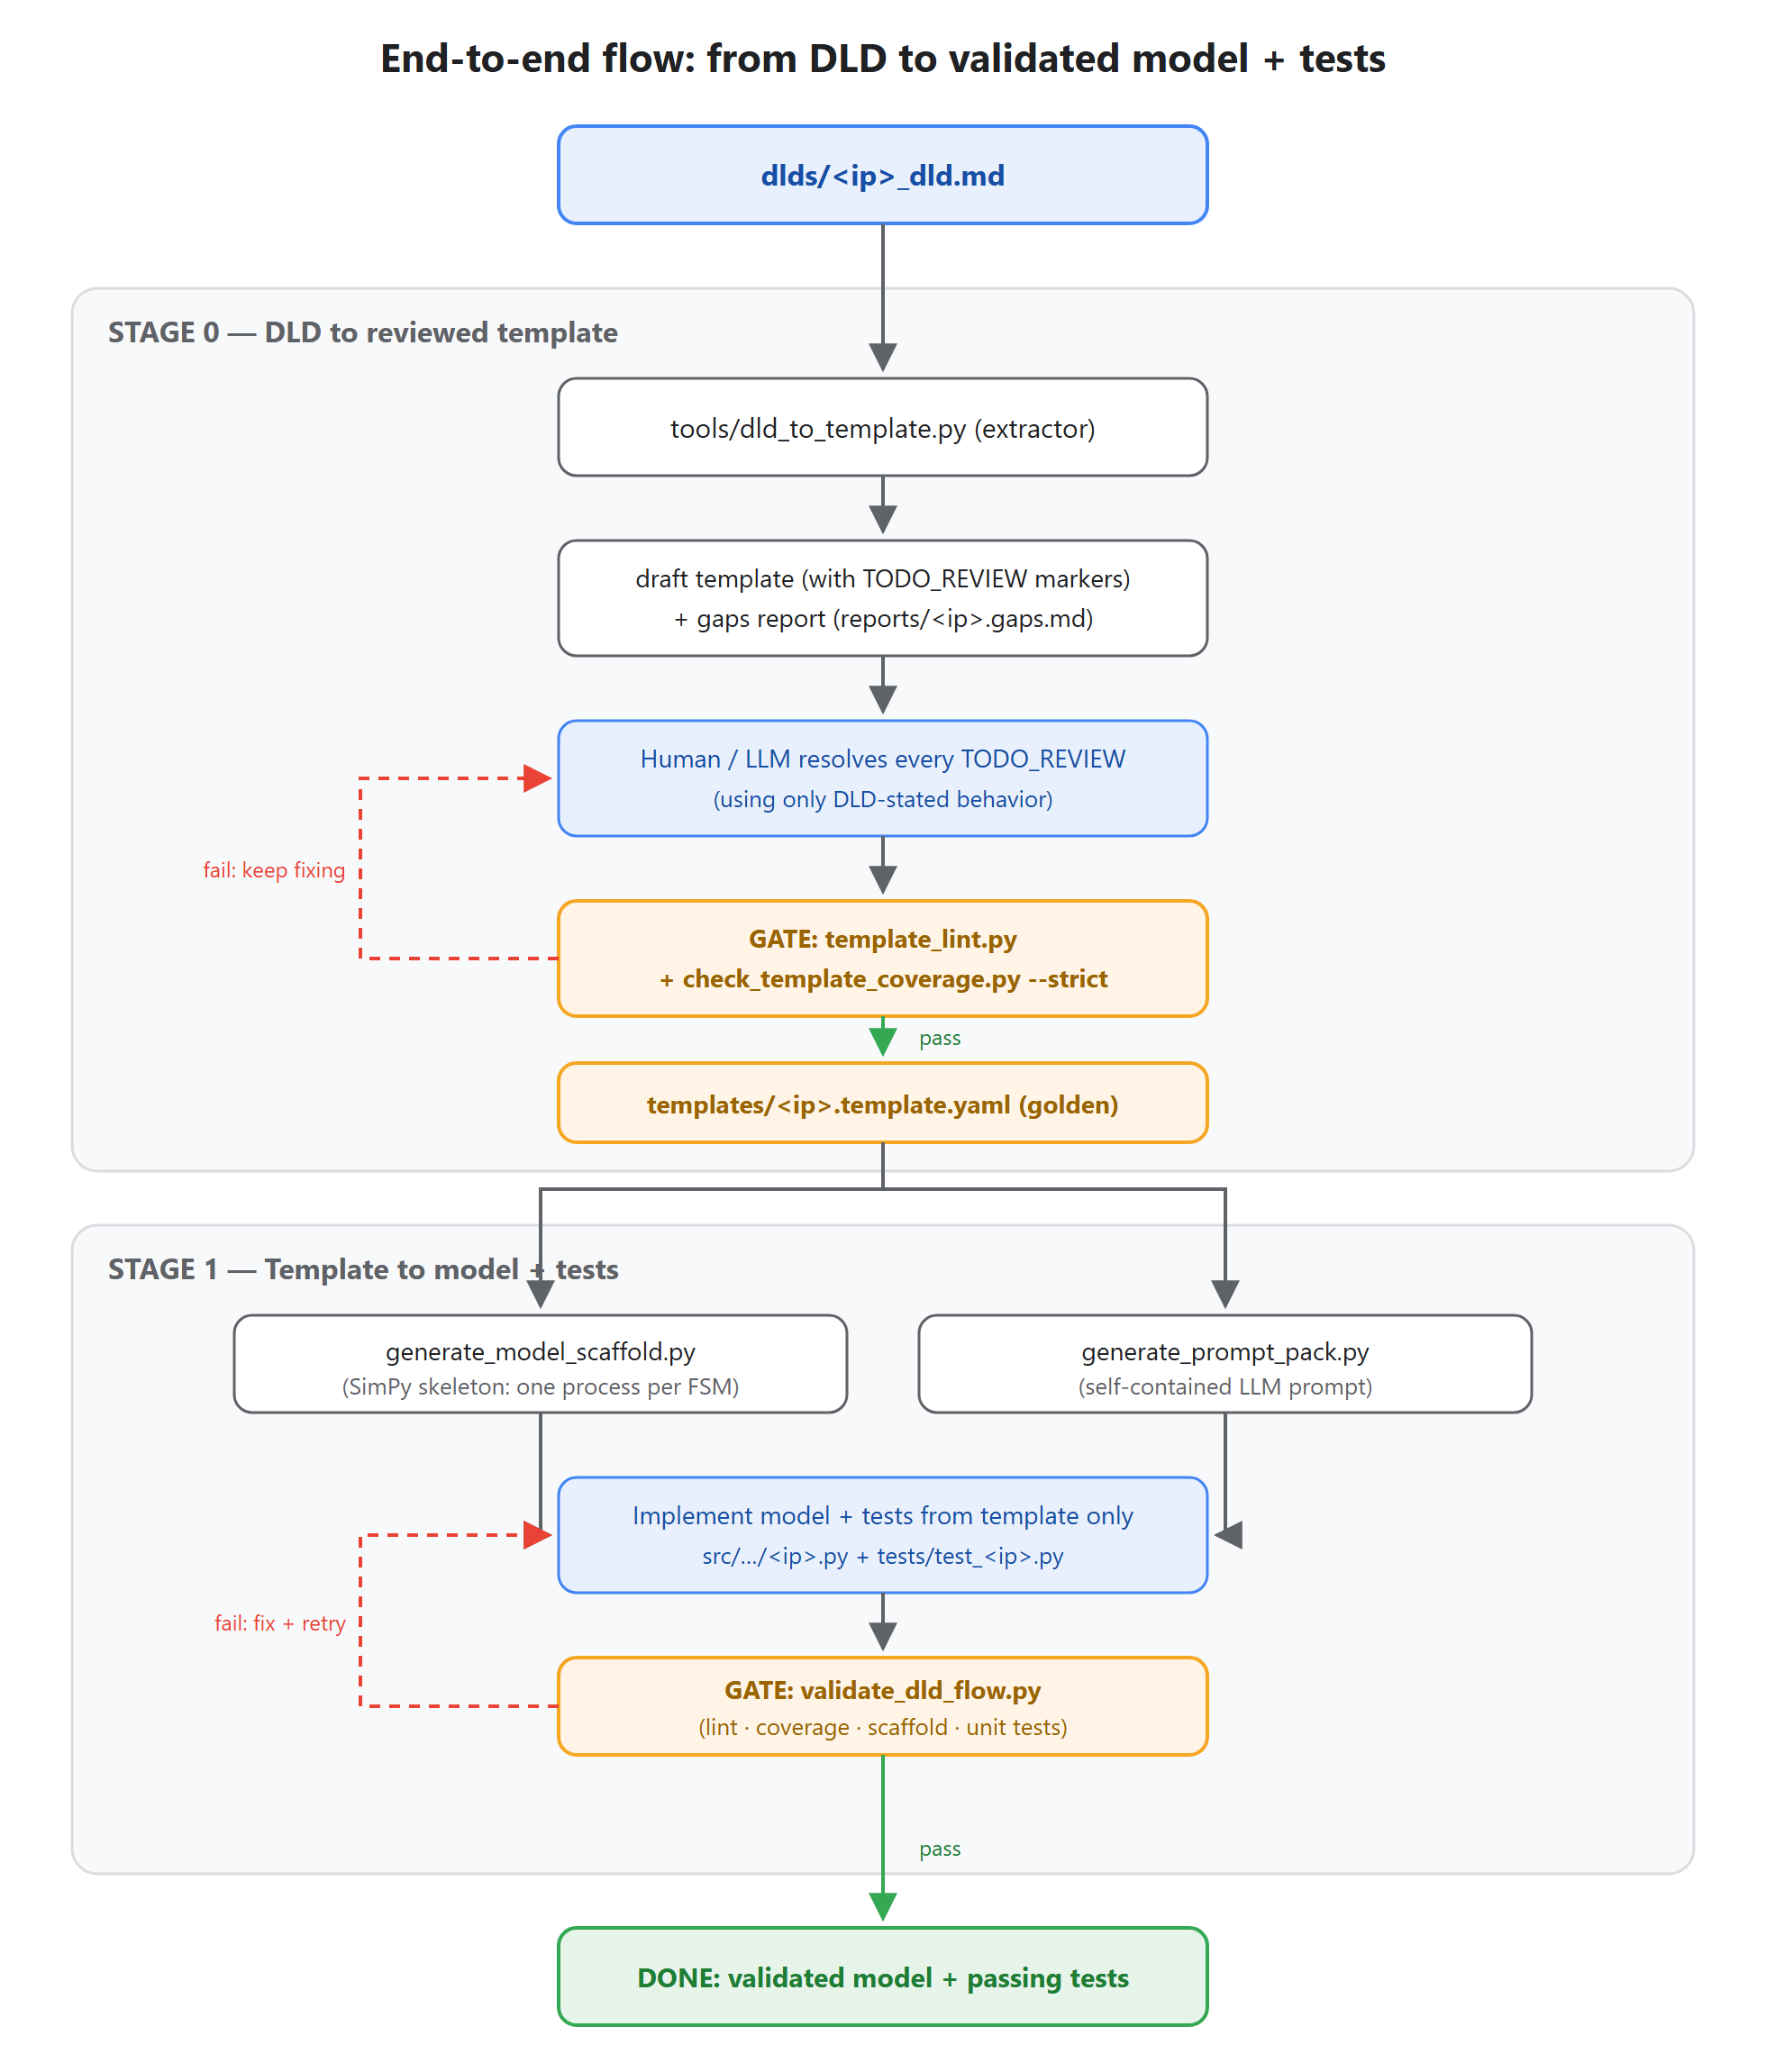
Figure 2 — End-to-end flow: Stage 0 (DLD → reviewed template) and Stage 1 (template → model + tests), with the two fail/retry loops.
Step 1 — Write the DLD — dlds/<ip>_dld.md, with the usual sections: Purpose, Interfaces, FSMs (with their states), a timing table, and Open Items. Any existing DLD in dlds/ is a good example to copy the shape of.
Step 2 — Extract a draft spec and a gaps report:
python tools\dld_to_template.py dlds\<ip>_dld.md
Step 3 — Review the draft (templates/<ip>.template.draft.yaml): replace every TODO_REVIEW marker. The rule: fill in only what the DLD states — if the DLD is silent, fix the DLD, don't invent.
Step 4 — Pass the gates, then promote the draft:
python tools\check_template_coverage.py templates\<ip>.template.draft.yaml dlds\<ip>_dld.md --strict
python tools\template_lint.py templates\<ip>.template.yaml
Step 5 — Generate the model scaffold and fill in behavior from the template only:
python tools\generate_model_scaffold.py templates\<ip>.template.yaml --output-dir src\ip_model_automation
Step 6 — Write unit tests from the template's test_scenarios (and register the model in common.py + ip.py).
Step 7 — Validate everything:
python tools\validate_dld_flow.py
This exact path added mailbox_ip, spi_master_ip, and i3c_ip to the repo: brand-new DLDs in, validated models and tests out.

What makes a DLD “extract well”
The extractor understands common DLD conventions. It reliably picks up:
- FSM names, their states, and the total FSM count
- Interface sections
- Per-FSM timing operations and the clock rate
It deliberately leaves for human review: command encodings, test scenarios, invariants, and transition details — these are where DLDs are most often ambiguous, so they get flagged instead of guessed.

Part 3 — How it works behind the scenes

The central idea: a template in the middle
The system never generates a model directly from the DLD. The DLD is human-written prose — inconsistent and incomplete by nature. Instead, a normalized, machine-checkable template (a YAML file with a fixed schema) sits in the middle as the golden reference. The template captures, in one fixed shape regardless of how the DLD was written: the IP's FSM processes and states, interfaces, commands, timing model, invariants, and test scenarios. The annotated templates/reference_template.yaml documents every section.

Two sources of truth — but only one at a time
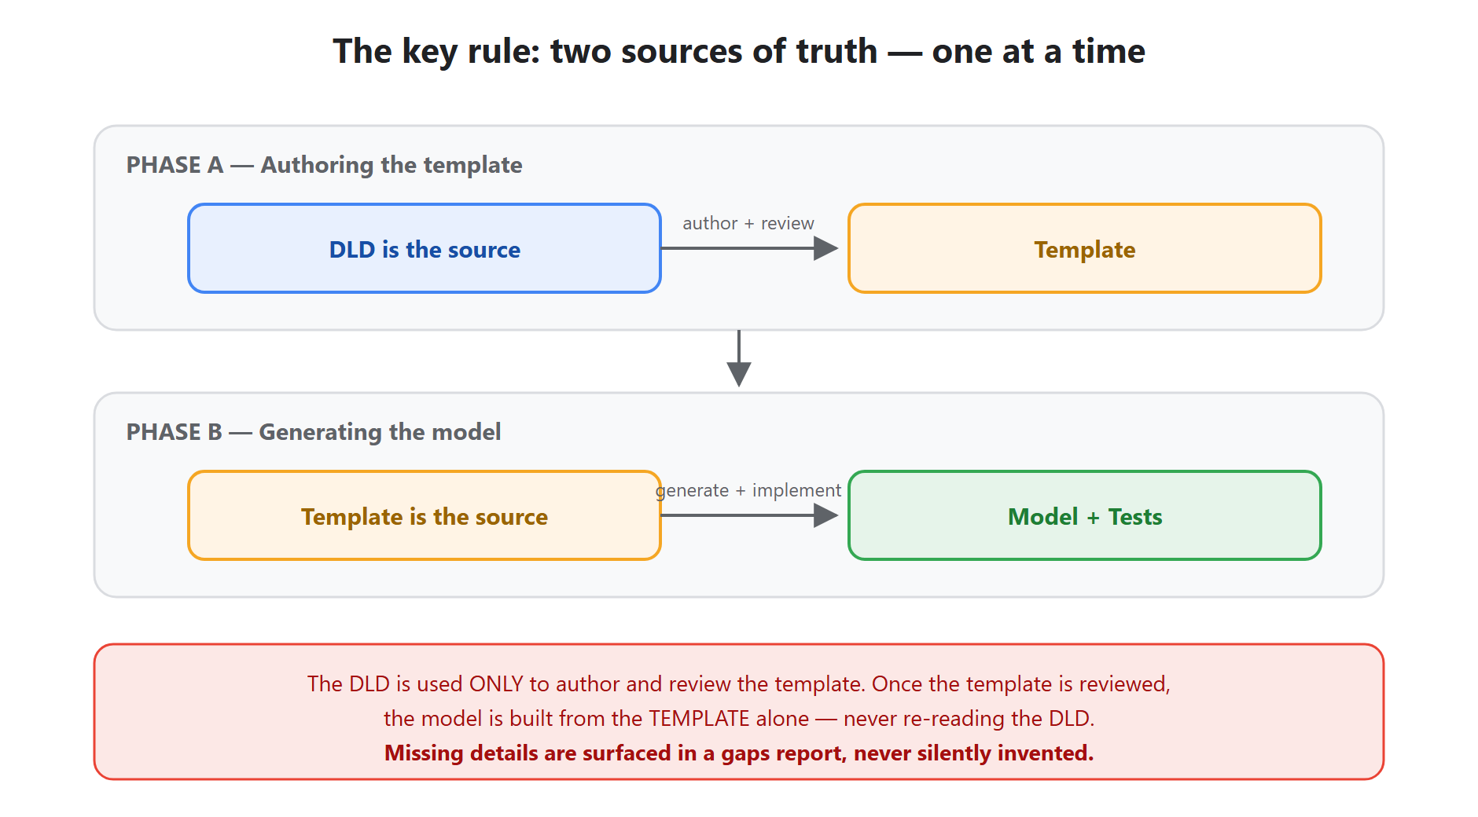
Figure 3 — The rule the whole system is built around.
Why this matters: a reviewer signs off the template once, and everything downstream (model, tests, docs, experiments) is a faithful function of that reviewed artifact. If the model did something the template doesn't say, that's a bug — not a judgment call.

Stage 0: DLD → reviewed template
tools/dld_to_template.py is a best-effort parser, not an oracle. It maps DLD sections onto template fields and marks everything else:
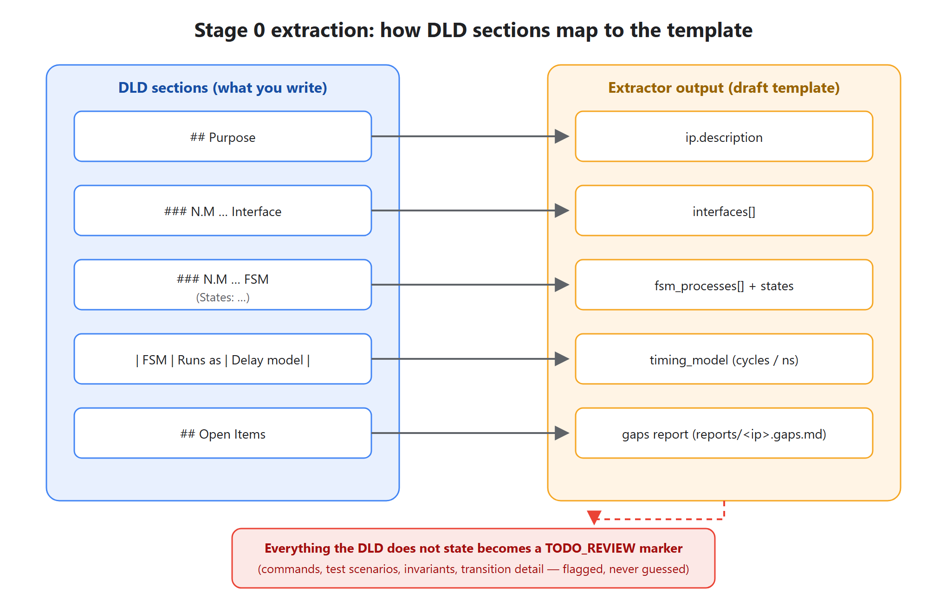
Figure 4 — How DLD sections map to template fields; the un-derivable rest becomes TODO_REVIEW markers and the gaps report.
The gaps report (reports/<ip>.gaps.md) combines the DLD's own “Open Items” section with every field the extractor couldn't derive. The point: missing information becomes visible and tracked instead of silently filled with a plausible-but-wrong assumption.
How we know the extractor can be trusted: it's calibrated against every existing golden IP — re-parsing each DLD must reproduce its template's FSM name set exactly, and the DLD's stated FSM count must match the template's fsm_count. That equality runs as a regression gate; if a change breaks extraction, calibration fails loudly. (Interface matching is report-only, because templates legitimately consolidate DLD interface sections; FSM coverage is the hard gate.)

Stage 1: template → model + tests
From the reviewed template:
- tools/generate_model_scaffold.py emits a SimPy skeleton — one model class, one process method per template FSM.
- tools/generate_prompt_pack.py bundles the template + contract + skill instructions into a self-contained prompt, so an LLM can fill in behavior without seeing (or needing) anything else.
- The implementer — human or LLM — fills in model behavior and unit tests from the template only.

What a generated model looks like
Each template FSM becomes one concurrent SimPy process; queues and stores connect them. Here is the real Mailbox IP model (added through this pipeline):
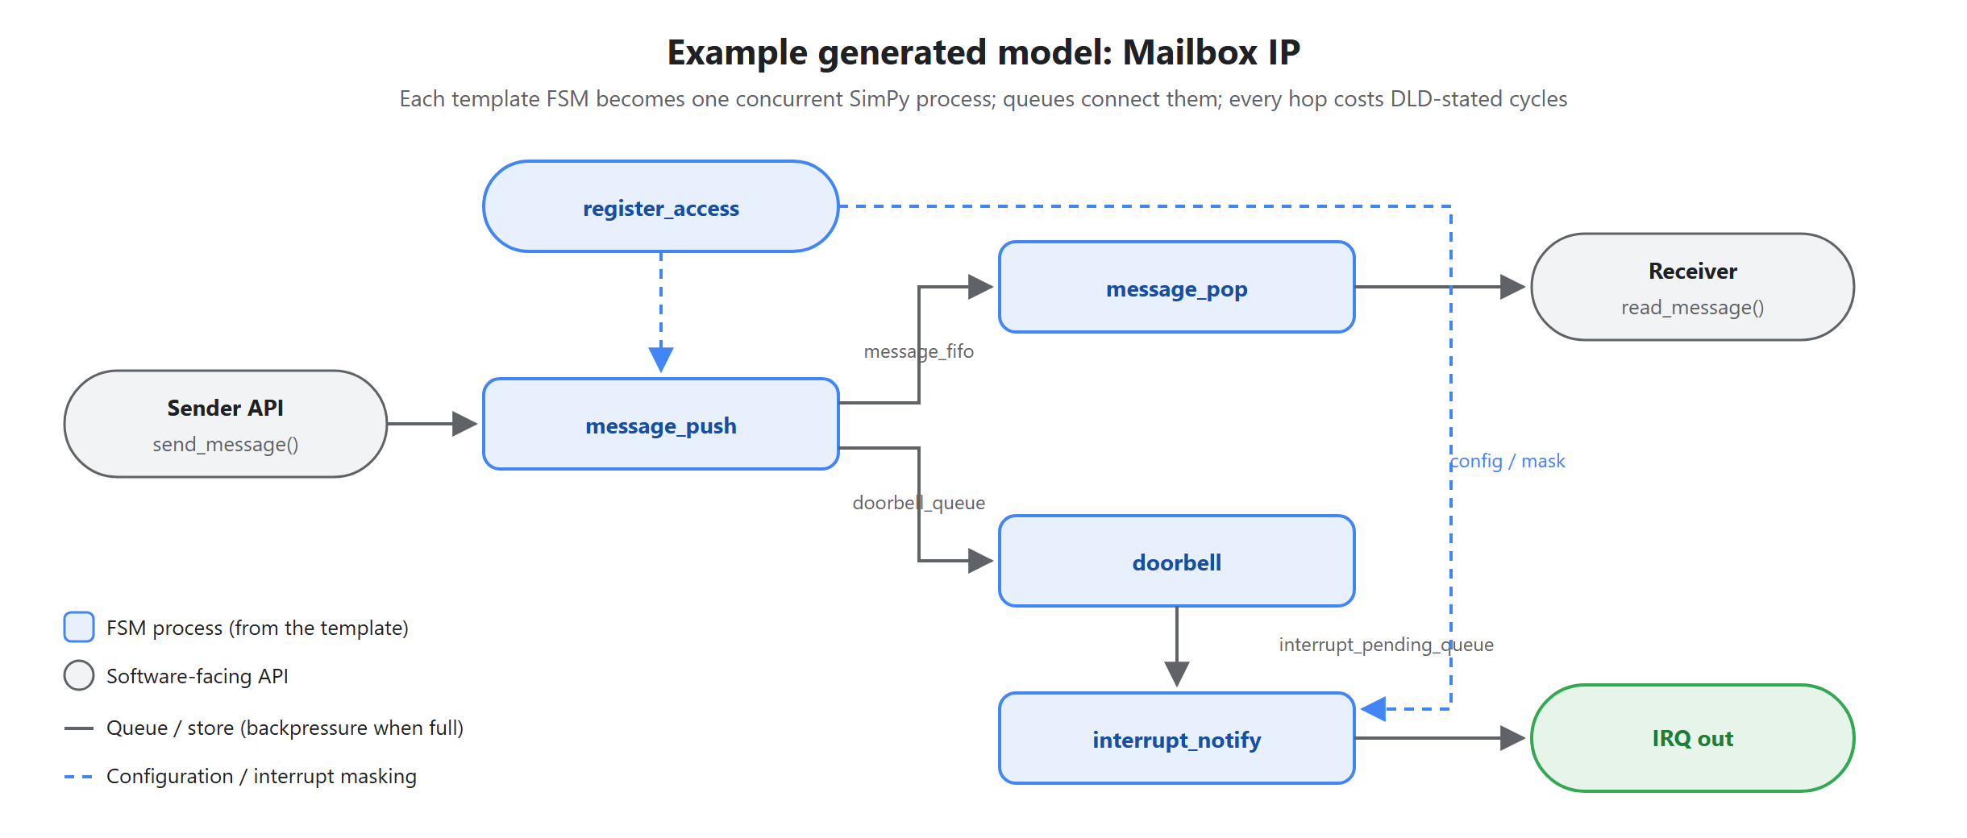
Figure 5 — The Mailbox IP model: FSM processes connected by queues, with masking and backpressure.
Reading this diagram: when software calls send_message(), the message_push process enqueues the message (blocking if the FIFO is full — that's backpressure), raises a doorbell, and the doorbell flows through interrupt_notify to become an IRQ — unless the channel is masked via the register_access process. Every arrow hop costs the number of cycles the DLD's timing table specified.
Every model also ships with:
- IP-tagged logging ([mailbox_ip] …) with log_level / log_file constructor arguments (default WARNING; also appends to run.log), and
- a metrics dict the unit tests assert on (counts, latencies, occupancies).

Code conventions
- One flat file per IP: src/ip_model_automation/<ip>.py — no per-IP folders, and no files named perf_model.py / functional_model.py / soc_models.py (deliberate repo rule).
- Shared dataclasses, registry metadata, and helpers: common.py; public export surface: ip.py.
- Per-IP tests in tests/test_<ip>.py, derived from the template's test_scenarios.
Run the whole test suite from the repo root:
$env:PYTHONPATH="$PWD\src"
python -m unittest discover -s tests

The gates: what “validated” actually means
Every stage is guarded by an automated check. Nothing advances until its gate is green — this is what lets a reviewer trust a green result without re-reading everything:
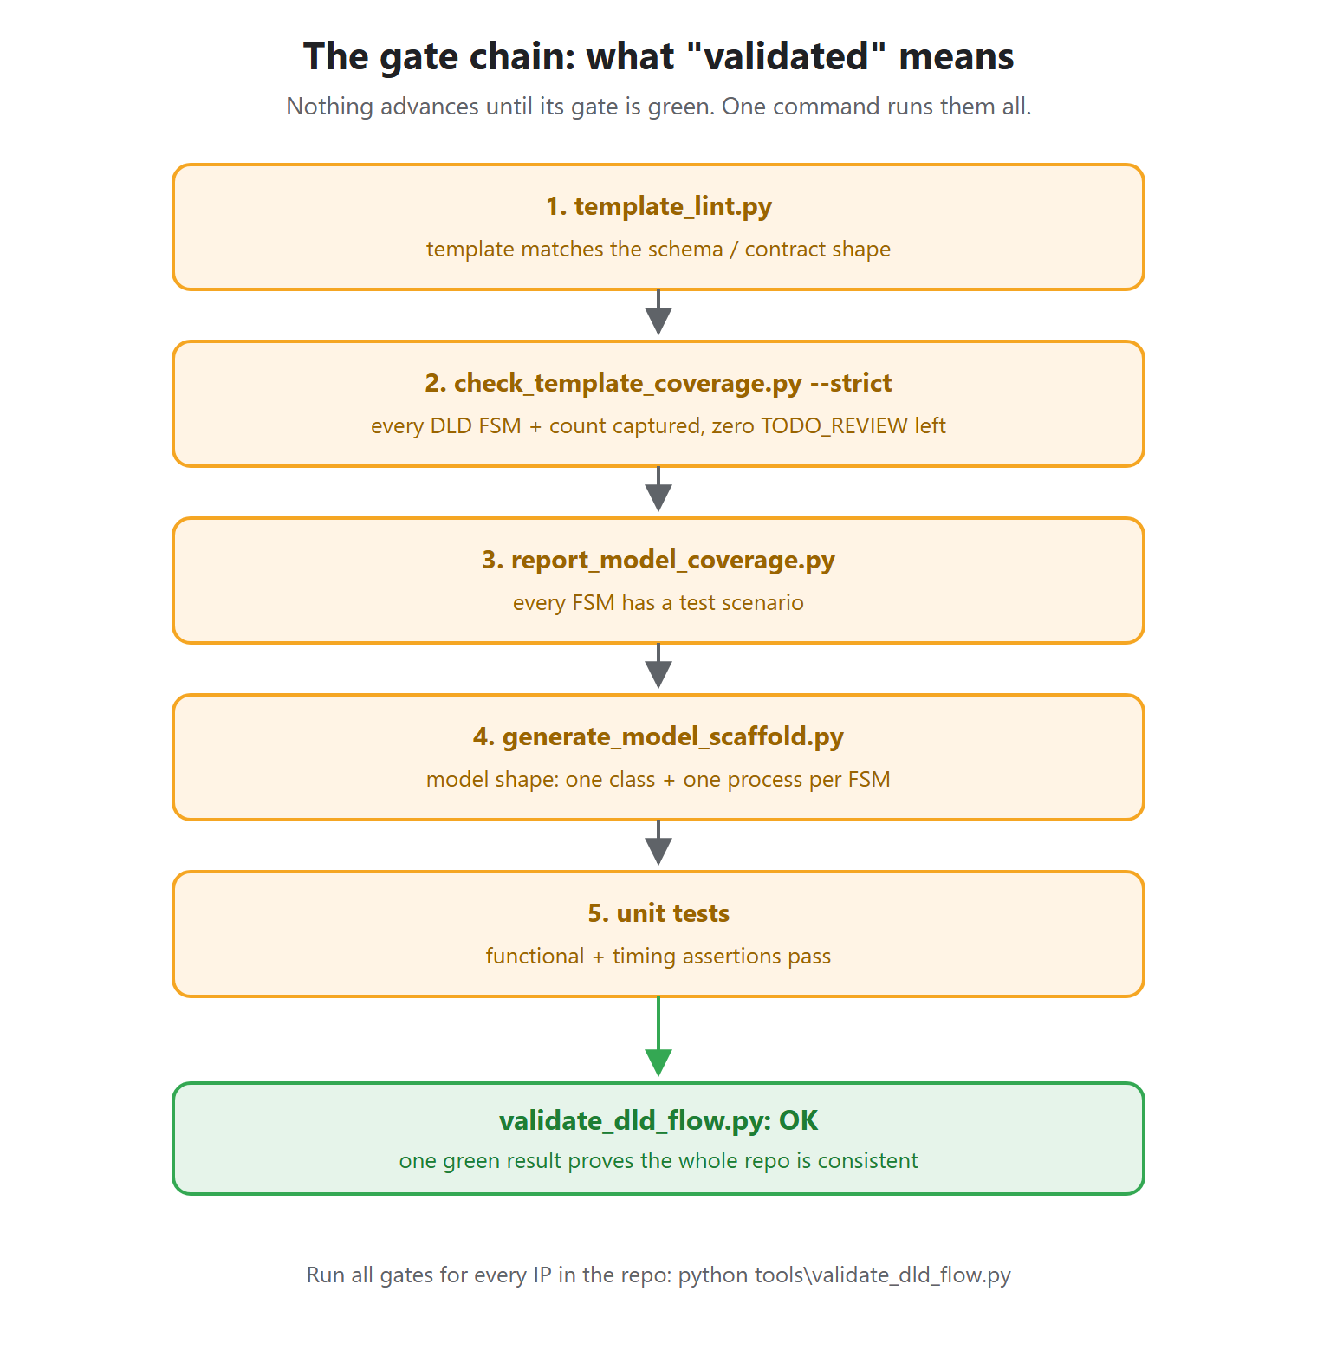
Figure 6 — The five-check gate chain behind a green validate_dld_flow.py.
One command — python tools\validate_dld_flow.py — runs the front-end gate for every DLD in the repo (template exists, lints, covers its DLD), then the model/test flow, and regenerates the readable template docs. A single green result proves the whole repo is consistent.

The automated pipeline runner
tools/auto_ip_pipeline.py is the orchestrator that strings all of the above together so you don't have to run each tool by hand:
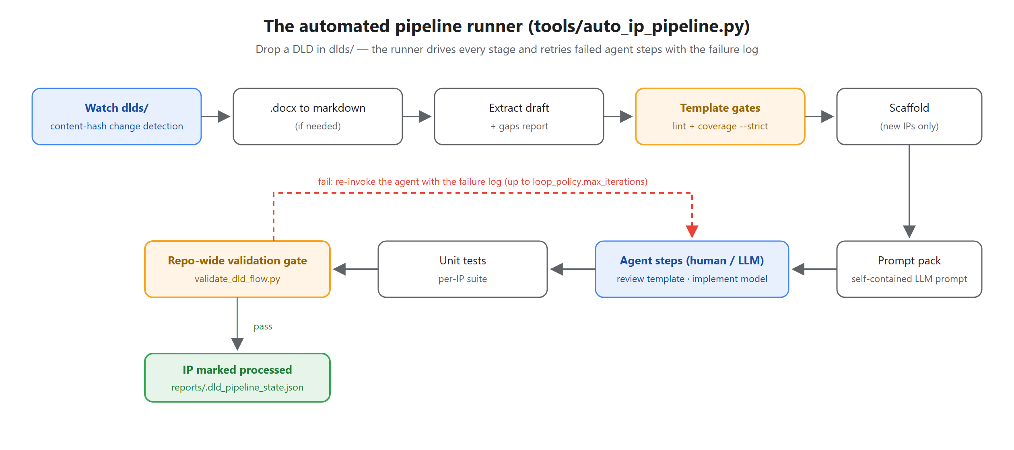
Figure 7 — The change-driven runner, including the agent retry loop.
- Change detection: Change detection hashes DLD content into reports/.dld_pipeline_state.json. An IP is only marked processed after its full chain passes — so a half-finished IP is automatically picked up again next run.
- Agent steps: The two agent steps (template review, model implementation) are the only places judgment is needed. Without --agent-cmd, the runner writes the prompt to reports/agent_requests/<ip>.<step>.prompt.md and reports the IP as awaiting. With --agent-cmd, it pipes the prompt to your LLM command and, when validation fails, re-invokes it with the failure log — up to loop_policy.max_iterations from harness/ip_generation_loop.yaml.

Beyond single IPs: subsystems
A subsystem (several IPs wired together) is modeled as “just another IP”: its FSM processes are the glue between member IP models, and the member models are its resources. It rides the same DLD → template → model → tests pipeline, so every gate applies unchanged. One extra check, tools/check_subsystem_wiring.py, verifies the wiring is real: members exist, the member APIs and glue FSMs referenced by connections: exist, and the model actually instantiates its members.

Map of the repository
Area | Role
dlds/*_dld.md | Your design intent (authoring source only).
templates/*.template.yaml | Golden reference — source of truth for generation.
templates/*.template.draft.yaml | Extractor output awaiting review (gitignored).
schemas/…schema.json | Machine-checkable template contract.
tools/*.py | Deterministic extraction, linting, coverage, generation, validation.
skills/, harness/, agents/ | Instructions/contract for the human or LLM that fills templates, models, and tests.
src/ip_model_automation/*.py | Flat, one-file-per-IP SimPy delay models.
tests/test_*.py | Per-IP unit tests derived from test_scenarios.
reports/ | All generated output (gitignored): gaps reports, readable template docs, agent requests, experiment results, pipeline state.
prompt_packs/ | Generated LLM prompt bundles (gitignored).

Part 4 — Current status
As of 2026-07-09: all gates green — validate_dld_flow.py OK, 60 unit tests passing.

Modeled IPs (9)
IP | What it models
arbitration_ip | Hierarchical port/tenant/SQ arbitration with pending bitmaps, RR/WRR policy, burst-limited issue pipeline.
completion_ip | Command completion scheduling with per-tenant QoS tokens, WWV write accounting, soft/hard burst behavior, output backpressure.
gdma_ip | Descriptor-driven DMA with multiple parallel/sequential FSMs.
timer_ip | Register, tick, compare, watchdog, debug-freeze, and interrupt timer behavior.
axi_interconnect_ip | AXI read/write routing, arbitration, response routing, decode-error handling.
interrupt_controller_ip | Source sampling, pending/filter/priority, delivery, ACK, EOI, software interrupts.
mailbox_ip | Multi-channel inter-processor messaging: per-channel FIFOs, doorbells, masked interrupt aggregation.
spi_master_ip | SPI master with TX/RX byte FIFOs, bit-shift transfer engine, chip-select framing, masked interrupts.
i3c_ip | I3C master with queued command engine, bit-level SDR transfer engine, IBI detection/arbitration, masked interrupts.

Modeled subsystems (2)
Subsystem | What it composes
dma_subsystem | Connected data-mover composing gdma_ip, axi_interconnect_ip, arbitration_ip, completion_ip. Descriptors fan out to an engine leg and a fabric leg; the subsystem IRQ fires when both legs complete. A backpressure monitor couples fabric congestion to GDMA memory readiness and completion backlog to arbitration issue readiness.
mailbox_irq_subsystem | Interrupt-delivery cluster composing mailbox_ip (doorbell source) and interrupt_controller_ip (delivery fabric) with a modeled software service loop (ack, read, clear, EOI). True level-triggered semantics (EOI re-pends while unserviced messages remain) and duty-cycle interrupt-storm throttling.

Pipeline maturity
- mailbox_ip, spi_master_ip, and i3c_ip were added end-to-end through the pipeline: brand-new DLDs went through extraction, review, modeling, and testing, and the whole suite validated. The same path carries both subsystems.
- The change-driven runner (auto_ip_pipeline.py), readable template docs (Markdown + HTML), and the performance-experiments layer are in place.
- Extractor calibration holds for every golden IP (FSM name set + count reproduce exactly).

Summary
- You write a DLD; the system produces a validated SimPy model and unit tests.
- A normalized template sits in the middle as the golden reference — the DLD authors it, the template generates everything else.
- Deterministic tools do extraction, linting, coverage, and validation; a human or LLM fills the judgment gaps under a strict contract.
- Missing details are surfaced in a gaps report, never invented.
- Every stage has an automated gate, and one command (validate_dld_flow.py) proves the whole repo is consistent.

