Git HW Due Sept 5, 11:59pm via Canvas

For this homework, you will be asked to take screenshots of your terminal to prove that you have completed all the necessary steps in the terminal. This has to be done on the head node of the cluster.
This document has 5 parts where you need to add screenshots.
Do not add this document to github.

Log onto the cluster
Include a screenshot of your terminal showing that you have logged onto the trantor cluster for this class.
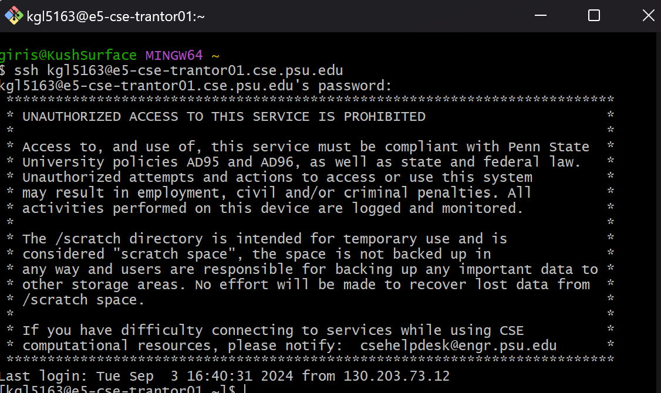
[replace this with the screenshot of the terminal]

Cloning
Please read the “using github classroom” page on canvas carefully. Follow the directions in Step 2 of that document. Include screenshots (note: plural) here to show that you correctly followed each sub-step using the terminal.
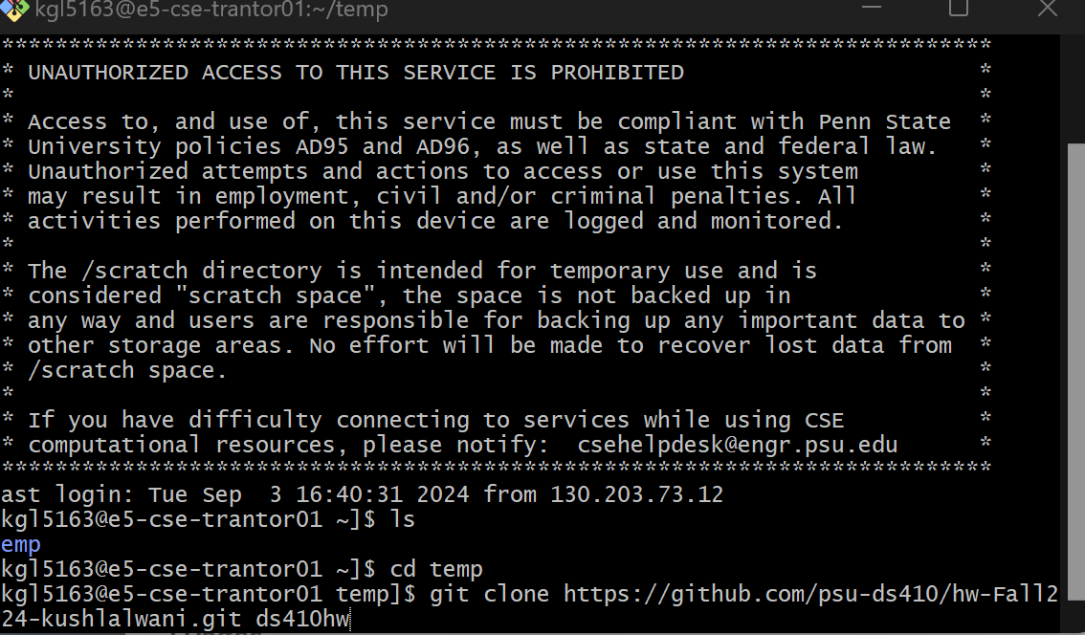
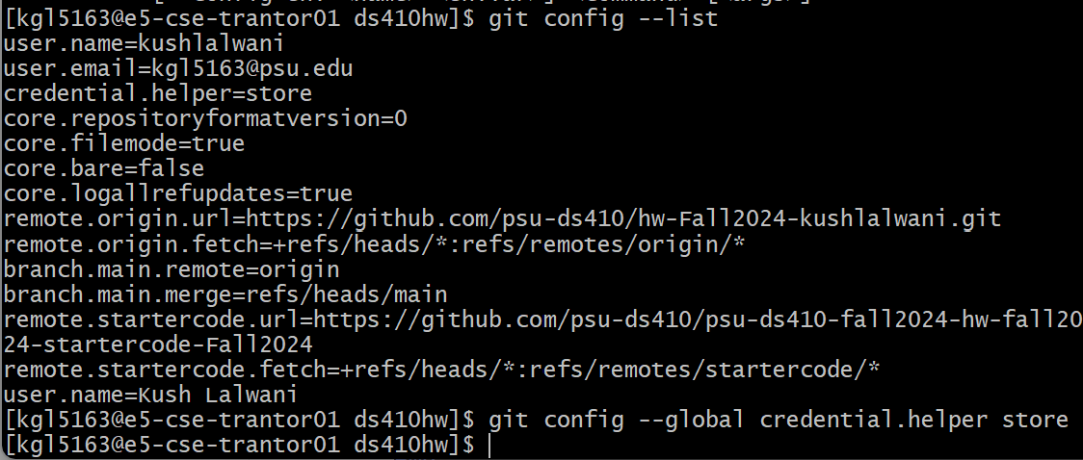
[replace this with screenshots of the terminal]

Getting new assignments
Please follow directions for Step 3 for getting updates. Include screenshots to show you correctly followed the sub-steps. Depending on when you cloned the repository, you may or may not get new files when you follow these directions.
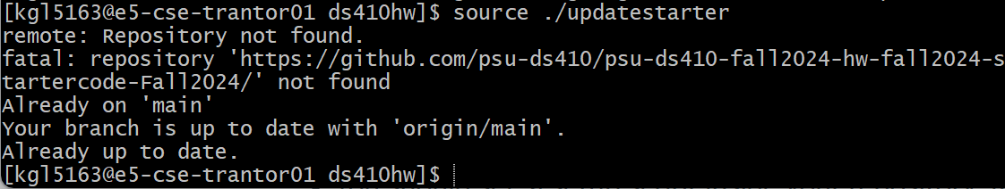
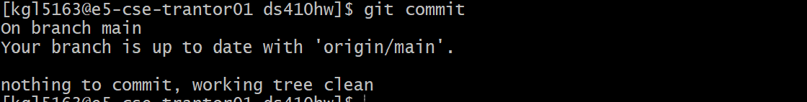
[replace this with screenshots of the terminal]

Git status
Use “git status” to check what needs to be done with your github repository. If git suggests that you need to do something, do it, and then run git status again (keep doing this until git status says there is nothing more you need to do). Include screenshots of your terminal showing you using git status and doing the actions it recommends.
[replace this with screenshots of the terminal]
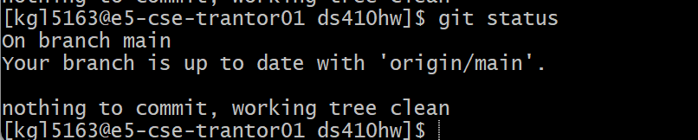

VI
Instructions for using VI are in the “using the cluster page”
Use vi to create a new file called usingvi.md inside the githw directory in your github repository. Edit the file so that it contains the sentence “I will not add .doc files to github”. Save the file then add/commit/push. This step should have 3 terminal screenshots: (1) the command you use to create the file, (2) showing that you have added the sentence into the file in vi, (3) commands showing that you have added, commited, pushed the file and then used git status to check if anything else needs to be done (I believe that all of these git commands can fit into the same screenshot; if now, you can upload additional screenshots).

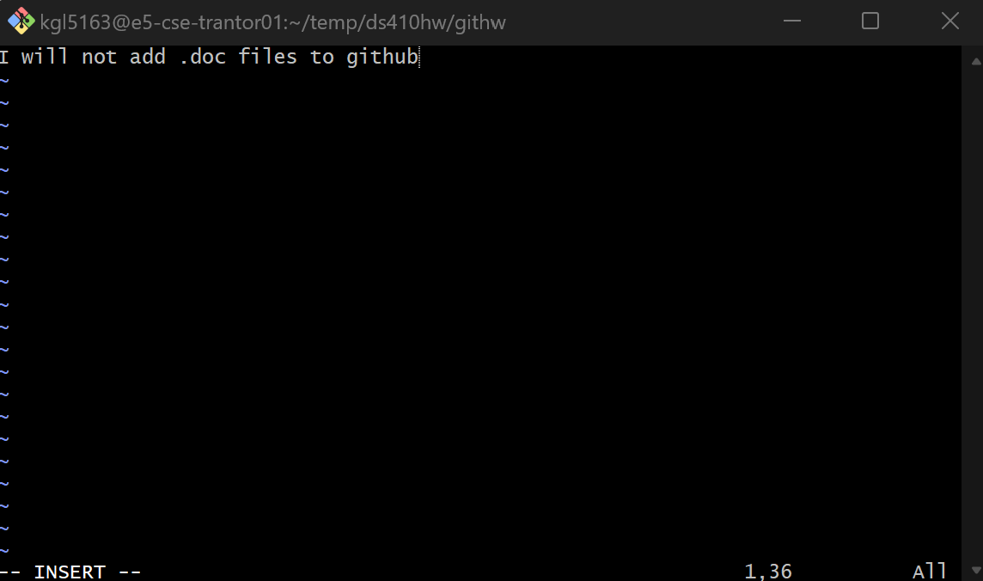
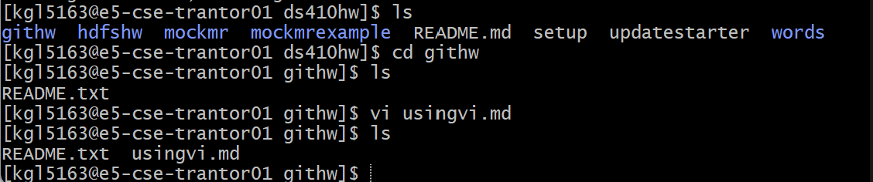
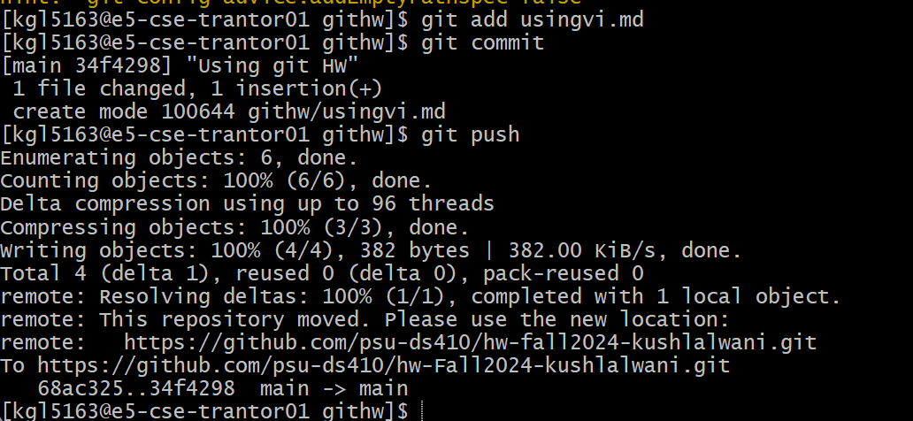
replace this with screenshots]

