Agent Workflow Documentation
Vehicle Fleet Management Assistant — Milestone 2
Vachan, Kush, Aadit
Team Project
Purpose. This document describes the design and implementation of the agentic AI workflow used in the Vehicle Fleet Management Assistant. The agent is built using LangGraph, a stateful workflow orchestration framework, and follows a clear five-node pipeline that takes raw vehicle data and produces a grounded, structured maintenance assessment report.

1. Architecture Overview
The agent runs as a directed acyclic graph of five sequential nodes. State flows linearly through every node, with each node contributing additional fields to a single shared dictionary.
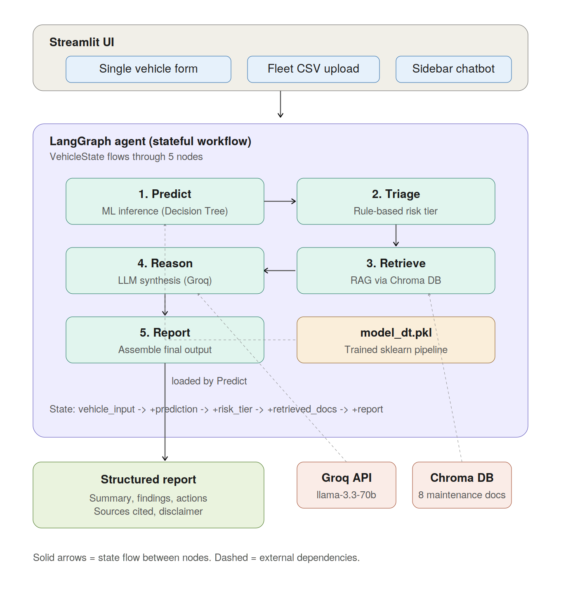
Figure 1. End-to-end system architecture, showing the Streamlit user interface, the LangGraph agent's five nodes, and external dependencies (the trained ML model, the Chroma vector database, and the Groq LLM API).

2. Why LangGraph
LangGraph was chosen over alternatives (LangChain agents, raw function calls, custom orchestrators) because of:
- Explicit state management. The state schema is a TypedDict; every field has a clear owner. There is no 'dictionary soup'.
- Visual workflow. The node-edge graph is easy to reason about and modify. Adding a new node is a one-line change.
- Per-node debuggability. Every node's contribution is isolated, so issues can be traced precisely to the responsible step.
- Future extensibility. Conditional edges, parallel branches, and loops are first-class concepts. For example, a future verification node could re-check the LLM output and loop back if invalid.

3. State Object
The shared state object is defined in agent/state.py:
class VehicleState(TypedDict, total=False):
# Input
vehicle_input: dict
vehicle_id: str

# Added by Predict
prediction: int # 0 or 1
probability: float
prediction_features: dict

# Added by Triage
risk_tier: str # CRITICAL | HIGH | MEDIUM | LOW
triage_reasons: list[str]

# Added by Retrieve
retrieved_docs: list[dict] # [{source, content}, ...]
retrieval_query: str

# Added by Reason
executive_summary: str
detailed_findings: list[dict]
action_plan: list[dict]
risk_assessment: str
preventive_recommendations: list[str]

# Added by Report
final_report: dict # complete structured output

State is immutable per node; each node returns a partial dictionary that LangGraph merges into the running state. This makes the pipeline easy to debug because every step's contribution is isolated and traceable.

4. Node Descriptions

4.1 Node 1: Predict (agent/nodes/predict.py)
Purpose. Run the trained ML model on the vehicle features.
Implementation.
- Loads model_dt.pkl (Decision Tree pipeline) once and caches it via lru_cache.
- Builds a single-row DataFrame in the exact feature order expected by the model.
- Returns prediction (0 or 1) and probability of class 1.
Why a separate node. Keeps ML inference isolated from agentic logic. If the model changes (for example, switching to a Random Forest or retraining on new data), nothing else in the pipeline needs to change.

4.2 Node 2: Triage (agent/nodes/triage.py)
Purpose. Assign a risk tier using deterministic rules.
Implementation. A rule-based classifier following the tier definitions in maintenance_docs/07_fleet_risk_tiers.md. Examples:
- CRITICAL if: brake condition is 'Worn Out', OR reported issues = 5, OR two or more components in worst state simultaneously.
- HIGH if: any single component in worst state, OR 3-4 reported issues, OR model probability ≥ 80%, etc.
- MEDIUM if: 2 reported issues, OR maintenance history is poor, etc.
- LOW otherwise.
Why rule-based, not LLM. Safety-critical classification must be reproducible and explainable. An LLM could 'hallucinate' away a CRITICAL finding under the wrong prompt; a rule cannot. Each rule that fires is also returned as a triage_reason, giving a transparent audit trail.

4.3 Node 3: Retrieve (agent/nodes/retrieve.py)
Purpose. Pull the most relevant maintenance guideline excerpts from the knowledge base.
Implementation.
- Builds a descriptive query string from the vehicle's specific issues (for example, 'high risk vehicle: worn out brakes, weak battery, 9 year old vehicle').
- Queries the Chroma vector DB (k = 5) for the most semantically similar chunks.
- Returns each chunk together with its source filename for citation.
Knowledge base. 8 markdown documents in maintenance_docs/, covering brakes, tires, battery, reported issues, age and mileage, maintenance and accident history, fleet risk tiering, and safety disclaimers.
Embedding model. sentence-transformers/all-MiniLM-L6-v2. Lightweight, runs locally on CPU, approximately 90 MB.

4.4 Node 4: Reason (agent/nodes/reason.py)
Purpose. Have the LLM synthesize a detailed assessment, grounded in the retrieved guidelines.
Implementation.
- Constructs a structured prompt containing decoded vehicle data (e.g., 'Brake Condition: Worn Out' instead of 2), the ML prediction and triage reasons, and all retrieved guideline excerpts with their source labels.
- Calls Groq's llama-3.3-70b-versatile with temperature = 0.2 for deterministic, factual output.
- Forces JSON output via system prompt (no markdown fences, no preamble).
- Robustly parses the JSON, with fallback regex extraction for malformed responses.
Hallucination mitigation strategies.
- Strict instructions to ground every claim in provided excerpts.
- JSON-only output to constrain shape.
- Required source field on every action and finding (forces citation).
- Low temperature for consistency.
- Explicit instruction to say 'not covered' when guidelines do not address something.

4.5 Node 5: Report (agent/nodes/report.py)
Purpose. Assemble the final structured output for the UI.
Implementation.
- Collects all source filenames cited in findings and actions (deduplicated).
- Attaches the standard safety disclaimer.
- Returns the complete final_report dictionary that the UI renders.
The report has 8 visual sections in the UI:
- Executive Summary — paragraph from the LLM
- Vehicle Data Sheet — table of all input values
- Vehicle Health Overview — radar chart
- Key Findings — observations with context
- Recommended Actions — service items with rationale, timeline, cost, source
- Risk if Unaddressed — what happens if ignored
- Preventive Recommendations — proactive tips
- Sources Consulted — list of cited documents

5. Chatbot (Separate Module)
The follow-up chatbot (agent/chat.py) is intentionally outside the LangGraph pipeline. It runs after the report is generated and lets users ask questions about the assessment.
How it works.
- Receives the user's question, the full report context, and recent chat history.
- Runs a fresh RAG query specific to the question.
- Calls Groq with the assembled context (report + new excerpts + history).
- Cites sources inline in its response.
Why it is separate. The main pipeline is one-shot (input → report). The chatbot is multi-turn and stateful per session. Mixing them in LangGraph would have added unnecessary complexity.

6. End-to-End Latency
Approximate timings on local hardware for a single vehicle:
Node | Time
Predict | < 50 ms
Triage | < 10 ms
Retrieve | ~200 ms (cold), ~50 ms cached
Reason | 4-7 seconds (Groq LLM call)
Report | < 10 ms
Total | ~5-8 seconds per vehicle

Fleet mode runs nodes 1-5 sequentially per vehicle, so 10 vehicles take approximately 60-80 seconds.

7. File Layout
File | Role
agent/state.py | State schema (VehicleState TypedDict)
agent/graph.py | Workflow definition (wires nodes together)
agent/chat.py | Follow-up Q&A chatbot
agent/nodes/predict.py | Node 1: ML prediction
agent/nodes/triage.py | Node 2: Risk tiering
agent/nodes/retrieve.py | Node 3: RAG retrieval
agent/nodes/reason.py | Node 4: LLM reasoning
agent/nodes/report.py | Node 5: Report assembly
rag/build_index.py | Builds Chroma DB from maintenance docs
rag/retriever.py | Query interface for the vector DB
maintenance_docs/*.md | 8 maintenance guideline documents (knowledge base)

8. Workflow Wiring
The pipeline is wired together in agent/graph.py:
from langgraph.graph import StateGraph, END
from agent.state import VehicleState
from agent.nodes.predict import predict_node
from agent.nodes.triage import triage_node
from agent.nodes.retrieve import retrieve_node
from agent.nodes.reason import reason_node
from agent.nodes.report import report_node

def build_graph():
g = StateGraph(VehicleState)

g.add_node("predict", predict_node)
g.add_node("triage", triage_node)
g.add_node("retrieve", retrieve_node)
g.add_node("reason", reason_node)
g.add_node("report", report_node)

g.set_entry_point("predict")
g.add_edge("predict", "triage")
g.add_edge("triage", "retrieve")
g.add_edge("retrieve", "reason")
g.add_edge("reason", "report")
g.add_edge("report", END)

return g.compile()

The workflow is compiled once and cached at module load. Each invocation calls graph.invoke(initial_state) with the user input dictionary.

