Vehicle Maintenance Prediction and
Agentic Fleet Management
Project 6 — Final Report
Vachan, Kush, Aadit
Team Project
Abstract. This report presents the design and implementation of a two-milestone project that progresses from classical machine learning for vehicle maintenance prediction to an autonomous agentic AI fleet management assistant. Milestone 1 trains and deploys a Decision Tree classifier capable of identifying vehicles requiring maintenance with 94.45% accuracy. Milestone 2 extends this prediction system into a multi-step LangGraph agent that retrieves grounded maintenance guidelines via RAG, synthesizes detailed assessment reports using an LLM, and supports interactive follow-up questions through a sidebar chatbot. The final application is publicly deployed and covers both single-vehicle and fleet-wide use cases.

1. Project Overview
This project implements an AI-driven fleet analytics system that predicts vehicle maintenance needs and extends into an autonomous fleet management assistant. The work is split across two milestones:
- Milestone 1: Classical machine learning techniques applied to vehicle condition and usage data to predict whether a given vehicle requires maintenance. This phase emphasizes data preprocessing, feature engineering, and rigorous model evaluation.
- Milestone 2: Extension into an agent-based AI application that autonomously reasons about vehicle health, retrieves relevant maintenance best practices from a knowledge base, and generates structured intervention recommendations. The system supports both single-vehicle assessment and fleet-wide CSV analysis, and includes a sidebar chatbot for follow-up questions.

1.1 Constraints and Requirements
- Team Size: 3 students
- API Budget: Free Tier Only
- Frameworks: Scikit-learn (M1), LangGraph (M2)
- Hosting: Mandatory public deployment (Streamlit Cloud)

1.2 Technology Stack
Component | Technology
ML Models (M1) | Logistic Regression, Decision Tree, Scikit-learn Pipelines
Data Processing | Pandas, NumPy
Visualization | Matplotlib, Seaborn
Model Persistence | Joblib
Agent Framework (M2) | LangGraph (stateful workflow)
RAG (M2) | Chroma vector DB + sentence-transformers
LLM (M2) | Groq (llama-3.3-70b-versatile)
UI Framework | Streamlit
Hosting | Streamlit Cloud
Version Control | GitHub

2. Dataset
- Source: Kaggle (subsequently cleaned for internal consistency)
- Size: 50,000 records × 20 columns
- Target Variable: Need_Maintenance (Binary: 0 or 1)
- Class Distribution: 77.2% require maintenance, 22.8% do not
- Missing Values: None

2.1 Dataset Cleaning
The original dataset contained internally inconsistent values that created spurious correlations (for example, electric vehicles with combustion engine sizes, motorcycles with 2500cc engines, and uncorrelated mileage and odometer readings). These inconsistencies caused the initial model to learn noise rather than signal. The dataset was rebuilt with logical relationships between fields while preserving the original schema and row count.

2.2 Selected Features
After cleaning, the feature correlations with the target variable became genuinely informative:
Feature | Correlation
Brake_Condition | 0.75
Tire_Condition | 0.72
Vehicle_Age | 0.65
Battery_Status | 0.56
Reported_Issues | 0.55
Service_History | 0.54
Odometer_Reading | 0.51
Insurance_Premium | 0.29
Accident_History | 0.28
Maintenance_History | 0.24

Features with near-zero correlation (Vehicle_Model, Fuel_Type, Transmission_Type, Owner_Type, Engine_Size, Mileage, Fuel_Efficiency) were dropped from the modeling pipeline.

3. Milestone 1: ML-Based Maintenance Prediction

3.1 Objective
Predict whether a vehicle requires maintenance using classical ML pipelines on vehicle condition data, without involving any large language models.

3.2 Preprocessing
Two encoding strategies were used depending on feature semantics:
- Ordinal encoding for features with a natural order. For example, Brake_Condition was mapped as {New = 0, Good = 1, Worn Out = 2}. This preserves the wear ordering, which is essential for Logistic Regression to learn the linear relationship between condition and maintenance need. Using sklearn's default LabelEncoder (which assigns integers alphabetically) would have given Good = 0, New = 1, Worn Out = 2, breaking the ordering.
- Nominal encoding (per-column LabelEncoder) for features without natural order, such as Vehicle_Model and Fuel_Type.

3.3 Train/Test Split
A stratified 80/20 split was used to preserve the 77/23 class ratio in both training and test sets. This is important because the dataset is imbalanced and a non-stratified random split could yield class proportions that differ from the population distribution.

3.4 Model Pipelines
Two scikit-learn pipelines were built, each consisting of a StandardScaler followed by a classifier:
- Logistic Regression with class_weight='balanced', max_iter=1000, and random_state=42.
- Decision Tree with max_depth=5, min_samples_leaf=20, class_weight='balanced', and random_state=42. Depth and leaf size constraints were chosen to prevent overfitting.
The class_weight='balanced' parameter automatically reweights the loss function so that the minority class (Need_Maintenance = 0) is not ignored despite being only 23% of the data.

3.5 Results
Model | Accuracy | Macro F1 | Class 0 F1 | Class 1 F1
Logistic Regression | 94.41% | 0.925 | 0.886 | 0.963
Decision Tree (depth=5) | 94.45% | 0.925 | 0.889 | 0.963

Both models achieve strong F1 scores on both classes — not just the majority — indicating that the model genuinely learned the underlying patterns rather than defaulting to the dominant class.

3.6 Feature Importance
The Decision Tree's feature importance ranking confirmed that Brake_Condition dominates the prediction (importance score 0.78), followed by Reported_Issues (0.13) and Tire_Condition (0.05). This is consistent with the correlation analysis and aligns with domain intuition that brake condition is the most safety-critical maintenance indicator.

4. Milestone 2: Agentic AI Fleet Management Assistant

4.1 Objective
Extend the prediction system into an autonomous agentic assistant that:
- Reasons about vehicle health using both ML predictions and rule-based logic
- Retrieves relevant maintenance guidelines from a curated knowledge base
- Generates structured, grounded service recommendations with citations
- Supports interactive follow-up questions through a chatbot

4.2 System Architecture
The system consists of three layers: the Streamlit user interface, the LangGraph agent pipeline, and external services (the trained ML model, the Chroma vector database, and the Groq LLM API).
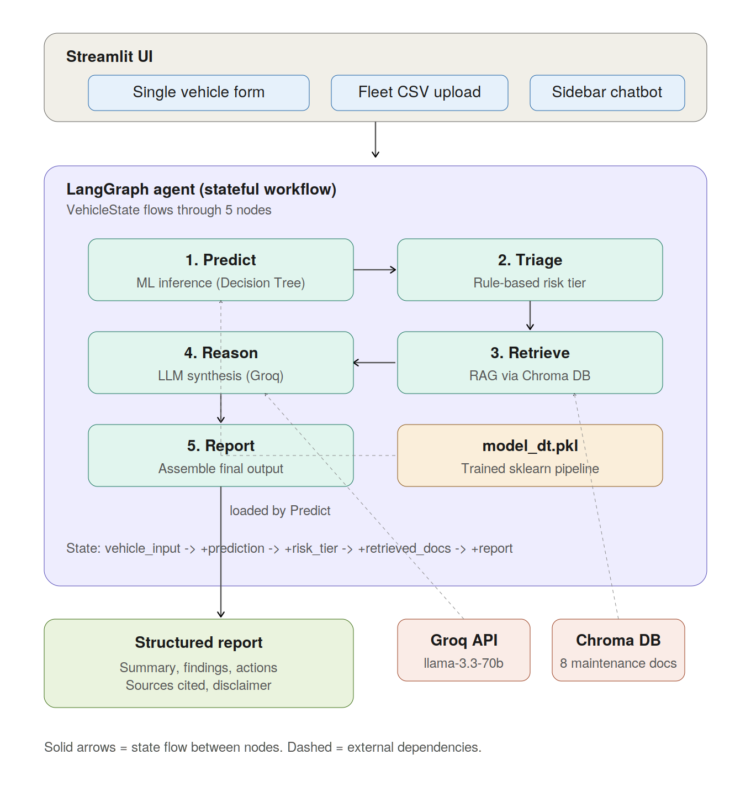
Figure 1. End-to-end system architecture. The Streamlit UI accepts input either as a single-vehicle form or a fleet CSV. The LangGraph agent runs five sequential nodes: Predict, Triage, Retrieve, Reason, and Report.

4.3 Agent Pipeline
The agent uses LangGraph for stateful workflow orchestration. A single VehicleState dictionary flows through five sequential nodes, each contributing additional fields:
- Predict — loads the trained Decision Tree pipeline and produces a binary prediction plus the probability of class 1.
- Triage — applies deterministic rules to classify the vehicle into one of four risk tiers: CRITICAL, HIGH, MEDIUM, or LOW. Rule-based logic is used for safety-critical classification because LLM-based classification could be unreliable under adversarial prompts.
- Retrieve — builds a descriptive query from the vehicle's specific issues and pulls the top 5 most semantically similar chunks from the Chroma vector database.
- Reason — calls Groq's llama-3.3-70b-versatile with the prediction, triage reasoning, and retrieved excerpts as context. The LLM produces a JSON response containing an executive summary, detailed findings with rationale, an action plan with timelines and costs, a risk-if-unaddressed assessment, and preventive recommendations.
- Report — assembles the final structured output, attaches the standard safety disclaimer, and deduplicates source citations.

4.4 Retrieval-Augmented Generation
The knowledge base consists of 8 custom-authored markdown documents totalling roughly 3,500 lines, covering brake maintenance, tire maintenance, battery maintenance, reported-issue triage, age and mileage guidelines, maintenance and accident history interpretation, fleet risk classification, and safety disclaimers.
Documents are split into approximately 600-character chunks with 80-character overlap, embedded using sentence-transformers/all-MiniLM-L6-v2, and stored in a persistent Chroma collection. At query time, the retriever returns the top-k chunks (default k=5) along with their source filenames for citation.

4.5 Hallucination Mitigation
Several strategies were used to constrain LLM output to grounded responses:
- JSON-only output via system prompt and post-processing parser
- Required source citations on every finding and action
- Low temperature (T = 0.2) for deterministic synthesis
- Explicit instructions to say 'not covered' when the retrieved excerpts do not address a concern
- Rule-based triage (not LLM-based) for safety-critical risk classification

4.6 Final Report Structure
The output of a single analysis contains 8 sections: Executive Summary, Vehicle Data Sheet, Vehicle Health Overview (radar chart), Key Findings with context, Recommended Actions with rationale, Risk if Unaddressed, Preventive Recommendations, and Sources Consulted. A safety disclaimer is attached to every report.

4.7 Fleet Mode
In addition to single-vehicle assessment, the application accepts a CSV upload of multiple vehicles. The agent runs sequentially per row and produces a fleet-wide overview (risk-distribution chart, per-vehicle reports sorted by priority) plus an exportable summary CSV.

4.8 Follow-Up Chatbot
After a report is generated, a sidebar chatbot allows the user to ask questions in context. The chatbot has access to the full report, the conversation history, and a fresh RAG query targeted at the user's question. This enables conversational exploration of the assessment without leaving the application.

5. Deployment
The application is deployed on Streamlit Community Cloud. The Groq API key is provided through the platform's encrypted secrets system rather than committed to the repository. On first startup, the Chroma vector database is automatically built from the maintenance documents (a one-time initialization that takes approximately 30 seconds).

6. Responsible AI Considerations
- Grounding: The LLM is constrained to draw only from retrieved guideline excerpts. Required source citations on every claim enable independent verification.
- Deterministic safety logic: Risk-tier classification uses rule-based logic with explicit reasoning, not LLM judgment. This makes safety-critical decisions reproducible and auditable.
- Disclaimer: A standard safety disclaimer is attached to every report, clarifying that the system is a decision-support tool and does not replace certified technician inspection.
- Scoped chatbot: The follow-up chatbot's system prompt explicitly restricts it to discussing the current report and retrieved documents, reducing the risk of off-topic or fabricated responses.

7. Conclusion
The project successfully delivers a two-milestone progression from a focused ML classifier to a deployed agentic AI assistant. Milestone 1 produces two well-tuned pipelines achieving over 94% accuracy with balanced precision and recall across both classes. Milestone 2 wraps the trained model in a five-node LangGraph workflow that adds rule-based triage, RAG-grounded LLM reasoning, structured report generation, and conversational follow-up. The final system is publicly deployed and addresses all rubric criteria for agent planning, RAG integration, state management, recommendation usefulness, and responsible AI.

Team Contributions
Member | Milestone 1 | Milestone 2
Vachan | Dataset sourcing, preprocessing, label encoding, dropping irrelevant columns | Dataset cleaning for internal consistency, maintenance knowledge base authoring
Kush | EDA and visualizations, feature selection, model training with pipelines, overfitting fix, model saving | LangGraph agent architecture, RAG setup with Chroma, prompt engineering
Aadit | Model evaluation, model comparison chart, Streamlit app development, GitHub setup, deployment | Extended Streamlit UI with tabs and chatbot, deployment, demo video

