
Survey on Accessibility and Usability of Streaming Services v2
Full Results Report

Prepared for

Audio Description Project

Contents

Background
- Purpose: measure how blind and low-vision viewers experience the eight major streaming services Amazon Prime, Apple TV+, Disney+, HBO Max, Hulu, Paramount Plus, Netflix and Peacock.
- Run by the Moakley Center for Public Management at Suffolk University for the Audio Description Project.
- Covers all 337 responses collected to date.
- Asks how viewers find and activate audio description, how well each platform works with their screen reader, and where browsing, searching and playback break down.
- Closed-ended results and rating averages come from the SurveyMonkey rollups; open-ended results are summarised as themes and sentiment from the per-question exports.

Who Responded
- A profile of the 337 people who took part, covered in Section 1: Demographics and User Profile.
- Q1 vision status: 74.5% blind, 16.4% low vision, 9.1% neither (n = 329).
- Q2 age range: largest group 40 to 49 at 24.5%, with 47.4% aged 50 or older (n = 331).
- Q3 country of residence: 89.6% in the United States; 33 respondents elsewhere, chiefly Canada, Australia, New Zealand and Thailand (n = 318).
- Q4 primary screen reader: VoiceOver 44.7%, JAWS 15.0%, NVDA 8.1% (n = 333).
- Q5 visual access features used (select all): dark mode 52.1%, screen magnification 20.8% (n = 192).

Key Observations
- Each service is scored on nine aspects on a 1-to-5 scale and ranked on the unweighted mean.
- Apple TV+ leads at 3.84, followed by Disney+ (3.67) and Netflix (3.61); Amazon Prime (3.30) and Paramount Plus (3.17) sit at the bottom.
- Audio description activation reliability is the weakest link industry-wide and shows the widest spread of any aspect 1.20 points between Apple TV+ (3.99) and Paramount Plus (2.79).
- It is also the issue named most often in the open-ended comments.
- Independent volume control for the description track is the lowest-scoring aspect for six of the eight services; logging in and accessing your profile is the strongest almost everywhere.
- Includes all 28 head-to-head service comparisons.

Recommendations
- Make audio description discoverable before playback, so viewers can tell which titles carry it without opening each one.
- Keep AD switched on reliably between episodes and sessions.
- Give the description track its own volume control.
- Label playback and settings buttons properly so screen readers announce them.
- Stop playback controls from hiding mid-programme.
- Sentiment behind these asks: 88–99% positive on the best-feature question against 81–98% negative on the frustration question, depending on the service.

Data tables
- Full response tables behind every chart — answer choices, percentages and counts for each question.
- Open-ended comment lists are not reproduced in this public version; their counts, themes and sentiment are summarised under each question.
- Section 1: demographics and user profile (Q1–Q5).
- Section 2: streaming habits and how respondents reach audio described content (Q6).
- Section 3: per-service experience (Q7–Q40) — usage table, nine-aspect rating table, and themed frustration and best-feature lists.
- Sample sizes vary by question and by service, so each table states its own n.

Executive summary
Streaming accessibility is broadly workable but unreliable at the one point that matters most to this audience: turning audio description on and keeping it on. Across 337 respondents — 74.5% blind, 16.4% low vision — every one of the eight services scores between 3.17 and 3.84 out of 5 overall, so no platform is failing outright, and none is excelling. The differences that separate them are concentrated in audio description handling, not in general navigation.

What the ratings show
- Apple TV+ ranks first at 3.84, followed by Disney+ (3.67), Netflix (3.61), HBO Max (3.58), Hulu (3.49), Peacock (3.42), Amazon Prime (3.30) and Paramount Plus (3.17).
- The spread between best and worst is only 0.67 of a point, so service choice matters less than the specific task a viewer is trying to complete.
- Logging in and accessing a profile is the strongest aspect on almost every service; independent volume control for the description track is the weakest on six of the eight.
- Paramount Plus is the only service with four aspects below the neutral 3.0 midpoint.

Where accessibility breaks down
- Audio description activation reliability shows the widest gap of any aspect measured — 1.20 points between Apple TV+ (3.99) and Paramount Plus (2.79) — and is the issue named most often in the open-ended comments.
- Viewers cannot tell which titles carry audio description without opening each one, making discovery the single most common complaint.
- Audio description does not stay switched on between episodes and sessions.
- Unlabelled playback and settings buttons are announced inconsistently by screen readers, and playback controls hide themselves mid-programme.

What to do about it
- Surface audio description availability at the browse level, before playback.
- Persist the AD setting across episodes, sessions and devices.
- Give the description track its own volume control, independent of programme audio.
- Label every playback and settings control so screen readers announce it correctly.
- Keep playback controls reachable throughout playback rather than auto-hiding them.

About this report
This report covers all 337 responses collected to date. Closed-ended results and rating averages are taken directly from SurveyMonkey’s response rollups. Verbatim open-ended comments are omitted from this public version to protect respondent privacy; themes, counts and sentiment are shown for every open-ended question.
How comments were handled
- Only true non-answers were removed — responses consisting solely of "N/A", "NA" or "n.a.". Every other response is retained and counted, including short answers such as "None", "nothing", "0" and "idk", which carry meaning on these questions.
- The n shown under each open-ended question is the count after that filter. Where it differs from the raw export count, the raw figure is noted alongside it.
- Sentiment is scored using the question’s framing. On a "most frustrating challenge" question, a response that simply names a problem is counted as negative even where it uses no negative wording; explicit no-problem answers ("none", "no issues", "very easy to use") override that and are counted as positive or neutral. The same logic runs in reverse on best-feature questions.
- Themes are assigned by keyword matching and are not mutually exclusive — one comment can count toward several themes, so theme totals exceed the number of comments.

Coverage
All 41 questions in this report draw on the current wave. Every open-ended theme count and sentiment figure is built from the September 3, 2026, per-question exports, and every rating table, chart and ranking is built from the SurveyMonkey rollups for the same 337 responses.

Section 1: Demographics and User Profile

Q1 Which of the following best describes your vision status?
n = 329
Chart 1: Vision Status Distribution

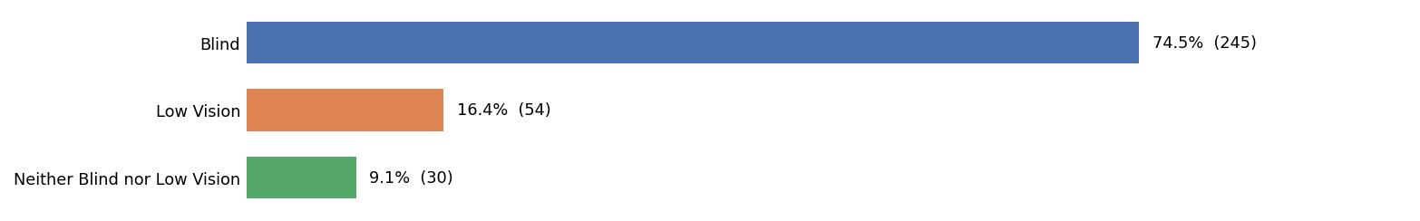

ANSWER CHOICES | RESPONSES
Blind | 74.50%
Low Vision | 16.40%
Neither Blind nor Low Vision | 9.10%
TOTAL | 100%

Q2 Please select your age range.
n = 331
Chart 2: Age Range Distribution

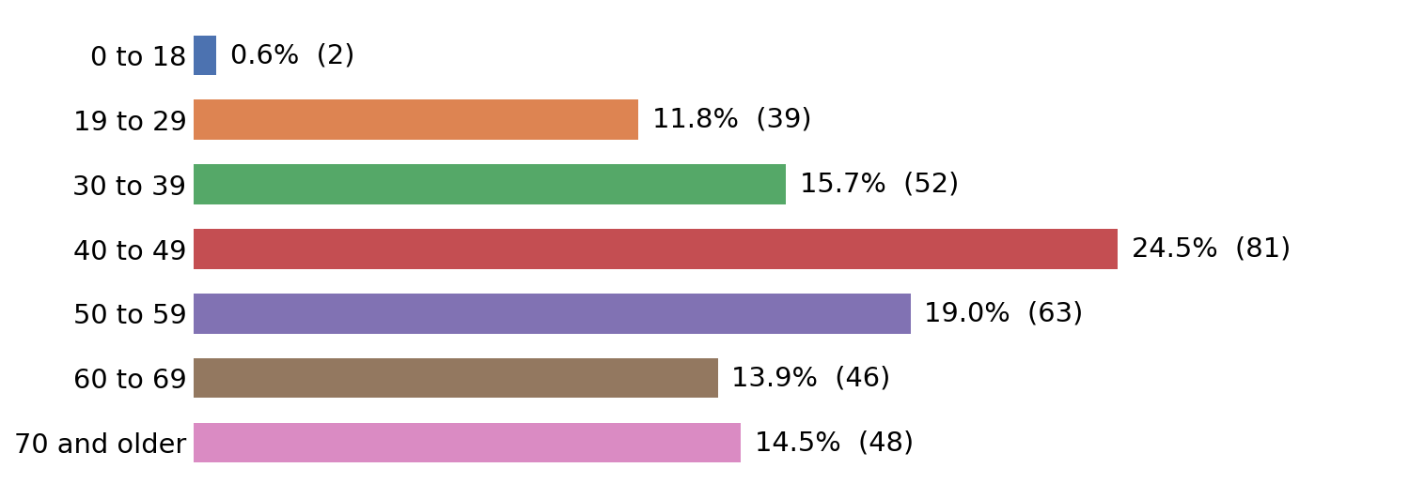

ANSWER CHOICES | RESPONSES
0 to 18 | 0.60%
19 to 29 | 11.80%
30 to 39 | 15.70%
40 to 49 | 24.50%
50 to 59 | 19.00%
60 to 69 | 13.90%
70 and older | 14.50%
TOTAL | 100%

Q3 In which country do you primarily reside?
n = 318
Chart 3: Country of Residence

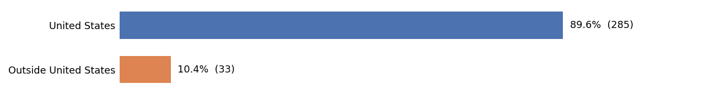

ANSWER CHOICES | RESPONSES
United States | 89.62%
Outside United States | 10.38%
TOTAL | 100%
Key takeaways
- Of 318 respondents who named a country, 33 reside outside the United States.
- The largest non-US groups are Canada (10), Australia (6), New Zealand (4), Thailand (2).

Q4 Which of the following screen readers do you primarily use to access digital content?
n = 333
Chart 4: Screen Reader Usage

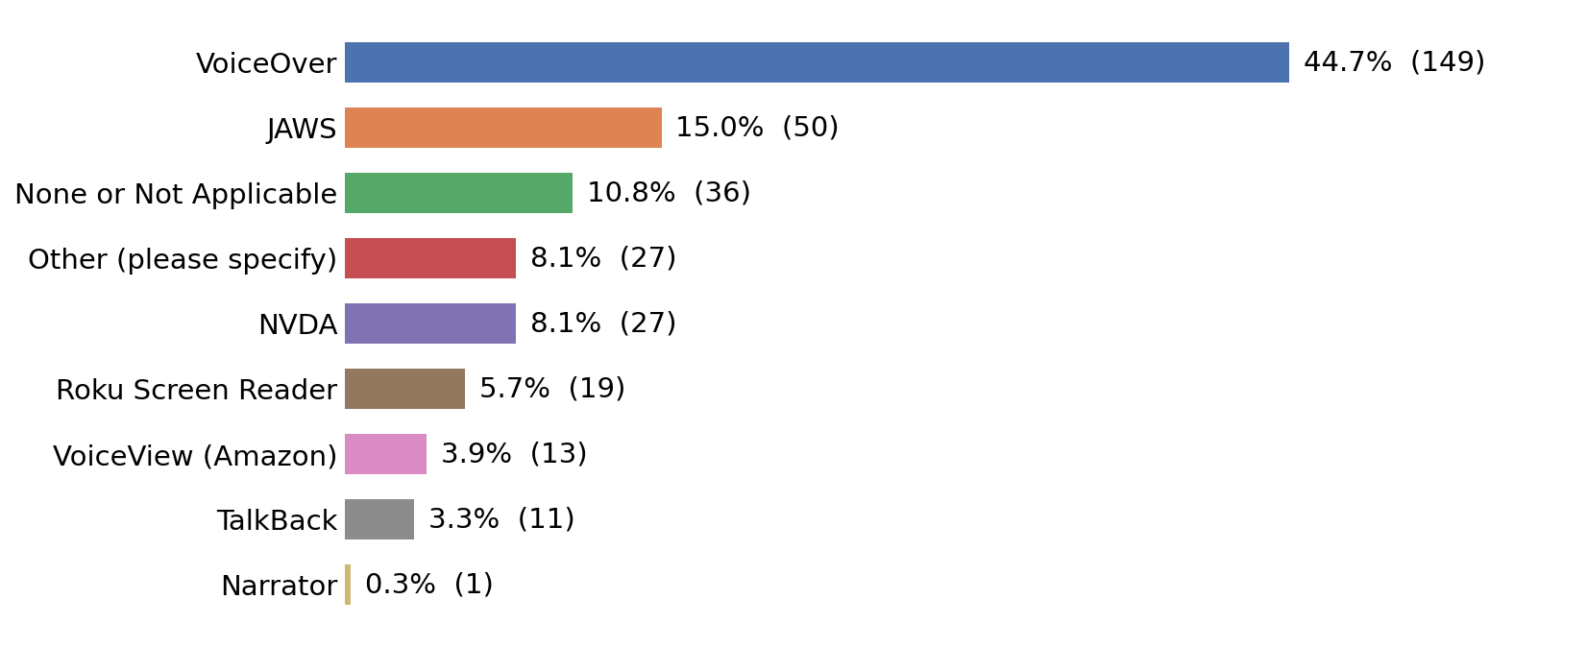

ANSWER CHOICES | RESPONSES
VoiceOver | 44.70%
JAWS | 15.00%
None or Not Applicable | 10.80%
Other (please specify) | 8.10%
NVDA | 8.10%
Roku Screen Reader | 5.70%
VoiceView (Amazon) | 3.90%
TalkBack | 3.30%
Narrator | 0.30%
TOTAL | 100%

Q5 Which of the following visual access features do you use?
n = 192
Select all that apply; percentages sum to more than 100%.

Chart 5: Visual Access Features Used

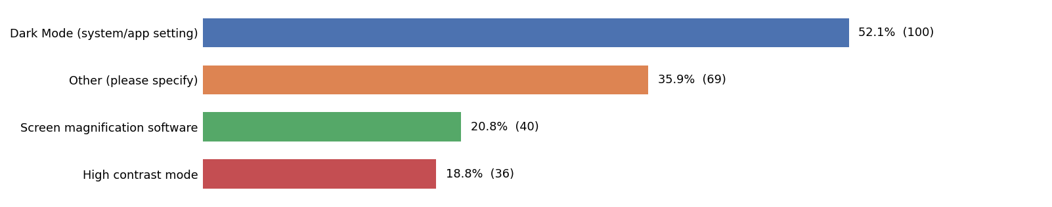

ANSWER CHOICES | RESPONSES
Dark Mode (system/app setting) | 52.10%
Other (please specify) | 35.90%
Screen magnification software | 20.80%
High contrast mode | 18.80%
TOTAL | 128%

Section 2: About Your Streaming Habits

Q6 How do you access your audio described content?
n = 322
Select all that apply; percentages sum to more than 100%.

Chart 6: Audio Description Access Methods

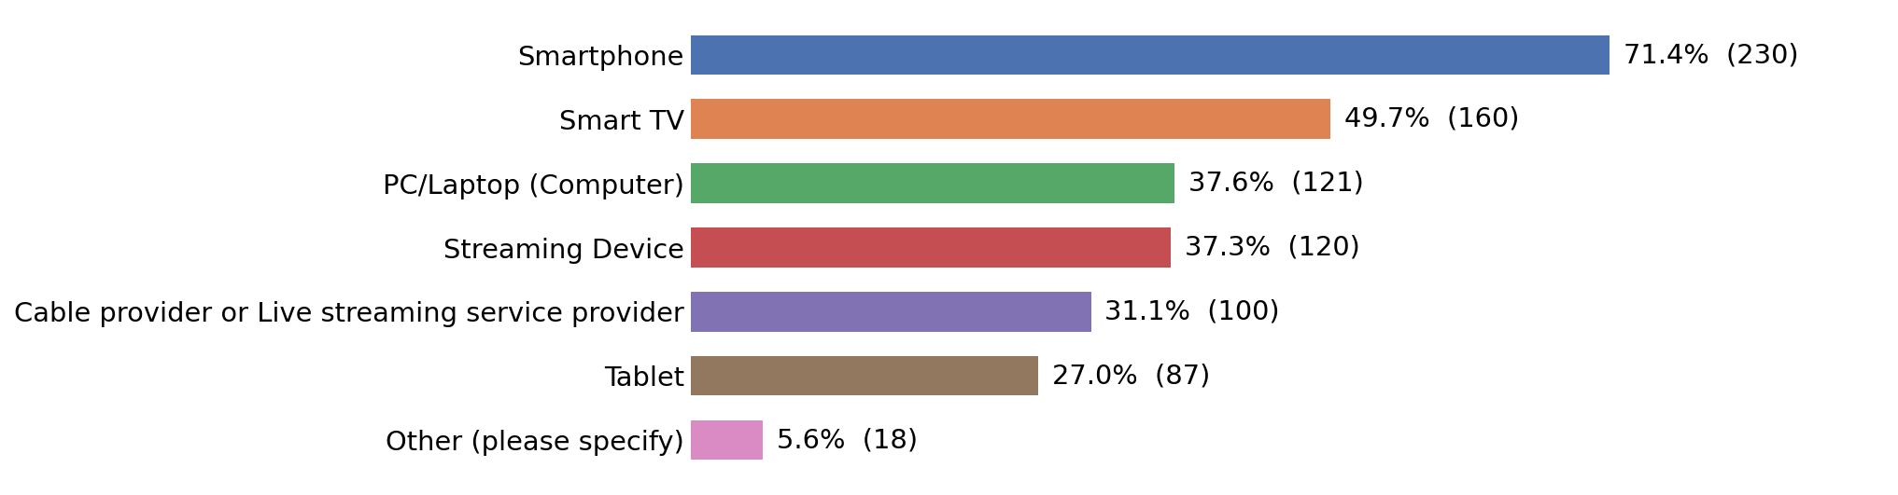

ANSWER CHOICES | RESPONSES
Smartphone | 71.40%
Smart TV | 49.70%
PC/Laptop (Computer) | 37.60%
Streaming Device (e.g., Firestick, Roku device, Google TV device) | 37.30%
Cable provider or Live streaming service provider (e.g., YouTube TV, Direct TV) | 31.10%
Tablet | 27.00%
Other (please specify) | 5.60%
TOTAL | 260%

Section 3: Your Experience with Accessibility and Usability

Q7 Do you use Amazon Prime as a streaming service?
n = 311
Chart 7: Amazon Prime Usage
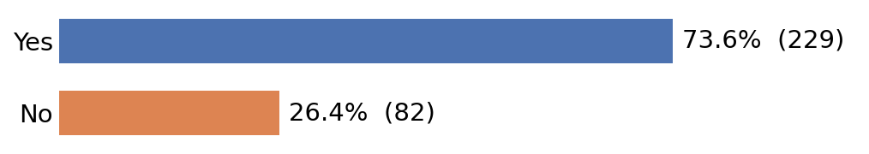
ANSWER CHOICES | RESPONSES
Yes | 73.60%
No | 26.40%
TOTAL | 100%

Q8 Please rate your experience with the following aspects of Amazon Prime streaming services on a scale from 1 to 5, where 1 is Very Difficult and 5 is Very Easy.
n = 180
Chart 8: Amazon Prime Rating Analysis by Aspect
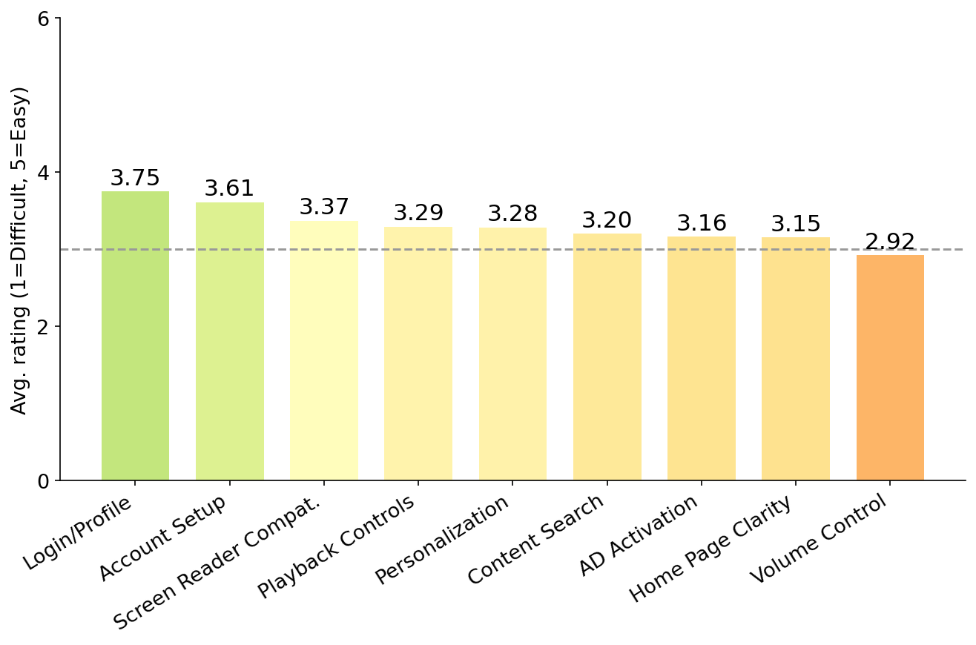

ASPECT | 1 | 2 | 3 | 4 | 5 | Total | Avg
Ease of setting up the service and creating an account. | 4% (7) | 9% (16) | 26% (46) | 32% (58) | 20% (36) | 163 | 3.61
Ease of logging in and accessing your personal profile. | 4% (7) | 9% (17) | 20% (36) | 31% (55) | 28% (50) | 165 | 3.75
Ease of finding and setting up personalization options (e.g., profile picture, Closed Captions, parental controls). | 6% (11) | 16% (28) | 28% (50) | 26% (46) | 13% (24) | 159 | 3.28
Ease of finding and activating the audio description setting. | 9% (16) | 24% (43) | 16% (29) | 26% (46) | 15% (27) | 161 | 3.16
Compatibility of the service with your primary screen reader. | 5% (9) | 9% (17) | 32% (57) | 27% (48) | 12% (22) | 153 | 3.37
Ability to set independent volume levels for screen reader. | 14% (25) | 16% (29) | 29% (53) | 15% (27) | 11% (20) | 154 | 2.92
Clarity and usability of the home page or landing page layout for navigation. | 5% (9) | 20% (36) | 29% (52) | 18% (32) | 12% (22) | 151 | 3.15
Ease of finding specific content (e.g., using search, browse genres, navigating categories). | 6% (11) | 22% (40) | 21% (37) | 26% (46) | 13% (24) | 158 | 3.20
Ease of finding and accessing playback controls while watching content (e.g., play, pause, rewind, volume). | 6% (11) | 17% (30) | 24% (44) | 26% (46) | 14% (26) | 157 | 3.29
Key takeaways
- Logging in and accessing your profile is the strongest-rated aspect (3.75); independent volume control is the weakest (2.92).
- The gap between best and worst aspect is 0.83 points. 1 aspect (independent volume control) sits below the neutral 3.0 midpoint.
- The remaining aspects cluster between 3.15 and 3.61, with n=180 respondents rating Amazon Prime this wave.

Q9 What is the single most frustrating accessibility challenge you have encountered while using Amazon Prime’s streaming service?
n = 135
Chart 9: Amazon Prime Frustration Themes

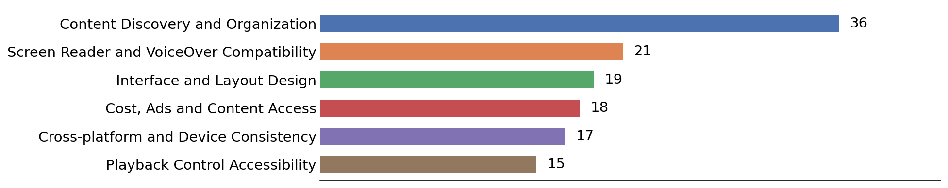

Key takeaways
- 98% of scored comments were negative on this frustration question (3 positive / 127 negative / 5 neutral; 130 comments carried a clear signal, n=135 total).
- Content Discovery and Organization is the most-mentioned theme (36 mentions), making it the clearest single driver of frustration for Amazon Prime this wave.
- Screen Reader and VoiceOver Compatibility (21 mentions) and Interface and Layout Design (19 mentions) are the next most common themes among Amazon Prime comments.
- Smaller but distinct themes include Cost, Ads and Content Access (18 mentions) and Cross-platform and Device Consistency (17 mentions).

Q10 What is the best accessibility feature you have encountered while using Amazon Prime’s streaming service?
n = 116
Chart 10: Amazon Prime Best-Feature Themes

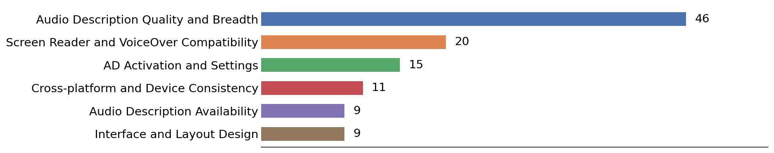

Key takeaways
- 94% of scored comments were positive on this best-feature question (103 positive / 7 negative / 6 neutral; 110 comments carried a clear signal, n=116 total).
- Audio Description Quality and Breadth is the most-mentioned theme (46 mentions), making it the clearest single driver of praise for Amazon Prime this wave.
- Screen Reader and VoiceOver Compatibility (20 mentions) and AD Activation and Settings (15 mentions) are the next most common themes among Amazon Prime comments.
- Smaller but distinct themes include Cross-platform and Device Consistency (11 mentions) and Audio Description Availability (9 mentions).

Q11 Do you use Apple TV+ as a streaming service?
n = 240
Chart 11: Apple TV+ Usage

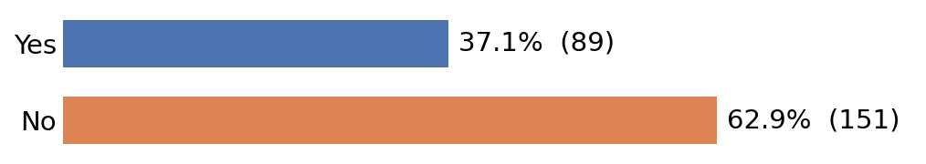

ANSWER CHOICES | RESPONSES
Yes | 37.10%
No | 62.90%
TOTAL | 100%

Q12 Please rate your experience with the following aspects of Apple TV+ streaming services on a scale from 1 to 5, where 1 is Very Difficult and 5 is Very Easy.
n = 82
Chart 12: Apple TV+ Rating Analysis by Aspect

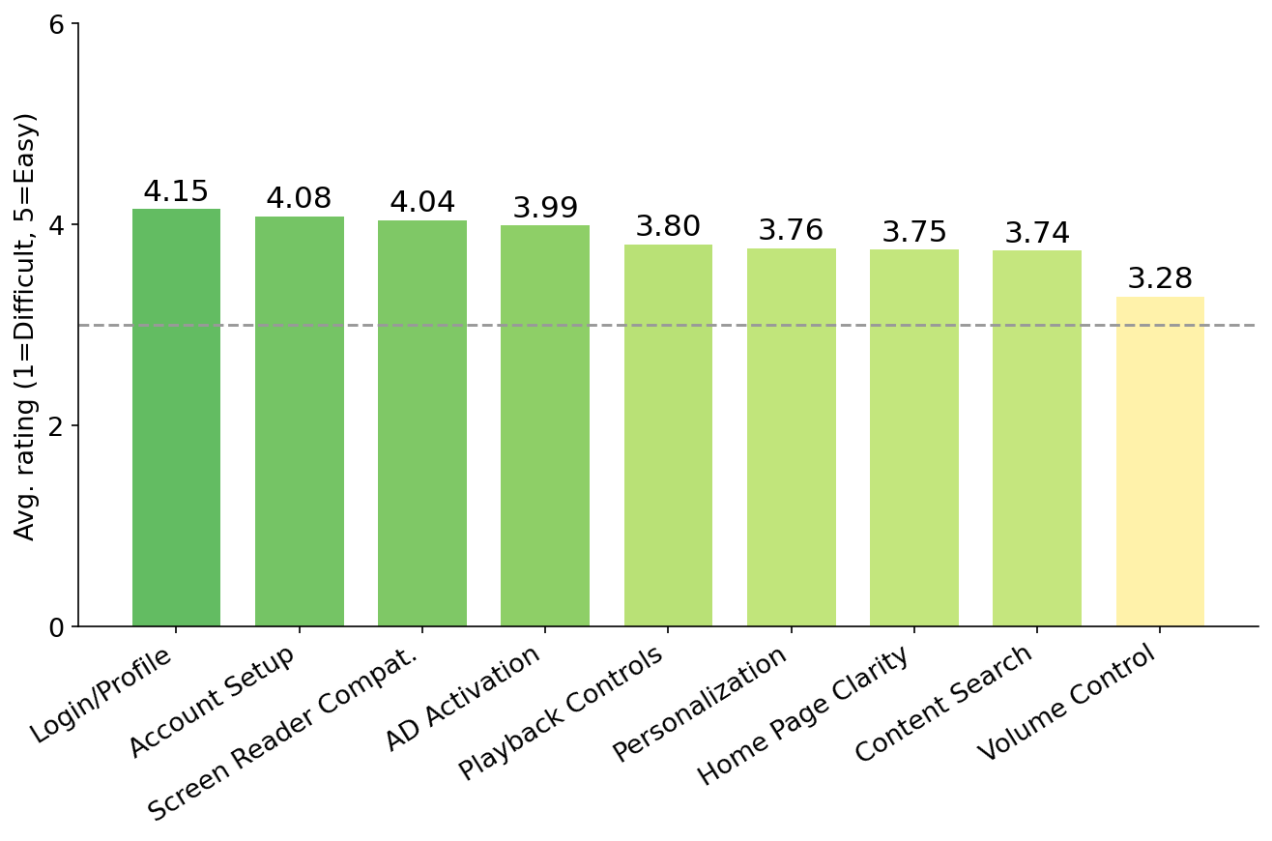

ASPECT | 1 | 2 | 3 | 4 | 5 | Total | Avg
Ease of setting up the service and creating an account. | 0% (0) | 6% (5) | 20% (16) | 26% (21) | 39% (32) | 74 | 4.08
Ease of logging in and accessing your personal profile. | 0% (0) | 4% (3) | 21% (17) | 24% (20) | 42% (34) | 74 | 4.15
Ease of finding and setting up personalization options (e.g., profile picture, Closed Captions, parental controls). | 1% (1) | 8% (7) | 28% (23) | 27% (22) | 27% (22) | 75 | 3.76
Ease of finding and activating the audio description setting. | 1% (1) | 7% (6) | 18% (15) | 29% (24) | 35% (29) | 75 | 3.99
Compatibility of the service with your primary screen reader. | 2% (2) | 4% (3) | 26% (21) | 15% (12) | 44% (36) | 74 | 4.04
Ability to set independent volume levels for screen reader. | 10% (8) | 7% (6) | 38% (31) | 12% (10) | 20% (16) | 71 | 3.28
Clarity and usability of the home page or landing page layout for navigation. | 1% (1) | 6% (5) | 34% (28) | 18% (15) | 28% (23) | 72 | 3.75
Ease of finding specific content (e.g., using search, browse genres, navigating categories). | 1% (1) | 7% (6) | 30% (25) | 24% (20) | 26% (21) | 73 | 3.74
Ease of finding and accessing playback controls while watching content (e.g., play, pause, rewind, volume). | 5% (4) | 5% (4) | 23% (19) | 23% (19) | 30% (25) | 71 | 3.80

Key takeaways
- Logging in and accessing your profile is the strongest-rated aspect (4.15); independent volume control is the weakest (3.28).
- The gap between best and worst aspect is 0.87 points, and no aspect falls below the neutral 3.0 midpoint this wave.
- The remaining aspects cluster between 3.74 and 4.08, with n=82 respondents rating Apple TV+ this wave.

Q13 What is the single most frustrating accessibility challenge you have encountered while using Apple TV+’s streaming service?
n = 53
Chart 13: Apple TV+ Frustration Themes

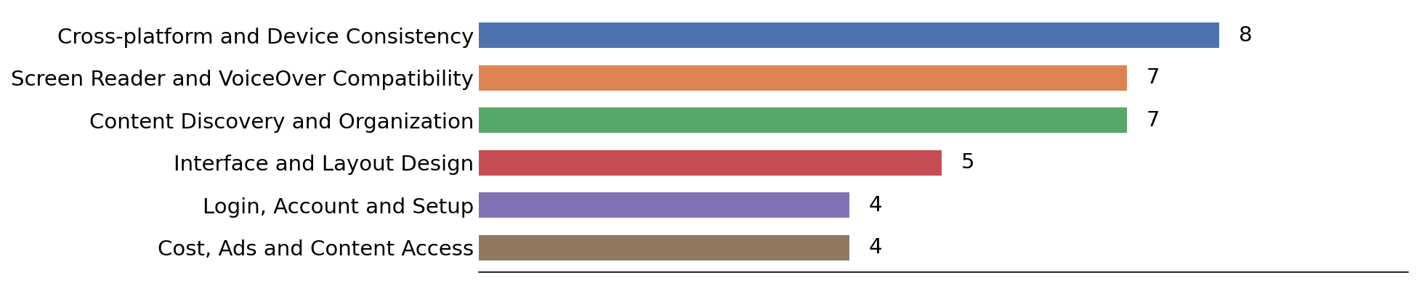

Key takeaways
- 81% of scored comments were negative on this frustration question (9 positive / 38 negative / 6 neutral; 47 comments carried a clear signal, n=53 total).
- Cross-platform and Device Consistency is the most-mentioned theme (8 mentions), making it the clearest single driver of frustration for Apple TV+ this wave.
- Screen Reader and VoiceOver Compatibility (7 mentions) and Content Discovery and Organization (7 mentions) are the next most common themes among Apple TV+ comments.
- Smaller but distinct themes include Interface and Layout Design (5 mentions) and Login, Account and Setup (4 mentions).

Q14 What is the best accessibility feature you have encountered while using Apple TV+’s streaming service?
n = 58
Chart 14: Apple TV+ Best-Feature Themes

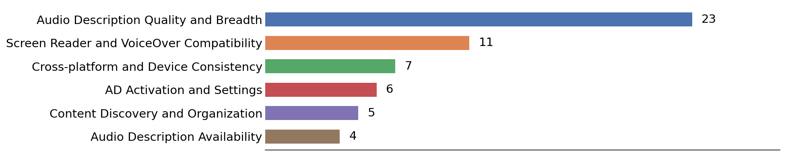

Key takeaways
- 98% of scored comments were positive on this best-feature question (52 positive / 1 negative / 5 neutral; 53 comments carried a clear signal, n=58 total).
- Audio Description Quality and Breadth is the most-mentioned theme (23 mentions), making it the clearest single driver of praise for Apple TV+ this wave.
- Screen Reader and VoiceOver Compatibility (11 mentions) and Cross-platform and Device Consistency (7 mentions) are the next most common themes among Apple TV+ comments.
- Smaller but distinct themes include AD Activation and Settings (6 mentions) and Content Discovery and Organization (5 mentions).

Q15 Do you use Disney+ as a streaming service?
n = 218
Chart 15: Disney+ Usage

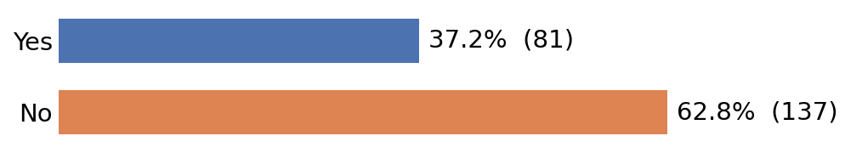

ANSWER CHOICES | RESPONSES
Yes | 37.20%
No | 62.80%
TOTAL | 100%

Q16 Please rate your experience with the following aspects of Disney+ streaming services on a scale from 1 to 5, where 1 is Very Difficult and 5 is Very Easy.
n = 75
Chart 16: Disney+ Rating Analysis by Aspect

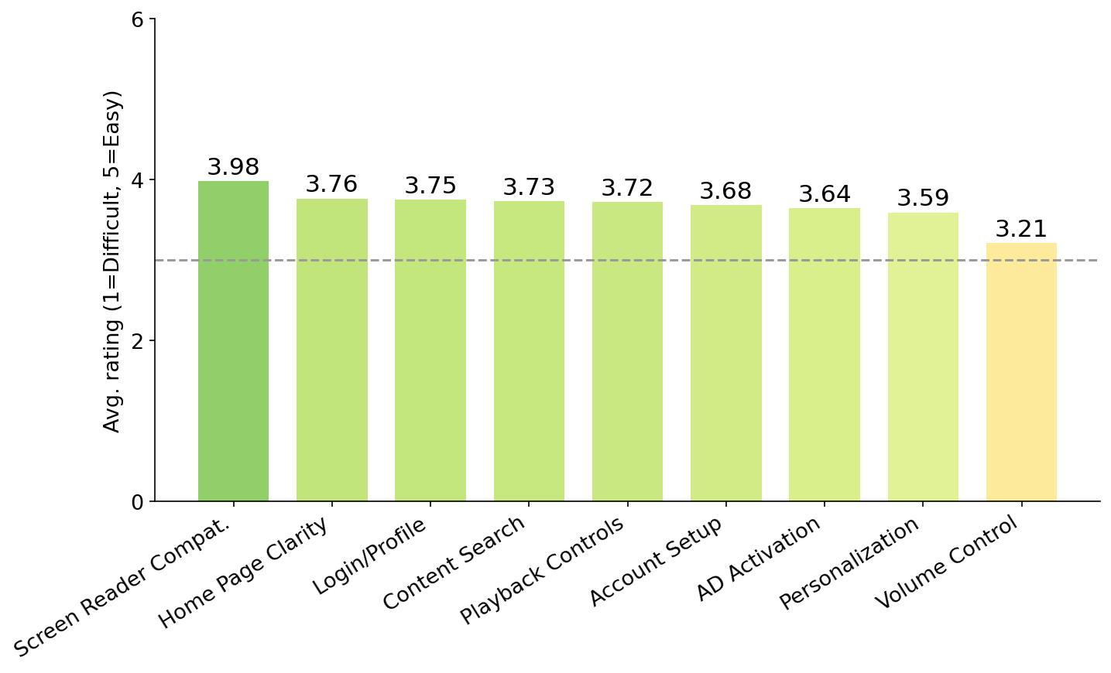

ASPECT | 1 | 2 | 3 | 4 | 5 | Total | Avg
Ease of setting up the service and creating an account. | 3% (2) | 13% (10) | 21% (16) | 28% (21) | 27% (20) | 69 | 3.68
Ease of logging in and accessing your personal profile. | 5% (4) | 3% (2) | 25% (19) | 28% (21) | 25% (19) | 65 | 3.75
Ease of finding and setting up personalization options (e.g., profile picture, Closed Captions, parental controls). | 4% (3) | 11% (8) | 25% (19) | 25% (19) | 23% (17) | 66 | 3.59
Ease of finding and activating the audio description setting. | 5% (4) | 11% (8) | 19% (14) | 31% (23) | 24% (18) | 67 | 3.64
Compatibility of the service with your primary screen reader. | 1% (1) | 4% (3) | 20% (15) | 28% (21) | 31% (23) | 63 | 3.98
Ability to set independent volume levels for screen reader. | 11% (8) | 12% (9) | 31% (23) | 11% (8) | 20% (15) | 63 | 3.21
Clarity and usability of the home page or landing page layout for navigation. | 1% (1) | 9% (7) | 23% (17) | 24% (18) | 25% (19) | 62 | 3.76
Ease of finding specific content (e.g., using search, browse genres, navigating categories). | 1% (1) | 9% (7) | 24% (18) | 27% (20) | 24% (18) | 64 | 3.73
Ease of finding and accessing playback controls while watching content (e.g., play, pause, rewind, volume). | 3% (2) | 12% (9) | 17% (13) | 29% (22) | 25% (19) | 65 | 3.72

Key takeaways
- Screen-reader compatibility is the strongest-rated aspect (3.98); independent volume control is the weakest (3.21).
- The gap between best and worst aspect is 0.77 points, and no aspect falls below the neutral 3.0 midpoint this wave.
- The remaining aspects cluster between 3.59 and 3.76, with n=75 respondents rating Disney+ this wave.

Q17 What is the single most frustrating accessibility challenge you have encountered while using Disney+’s streaming service?
n = 61
Chart 17: Disney+ Frustration Themes

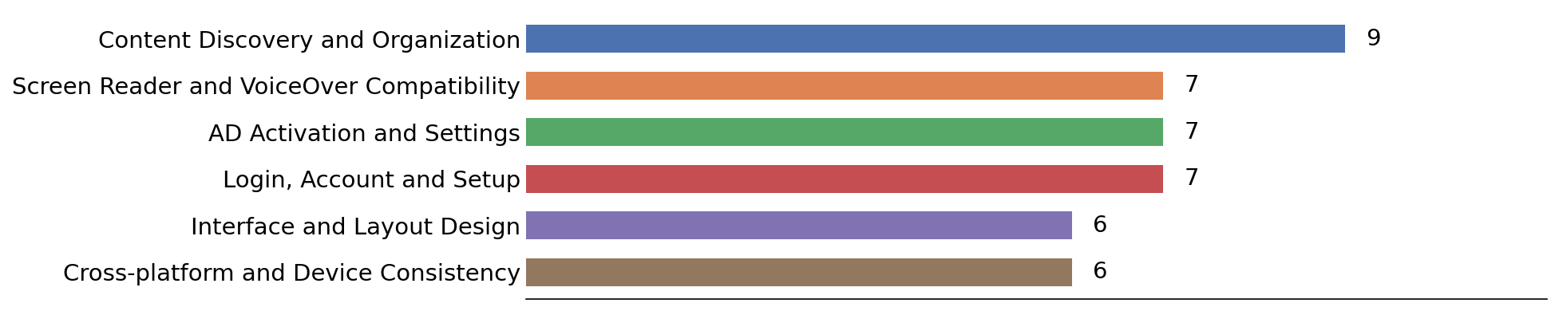

Key takeaways
- 87% of scored comments were negative on this frustration question (7 positive / 48 negative / 6 neutral; 55 comments carried a clear signal, n=61 total).
- Content Discovery and Organization is the most-mentioned theme (9 mentions), making it the clearest single driver of frustration for Disney+ this wave.
- Screen Reader and VoiceOver Compatibility (7 mentions) and AD Activation and Settings (7 mentions) are the next most common themes among Disney+ comments.
- Smaller but distinct themes include Login, Account and Setup (7 mentions) and Interface and Layout Design (6 mentions).

Q18 What is the best accessibility feature you have encountered while using Disney+’s streaming service?
n = 62
Chart 18: Disney+ Best-Feature Themes

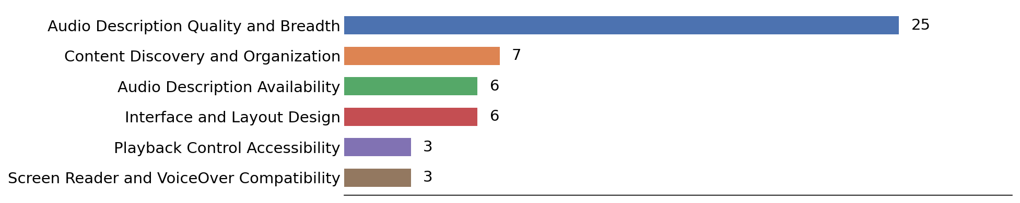

Key takeaways
- 93% of scored comments were positive on this best-feature question (50 positive / 4 negative / 8 neutral; 54 comments carried a clear signal, n=62 total).
- Audio Description Quality and Breadth is the most-mentioned theme (25 mentions), making it the clearest single driver of praise for Disney+ this wave.
- Content Discovery and Organization (7 mentions) and Audio Description Availability (6 mentions) are the next most common themes among Disney+ comments.
- Smaller but distinct themes include Interface and Layout Design (6 mentions) and Playback Control Accessibility (3 mentions).

Q19 Do you use HBO Max as a streaming service?
n = 206
Chart 19: HBO Max Usage

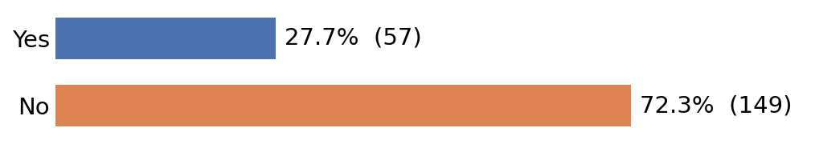

ANSWER CHOICES | RESPONSES
Yes | 27.70%
No | 72.30%
TOTAL | 100%

Q20 Please rate your experience with the following aspects of HBO Max streaming services on a scale from 1 to 5, where 1 is Very Difficult and 5 is Very Easy.
n = 57
Chart 20: HBO Max Rating Analysis by Aspect

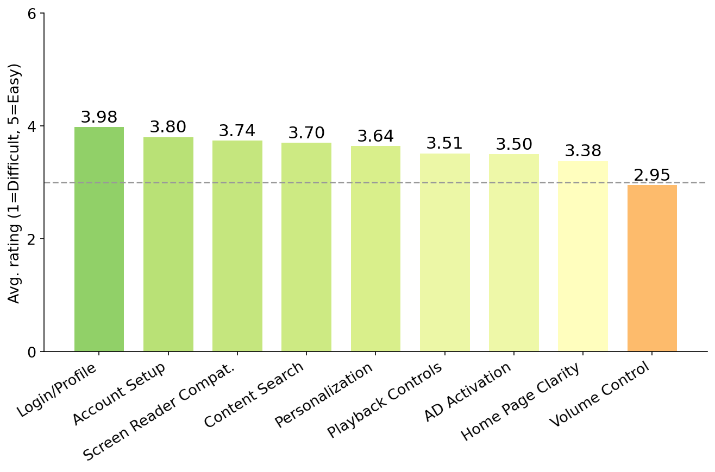

ASPECT | 1 | 2 | 3 | 4 | 5 | Total | Avg
Ease of setting up the service and creating an account. | 5% (3) | 7% (4) | 19% (11) | 35% (20) | 30% (17) | 55 | 3.80
Ease of logging in and accessing your personal profile. | 5% (3) | 0% (0) | 16% (9) | 40% (23) | 30% (17) | 52 | 3.98
Ease of finding and setting up personalization options (e.g., profile picture, Closed Captions, parental controls). | 5% (3) | 9% (5) | 19% (11) | 33% (19) | 21% (12) | 50 | 3.64
Ease of finding and activating the audio description setting. | 9% (5) | 10% (6) | 14% (8) | 37% (21) | 18% (10) | 50 | 3.50
Compatibility of the service with your primary screen reader. | 5% (3) | 5% (3) | 21% (12) | 32% (18) | 25% (14) | 50 | 3.74
Ability to set independent volume levels for screen reader. | 16% (9) | 4% (2) | 35% (20) | 10% (6) | 10% (6) | 43 | 2.95
Clarity and usability of the home page or landing page layout for navigation. | 5% (3) | 10% (6) | 30% (17) | 25% (14) | 14% (8) | 48 | 3.38
Ease of finding specific content (e.g., using search, browse genres, navigating categories). | 0% (0) | 12% (7) | 16% (9) | 39% (22) | 16% (9) | 47 | 3.70
Ease of finding and accessing playback controls while watching content (e.g., play, pause, rewind, volume). | 4% (2) | 12% (7) | 21% (12) | 30% (17) | 16% (9) | 47 | 3.51

Key takeaways
- Logging in and accessing your profile is the strongest-rated aspect (3.98); independent volume control is the weakest (2.95).
- The gap between best and worst aspect is 1.03 points. 1 aspect (independent volume control) sits below the neutral 3.0 midpoint.
- The remaining aspects cluster between 3.38 and 3.80, with n=57 respondents rating HBO Max this wave.

Q21 What is the single most frustrating accessibility challenge you have encountered while using HBO Max’s streaming service?
n = 42
Chart 21: HBO Max Frustration Themes

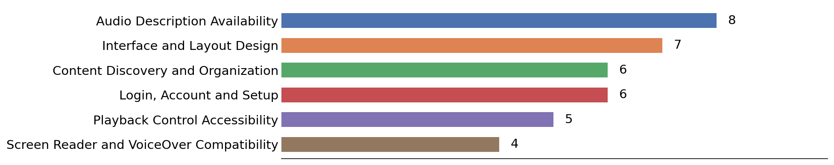

Key takeaways
- 87% of scored comments were negative on this frustration question (5 positive / 34 negative / 3 neutral; 39 comments carried a clear signal, n=42 total).
- Audio Description Availability is the most-mentioned theme (8 mentions), making it the clearest single driver of frustration for HBO Max this wave.
- Interface and Layout Design (7 mentions) and Content Discovery and Organization (6 mentions) are the next most common themes among HBO Max comments.
- Smaller but distinct themes include Login, Account and Setup (6 mentions) and Playback Control Accessibility (5 mentions).

Q22 What is the best accessibility feature you have encountered while using HBO Max’s streaming service?
n = 41
Chart 22: HBO Max Best-Feature Themes
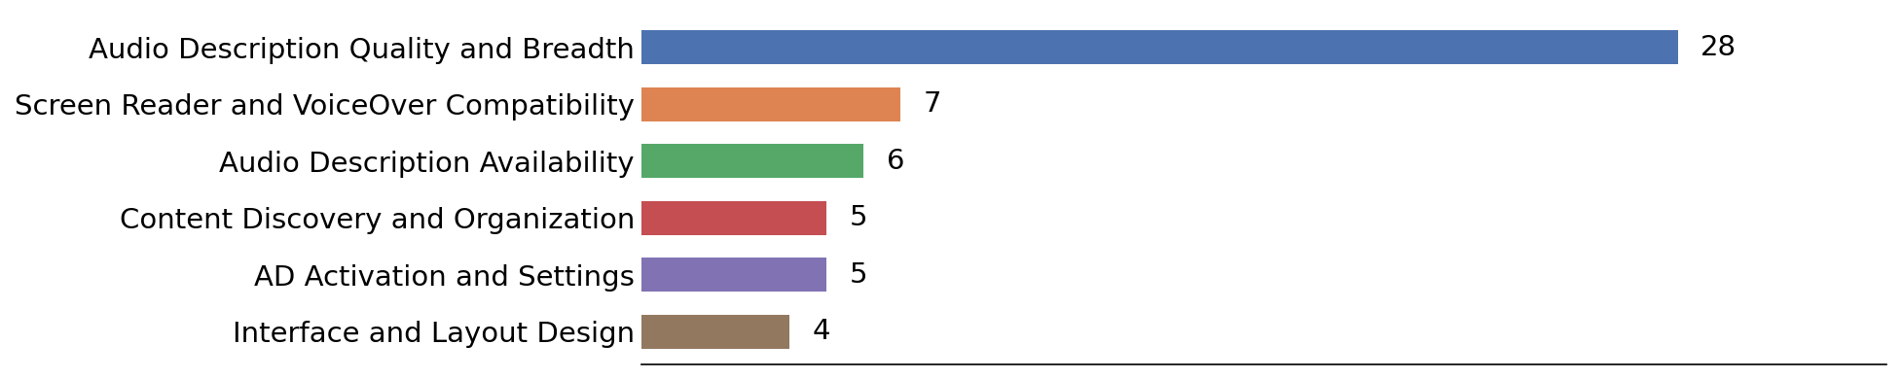

Key takeaways
- 97% of scored comments were positive on this best-feature question (38 positive / 1 negative / 2 neutral; 39 comments carried a clear signal, n=41 total).
- Audio Description Quality and Breadth is the most-mentioned theme (28 mentions), making it the clearest single driver of praise for HBO Max this wave.
- Screen Reader and VoiceOver Compatibility (7 mentions) and Audio Description Availability (6 mentions) are the next most common themes among HBO Max comments.
- Smaller but distinct themes include Content Discovery and Organization (5 mentions) and AD Activation and Settings (5 mentions).

Q23 Do you use Hulu as a streaming service?
n = 203
Chart 23: Hulu Usage

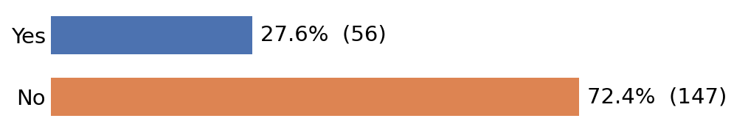
ANSWER CHOICES | RESPONSES
Yes | 27.60%
No | 72.40%
TOTAL | 100%

Q24 Please rate your experience with the following aspects of Hulu streaming services on a scale from 1 to 5, where 1 is Very Difficult and 5 is Very Easy.
n = 57
Chart 24: Hulu Rating Analysis by Aspect

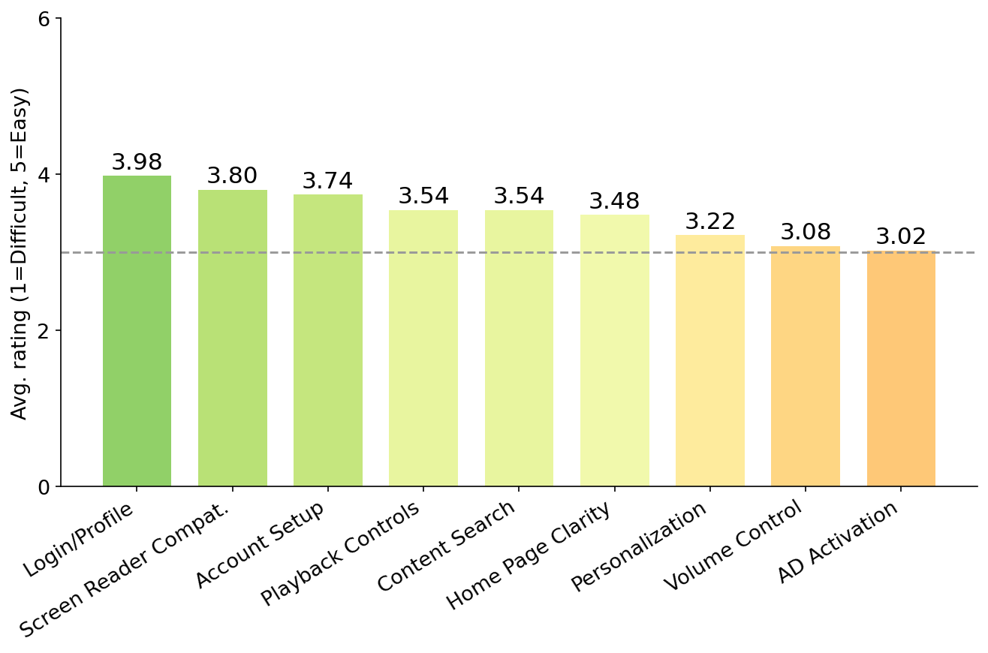

ASPECT | 1 | 2 | 3 | 4 | 5 | Total | Avg
Ease of setting up the service and creating an account. | 4% (2) | 9% (5) | 23% (13) | 32% (18) | 26% (15) | 53 | 3.74
Ease of logging in and accessing your personal profile. | 0% (0) | 7% (4) | 14% (8) | 44% (25) | 26% (15) | 52 | 3.98
Ease of finding and setting up personalization options (e.g., profile picture, Closed Captions, parental controls). | 4% (2) | 21% (12) | 37% (21) | 18% (10) | 16% (9) | 54 | 3.22
Ease of finding and activating the audio description setting. | 14% (8) | 14% (8) | 28% (16) | 26% (15) | 9% (5) | 52 | 3.02
Compatibility of the service with your primary screen reader. | 2% (1) | 2% (1) | 35% (20) | 21% (12) | 26% (15) | 49 | 3.80
Ability to set independent volume levels for screen reader. | 10% (6) | 10% (6) | 39% (22) | 10% (6) | 14% (8) | 48 | 3.08
Clarity and usability of the home page or landing page layout for navigation. | 10% (6) | 4% (2) | 26% (15) | 33% (19) | 18% (10) | 52 | 3.48
Ease of finding specific content (e.g., using search, browse genres, navigating categories). | 7% (4) | 12% (7) | 18% (10) | 33% (19) | 21% (12) | 52 | 3.54
Ease of finding and accessing playback controls while watching content (e.g., play, pause, rewind, volume). | 2% (1) | 10% (6) | 35% (20) | 19% (11) | 21% (12) | 50 | 3.54

Key takeaways
- Logging in and accessing your profile is the strongest-rated aspect (3.98); AD activation reliability is the weakest (3.02).
- The gap between best and worst aspect is 0.96 points, and no aspect falls below the neutral 3.0 midpoint this wave.
- The remaining aspects cluster between 3.08 and 3.80, with n=57 respondents rating Hulu this wave.

Q25 What is the single most frustrating accessibility challenge you have encountered while using Hulu’s streaming service?
n = 46
Chart 25: Hulu Frustration Themes

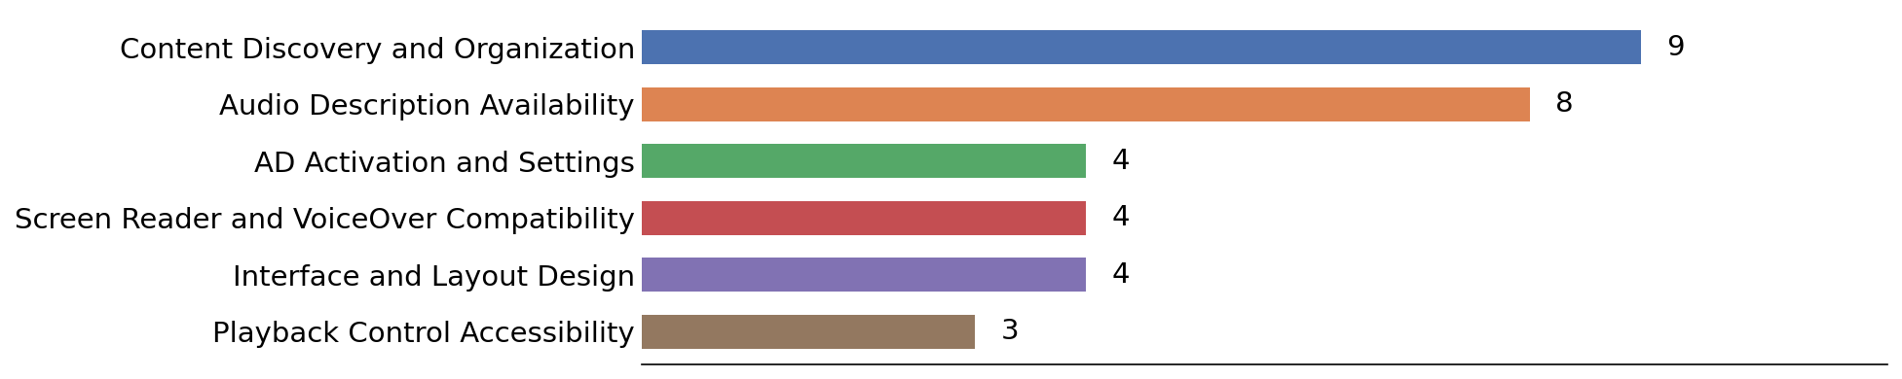

Key takeaways
- 98% of scored comments were negative on this frustration question (1 positive / 40 negative / 5 neutral; 41 comments carried a clear signal, n=46 total).
- Content Discovery and Organization is the most-mentioned theme (9 mentions), making it the clearest single driver of frustration for Hulu this wave.
- Audio Description Availability (8 mentions) and AD Activation and Settings (4 mentions) are the next most common themes among Hulu comments.
- Smaller but distinct themes include Screen Reader and VoiceOver Compatibility (4 mentions) and Interface and Layout Design (4 mentions).

Q26 What is the best accessibility feature you have encountered while using Hulu’s streaming service?
n = 43
Chart 26: Hulu Best-Feature Themes

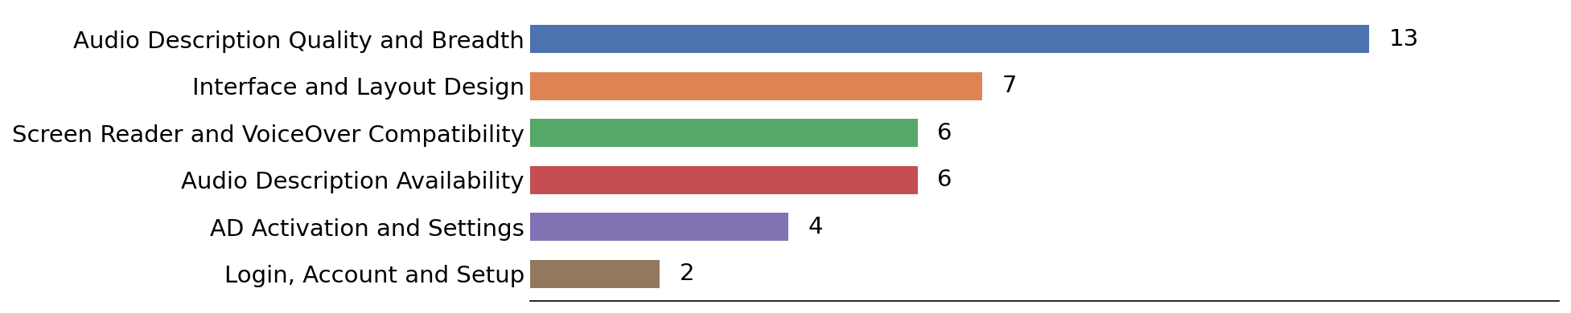

Key takeaways
- 92% of scored comments were positive on this best-feature question (34 positive / 3 negative / 6 neutral; 37 comments carried a clear signal, n=43 total).
- Audio Description Quality and Breadth is the most-mentioned theme (13 mentions), making it the clearest single driver of praise for Hulu this wave.
- Interface and Layout Design (7 mentions) and Screen Reader and VoiceOver Compatibility (6 mentions) are the next most common themes among Hulu comments.
- Smaller but distinct themes include Audio Description Availability (6 mentions) and AD Activation and Settings (4 mentions).

Q27 Do you use Paramount Plus as a streaming service?
n = 201
Chart 27: Paramount Plus Usage

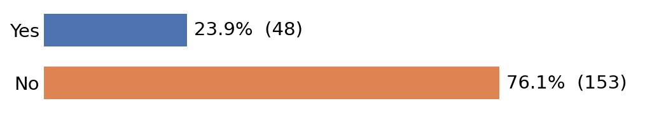

ANSWER CHOICES | RESPONSES
Yes | 23.90%
No | 76.10%
TOTAL | 100%

Q28 Please rate your experience with the following aspects of Paramount Plus streaming services on a scale from 1 to 5, where 1 is Very Difficult and 5 is Very Easy.
n = 48
Chart 28: Paramount Plus Rating Analysis by Aspect

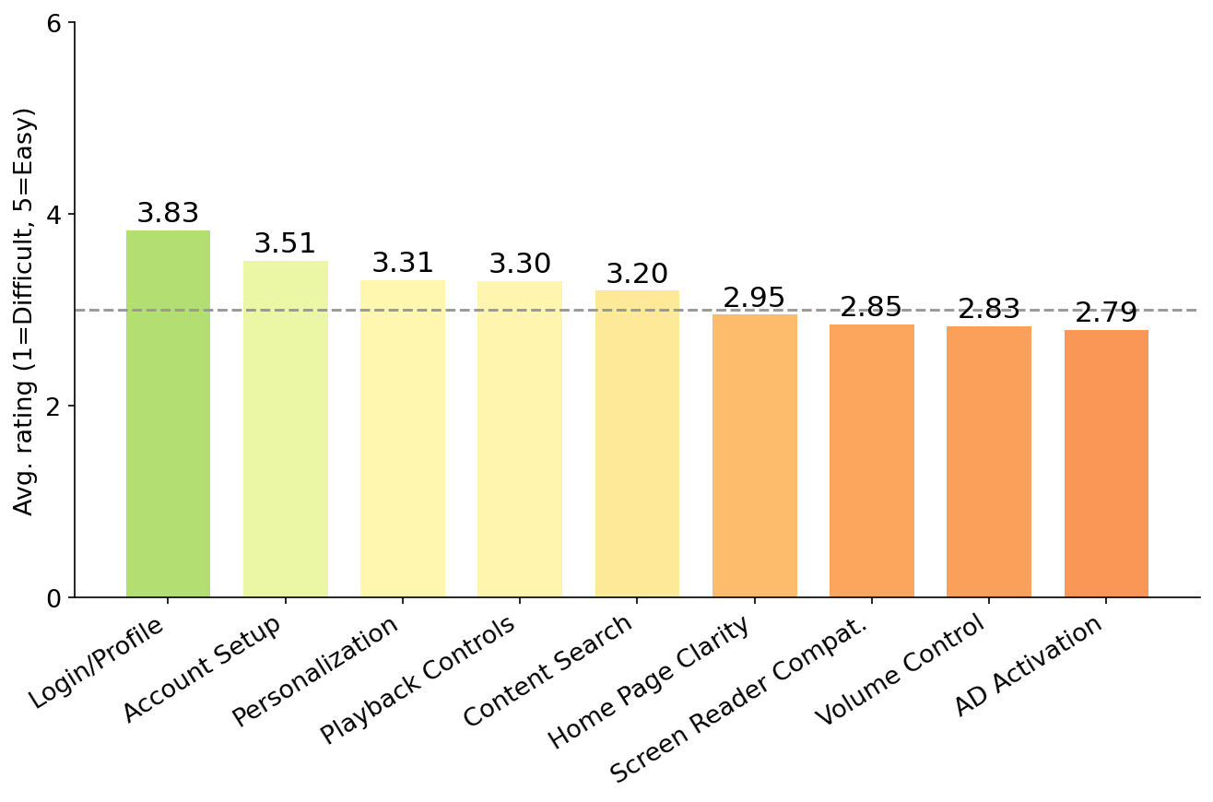
ASPECT | 1 | 2 | 3 | 4 | 5 | Total | Avg
Ease of setting up the service and creating an account. | 6% (3) | 23% (11) | 8% (4) | 23% (11) | 29% (14) | 43 | 3.51
Ease of logging in and accessing your personal profile. | 6% (3) | 10% (5) | 8% (4) | 25% (12) | 33% (16) | 40 | 3.83
Ease of finding and setting up personalization options (e.g., profile picture, Closed Captions, parental controls). | 10% (5) | 17% (8) | 19% (9) | 19% (9) | 23% (11) | 42 | 3.31
Ease of finding and activating the audio description setting. | 23% (11) | 21% (10) | 6% (3) | 12% (6) | 19% (9) | 39 | 2.79
Compatibility of the service with your primary screen reader. | 21% (10) | 19% (9) | 15% (7) | 15% (7) | 17% (8) | 41 | 2.85
Ability to set independent volume levels for screen reader. | 17% (8) | 15% (7) | 31% (15) | 8% (4) | 12% (6) | 40 | 2.83
Clarity and usability of the home page or landing page layout for navigation. | 17% (8) | 19% (9) | 17% (8) | 19% (9) | 15% (7) | 41 | 2.95
Ease of finding specific content (e.g., using search, browse genres, navigating categories). | 8% (4) | 21% (10) | 17% (8) | 21% (10) | 17% (8) | 40 | 3.20
Ease of finding and accessing playback controls while watching content (e.g., play, pause, rewind, volume). | 8% (4) | 19% (9) | 17% (8) | 19% (9) | 21% (10) | 40 | 3.30

Key takeaways
- Logging in and accessing your profile is the strongest-rated aspect (3.83); AD activation reliability is the weakest (2.79).
- The gap between best and worst aspect is 1.04 points. 4 aspects (AD activation reliability, screen-reader compatibility, independent volume control, home page clarity) sit below the neutral 3.0 midpoint.
- The remaining aspects cluster between 2.83 and 3.51, with n=48 respondents rating Paramount Plus this wave.

Q29 What is the single most frustrating accessibility challenge you have encountered while using Paramount Plus’s streaming service?
n = 38
Chart 29: Paramount Plus Frustration Themes

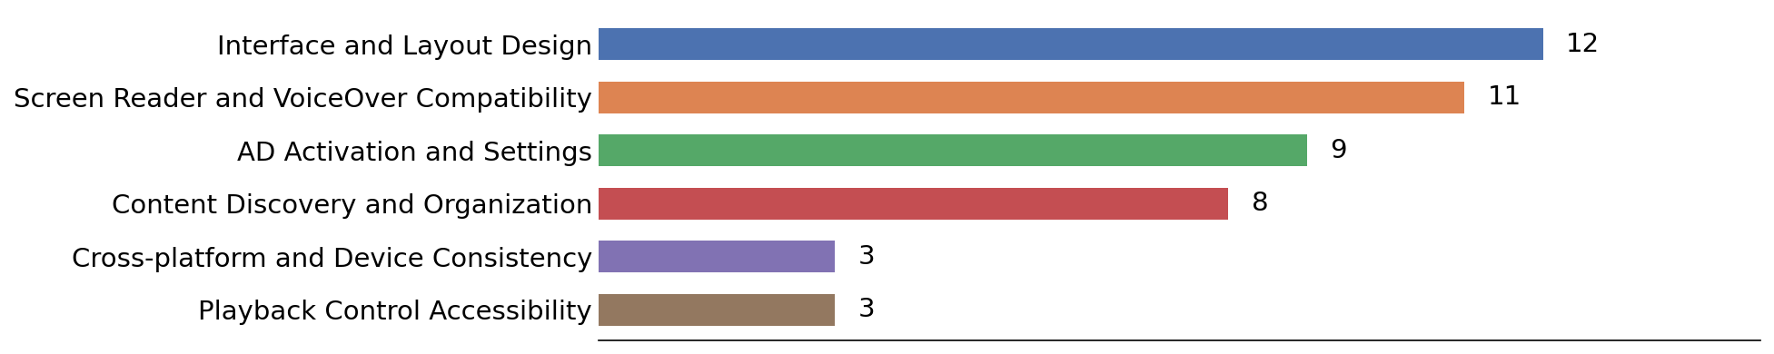

Key takeaways
- 92% of scored comments were negative on this frustration question (3 positive / 34 negative / 1 neutral; 37 comments carried a clear signal, n=38 total).
- Interface and Layout Design is the most-mentioned theme (12 mentions), making it the clearest single driver of frustration for Paramount Plus this wave.
- Screen Reader and VoiceOver Compatibility (11 mentions) and AD Activation and Settings (9 mentions) are the next most common themes among Paramount Plus comments.
- Smaller but distinct themes include Content Discovery and Organization (8 mentions) and Cross-platform and Device Consistency (3 mentions).

Q30 What is the best accessibility feature you have encountered while using Paramount Plus’s streaming service?
n = 28
Chart 28: Paramount Plus Best-Feature Themes

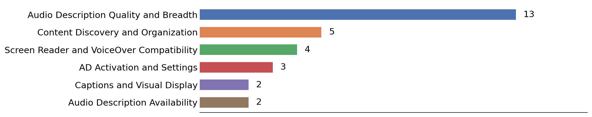

Key takeaways
- 88% of scored comments were positive on this best-feature question (22 positive / 3 negative / 3 neutral; 25 comments carried a clear signal, n=28 total).
- Audio Description Quality and Breadth is the most-mentioned theme (13 mentions), making it the clearest single driver of praise for Paramount Plus this wave.
- Content Discovery and Organization (5 mentions) and Screen Reader and VoiceOver Compatibility (4 mentions) are the next most common themes among Paramount Plus comments.
- Smaller but distinct themes include AD Activation and Settings (3 mentions) and Captions and Visual Display (2 mentions).

Q31 Do you use Netflix as a streaming service?
n = 199
Chart 28: Netflix Usage

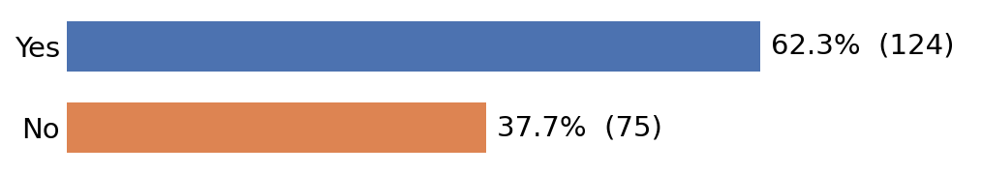
ANSWER CHOICES | RESPONSES
Yes | 62.30%
No | 37.70%
TOTAL | 100%

Q32 Please rate your experience with the following aspects of Netflix streaming services on a scale from 1 to 5, where 1 is Very Difficult and 5 is Very Easy.
n = 119
Chart 32: Netflix Rating Analysis by Aspect

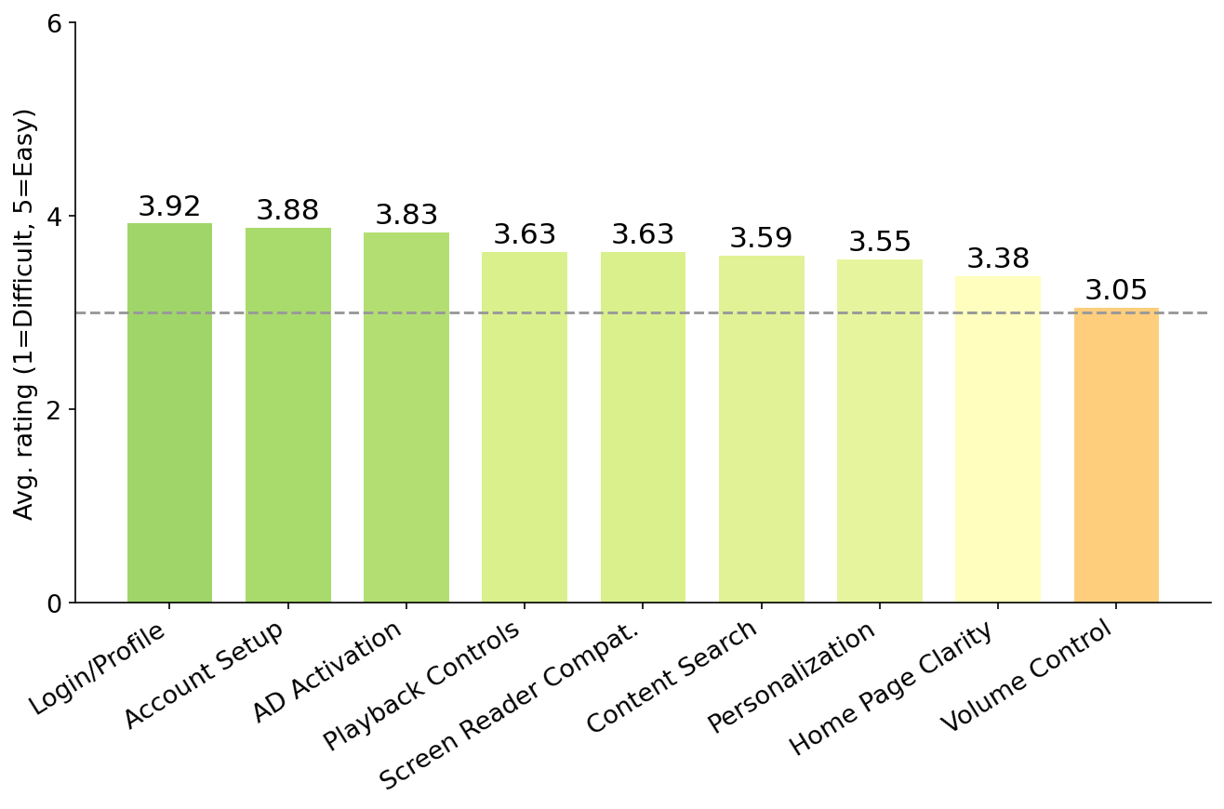

ASPECT | 1 | 2 | 3 | 4 | 5 | Total | Avg
Ease of setting up the service and creating an account. | 2% (3) | 10% (12) | 17% (20) | 31% (37) | 34% (40) | 112 | 3.88
Ease of logging in and accessing your personal profile. | 3% (4) | 9% (11) | 17% (20) | 24% (29) | 38% (45) | 109 | 3.92
Ease of finding and setting up personalization options (e.g., profile picture, Closed Captions, parental controls). | 3% (4) | 13% (16) | 25% (30) | 26% (31) | 22% (26) | 107 | 3.55
Ease of finding and activating the audio description setting. | 5% (6) | 10% (12) | 13% (16) | 24% (29) | 34% (40) | 103 | 3.83
Compatibility of the service with your primary screen reader. | 8% (9) | 8% (10) | 19% (23) | 26% (31) | 26% (31) | 104 | 3.63
Ability to set independent volume levels for screen reader. | 13% (15) | 13% (16) | 34% (40) | 9% (11) | 17% (20) | 102 | 3.05
Clarity and usability of the home page or landing page layout for navigation. | 8% (10) | 14% (17) | 20% (24) | 22% (26) | 21% (25) | 102 | 3.38
Ease of finding specific content (e.g., using search, browse genres, navigating categories). | 7% (8) | 13% (16) | 13% (15) | 29% (34) | 24% (29) | 102 | 3.59
Ease of finding and accessing playback controls while watching content (e.g., play, pause, rewind, volume). | 6% (7) | 12% (14) | 18% (21) | 25% (30) | 27% (32) | 104 | 3.63

Key takeaways
- Logging in and accessing your profile is the strongest-rated aspect (3.92); independent volume control is the weakest (3.05).
- The gap between best and worst aspect is 0.87 points, and no aspect falls below the neutral 3.0 midpoint this wave.
- The remaining aspects cluster between 3.38 and 3.88, with n=119 respondents rating Netflix this wave.

Q33 What is the single most frustrating accessibility challenge you have encountered while using Netflix’s streaming service?
n = 91
Chart 33: Netflix Frustration Themes

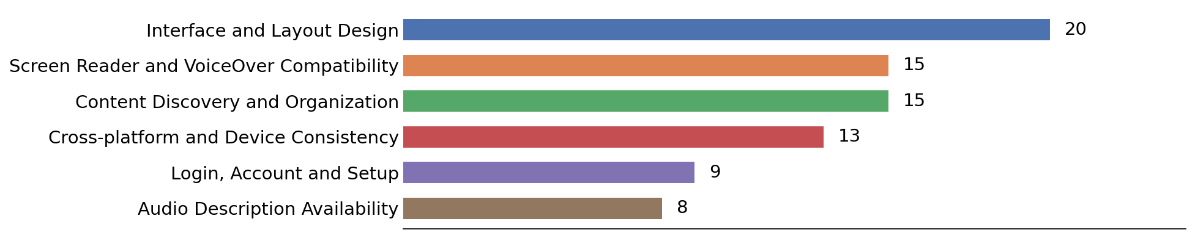

Key takeaways
- 93% of scored comments were negative on this frustration question (6 positive / 79 negative / 6 neutral; 85 comments carried a clear signal, n=91 total).
- Interface and Layout Design is the most-mentioned theme (20 mentions), making it the clearest single driver of frustration for Netflix this wave.
- Screen Reader and VoiceOver Compatibility (15 mentions) and Content Discovery and Organization (15 mentions) are the next most common themes among Netflix comments.
- Smaller but distinct themes include Cross-platform and Device Consistency (13 mentions) and Login, Account and Setup (9 mentions).

Q34 What is the best accessibility feature you have encountered while using Netflix’s streaming service?
n = 89
Chart 34: Netflix Best-Feature Themes

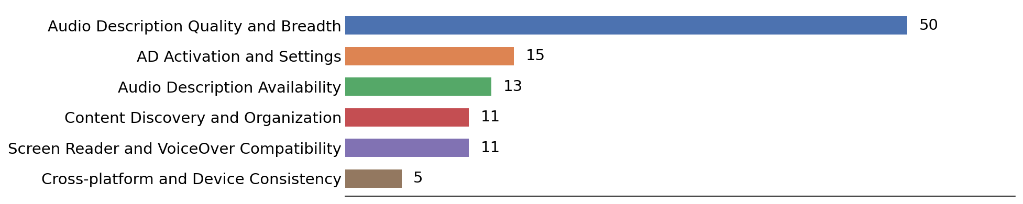

Key takeaways
- 99% of scored comments were positive on this best-feature question (83 positive / 1 negative / 5 neutral; 84 comments carried a clear signal, n=89 total).
- Audio Description Quality and Breadth is the most-mentioned theme (50 mentions), making it the clearest single driver of praise for Netflix this wave.
- AD Activation and Settings (15 mentions) and Audio Description Availability (13 mentions) are the next most common themes among Netflix comments.
- Smaller but distinct themes include Content Discovery and Organization (11 mentions) and Screen Reader and VoiceOver Compatibility (11 mentions).

Q35 Do you use Peacock as a streaming service?
n = 188
Chart 35: Peacock Usage

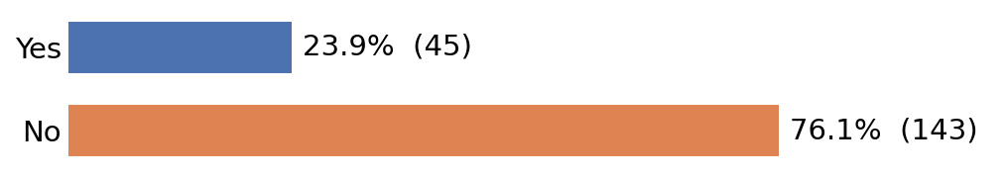

ANSWER CHOICES | RESPONSES
Yes | 23.90%
No | 76.10%
TOTAL | 100%

Q36 Please rate your experience with the following aspects of Peacock streaming services on a scale from 1 to 5, where 1 is Very Difficult and 5 is Very Easy.
n = 46
Chart 46: Peacock Rating Analysis by Aspect

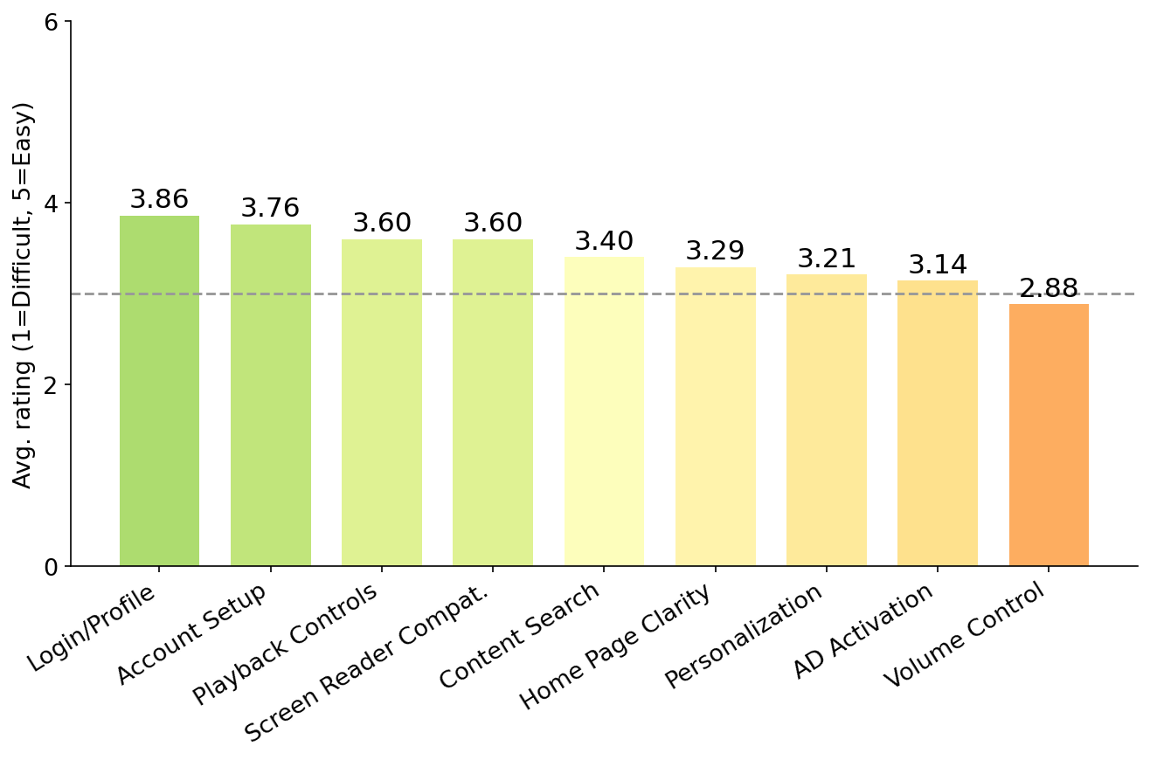

ASPECT | 1 | 2 | 3 | 4 | 5 | Total | Avg
Ease of setting up the service and creating an account. | 2% (1) | 11% (5) | 24% (11) | 33% (15) | 28% (13) | 45 | 3.76
Ease of logging in and accessing your personal profile. | 0% (0) | 9% (4) | 20% (9) | 39% (18) | 24% (11) | 42 | 3.86
Ease of finding and setting up personalization options (e.g., profile picture, Closed Captions, parental controls). | 9% (4) | 20% (9) | 22% (10) | 26% (12) | 15% (7) | 42 | 3.21
Ease of finding and activating the audio description setting. | 11% (5) | 24% (11) | 20% (9) | 20% (9) | 20% (9) | 43 | 3.14
Compatibility of the service with your primary screen reader. | 6% (3) | 9% (4) | 26% (12) | 24% (11) | 26% (12) | 42 | 3.60
Ability to set independent volume levels for screen reader. | 20% (9) | 15% (7) | 28% (13) | 9% (4) | 17% (8) | 41 | 2.88
Clarity and usability of the home page or landing page layout for navigation. | 11% (5) | 13% (6) | 20% (9) | 30% (14) | 15% (7) | 41 | 3.29
Ease of finding specific content (e.g., using search, browse genres, navigating categories). | 9% (4) | 9% (4) | 30% (14) | 28% (13) | 17% (8) | 43 | 3.40
Ease of finding and accessing playback controls while watching content (e.g., play, pause, rewind, volume). | 6% (3) | 11% (5) | 26% (12) | 17% (8) | 30% (14) | 42 | 3.60

Key takeaways
- Logging in and accessing your profile is the strongest-rated aspect (3.86); independent volume control is the weakest (2.88).
- The gap between best and worst aspect is 0.98 points. 1 aspect (independent volume control) sits below the neutral 3.0 midpoint.
- The remaining aspects cluster between 3.14 and 3.76, with n=46 respondents rating Peacock this wave.

Q37 What is the single most frustrating accessibility challenge you have encountered while using Peacock’s streaming service?
n = 38
Chart 37: Peacock Frustration Themes

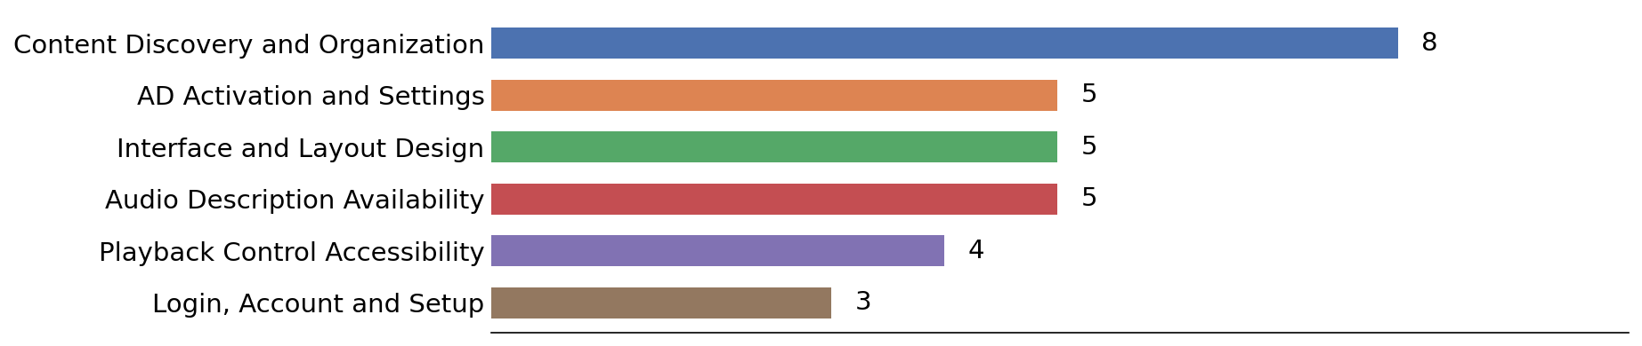

Key takeaways
- 97% of scored comments were negative on this frustration question (1 positive / 32 negative / 5 neutral; 33 comments carried a clear signal, n=38 total).
- Content Discovery and Organization is the most-mentioned theme (8 mentions), making it the clearest single driver of frustration for Peacock this wave.
- AD Activation and Settings (5 mentions) and Interface and Layout Design (5 mentions) are the next most common themes among Peacock comments.
- Smaller but distinct themes include Audio Description Availability (5 mentions) and Playback Control Accessibility (4 mentions).

Q38 What is the best accessibility feature you have encountered while using Peacock’s streaming service?
n = 35
Chart 38: Peacock Best-Feature Themes

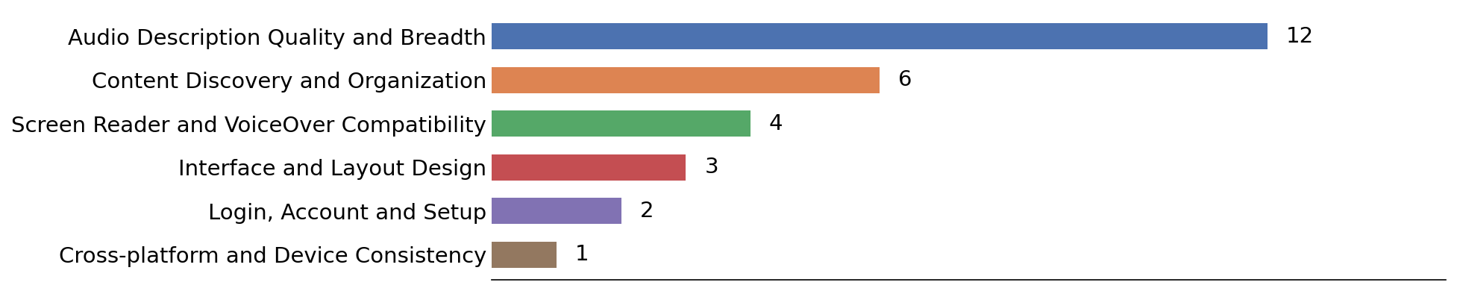

Key takeaways
- 90% of scored comments were positive on this best-feature question (26 positive / 3 negative / 6 neutral; 29 comments carried a clear signal, n=35 total).
- Audio Description Quality and Breadth is the most-mentioned theme (12 mentions), making it the clearest single driver of praise for Peacock this wave.
- Content Discovery and Organization (6 mentions) and Screen Reader and VoiceOver Compatibility (4 mentions) are the next most common themes among Peacock comments.
- Smaller but distinct themes include Interface and Layout Design (3 mentions) and Login, Account and Setup (2 mentions).

Q39 Are there any other streaming services that you have used?
n = 123
Chart 39: Other Streaming Services Mentioned

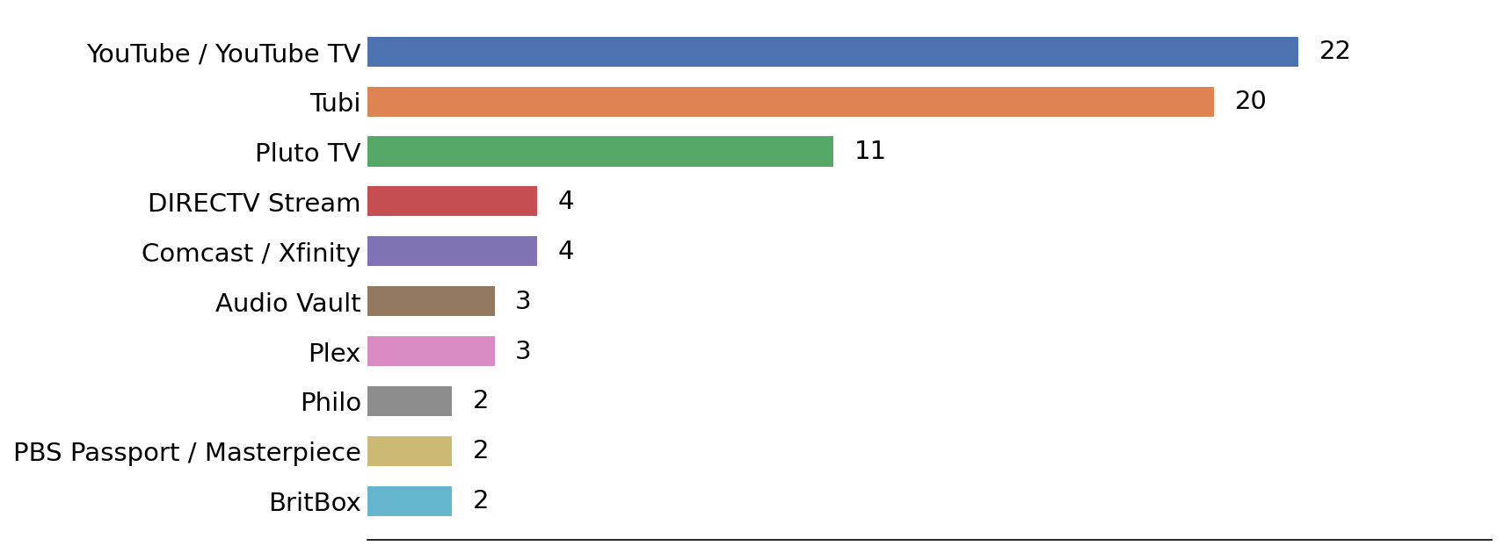
Key takeaways
- YouTube / YouTube TV (22 mentions), Tubi (20), and Pluto TV (11) are the most frequently named services beyond the eight asked about directly — free, ad-supported platforms continue to fill gaps in the paid landscape.
- 51 of the 123 respondents who answered named no additional service at all, so the mention counts below come from roughly 72 substantive answers.
- Traditional cable and live-TV providers (Comcast/Xfinity, DIRECTV Stream, Spectrum, Verizon FiOS) remain part of the accessibility conversation for a meaningful minority of respondents.
- A long tail of niche and regional services (BritBox, Acorn TV, Crunchyroll, TVNZ+, ABC iView, PBS Passport, Kanopy, Starz, Crave) appear once or twice each, reflecting a fragmented landscape for BLV consumers.
- Several respondents named third-party audio-description archives (Audio Vault, Sero) as their primary source of described content when mainstream apps fall short.

Q40 Please use this space to add any additional comments, feedback, or suggestions about your overall experience with streaming services and accessibility.
n = 104
Chart 40: Additional Comments Themes

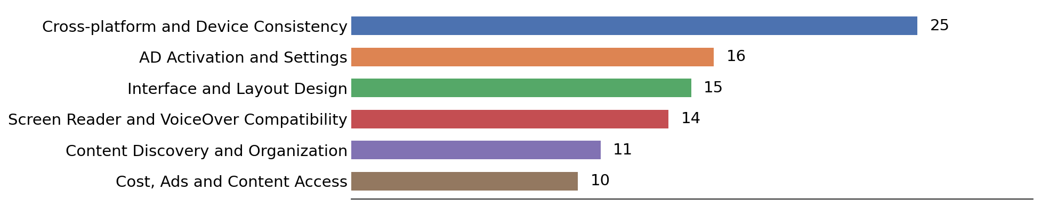

Key takeaways
- Sentiment here is far more mixed than on the service-specific questions (34 positive / 31 negative / 39 neutral of 104 comments) — many respondents used this space for broad policy requests rather than direct complaints.
- Cross-platform and Device Consistency is the dominant theme even in unprompted feedback (25 mentions): the same title’s AD differs by region and by device, and every service uses different terminology and menus.
- AD Activation and Settings (16 mentions) and Interface and Layout Design (15 mentions) round out the top general themes.
- A recurring request is standardization — a common way to find and switch on audio description across all services, and an "has AD" filter or category on every platform.
- Several respondents explicitly preferred human-narrated AD over TTS, and a number reported that the overall experience has felt harder, not easier, over the last 18–24 months.

Q41 Overall Accessibility Rating by Services
Chart 41: Overall Accessibility Rating by Service

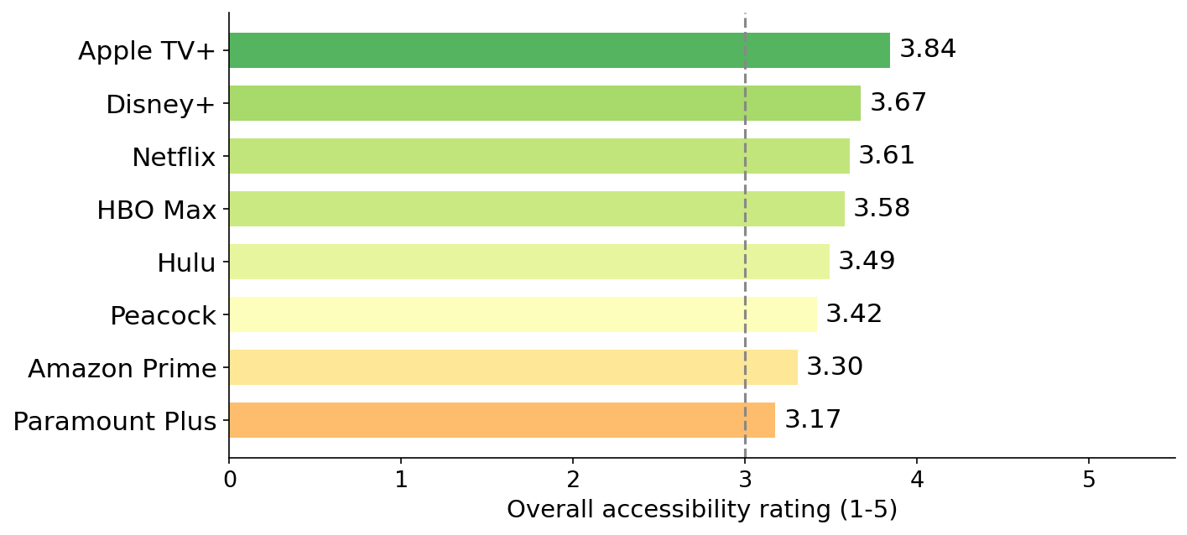

STREAMING SERVICE | OVERALL RATING (1-5) | RANK
Apple TV+ | 3.84 | 1
Disney+ | 3.67 | 2
Netflix | 3.61 | 3
HBO Max | 3.58 | 4
Hulu | 3.49 | 5
Peacock | 3.42 | 6
Amazon Prime | 3.30 | 7
Paramount Plus | 3.17 | 8
Each service’s overall rating is the unweighted mean of its nine aspect averages. Ratings reflect only respondents who use that service and answered its rating question, so sample sizes vary considerably by service (n=82 for Apple TV+ against n=180 for Amazon Prime) and are not adjusted for those differences.

Key takeaways
- Apple TV+ (3.84) — Rank #1 this wave. Best aspect: logging in and accessing your profile (4.15); weakest: independent volume control (3.28). Comment sentiment: 98% positive on the best-feature question (n=58), 81% negative on the frustration question (n=53). No aspect falls below 3.0. Rated by n=82 respondents.
- Disney+ (3.67) — Rank #2 this wave. Best aspect: screen-reader compatibility (3.98); weakest: independent volume control (3.21). Comment sentiment: 93% positive on the best-feature question (n=62), 87% negative on the frustration question (n=61). No aspect falls below 3.0. Rated by n=75 respondents.
- Netflix (3.61) — Rank #3 this wave. Best aspect: logging in and accessing your profile (3.92); weakest: independent volume control (3.05). Comment sentiment: 99% positive on the best-feature question (n=89), 93% negative on the frustration question (n=91). No aspect falls below 3.0. Rated by n=119 respondents.
- HBO Max (3.58) — Rank #4 this wave. Best aspect: logging in and accessing your profile (3.98); weakest: independent volume control (2.95). Comment sentiment: 97% positive on the best-feature question (n=41), 87% negative on the frustration question (n=42). 1 aspect sits below the neutral 3.0 midpoint. Rated by n=57 respondents.
- Hulu (3.49) — Rank #5 this wave. Best aspect: logging in and accessing your profile (3.98); weakest: AD activation reliability (3.02). Comment sentiment: 92% positive on the best-feature question (n=43), 98% negative on the frustration question (n=46). No aspect falls below 3.0. Rated by n=57 respondents.
- Peacock (3.42) — Rank #6 this wave. Best aspect: logging in and accessing your profile (3.86); weakest: independent volume control (2.88). Comment sentiment: 90% positive on the best-feature question (n=35), 97% negative on the frustration question (n=38). 1 aspect sits below the neutral 3.0 midpoint. Rated by n=46 respondents.
- Amazon Prime (3.30) — Rank #7 this wave. Best aspect: logging in and accessing your profile (3.75); weakest: independent volume control (2.92). Comment sentiment: 94% positive on the best-feature question (n=116), 98% negative on the frustration question (n=135). 1 aspect sits below the neutral 3.0 midpoint. Rated by n=180 respondents.
- Paramount Plus (3.17) — Rank #8 this wave. Best aspect: logging in and accessing your profile (3.83); weakest: AD activation reliability (2.79). Comment sentiment: 88% positive on the best-feature question (n=28), 92% negative on the frustration question (n=38). 4 aspects sit below the neutral 3.0 midpoint. Rated by n=48 respondents.

Streaming Services Accessibility: Head-to-Head Comparison
All 28 pairwise comparisons across the eight services covered in this survey, grounded in the current rating tables and comment analysis.

Chart 1: Accessibility rating by aspect
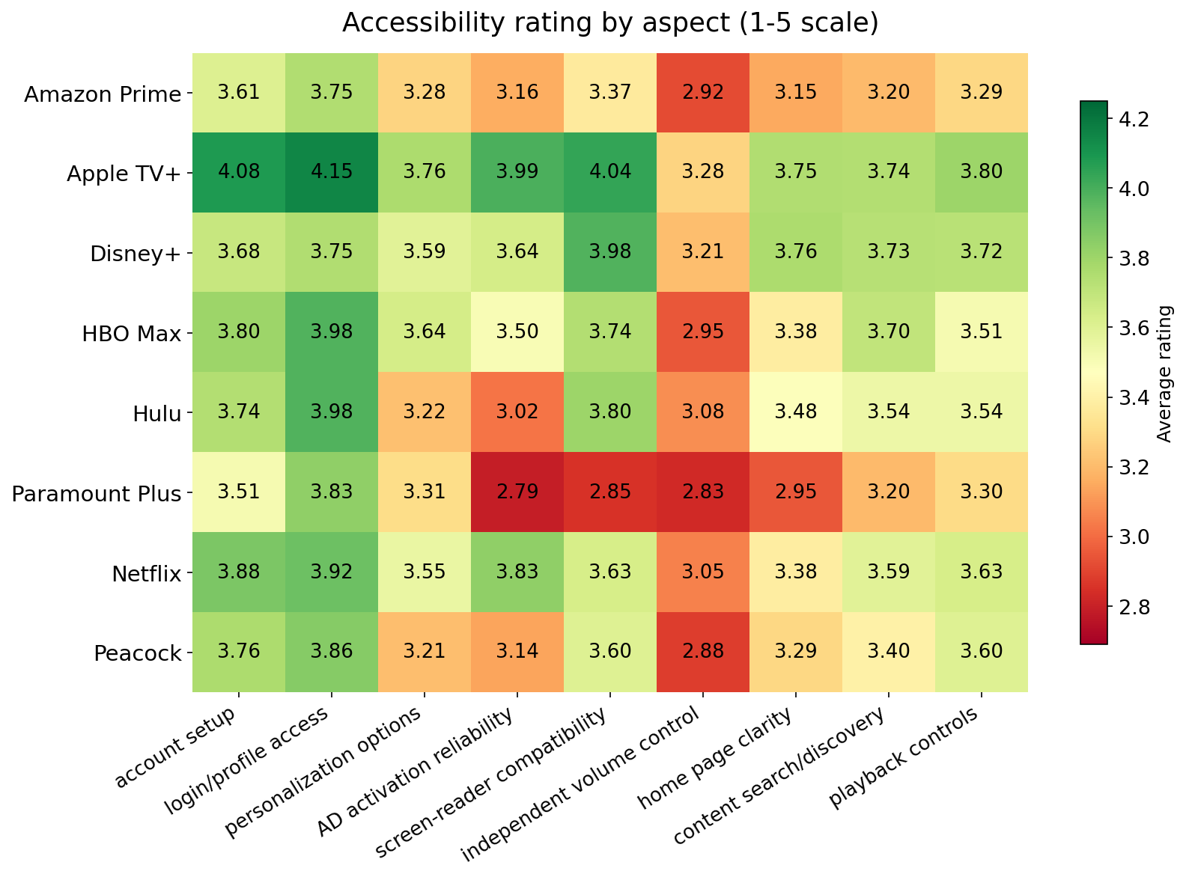

Chart 2: AD activation reliability — the widest service-to-service gap

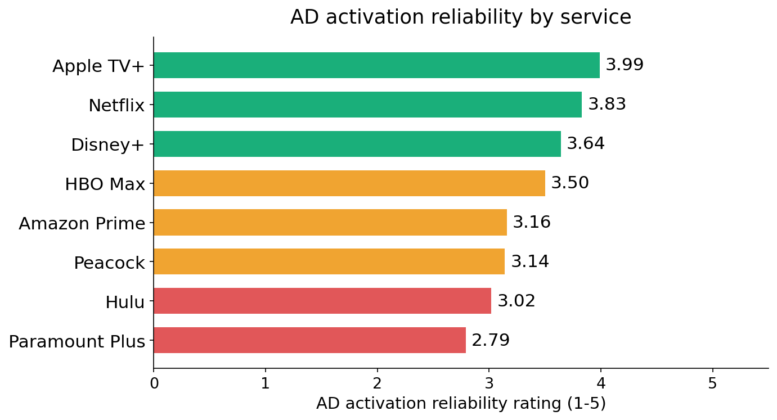
AD activation reliability shows the largest spread of any aspect measured: 1.20 points between Apple TV+ (3.99) and Paramount Plus (2.79). It is also the aspect most often named in the open-ended comments across every service.

All 28 head-to-head comparisons

1. Amazon Prime vs Apple TV+
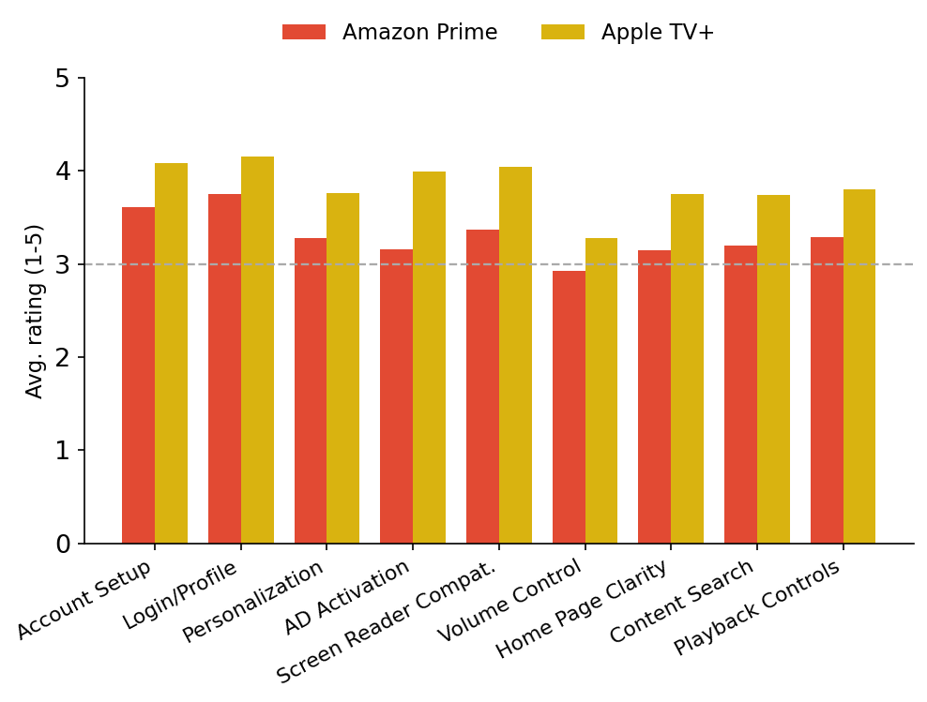
Aspect | Amazon Prime | Apple TV+ | Higher
Account Setup | 3.61 | 4.08 | Apple TV+
Login/Profile | 3.75 | 4.15 | Apple TV+
Personalization | 3.28 | 3.76 | Apple TV+
AD Activation | 3.16 | 3.99 | Apple TV+
Screen Reader Compat. | 3.37 | 4.04 | Apple TV+
Volume Control | 2.92 | 3.28 | Apple TV+
Home Page Clarity | 3.15 | 3.75 | Apple TV+
Content Search | 3.20 | 3.74 | Apple TV+
Playback Controls | 3.29 | 3.80 | Apple TV+

- Apple TV+ rates higher overall (3.84 vs 3.30). The clearest gap is AD activation reliability (0.83-point spread, favoring Apple TV+).
- Apple TV+ users most often credit tight VoiceOver integration and accessibility settings that carry across the Apple ecosystem.
- Amazon Prime’s biggest complaint: content discovery: there is no way to tell which titles carry AD without opening each one, and some titles labeled AD do not play it.

2. Amazon Prime vs Disney+
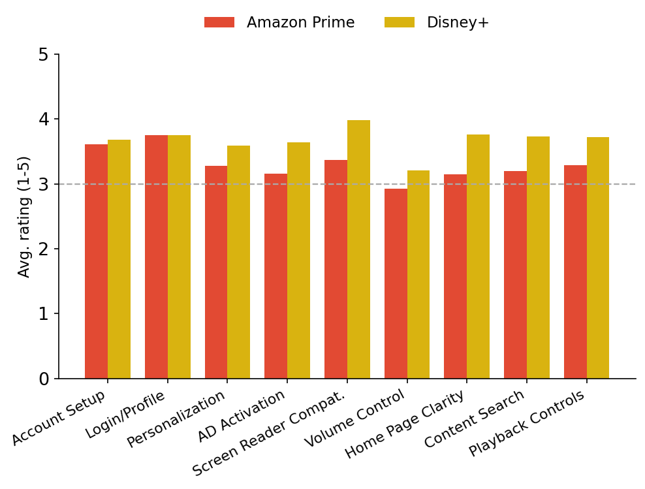
Aspect | Amazon Prime | Disney+ | Higher
Account Setup | 3.61 | 3.68 | Disney+
Login/Profile | 3.75 | 3.75 | Tie
Personalization | 3.28 | 3.59 | Disney+
AD Activation | 3.16 | 3.64 | Disney+
Screen Reader Compat. | 3.37 | 3.98 | Disney+
Volume Control | 2.92 | 3.21 | Disney+
Home Page Clarity | 3.15 | 3.76 | Disney+
Content Search | 3.20 | 3.73 | Disney+
Playback Controls | 3.29 | 3.72 | Disney+

- Disney+ rates higher overall (3.67 vs 3.30). The clearest gap is screen-reader compatibility (0.61-point spread, favouring Disney+).
- Disney+ users most often credit clearly marked AD on applicable titles and deep coverage of older library films.
- Amazon Prime’s biggest complaint: content discovery: there is no way to tell which titles carry AD without opening each one, and some titles labelled AD do not play it.

3. Amazon Prime vs HBO Max
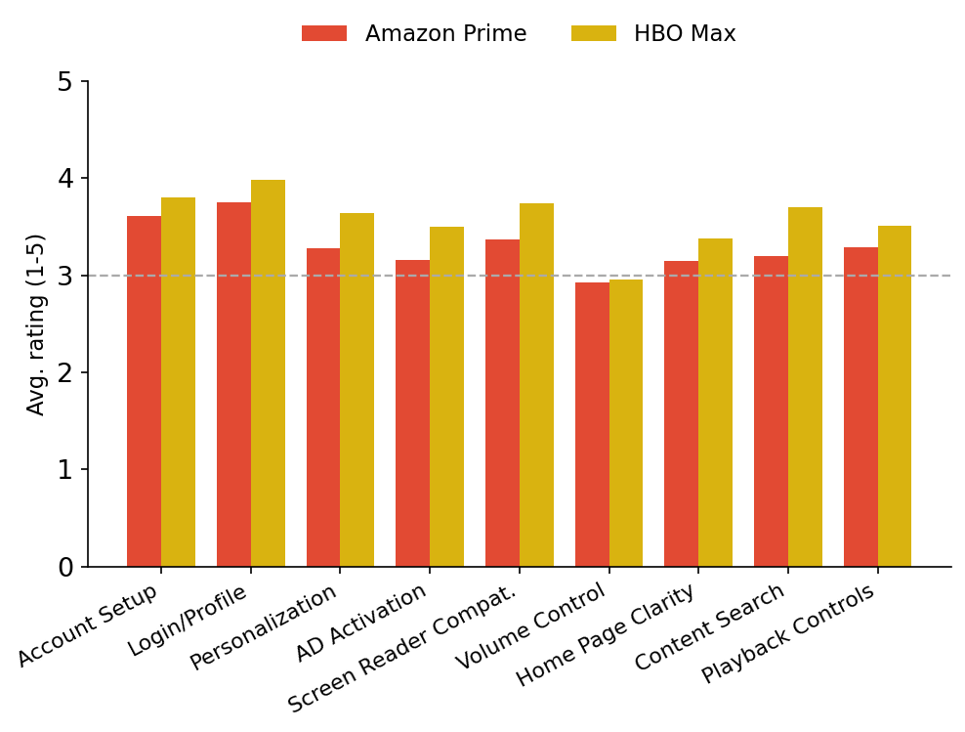
Aspect | Amazon Prime | HBO Max | Higher
Account Setup | 3.61 | 3.80 | HBO Max
Login/Profile | 3.75 | 3.98 | HBO Max
Personalization | 3.28 | 3.64 | HBO Max
AD Activation | 3.16 | 3.50 | HBO Max
Screen Reader Compat. | 3.37 | 3.74 | HBO Max
Volume Control | 2.92 | 2.95 | HBO Max
Home Page Clarity | 3.15 | 3.38 | HBO Max
Content Search | 3.20 | 3.70 | HBO Max
Playback Controls | 3.29 | 3.51 | HBO Max

- HBO Max rates higher overall (3.58 vs 3.30). The clearest gap is content search (0.50-point spread, favouring HBO Max).
- HBO Max users most often credit human-narrated AD tracks and a dedicated Audio Description tab listing all AD titles A-Z.
- Amazon Prime’s biggest complaint: content discovery: there is no way to tell which titles carry AD without opening each one, and some titles labelled AD do not play it.

4. Amazon Prime vs Hulu
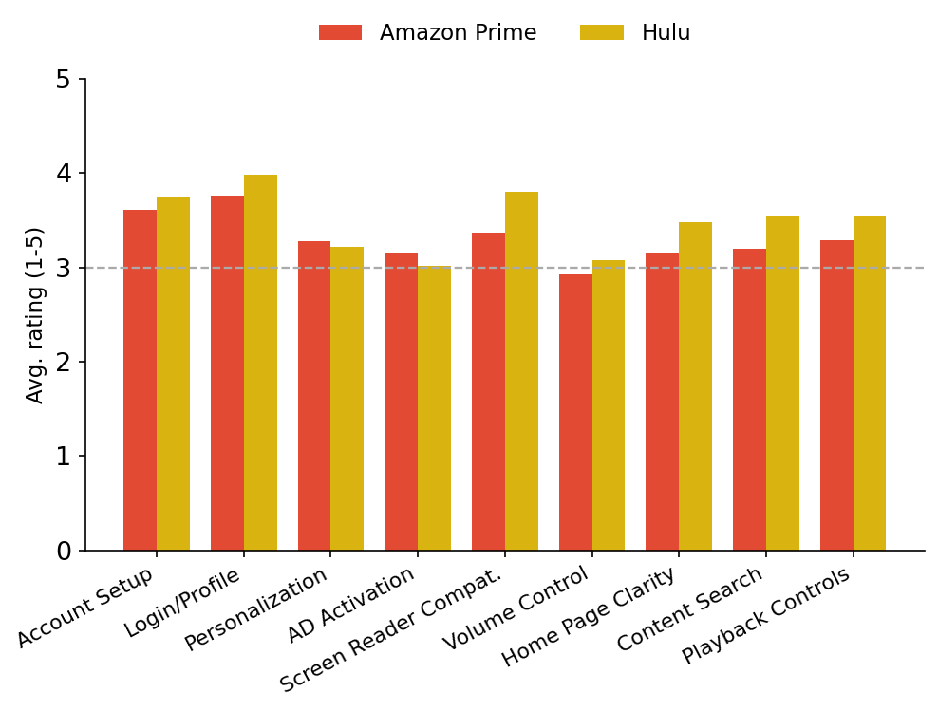
Aspect | Amazon Prime | Hulu | Higher
Account Setup | 3.61 | 3.74 | Hulu
Login/Profile | 3.75 | 3.98 | Hulu
Personalization | 3.28 | 3.22 | Amazon Prime
AD Activation | 3.16 | 3.02 | Amazon Prime
Screen Reader Compat. | 3.37 | 3.80 | Hulu
Volume Control | 2.92 | 3.08 | Hulu
Home Page Clarity | 3.15 | 3.48 | Hulu
Content Search | 3.20 | 3.54 | Hulu
Playback Controls | 3.29 | 3.54 | Hulu

- Hulu rates higher overall (3.49 vs 3.30). The clearest gap is screen-reader compatibility (0.43-point spread, favouring Hulu).
- Hulu users most often credit AD that stays active once switched on and a consistent, uncluttered layout.
- Amazon Prime’s biggest complaint: content discovery: there is no way to tell which titles carry AD without opening each one, and some titles labelled AD do not play it.

5. Amazon Prime vs Paramount Plus
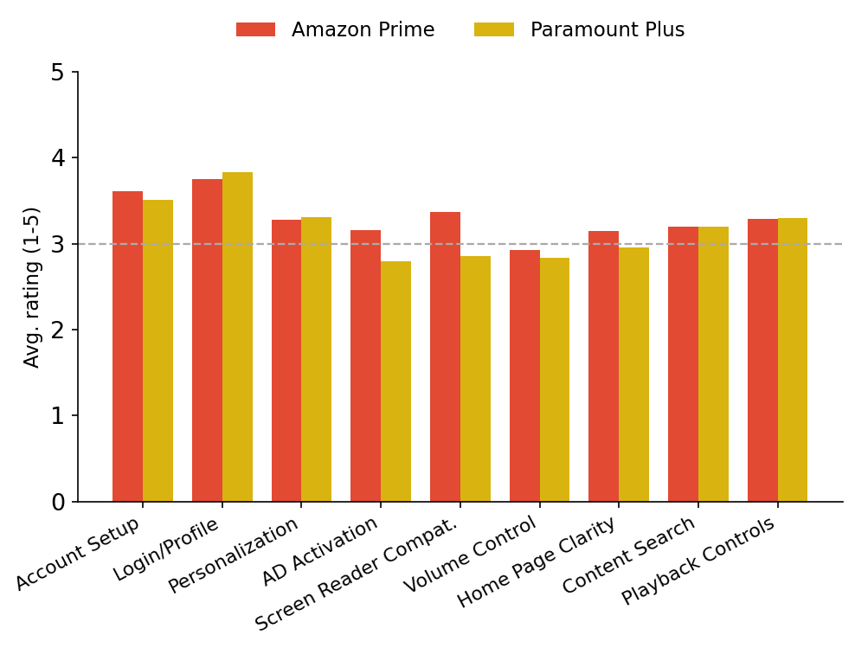
Aspect | Amazon Prime | Paramount Plus | Higher
Account Setup | 3.61 | 3.51 | Amazon Prime
Login/Profile | 3.75 | 3.83 | Paramount Plus
Personalization | 3.28 | 3.31 | Paramount Plus
AD Activation | 3.16 | 2.79 | Amazon Prime
Screen Reader Compat. | 3.37 | 2.85 | Amazon Prime
Volume Control | 2.92 | 2.83 | Amazon Prime
Home Page Clarity | 3.15 | 2.95 | Amazon Prime
Content Search | 3.20 | 3.20 | Tie
Playback Controls | 3.29 | 3.30 | Paramount Plus

- Amazon Prime rates higher overall (3.30 vs 3.17). The clearest gap is screen-reader compatibility (0.52-point spread, favouring Amazon Prime).
- Amazon Prime users most often credit the sheer size of the described catalogue and audio description that stays on once enabled.
- Paramount Plus’s biggest complaint: screen-reader incompatibility across the app, and AD that will not stay switched on.

6. Amazon Prime vs Netflix
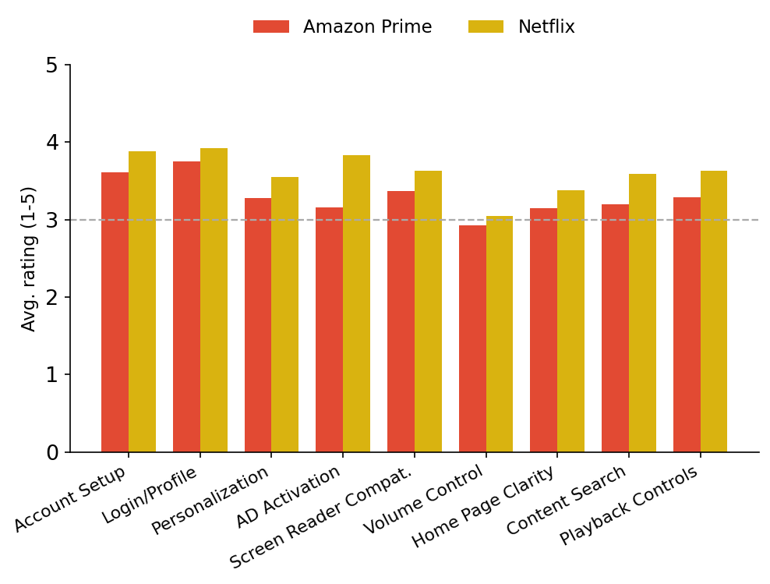
Aspect | Amazon Prime | Netflix | Higher
Account Setup | 3.61 | 3.88 | Netflix
Login/Profile | 3.75 | 3.92 | Netflix
Personalization | 3.28 | 3.55 | Netflix
AD Activation | 3.16 | 3.83 | Netflix
Screen Reader Compat. | 3.37 | 3.63 | Netflix
Volume Control | 2.92 | 3.05 | Netflix
Home Page Clarity | 3.15 | 3.38 | Netflix
Content Search | 3.20 | 3.59 | Netflix
Playback Controls | 3.29 | 3.63 | Netflix

- Netflix rates higher overall (3.61 vs 3.30). The clearest gap is AD activation reliability (0.67-point spread, favouring Netflix).
- Netflix users most often credit AD that persists across titles and profiles, plus the widest multi-language AD support.
- Amazon Prime’s biggest complaint: content discovery: there is no way to tell which titles carry AD without opening each one, and some titles labelled AD do not play it.

7. Amazon Prime vs Peacock
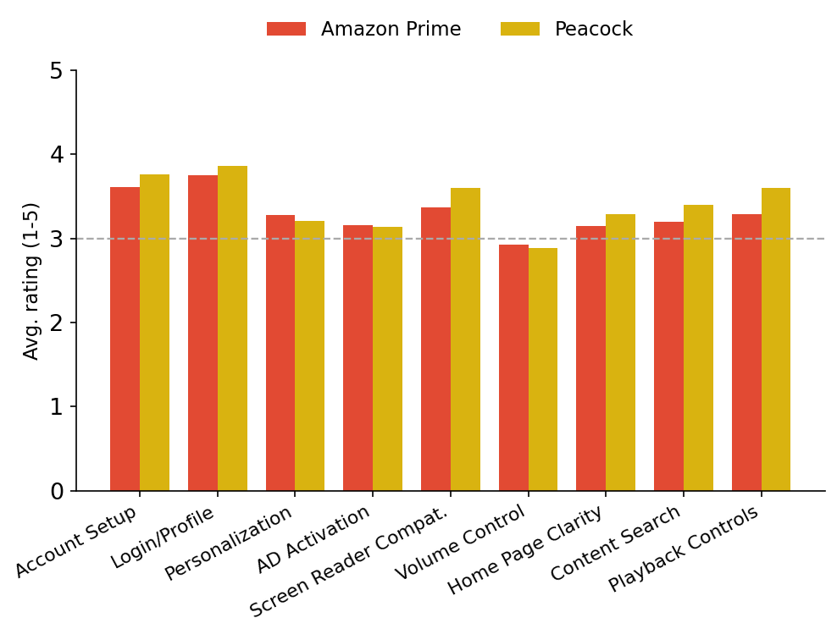
Aspect | Amazon Prime | Peacock | Higher
Account Setup | 3.61 | 3.76 | Peacock
Login/Profile | 3.75 | 3.86 | Peacock
Personalization | 3.28 | 3.21 | Amazon Prime
AD Activation | 3.16 | 3.14 | Amazon Prime
Screen Reader Compat. | 3.37 | 3.60 | Peacock
Volume Control | 2.92 | 2.88 | Amazon Prime
Home Page Clarity | 3.15 | 3.29 | Peacock
Content Search | 3.20 | 3.40 | Peacock
Playback Controls | 3.29 | 3.60 | Peacock

- Peacock rates higher overall (3.42 vs 3.30). The clearest gap is playback controls (0.31-point spread, favouring Peacock).
- Peacock users most often credit next-day AD on recently aired shows and a genre navigation row few rivals offer.
- Amazon Prime’s biggest complaint: content discovery: there is no way to tell which titles carry AD without opening each one, and some titles labelled AD do not play it.

8. Apple TV+ vs Disney+
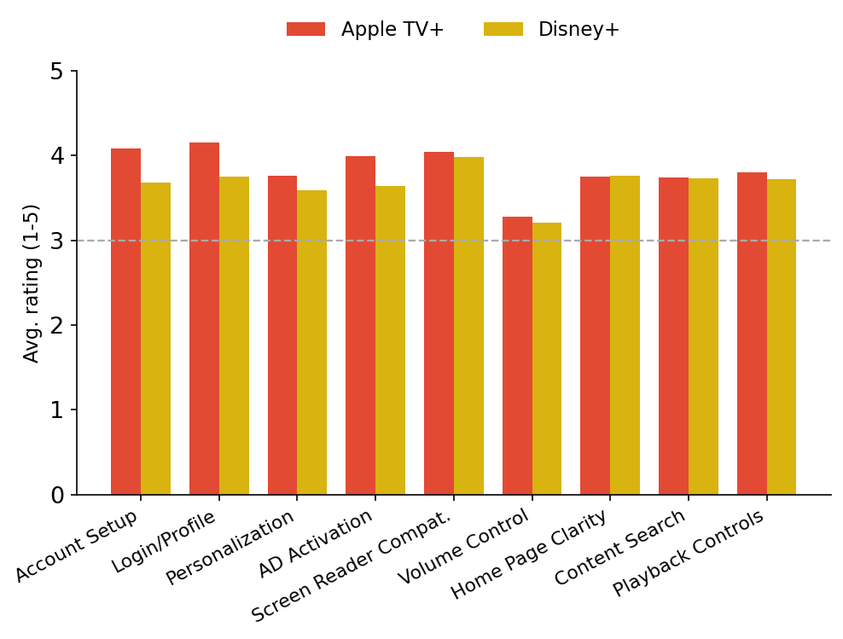
Aspect | Apple TV+ | Disney+ | Higher
Account Setup | 4.08 | 3.68 | Apple TV+
Login/Profile | 4.15 | 3.75 | Apple TV+
Personalization | 3.76 | 3.59 | Apple TV+
AD Activation | 3.99 | 3.64 | Apple TV+
Screen Reader Compat. | 4.04 | 3.98 | Apple TV+
Volume Control | 3.28 | 3.21 | Apple TV+
Home Page Clarity | 3.75 | 3.76 | Disney+
Content Search | 3.74 | 3.73 | Apple TV+
Playback Controls | 3.80 | 3.72 | Apple TV+

- Apple TV+ rates higher overall (3.84 vs 3.67). The clearest gap is logging in and accessing your profile (0.40-point spread, favouring Apple TV+).
- Apple TV+ users most often credit tight VoiceOver integration and accessibility settings that carry across the Apple ecosystem.
- Disney+’s biggest complaint: inconsistent AD coverage across episodes and franchises, and the shift to TTS narration.

9. Apple TV+ vs HBO Max
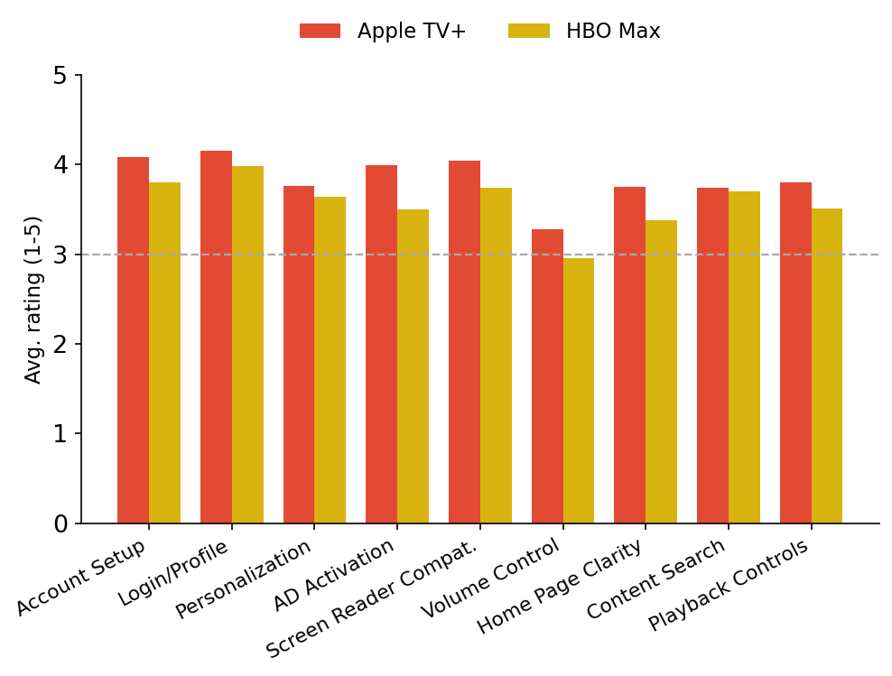
Aspect | Apple TV+ | HBO Max | Higher
Account Setup | 4.08 | 3.80 | Apple TV+
Login/Profile | 4.15 | 3.98 | Apple TV+
Personalization | 3.76 | 3.64 | Apple TV+
AD Activation | 3.99 | 3.50 | Apple TV+
Screen Reader Compat. | 4.04 | 3.74 | Apple TV+
Volume Control | 3.28 | 2.95 | Apple TV+
Home Page Clarity | 3.75 | 3.38 | Apple TV+
Content Search | 3.74 | 3.70 | Apple TV+
Playback Controls | 3.80 | 3.51 | Apple TV+

- Apple TV+ rates higher overall (3.84 vs 3.58). The clearest gap is AD activation reliability (0.49-point spread, favouring Apple TV+).
- Apple TV+ users most often credit tight VoiceOver integration and accessibility settings that carry across the Apple ecosystem.
- HBO Max’s biggest complaint: a cluttered home page that is hard to browse with a screen reader, and gaps in AD for older titles.

10. Apple TV+ vs Hulu
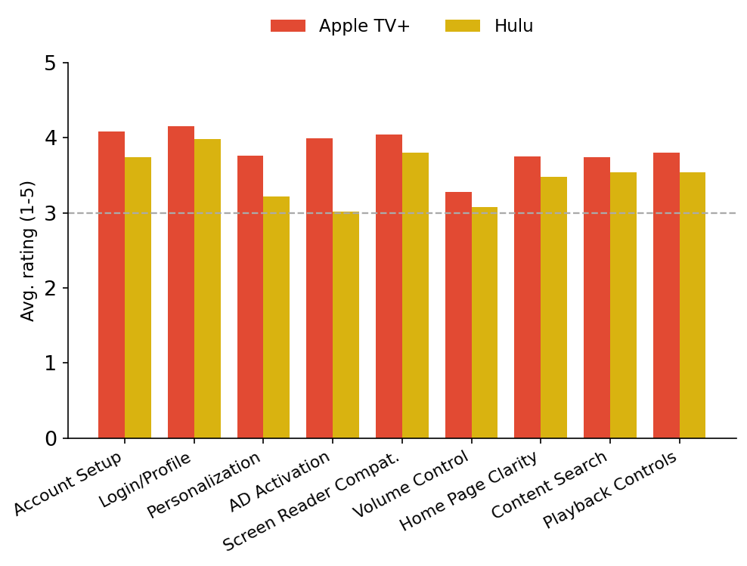
Aspect | Apple TV+ | Hulu | Higher
Account Setup | 4.08 | 3.74 | Apple TV+
Login/Profile | 4.15 | 3.98 | Apple TV+
Personalization | 3.76 | 3.22 | Apple TV+
AD Activation | 3.99 | 3.02 | Apple TV+
Screen Reader Compat. | 4.04 | 3.80 | Apple TV+
Volume Control | 3.28 | 3.08 | Apple TV+
Home Page Clarity | 3.75 | 3.48 | Apple TV+
Content Search | 3.74 | 3.54 | Apple TV+
Playback Controls | 3.80 | 3.54 | Apple TV+

- Apple TV+ rates higher overall (3.84 vs 3.49). The clearest gap is AD activation reliability (0.97-point spread, favouring Apple TV+).
- Apple TV+ users most often credit tight VoiceOver integration and accessibility settings that carry across the Apple ecosystem.
- Hulu’s biggest complaint: no way to tell whether a title carries AD without starting playback, and AD tracks that do not travel with the content.

11. Apple TV+ vs Paramount Plus
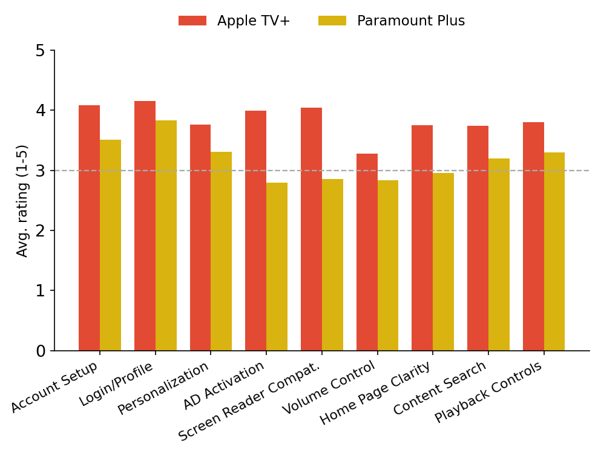
Aspect | Apple TV+ | Paramount Plus | Higher
Account Setup | 4.08 | 3.51 | Apple TV+
Login/Profile | 4.15 | 3.83 | Apple TV+
Personalization | 3.76 | 3.31 | Apple TV+
AD Activation | 3.99 | 2.79 | Apple TV+
Screen Reader Compat. | 4.04 | 2.85 | Apple TV+
Volume Control | 3.28 | 2.83 | Apple TV+
Home Page Clarity | 3.75 | 2.95 | Apple TV+
Content Search | 3.74 | 3.20 | Apple TV+
Playback Controls | 3.80 | 3.30 | Apple TV+

- Apple TV+ rates higher overall (3.84 vs 3.17). The clearest gap is AD activation reliability (1.20-point spread, favouring Apple TV+).
- Apple TV+ users most often credit tight VoiceOver integration and accessibility settings that carry across the Apple ecosystem.
- Paramount Plus’s biggest complaint: screen-reader incompatibility across the app, and AD that will not stay switched on.

12. Apple TV+ vs Netflix
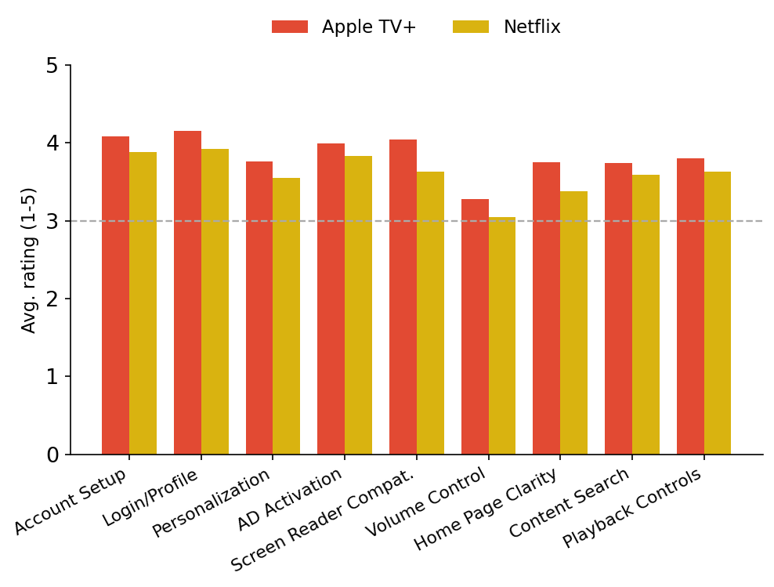
Aspect | Apple TV+ | Netflix | Higher
Account Setup | 4.08 | 3.88 | Apple TV+
Login/Profile | 4.15 | 3.92 | Apple TV+
Personalization | 3.76 | 3.55 | Apple TV+
AD Activation | 3.99 | 3.83 | Apple TV+
Screen Reader Compat. | 4.04 | 3.63 | Apple TV+
Volume Control | 3.28 | 3.05 | Apple TV+
Home Page Clarity | 3.75 | 3.38 | Apple TV+
Content Search | 3.74 | 3.59 | Apple TV+
Playback Controls | 3.80 | 3.63 | Apple TV+

- Apple TV+ rates higher overall (3.84 vs 3.61). The clearest gap is screen-reader compatibility (0.41-point spread, favouring Apple TV+).
- Apple TV+ users most often credit tight VoiceOver integration and accessibility settings that carry across the Apple ecosystem.
- Netflix’s biggest complaint: the removal of the audio description category and focus that jumps while navigating the home page.

13. Apple TV+ vs Peacock
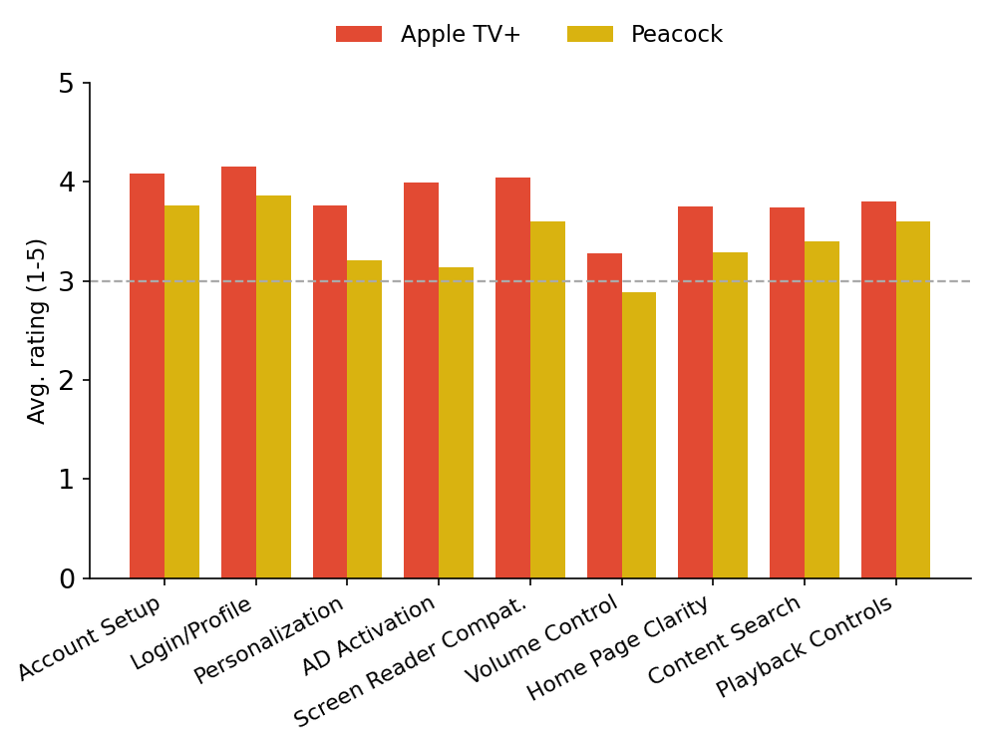
Aspect | Apple TV+ | Peacock | Higher
Account Setup | 4.08 | 3.76 | Apple TV+
Login/Profile | 4.15 | 3.86 | Apple TV+
Personalization | 3.76 | 3.21 | Apple TV+
AD Activation | 3.99 | 3.14 | Apple TV+
Screen Reader Compat. | 4.04 | 3.60 | Apple TV+
Volume Control | 3.28 | 2.88 | Apple TV+
Home Page Clarity | 3.75 | 3.29 | Apple TV+
Content Search | 3.74 | 3.40 | Apple TV+
Playback Controls | 3.80 | 3.60 | Apple TV+

- Apple TV+ rates higher overall (3.84 vs 3.42). The clearest gap is AD activation reliability (0.85-point spread, favoring Apple TV+).
- Apple TV+ users most often credit tight VoiceOver integration and accessibility settings that carry across the Apple ecosystem.
- Peacock’s biggest complaint: locating and activating AD at all, and no accessibility settings in the profile.

14. Disney+ vs HBO Max
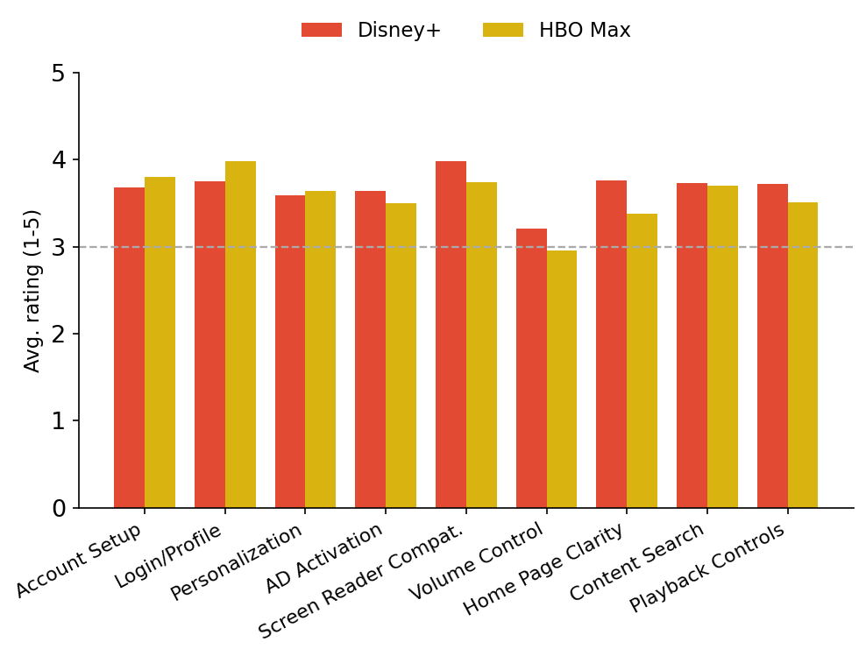
Aspect | Disney+ | HBO Max | Higher
Account Setup | 3.68 | 3.80 | HBO Max
Login/Profile | 3.75 | 3.98 | HBO Max
Personalization | 3.59 | 3.64 | HBO Max
AD Activation | 3.64 | 3.50 | Disney+
Screen Reader Compat. | 3.98 | 3.74 | Disney+
Volume Control | 3.21 | 2.95 | Disney+
Home Page Clarity | 3.76 | 3.38 | Disney+
Content Search | 3.73 | 3.70 | Disney+
Playback Controls | 3.72 | 3.51 | Disney+

- Disney+ rates higher overall (3.67 vs 3.58). The clearest gap is home page clarity (0.38-point spread, favouring Disney+).
- Disney+ users most often credit clearly marked AD on applicable titles and deep coverage of older library films.
- HBO Max’s biggest complaint: a cluttered home page that is hard to browse with a screen reader, and gaps in AD for older titles.

15. Disney+ vs Hulu
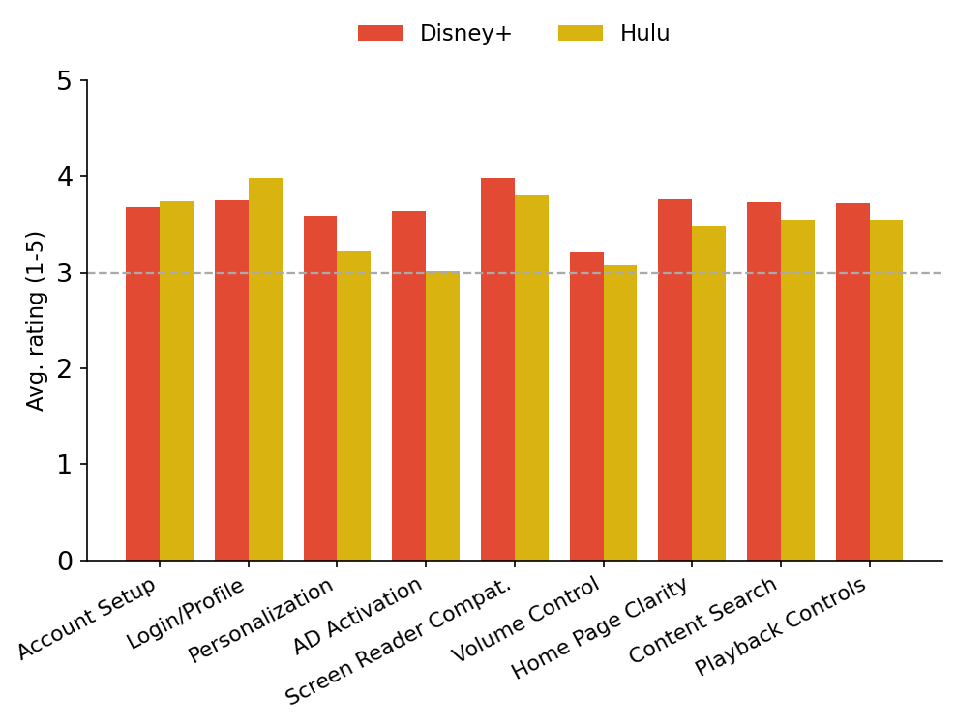
Aspect | Disney+ | Hulu | Higher
Account Setup | 3.68 | 3.74 | Hulu
Login/Profile | 3.75 | 3.98 | Hulu
Personalization | 3.59 | 3.22 | Disney+
AD Activation | 3.64 | 3.02 | Disney+
Screen Reader Compat. | 3.98 | 3.80 | Disney+
Volume Control | 3.21 | 3.08 | Disney+
Home Page Clarity | 3.76 | 3.48 | Disney+
Content Search | 3.73 | 3.54 | Disney+
Playback Controls | 3.72 | 3.54 | Disney+

- Disney+ rates higher overall (3.67 vs 3.49). The clearest gap is AD activation reliability (0.62-point spread, favouring Disney+).
- Disney+ users most often credit clearly marked AD on applicable titles and deep coverage of older library films.
- Hulu’s biggest complaint: no way to tell whether a title carries AD without starting playback, and AD tracks that do not travel with the content.

16. Disney+ vs Paramount Plus
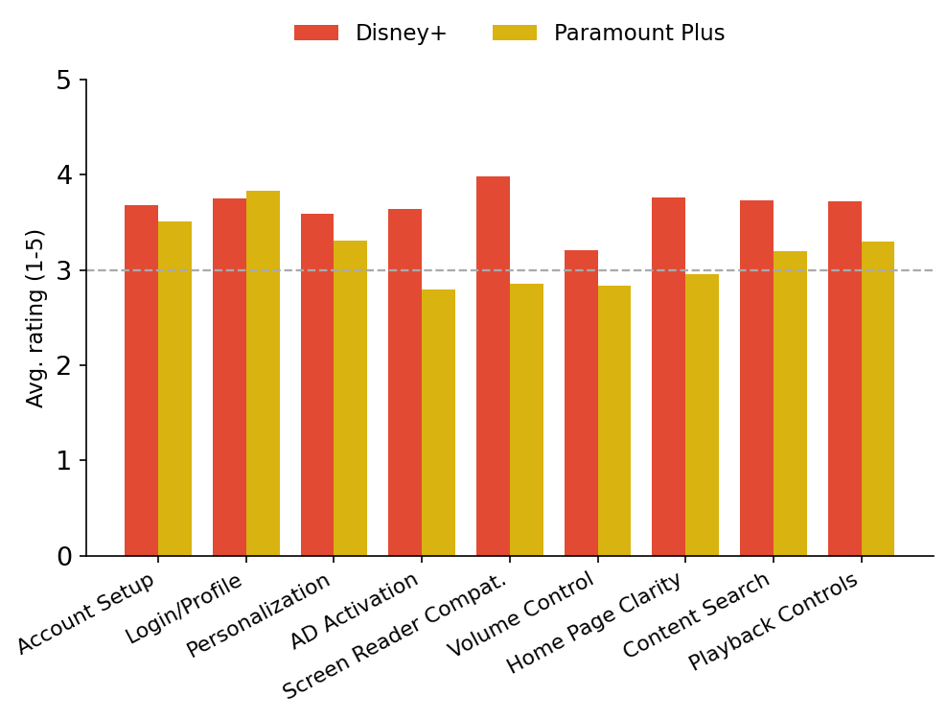
Aspect | Disney+ | Paramount Plus | Higher
Account Setup | 3.68 | 3.51 | Disney+
Login/Profile | 3.75 | 3.83 | Paramount Plus
Personalization | 3.59 | 3.31 | Disney+
AD Activation | 3.64 | 2.79 | Disney+
Screen Reader Compat. | 3.98 | 2.85 | Disney+
Volume Control | 3.21 | 2.83 | Disney+
Home Page Clarity | 3.76 | 2.95 | Disney+
Content Search | 3.73 | 3.20 | Disney+
Playback Controls | 3.72 | 3.30 | Disney+

- Disney+ rates higher overall (3.67 vs 3.17). The clearest gap is screen-reader compatibility (1.13-point spread, favouring Disney+).
- Disney+ users most often credit clearly marked AD on applicable titles and deep coverage of older library films.
- Paramount Plus’s biggest complaint: screen-reader incompatibility across the app, and AD that will not stay switched on.

17. Disney+ vs Netflix
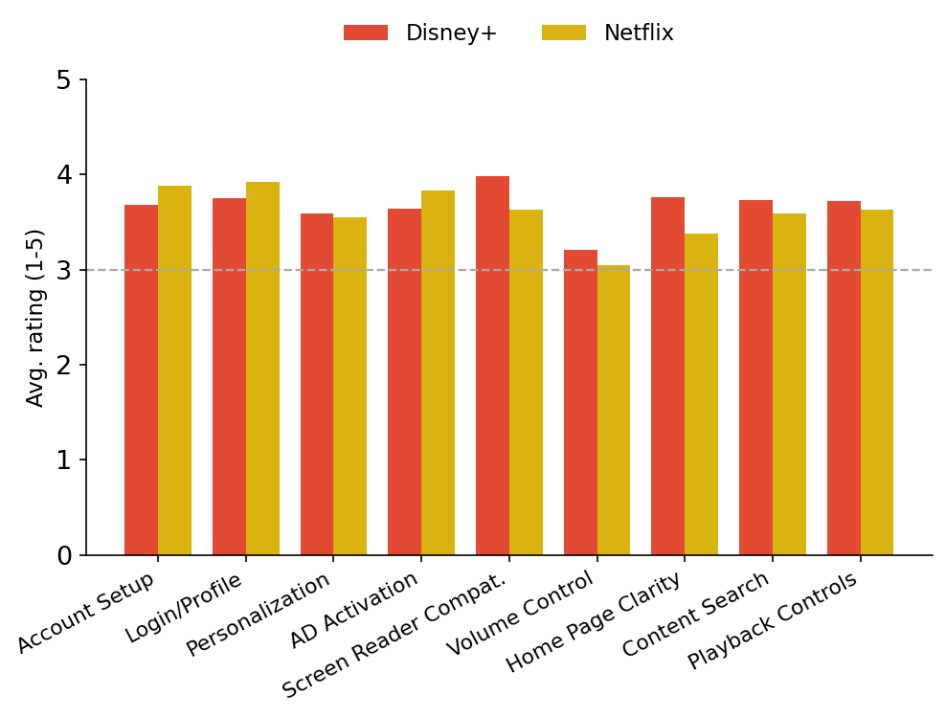
Aspect | Disney+ | Netflix | Higher
Account Setup | 3.68 | 3.88 | Netflix
Login/Profile | 3.75 | 3.92 | Netflix
Personalization | 3.59 | 3.55 | Disney+
AD Activation | 3.64 | 3.83 | Netflix
Screen Reader Compat. | 3.98 | 3.63 | Disney+
Volume Control | 3.21 | 3.05 | Disney+
Home Page Clarity | 3.76 | 3.38 | Disney+
Content Search | 3.73 | 3.59 | Disney+
Playback Controls | 3.72 | 3.63 | Disney+

- Disney+ rates higher overall (3.67 vs 3.61). The clearest gap is home page clarity (0.38-point spread, favouring Disney+).
- Disney+ users most often credit clearly marked AD on applicable titles and deep coverage of older library films.
- Netflix’s biggest complaint: the removal of the audio description category and focus that jumps while navigating the home page.

18. Disney+ vs Peacock
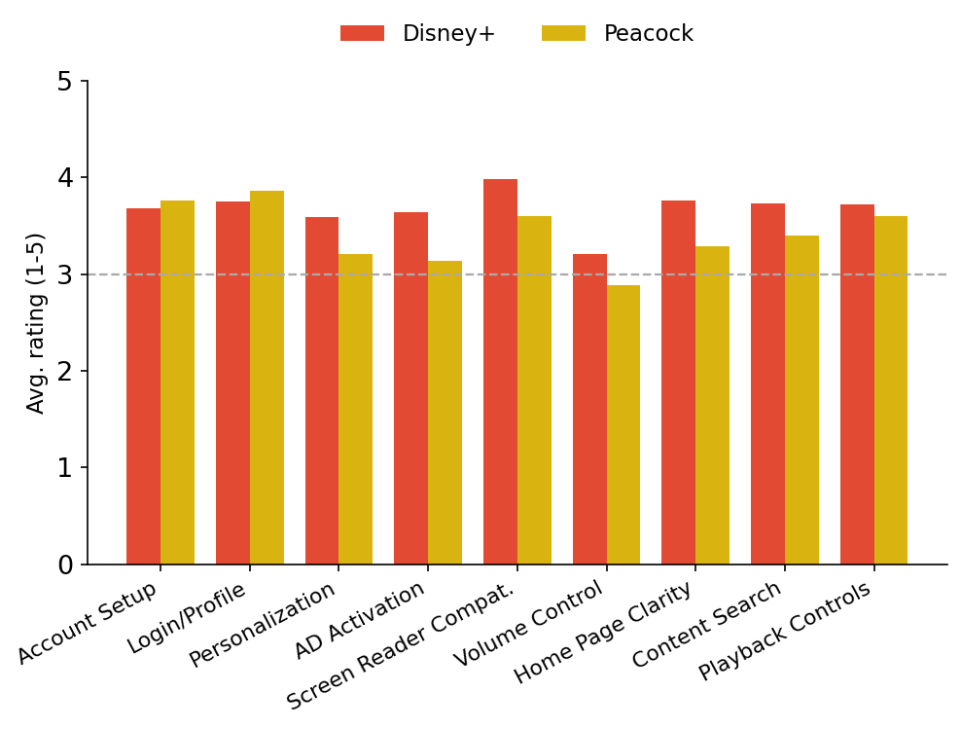
Aspect | Disney+ | Peacock | Higher
Account Setup | 3.68 | 3.76 | Peacock
Login/Profile | 3.75 | 3.86 | Peacock
Personalization | 3.59 | 3.21 | Disney+
AD Activation | 3.64 | 3.14 | Disney+
Screen Reader Compat. | 3.98 | 3.60 | Disney+
Volume Control | 3.21 | 2.88 | Disney+
Home Page Clarity | 3.76 | 3.29 | Disney+
Content Search | 3.73 | 3.40 | Disney+
Playback Controls | 3.72 | 3.60 | Disney+

- Disney+ rates higher overall (3.67 vs 3.42). The clearest gap is AD activation reliability (0.50-point spread, favouring Disney+).
- Disney+ users most often credit clearly marked AD on applicable titles and deep coverage of older library films.
- Peacock’s biggest complaint: locating and activating AD at all, and no accessibility settings in the profile.

19. HBO Max vs Hulu
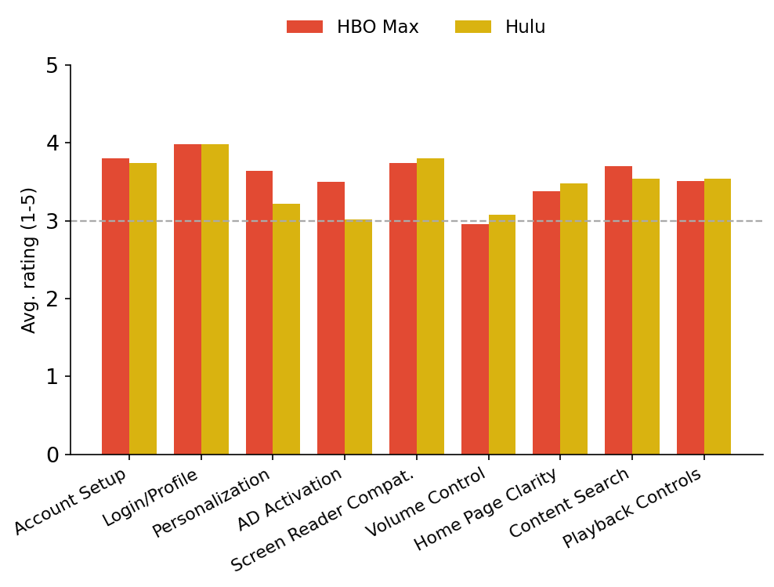
Aspect | HBO Max | Hulu | Higher
Account Setup | 3.80 | 3.74 | HBO Max
Login/Profile | 3.98 | 3.98 | Tie
Personalization | 3.64 | 3.22 | HBO Max
AD Activation | 3.50 | 3.02 | HBO Max
Screen Reader Compat. | 3.74 | 3.80 | Hulu
Volume Control | 2.95 | 3.08 | Hulu
Home Page Clarity | 3.38 | 3.48 | Hulu
Content Search | 3.70 | 3.54 | HBO Max
Playback Controls | 3.51 | 3.54 | Hulu

- HBO Max rates higher overall (3.58 vs 3.49). The clearest gap is AD activation reliability (0.48-point spread, favouring HBO Max).
- HBO Max users most often credit human-narrated AD tracks and a dedicated Audio Description tab listing all AD titles A-Z.
- Hulu’s biggest complaint: no way to tell whether a title carries AD without starting playback, and AD tracks that do not travel with the content.

20. HBO Max vs Paramount Plus
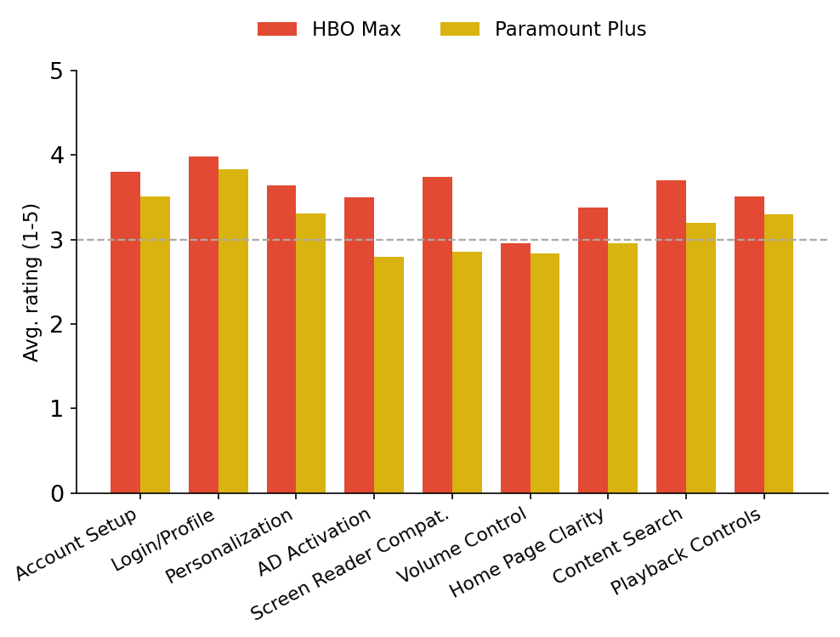
Aspect | HBO Max | Paramount Plus | Higher
Account Setup | 3.80 | 3.51 | HBO Max
Login/Profile | 3.98 | 3.83 | HBO Max
Personalization | 3.64 | 3.31 | HBO Max
AD Activation | 3.50 | 2.79 | HBO Max
Screen Reader Compat. | 3.74 | 2.85 | HBO Max
Volume Control | 2.95 | 2.83 | HBO Max
Home Page Clarity | 3.38 | 2.95 | HBO Max
Content Search | 3.70 | 3.20 | HBO Max
Playback Controls | 3.51 | 3.30 | HBO Max

- HBO Max rates higher overall (3.58 vs 3.17). The clearest gap is screen-reader compatibility (0.89-point spread, favouring HBO Max).
- HBO Max users most often credit human-narrated AD tracks and a dedicated Audio Description tab listing all AD titles A-Z.
- Paramount Plus’s biggest complaint: screen-reader incompatibility across the app, and AD that will not stay switched on.

21. HBO Max vs Netflix
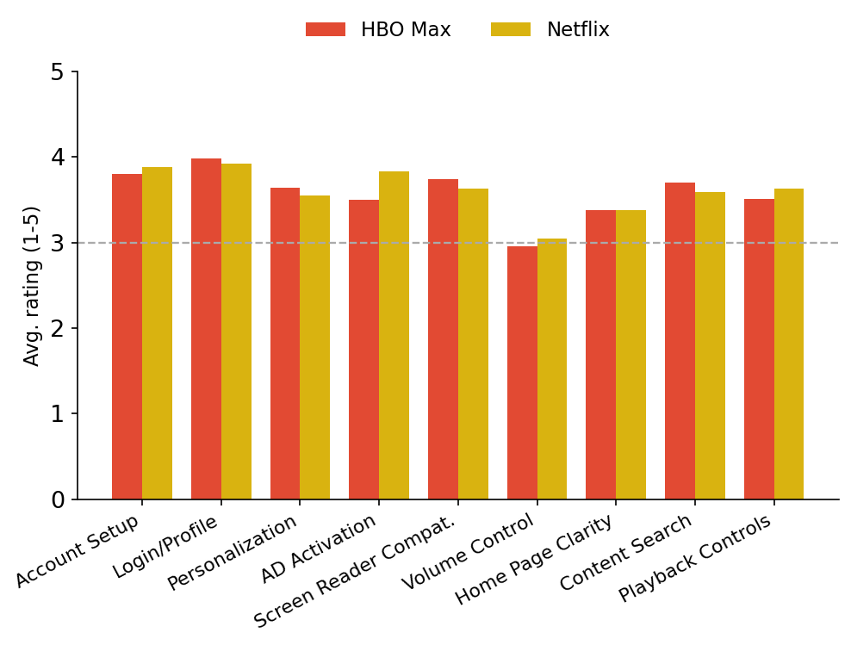
Aspect | HBO Max | Netflix | Higher
Account Setup | 3.80 | 3.88 | Netflix
Login/Profile | 3.98 | 3.92 | HBO Max
Personalization | 3.64 | 3.55 | HBO Max
AD Activation | 3.50 | 3.83 | Netflix
Screen Reader Compat. | 3.74 | 3.63 | HBO Max
Volume Control | 2.95 | 3.05 | Netflix
Home Page Clarity | 3.38 | 3.38 | Tie
Content Search | 3.70 | 3.59 | HBO Max
Playback Controls | 3.51 | 3.63 | Netflix

- Netflix rates higher overall (3.61 vs 3.58). The clearest gap is AD activation reliability (0.33-point spread, favouring Netflix).
- Netflix users most often credit AD that persists across titles and profiles, plus the widest multi-language AD support.
- HBO Max’s biggest complaint: a cluttered home page that is hard to browse with a screen reader, and gaps in AD for older titles.

22. HBO Max vs Peacock
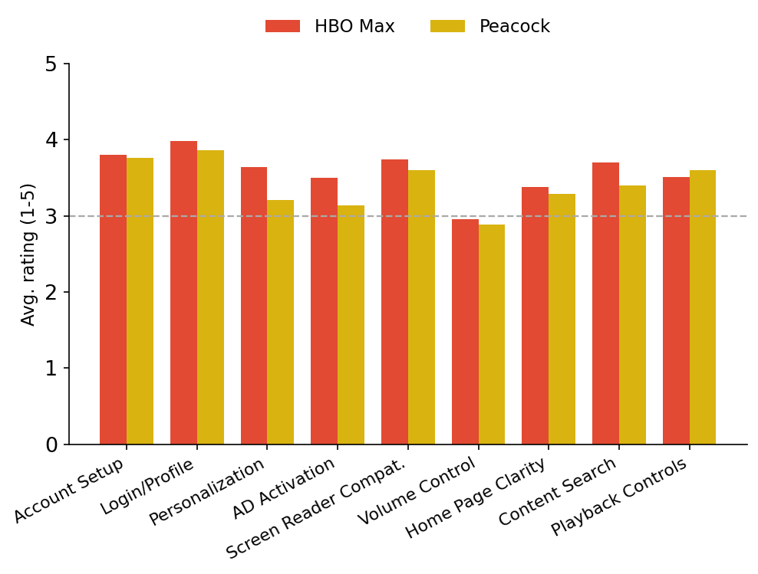
Aspect | HBO Max | Peacock | Higher
Account Setup | 3.80 | 3.76 | HBO Max
Login/Profile | 3.98 | 3.86 | HBO Max
Personalization | 3.64 | 3.21 | HBO Max
AD Activation | 3.50 | 3.14 | HBO Max
Screen Reader Compat. | 3.74 | 3.60 | HBO Max
Volume Control | 2.95 | 2.88 | HBO Max
Home Page Clarity | 3.38 | 3.29 | HBO Max
Content Search | 3.70 | 3.40 | HBO Max
Playback Controls | 3.51 | 3.60 | Peacock

- HBO Max rates higher overall (3.58 vs 3.42). The clearest gap is personalization options (0.43-point spread, favouring HBO Max).
- HBO Max users most often credit human-narrated AD tracks and a dedicated Audio Description tab listing all AD titles A-Z.
- Peacock’s biggest complaint: locating and activating AD at all, and no accessibility settings in the profile.

23. Hulu vs Paramount Plus
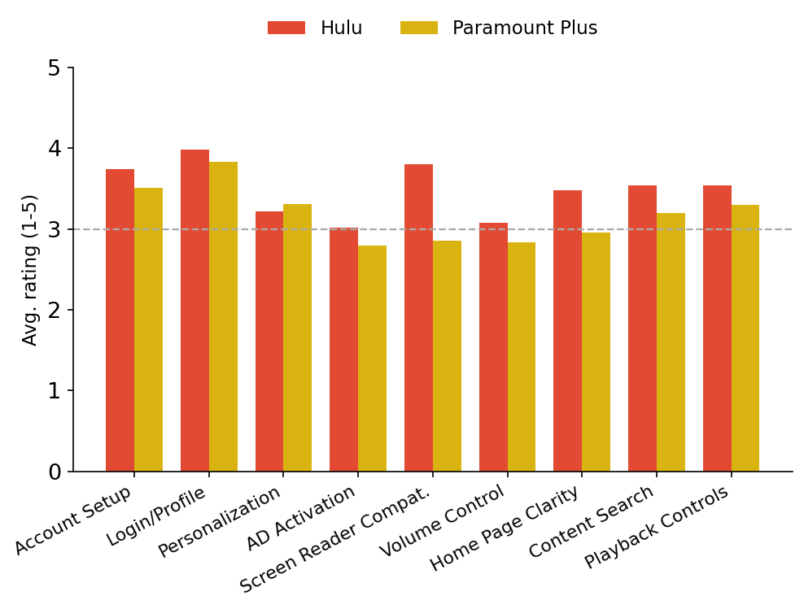
Aspect | Hulu | Paramount Plus | Higher
Account Setup | 3.74 | 3.51 | Hulu
Login/Profile | 3.98 | 3.83 | Hulu
Personalization | 3.22 | 3.31 | Paramount Plus
AD Activation | 3.02 | 2.79 | Hulu
Screen Reader Compat. | 3.80 | 2.85 | Hulu
Volume Control | 3.08 | 2.83 | Hulu
Home Page Clarity | 3.48 | 2.95 | Hulu
Content Search | 3.54 | 3.20 | Hulu
Playback Controls | 3.54 | 3.30 | Hulu

- Hulu rates higher overall (3.49 vs 3.17). The clearest gap is screen-reader compatibility (0.95-point spread, favouring Hulu).
- Hulu users most often credit AD that stays active once switched on and a consistent, uncluttered layout.
- Paramount Plus’s biggest complaint: screen-reader incompatibility across the app, and AD that will not stay switched on.

24. Hulu vs Netflix
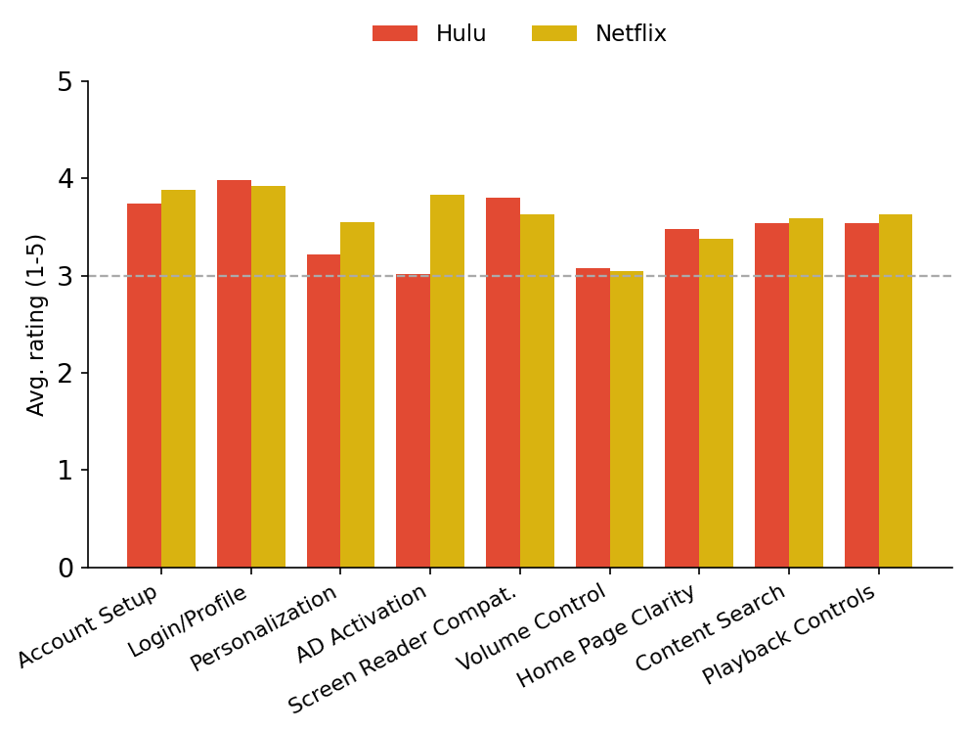
Aspect | Hulu | Netflix | Higher
Account Setup | 3.74 | 3.88 | Netflix
Login/Profile | 3.98 | 3.92 | Hulu
Personalization | 3.22 | 3.55 | Netflix
AD Activation | 3.02 | 3.83 | Netflix
Screen Reader Compat. | 3.80 | 3.63 | Hulu
Volume Control | 3.08 | 3.05 | Hulu
Home Page Clarity | 3.48 | 3.38 | Hulu
Content Search | 3.54 | 3.59 | Netflix
Playback Controls | 3.54 | 3.63 | Netflix

- Netflix rates higher overall (3.61 vs 3.49). The clearest gap is AD activation reliability (0.81-point spread, favouring Netflix).
- Netflix users most often credit AD that persists across titles and profiles, plus the widest multi-language AD support.
- Hulu’s biggest complaint: no way to tell whether a title carries AD without starting playback, and AD tracks that do not travel with the content.

25. Hulu vs Peacock
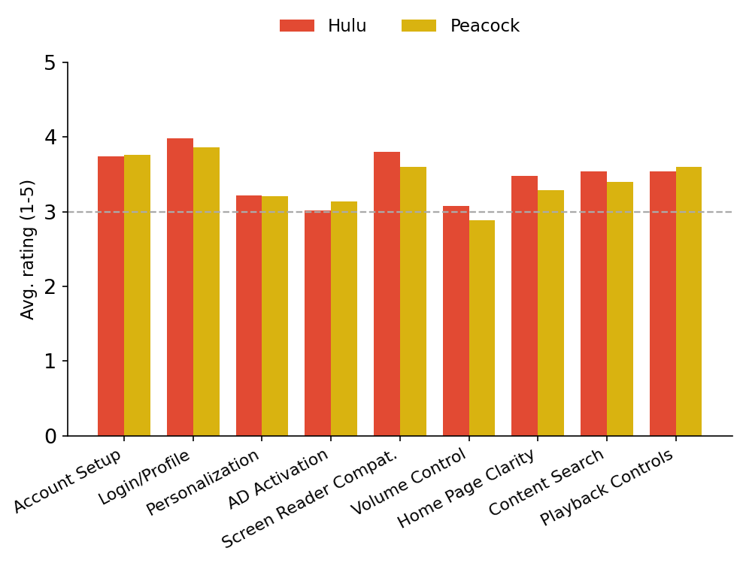
Aspect | Hulu | Peacock | Higher
Account Setup | 3.74 | 3.76 | Peacock
Login/Profile | 3.98 | 3.86 | Hulu
Personalization | 3.22 | 3.21 | Hulu
AD Activation | 3.02 | 3.14 | Peacock
Screen Reader Compat. | 3.80 | 3.60 | Hulu
Volume Control | 3.08 | 2.88 | Hulu
Home Page Clarity | 3.48 | 3.29 | Hulu
Content Search | 3.54 | 3.40 | Hulu
Playback Controls | 3.54 | 3.60 | Peacock

- Hulu rates higher overall (3.49 vs 3.42). The clearest gap is independent volume control (0.20-point spread, favouring Hulu).
- Hulu users most often credit AD that stays active once switched on and a consistent, uncluttered layout.
- Peacock’s biggest complaint: locating and activating AD at all, and no accessibility settings in the profile.

26. Paramount Plus vs Netflix
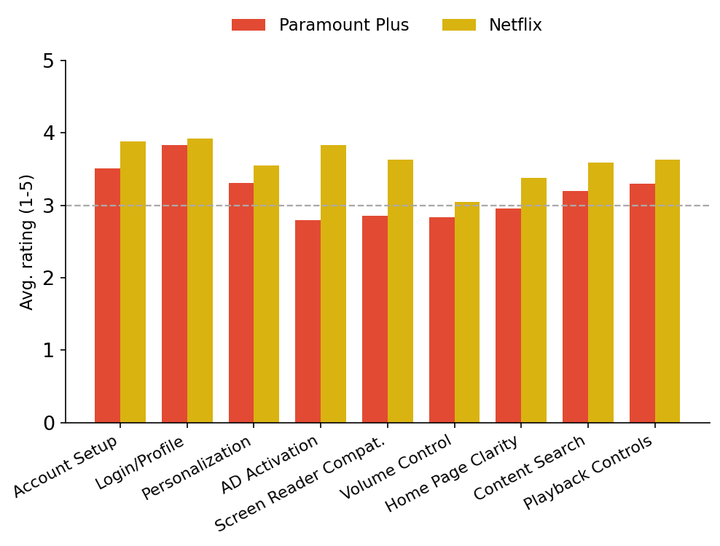
Aspect | Paramount Plus | Netflix | Higher
Account Setup | 3.51 | 3.88 | Netflix
Login/Profile | 3.83 | 3.92 | Netflix
Personalization | 3.31 | 3.55 | Netflix
AD Activation | 2.79 | 3.83 | Netflix
Screen Reader Compat. | 2.85 | 3.63 | Netflix
Volume Control | 2.83 | 3.05 | Netflix
Home Page Clarity | 2.95 | 3.38 | Netflix
Content Search | 3.20 | 3.59 | Netflix
Playback Controls | 3.30 | 3.63 | Netflix

- Netflix rates higher overall (3.61 vs 3.17). The clearest gap is AD activation reliability (1.04-point spread, favouring Netflix).
- Netflix users most often credit AD that persists across titles and profiles, plus the widest multi-language AD support.
- Paramount Plus’s biggest complaint: screen-reader incompatibility across the app, and AD that will not stay switched on.

27. Paramount Plus vs Peacock
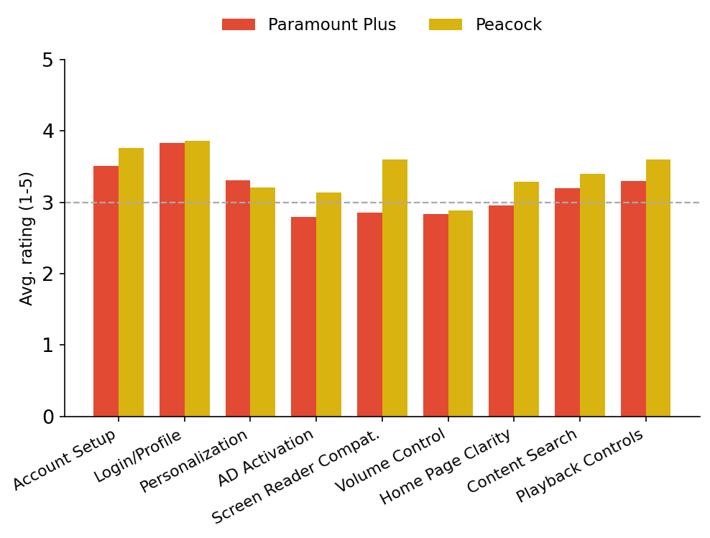
Aspect | Paramount Plus | Peacock | Higher
Account Setup | 3.51 | 3.76 | Peacock
Login/Profile | 3.83 | 3.86 | Peacock
Personalization | 3.31 | 3.21 | Paramount Plus
AD Activation | 2.79 | 3.14 | Peacock
Screen Reader Compat. | 2.85 | 3.60 | Peacock
Volume Control | 2.83 | 2.88 | Peacock
Home Page Clarity | 2.95 | 3.29 | Peacock
Content Search | 3.20 | 3.40 | Peacock
Playback Controls | 3.30 | 3.60 | Peacock

- Peacock rates higher overall (3.42 vs 3.17). The clearest gap is screen-reader compatibility (0.75-point spread, favouring Peacock).
- Peacock users most often credit next-day AD on recently aired shows and a genre navigation row few rivals offer.
- Paramount Plus’s biggest complaint: screen-reader incompatibility across the app, and AD that will not stay switched on.

28. Netflix vs Peacock
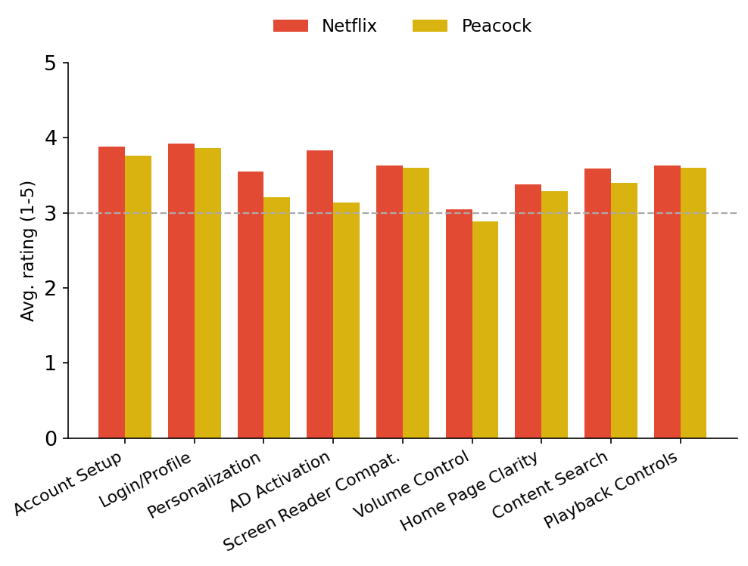
Aspect | Netflix | Peacock | Higher
Account Setup | 3.88 | 3.76 | Netflix
Login/Profile | 3.92 | 3.86 | Netflix
Personalization | 3.55 | 3.21 | Netflix
AD Activation | 3.83 | 3.14 | Netflix
Screen Reader Compat. | 3.63 | 3.60 | Netflix
Volume Control | 3.05 | 2.88 | Netflix
Home Page Clarity | 3.38 | 3.29 | Netflix
Content Search | 3.59 | 3.40 | Netflix
Playback Controls | 3.63 | 3.60 | Netflix

- Netflix rates higher overall (3.61 vs 3.42). The clearest gap is AD activation reliability (0.69-point spread, favouring Netflix).
- Netflix users most often credit AD that persists across titles and profiles, plus the widest multi-language AD support.
- Peacock’s biggest complaint: locating and activating AD at all, and no accessibility settings in the profile.

