METRO DISPLAY screen - - > retailor uplaod there ads video and photo

step 1 : sign up
- sign up name of BUSINESSES, category, AADHAR,pan VERIFICATIONS, admin approve

Step:2
- login through number and otp
step : 3
- show metro ads photos and video
- show total screen and active ads
- recent ads
- quick action button
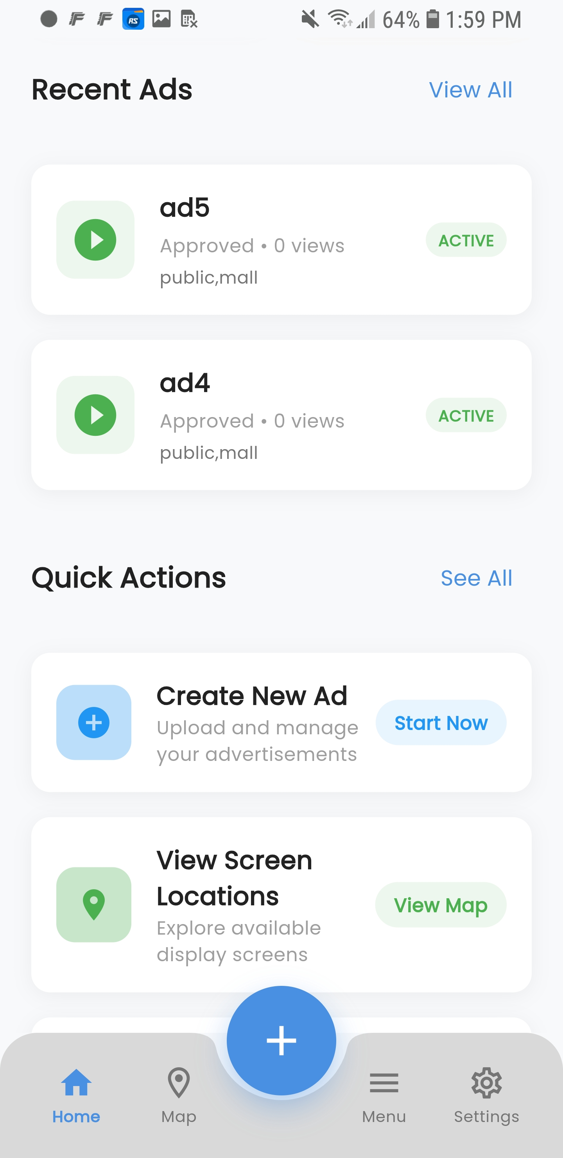
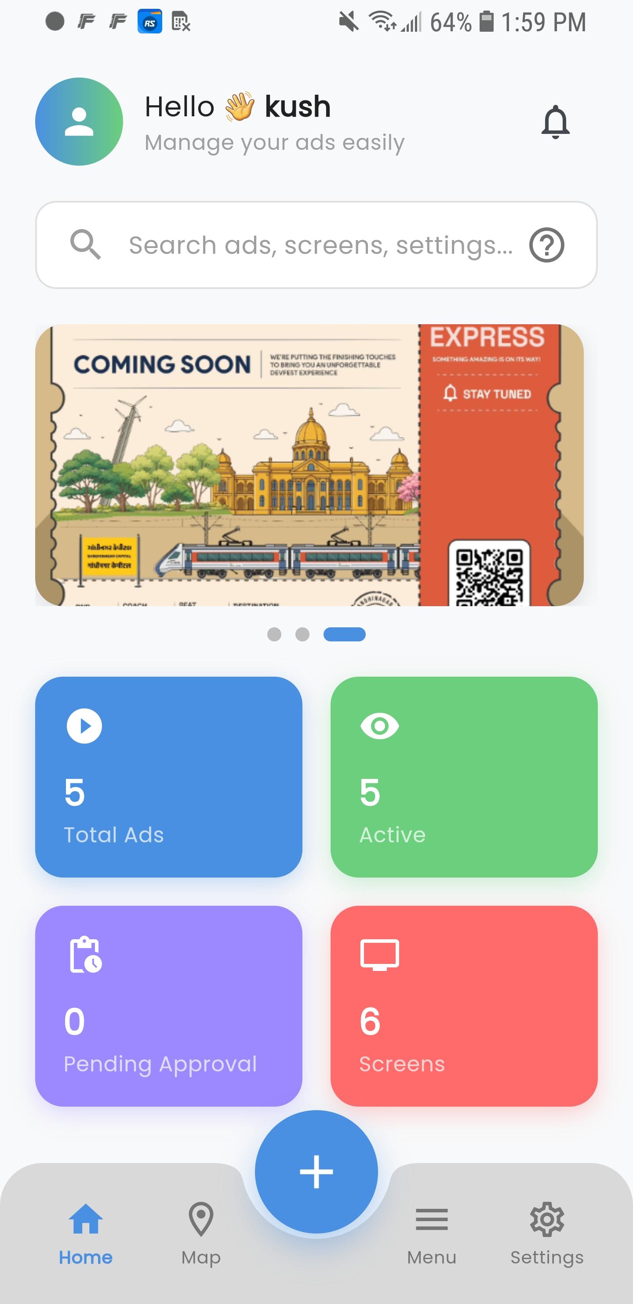

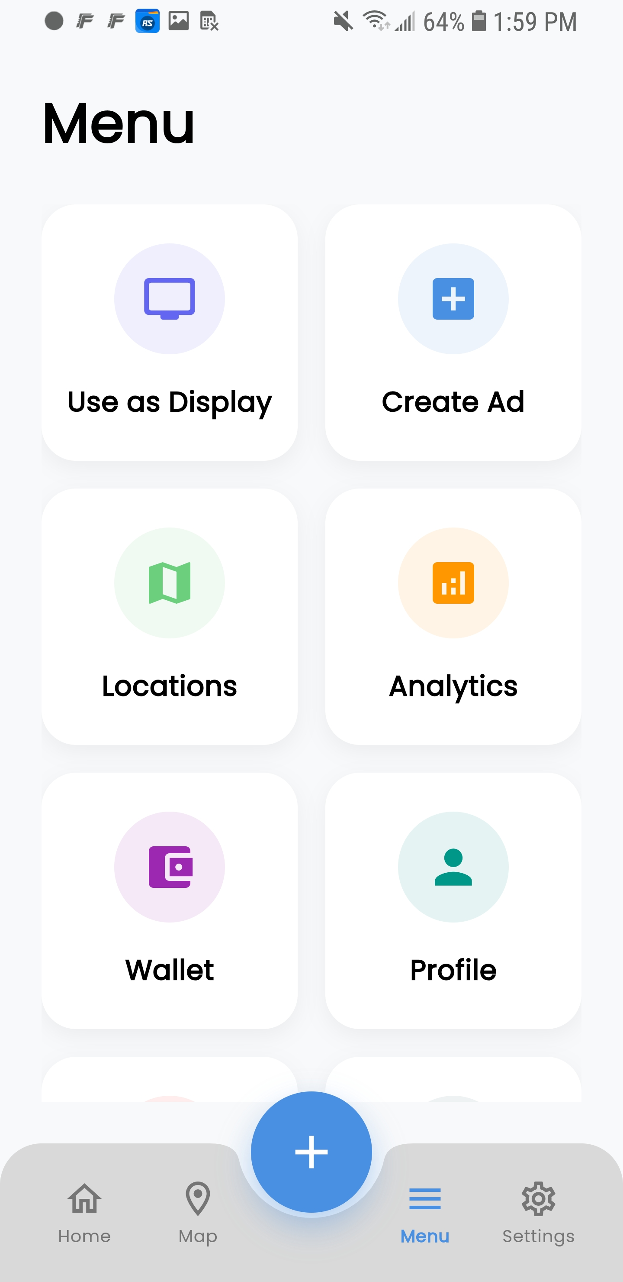
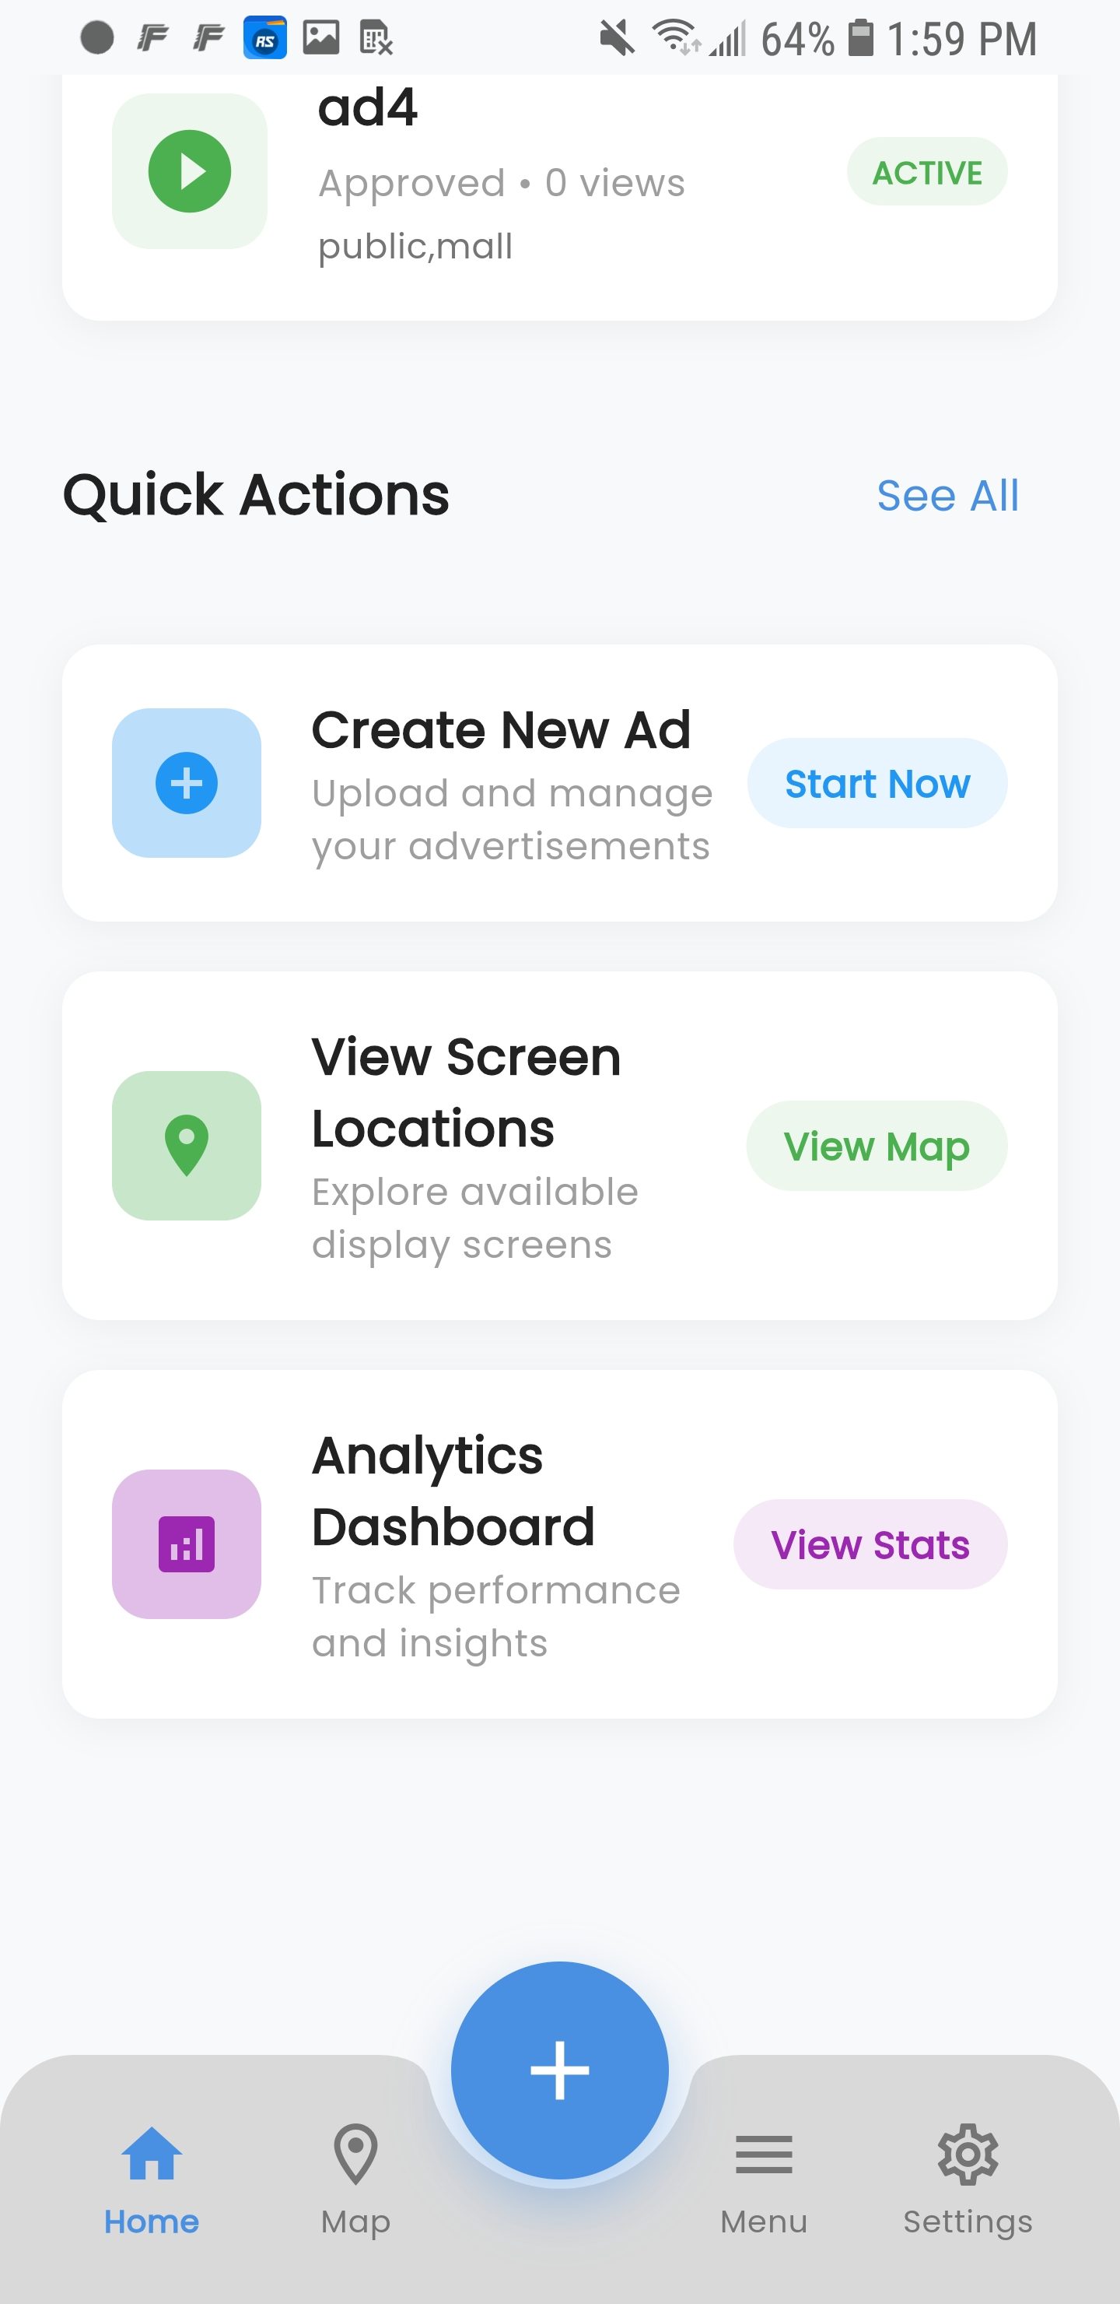

how add video and photo of ad by clients
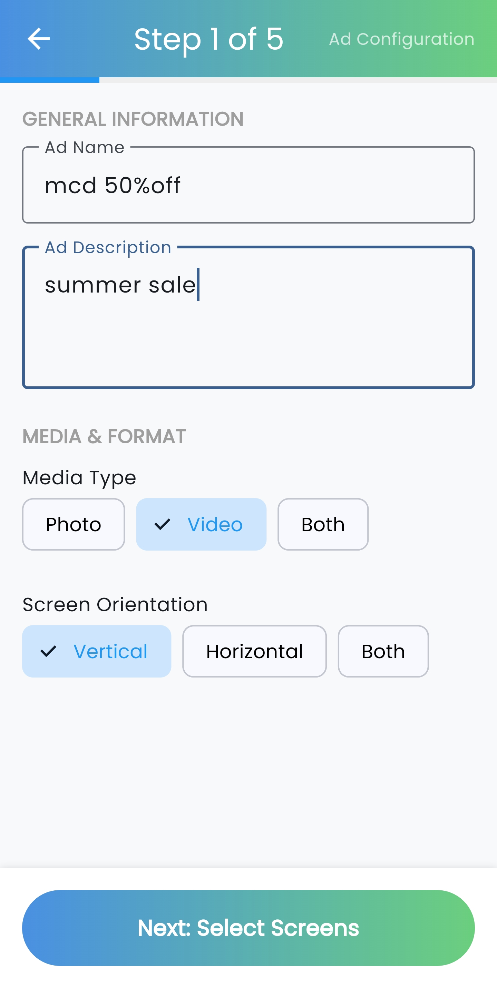
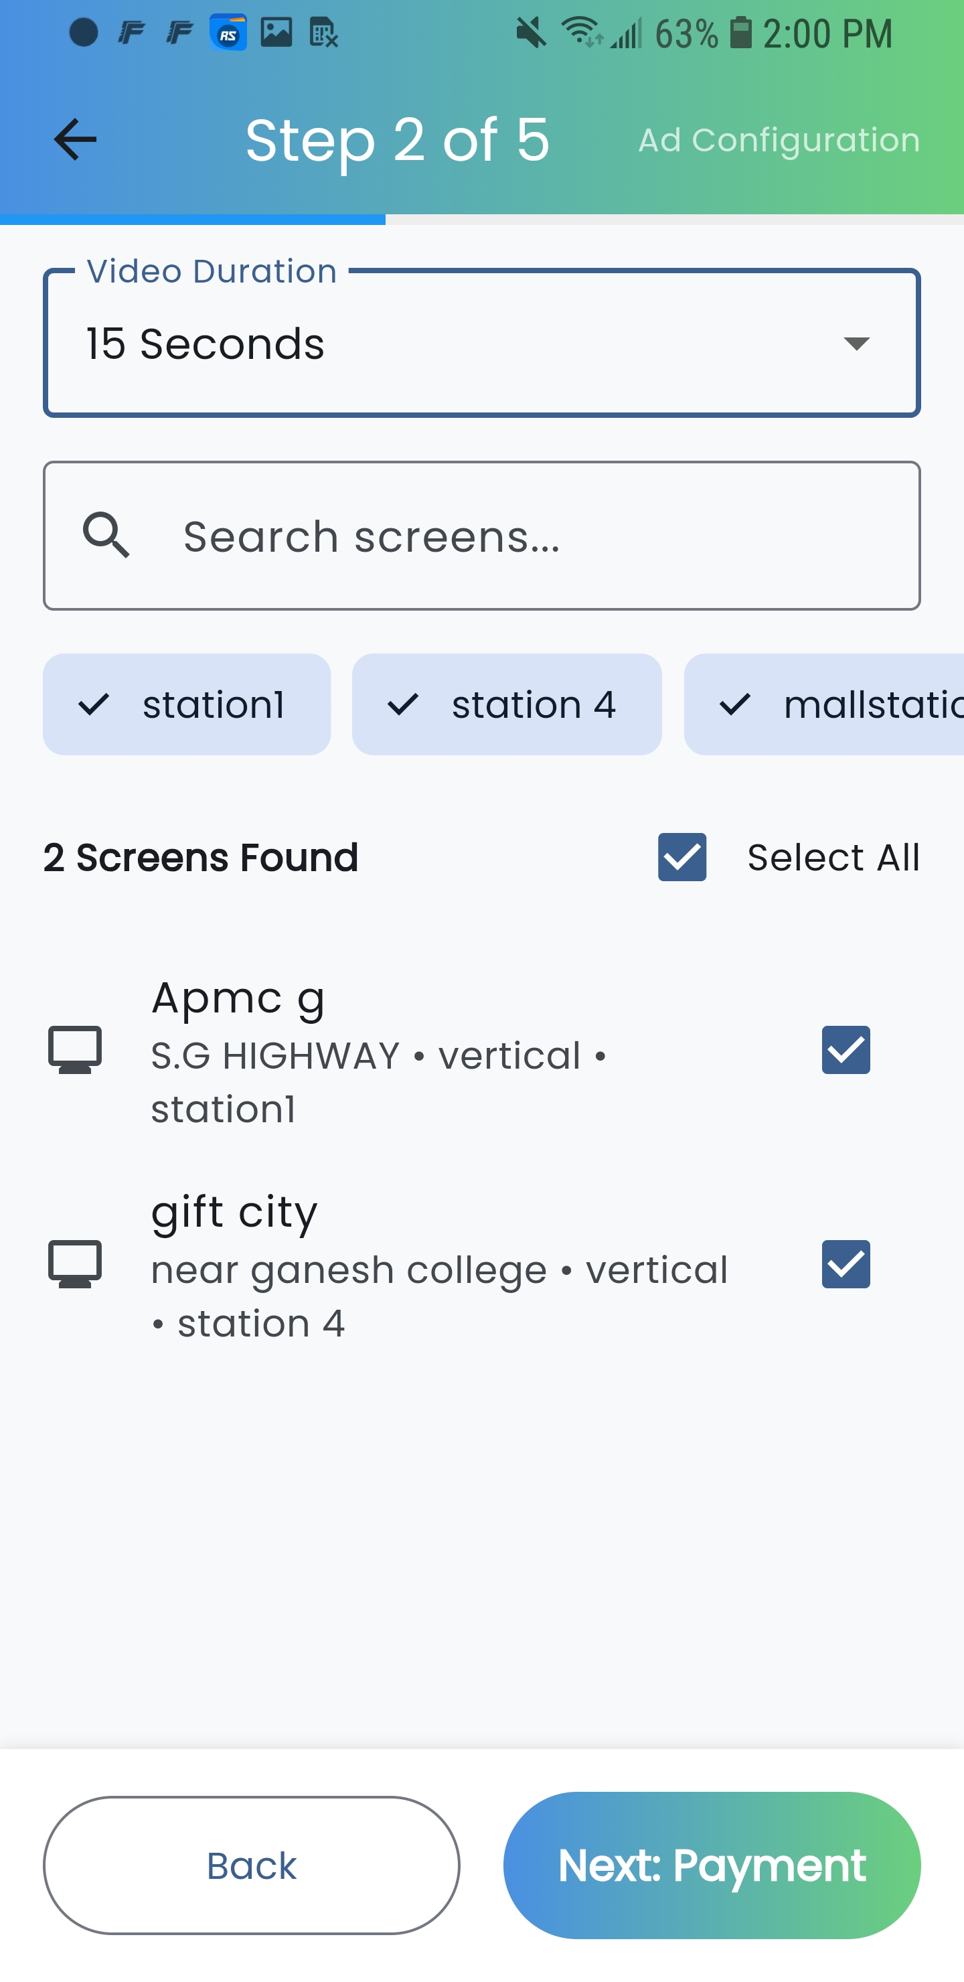

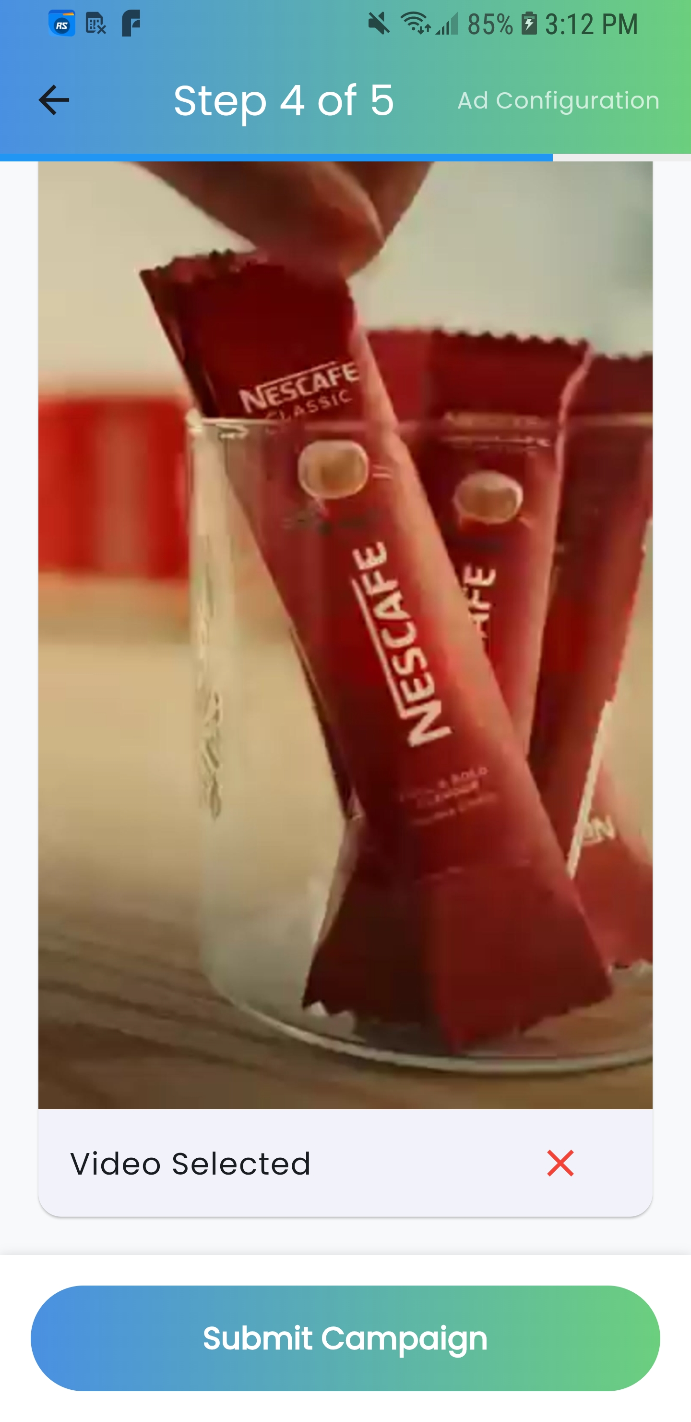
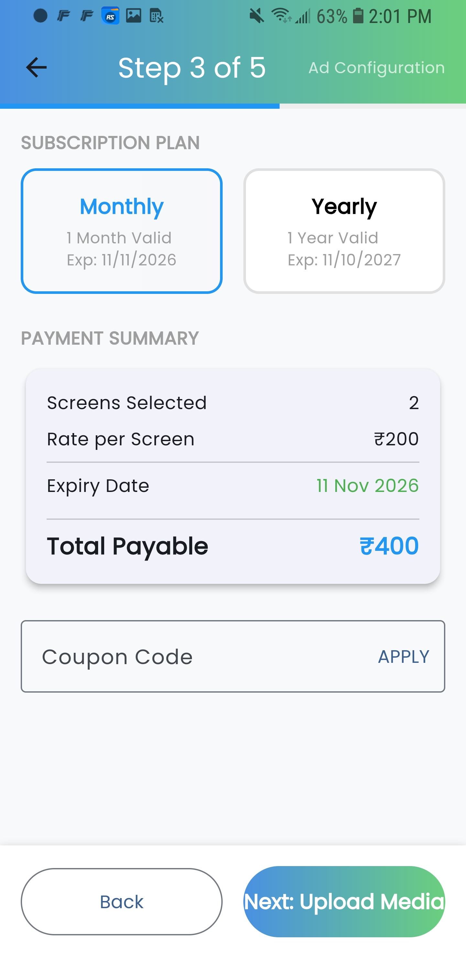

AFTER PAYMENT CAMPAIGN SEND TO ADMIN FOR APPROVED TO VERIFY THE CONTENT
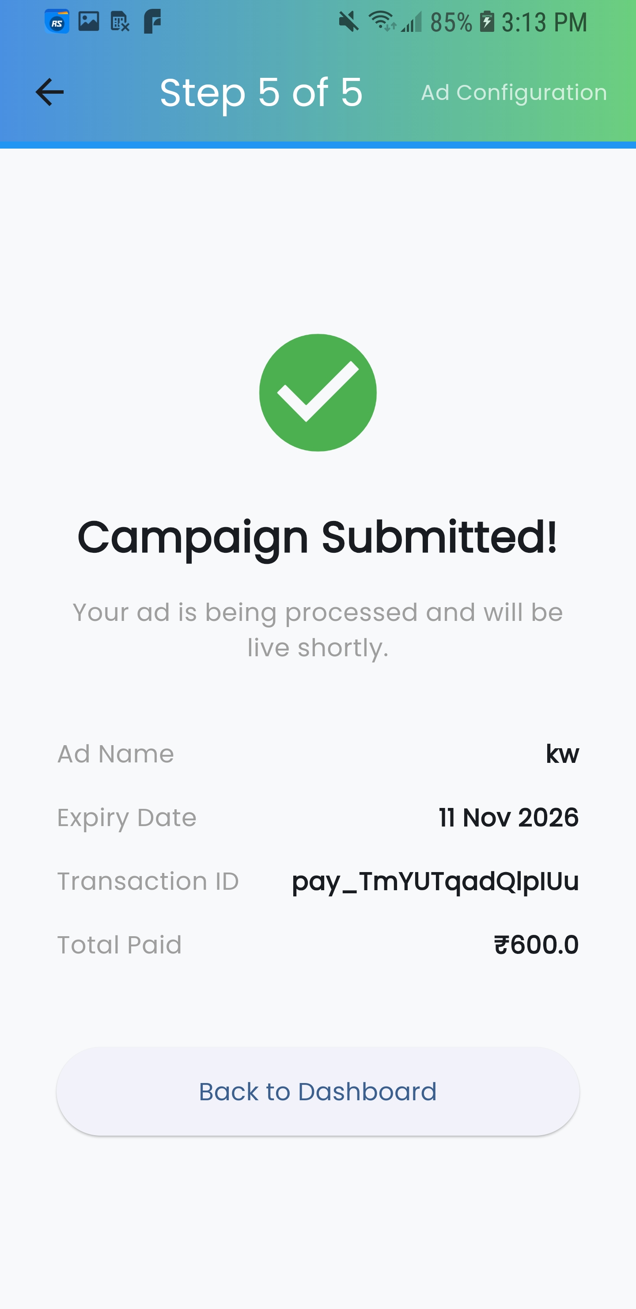

ADMIN APPROVE DENY OPTION
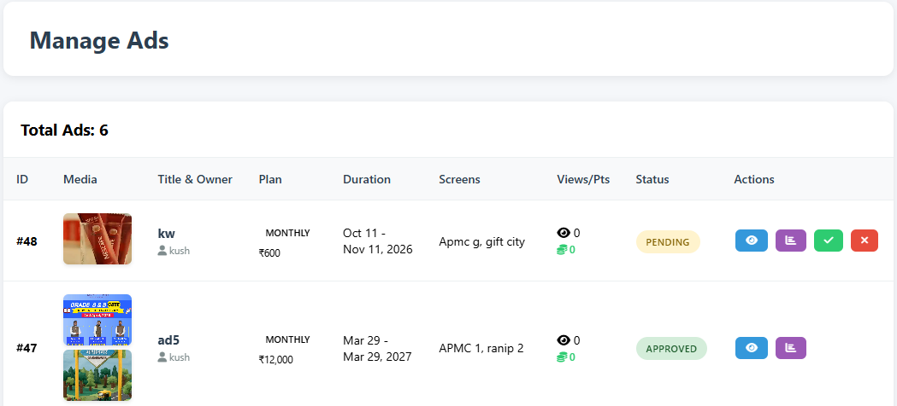

THERE IS OPTION IN APP FROM WHICH SHOW AVAILABILITY OF SCREEN
HOW MANY VIEW COME ON THAT SCREEN
ANALYSIS OF ADS DAILY PLAY ETC
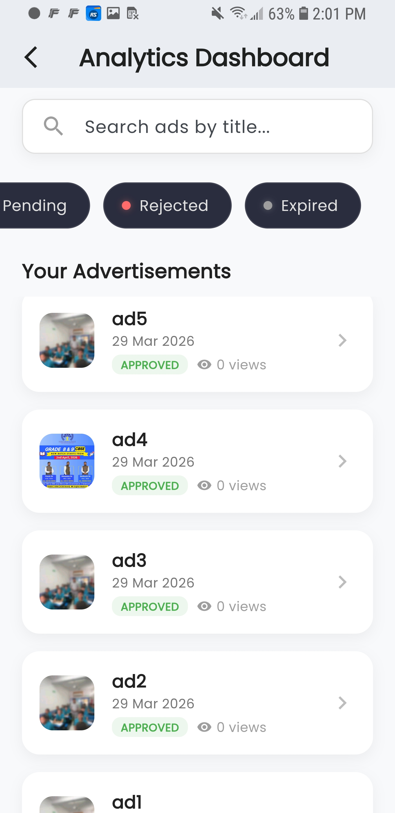
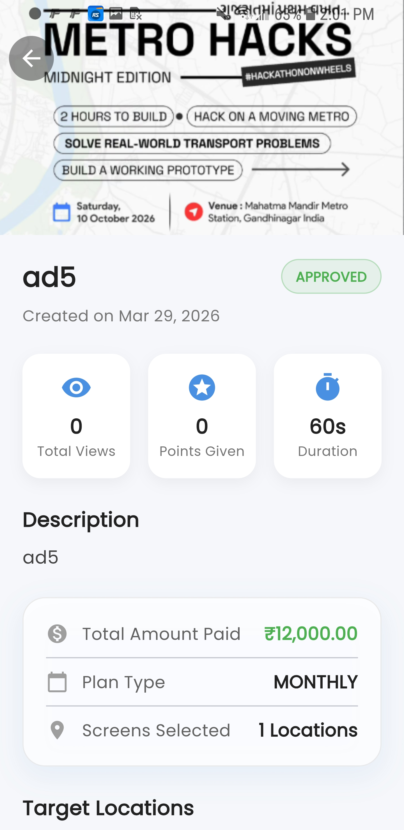

GRAPH BASES USES AND ALL ANALYSIS WE CAN DO

retailor(COMANPY) CAN PUT THERE PERSONAL SCREEN ON METRO STATION
WE MONITIZE THERE SCREEN
THEY PAY RENT OF SCREEN PUT ON METRO STATION
SAME APP TO MANAGE ALL THING

DEMO LINK ARE NOT LIVE WE HAVE APK FILE FOR ADMIN AND CUSTOMER AND ALL
75% PROJECT IS COMPLETED FOR FURTHER INFORMATION CONTACT US ON 9687343235

