House Mate Model Service Design Document

Date: October 7, 2015

Author: Kush Patel

Reviewer(s): Carolina Nobre & Benjamin Trey

# Introduction

The House Mate Model Service (HMMS) is an evolved system from the Knowledge Graph implementing the singleton design and storing data. The structure of this design provides a simple yet effective way to communicate data via commands.

These commands are the driving component to the HMMS which would allow homes to be automated for each individual user interacting with them. This system would allow all registered occupants in a home to control different aspects of their environment as well as get information. Examples such as preheating the oven to 350 for brownies, or determining which smoke detector is beeping really drive the need for a system like this in every home.

Overview

Now that cellphones are parsing voice commands, why can’t our home? The House Mate System is attempting to automate / add voice control of different components of people’s home. Something as simple as preheating the oven to 350 for your brownies to locating where a fire is in a home by getting the location of the smoke detector setting off the alarm. This system would increase efficiency in our daily home activities as well as provide safety and security; such as identifying unregistered occupants: a possible burglar. A system like will definitely be in high demand due to the new age of automation technology in everything people do.

# Requirements

* Commands provided must be precise for proper configuration and results
* Model must support storing and retrieving data for the following entities: House, Room, Occupant, Sensor, Appliance
* The HMMS should provide a service interface for the controller to complete the actions required: define, set, show

# Use Cases

Different use cases (supplied from requirements document)

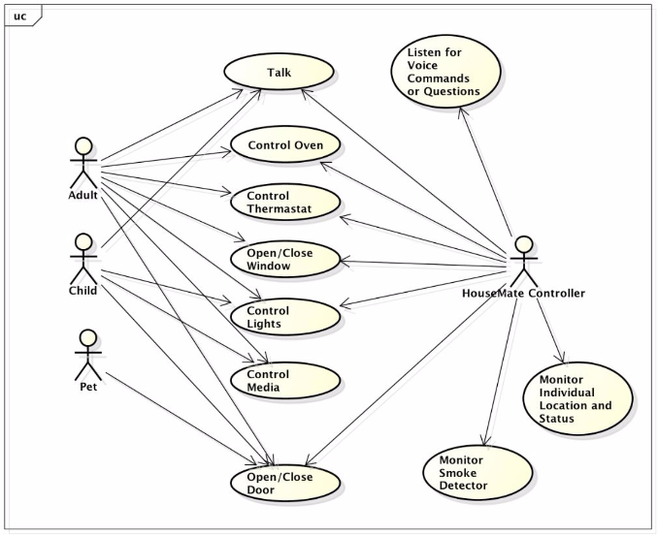

1. System/Admin adds new occupant, house, room, appliance, sensor
2. System/Admin/User sets location/status for: occupant, appliance, sensor
3. System/Admin/user query for configuration or status

# 

# Implementation

# Class Diagram

The following class diagram defines the House Mate Model Service implantation and all classes used for this solution and their affiliations to the overall system.

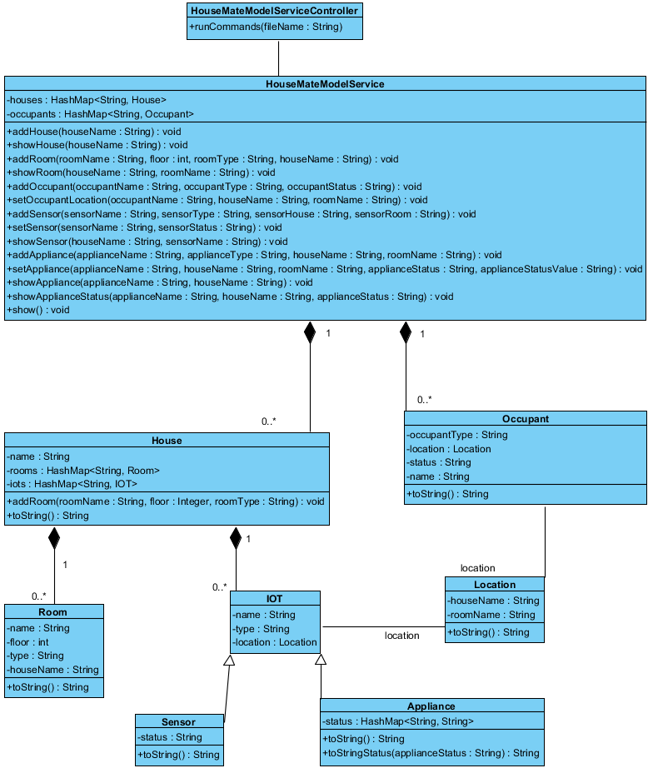

# Class Dictionary

*\*\*NOTE: All methods are public.*

**HouseMateModelServiceController**

The HMMSController is responsible for reading each individual command and parsing them; then calling the appropriate method in the HMMS to either input the configuration, or print out information. The key to the runCommand feature is the format of the input; given that these would be controlled commands via an API, the format for each line should always be consitant; thus the command parser does error out due to poor input format.

**Methods**

|  |  |  |
| --- | --- | --- |
| **Method Name** | **Signature** | **Description** |
| runCommands | (fileName : String) | Reads in all the lines from the filename provided; ignores lines with a “#” as they can be comments for a user reading the command list. Then runs each command step by step, so “show” commands should be at the end once all the configuration has been loaded. |

**HouseMateModelService**

The HMMS is a singleton class that gets initialized once the application starts which is important since its storing all the data and configuration for the whole House Mate system and so data isn’t accidentally set in a different new HMMS.

**Methods**

|  |  |  |
| --- | --- | --- |
| **Method Name** | **Signature** | **Description** |
| addHouse | (houseName : String) : void | Method to add a new House to the system. Must have a unique houseName. |
| showHouse | (houseName : String) : void | Method that prints out the configuration of the housename provided, or HouseNotFoundException |
| addRoom | (roomName : String, floor : int, roomType : String, houseName : String) : void | Method to add a new room to a house; must provide a valid house, and a unique room name, integer floor value, and string type. Throws HouseNotFoundException if house is invalid. |
| showRoom | (houseName : String, roomName : String) : void | Method that prints out the configuration of the room. Throws HouseNotFoundException or RoomNotFoundException accordingly if the house name / room name are invalid. |
| addOccupant | (occupantName : String, occupantType : String, occupantStatus : String) : void | Method that adds an occupant into the HMMS. Must have unique name, a type, and status. |
| setOccupantLocation | (occupantName : String, houseName : String, roomName : String) : void | Method that gives an occupant a location. Must have a valid house name and room name, else it throws a HouseNotFoundException and RoomNotFoundException accordingly. |
| addSensor | (sensorName : String, sensorType : String, sensorHouse : String, sensorRoom : String) : void | Method to add a new sensor to the system. Must have a unique sensor name, a type, a valid house name and valid room name; else it throws a HouseNotFoundException and RoomNotFoundException accordingly. |
| setSensor | (sensorName : String, houseName : String, sensorStatus : String) : void | Method to set the status of a sensor, must have a valid house name and sensor name, else it throws a HouseNotFoundException and SensorNotFoundException accordingly. |
| showSensor | (houseName : String, sensorName : String) : void | Method to print out sensor information. Must have valid house name and sensor name, else it throws a HouseNotFoundException and SensorNotFoundException accordingly.  Returns location and status of the sensor. |
| addAppliance | (applianceName : String, applianceType : String, houseName : String, roomName : String) : void | Method to add an appliance to the HMMS, must have a valid house name, room name, and unique appliance name; else it throws a HouseNotFoundException and RoomNotFoundException accordingly. |
| setAppliance | (applianceName : String, houseName : String, roomName : String, applianceStatus : String, applianceStatusValue : String) : void | Configures an appliance: either update existing values or adding new status such as: temperature =400. Or add new one: ovenclean=needed |
| showAppliance | (applianceName : String, houseName : String) : void | Returns the appliance and all the status and values for it. |
| showApplianceStatus | (applianceName : String, houseName : String, applianceStatus : String) : void | Returns the specific value for the status request on the specific appliance. |
| show | (): void | Shows the configuration for all the houses and everything in the system |

**Properties**

|  |  |  |
| --- | --- | --- |
| **Property Name** | **Type** | **Description** |
| houses | HashMap<String, House> | Map of all the houses registered and configured in the system |
| occupants | HashMap<String, Occupant> | Map of all the occupants in the system, don’t necessarily have to be affiliated with a house, but are registered and configured. |

**House**

The house class is used to model a house that is configured and controlled by the HMMS.

**Methods**

|  |  |  |
| --- | --- | --- |
| **Method Name** | **Signature** | **Description** |
| addRoom | (roomName : String, floor : Integer, roomType : String) : void | Method to add rooms to a house. Since each room is specific to a house, and can’t move from house to house. |
| toString | ():String | Custom toString to print information when “show” is called |

**Properties**

|  |  |  |
| --- | --- | --- |
| **Property Name** | **Type** | **Description** |
| Name | String | Unique name of the house |
| Rooms | HashMap<String, Room> | Map containing all the rooms in a house; each with a unique name to distinguish between similar rooms |
| IOTs | HashMap<String, IoT> | Map containing all the IoTs in a house; each with a unique name to distinguish between similar devices |

**Associations**

|  |  |  |
| --- | --- | --- |
| **Association Name** | **Type** | **Description** |
| Houses | HashMap<String, House> | HMMS has many houses in its system each with a unique name to identify that house and then all the configurations affiliated for that house. |

**Occupant**

Occupant is any person / animal that is registered in the HMMS system. They do not necessarily have to be residents of the home, but can be anyone whose voice and facial recognition is in the system. This way the system can track all occupants in and out of a house, and identify any suspicious characters.

**Methods**

|  |  |  |
| --- | --- | --- |
| **Method Name** | **Signature** | **Description** |
| toString | ():String | Custom toString to print information when “show” is called |

**Properties**

|  |  |  |
| --- | --- | --- |
| **Property Name** | **Type** | **Description** |
| Name | String | The unique name of the occupant |
| OccupantType | String | Adult, child, animal |
| Location | String | Not required, but gets set as the occupant enters a house and moves around the house, their location gets updated. |
| Status | String | Active / Sleeping (could be many more statuses such as “injured”) thus tracking specific states of a person as well |

**Associations**

|  |  |  |
| --- | --- | --- |
| **Association Name** | **Type** | **Description** |
| Occupants | HashMap<String, Occupant> | Many people can be registered in the HMMS, whether they are residents of the house or friends or neighbors or anyone. This way the system can track all users it recognizes. |

**Room**

The room class is used to model a room in the house. It is used part of location to identify where occupants and/or IoTs are located within a house.

**Methods**

|  |  |  |
| --- | --- | --- |
| **Method Name** | **Signature** | **Description** |
| toString | ():String | Custom toString to print information when “show” is called |

**Properties**

|  |  |  |
| --- | --- | --- |
| **Property Name** | **Type** | **Description** |
| name | String | Unique identifier of the room. |
| floor | Integer | The level of which this room is located in the house. |
| type | String | The kind of room, help user to identify bathroom at a neighbor’s house maybe. |
| houseName | String | The house in which this room is located. |

**Associations**

|  |  |  |
| --- | --- | --- |
| **Association Name** | **Type** | **Description** |
| Rooms | HashMap<String, Room> | A house has many unique rooms. Possible to have multiple bedrooms, but they are still unique. |

**IOT**

The generic class of al interactive devices in a house that can provide information about the house, or complete actions such as: starting laundry, prepping oven, launch Roomba to vacuum.

**Properties**

|  |  |  |
| --- | --- | --- |
| **Property Name** | **Type** | **Description** |
| name | String | The unique name of the device |
| type | String | The type of the device |
| location | Location | The location(house + room) of the device |

**Associations**

|  |  |  |
| --- | --- | --- |
| **Association Name** | **Type** | **Description** |
| House | HashMap<String, IOT> | A house a set list of devices, though there might be multiple similar devices like many smoke detectors, they all must have a unique identifier to say which one has error. |

**Location**

Not mentioned as part of the original design, but definitely a handy tool if generic locations want to be used in the future. Comprised of a houseName and roomName and so if a user may want to turn on the lights, but doesn’t know which lights are in this room, they could potentially use their location and match with all lights with the same “location” and turn them on.

**Methods**

|  |  |  |
| --- | --- | --- |
| **Method Name** | **Signature** | **Description** |
| toString | ():String | Custom toString to print information when “show” is called |

**Properties**

|  |  |  |
| --- | --- | --- |
| **Property Name** | **Type** | **Description** |
| houseName | String | The house part of the location (since an occupant could be your neighbor looking to turn on your lights.) |
| roomName | String | The room in the house. |

**Associations**

|  |  |  |
| --- | --- | --- |
| **Association Name** | **Type** | **Description** |
| IoT | Location | IoTs are all installed in specific locations |
| Occupant | Location | Occupants have a specific location they are |

**Sensor**

Sensors are a subset of IoT devices that capture and share data about the house. Each sensor has a name, type, location, and status. Example: a smoke_alarm could have status: OK or FIRE or Battery_Low. Whatever the status, communicating with the HMMS, the show sensor command will give you the status.

**Methods**

|  |  |  |
| --- | --- | --- |
| **Method Name** | **Signature** | **Description** |
| toString | ():String | Custom toString to print information when “show” is called |

**Properties**

|  |  |  |
| --- | --- | --- |
| **Property Name** | **Type** | **Description** |
| status | String | The state in which the sensor is in. |

**Associations**

|  |  |  |
| --- | --- | --- |
| **Association Name** | **Type** | **Description** |
| IOT | Subclass | IOT are the overarching devices that the house mate system controls / communicates with. Sensors are a subset or (subclass) and so they are an extension on it. |

**Appliance**

Appliances are also a subset of IoT devices but these are about to be controlled. These can have more elaborate states and values for their states. Example: if the oven is on, it would have a status: temperature with a value: 350.

**\*\*NOTE:** control/status for appliances was grouped to 1 hashmap property due to the similarity in their nature for an appliance. On/Off or 350/425 or Open/close are essentially state values for something that can be controlled, but in the end, simply only need a value to the key since we not defining many advance characteristics in this higher level, 1st iteration of the project.

**Methods**

|  |  |  |
| --- | --- | --- |
| **Method Name** | **Signature** | **Description** |
| toString | ():String | Custom toString to print information when “show” is called |

**Properties**

|  |  |  |
| --- | --- | --- |
| **Property Name** | **Type** | **Description** |
| status | HashMap<String, String> | The map that stores a status and the value for the status. |

**Associations**

|  |  |  |
| --- | --- | --- |
| **Association Name** | **Type** | **Description** |
|  | Subclass | IOT are the overarching devices that the house mate system controls / communicates with. Sensors are a subset or (subclass) and so they are an extension on it. |

# Implementation Details

*Explain details of the implementation.*

This project requires the implementation of a service used to configure and manage an instance of a House Mate. A system that automates daily house activities as well as providing real time data / status updates when needed. The HMMSController is the command parser; any errors with the commands or the files are handled here; otherwise it calls the appropriate method in the HMMS to complete the action required for the command. The HMMS is a single entity, aka singleton that stores all the data for this current House Mate and prints out any information that has been requested. Once the application is initialized, the singleton is initialized and keeps that static state for the remainder of the application. The HMMS supports a Command Line Interface for configuring the houses, rooms, sensors, appliances, and occupants, as well as printing data / configurations for each of them. Essentially each object is just a data storage item, and the HMMS configures the correlation between them, and then stores the highest level objects (house and occupants) in itself.

# Testing

**Functional Testing:** providing a proper main method to call the HMMS system, and providing a proper input file. Run that file and verify that the output of the system is valid. Thus proving that the input/update commands ran successfully resulting in a properly configured HMMS.

**Performance Testing:** Cloning the input commands many times with different names to meet the unique requirements. Then running that file and monitoring the speed vs the small original input. Hardly any difference noticed, but this is also a small-medium scale application.

**Regression Testing:** Modifying the input file commands to have invalid names or inputs and verifying that the correct exceptions are thrown.

**Exception Handling:** A part of regression handling, all exception scenarios is tested. Also, instead of returning a massive stack trace, exceptions simply print out a human friendly error with the invalid input or filename for the user to investigate the input.

# Risks

This whole HMMS system is stored live in memory as the application runs, so if the command file in extremely large, building out a very large complex HMMS system, could run out of memory allocated to the JVM. The design assumes for small-medium files. Anything larger, then a proper database system to store the data would be recommended.