Build APIs with Node.js and Express.js for Shoppyglobe

1. POST /auth/register – User Registration
Request: POST http://localhost:5000/register
Content-Type: application/json
{
"name": "John Doe",
"email": "john@example.com",
"password": "password123"
}

Expected Response:
- Status 201: User registered successfully.
- Status 400: Email already exists or invalid data.
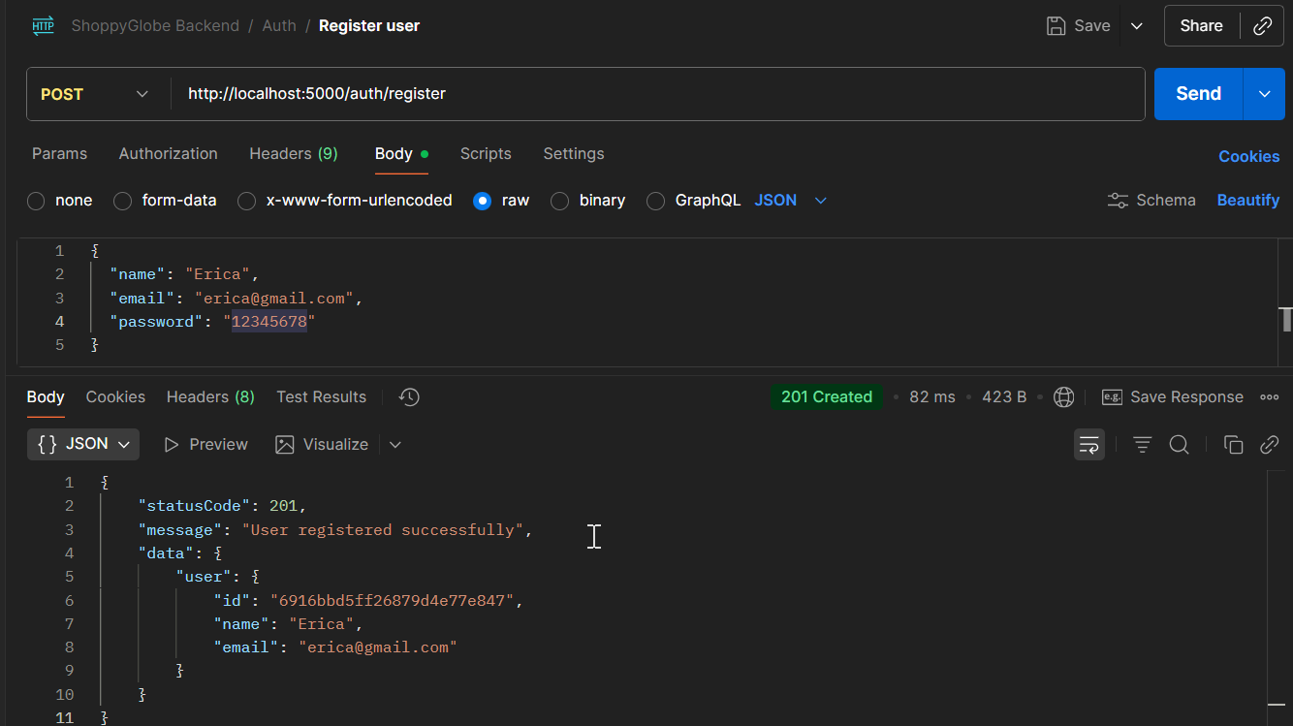
Fig1: Register user
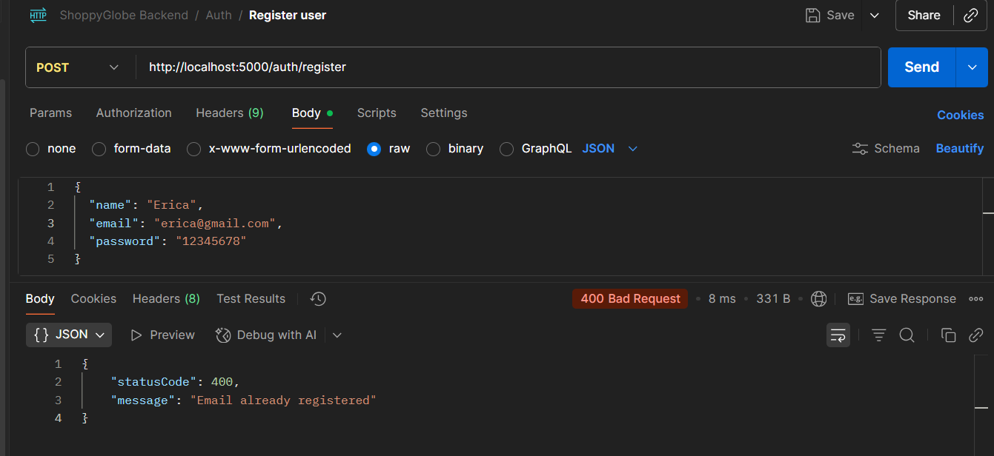
Fig2: Email already exist validation
Description:
- Creates a new user in the database.
- Validates email uniqueness and password should be 8 lengths.

2. POST /auth/login – User Login
Request: POST http://localhost:5000/login
Content-Type: application/json
{
"email": "john@example.com",
"password": "password123"
}

Expected Response:
- Status 200: Login successful, returns JWT token.
- Status 401: Invalid credentials, Unauthorized.
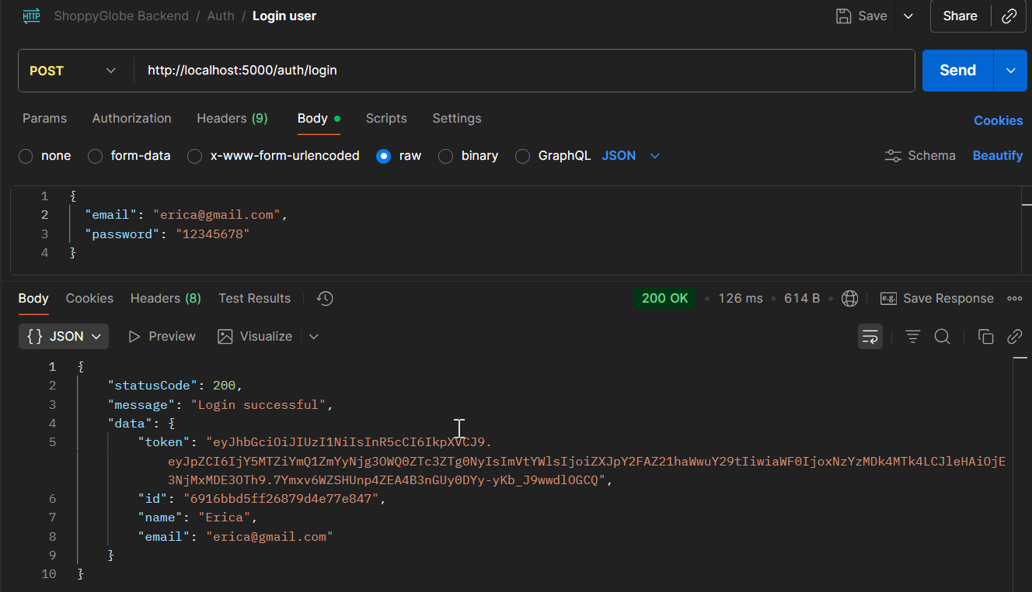
Fig3: Login user
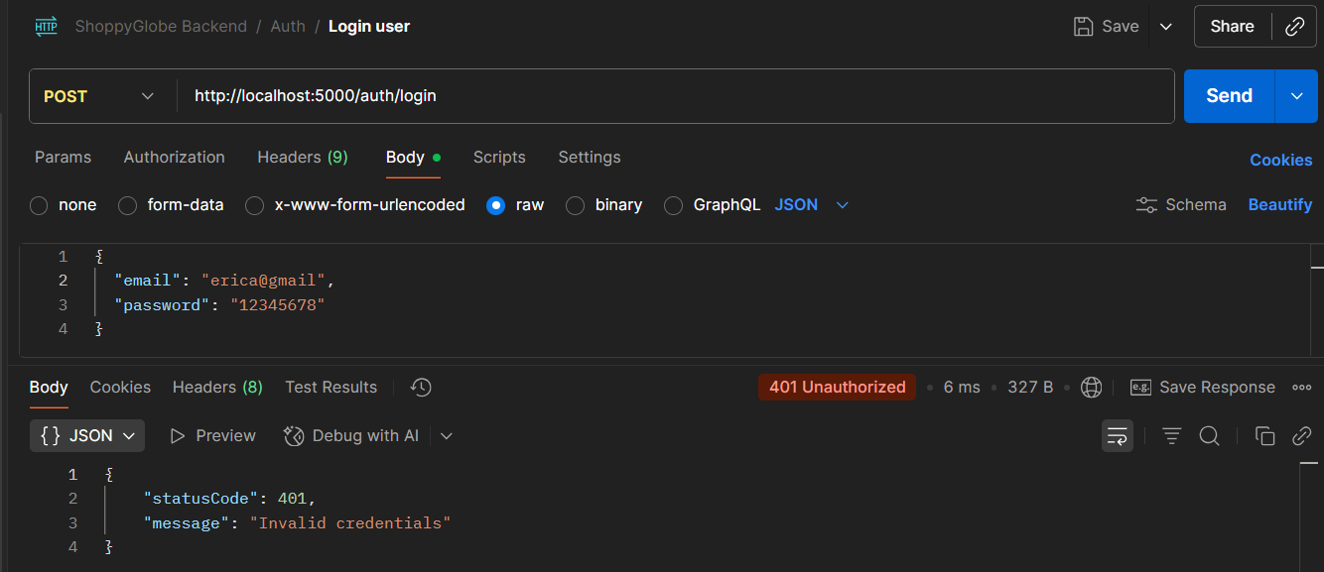
Fig4: Invalid Credentials
Description:
- Authenticates the user and generates JWT token for protected routes.
- If credentials didn’t match, it returns 401 unauthorized error.

3. GET /products – Fetch all products
Request: GET http://localhost:5000/products
Expected Response:
- Status 200: Returns all products successfully.
- Status 404: Returns error if no products exist.

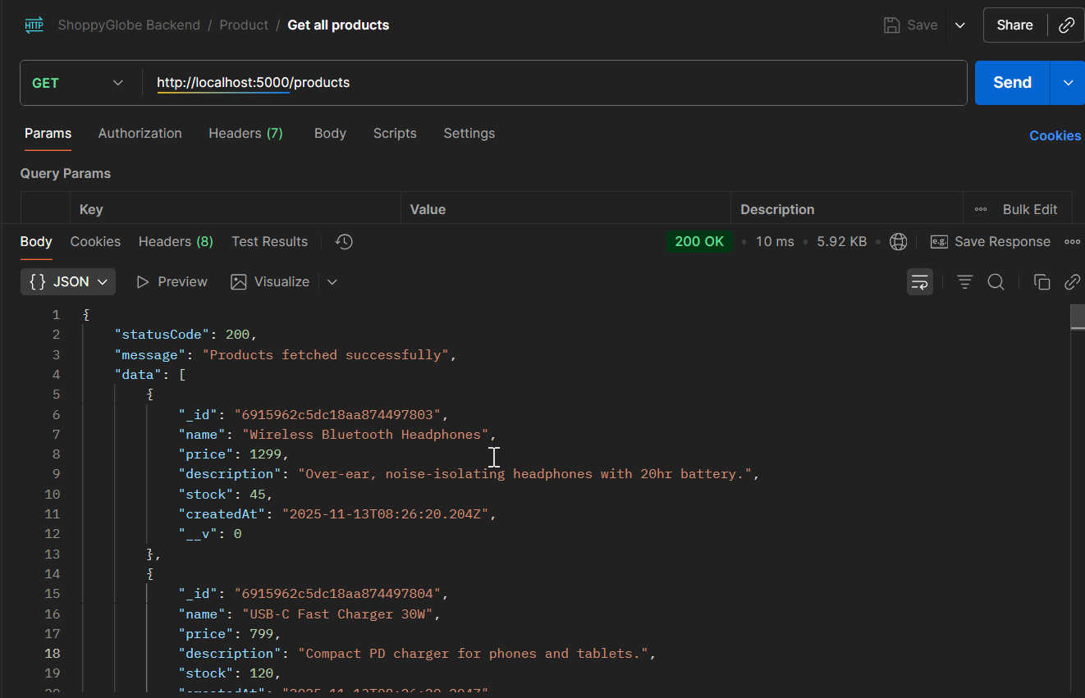
Fig5: Get all products

Description:
- Retrieves the complete list of products from the MongoDB database.
- If the product collection is empty, returns 404 with message: "No products found.".
- Otherwise, returns 200 with all product objects in data.

4. GET /products/:id – Fetch single product by ID
Request: GET http://localhost:5000/products/<productId>
Expected Response:
- Status 200: Returns product details successfully
- Status 404: Returns error if product with given ID does not exist.
- Status 400: Returns error if product id not valid.
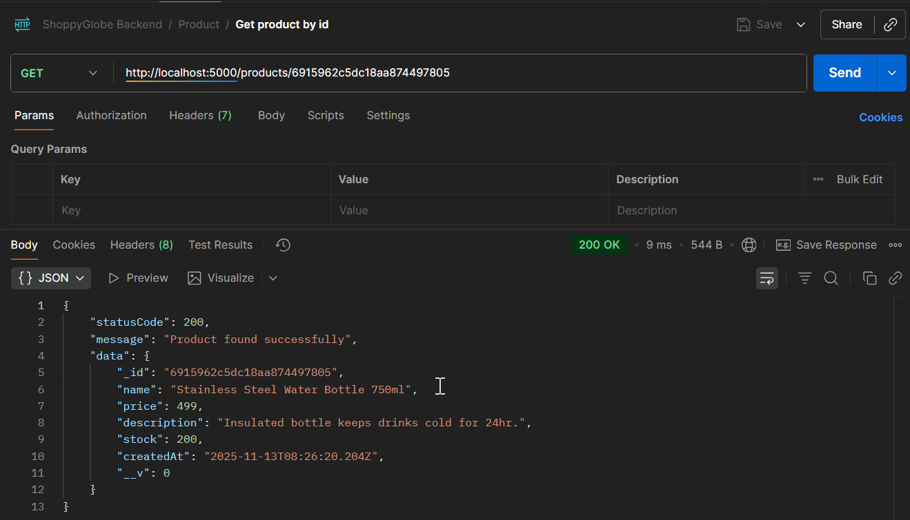
Fig6: Get product by id
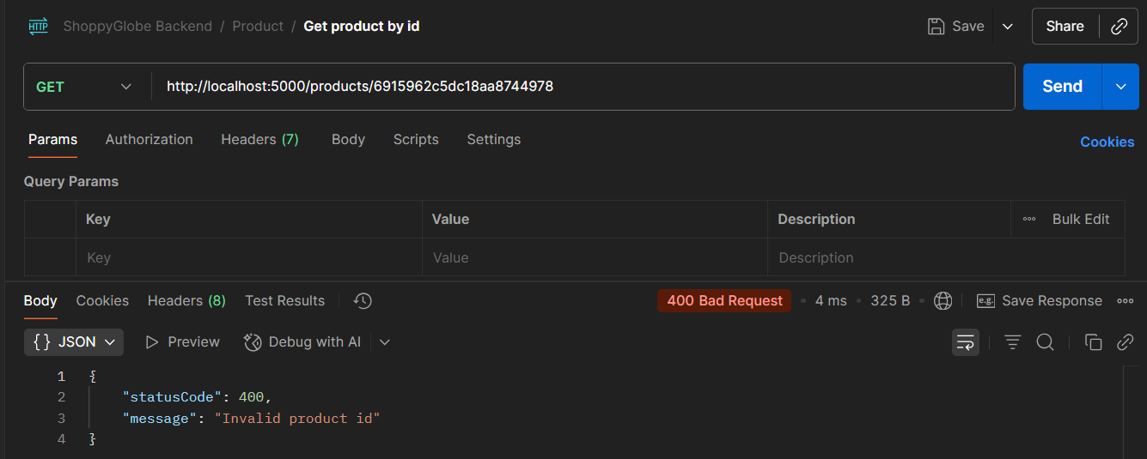
Fig7: Invalid product id
Description:
- Retrieves details of a specific product using its _id.
- If product id is invalid, returns 400 with message: “Invalid product id”.
- If product does not exist, returns 404 with message: "Product not found".
- Otherwise, returns 200 with product object in data.

5. POST /cart – Add a product to the cart
Request: POST http://localhost:5000/cart
Content-Type: application/json
{
"productId": "<productId>",
"quantity": 2
}
Expected Response:
- Status 201: Product added successfully.
- Status 400: Invalid product ID, quantity must be integer or product insufficient stock.
- Status 404: If product is not exist, give message “Product not found”.
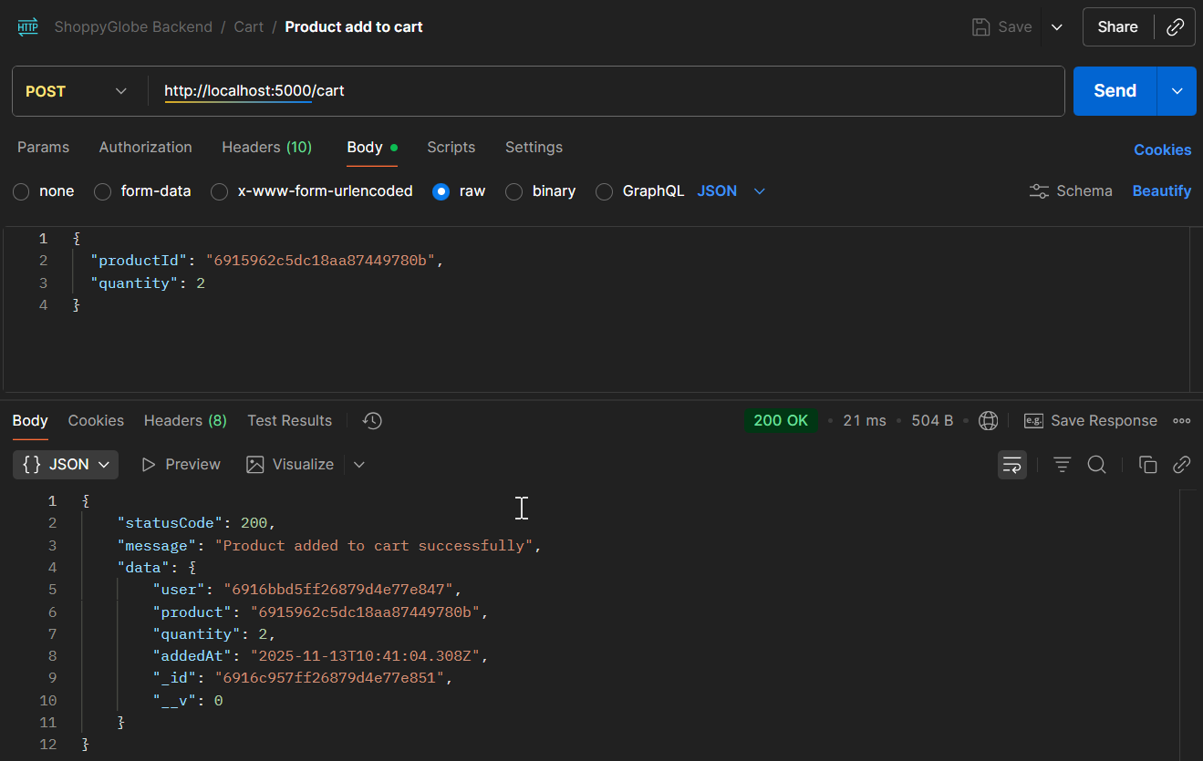
Fig8: Product added to cart successfully
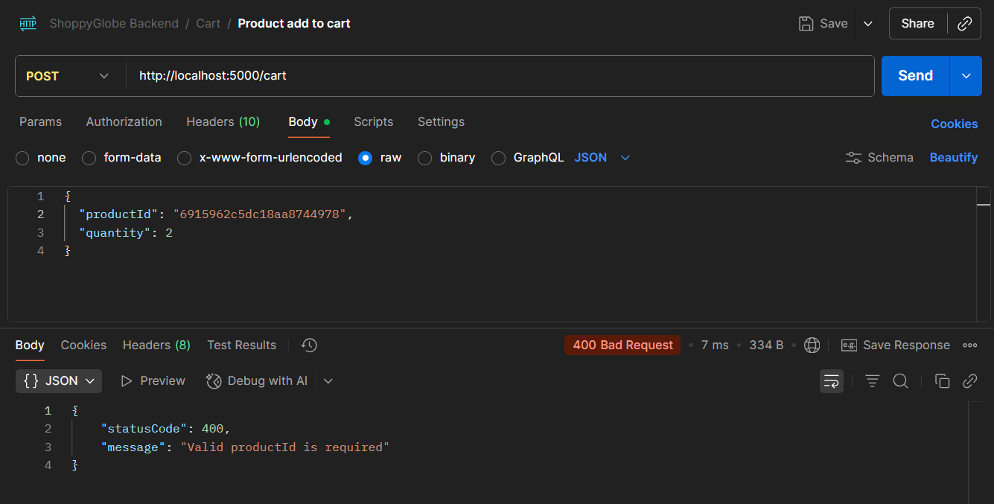
Fig9: Invalid product id
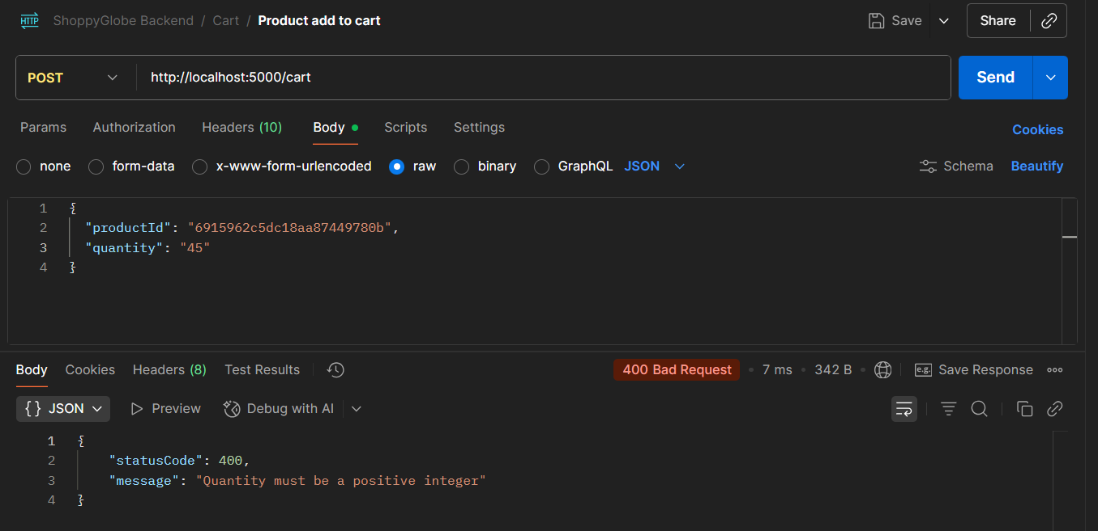
Fig10: Quantity must be positive number
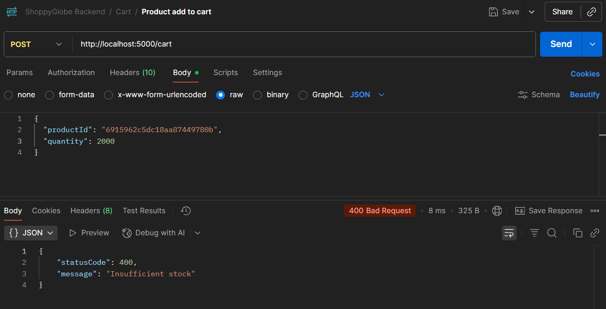
Fig10: Insufficient stock
Description:
- Adds a product to the authenticated user's cart.
- Validates if product id exists and quantity is positive.
- Returns 201 on success with cart item details.

6. PUT /cart/:id – Update product quantity in cart
Request: PUT http://localhost:5000/cart/<cartItemId>
Content-Type: application/json
{ "quantity": 3 }
Expected Response:
- Status 200: Cart item updated successfully.
- Status 400: Invalid cart item id, quantity must be integer or product insufficient stock.
- Status 404: If product and cart item are not exist, give message “Product/CartItem not found”.
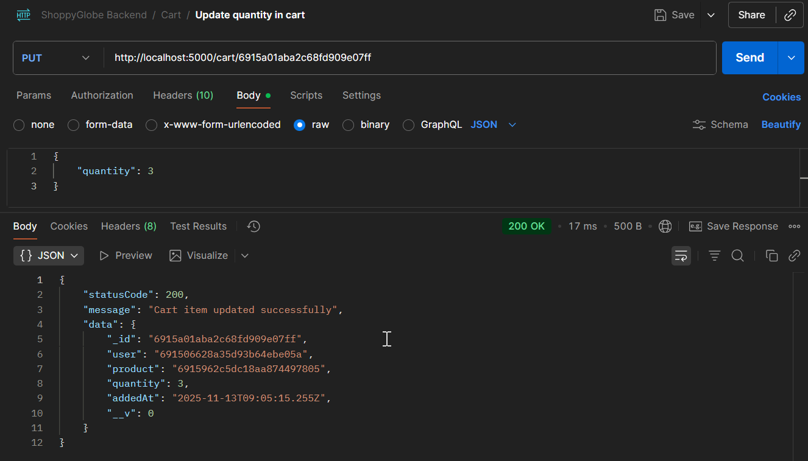
Fig11: Update product quantity in cart successfully

7. DELETE /cart/:id – Remove product from cart
Request: DELETE http://localhost:5000/cart/<cartItemId>
Expected Response:
- Status 200: Cart item removed successfully.
- Status 404: Cart item not found.
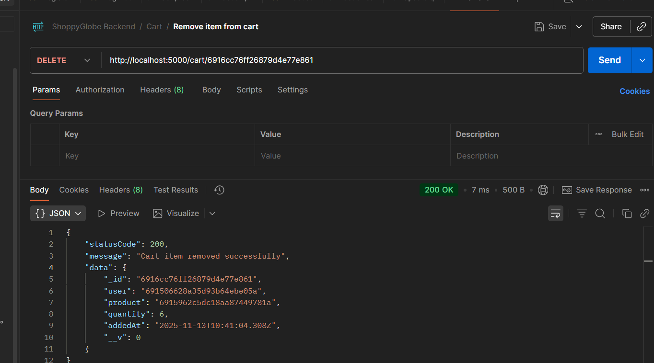
Fig12: Remove product from cart

