LOG FILE ANALYZER

Project report submitted in partial fulfillment of the requirement for the Internship
By
Manish (768940)
Vikas (768997)
Under the supervision of
Dr. Pankaj Anadure
To



Cognizant Technology Solutions India Pvt Ltd , Manyata Tech Park, Nagawara, Bengaluru, Karnataka 560045

CERTIFICATE

Candidate’s Declaration
We hereby declare that the work presented in this report entitled “Log File Analyzer” in partial fulfillment of the requirements for the award of the internship is an authentic record of my own work carried out over a period from Feb 2019 to April 2019 under the supervision of Mr. Pankaj Anadure.
The matter embodied in the report has not been submitted for the award of any other degree or diploma.

Manish (768940) Vikas (768997)
This is to certify that the above statement made by the candidate is true to the best of my knowledge.

Mr. Pankaj Anadure
Dated :

ACKNOWLEDGEMENT
Learning through the project under the guidance of our esteemed mentor Mr. Pankaj Anadure, whose expertise knowledge in the domain of Frontend and Backend Development, not only cleared all our ambiguities but also generated a high level of interest and gusto in the subject. We are truly grateful for his guidance and support throughout the project. We would also like to thank our SME for allocation of the project as well as its resources.
The prospect of working in a group with high level of accountability fostered a spirit of teamwork and created a feeling of oneness which thus, expanded our ken, motivated us to perform to the level best of our ability and create a report of the highest quality.
To do the best quality work, with utmost sincerity and precision has been our constant endeavor.

Date: Manish (768940)
Vikas (768997)

TABLE OF CONTENT
Chapter 1 Introduction
  - Problem Statement
  - Objective
  - Methodology
Chapter 2 Literature Survey
  - Online Log File Analyzer
  - What can we get from Log Files
  - Text Processing Languages
  - Sample Questions
  - Chapter Summary
Chapter 3 System Requirements
  - Tools and Framework
    - Visual studio code
    - Angular
    - Typescript
    - Python
    - Node JS
    - Flask
  - Libraries
    - Numpy
    - Pandas
    - Matplotlib
  - Log Files Format
    - Android
    - Windows
    - Apache
    - HDFS
    - BGL
    - Hadoop
    - HPC
    - Linux
    - Mac
    - OpenSSH
    - OpenStack
    - Proxifier
    - Spark
    - Thunderbird
  - Restful Services to integrate Angular and Python
    - What is REST Architecture
    - HTTP Methods
    - Introduction to Restful Web Services
      - What is Resource
      - Representation of Resources
      - Good Resources Representation
Chapter 4 System Design & Implementation
  - Language of Metadata
  - Operation
    - Job setup
    - Send Metadata
    - Read MetaData
    - Filtering and cleaning
    - Data Analysis
    - Processing Result
    - Searching
    - Sorting
Chapter 5 Test Plan
Chapter 6 Result analysis
References
Terms & Conditions

LIST OF FIGURES
S.NO. | TITLE | Page NO
1. | Overview of the methodology | 11
2. | Angular Component | 20
3. | Data Binding | 21
4. | Log Files Format | 24 - 30
5. | Angular Front Page | 33
6. | Send Metadata Page | 34
7. | REST API Service ( Angular ) | 34
8. | REST API Service ( Python ) | 35
9. | Save File using Pandas | 35
10 . | Data Analysis | 36
11 . | Searching | 37
12. | Sorting | 37
13. | Output Log Files | 38 - 42

ABSTRACT

Log analysis is the process of turning your log files into data and then making intelligent decisions based on that data. In software testing, the analysis of logs is designed to check and monitor the application work. Also logs help to fix some errors. Logs are the text lines which contains systematic information about service work and actions such as: IP-address, dates, time, and viewed sites, potential buyers domains, status code, and the size of the answer, the general info about query, loading time, user-agent, etc. of particular operations that occur in different environments - application itself or the system that runs an app. Logs include the messages of several types: informational, warning and error.
Logs help to specify who uses an application and how often it is used. Moreover, testers can define whether the session was successful, and to detect possible mismatches or mistakes a users of the app can face. The log analysis helps to design new scenarios for further web or mobile testing.

Chapter – 1
INTRODUCTION

In computer log management, log analysis (or system and network log analysis) is an art and science seeking to make sense out of computer-generated records (also called log or audit trail records). The process of creating such records is called data logging.
Logs are emitted by network devices, operating systems, applications and all manner of intelligent or programmable device. A stream of messages in time-sequence often comprise a log. Logs may be directed to files and stored on disk, or directed as a network stream to a log collector.
Log messages must usually be interpreted with respect to the internal state of its source (e.g., application) and announce security-relevant or operations-relevant events (e.g., a user login, or a systems error).
Logs are often created by software developers to aid in the debugging of the operation of an application or understanding how users are interacting with a system, such as search engine. The syntax and semantics of data within log messages are usually application or vendor-specific. Terminology may also vary; for example, the authentication of a user to an application may be described as a login, a logon, a user connection or authentication event. Hence, log analysis must interpret messages within the context of an application, vendor, system or configuration in order to make useful comparisons to messages from different log sources.
Log message format or content may not always be fully documented. A task of the log analyst is to induce the system to emit the full range of messages in order to understand the complete domain from which the messages must be interpreted.
  - PROBLEM STATEMENT
This is the project has its motivation from the log files which are cumbersome to read. Log Files contains huge amount of useful information about which must be taken care. This project is created for debugging of the operation of the application or understanding how users are interacting with a system. The overall goal of this research is to invent and design a good model of generic processing of log files.

The following list sums up areas involved by this research :
- formal definition of a log file
- formal description of the structure and syntax of a log file (metadata)
- formal specification of a programming language for easy and efficient log analysis
- design of a basic library/API and functions or operators for easy handling of logs within the programming language
- deployment of data mining/warehousing techniques if applicable
- design of user interface The expected results are both theoretical both practical.

  - OBJECTIVE
The essential goal of the venture is:
- To design a framework
- To extract the raw data and convert that data into useful or readable form.
- To analyze the data and perform certain actions like searching, sorting, etc.
- To visualize different parameters of the data to get some results.

  - METHODOLOGY
A diagram of our strategy is given in Figure 1. We first preprocess the raw data into some useful information. Utilizing this preprocessed information, we perform certain actions on that information like searching particular rows across the data, perform sorting among different parameters, also try to visualize the effect of different parameters.

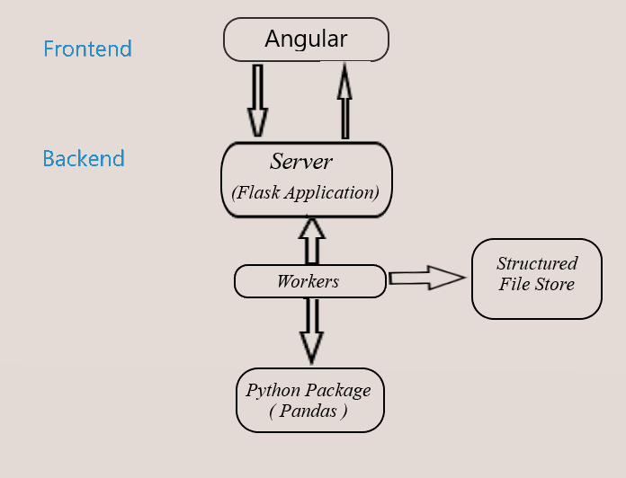

Figure 1: Overview of the methodology

Chapter – 2

LITERATURE SURVEY

There are various applications (known as log file analyzers or log files visualization tools) that can digest a log file of specific vendor or structure and produce easily human readable summary reports. Such tools are undoubtedly useful, but their usage is limited only to log files of certain structure. Although such products have configuration options, they can answer only built-in questions and create built-in reports. The initial motivation of this work was the lack of Cisco NetFlow analyzer that could be used to monitor and analyze large computer networks like the metropolitan area network of the University of West Bohemia (WEBNET) or the country-wide backbone of the Czech Academic Network (CESNET) using Cisco NetFlow data exports. Because the amount of log data (every packet is logged!), evolution of the NetFlow log format in time and wide spectrum 4 of monitoring goals/questions, it seems that introduction of an new, systematic, efficient and open approach to the log analysis is necessary. There is also a belief that it is useful to research in the field of log files analysis and to design an open, very flexible modular tool, that would be capable to analyze almost any log file and answer any questions, including very complex ones. Such analyzer should be programmable, extendable, efficient (because of the volume of log files) and easy to use for end users. It should not be limited to analyze just log files of specific structure or type and also the type of question should not be restricted.
2.1 Various others online Log File Analyzer :
Log MX
It’s an intuitive tool for analyzing log files. Log MX is not just reading log files, it parses log events from any file or data stream, in order to display a structured view of your logs. No need to install a web server or update your logs producers, Log MX is a standalone application weighing only about 6 MB.
The disadvantage of this analyzer you can’t analyze your log files for free you have to make an account and buy this tool.

G suite
It’s another online log file analyzer tool. Purpose is same but the disadvantage is it can analyze limited no of log files. It’s domain to analyze various log files is very less. You can analyze only certain no of log files such as Chrome OS, GSSMO, GSMME, GSMMO, GCDS, GSPS.
2.2 What Can We Get from Log Files
This paragraph summarizes application of log files in software development, testing and monitoring. The desired useful information that resides in log files can be divided into several classes:
- Generic statistics (peak and average values, median, modus, deviations..)
Goal: finding and processing of set of report elements
Useful for: setting hardware requirements, accounting

- Program/system warnings (power failure, low memory)
Goal: finding all occurrences of reports
Useful for: system maintenance

- Security related warnings
Goal: finding all occurrences of reports in report trace

- Validation of program runs
Goal: construction and examination of state machine
Useful for: software testing

- Time related characteristics
Goal: computing or guessing time periods between multiple occurrences of report
Useful for: software profiling & benchmarking

- Causality and trends
Goal: finding a set of reports that often (or every time) preceed
(or follow) within a given time period (or withing a given count of reports)
Useful for: data mining

- Behavioral patterns
Goal: using a set of reports as the set of transitions of Markov process
Useful for: determining performance and reliability

  - Text Processing Languages
There are several languages designed for easy text processing. Their operation is based on regular expressions that makes their usage surprisingly efficient. The well-known representatives are AWK and PYTHON. Log analysis (or at least simple log analysis) is in fact a text processing task, so the need to examine such languages is obvious. We will concentrate on PYTHON, because its application is in text processing. The basic function of awk is to search files for lines (or other units of text) that contain certain patterns. When a line matches one of the patterns, awk performs specified actions on that line. awk keeps processing input lines in this way until the end of the input files are reached. Programs in awk are different from programs in most other languages, because awk programs are data-driven; that is, you describe the data you wish to work with, and then what to do when you find it. Most other languages are procedural; you have to describe, in great detail, every step the program is to take. When working with procedural languages, it is usually much harder to clearly describe the data your program will process. For this reason, awk programs are often refreshingly easy to both write and read. When you run awk, you specify an awk program that tells awk what to do. The program consists of a series of rules. (It may also contain function definitions, an advanced feature which we will ignore for now. See section User-defined Functions.) Each rule specifies one pattern to search for, and one action to perform when that pattern is found.
  - Sample Questions
Although web server logs are not the primary objective of this thesis, this section provides a brief overview of typical questions concerning web usage.
• Who is visiting your site. The fundamental point is who are the readers of your server, who are they like, from what countries, institutions etc. Many servers identify returning visitors and offers personal or personalized pages for frequent visitors.
• The path visitors take through your pages. Where do visitors start reading your server, where they come from, how easily they navigate, do they often fail to find the right hyperlink and thus often return... In brief, the objectives are trends, paths, and patterns.
• How much time visitors spend on each page. From the answer you can deduce what pages are interesting and what are very confusing or dull.
• Where visitors leave your site. The last page a visitor viewed can be a logical place where end the visit or it can be a place where visitor bailed out.
• The success of users experiences at your site. Purchases transacted, downloads completed, information viewed, tasks accomplished. Such indicators can show whether the site it well made, organized and maintained, whether the offered products are well presented.
2.6 Chapter Summary
Log file analysis has many applications, such as site security. In terms of search engine optimization, the process usually involves downloading the file from your server and importing it into a log file analysis tool, where all the information about every “hit” on the site (whether bot or human) can be analyzed to inform SEO decisions and learn about previously unknown issues.
Log file analysis is an arduous process that frequently results in the discovery of critical technical problems that could be found no other way. Log files contain incredibly accurate data that allow a brand to better understand how search engines are crawling their site and the kind of information they are finding.
Log file data includes a record of the URL/resource that was requested, action taken, time and date, IP of the machine it originated from, user agent/browser type, and other pieces of information.

Chapter – 3
SYSTEM REQUIREMENTS
3.1 TOOLS & FRAMEWORKS
3.1.1 Visual Studio Code
Visual Studio Code is a source-code editor developed by Microsoft for Windows, Linux and macOS. It includes support for debugging, embedded Git control, syntax highlighting, intelligent code completion, snippets, and code refactoring. It is also customizable, so users can change the editor's theme, keyboard shortcuts, and preferences.
Visual Studio Code is based on Electron, a framework which is used to deploy Node.js applications for the desktop running on the Blink layout engine.
Visual Studio Code is a source code editor that can be used with a variety of programming languages. Instead of a project system it allows users to open one or more directories, which can then be saved in workspaces for future reuse.
It supports a number of programming languages and a set of features that differs per language. Unwanted files and folders can be excluded from the project tree via the settings. Many of Visual Studio Code features are not exposed through menus or the user interface, but can be accessed via the command palette.
3.1.2 ANGULAR
Angular (commonly referred to as "Angular 2+" or "Angular v2 and above") is a TypeScript-based open-source web application framework led by the Angular Team at Google and by a community of individuals and corporations. Angular is a complete rewrite from the same team that built AngularJS.
Angular is a platform that makes it easy to build applications with the web. Angular combines declarative templates, dependency injection, end to end tooling, and integrated best practices to solve development challenges. Angular empowers developers to build applications that live on the web, mobile, or the desktop.
Why Angular ?
- Angular presents you not only the tools but also design patterns to build your project in a maintainable way. When an Angular application is crafted properly, you don’t end up with a tangle of classes and methods that are hard to modify and even harder to test. The code is structured conveniently and you won’t need to spend much time in order to understand what is going on.
- It’s JavaScript, but better. Angular is built with TypeScript, which in turn relies on JS ES6. You don’t need to learn a totally new language, but you still receive features like static typing, interfaces, classes, namespaces, decorators etc.
- No need to reinvent the bicycle. With Angular, you already have lots of tools to start crafting the application right away. You have directives to give HTML elements dynamic behavior. You can power up the forms using Form Control and introduce various validation rules. You may easily send asynchronous HTTP requests of various types. You can set up routing with little hassle. And there are many more goodies that Angular can offer us!
- Components are decoupled. Angular strived to remove tight coupling between various components of the application. Injection happens in NodeJS-style and you may replace various components with ease.
- All DOM manipulation happens where it should happen. With Angular, you don’t tightly couple presentation and the application’s logic making your markup much cleaner and simpler.
- Testing is at the heart. Angular is meant to be thoroughly tested and it supports both unit and end-to-end testing with tools like Jasmine and Protractor.
- Angular is mobile and desktop-ready, meaning you have one framework for multiple platforms.
- Angular is actively maintained and has a large community and ecosystem. You can find lots of materials on this framework as well as many useful third-party tools.

Modules:
Angular NgModules differ from and complement JavaScript (ES2015) modules. An NgModule declares a compilation context for a set of components that is dedicated to an application domain, a workflow, or a closely related set of capabilities. An NgModule can associate its components with related code, such as services, to form functional units.
Every Angular app has a root module, conventionally named AppModule, which provides the bootstrap mechanism that launches the application. An app typically contains many functional modules.
Like JavaScript modules, NgModules can import functionality from other NgModules, and allow their own functionality to be exported and used by other NgModules. For example, to use the router service in your app, you import the Router NgModule.
Organizing your code into distinct functional modules helps in managing development of complex applications, and in designing for reusability. In addition, this technique lets you take advantage of lazy-loading—that is, loading modules on demand—to minimize the amount of code that needs to be loaded at startup.

Components
Every Angular application has at least one component, the root component that connects a component hierarchy with the page document object model (DOM). Each component defines a class that contains application data and logic, and is associated with an HTML template that defines a view to be displayed in a target environment.
The @Component() decorator identifies the class immediately below it as a component, and provides the template and related component-specific metadata.
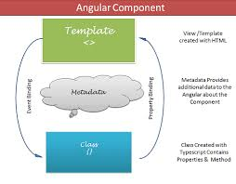

Templates, directives, and data binding:
A template combines HTML with Angular markup that can modify HTML elements before they are displayed. Template directives provide program logic, and binding markup connects your application data and the DOM. There are two types of data binding:
Event binding lets your app respond to user input in the target environment by updating your application data.
Property binding lets you interpolate values that are computed from your application data into the HTML.
Before a view is displayed, Angular evaluates the directives and resolves the binding syntax in the template to modify the HTML elements and the DOM, according to your program data and logic. Angular supports two-way data binding, meaning that changes in the DOM, such as user choices, are also reflected in your program data.
Your templates can use pipes to improve the user experience by transforming values for display. For example, use pipes to display dates and currency values that are appropriate for a user's locale. Angular provides predefined pipes for common transformations, and you can also define your own pipes.
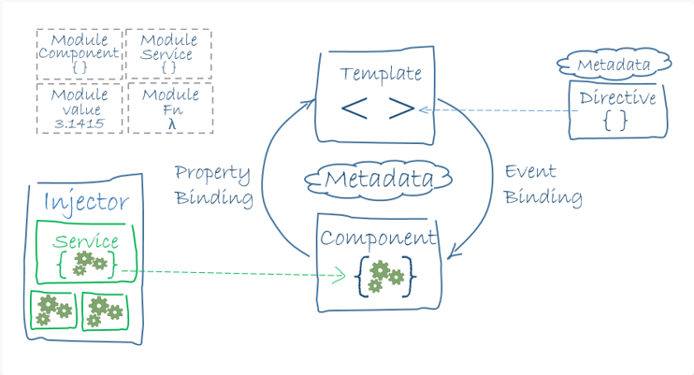

Services and dependency injection:
For data or logic that isn't associated with a specific view, and that you want to share across components, you create a service class. A service class definition is immediately preceded by the @Injectable() decorator. The decorator provides the metadata that allows other providers to be injected as dependencies into your class.
Dependency injection (DI) lets you keep your component classes lean and efficient. They don't fetch data from the server, validate user input, or log directly to the console; they delegate such tasks to services.

Routing:
The Angular Router NgModule provides a service that lets you define a navigation path among the different application states and view hierarchies in your app. It is modeled on the familiar browser navigation conventions:
Enter a URL in the address bar and the browser navigates to a corresponding page.
Click links on the page and the browser navigates to a new page.
Click the browser's back and forward buttons and the browser navigates backward and forward through the history of pages one has seen.
The router maps URL-like paths to views instead of pages. When a user performs an action, such as clicking a link, that would load a new page in the browser, the router intercepts the browser's behavior, and shows or hides view hierarchies.
If the router determines that the current application state requires particular functionality, and the module that defines it hasn't been loaded, the router can lazy-load the module on demand.
The router interprets a link URL according to your app's view navigation rules and data state. You can navigate to new views when the user clicks a button or selects from a drop box, or in response to some other stimulus from any source. The router logs activity in the browser's history, so the back and forward buttons work as well.
To define navigation rules, you associate navigation paths with your components. A path uses a URL-like syntax that integrates your program data, in much the same way that template syntax integrates your views with your program data. You can then apply program logic to choose which views to show or to hide, in response to user input and your own access rules.
3.1.3 TYPESCRIPT
TypeScript is an open-source programming language developed and maintained by Microsoft. It is a strict syntactical superset of JavaScript, and adds optional static typing to the language.
TypeScript is designed for development of large applications and trans compiles to JavaScript. As TypeScript is a superset of JavaScript, existing JavaScript programs are also valid TypeScript programs.
TypeScript lets you write JavaScript the way you really want to. TypeScript is a typed superset of JavaScript that compiles to plain JavaScript. TypeScript is pure object oriented with classes, interfaces and statically typed like C# or Java. The popular JavaScript framework Angular 2.0 is written in TypeScript. Mastering TypeScript can help programmers to write object-oriented programs and have them compiled to JavaScript, both on client-side and server-side (Node.js) execution.

3.1.4 PYTHON
Python is very simple programming language. It is very easy to learn Python. The concept of objects and classes can be used in the Python very easily, so that’s why it is called object-oriented programming language. Python source code is converted to byte code when we compile the source code. After that this byte code is executed by the interpretor. So this language is also known as the Interpreted language. Python has facility of in built high level data structures which makes this language very easy to learn.
3.1.5 NODE JS
Node.js is an open-source, cross-platform JavaScript run-time environment that executes JavaScript code outside of a browser. JavaScript is used primarily for client-side scripting, in which scripts written in JavaScript are embedded in a webpage's HTML and run client-side by a JavaScript engine in the user's web browser.
Node.js lets developers use JavaScript to write command line tools and for server-side scripting—running scripts server-side to produce dynamic web page content before the page is sent to the user's web browser. Consequently, Node.js represents a "JavaScript everywhere" paradigm, unifying web application development around a single programming language, rather than different languages for server side and client side scripts.
3.1.6 FLASK
Flask is a micro web framework written in Python. It is classified as a microframework because it does not require particular tools or libraries. It has no database abstraction layer, form validation, or any other components where pre-existing third-party libraries provide common functions.
However, Flask supports extensions that can add application features as if they were implemented in Flask itself. Extensions exist for object-relational mappers, form validation, upload handling, various open authentication technologies and several common framework related tools. Extensions are updated far more regularly than the core Flask program.

3.2 LIBRARIES
3.2.1 NUMPY
Numpy is a Library which provide the facility of easy manipulation of multi-dimensional array in Python. Without this library the facility of use of multidimensional array is little bit difficult. By importing this package, multidimensional array can be manipulated easily. Also, other high dimensional operation of mathematics can be used with the help of this package.
3.2.2 PANDAS
Data analysis can be done very easily with the help of Python. Python provides multiple packages and libraries which provides user to different type of facilities. Pandas is one of them. This library is used for data analysis. With the help of this library user can optimized performance.
Data can be analyzing in Pandas with: - series and data frames. Series means 1-D array in Pandas. With the help of Series user can store any datatype. DataFrames means rows and columns.so Data frame is 2-D array.
3.2.3 MATPLOTLIB
Matplotlib is one of the most important library in Python. This library generally used by the user for creation of graphs. Data can be visualized very easily with the help of this library. This library supports users to create different type of graphs such as- Histogram, Power spectra, Error charts etc.
3.3 LOG FILES FORMAT
3.3.1 Android
Format: ['Date', 'Time', 'Pid', 'Tid', 'Level', 'Component', 'Content']
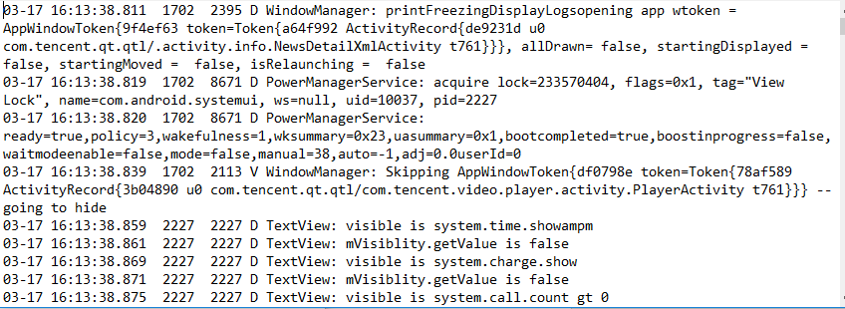
3.3.2 Windows
Format: ['Date', 'Time', 'Level', 'Component', 'Content']
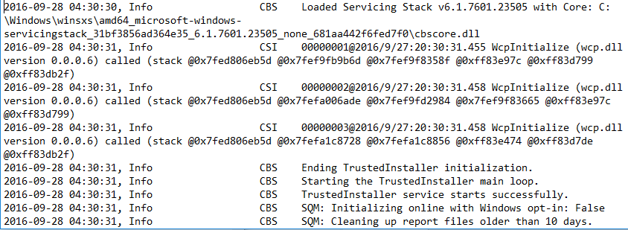

3.3.3 Apache
Format: ['Day', 'Month', 'Date', 'Time', 'Year', 'Level', 'Content']
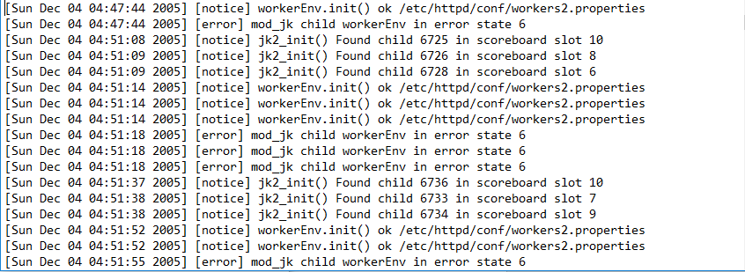

3.3.4 HDFS
Format: ['Date', 'Time', 'Pid', 'Level', 'Component', 'Content']
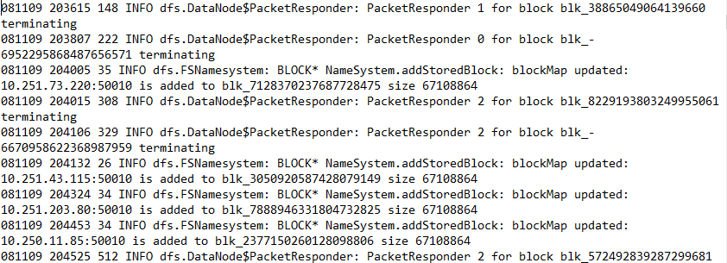

3.3.5 BGL
Format: ['Label', 'Timestamp', 'Date', 'Node', 'Time', 'Node Repeat', 'Type', 'Component', 'Level', 'Content']
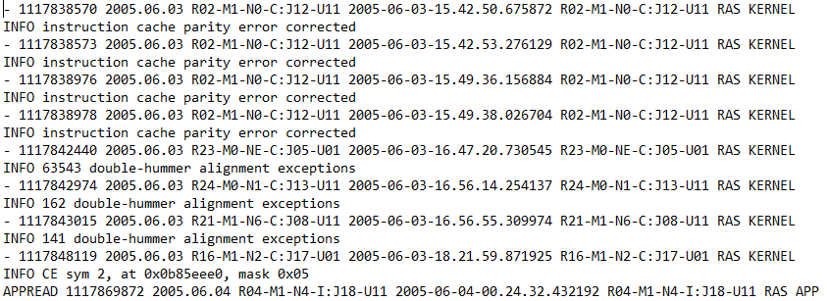

3.3.6 Hadoop
Format: ['Date', 'Time', 'Level', 'Process', 'Component', 'Content']
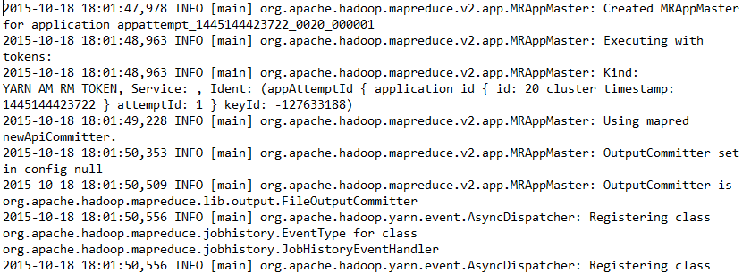
3.3.7 HPC
Format: ['Log Id', 'Node', 'Component', 'State', 'Time', 'Flag', 'Content']
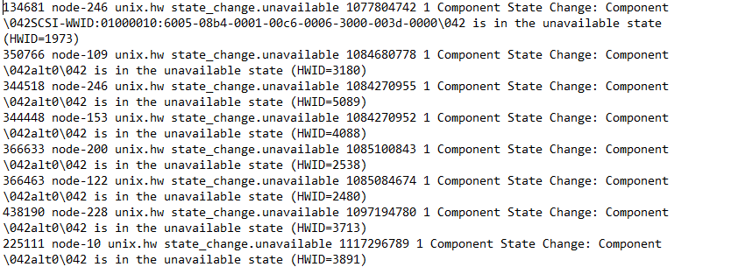
3.3.8 Linux
Format: ['Month', 'Date', 'Time', 'Level', 'Component', 'PID', 'Content']
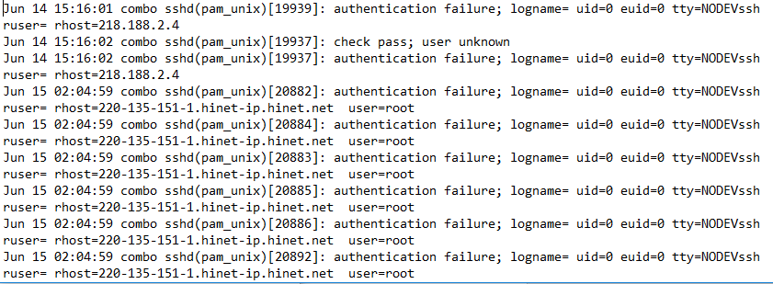

3.3.9 Mac
Format: ['Month', 'Date', 'Time', 'User', 'Component', 'PID', 'Address', 'Content']
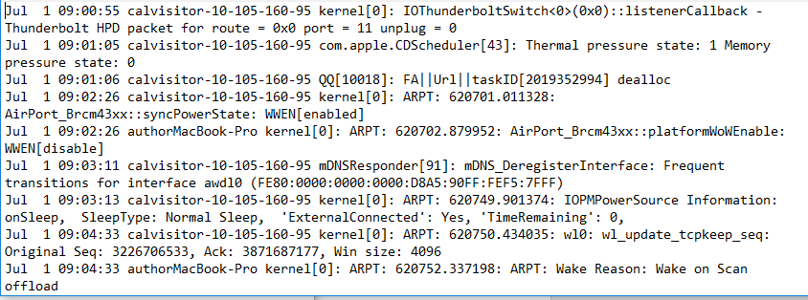
3.3.10 OpenSSH
Format: [ 'Date', 'Day', 'Time', 'Component', 'Pid', 'Content']
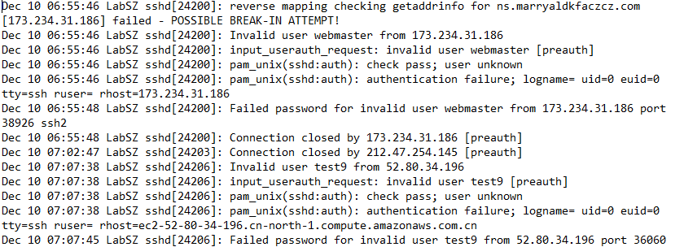
3.3.11 OpenStack
Format: ['Log record', 'Date', 'Time', 'Pid', 'Level', 'Component', 'ADDR', 'Content']
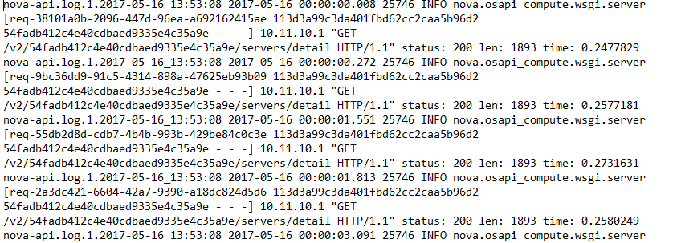
3.3.12 Proxifier
Format: ['Time', 'Program', 'Content']
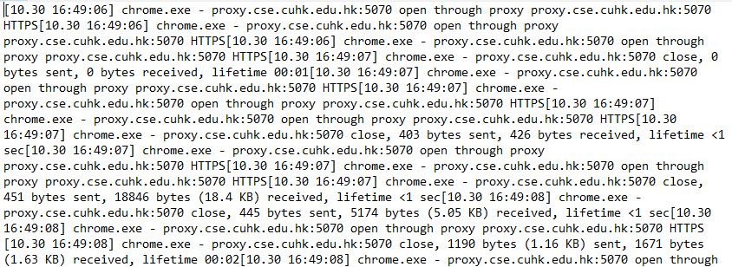

3.3.13 Spark
Format: ['Date', 'Time', 'Level', 'Content']
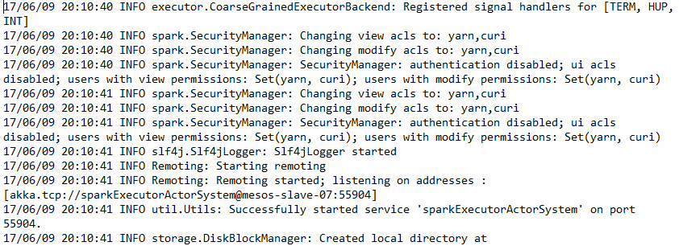

3.3.14 ThunderBird
Format: ['Label', 'Timestamp', 'Date', 'User', 'Month', 'Day', 'Time', 'Location', 'Component', 'Content']
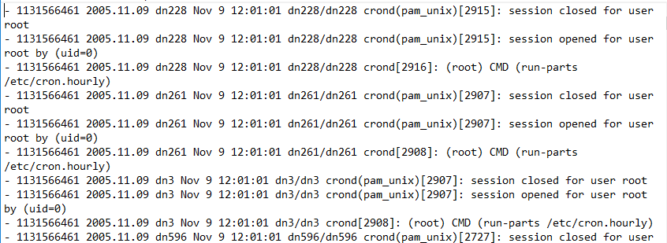

3.4 Restful Services to integrate Angular and Python
RESTful Web Services are basically REST Architecture based Web Services. In REST Architecture everything is a resource. RESTful web services are light weight, highly scalable and maintainable and are very commonly used to create APIs for web-based applications.

3.4.1 What is REST architecture?
REST stands for REpresentational State Transfer. REST is web standards based architecture and uses HTTP Protocol. It revolves around resource where every component is a resource and a resource is accessed by a common interface using HTTP standard methods. REST was first introduced by Roy Fielding in 2000.
In REST architecture, a REST Server simply provides access to resources and REST client accesses and modifies the resources. Here each resource is identified by URIs/ global IDs. REST uses various representation to represent a resource like text, JSON, XML. JSON is the most popular one.

3.4.2 HTTP methods
Following four HTTP methods are commonly used in REST based architecture.
- GET − Provides a read only access to a resource.
- POST − Used to create a new resource.
- DELETE − Used to remove a resource.
- PUT − Used to update a existing resource or create a new resource.

Introduction to RESTFul web services
A web service is a collection of open protocols and standards used for exchanging data between applications or systems. Software applications written in various programming languages and running on various platforms can use web services to exchange data over computer networks like the Internet in a manner similar to inter-process communication on a single computer. This interoperability (e.g., between Java and Python, or Windows and Linux applications) is due to the use of open standards.
Web services based on REST Architecture are known as RESTful web services. These webservices uses HTTP methods to implement the concept of REST architecture. A RESTful web service usually defines a URI, Uniform Resource Identifier a service, provides resource representation such as JSON and set of HTTP Methods.

What is a Resource?
REST architecture treats every content as a resource. These resources can be Text Files, Html Pages, Images, Videos or Dynamic Business Data. REST Server simply provides access to resources and REST client accesses and modifies the resources. Here each resource is identified by URIs/ Global IDs. REST uses various representations to represent a resource where Text, JSON, XML. The most popular representations of resources are XML and JSON.

Representation of Resources
A resource in REST is a similar Object in Object Oriented Programming or is like an Entity in a Database. Once a resource is identified then its representation is to be decided using a standard format so that the server can send the resource in the above said format and client

Good Resources Representation
REST does not impose any restriction on the format of a resource representation. A client can ask for JSON representation whereas another client may ask for XML representation of the same resource to the server and so on. It is the responsibility of the REST server to pass the client the resource in the format that the client understands.
Following are some important points to be considered while designing a representation format of a resource in RESTful Web Services.
- Understandability − Both the Server and the Client should be able to understand and utilize the representation format of the resource.
- Completeness − Format should be able to represent a resource completely. For example, a resource can contain another resource. Format should be able to represent simple as well as complex structures of resources.
- Linkablity − A resource can have a linkage to another resource, a format should be able to handle such situations.
However, at present most of the web services are representing resources using either XML or JSON format. There are plenty of libraries and tools available to understand, parse, and modify XML and JSON data.

Chapter - 4
System Design & Implementation
This section describes in more detail some design issues and explains decisions that have been made.

4.1 Language of Metadata

The first stage of log file analysis is the process of understanding log content. This is done by lexical scanning of log entries and parsing them into internal data structures according to a given syntax and semantics. The semantics can be either explicitly specified in the log file or it must be provided by a human (preferably by the designer of the involved software product) in another way, i.e. by a description in corresponding metadata file.
4.2 Operation
Before a detailed description of analyzer's components, let us enumerate the basic stages of log processing from user point of view and thus explain how the analyzer operates.

- Job Setup :
In a typical session, the user specifies via an user interface one or more log files, a metadata file and selects modules that should participate in the job, each module for one analytical task.

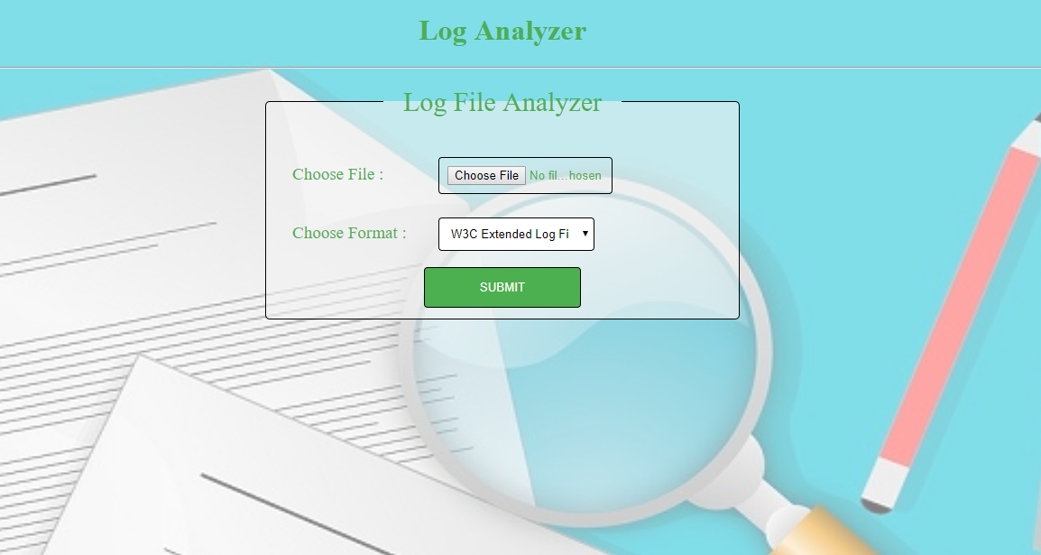

- Send Metadata ( Angular ):
The analyzer then reads metadata information (using lexical and syntax analyzers) and thus send the structure of the given log file to the server. We have created Rest API Service in Angular Client Side to send the data to the Backend Server i.e Flask.

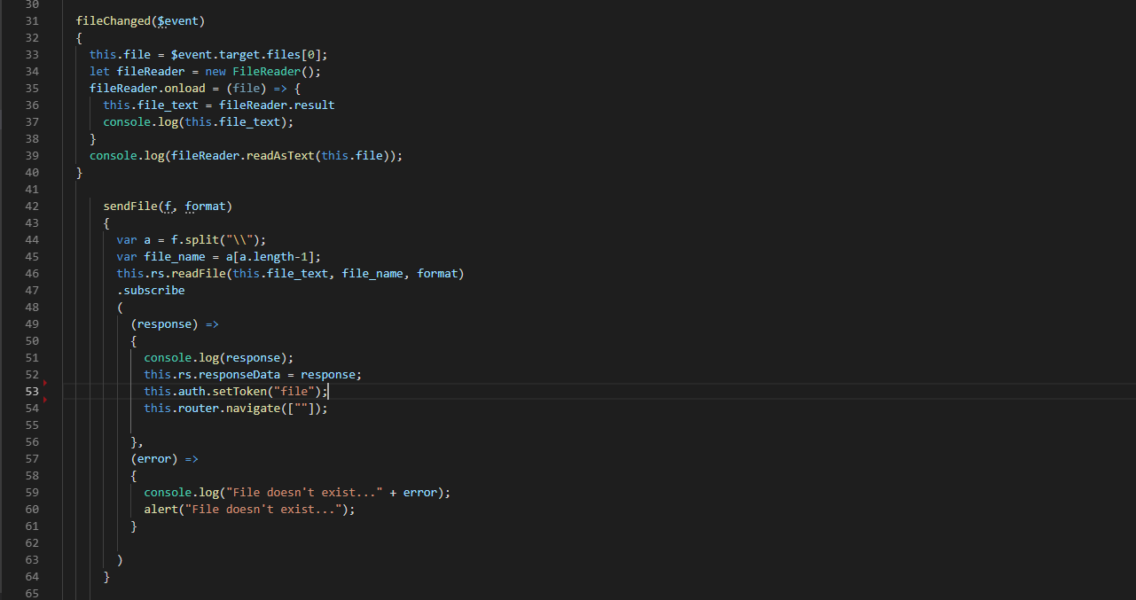

REST API Service ( Angular ) :

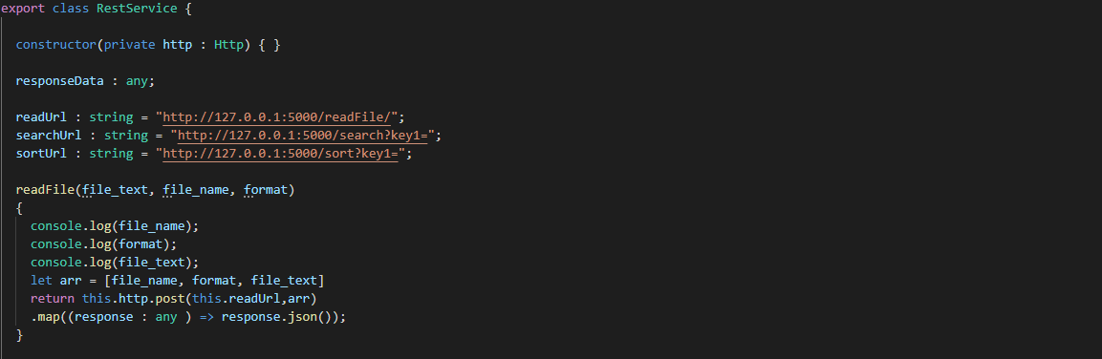

- Read Metadata ( Flask ) :
After sending the metadata from Angular i.e from Client Side, now we have to fetch that data. So for that we integrate Angular Rest Services and Python Rest Services using Flask Web Framework.

REST API Service ( Python ) :

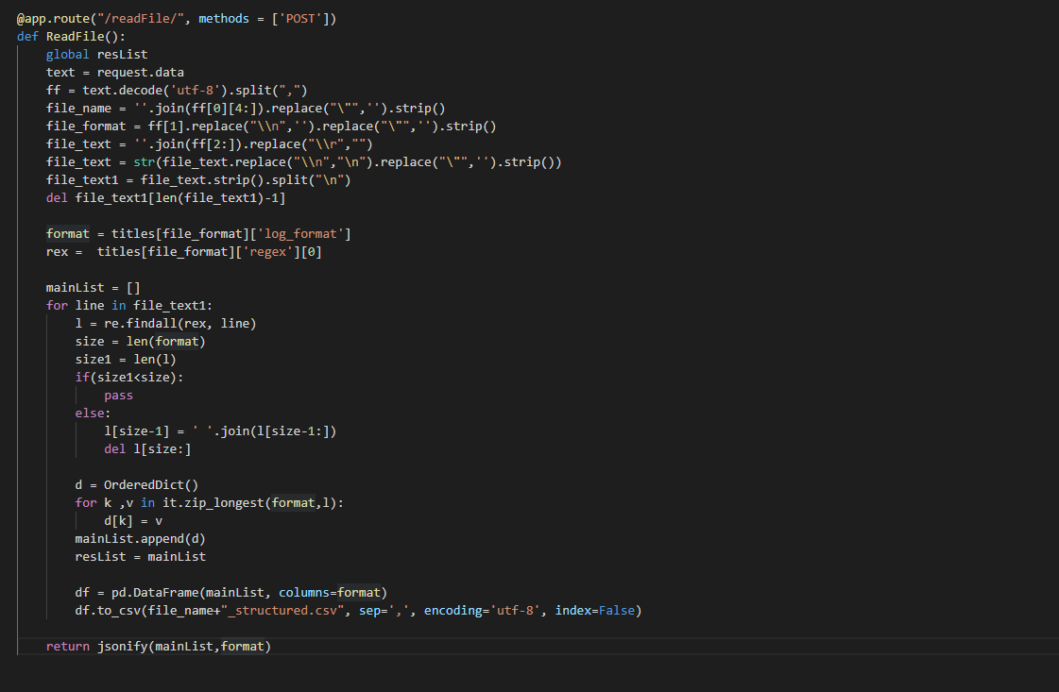

- Filtering & Cleaning
After learning log structure, the analyzer starts reading the log file and according the metadata
stores pieces of information into the structured file of .csv format. During this process some unwanted records can be filtered out or some selected parts of each record can be omitted to reduce the file size.

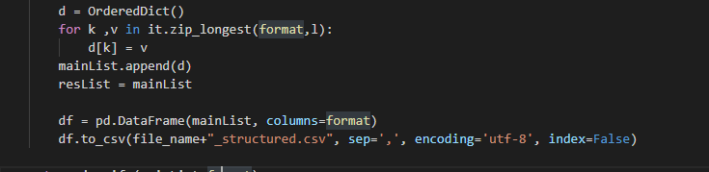

- Data Analysis :
When all logs are read and stored in the file, the analyzers executes one-after-one all user written modules that perform analytical tasks. Each program is expected to produce some output in form of a set of variables or the output may be missing if the log does not contain the sought-after pattern etc.
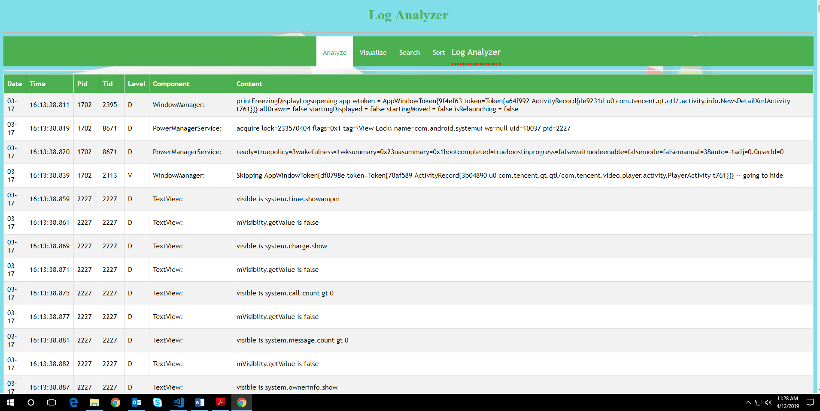

- Processing of Results ( Visualization ) :
Output of each module (if any) is passed to the visualization module that uses yet another type of files (visual plug-ins) to learn how to present obtained results. For example, it can transform the obtained variables into pie charts, bar graphs, nice{looking tables, lists, sentences etc. Finally, the transformed results are either displayed to user via the user interface module or they are stored in an output file.
- Searching :
In this operation, client can search the queries to get result of particular fields. The Search operation is fully performed by the Backend Server i.e using Python REST API Service and the results are directly displayed on the Angular i.e on Client Side.
Example : Client searches in the column of “Component” for Keywords as “WindowManager”. The Server responds only that rows which have “WindowManager” in “Component” column.
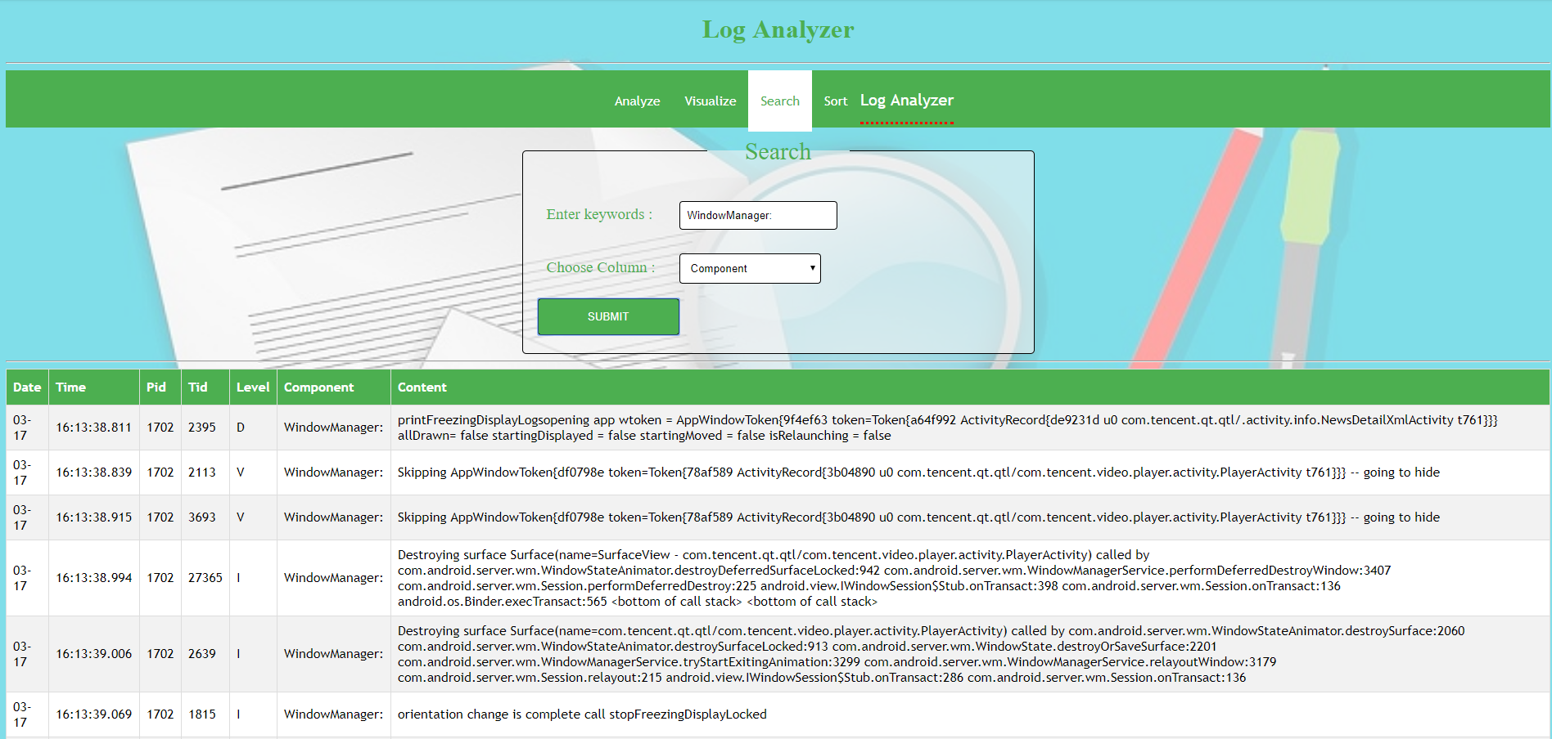
- Sorting
In this operation, client sort the data on the basis of columns fields. The Sort operation is fully performed by the Backend Server i.e using Python REST API Service and the results are directly displayed on the Angular i.e on Client Side.
Example : Client requested to sort data on the basis of column “Component”. The Server responds or sort data according to column “Component”.

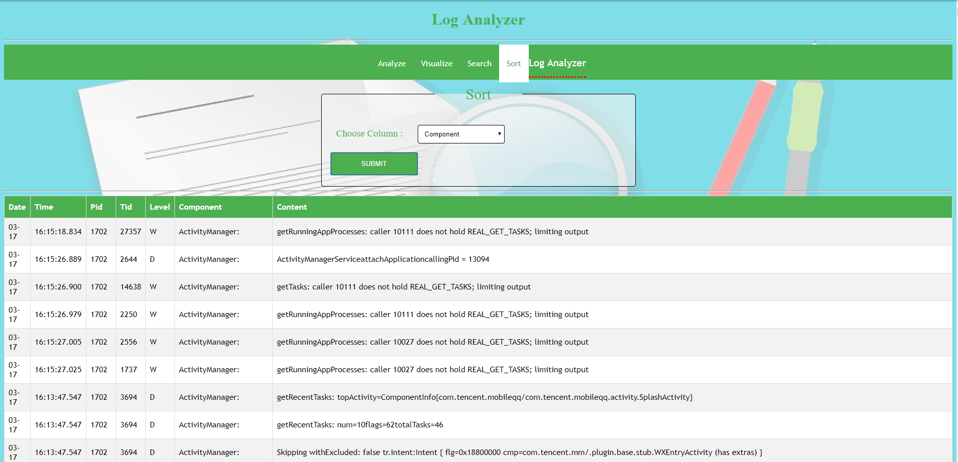

Chapter - 5
TEST PLAN

Table 3: Number of different tests to be performed
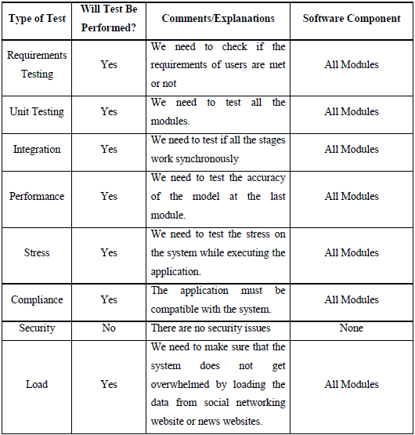

Chapter – 6
RESULT ANALYSIS
Output LOG FILES
- Android Log
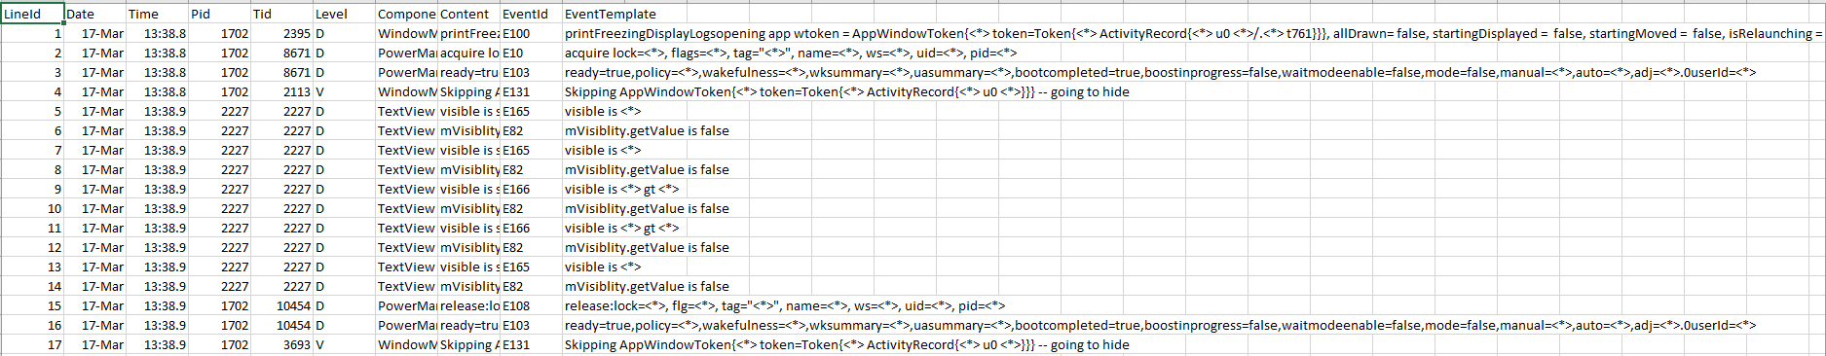
- Apache log
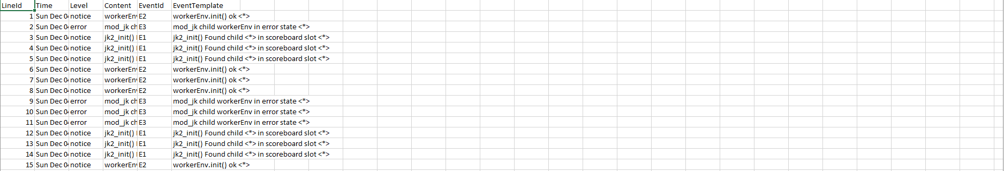
- BGL log
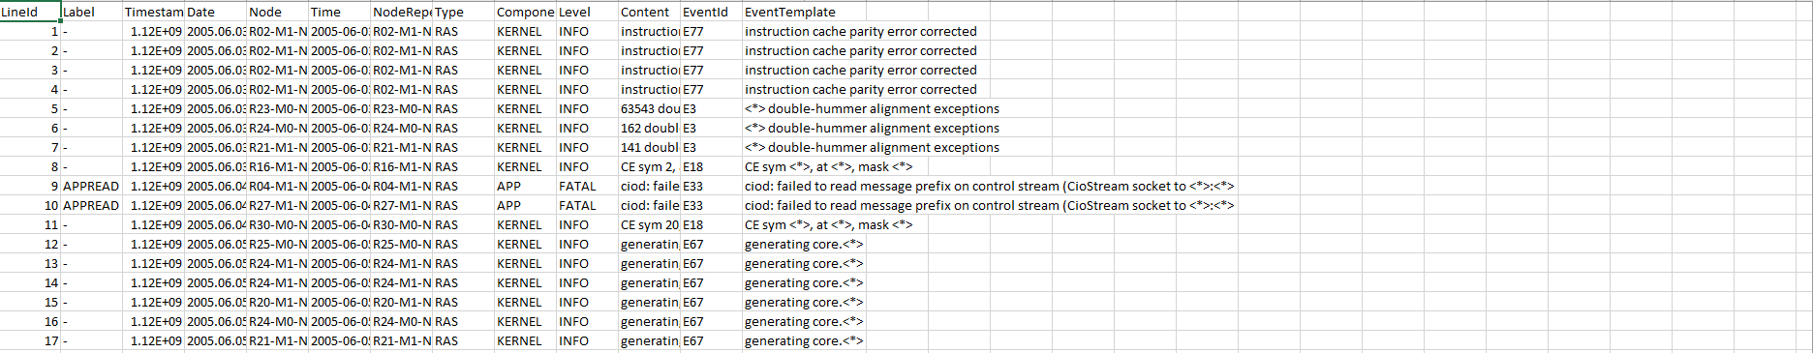

- Hadoop log
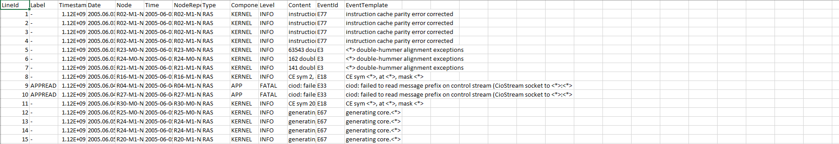
- HDFS log
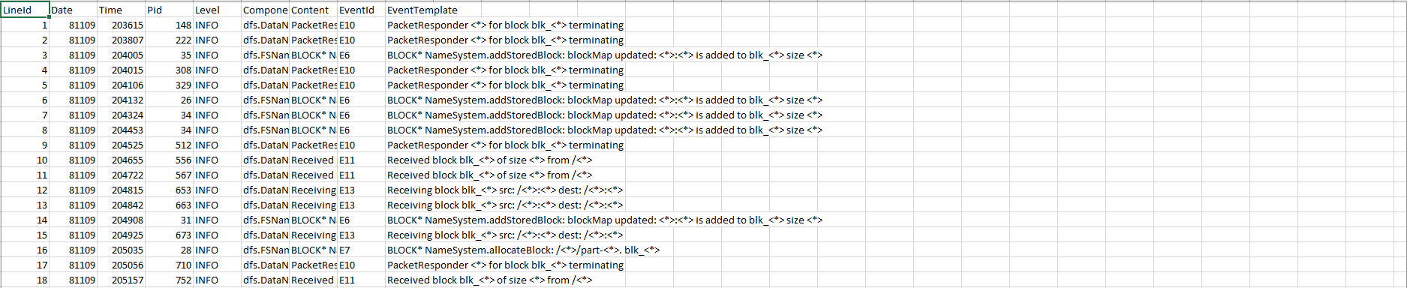
- Application log
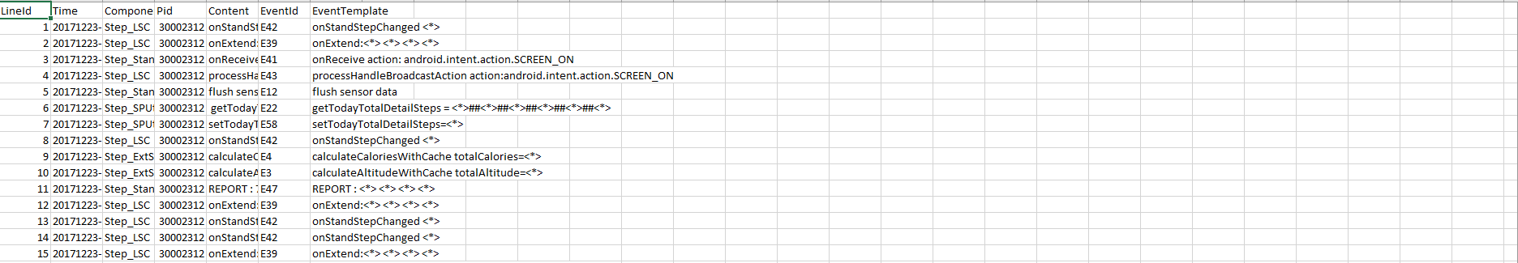
- HPC log
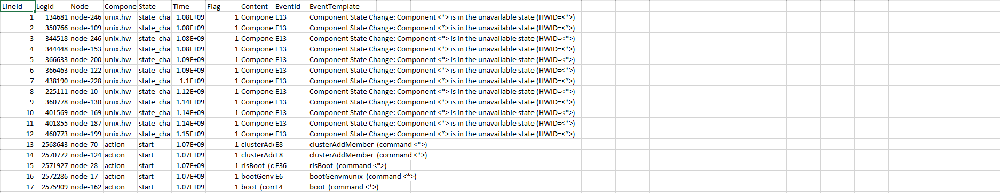
- Linux log
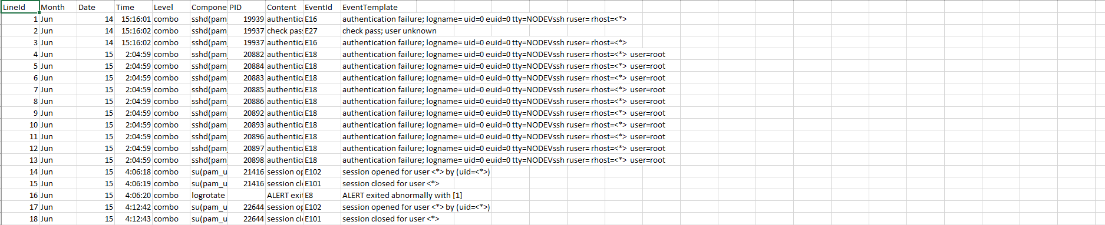
- MAC log
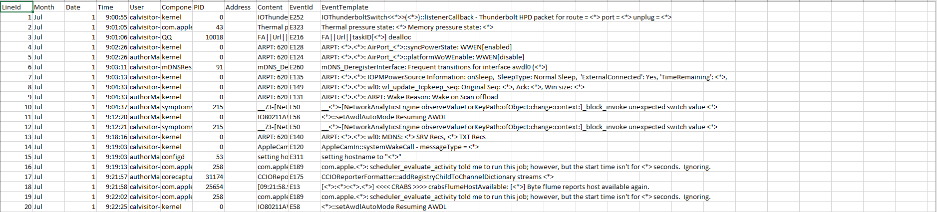

- OpenSSH log
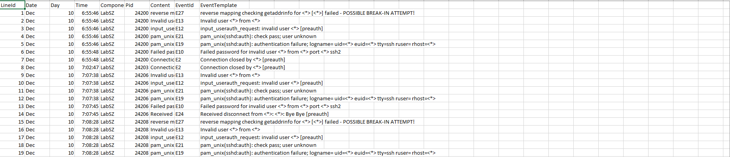
- OpenStack log
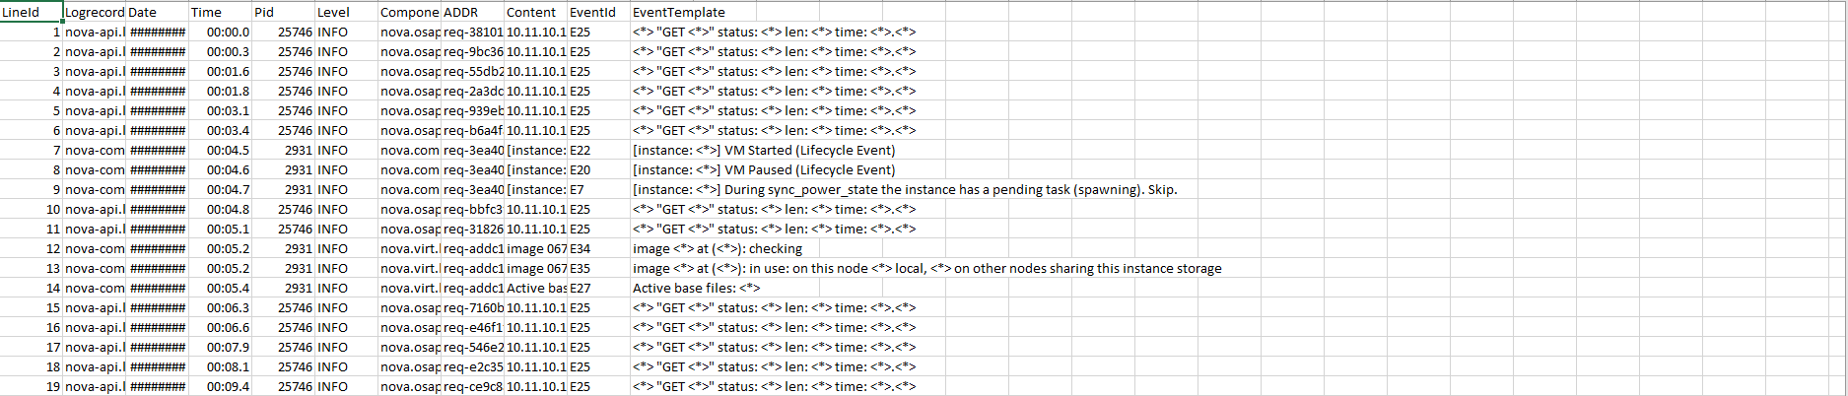
- Proxifier
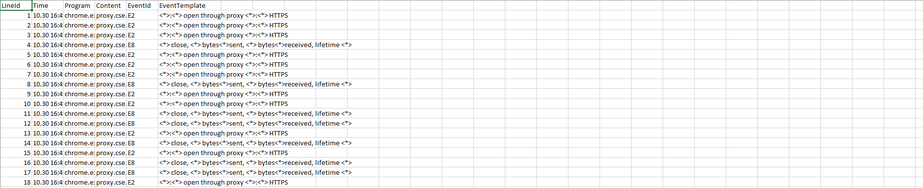

- Spark
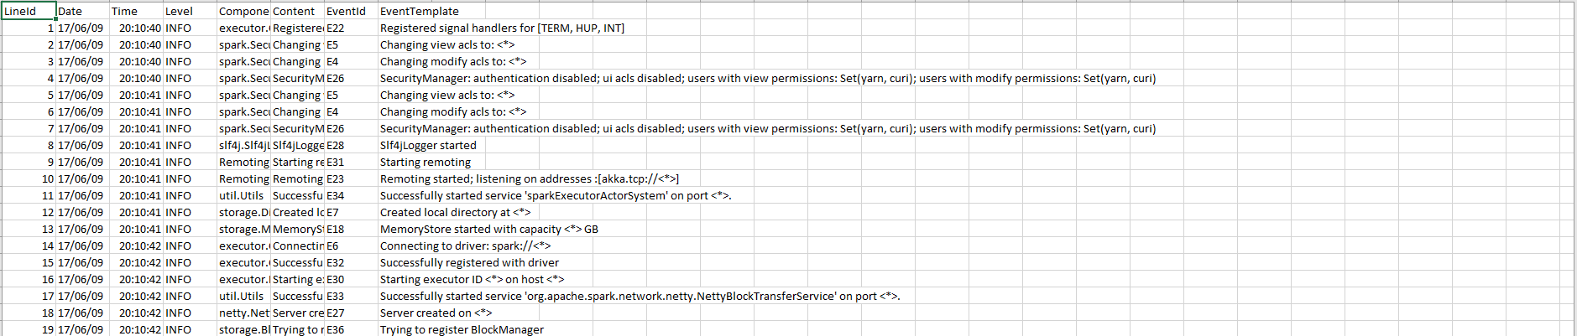
- ThunderBird
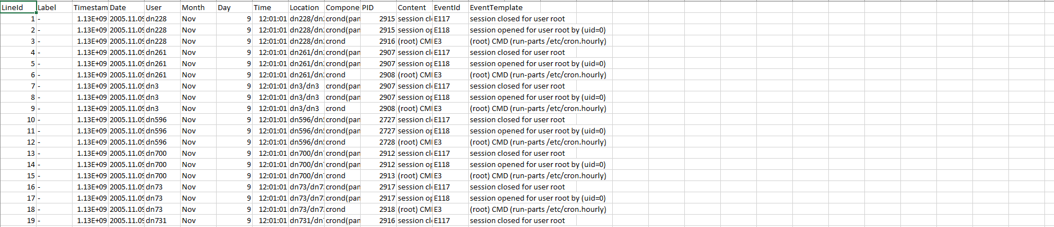
- Windows
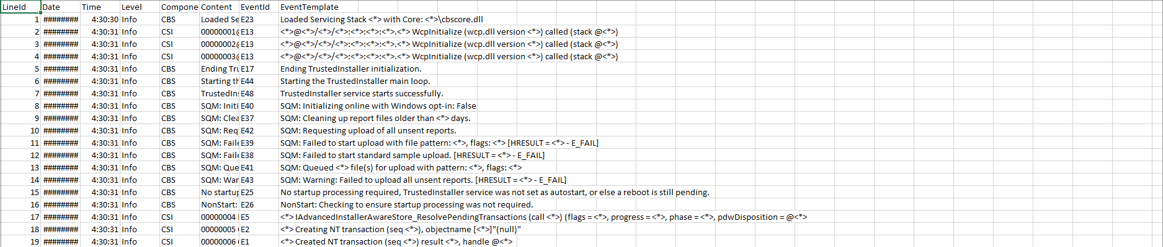

References

[1] J. H. Andrews: \Theory and practice of log file analysis." Technical Report 524, Department of Computer Science, University of Western Ontario, May 1998.

[2] J. H. Andrews: \Testing using log file analysis: tools, methods, and issues." Proc. 13 th IEEE International Conference on Automated Software Engineering, Oct. 1998, pp. 157-166.

[3] J. H. Andrews: \A Framework for Log File Analysis." http://citeseer.nj.nec.com/159829.html

[4] J. H. Andrews, Y. Zhang: \Broad-spectrum studies of log file analysis." International Conference on Software Engineering, pages 105-114, 2000

[5] J. H. Andrews: \Testing using Log File Analysis: Tools, Methods, and Issues." available at http://citeseer.nj.nec.com

[6] M. Guzdial, P. Santos, A. Badre, S. Hudson, M. Gray: \Analyzing and visualizing log files: A computational science of usability." Presented at HCI Consortium Workshop, 1994.

[7] M. J. Guzdial: \Deriving software usage patterns from log files." Georgia Institute of Technology. GVU Center Technical Report. Report #93-41. 1993.

[8] Tec-Ed, Inc.: \Assessing Web Site Usability from Server Log Files White
Paper." http://citeseer.nj.nec.com/290488.html

Terms & Conditions
Interns shall be solely responsible for all its acts and omissions under this program. Interns will comply at all times with all applicable laws. Interns shall not use Cognizant’s name, logo and trademark in any promotional materials or other communications with third parties without the prior written consent of Cognizant. Any materials used by interns in relation to program will not infringe the copyrights, trademarks, patents, trade secrets or other intellectual property rights, privacy or similar rights of any person or entity. Interns agrees not to post, draw, make, display any content that is threatening, libelous, obscene, defamatory, abusive, pornographic, or advocates/encourages any conduct that could constitute a criminal offence or give rise to any civil liability. Cognizant its associates’ personal details including but not limited to name, address, contact number shall not be shared or forwarded to any third party, without prior written consent of Cognizant, its associates. All intellectual property provided by Cognizant as part of program shall be owned exclusively by Cognizant. Intern shall indemnify, defend and indemnify Cognizant its associates, officers, directors from and against any claims, demands, loss, damage, liability, causes of action, judgments, or costs and expenses of every nature (including attorney’s fees and expenses) incurred by Cognizant based on any claim that any breach of terms and conditions of this program.

