1. Unzip NumberToWords.zip
2. Import NumberToWords project into eclipse as a maven project.
3. Compile and the run the SpringBootdApplication.java as a Java

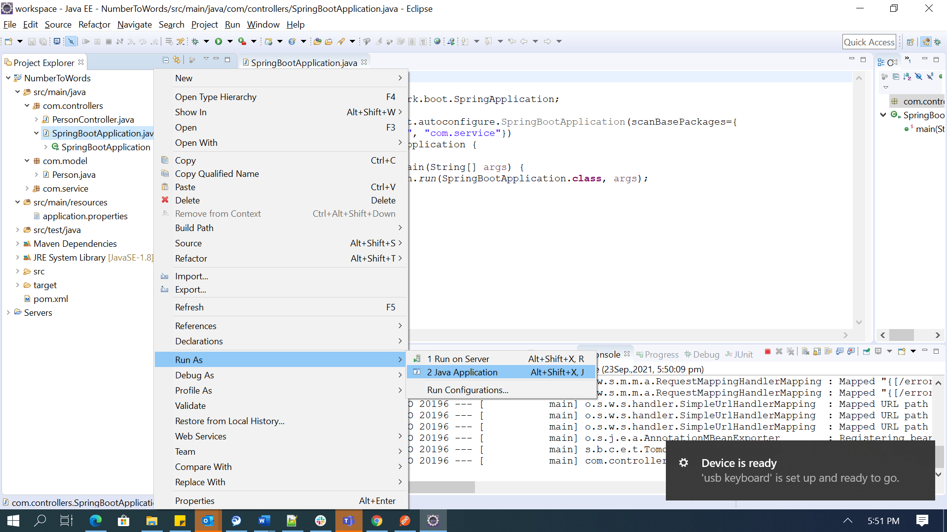

1. <http://localhost:8080/convert?name=puneet&money=924.6>
2. 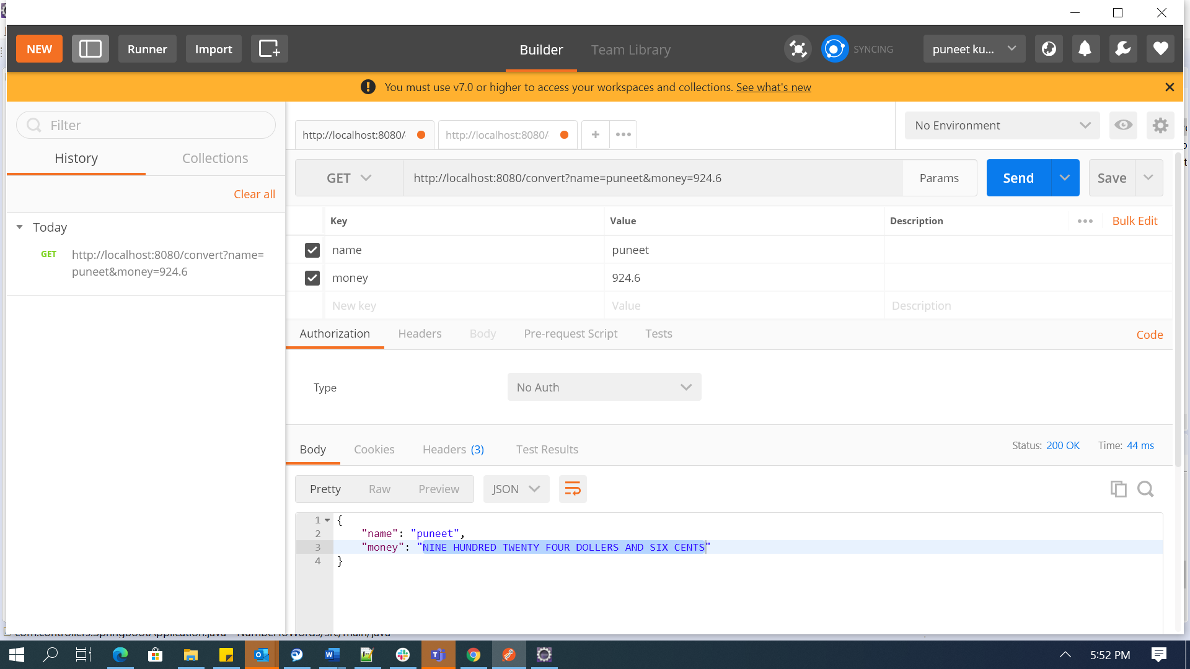
3. Junt test cases

