

Natural Language Processing Assignment-01

NAME | Masupalli Kushwanth
REG NO | 23BCE9362
SLOT | E2
FACULTY | GUNDIMEDA VENUGOPAL
COURSE CODE | CSE 3015
DATE | 21-01-2026

Git-hub link whole study :
https://github.com/kushwanth-masupalli/ac/tree/main/NLP/assignment
Source code :
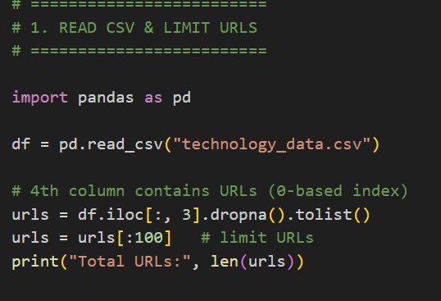
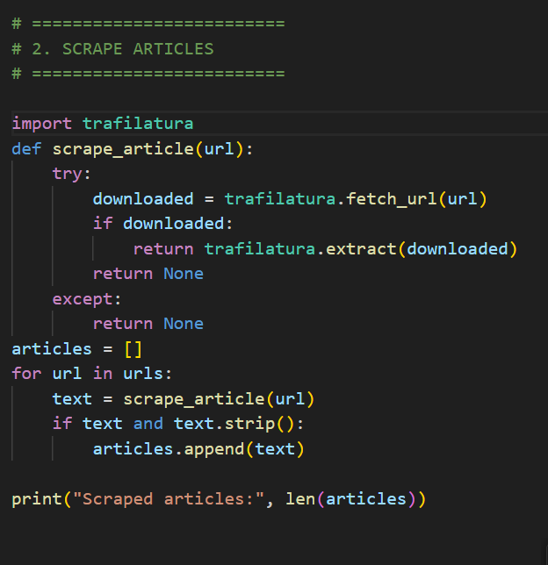
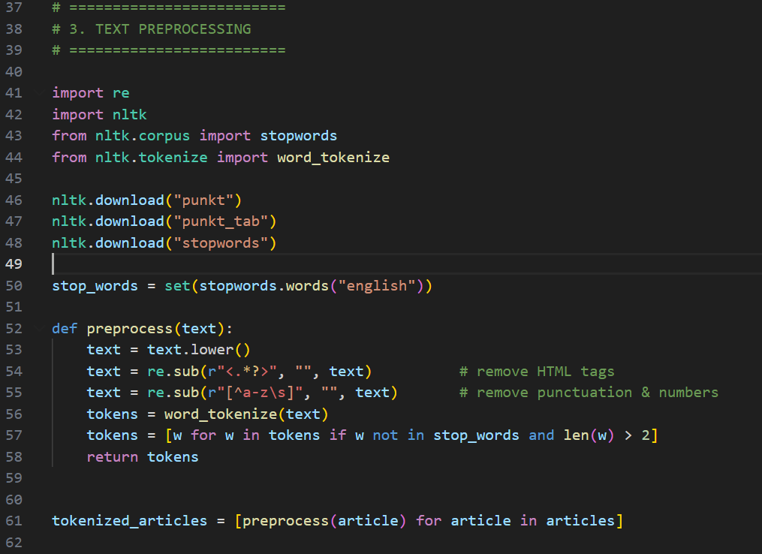
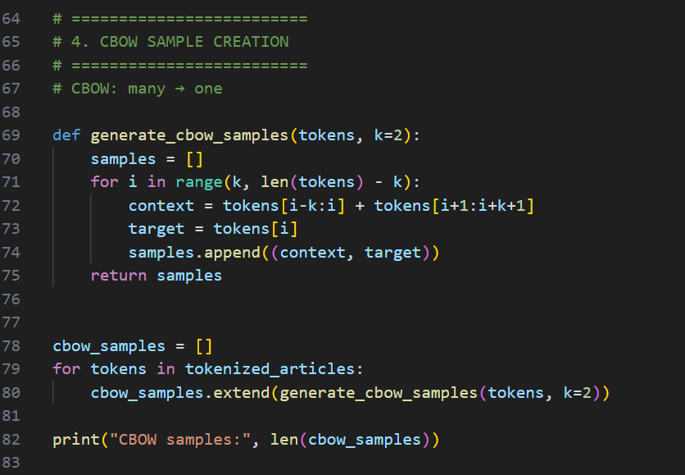
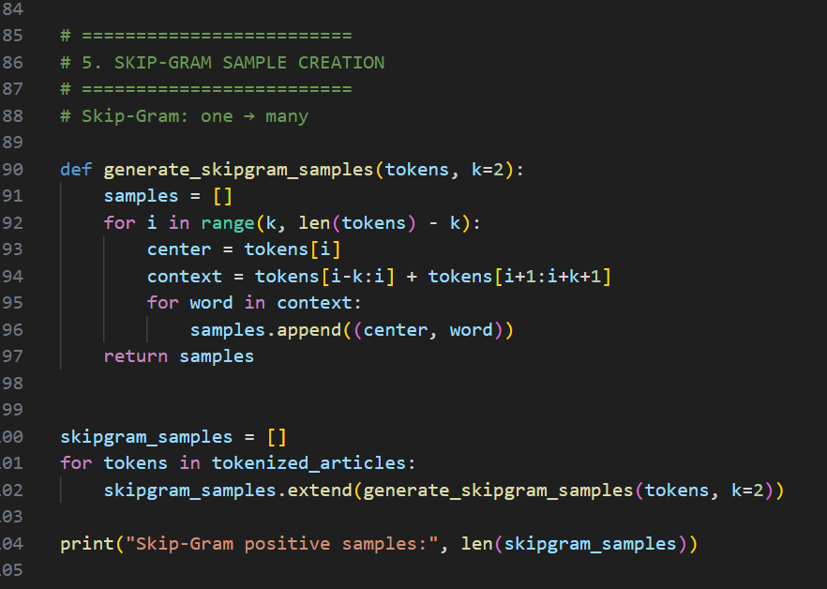
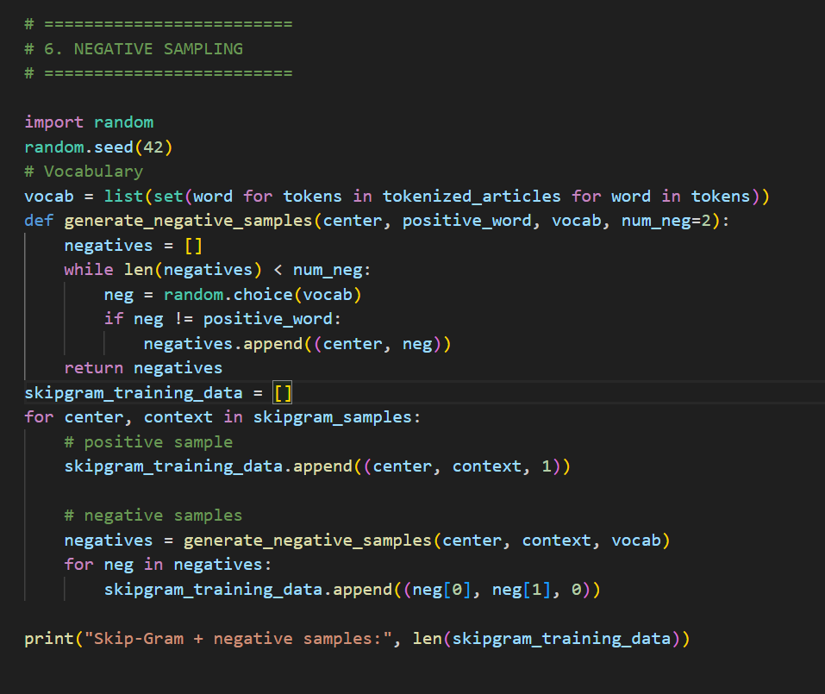

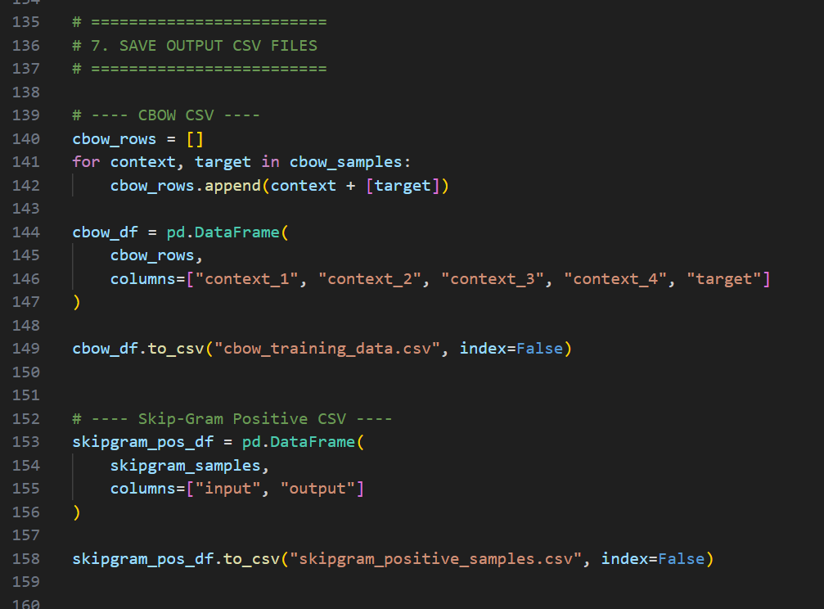
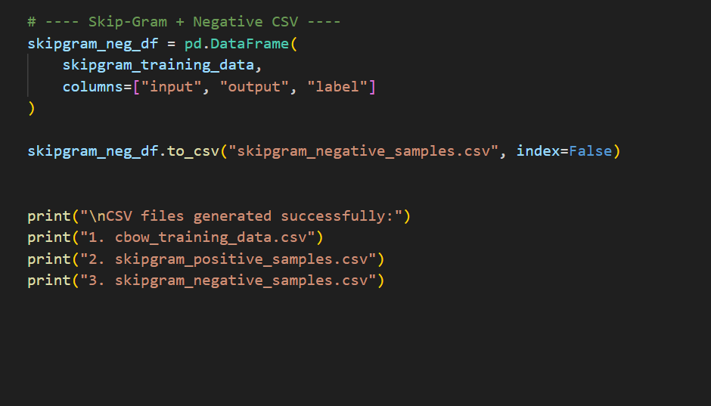

Output :
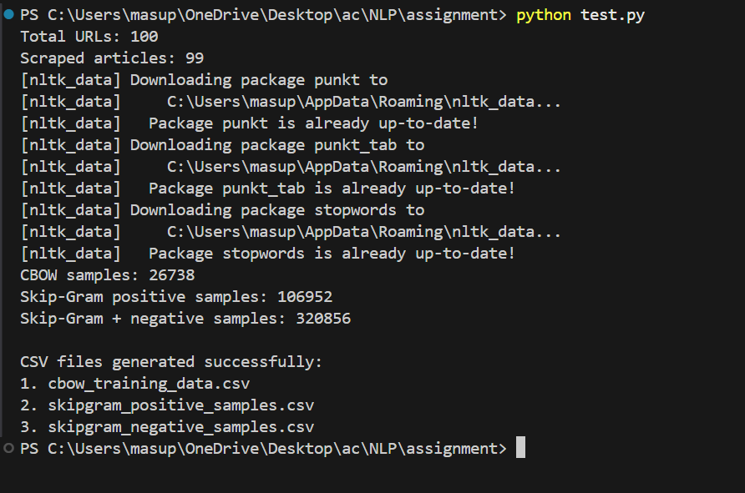

Cbow training data csv head :
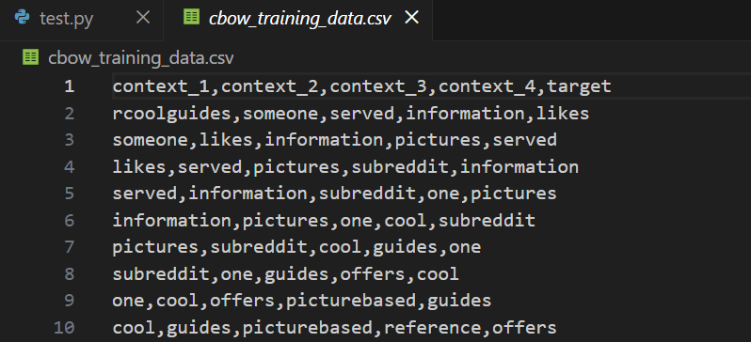

Skip gram training data +ve samples head :

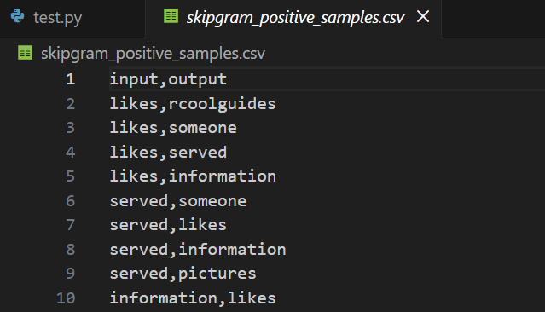

Skip gram training data +ve samples head :
