Course Code: CSE4004 |  | Course Title: Web Technologies | TPC | 3 | 2 | 4
Version No. |  | 4.0
Course Pre-requisites/ Co-requisites |  | None
Anti-requisites (if any). |  | SWE4001
Objectives: |  | - Understand state-of-the-art in Client-side application development web technologies, architectures, and applications.  - To get hands on experience on various Full Stack Development tools and techniques.  - To understand Java script ES6 features to perform CRUD operations
CO's Mapping with PO's and PEO's
Course Outcomes | Course Outcome Statement | PO's / PEO's
CO1 | Understand basic concepts of web technology and markup languages, CSS | PO1, PO2, PO3, PEO1, PEO3
CO2 | Designing static and dynamic web pages | PO2, PO3
CO3 | To understand open-source object-relational database management system (DBMS) that provides enterprise-level services, including high performance and scalability using MongoDB. | PO2, PO3
CO4 | Explore different ES6 features in Java script. | PO2, PO3
CO5 | To focus on contemporary front-end technologies like React | PO2, PO3
CO6 | To understand data access through NodeJS | PO2, PO3
CO7 | To Learn complete web development process | PO2, PO3
TOTAL HOURS OF INSTRUCTIONS: 45
a
Module No. 1 | Introduction to Web Design |  |  |  | 8 Hours
Introduction to HTML 5, syntax, attributes, events, SVG, Web storage, Introduction to Canvas, Audio & Video, Geolocations, Drag & Drop, Web workers, working with Fonts, working with other graphics.
Style sheets: Introduction CSS, Applying CSS to HTML, Selectors, Properties and Values, CSS Colors and Backgrounds, CSS Box Model, CSS Margins, Padding, and Borders, CSS Text and Font Properties
Module No. 2 | JavaScript & AJAX |  |  |  | 7 Hours
Client-side Scripting using Java Script, Java Script Language basis: variable, operator, conditions, loops, string, array, object, event, functions, DOM Manipulation, Client-side form validations, AJAX, Reading XML and JSON.
Module No. 3 | CRUD Operations |  |  |  | 6 Hours
Importance of NoSQL databases, Data types, Documents, nested Documents, CRUD Basics, Introduction to MongoDB, creating databases, Operations, Storage Classes, Indexing Aggregation, Replication, Sharding, Atomic Operations.
Module No. 4 | ES6 Features |  |  |  | 8 Hours
Introduction to ES6 features, ES5 vs Es6, Scoping - var vs let vs cons, Arrow functions, default parameters, destructuring elements, Higher order functions, defining classes, accessing data members, constructors, inheritance, super.
Module No. 5 | React JS |  |  |  | 8 Hours
ReactJS: Introduction, Templating using JSX, Components, Rendering, State and Props, Types of Components – Component Lifecycle, Forms and User Input, Event Handling, Communicate between Components, React Routing, Introduction to Hooks, State management.
Module No. 6 | Node JS |  |  |  | 8 Hours
Overview, Node JS - Basics and Setup, Node JS Console, Node JS Command Utilities, Node JS Modules, Node JS Concepts, Node JS Events, Node JS with Express JS, Case Studies for building dynamic web applications
Text Books
- HTML5, Black book, Dreamtech Publications, 2nd Edition, 2016
- Greg Lim. (2017). “Beginning React”, Createspace Independent Publisher.
- Manu Sharma. (2022). “Full Stack Development with MongoDB”, 3rd Edition, BPB Publishers
- Subramanian, V. (2019). Pro Mern Stack: Full Stack Web App Development with Mongo, Express, React and Node. Apress.
References
- Ramgir, M. (2020). Full Stack Java Development with SPRING MVC, Hibernate, jQuery, and Bootstrap. Packt Publishing.
- Hinkula, J. (2018). Hands-on Full Stack Development with Spring Boot 2.0 and React: Build Modern and Scalable Full Stack Applications Using the Java-based Spring Framework 5.0 and React. Packt Publishing Ltd.
Lab Exercises

- Create the following patterns using HTML and CSS only.
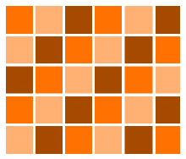
- Implement Drag n Drop feature in HTML 5
- Design a Calculator using Java script and relevant CSS.

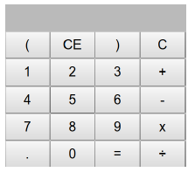
- Design a 6*6 Sudoku solver using DOM.
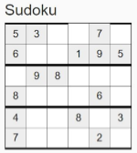
- Design an Income Tax Calculator with using Java script and CSS.
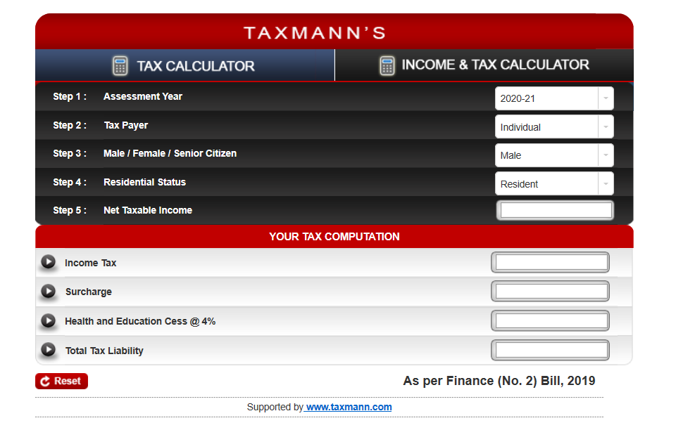

- Create a schema in MongoDB and Demonstrate CRUD operations using MongoDB

- Establish a connection with a database or access any tabular data source using Java Driver to do the following operations.
a) Send various MongoDB statements.
b) Retrieve and process the results received from the database

- Download a zip code dataset at http://media.mongodb.org/zips.json .Use mongo import to import the zip code dataset into Mongo DB. After importing the data,
answer the following questions by using aggregation pipelines:
(1) Find all the states that have a city called “BOSTON”.
(2) Find all the states and cities whose names include the string “BOST”.
(3) Each city has several zip codes. Find the city in each state with the most number of zip codes and rank those cities along with the states using the city populations.
Mongo DB can query on spatial information.

- Explore the features of ES6 like arrow functions, callbacks, promises, async/await. Implement an application for reading the weather information from openweathermap.org and display the information in the form of a graph on the web page.
- Create a Class Component for Counter, Changing the color of the text given, and viewing an array of objects in a tabular form in React JS

- Design a BMI calculator using React JS based on the description given below:
BMI is a measurement of a person's leanness or corpulence based on their height and weight, and is intended to quantify tissue mass. It is widely used as a general indicator of whether a person has a healthy body weight for their height.
Formula:
weight (kg) / [height (m)]2 (or) [weight (kg) / height (cm) / height (cm)] x 10,000

BMI table for adults: This is the World Health Organization's (WHO) recommended body weight based on BMI values for adults. It is used for both men and women, age 18 or older.
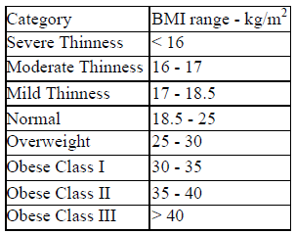

- Deploying React - Case Studies for building dynamic web applications
- Create a Node JS application to view EMI calculator. A specific view is given below:

- Create a TODO application in Node JS with necessary components and deploy it into github
- Design the following Hotel bill screen using Node JS. User can select as many items as possible from the dropdown box and is allowed to enter in the text field provided. Each transaction must be added in the table given below along with the bill amount.

Course Type |  | Embedded Theory and Lab(ETL)
Mode of Evaluation |  | Theory 75%  Continuous Assessment Test-1 15%  Continuous Assessment Test-2 15%  Digital Assignments/Quizzes 30%  Final Assessment Test 40%  Laboratory 25%
Modified by |  | Dr. Naresh Sammeta, Dr. Rajesh Duvvuri & Karthika Natarajan
Recommended by the Board of Studies on |  | 14th BoS, 11.05.2024
Date of Approval by the Academic Council |  | 12th Academic Council, 25.05.2024

