Annotations

- @Controller: @Controller will mark a class as a spring MVC contoller
It is responsible for :
- Handling http requests and returning views like .html
- There may be thousands of controller classes the dispatch servlet will route the request to the corresponding controller class
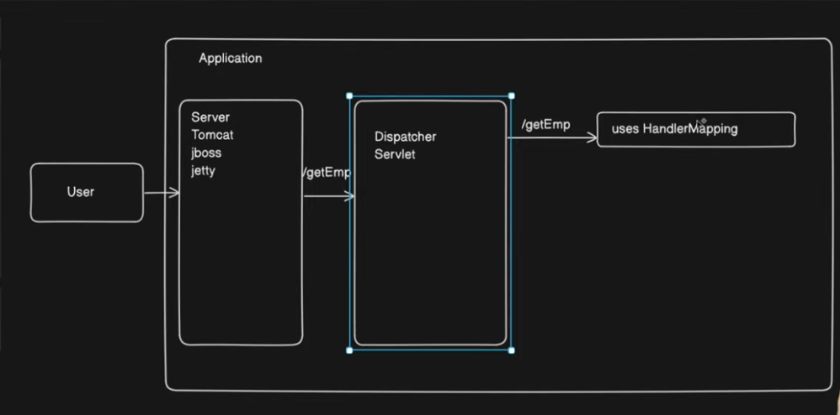

- @RequestMapping is used to map HTTP requests to a specific controller class or method.
* It can be used at both class level and method level.
* It defines:
URL path
HTTP method
- Content type (optional)
Modern Shortcuts (Recommended):
Shortcut Annotation | Equivalent To
@GetMapping | @RequestMapping(method = GET)
@PostMapping | @RequestMapping(method = POST)
@PutMapping | @RequestMapping(method = PUT)
@DeleteMapping | @RequestMapping(method = DELETE)

- @Response Body : Do NOT resolve a view. Whatever this method returns, send it directly as HTTP response body.
- @RestController : if you want the controller to be a rest controller not a controller that will send views we can make it as rest controller It sends whatever the method returns directly into response body.. so now we don’t have to use the resoponse body annotation for every controller method.
RestController = Controller + ResponsBody
- RequestParam : if the use send some id or some kind of data to the server to get some data , if you use this annotation before the actual parameter of the controller method, this method will expect that paremeter from the request of the user .
@RequestParam is used to bind query parameters from the HTTP request to method parameters in a controller. It tells Spring that the method expects a value from the request.
- PathVariable : @PathVariable is used to extract values from the URL path and bind them to method parameters in a controller.
🔥 Easy Memory Trick
@RequestParam → after ?
@PathVariable → inside /
- @RequestBody is used to bind JSON data from the HTTP request body to a Java object in a controller method

- @Component is used to mark a class as a Spring bean so that it is managed by the Spring IoC container.

- @Service : if you want to mark a class as a service class in spring mvc

- @Repository : if you want to mark a class a resposirty class in spring mvc . Converts database exceptions into Spring’s DataAccessException.

- @autowired : is used for dependency injection.

