- What is Bean?

Bean is a java object ,
A normal object in java is called as pojo (plain old java object)
If a pojo is managed by spring then it is called as bean .

- IoC container is the place where sping will take care of the beans and its life cycle
- Application contect Is the implementationo of the IoC container
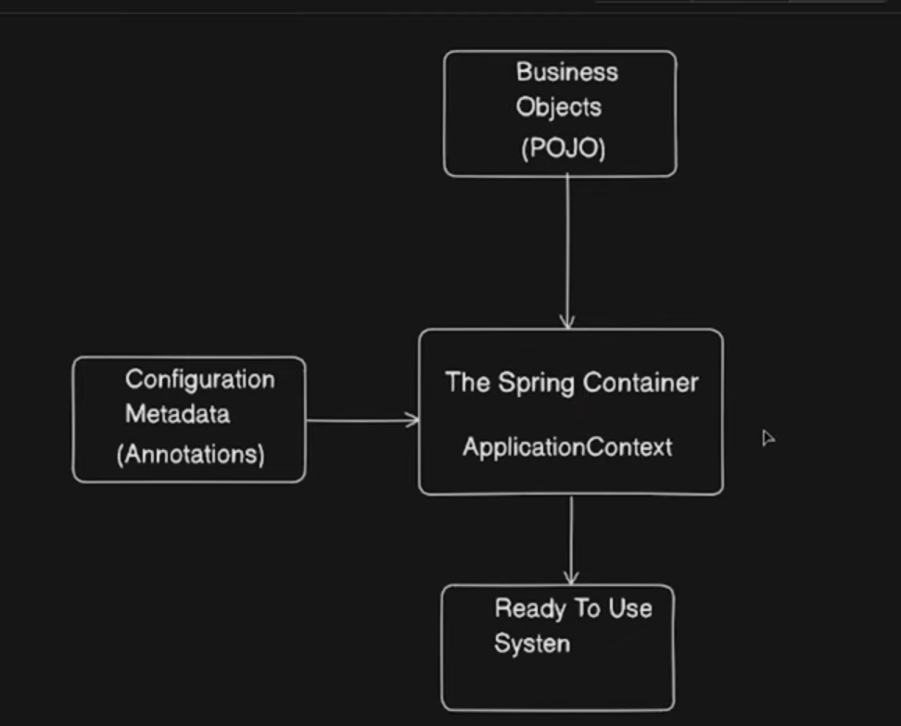

- How to check if the bean Is created or not
- Actuators = we need to donwload a dependecny (spring-boot-actuator) as well as web dependency because it returns the otuptu as http request. localhost:8080/actuators/beans . in the properties file we need to have a like like

Management.endpoints.web.exposure.include = * and the hit the endpoint mentioned above
- Application Context

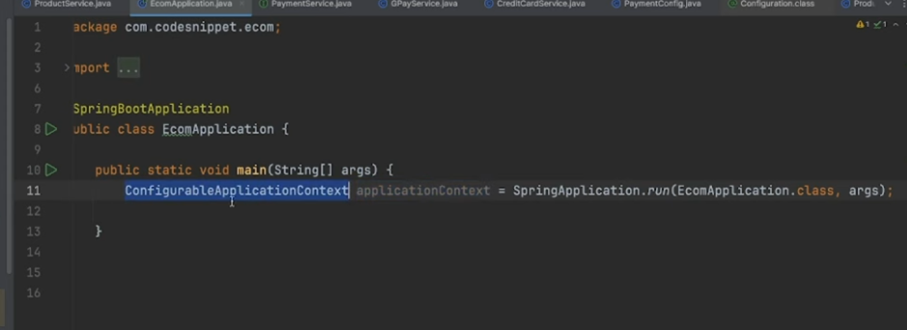

Check If Bean Exists

By name:
applicationContext.containsBean("myBean");
Returns:
true → bean exists
false → bean not present
By type:

applicationContext.getBean(MyService.class);
If bean exists → returns it
If not → throws NoSuchBeanDefinitionException

- There are two ways to create beans
- Annotation - @Component
- @Cofiguration and @Bean

2) 

