- What is dependecy injection ?

An object does NOT create the objects it depends on.
Instead, they are given (injected) from outside.

Why do we need it ?

The primary benefit of DI, as already mentioned, is that it decouples classes from its dependencies. A given class, instead of depending on a concrete class, can depend on an abstraction, that represents, in a higher-level, the needed behavior. What does that accomplish

- Types of Dependency Injection (TL;DR)
1️⃣ Constructor Injection ✅ (Best)
Dependency passed in constructor
Required dependency
Easy to test
Recommended in Spring Framework
if there are more than two constructors then we need too use the @Autowired annotation if there is only one constructor don’t need

2️⃣ Setter Injection
Dependency passed via setter
Optional dependency

@Autowired annotatoin is mandatory

3️⃣ Field Injection ⚠️ (Avoid)
Uses @Autowired directly on field
Hard to test
Not clean design

- Problems in di
- Circular dependecny -> A depends on B and B depends on A
- Unstatisfied dependecny : comes into picture when spring Spring tries to inject a dependency
BUT it cannot find a matching bean in the container.
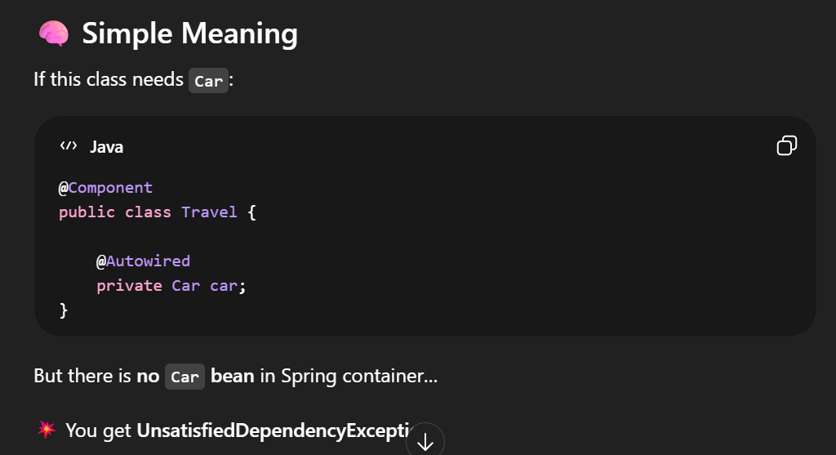

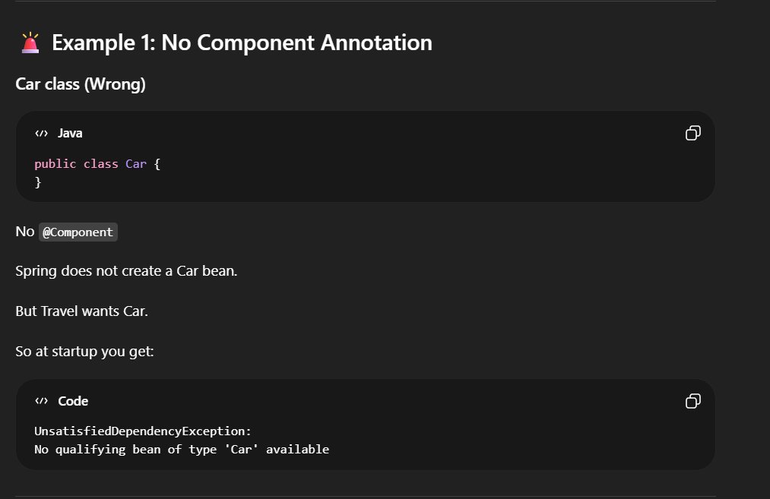
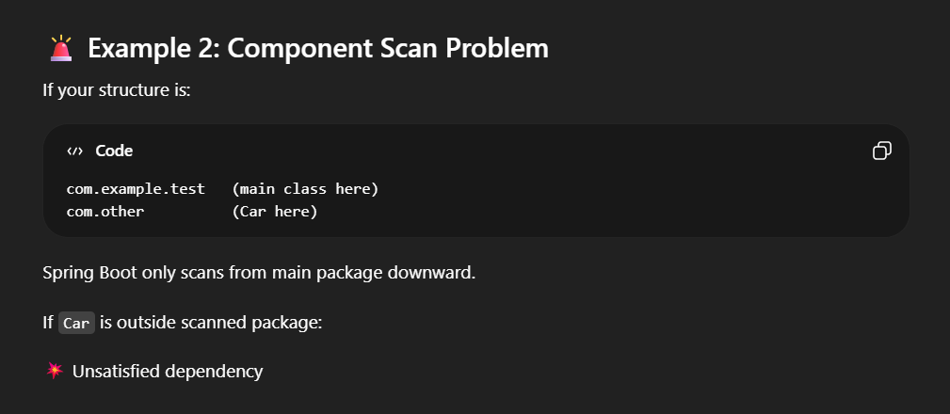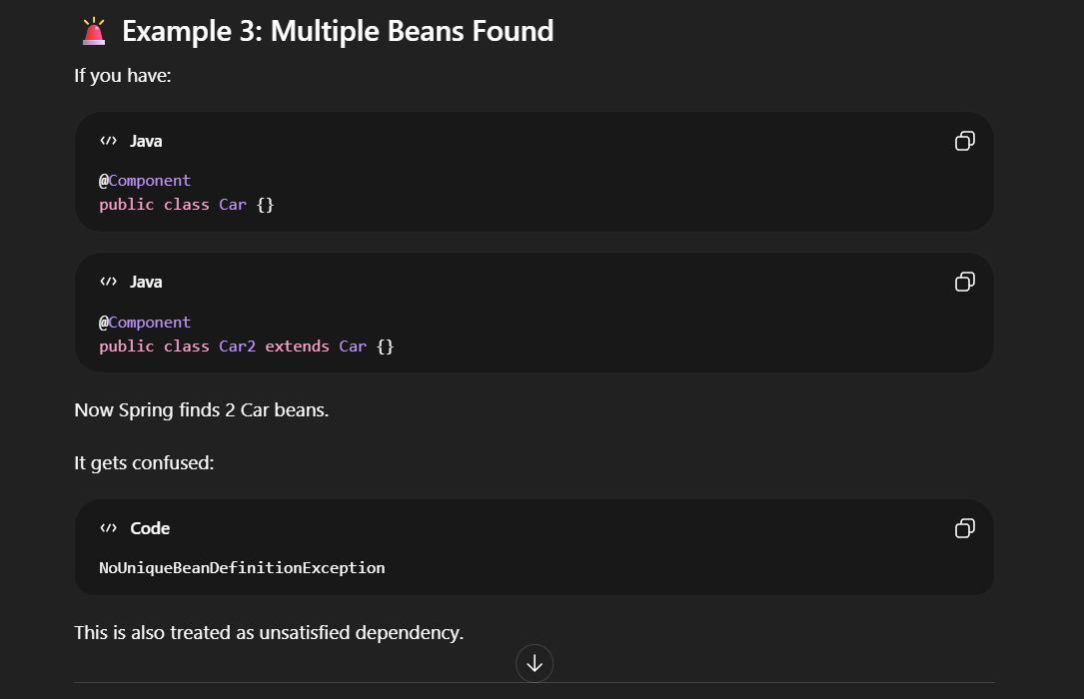

- For the third problem is the crucial one we can solve it using two ways


