AI - Based College Complaint Management System
S. Kushwanth Reddy  UG Scholar  Department of Artificial Intelligence & Data Science  Vel Tech Rangarajan Dr. Sagunthala R&D Institute of Science and Technology  Chennai– 600062, India  kushwanthsura@gmail.com | E. Krishna Sai  UG Scholar  Department of Artificial Intelligence & Data Science  Vel Tech Rangarajan Dr. Sagunthala R&D Institute of Science and Technology  Chennai– 600062, India  Ethamakulakrishnasai2006@gmail.com | L. Aneesh Euprazia  Assistant Professor  Department of Artificial Intelligence & Data Science  Vel Tech Rangarajan Dr. Sagunthala R&D Institute of Science and Technology  Chennai– 600062, India  draneesheuprazial@veltech.edu.in

Abstract — CampusDesk is a web-based college complaint management system with separate student, department-staff, and super-administrator pages. Its Express server checks campus relevance, recommends a department and priority, stores complaints in MongoDB, links related service reports, and supports staff review. The category and priority components are Multinomial Naive Bayes models trained on a supplied 3,000-row dataset. Each model used 2,056 training rows, 446 validation rows, and 498 held-out test rows. Both achieved 100% accuracy and 100% macro-F1 on validation and test splits. The dataset source and label provenance were not supplied, and its recurring phrasing may make this score optimistic. These results describe performance on this dataset only and do not establish accuracy on real campus complaints. Campus relevance screening remains rule-based and was not evaluated as a trained model.
Index Terms—complaint management, campus services, text classification, relevance screening, incident consolidation, human review.

I. Introduction
Students report campus service problems through different channels and may have difficulty identifying the responsible department or tracking related reports. CampusDesk provides a shared portal for hostel, mess, academic, network, transport, library, and general concerns. Students can follow their own reports; department staff handle assigned complaints; and a super administrator manages staff access and department assignments.
A prototype analysis of unrelated text, such as a request for dating advice, showed why priority keywords alone cannot determine whether a submission belongs in a campus complaint workflow. CampusDesk first applies a rule-based relevance check. Safety and student-conduct reports can pass the gate even when they do not match routine service categories. Category and priority outputs are recommendations that authorized users can review and change.
The reported model metrics were read from the repository artifacts trained on the supplied college_complaints_3000.csv file. The category target is department and the priority target is severity. Label provenance was not supplied, so the scores measure agreement with this dataset’s labels rather than independently verified staff judgments.

II. Related Work
Web-based complaint systems for tertiary institutions provide structured submission and follow-up. Alifat et al. describe a campus complaint portal for recording and tracking requests [1], while Anusiuba et al. present a web-based system for a tertiary institution [2]. These studies motivate centralized records and visible handling stages. CampusDesk builds on that workflow with server-side relevance rules, role-scoped access, text-classification services, and incident linking.
Complaint text can also be classified by subject. HaCohen-Kerner et al. study automatic assignment of Hebrew complaint letters to service-provider categories [3]. Yang and Liu compare text-categorization methods [4], and Joachims applies support vector machines to text features [5]. Later work explores convolutional neural networks for sentence classification [6] and transformer-based language representations [7], [8]. These methods offer alternatives for future experiments, but model selection depends on the availability of representative, labeled data.
Complaint urgency is a separate prediction task from sentiment. Jin and Aletras study the severity of complaint speech acts, highlighting the need to define urgency labels directly. Negative tone alone does not establish a safety emergency or a widespread service outage.
CampusDesk combines a learned priority suggestion with explicit safety rules and a staff override. The present priority labels come from the supplied dataset; they are not independently confirmed staff assessments. The reported priority metrics therefore measure agreement with those dataset labels.
The literature supports two design choices in this prototype. First, keep complaint records and workflow status visible when automated classification is uncertain. Second, evaluate any future model on campus-specific data using clearly documented labels. This paper does not claim that the Naive Bayes baseline outperforms the methods in these studies.

III. System Architecture and Workflow
The application provides separate URLs for the landing page (/), student dashboard (/student), staff dashboard (/staff), and super-administrator area (/admin). The browser sends same-origin requests to an Express server, which manages sessions, enforces role checks, and applies the relevance rules before a complaint is analyzed and saved. MongoDB Atlas stores users, complaints, history, and sessions; incident information is held in complaint records. SMTP supports password-reset codes. The optional FastAPI process serves category predictions; if it is unavailable, Express uses the local JavaScript classifier.
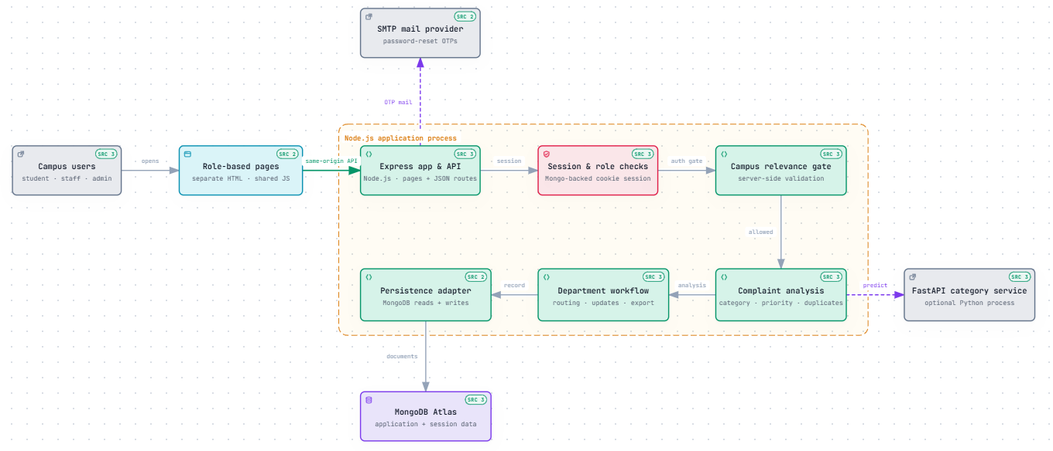

Fig. 1. Runtime architecture reconstructed from the current repository. Solid arrows show the main request and persistence path; the FastAPI category endpoint and SMTP mail provider are external dependencies.

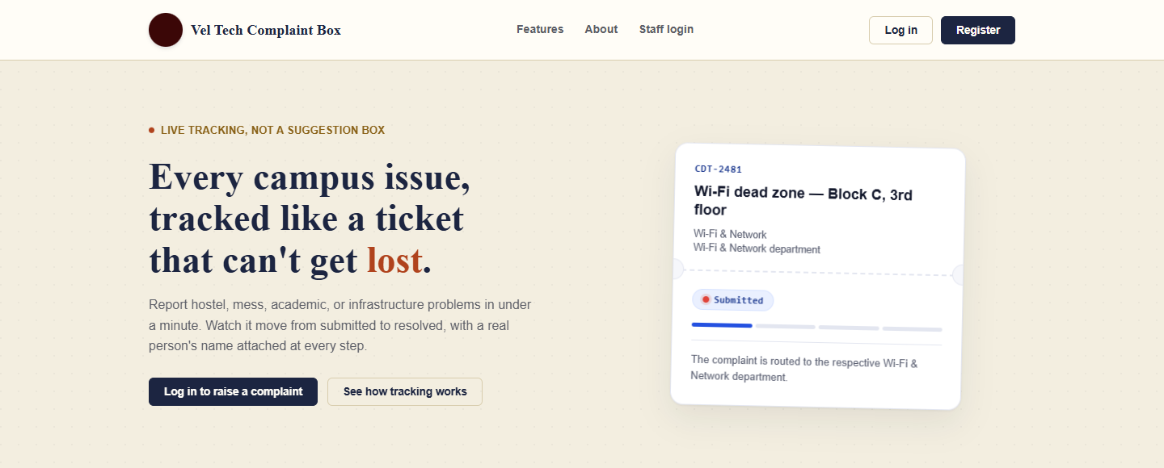

Fig. 2. Landing page with a sample complaint-tracking card shown by the interface.

A student submits a complaint with a title, description, department, and location. The server validates the request and applies the campus-relevance rules before saving it. For an eligible report, the application requests category and priority suggestions, applies a direct Critical override for recognized safety terms, and routes the complaint to authorized staff. Related reports may be linked to a shared incident while remaining separate complaint records.

The interface can show a summary, category and location signals, possible matching reports, and suggested next steps. The complaint is saved and routed to authorized staff in the selected department for review.
For supported service failures, incident matching considers category, normalized location, open status, and a ten-minute window measured from the first report. A matching failure signal or sufficient text similarity can link a new complaint to the incident. Each student report remains a separate record. When at least 20 distinct student accounts report the matching occurrence within the configured period, the incident is escalated to Critical. Staff can review linked reports together, while students see their own complaint histories.

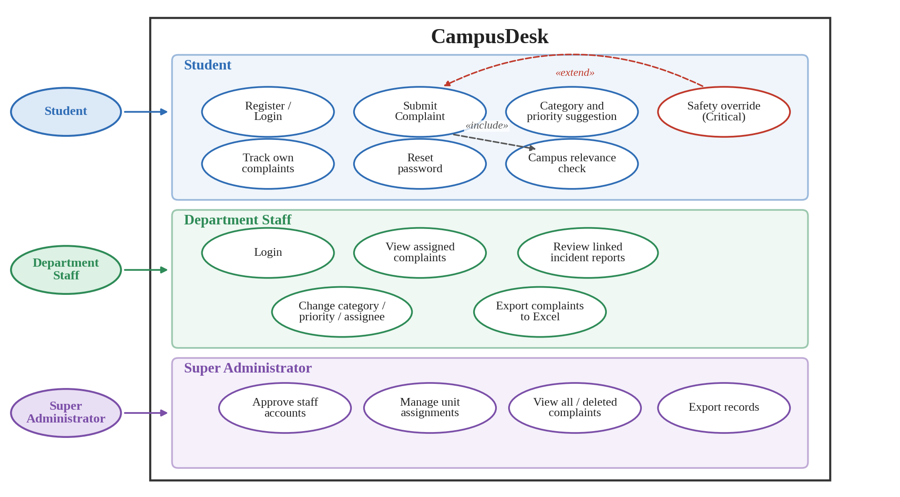

Fig. 3. Application instances based on roles, for the student users, section staff users and super-administrator users.

IV. Text Analysis and Incident Rules

A. Category and Priority Models
The repository includes serialized Multinomial Naive Bayes category and priority models. Both use unigram and adjacent-bigram text features. The category labels are Hostel, Mess, Academic, Wi-Fi & Network, Transport, Library, and General. The model returns a category and score-derived confidence value; this value is not a calibrated probability.
The priority model predicts Low, Medium, High, or Critical. Recognized safety terms trigger a direct Critical override before the learned suggestion is applied. Other priority suggestions come from the trained model; its labels originate from the supplied dataset and are not independently staff-confirmed.

B. Campus Relevance Screening
Campus relevance screening is implemented as server-side rules and runs during analysis and complaint creation. It blocks recognizable personal-advice requests, accepts text with campus context and an issue signal, and may request more campus detail when wording is unclear. Safety and conduct concerns, including harassment, bullying, threats, or assault, can pass without routine service context. This gate is not a trained model, and its accuracy has not been measured on a labeled relevance dataset.

C. Duplicate and Incident Handling
Duplicate and incident handling use text normalization and Jaccard similarity to identify possible matching complaints. Incident linking additionally checks category, normalized location, open status, and a ten-minute window anchored to the first report. Known service-failure signals can be matched directly; the fallback similarity threshold is 0.60. Escalation counts distinct student IDs so multiple submissions from one account do not inflate the affected-student total.

V. Implementation and Security
The interface uses HTML pages with shared CSS and JavaScript. Node.js and Express serve the page routes and JSON endpoints. MongoDB Atlas stores application data and sessions. Passwords and one-time reset codes are protected with bcrypt, and session cookies are HTTP-only. The optional Python FastAPI process exposes a category-prediction endpoint that reads the same JSON model artifact. It binds to localhost by default and should not be exposed publicly without appropriate access controls.

TABLE I
User Roles and Access Scope
Role | Scope | Typical actions
Student | Own records | Submit, track, review deleted reports, and give resolution feedback
Department staff | Assigned department | Review reports, update status and priority, add notes, export department records
Super administrator | System-wide administration | Approve staff, assign departments, manage users, and export all active complaints

VI. Algorithm
Algorithm 1 summarizes complaint processing. The server validates the student session and request, applies the rule-based relevance check, requests category and priority suggestions, applies the safety override, and saves and routes an eligible complaint. Incident matching may link the complaint to related reports. Authorized staff can review and adjust the resulting fields.

Algorithm 1: Complaint processing in CampusDesk
Input: complaint r = (title, description, category, location, student ID)
Output: saved complaint record and, when matched, an incident link
1: Validate the request and the student session.
2: if CampusRelevant(r) is false then return r for revision; do not save.
3: Request the category from FastAPI; if it is unavailable or invalid, use the local Node.js classifier.
4: Obtain the learned priority suggestion for r.
5: if r contains a recognized safety term then priority ← Critical.
6: Show identical and matching candidates with Jaccard similarity ≥ 0.45 on normalized writing.
7: Assign r to authorized staff of the selected division; save r as its own record.
8: if an open event correspondences category, normalized location, and the ten-minute window then link r to it.
9: if the event has ≥ 20 distinct student IDs within ten minutes then event priority ← Critical.
10: Authorized staff may evaluate and adjust category, priority, or task.
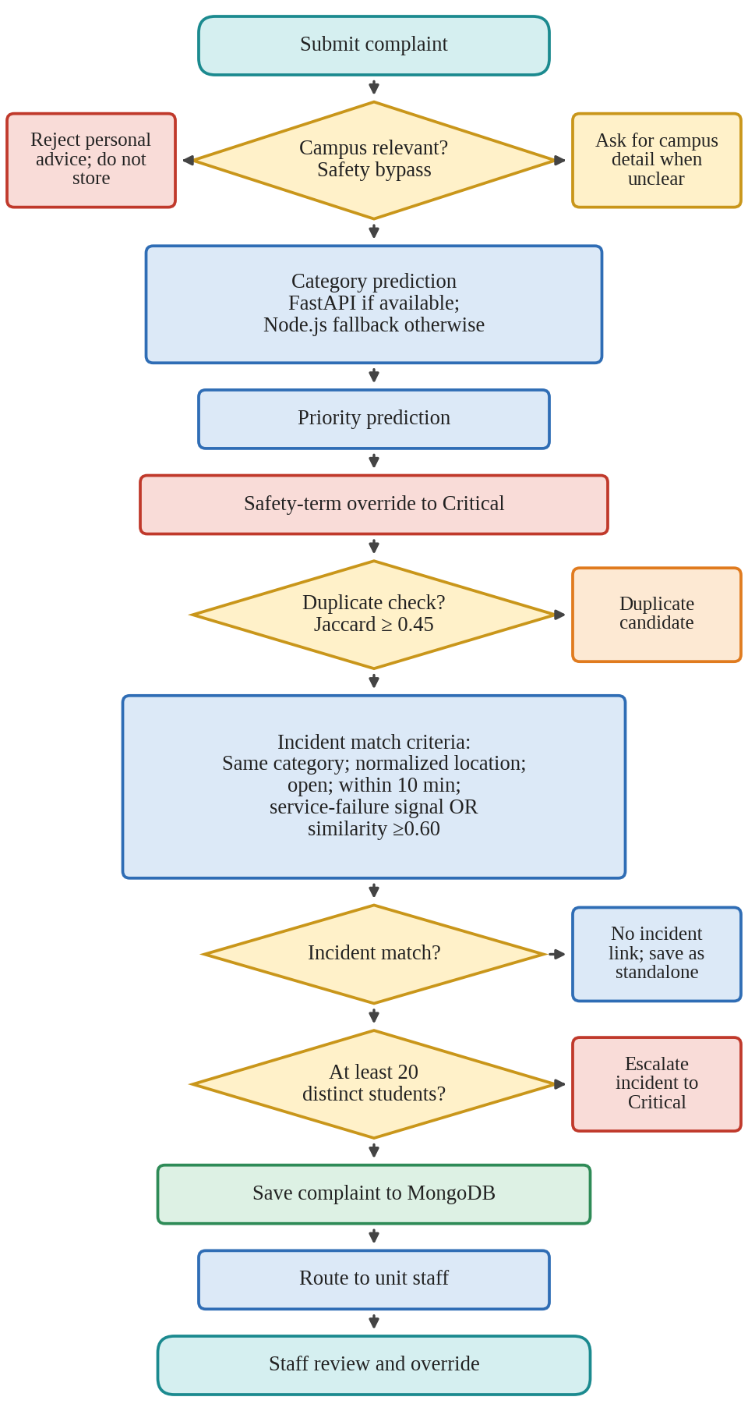

Fig. 4. Processing steps for a submitted complaint, from relevance screening to staff review.

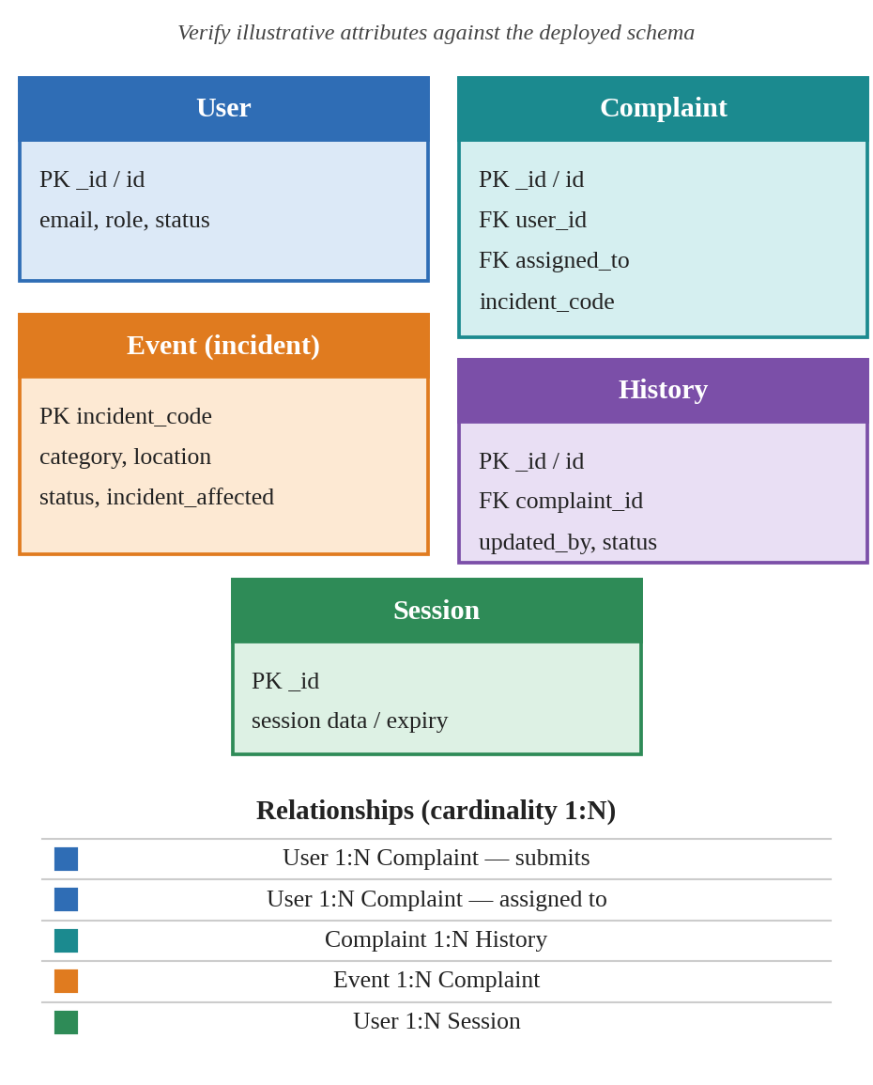

Fig. 5. Data model and relationships. Schema note: verify attribute names against the deployed schema. In this repository, an event is represented by incident fields on complaint records rather than a separate events collection.

VII. Validation
The supplied dataset contains 3,000 rows. The saved category and priority models each record 2,056 training rows, 446 validation rows, and 498 test rows. Splits are deterministic and group rows sharing the first five normalized tokens to reduce recurring-template leakage; validation coverage is checked for department and severity labels. Both models achieved 100% accuracy and 100% macro-F1 on validation and test data. The source and annotation provenance were not supplied, and recurring phrasing may still make the scores optimistic. Table II reports held-out test metrics; Fig. 7 shows the category confusion matrix, and Fig. 8 shows per-class F1 scores.
TABLE II
Saved Test Metrics of the Trained Models
Task | Training rows | Test rows | Accuracy | Macro-F1
Department category | 2,056 | 498 | 100% | 100%
Priority severity | 2,056 | 498 | 100% | 100%

Saved Test Metrics on the Supplied Dataset

Fig. 6. Complaint lifecycle from student submission to staff review and status revision.

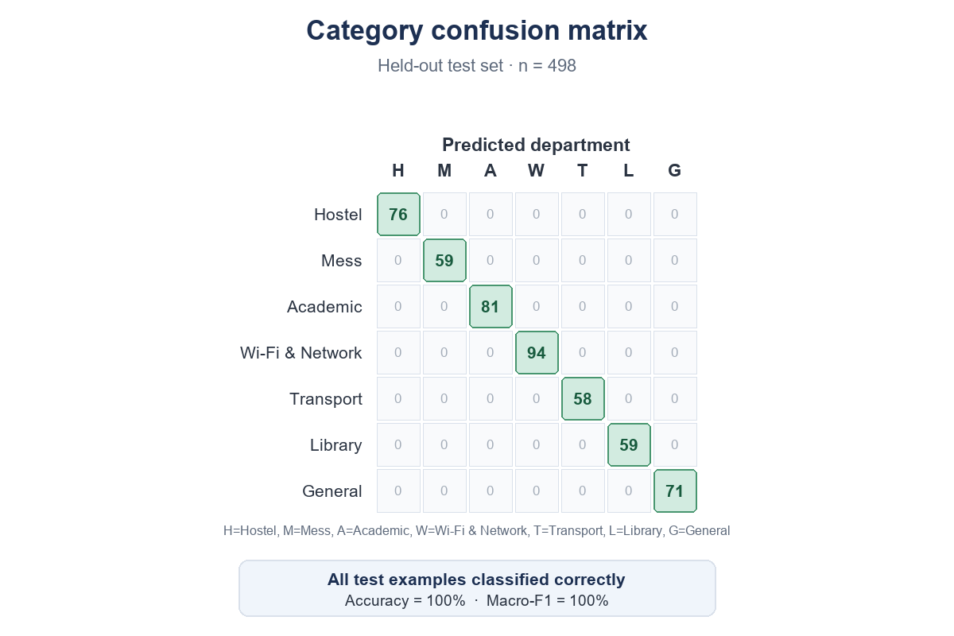

Fig. 7. Category confusion matrix on the 498-row held-out test set (rows: actual labels; columns: predicted labels). Diagonal values show class support.

VIII. Outcomes and Analysis
On the 498-row held-out test split, the category model achieved 100% accuracy and 100% macro-F1. The priority model achieved the same scores. Each department and severity class also had an F1 score of 1.00 on this split. These are perfect results on this dataset, not evidence of expected performance on real campus submissions: source and label provenance are unknown, and recurring wording may remain despite grouping by the first five normalized tokens. Priority metrics measure agreement with dataset severity labels, not independently reviewed staff judgments. Relevance screening is rule-based and has no labeled evaluation here. The repository contains tests for analysis, incident aggregation, database mapping, and browser behavior; this paper revision does not claim a new test run. Live Atlas concurrency, SMTP delivery, and deployment-scale behavior remain unverified.
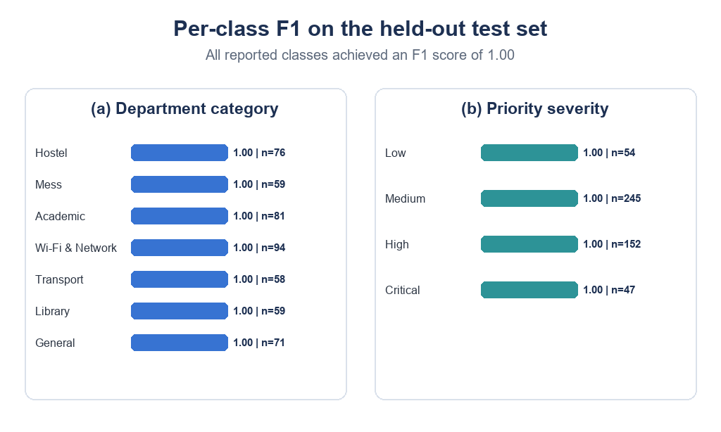

Fig. 8. Per-class F1 on the held-out test set for (a) department category and (b) priority severity; values are shown with class support.

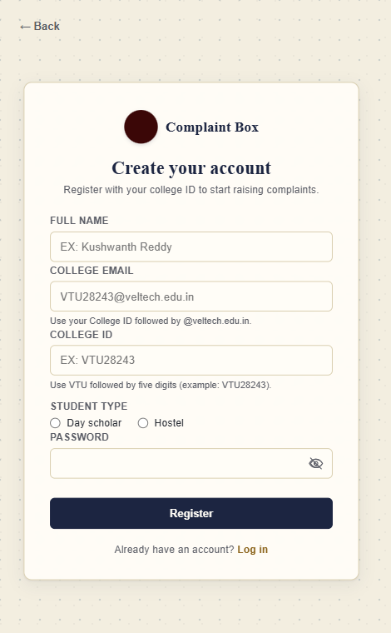 | 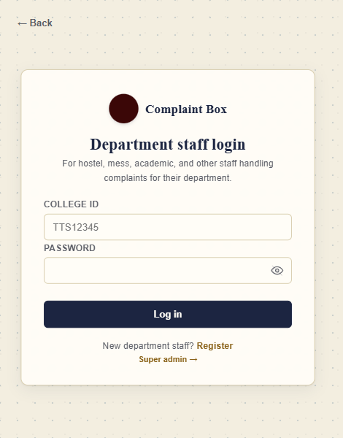 | 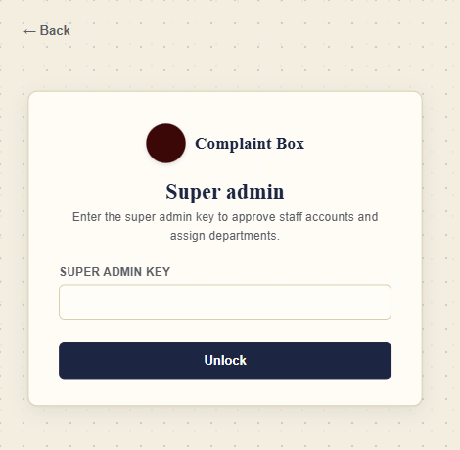
(a) Student registration | (b) Department staff login | (c) Super-administrator access

Fig. 9. Student registration, department staff login and super-administrator entry interfaces.

IX. Future Work and Implementation
Future work should build an anonymized, staff-labeled campus complaint dataset with clear guidelines for category, relevance, and urgency, including an option for uncertain cases. Evaluation should separately test relevance screening, category assignment, and priority prediction using group-separated data and per-class precision, recall, F1-score, and error examples. The current Multinomial Naive Bayes baseline can be compared with TF-IDF plus linear SVM and, if data and resources permit, a transformer model. Incident matching should be evaluated using staff-confirmed related and unrelated report pairs. The repository’s main implementation files include server.js, db/database.js, lib/complaint-ai.js, lib/incidents.js, and the public pages for student, staff, and administrator workflows. The figures show local prototype captures; no hosted live demonstration is claimed.

X. Advantages
The prototype preserves each student complaint and its status history while allowing related service reports to be linked to a shared incident. Role-scoped pages route work to assigned departments, and authorized staff can review or correct automated suggestions. Rule-based relevance screening helps keep unrelated personal-advice requests out of campus service workflows, while the local classifier provides category suggestions when the optional FastAPI process is unavailable. These are implemented functions; the reported dataset scores do not demonstrate production accuracy.

XI. Conclusion
This paper describes CampusDesk, a web-based complaint management prototype with separate role pages, Express APIs, session and role checks, rule-based campus relevance screening, learned category and priority suggestions, department routing, complaint histories, and incident linking. The saved Multinomial Naive Bayes artifacts were trained on 2,056 rows and evaluated on 446 validation rows and 498 held-out test rows from the supplied dataset. Both models achieved 100% accuracy and macro-F1 on validation and test data. Because source and label provenance were not supplied and the data contains recurring phrasing, these scores should not be treated as expected real-campus performance. Priority labels have not been confirmed by staff, and relevance screening has not been evaluated as a trained model. A de-identified, staff-reviewed campus dataset and broader evaluation are needed before relying on the predictions.

References
[2] Design and implementation of an institution web-based student complaint management system is presented by I. O. Anusiuba, K. Usman O. U. Ekwealor and J. O. Igbonekwu in Int. J. Softw. Hardw. Res. Eng. volume 9 number 8 pages 23–36 2021 doi: 10.26821/IJSHRE.9.8.2021.9802.
[3] Automatic classification of complaint letters according to service provider categories is examined by Y. HaCohen‑Kerner, R. Dilmon, M. Hone and M. A. Ben‑Basan in Inf. Process. Manage. volume 56 number 6 article 102102 2019 doi: 10.1016/j.ipm.2019.102102.
[4] A re‑examination of text categorization methods is reviewed by Y. Yang and X. Liu in Proc. 22Nd Annu. Int. ACM SIGIR Conf. Res. Develop. Inf. Retrieval, 1999 pages 42–49 doi: 10.1145/312624.312647.
[5] Text categorization with support vector machines: Learning with relevant features is discussed by T. Joachims in Proc. 10Th Eur. Conf. Mach. Learn., 1998 pages 137–142.
[6] Convolutional neural networks for sentence classification is studied by Y. Kim in Proc. Conf. Empirical Methods Natural Lang. Process. 2014, pages 1746–1751, doi: 10.3115/v1/D14-1181.
[7] BERT: Pre‑training of two‑way transformers, for language understanding was introduced by J. Devlin, M.-W. Chang, K. Lee and K. Toutanova. It appears in the conference proceedings.Conf. North Amer. Chapter Assoc. Comput. Linguistics: Human Lang. Technol., 2019 pages 4171–4186, doi: 10.18653/v1/N19-1423.
[8] Attention is all you need is presented by A. Vaswani et al. In Proc. Adv. Neural Inf. Process. Syst. volume 30 2017 pages 5998–6008.

