Course notes

In this course we will install Python that's distributed with a scientific software package called Anaconda.

Anaconda makes the life of a developer easy because it packages many of the most essential Python features into a single, easily managed distribution.

We'll use many of the scientific libraries in later courses, so we'll install them now.

Installation steps:

1. Go to <https://www.anaconda.com/products/individual>

2. Navigate to the download section at the bottom of the page. You should see this:

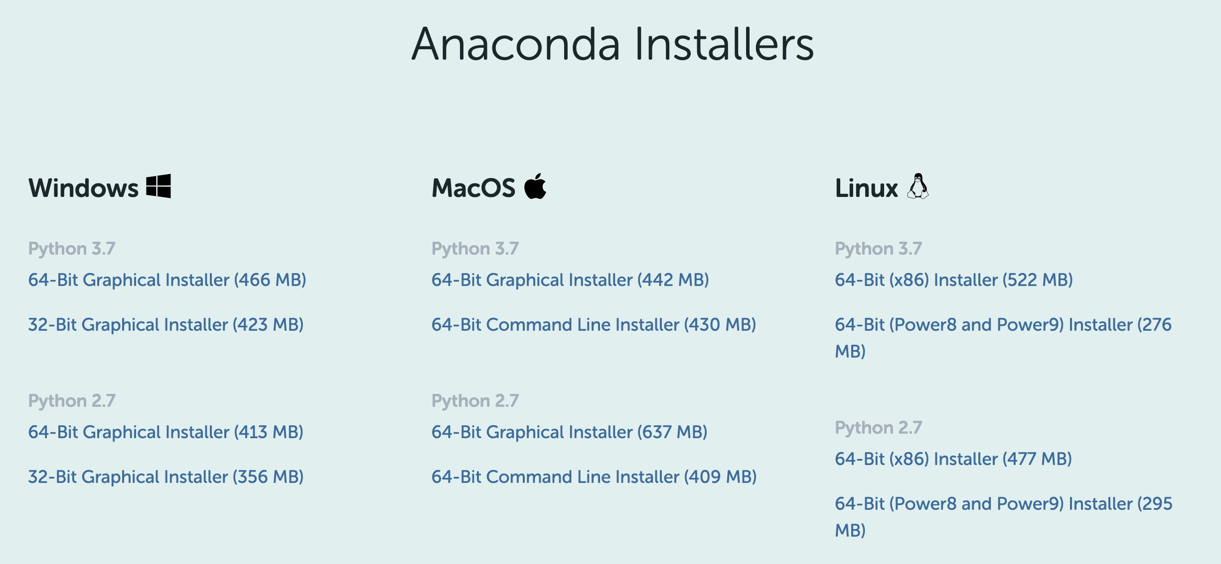What the install section looks like at <https://www.anaconda.com/products/individual>

3. Click on the "64-Bit Graphical Installer" for Python 3.7 for your particular operating system (eg Windows). Save the file to your computer.

4. Click on the installer file and you'll see the install dialogue box come up, as follows:

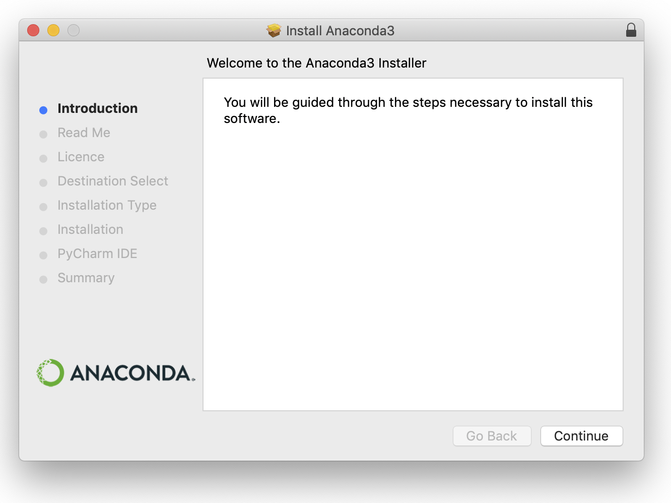

5. Click through the installation process (above). Agree to the license conditions when prompted. Use the default install location.

**Congratulations, you've got Python on your machine!**