Lab Excercises
Lab Exercises for - ASP.NET

Lab 1
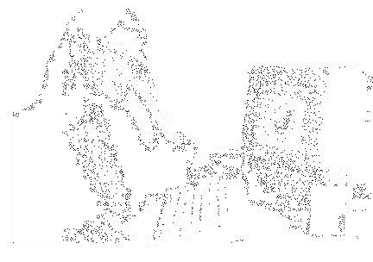
Excercise 1

Write a program to display the following feedback form.

The different options for the list box must be ASP-XML, DotNET, JavaPro and Unix,C,C++. When the Submit Form button is clicked after entering the data, a message as seen in the last line of the above figure must be displayed.
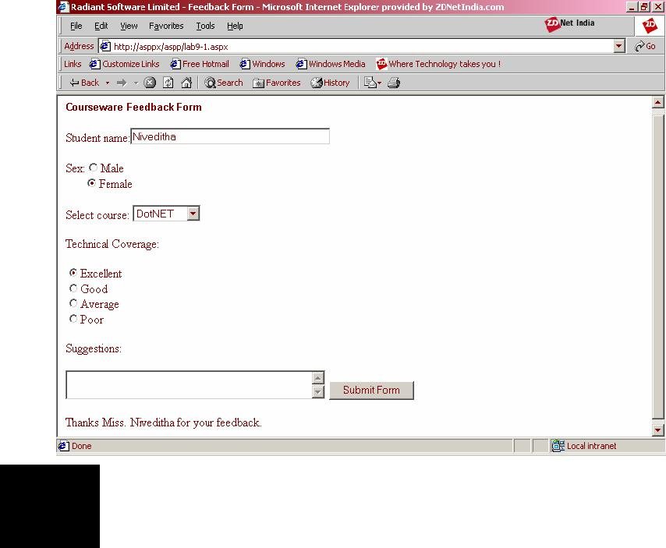

Excercise 2

Write a program to display three images in a line. When any one of the images is clicked, it must be displayed below. On clicking the displayed image it must be cleared. The screen must look as in the figure given below:
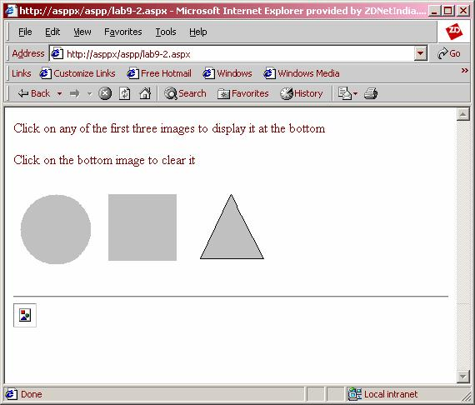

Lab 2

Excercise 1

Write a simple ASP.NET program to display the following Web Controls:

- A button with text “click me”. The button control must be in the center of the form.

₁

ASP.NET
- A label with a text hello

- A checkbox.

The form name must be Web Controls
Excercise 2

Write a program to display “Welcome To Radiant” in the form when the “click” button is clicked. The form title must be ASP.NET.
Excercise 3

Write a program that displays a button in green color and it should change into yellow when the mouse moves over it.

Lab 3

Excercise 1

Write a program containing the following controls:

- A ListBox

- A Button

- An Image

- A Label

The listbox is used to list items available in a store. When the user clicks on an item in the listbox, its image is displayed in the image control. When the user clicks the button, the cost of the selected item is displayed in the control.
Excercise 2

Extend the above program to add the following controls:

- Two labels

- A TextBox

- A Button

One of the labels is displayed adjacent to the textbox , displaying the message “Enter the quantity:”. When the user enters the quantity in the textbox and clicks the button, the total cost is evaluated and displayed in another label.
Excercise 3

Write a JavaScript program to display a calendar with the following specifications:

- The width of the border is 10 units

- The border is set to inset style

- The cellpadding is set to 1

- The cellspacing is set to 4

- The height of the calendar is 300px

- The width of the calendar is 500px

- The Days are displayed as “Sun”, “Mon” etc.

- The first day of the week is Saturday
2

Lab Excercises
- The days are displayed in brown color

- The names of the next and previous months are displayed as full months

- The next and previous months are displayed in white color

- The days of other months are displayed in gray color

- The SelectionMode is set to DayWeekMonth

- The background color of the selected day(s) is lightblue

- The background color of the selector tab is lightgreen and its text is in black

- The current day is set to blue color and its text is made bold

- The background color of the title is green, its text is white and it is made bold
Excercise 4

Write a JavaScript code that displays two advertisements alternately. When the user clicks on one of the advertisements, he/she is redirected to “www.amazon.com”, and the other advertisement redirects the user to “www.fabmart.com”. The weightage of the amazon advertisement is 50 and that of the other one is 40. The advertisement should be centered horizontally and should cover 60% of the width of the screen. Its height should be 80 units. The width of the border should be 5 units.

Lab 4

Excercise 1

Write a program to get a user input such as the boiling point of water and test it to the appropriate value using CompareValidator.
Excercise 2

Write a program that uses a textbox for a user input name and validate it for RequiredField Validation.
Excercise 3

Write a prgoram that gets user input such as the user name, mode of payment, appropriate credit card. After the user enters the appropriate values the Validation button validates the values entered.

Lab 5

Excercise 1

Create a Form that receives the user name, address, date, nationality, country preferred for working and skill sets from the user and stores the user name in the client using cookies. The country preferred data should appear in a dropdownlist whereas, others should be entered in a textbox. Validate all the controls. The Form is named “formexp.aspx”. The date should appear between “1/1/1900” and “1/1/2090”.

Lab 6

Excercise 1

Create an application that illustrates how a content can be buffered.
3
ASP.NET
Lab 7

Excercise 1

Create a Global.asax file with Application variables cont, color1 and gotohp. Create a Session variable called cont1. Initialize cont as 0 and assign any color to color1. For the variable gotohp, give a hyperlink to any Website. Use the variables in a Web Form. Try these with the lock and unlock methods.

Lab 8

Excercise 1

1. Create table CANDIDATE with the following columns and datatypes

 |  | Column name |  |  | Datatype
 |  | Ccode |  |  | Int
 |  | Name |  |  | Char(20)
 |  | DOJ |  |  | Date
2. |  | Insert few records into the table.
 |  | Code |  | 1001 |  | 1002 | 1003
 |  | Name |  | S.Raman |  | M.Sushil | Mohanyes
 |  | DOJ |  | 12-jun-97 |  | 12-nov-97 | 30-jul-97
3. |  |  | Change the candidate name from ‘S.Raman’ to ‘R.Krishnan’ in the first record in CANDIDATE
 |  |  | table.
4. |  |  | Drop the table CANDIDATE.
5. |  |  | Create table Employee with the following columns and datatypes.
 |  | Dept |  |  | Numeric
 |  | Name |  |  | Varchar(20)
 |  | Doj |  |  | Datetime
 |  | Sal |  |  | Float
 |  | Desgin |  |  | Varchar(20)
6. |  |  | Insert the following rows into the employee table.
 |  | 10 | Shruthi | 10-jan-98 |  | 4000 | Analyst
 |  | 10 | Shanthi | 12-jun-98 |  | 6000 | Manager
 |  | 20 | James | 03-jul-99 |  | 15000 | System manager
 |  | 20 | Goodwill | 13-dec-99 |  | 10000 | Senior analyst
7. |  |  | Display all the employees whose SAL is less than 3000
8. |  |  | Display all the employees who are working as MANAGER or ANALYST.
9. |  |  | Select all the employees who work in department 20 and whose salary exceeds 2000.
10. |  |  | Select the details of employees whose name starts with ‘J’.

₄

Lab Excercises
- Select the employee name, which has ‘o’ as 2 and 3 letter.

- Update the salary of employees by 1000 for those drawing less than 2000.

- Find out the average salaries of employees department wise.

- Create a table “students” with the below given column.

COLUMN | DATATYPE
Scode | number(6)
Sname | char(30)
Marks | number(3)

- Insert few records into the table.

- Delete those students who get less than 40 marks.

Lab 9

Excercise 1

Write a program to connect to the master database in SQL Server, in the Page_Load event. When the connection is established, the message “Connection has been established” should be displayed in a label in the form.
Excercise 2

Write a program to create a table emp in the master database with the following fields:

Field Name Datatype

eno | Integer
ename | Varchar(20)
salary | Float

Suppose the emp table contains the following records:

Eno | Ename | Salary
98 | Shalini | 9200
99 | Ramesh | 7800
100 | Rishab | 7000
101 | Dharani | 7800
102 | Vijay | 8500
103 | Yamuna | 9500
Excercise 3

Write a program that updates the ename field of the emp table with the given name, where eno=102.

Excercise 4

Write a program to select those rows from the emp table whose eno >=100.
5

ASP.NET
Lab 10

Excercise 1

Select the names of the employees from the emps table. Retrieve the result in a DataSet and display it in a CheckBoxList.

Excercise 2

Select names from the emps table. Retrieve the result in a DataSet. Bind the DataSet to a RadioButtonList and display the result in three diferent forms as follows:

- The RepeatDirection property of the RadioButtonList is set to horizontal and its RepeatLayout property is set to Table.

- The RepeatDirection property of the RadioButtonList is set to Vertical and its RepeatLayout property is set to Table.
- The RepeatLayout property of the RadioButtonList is set to flow.

Excercise 3

Create a Table, which displays two columns and three rows. The first row displays eno, the second displays ename and the third displays esal, all of these being retrieved from the emps table. Each of the above is displayed as a drop-down list, containing all the values of the corresponding column in the table.

Lab 11

Excercise 1

Write a program that binds the properties ID, Name, Price and Qty of a page to the following values:

ID: 10

Name: Wheat

Price: 14.25

Qty: 1000
Excercise 2

Create a RadioButtonList that displays the names of some flowers in two columns. Bind a label to the RadioButtonList so that when the user selects an option from the list and clicks on a button, the label displays the flower selected by the user.

Excercise 3

Bind a CheckBoxList to the pname field of the product table in the master database so that all the name of the product are displayed as a series of checkboxes.

6

Lab Excercises
Lab 12

Excercise 1

Write a program to display the records from the database as shown in the figure:
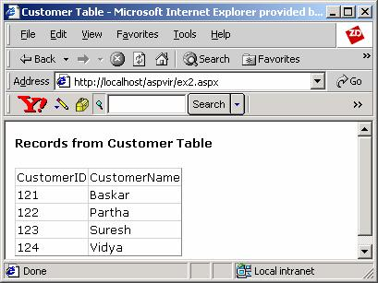

Note: Create a table Customer with records shown in the above figure.
Excercise 2

Write a program to implement the sorting feature in the customer table as shown in the figure:
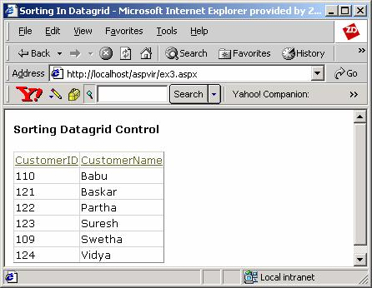

Note: Create a table Customer with records shown in the above figure.
7

ASP.NET

Excercise 3

Write a program to implement paging feature in the customer table as shown in the figure below.
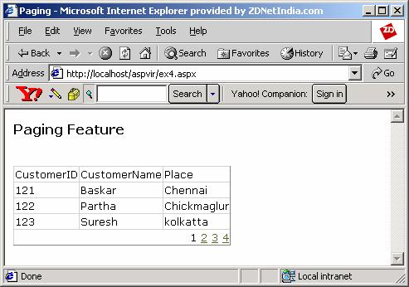

Note: Create a table Customer with records shown in the above figure.

Lab 13

Excercise 1

Write an application that contains a list of following technologies:

- ASP.NET

- ADO.NET

- C#

It also contains a textbox in which the user has to enter a name and a textarea in which the user has to enter his comments. When the Submit is clicked, the output should display the name entered in the textbox and the user-selection from the listbox. All the above should be displayed with the tracing for the page being enabled.

Excercise 2

Write a Web application that generates the “IndexOutOfRange” exception when a button is clicked. Instead of displaying the above exception, it redirects the user to a custom error page. All the above should be done with the trace for the page being enabled.

Excercise 3

₈

Lab Excercises

Write a Web application that retrieves the names of the employees from the emp table. The trace for the page should be enabled.

Lab 14

Excercise 1

Create a user control that contains a list of colors. Add a button to the Web Form which when clicked changes the color of the Form to the color selected from the list.

Excercise 2

Create a user control that displays the current date and time. Include it in a Web Form and refresh it each time a button is clicked.

Excercise 3

Create a user control that receives the user name and password from the user and validates them. If the user name is “Radiant” and the password is “asp.net” then the user is authorized, otherwise not.

Lab 15

Excercise 1

Create a component that receives two numbers from the user through a Web Form, and based on the user’s selection it adds or subtracts the two numbers and returns the result to the Web Form. The result should be displayed in the Web Form.

Excercise 2

Create two components, the first of which is an abstract class containing an abstract method. The second component should implement the first component’s abstract class and returns a string from the method. Display the result in a Web Form.
Excercise 3

Create a component that contains an array of 100 integers and a corresponding indexer. From a Web page, assign values to some of its elements. Then the Web Form should display the first 10 elements of the indexer.

₉

ASP.NET
Lab Solutions for - ASP.NET

Lab – 1

Exercise : 1

<html>

<head>

<title>Radiant Software Limited - Feedback Form</title> <script language=”C#” runat=”server”>
void Button1_Click(object Source, EventArgs e)

{

String str = “”;

if (Male.Checked == true) str=”Mr.”;
else if (Female.Checked == true) str=”Miss.”;

Message.InnerHtml=”Thanks “+str+” “+name.Value+” for your feedback.”;

}

</script>

</head>

<body>

<h5><font face=”Arial”>Courseware Feedback Form</font></h5> <form runat=server>
<p>Student name:<input id=”name” type=text size=40 runat=”server”><br>

<p>Sex:<input type=”radio” id=”Male” name=”Mode” runat=”server”/>Male<br> &nbsp;&nbsp;&nbsp;&nbsp;&nbsp;&nbsp;<input type=”radio” id=”Female” name=”Mode” runat=”server”/>Female<br>

<p>Select course: <select id=”ColorSelect” runat=”server”> <option>ASP-XML</option>
<option>DotNET</option>

<option>JavaPro</option>

<option>Unix,C,C++</option>

</select><br>

<p>Technical Coverage:</p>

<input type=”radio” id=”Excellent” name=”Mode2" runat=”server”/>Excellent<br>
<input type=”radio” id=”Good” name=”Mode2" runat=”server”/>Good<br> <input type=”radio” id=”Average” name=”Mode2" runat=”server”/>Average<br>
<input type=”radio” id=”Poor” name=”Mode2" runat=”server”/>Poor

<p>Suggestions:</p>

<textarea id=”TextArea1" runat=”server” cols=40 rows=2 /> <input type=button id=”Button1" value=”Submit Form” OnServerClick=”Button1_Click” runat=”server”>

<p><span id=”Message” runat=”server”/> </form>
10

Lab Solutions
</body>

</html>
Exercise : 2

<head>

<script language=”C#” runat=”server”>

void Button1_Click(object Source, ImageClickEventArgs e)

{

Image4.Src=Image1.Src;

}

void Button2_Click(object Source, ImageClickEventArgs e)

{

Image4.Src=Image2.Src;

}

void Button3_Click(object Source, ImageClickEventArgs e)

{

Image4.Src=Image3.Src;

}

void Button4_Click(object Source, ImageClickEventArgs e)

{

Image4.Src=””;

}

</script>

</head>

<form runat=”server”>

<p>Click on any of the first three images to display it at the bottom <p>Click on the bottom image to clear it</p>
<p><input type=image id=”Image1" src=”d:/images/circle.bmp”

OnServerClick=”Button1_Click” runat=”server”>

<input type=image id=”Image2" src=”d:/images/square.bmp”

OnServerClick=”Button2_Click” runat=”server”>

<input type=image id=”Image3" src=”d:/images/triangle.bmp”

OnServerClick=”Button3_Click” runat=”server”> </p>

<hr>

<input type=image id=”Image4" src=”” OnServerClick=”Button4_Click”

runat=”server”>

</form>

₁₁

ASP.NET
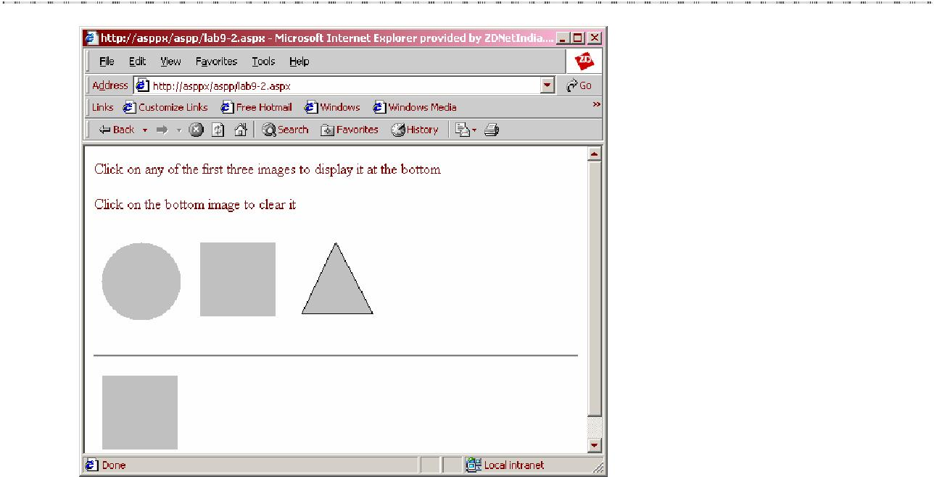

Lab – 2

Exercise : 1

<html>

<head>

<title> Web Controls </title> <center>
<asp:button id=”b1" text=”Click me” runat=”server” /> </asp:button>

</center>

<asp:label id=”L1" text=”Hello” runat=”server” /> </asp:label>

<asp:checkbox id=”C1" runat=server/> </asp:checkbox>
</head>

</html>
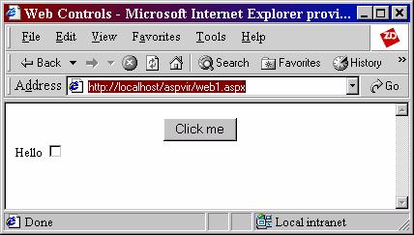

₁₂

Lab Solutions

Exercise : 2

<html>

<head>

<title> ASP.NET </title>

<script language=”c#” runat=”server”>

void button1_Click(Object Sender,EventArgs E)

{

s1.InnerHtml=”Welcome To Radiant”;

}

</script>

</head>

<form id=f1 runat=”server”> <body>

<center>

<asp:button id=”b1" OnClick=”button1_Click” text=”Click me” runat=”server” />
</asp:button>

</center>

<span id=s1 runat=”server” /> </form>
</body>

</html>
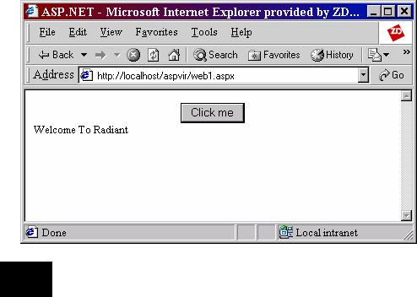

Exercise : 3
<html>
<head>
<title> ASP.NET </title>
</head>
13
ASP.NET
<form id=f1 runat=”server”> <body>
<font color=”green”>

<span id=s1 runat=”server” /> </font>

<br><br>

<h3> Move The Mouse Over Me and oy </h3>

<asp:button id=”Button2" OnServerClick=”Button2_Click” text=”Click me too!

“

style=”font: 8pt verdana;background-color:lightgreen;border-color:black;height=30;width:100"
onmouseover=”this.style.backgroundColor=’yellow’”

onmouseout=”this.style.backgroundColor=’lightgreen’”

runat=”server”/>

</form>

</body>

</html>
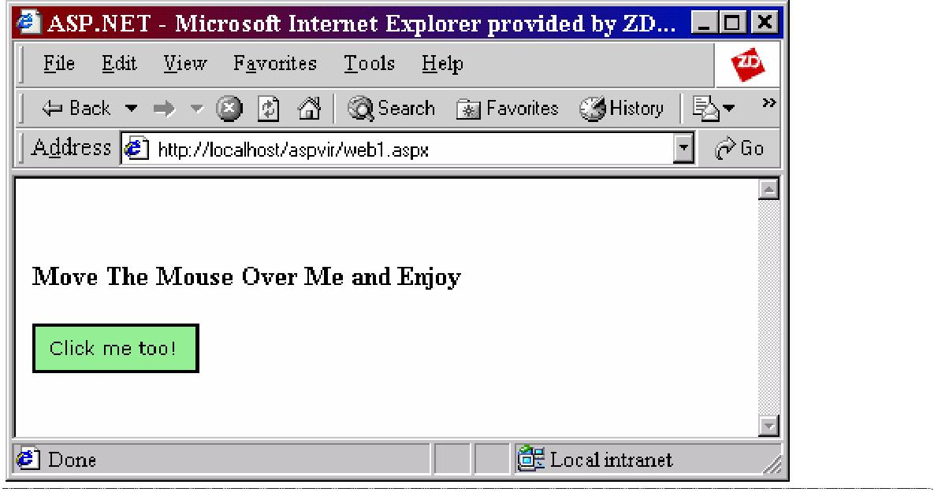

Lab – 3

Exercise : 1

<html>

<head>

<Script language=”c#” runat=”Server”>

void Calculate(Object sender,EventArgs e)

{

if (Store.SelectedIndex > -1){

int i = Store.SelectedIndex;
Cost.Text = | “You have chosen “ + Store.SelectedItem.Value + “ and
its cost is | Rs.”;
if (i==0)
 |  | 14
Lab Solutions
Cost.Text += “30”; else if (i==1)
Cost.Text += “32”; else if (i == 2)

Cost.Text += “28”; else
Cost.Text += “26”;

}

}

void display(Object sender, EventArgs e)

{

int i = Store.SelectedIndex; if (i==0)
{

Img.ImageUrl = “Cola.gif”;

Img.AlternateText = “Cola”;

}
else if | (i==1)
{
Img.ImageUrl = “Red_pop.gif”;
Img.AlternateText = “Red Pop”;
} | (i == 2)
else if | (i == 2)
{
Img.ImageUrl = “Lime.gif”;
Img.AlternateText = “Lime”;
}
else
{
Img.ImageUrl = “Purple_Rain.gif”;
Img.AlternateText = “Purple Rain”;
}
}
</Script>
</head>
<body>
<form runat=”server”>
<asp:label id = “label1” Text=”Choose one of the items below”
Font-Name=”Verdana” Font-Size=”18pt” runat=”server” />
<br><br>
<asp:listbox id=”Store” AutoPostBack=”True” width=”200"
runat=”server” onSelectedIndexChanged=”display”>
<asp:listitem>Cola</asp:listitem>
<asp:listitem>Red Pop</asp:listitem>
<asp:listitem>Lime</asp:listitem>
<asp:listitem>Purple Rain</asp:listitem>
</asp:listbox>
<asp:Image ID=”Img” ImageUrl=”” AlternateText=”” runat=”server” />
<br><br>
<asp:button id=”Find” text=”Find Cost” OnClick=”Calculate”
runat=”server”/>
<br><br>
<asp:textbox id=”Cost” text=”0" width=350 runat=”server”/>
 |  | 15
ASP.NET

</form>

</body>

</html>
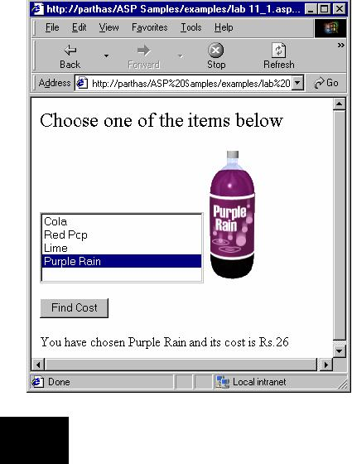

Exercise : 2
<html>
<head>
<Script language=”c#” runat=”Server”>
void Calculate(Object sender,EventArgs e)
{
if (Store.SelectedIndex > -1){
int i = Store.SelectedIndex;
Cost.Text = “You have chosen “ + Store.SelectedItem.Value + “ and
its cost is Rs.”;
if (i==0)
Cost.Text += “30”;
else if (i==1)
Cost.Text += “32”;
else if (i == 2)
Cost.Text += “28”;
else
Cost.Text += “26”;
}
}
void display(Object sender, EventArgs e)
{
int i = Store.SelectedIndex;
if (i==0)
{
Img.ImageUrl = “Cola.gif”;
16
Lab Solutions
Img.AlternateText = “Cola”;

}

else if (i==1)

{

Img.ImageUrl = “Red_pop.gif”;

Img.AlternateText = “Red Pop”;

}

else if (i == 2)

{

Img.ImageUrl = “Lime.gif”;

Img.AlternateText = “Lime”;

}

else

{

Img.ImageUrl = “Purple_Rain.gif”;

Img.AlternateText = “Purple Rain”;

}

}

void add(Object sender, EventArgs e)

{

int tot=0;

int qty = System.Int32.Parse(qtyText.Text); switch(Store.SelectedIndex)

{

case 0: tot = qty * 30; break;
case 1: tot = qty * 32; break;

case 2: tot = qty * 28; break;
case 3: tot = qty * 26; break;
}

total.Text = “You have to pay a total of Rs.” + tot;

}

</Script>

</head>

<body>

<form runat=”server”>

<asp:label id = “label1” Text=”Following are the items available with us” Font-Name=”Verdana” Font-Size=”18pt”

runat=”server” /> <br><br>
<asp:listbox id=”Store” AutoPostBack=”True” width=”200" runat=”server” onSelectedIndexChanged=”display”>
<asp:listitem>Cola</asp:listitem> <asp:listitem>Red Pop</asp:listitem> <asp:listitem>Lime</asp:listitem> <asp:listitem>Purple Rain</asp:listitem>

</asp:listbox>

<asp:Image ID=”Img” ImageUrl=”” AlternateText=”” runat=”server” /> <br><br>
<asp:button id=”Find” text=”Find Cost” OnClick=”Calculate” runat=”server”/> <br><br>
<asp:label id=”Cost” text=”0" width=350 runat=”server”/> <br><br>

<asp:label id=”qtyLabel” text=”Enter the quantity:” runat=”server”/>
17

ASP.NET
<asp:textbox id=”qtyText” Width = 30 text=”1" runat=”server”/> <br><br>
<asp:button id=”Buy” text=”Buy this” OnClick=”add” runat=”server”/> <br><br>

<asp:label id=”total” text=”” runat=”server”/> </form>
</body>

</html>
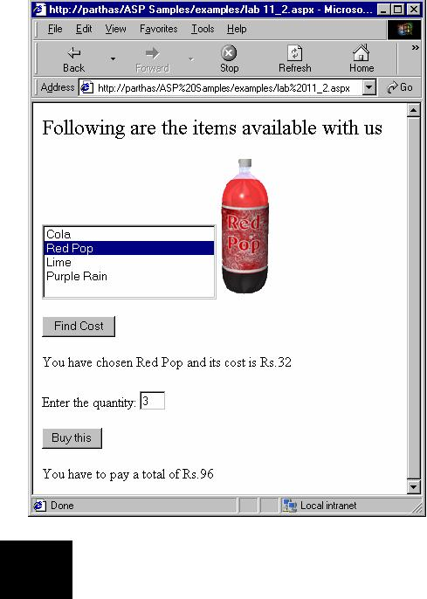

Exercise : 3
<form runat = “server”>
<asp:Calendar id=Calendar2 runat=”server”
borderwidth=10
borderstyle=”inset”
cellpadding=1
cellspacing=4
DayNameFormat=”Short”
Firstdayofweek=”saturday”
Forecolor=”brown”
Height=”300px”
Width=”500px”
NextPrevFormat=”fullmonth”
NextPrevStyle-ForeColor=”white”
OtherMonthDayStyle-ForeColor=”gray”
SelectionMode=”DayWeekMonth”
SelectedDayStyle-BackColor=”lightblue”
SelectorStyle-BackColor=”lightgreen”
SelectorStyle-ForeColor=”black”
TodayDayStyle-Font-Bold=”True”
TodayDayStyle-ForeColor=”blue”
18

TitleStyle-BackColor=”green” TitleStyle-ForeColor=”white” TitleStyle-Font-Bold=”True” />

</form>
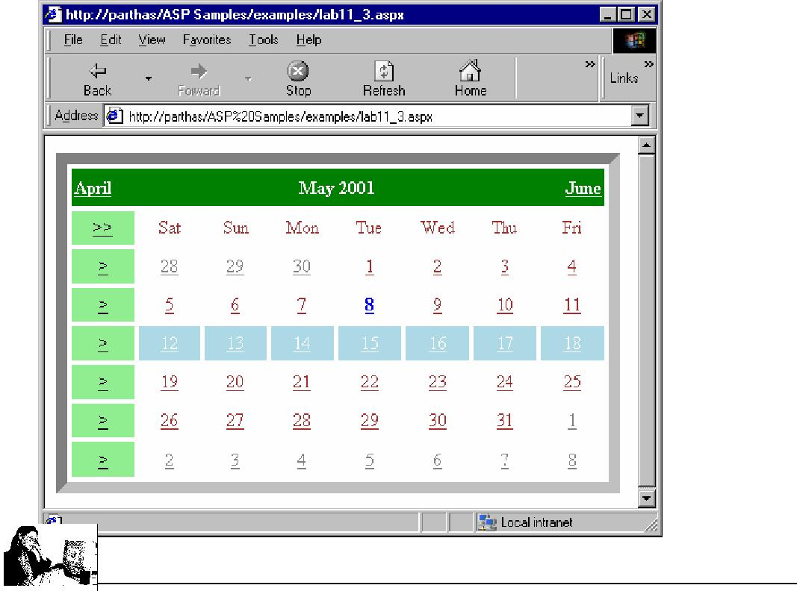

Exercise : 4

The ASPX file: <html>
<body>

<Center>

<asp:AdRotator Width = “60%” Height=80 id=a1 AdvertisementFile=”ads.xml” BorderWidth=5 runat=server />

</Center>

</body>

</html>

The XML file: <Advertisements> <Ad>

<ImageUrl> amazon.gif </ImageUrl>

<NavigateUrl> http://www.amazon.com </NavigateUrl> <AlternateText> Welcome to Amazon</AlternateText> <Keyword> websites </Keyword> <Impressions>50</Impressions>

</Ad>

<Ad>

<ImageUrl> fabmart.gif </ImageUrl>

<NavigateUrl> http://www.fabmart.com </NavigateUrl> <AlternateText> Welcome to Fabmart </AlternateText> <Keyword> websites </Keyword> <Impressions>40</Impressions>

Lab Solutions

19
ASP.NET
</Ad>

</Advertisements>
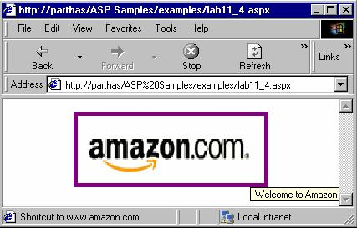

Lab – 4

Exercise : 1

<html>

<body>

<form runat=”server”>

<asp:label id=”label” text=”Enter the Boiling point of water : “ runat=”server” />
&nbsp;&nbsp;&nbsp;&nbsp;

<asp:textbox id=”text1" text=” “ runat=”server”/> <asp:comparevalidator id=”compboilpt” controltovalidate=”text1" Type=”Integer”

ValueToCompare=100 Operator=”Equal” display=”static” errormessage=”Please enter correct value” runat=”server”>

</asp:comparevalidator>

<asp:ValidationSummary id=”sumErrors” runat=”server” showSummary = true

displayMode = “BulletList” />

<br>

<asp:button id=bt1 runat=”server” text=”click”/> </form>
</body>

</html>

₂₀

Lab Solutions
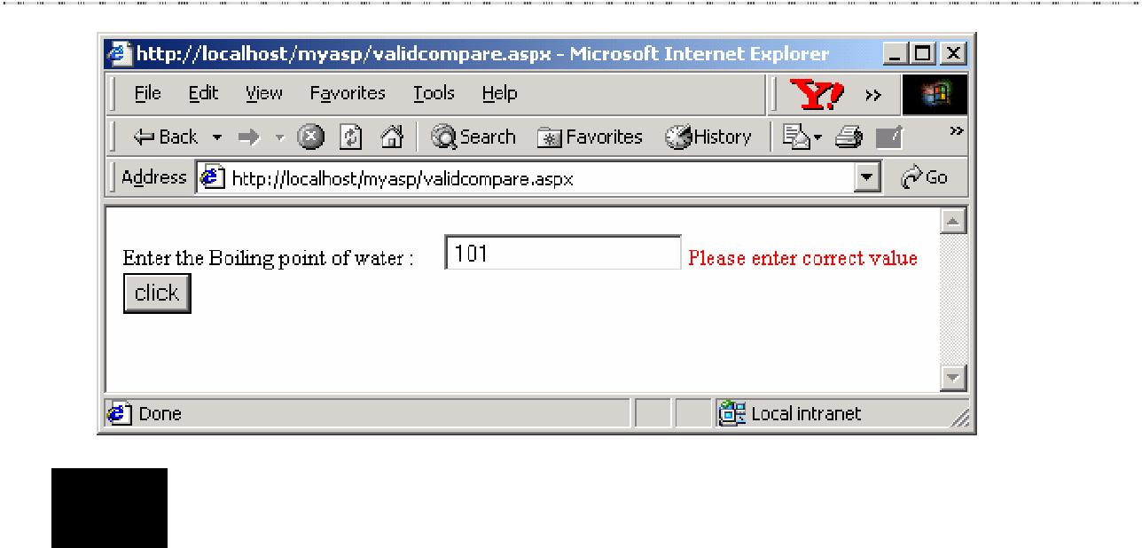

Exercise : 2

<html>

<body>

<h3>RequiredFieldValidation</h3> <form runat=server>
Name: <asp:Textbox id=”txtName” runat=”server”></asp:Textbox> <asp:button id=”Button1" runat=”server” text=”Validate” /> <p>
<asp:RequiredFieldValidator id=”RequiredFieldValidator1" runat=”server” ControlToValidate=”txtName”

ErrorMessage=”Name is a required field” ForeColor=”Red”>
</asp:RequiredFieldValidator>

</form>

</body>

</html>
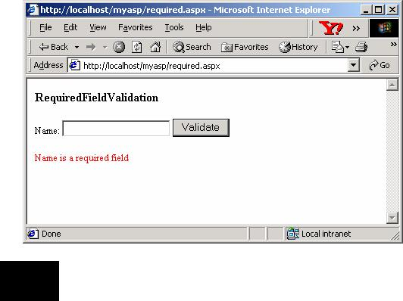

Exercise : 3
21

ASP.NET
<html>

<script language=”c#” runat=”server”> void btnclick(Object Sender,EventArgs E)
{

if (Page.IsValid ==true)

{

label1.Text=”Valid”;

}

}

</script>

<body bgcolor=”green”> <form runat=”server”>
<center><h4><font color=”blue”> Validation Controls </font> </h4></center> <table>

<tr>

<td style=color:”yellow”> Enter Your Name : </td> <td> <asp:textbox id=”idno” runat=”server”/> </td>
<td> <asp:requiredfieldvalidator id=”requiredfielddata” controltovalidate=”idno” errormessage=”Cannot leave this field blank” display=”static” runat=”server” /> </td>
</tr>

<tr>

<td style=color:”yellow”> Mode of payment :</td>

<td> <asp:radiobuttonlist id=”radio1" repeatlayout=”flow” runat=”server”> <asp:listitem style=color:”yellow”>Cash </asp:listitem> <asp:listitem style=color:”yellow”>Card </asp:listitem>

</asp:radiobuttonlist>

</td>

<td><asp:requiredfieldvalidator id=”requiredfielddata1" controltovalidate=”radio1" errormessage=”Click either cash or card”
display=”static” runat=”server” /> </td>
</tr>

<tr>

<td style=color:”yellow”> Please select any one from the List : </td> <td> <asp:dropdownlist id=”cardtype” columns=3 rows=7 runat=”server”>

<asp:listitem> None </asp:listitem> <asp:listitem> Visa </asp:listitem> <asp:listitem> Master </asp:listitem> <asp:listitem> Stc </asp:listitem> <asp:listitem> Hsbc </asp:listitem> <asp:listitem> SBI </asp:listitem> </asp:dropdownlist>

</td>

<td> <asp:requiredfieldvalidator id=”requiredfielddata2" controltovalidate=”cardtype” errormessage=”Sorry! please select any on e from above “ display=”static” runat=”server” /> </td>

</tr>

<tr>

<td><br><br><asp:button id=”bt1" text=”Check for validation” OnClick=”btnclick” runat=”server” style=color:”green” /></td> </tr>
</table>

<table>
22

Lab Solutions
<tr>

<td> <asp:label id=”label1" runat=”server” style=color:”pink”/> </td>
</tr>

</table>

</form>

</html>
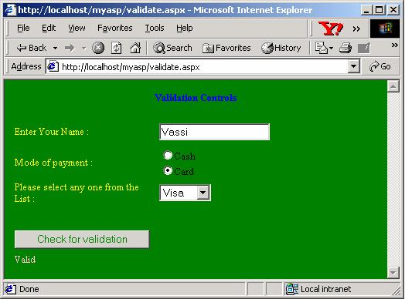

Lab 5
 |  | Exercise : 1
 | <html>
 | <title> Using Request Object </title>
 | <script language=”c#” runat=”server”>
 | void btnclick(object s,EventArgs e)
{ |  | if (Page.IsValid==true )
{
 | result.Text=”Thanks for Registering.Soon u will be Contacted”;
 |  | HttpCookie Cookie;
 |  | Cookie = new HttpCookie(“cookname”);
 |  | Cookie.Values.Add(“uname | “,Request.Form[“uname”]);
 |  | Response.AppendCookie(Cookie);
 |  | Cookie = Request.Cookies[“cookname”];
 |  | Response.Write (Cookie.Value + “ has visited the site .”);
}
 |  | else
{
 |  | result.Text=”Sorry you have to fill these fields”;
}
}
 | </script>
 | <form runat=”server” method=”Post” action=”formexp.aspx”>
 |  |  |  |  | 23
ASP.NET
<h3>Please fill your details here</h3> <br>
<table>

<tr> | Enter your | name </td>
<td> | Enter your | name </td>
<td> <asp:textbox |  | id=”uname” runat=”server” /></td>
<td> | <asp:requiredfieldvalidator id=”requname”
controltovalidate=”uname” runat=”server” errormessage=”Please enter your name” /></td>
</tr>

<tr>

<td> Enter your address</td>

<td><asp:textbox id=”uaddress” textmode=”multiline” runat=”server”/></td> <td><asp:Requiredfieldvalidator id=”requaddress” controltovalidate=”uaddress” runat=”server” errormessage=”Address has to be entered” display=”static”/> </td>

</tr>
<tr>
<td>Date of birth</td>
<td> | <asp:textbox id=”udate” runat=”server”/></td>
<td> | <asp:Requiredfieldvalidator id=”requdate”
controltovalidate=”udate” runat=”server” errormessage=”Enter your date of
birth” display=”static”/> </td>
<td> | <asp:Rangevalidator id=”reqrunation” controltovalidate=”udate”
runat=”server” type=”date” minimumvalue=”1/1/1900" maximumvalue=”1/1/2099"
errormessage=”Date should be in between 1/1/1900 - 1/1/2099"
display=”static”/></td>
</tr>
<tr>
<td>Nationality </td>
<td> | <asp:textbox id=”unation” runat=”server”/></td>
<td> | <asp:Requiredfieldvalidator id=”requnation”
controltovalidate=”unation” runat=”server” errormessage=”Enter correct data
“ display=”static”/> </td>
</tr>
<tr>
<td>Please select any Country:</td>
<td> | <asp:dropdownlist id=”uplace” runat=”server” >
 | <asp:listitem>U.S.A</asp:listitem>
 | <asp:listitem>Canada</asp:listitem>
 | <asp:listitem>U.K</asp:listitem>
 | <asp:listitem>Singapore </asp:listitem>
 | <asp:listitem>Malaysia </asp:listitem>
 | </asp:dropdownlist></td>
<td> | <asp:Requiredfieldvalidator id=”requplace”
controltovalidate=”uplace” runat=”server” errormessage=”Please Select any
country from the list” display=”static”/> </td>
</tr>
<tr>
<td>Mention your Skillsets here</td>
<td> | <asp:textbox id=”uskill” textmode=”multiline”
runat=”server”/></td>
 |  | 24
Lab Solutions
<td> <asp:Requiredfieldvalidator id=”requskill”

controltovalidate=”uskill” runat=”server” errormessage=”Please mention your skillsets here” display=”static”/> </td>
</tr>

</table><br>

<asp:button type=”submit” text=”submit” OnClick=”btnclick” runat=”server”/><br><br>

<asp:label id=”result” runat=”server” /> </form>
</html>
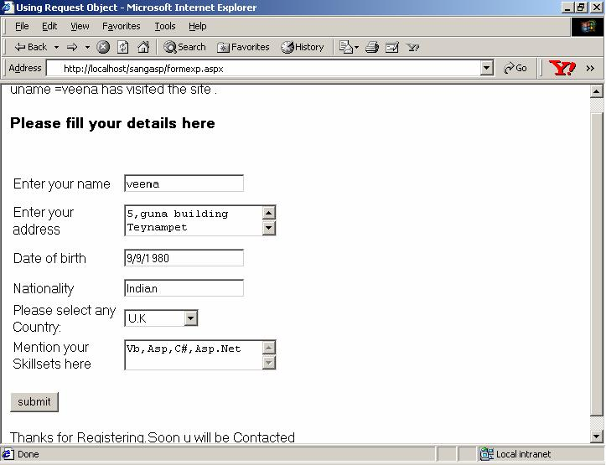

Lab 6

Exercise : 1

<script language=”c#” runat=server>

void Page_Load(Object sender,EventArgs e)

{

if (Response.BufferOutput == true)

{

Response.Flush(); Response.Write(“This is buffered”);
Response.End();

Response.Write(“This will not be sent to the Browser”);

}

}

</script>

₂₅

ASP.NET
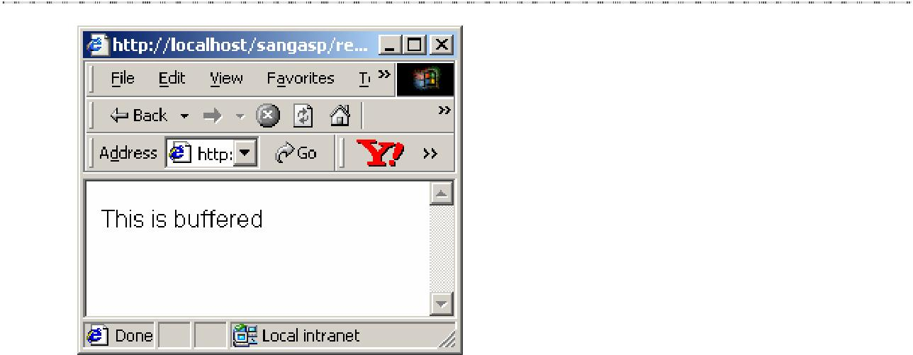

Lab 7

Exercise : 1

Global.asax:

<script language=”c#” runat=”server” >

void Application_Start(Object sender,EventArgs E)

{

Application[“cont”]=0;

Application[“color1”]=”Seagreen”;

Application[“gotohp”]=”http://www.msdn.microsoft.com/ms.htm”;

}

void Application_End(Object sender,EventArgs E)

{

}

void Session_Start(Object sender,EventArgs E)

{

Session[“cont1”]=0;

}

</script>

Web Form:

<html>

<title> Using Application and Session Variables </title> <script language=”c#” runat=”server”>
void Page_Load(Object sender,EventArgs e)

{

span1.Style[“background-Color”]=Application[“color1”].ToString() ; Application[“cont”]=(Int32)Application[“cont”]+1; Session[“cont1”]=(Int32)Session[“cont1”]+1;

Response.Write(“<br> The Value Of Application Variable is : “ + Application[“cont”].ToString());

Response.Write(“<br> The Value Of Session Variable is : “ + Session[“cont1”].ToString());
}

</script> <body >
26

Lab Solutions
<form runat=”server”> <br>
<a href=”useappsession.aspx”>Refresh </a> <br><br>

<span id=span1 runat=”server”>Using Application variables </span> </form>
</body>

</html>

<html>

<body>

<form runat=”server”> <br><br>
<center><h4>This site is under Construction.</h4></center> <br><br>

<center><a id=”a1" Href=”<%=Application(“gotohp”)%>” runat=”server” >Home Page </a></center>
</form>

</body>

</html>
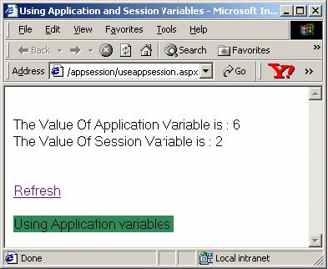

Lab 8

Exercise : 1

- Create table candidate(CCode numeric, name varchar(20), DOJ datetime)

- Insert into candidate values(1001,’s.raman’,’12-jun-97') Insert into candidate values(1002,’m.sushil’,’12-nov-97') Insert into candidate values(1003,’mohanyes’,’30-jul-97')

- Update candidate set name=’r.krishnan’where name=’s.raman’

- Drop table candidate

- Create table Employee(dept numeric,Name varchar(20),DOJ datetime,sal float,design varchar(20))

- Insert into Employee values(10,’shruthi’,’10-jan-99',10000,’Senior Analyst’) Insert into Employee values(10,’shanthi’,’12-jun-98',5000.0,’Manager’)

₂₇

ASP.NET
Insert into Employee values(20,’James’,’3-jul-99',15000,’System Manager’) Insert into Employee values(20,’Goodwill’,’13-dec-99',10000,’Senior Analyst’)
- Select * from employee where sal < 10000

- Select * from employee where desgin=’Manager’ or desgin=’Analyst’

- Select * from employee where dept=20 and sal>2000

- Select * from employee where Name like ‘j%’

- Select name from employee where name like ‘g_dwill’

- Update employee set sal=sal+1000 where sal<7000

- Select dept,avg(sal) from employee group by dept

- Select * from employee where desgin=’Manager’ or desgin=’Analyst’

- Create table students(scode numeric,sname varchar(30), Marks numeric)

- Delete from students where mark <40

Lab 9

Exercise : 1

<%@ Import Namespace=”System.Data” %>

<%@ Import Namespace=”System.Data.SQL” %> <html>

<title> Connecting to Pubs database </title> <script language=”C#” runat=”server”>
SQLConnection conn;

void Page_Load(Object Src, EventArgs E)

{

conn = new SQLConnection( “server=localhost;uid=sa;pwd=;database=master”);

conn.Open();

lbl.Text = “Connection has been established”; conn.Close();
}

</script>

<body>

<form>

<asp:label id = “lbl” runat=”server” /> </form>
</body>

</html>

₂₈

Lab Solutions
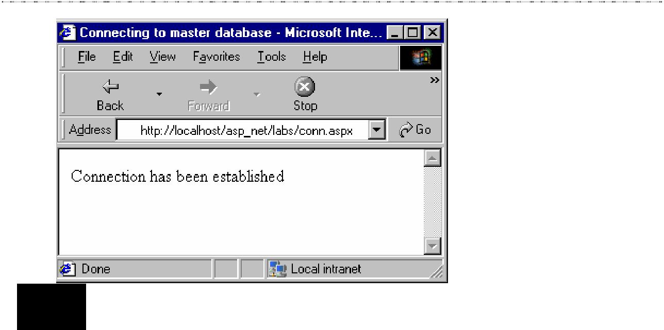

Exercise : 2

<%@ Import Namespace=”System.Data” %>

<%@ Import Namespace=”System.Data.SQL” %>

<html>

<title> Creating the table EMP</title> <script language=”C#” runat=”server”>
SQLConnection conn;

protected void Page_Load(Object Src, EventArgs E)

{

conn = new SQLConnection (“server=localhost;uid=sa;pwd=;database=master”);
}

public void CreTab(Object sender, EventArgs E)

{

String upd = “create table emp(eno integer, ename varchar(20), salary float)”;
SQLCommand com = new SQLCommand(upd,conn); com.ActiveConnection.Open();
try

{

com.ExecuteNonQuery();

lb.Text = “The table EMP has been created”;

}

catch (SQLException e)

{

lb.Text = “Error while creating the table”;

}

com.ActiveConnection.Close();

}

</script>

<body>

<form runat=”server”>

<asp:button OnClick=”CreTab” Text=”Create Table” runat=”server”/><br><br>

<asp:label id=”lb” runat=”server” />
29

ASP.NET
</form>

</body>

</html>
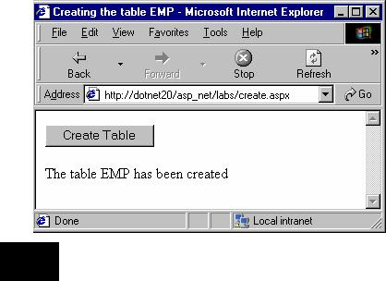

Exercise : 3

<%@ Import Namespace=”System.Data” %>

<%@ Import Namespace=”System.Data.SQL” %>

<html>

<title> Updating a record </title> <script language=”C#” runat=”server”>

SQLConnection conn;

protected void Page_Load(Object Src, EventArgs E)

{

conn = new SQLConnection

(“server=localhost;uid=sa;pwd=;database=master”);

}

public void UpdEmp(Object sender, EventArgs E)

{

String upd = “update emp set ename= ‘“ + ename.Text + “‘ where eno=102";

SQLCommand com = new SQLCommand(upd,conn); com.ActiveConnection.Open();
try

{

com.ExecuteNonQuery();

lb.Text = “The record has been modified”;

}

catch (SQLException e)

{

lb.Text = “Error while updating”;

}

com.ActiveConnection.Close();

}
30
Lab Solutions

</script>

<body>

<form runat=”server”>

Name: <asp:textbox id=”ename” runat=”server”/><br><br>

<asp:button OnClick=”UpdEmp” Text=”Update” runat=”server”/><br><br> <asp:label id=”lb” runat=”server” />
</form>

</body>

</html>
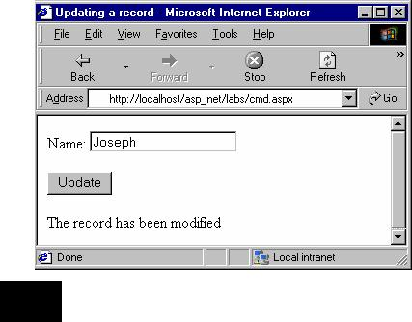

Exercise : 4

<html>

<title> Records from Emp </title> <script language=”C#” runat=”server”>

SQLConnection conn;

protected void Page_Load(Object Src, EventArgs E)

{

conn = new SQLConnection( “server=sangeetha;uid=sa;pwd=;database=master”);

SQLCommand com = new SQLCommand(“select distinct * from emp where eno>=100", conn);

conn.Open();
SQLDataReader dr;
com.Execute(out dr);
Response.Write(“<Table width=250 border=1 cellpadding=5>”);
Response.Write(“<TR>”);
Response.Write(“<TD>”);
Response.Write(“<B>ID </B>”);
31
ASP.NET

Response.Write(“</TD>”);

Response.Write(“<TD>”);

Response.Write(“<B>Name </B>”);

Response.Write(“</TD>”);

Response.Write(“<TD>”);

Response.Write(“<B>Salary </B>”);

Response.Write(“</TD>”);

Response.Write(“</TR>”);

while (dr.Read())

{

Response.Write(“<TR>”);

Response.Write(“<TD>”); Response.Write(dr[“eno”].ToString() + “ “);

Response.Write(“</TD>”);

Response.Write(“<TD>”); Response.Write(dr[“ename”].ToString() + “ “); Response.Write(“</TD>”); Response.Write(“<TD>”); Response.Write(dr[“sal”].ToString() + “ “); Response.Write(“</TD>”); Response.Write(“</TR>”);

}

conn.Close();

}

</script>

</html>
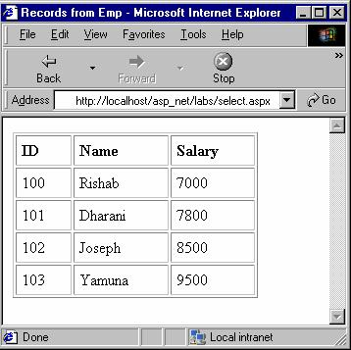

Lab 10

₃₂

Lab Solutions

Exercise : 1

<%@ Import Namespace=”System.Data” %>

<%@ Import Namespace=”System.Data.SQL” %>

<script language=”C#” runat=”server”> void Page_Load(Object o, EventArgs e)

{

DataSet ds; SQLConnection con; SQLDataSetCommand com; string strconn; string strSQL;

strconn=”server=localhost;uid=sa;pwd=;database=model”; con = new SQLConnection(strconn);

strSQL=”select distinct ename from emps”; com = new SQLDataSetCommand(strSQL,con); ds = new DataSet(); com.FillDataSet(ds,”emps”);
st.DataSource=ds.Tables[“emps”].DefaultView;

st.DataBind();

}

</script>

<html><head>

<title>Checkboxes from enames</title> </head>

<body bgcolor=”#FFFFFF”>

<h3><font face=”Verdana”>List of Names to choose from</font></h3> <ASP:CheckboxList id=”st” DataValueField=”ename” runat=”server”/> <br>

</body>

</html>
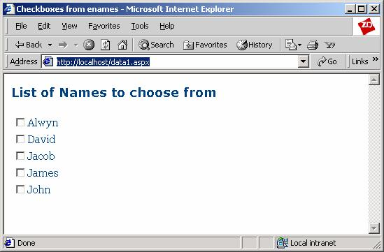

₃₃

ASP.NET

Exercise : 2

<%@ Import Namespace=”System.Data” %>

<%@ Import Namespace=”System.Data.SQL” %> <script language=”c#” runat=”server”> void Page_Load(Object o, EventArgs e)

{

DataSet ds; SQLConnection con; SQLDataSetCommand com; string strconn; string strSQL;

strconn=”server=localhost;uid=sa;pwd=;database=model”; con = new SQLConnection(strconn);
strSQL=”select distinct ename from emps”; com = new SQLDataSetCommand(strSQL,con); ds = new DataSet();
com.FillDataSet(ds, “emps”);

st.DataSource=ds.Tables[“emps”].DefaultView;

st.DataBind();

st2.DataSource=ds.Tables[“emps”].DefaultView;

st2.DataBind();

st3.DataSource=ds.Tables[“emps”].DefaultView;

st3.DataBind();

}

</script>

<html><head>

<title>Radio Buttons from States</title> </head>
<body bgcolor=”#FFFFFF”>

<h3><font face=”Verdana”>State(s) to Query</font></h3> <hr>
repeatcolumns 5, repeatdirection horizontal, repeatlayout table<br> <ASP:radiobuttonList

repeatcolumns=”5" repeatdirection=”horizontal” repeatlayout=”table” id=”st” datatextfield=”ename” DataValueField=”ename” runat=”server”/>
<br>

<hr>

repeatcolumns 5, repeatdirection vertical, repeatlayout table<br> <ASP:radiobuttonList
repeatcolumns=”5" repeatdirection=”vertical” repeatlayout=”table” id=”st2" datatextfield=”ename” DataValueField=”ename” runat=”server”/>
<hr>

repeatlayout flow<br> <ASP:radiobuttonList
repeatlayout=”flow”

id=”st3" datatextfield=”ename” DataValueField=”ename” runat=”server”/>

<hr>
</body>
</html>
34
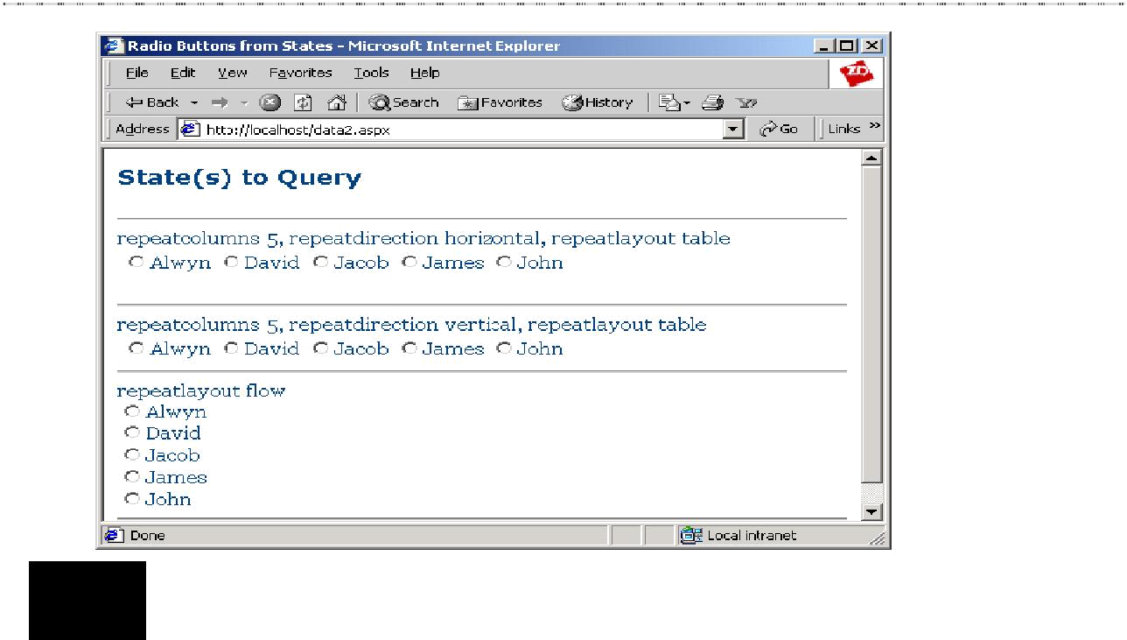

Exercise : 3

<%@ Import Namespace=”System.Data” %>

<%@ Import Namespace=”System.Data.SQL” %> <script language=”c#” runat=”server”> void Page_Load(Object o, EventArgs e)
{

DataSet ds; SQLConnection con; SQLDataSetCommand com; string strconn; string strSQL;

strconn=”server=localhost;uid=sa;pwd=;database=model”; con = new SQLConnection(strconn);

strSQL=”select distinct eno from emps”; com = new SQLDataSetCommand(strSQL,con); ds = new DataSet();
com.FillDataSet(ds, “emps”); cy.DataSource=ds.Tables[“emps”].DefaultView; cy.DataBind();

strSQL=”select distinct ename from emps”; com = new SQLDataSetCommand(strSQL,con); ds = new DataSet();

com.FillDataSet(ds, “emps”); st.DataSource=ds.Tables[“emps”].DefaultView; st.DataBind();

strSQL=”select distinct esal from emps”; com = new SQLDataSetCommand(strSQL,con); ds = new DataSet(); com.FillDataSet(ds,”emps”);

Lab Solutions

35
ASP.NET

zp.DataSource=ds.Tables[“emps”].DefaultView;

zp.DataBind();

}

</script>

<html><head>

<title>Grid of New York Data</title> </head>

<body bgcolor=”#FFFFFF”>

<h3><font face=”Verdana”>No, Name, Salary Lists of emps Table</font></h3>

<asp:Table runat=”server” GridLines=”both” BorderWidth=”1px”> <asp:TableRow>
<asp:TableCell>No</asp:TableCell> <asp:TableCell><ASP:DropDownList id=”cy” datatextfield=”eno” DataValueField=”eno” runat=”server”/></asp:TableCell> </asp:TableRow>

<asp:TableRow>

<asp:TableCell>Name</asp:TableCell> <asp:TableCell><ASP:DropDownList id=”st” datatextfield=”ename” DataValueField=”ename” runat=”server”/></asp:TableCell> </asp:TableRow>

<asp:TableRow>

<asp:TableCell>Salary</asp:TableCell> <asp:TableCell><ASP:DropDownList id=”zp” datatextfield=”esal” DataValueField=”esal” runat=”server”/></asp:TableCell> </asp:TableRow>
</asp:Table>

</body>

</html>
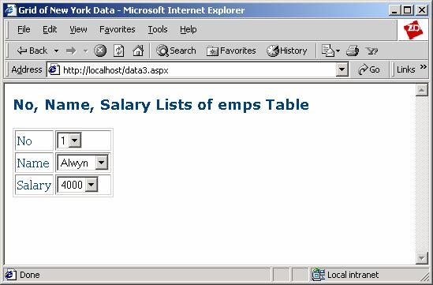

₃₆

Lab Solutions
Lab 11

Exercise : 1

<html>

<head>

<title> Details of products </title> <script language=”C#” runat=”server”>
void Page_Load(Object sender, EventArgs e) { Page.DataBind();
}

int ID{

get {

return 10;

}

}

string Name{ get {
return “Wheat”;

}

}

float Price{ get {
return 14.25f;

}

}

int Qty{ get {
return 1000;

}

}

</script>

</head>

<body>

<form runat=server>

Product ID: <b><%# ID %></b><br> Product Name: <b><%# Name %></b><br>
Price: <b><%# Price %></b><br> Quantity: <b><%# Qty %></b>
</form>

</body>

</html>

₃₇

ASP.NET
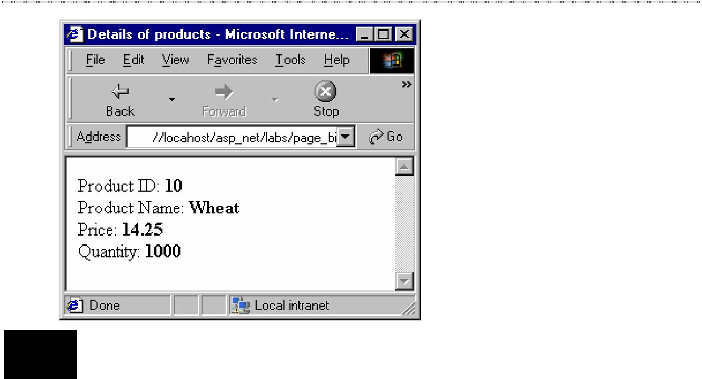

Exercise : 2

<html>

<head>

<title> Binding to a label </title> <script language=”C#” runat=”server”>
void Btn_Click(Object sender, EventArgs e) { Page.DataBind();

}

</script>

</head>

<body>

<form runat=server>

<asp:RadioButtonList id=”Flower” repeatcolumns=2 runat=”server” size=3> <asp:ListItem>Jasmine</asp:ListItem>
<asp:ListItem>Rose</asp:ListItem>

<asp:ListItem>Lotus</asp:ListItem>

<asp:ListItem>Lily</asp:ListItem>

<asp:ListItem>Daisy</asp:ListItem>

<asp:ListItem>Dahlia</asp:ListItem>

</asp:RadioButtonList>

<br><br>

<asp:button Text=”Submit” OnClick=”Btn_Click” runat=server/> <br><br>
Your favourite flower is: <asp:label text=’<%# Flower.SelectedItem.Text %>’ runat=server/>
</form>

</body>

</html>

₃₈

Lab Solutions
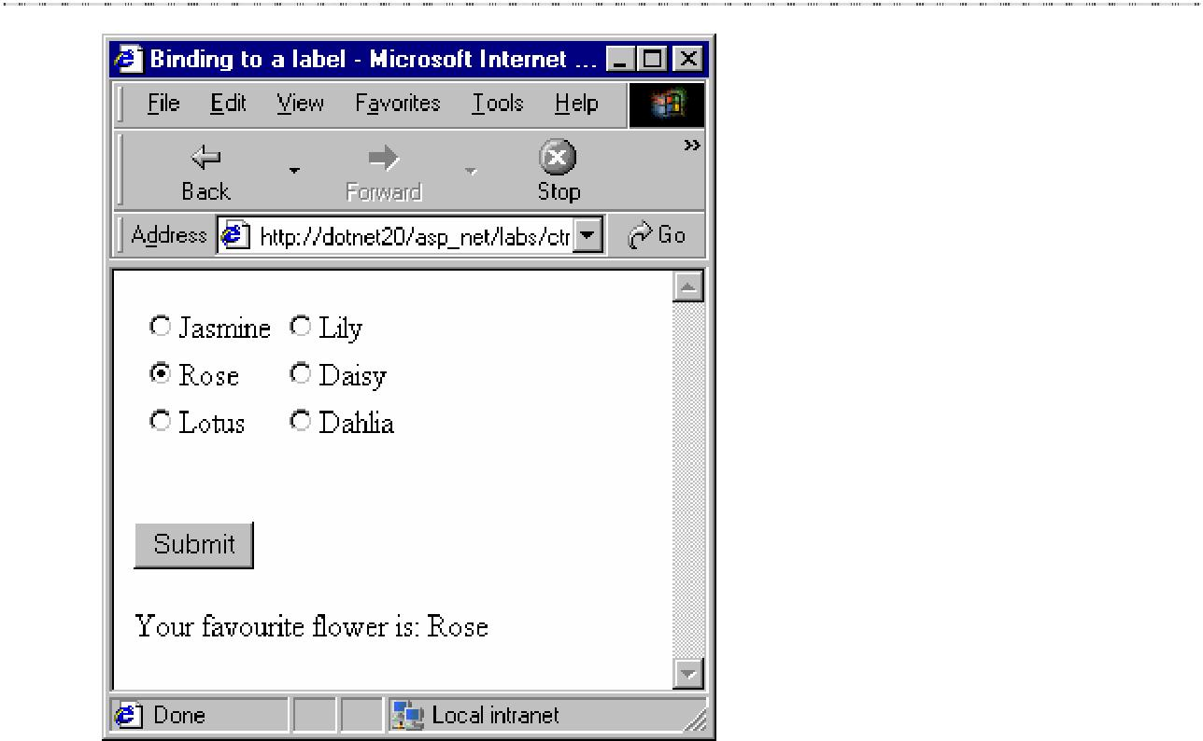

Exercise : 3

<%@ Import Namespace=”System.Data” %>

<%@ Import Namespace=”System.Data.SQL” %>

<title> Binding a List to the database </title>

<script language=”C#” runat=”server”> SQLConnection conn;
string connStr, query;

void Page_Load ( Object src, EventArgs e)

{

DataSet ds; SQLDataSetCommand cmd;

connStr=”server=localhost;uid=sa;database=master”; conn = new SQLConnection(connStr);

query=”select pname from product”;

cmd = new SQLDataSetCommand(query, conn); ds = new DataSet();

cmd.FillDataSet(ds, “product”);

prods.DataSource= ds.Tables[“product”].DefaultView; prods.DataTextField=”pname”;
Page.DataBind();

}
39

ASP.NET
</script>

<body>

<form runat=server>

<asp:Label id=”lbl” text=”Following is the list of available products: “ runat=”server” />
<br><br>

<asp:CheckBoxList id=”prods” runat=”server” /> </form>
</body>

</html>
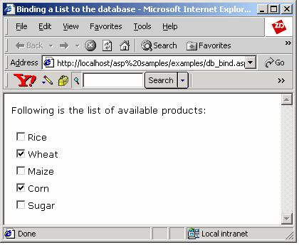

Lab 12

Exercise : 1

<head>

<script language=”c#” runat=”server” > String conn;

void Page_Load(object source,EventArgs e)

{

conn=”provider=microsoft.jet.oledb.4.0;data source=C:/sample.mdb”; ADOConnection myconnection=new ADOConnection(conn);

//For datasetcommand connection will be established implicitly
ADODataSetCommand mycommand=new ADODataSetCommand(“select
customerid,customername from customer”,conn);
DataSet ds=new DataSet();
mycommand.FillDataSet(ds,”customer”);
40
Lab Solutions

DataGrid1.DataSource = ds.Tables[“customer”].DefaultView; DataGrid1.DataBind();
}

</script>

</script>

</head>

<form runat=”server”>

<h4> Sorting Datagrid Control </h4> <asp:Datagrid id=”DataGrid1" runat=”server” /> </form>
</body>

</html>

Exercise : 2

<% @ Import Namespace=”System.Data” %>

<% @ Import Namespace=”System.Data.ADO” %> <html>

<head>

<title> Sorting In Datagrid </title> <script language=”c#” runat=”server” >
ADOConnection myconnection; String conn;
void Page_Load(object source,EventArgs e)

{

conn=”provider=microsoft.jet.oledb.4.0;data source=C:/sample.mdb”; myconnection=new ADOConnection(conn);

if (!IsPostBack) BindGrid(“CustomerID”);
}

void dbsort(object src,DataGridSortCommandEventArgs e)

{

BindGrid(e.SortField);

}

void BindGrid(String sortfield)

{

//For datasetcommand connection will be established implicitly ADODataSetCommand mycommand=new ADODataSetCommand(“select CustomerID,CustomerName from Customer”,conn);
DataSet ds=new DataSet(); mycommand.FillDataSet(ds,”customer”);
DataView dv= ds.Tables[“customer”].DefaultView; dv.Sort = sortfield;
DataGrid1.DataSource = dv; DataGrid1.DataBind();

}
41
ASP.NET

</script>

</head>

<form runat=”server”>

<h4> Sorting Datagrid Control </h4>

<asp:Datagrid id=”DataGrid1" onsortcommand=”dbsort” allowsorting=”true” runat=”server” autogeneratecolumns=”true”/>
</form>

</body>

</html>
Exercise : 3

<%@ Import Namespace=”System.Data” %>

<%@ Import Namespace=”System.Data.ADO” %>

<title> Paging </title>

<script language=”c#” runat=”server”>

void Page_Load(Object src, EventArgs e)

{

BindGrid();

}

void changePage(Object src,DataGridPageChangedEventArgs e)

{

BindGrid();

}

void BindGrid()

{

DataSet ds = new DataSet(); ADOConnection cnn = new
ADOConnection(“Provider=Microsoft.Jet.OLEDB.4.0;Data Source = C:/sample.mdb”) ;

ADODataSetCommand cmd = new ADODataSetCommand(“select CustomerID,CustomerName,Place from Customer”, cnn);
cmd.FillDataSet(ds, “customer”); dg.DataSource=ds.Tables[“customer”].DefaultView; dg.DataBind();
}

</script>

<form runat=”server”> <h3> Paging Feature </h3> <br>
<ASP:DataGrid id=”dg” runat=”server” AllowPaging=”True” PageSize=”3" PageCount=”1"
PagerStyle-Mode=”NumericPages” PagerStyle-HorizontalAlign=”Right” OnPageIndexChanged=”changePage”
/>

</form>

Lab 13

₄₂

Lab Solutions

Exercise : 1

<%@ Page Trace=”True” %>

<script language=”C#” runat=”Server”>

void Page_Load( Object s,EventArgs e)

{

Trace.Warn( “user”, “Page load event!” );

}
void Page_PreRender(Object s, EventArgs e)
{
Trace.Warn( “user”, “Page prerender event!” );
}
void test(Object s,EventArgs e)
{
myLabel.Text = “Hai “ + yourName.Text + “, your favorite
technology is “ + favTech.SelectedItem.Value;
Trace.Warn( “user”, “Now in test subroutine!” );
Trace.Write( “user”,”You selected “ + favTech.SelectedItem.Value);
}
</script>
<html>
<head><title>Tracing Events</title></head>
<body>
<% Trace.Warn( “user”, “page mid rendering event!” ); %>
<form runat=”server”>
<asp:label id=”myLabel” runat=”server”/>
<p>
<b>Enter Your Name:</b>
<br>
<asp:textbox id=”yourName” runat=”Server” />
<p>
<b>Pick Your Favorite technology:</b>
<br>
<asp:dropdownlist id=”favTech” runat=”server”>
<asp:listitem>ASP.NET</asp:listitem>
<asp:listitem>ADO.NET</asp:listitem>
<asp:listitem>C#</asp:listitem>
</asp:dropdownlist>
<p>
<b> Comments:</b>
<br>
<asp:textbox id=”comments” textmode=”multiline” cols=”20" rows=”5"
runat=”Server” />
<p>
<asp:button text=”Submit!” onClick=”test” runat=”server” />
</form>
</body>
43
ASP.NET
</html>
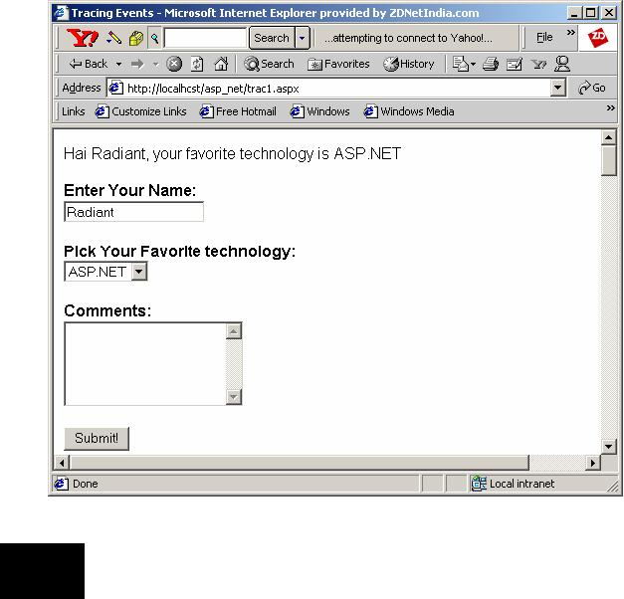

Exercise : 2

<%@ Page Trace=”true” TraceMode=”SortByCategory”%> <html>
<script language=”C#” runat=”server”>

void button1_click(object sender, EventArgs e)

{

try

{

int[] a={22,4,45,23,11,90}; a[7]=54; Response.Write(a[7].ToString());
}

catch(IndexOutOfRangeException ex)

{

throw(ex);

}

}

</script>

<form runat=”server”>

<asp:button id=”button1" onclick=”button1_click” text=”click me” runat=”server” />
</form>

</html>
44

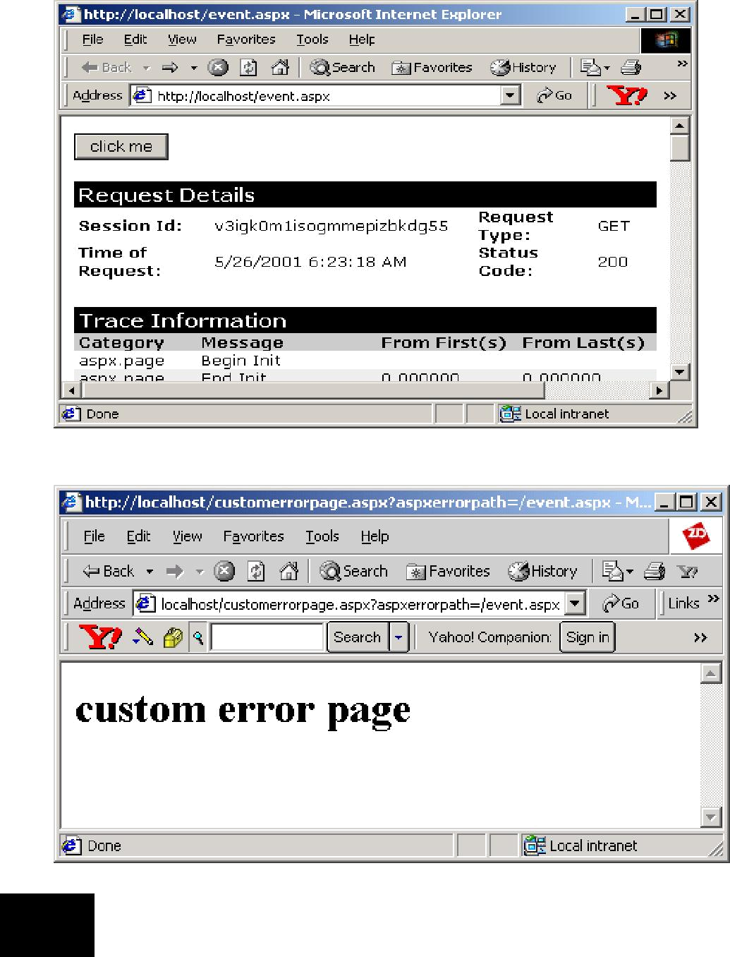

Exercise : 3

<%@ Page Trace=”true” TraceMode=”SortByTime”%> <%@ Import Namespace=”System.Data” %>
<%@ Import Namespace=”System.Data.SQL” %>

<html>

<script language=”C#” runat=”server”>

void Page_Load(Object Src, EventArgs E)

{

if(Trace.IsEnabled)

{

SQLConnection con = new SQLConnection(“server=localhost;uid=sa;pwd=”);

Lab Solutions

45
ASP.NET
SQLDataSetCommand com = new SQLDataSetCommand(“select ename from emptab”, con);
DataSet ds = new DataSet(); com.FillDataSet(ds, “emptab”); d.DataSource=ds.Tables[“emptab”].DefaultView; d.DataBind();

}

}

</script>

<body>

<ASP:DataGrid id=”d” runat=”server” Width=”100"
BackColor=”#ccccff”

BorderColor=”black”

CellPadding=3

CellSpacing=”0" Font-Name=”Verdana” Font-Size=”8pt” HeaderStyle-BackColor=”#aaaadd”
/>

</body>

</html>
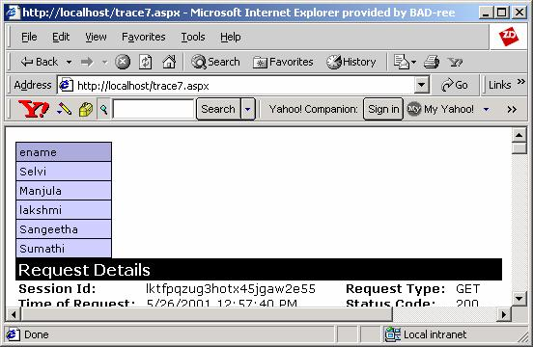

Lab 14

Exercise : 1

<script language=”C#” runat=”server”>

void Page_Load(Object sender, EventArgs E) { if(Page.IsPostBack)
{

display.Text=”You have selected the color: “ + col.SelectedItem.Text ;

}

}
46
Lab Solutions
public String Color { get {
return col.SelectedItem.Text;

}

}

</script>

Colors: <asp:ListBox id=”col” runat=”server” > <asp:ListItem>Green</asp:ListItem> <asp:ListItem>Yellow</asp:ListItem> <asp:ListItem>Blue</asp:ListItem> <asp:ListItem>Gray</asp:ListItem>

</asp:ListBox>

<br><br>

<b> <asp:Label id=”display” runat=”server” /> </b>

The Web Form:

<%@ Register TagPrefix=”User” TagName=”Color” Src=”Color.ascx” %> <html>
<title> Using Colors </title>

<script language=”C#” runat=”server” > void Btn_Click(Object sender, EventArgs E)
{

Body.Attributes[“bgcolor”]=UserColor.Color;

}

</script>

<body id=”Body” runat=”server”> <form id=”frm” runat=”server”>
<User:Color id=”UserColor” runat=”server”/> <p>
<asp:button id=”save” Text=”Submit” OnClick=”Btn_Click” runat=”server” /> </form>
</body>

</html>
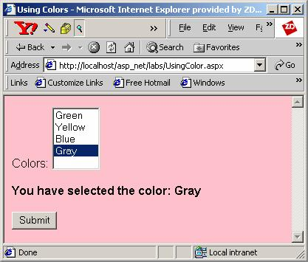

₄₇

ASP.NET

Exercise : 2

<script language=”C#” runat=”server”>

void Page_Load(Object sender, EventArgs E) {

dt.Text= System.DateTime.Today.Format(“dd/MM/yyyy”,null); tm.Text = System.DateTime.Now.Format(“HH:mm:ss”,null);
}

</script>

Today’s Date is: <asp:TextBox id=”dt” runat=”server” /> <br><br> The time now is: <asp:TextBox id=”tm” runat=”server” /> <br><br>

The Web Form:

<%@ Register TagPrefix=”User” TagName=”Dt” Src=”date.ascx” %> <title> Displaying Time </title>

<html>

<body>

<form runat=”server”>

<User:Dt id=”Today” runat=”server”/>

<asp:button id=”btn” Text=”Refresh” AutoPostBack=”true” runat=”server” /> </form>
</body>

</html>
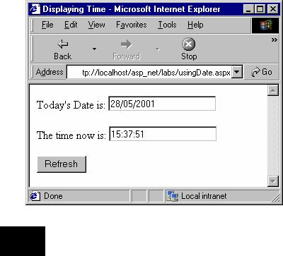

Exercise : 3
The user control:
<script language=”C#” runat=”server”>
void Btn_Click (Object sender, EventArgs E)
{
if( usrname.Text==”Radiant” && pwd.Text==”asp.net”)
48
Lab Solutions
Response.Write(“You are an authorized user”);

else

Response.Write(“You are not an authorized user”);

}

</script>

User Name: <asp:textbox id=”usrname” runat=”server” /> <br><br>

Password: <asp:textbox id=”pwd” textmode=”password” runat=”server” /> <br><br>
<asp:button id=”Btn” Text=”Submit” OnClick=”Btn_Click” runat=”server” />

The Web Form:

<%@ Register TagPrefix=”User” TagName=”Login” Src=”Login.ascx” %> <html>
<title> Login screen</title>

<body>

<form id=”frm” runat=”server”> <User:Login id=”log” runat=”server”/>
</form>

</body>

</html>
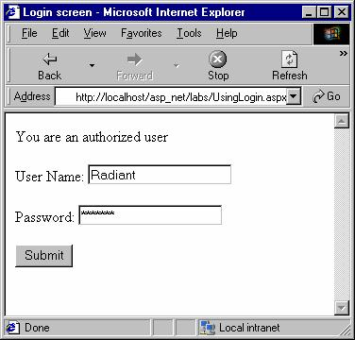

Lab 15

Exercise : 1
//calcomp.cs
using System;
namespace calcomp
{
public class cal
49
ASP.NET

{

public int add(String t1,String t2)

{

int a=Int32.Parse(t1); int b=Int32.Parse(t2);
return a+b;

}

public int sub(String t1,String t2)

{

int a=Int32.Parse(t1); int b=Int32.Parse(t2); return a-b;
}

}

}

//calapp.aspx

<html>

<script language=”C#” runat=”server”>

void button_add(Object Src, EventArgs E)

{

cal o1=new cal();

int c=o1.add(t1.Text,t2.Text);

Response.Write(“The value of a+b is “+c.ToString());

}

void button_sub(Object Src, EventArgs E)

{

cal o1=new cal();

int c=o1.sub(t1.Text,t2.Text);

Response.Write(“The value of a-b is “+c.ToString());

}

</script>

<body>

<form runat=server>

<h5>Enter the Value of a: </h5> <asp:textbox id=t1 Text=”0" runat=server/> <br>

<h5>Enter the Value of b: </h5> <asp:textbox id=t2 Text=”0" runat=server/> <p>

<asp:Button id=b1 text=”Add” OnClick=button_add runat=server/> <asp:Button id=b2 text=”Subtract” OnClick=button_sub runat=server/> </form>
</html>

₅₀

Lab Solutions
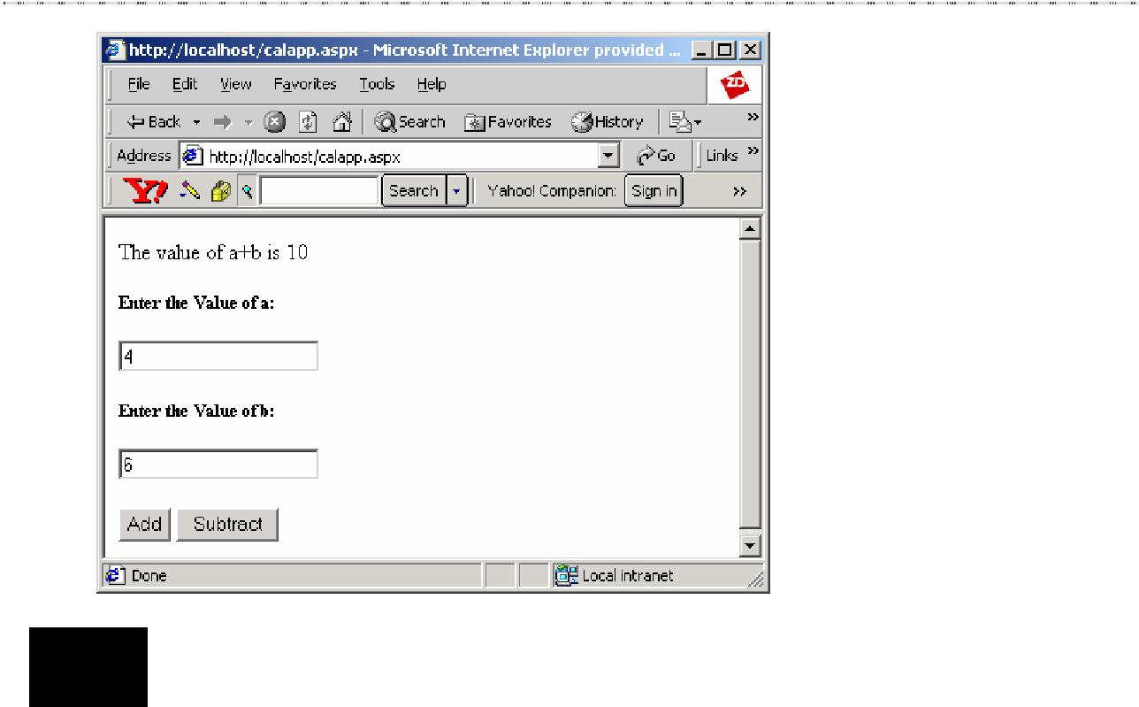

Exercise : 2
//abscomp.cs
using System;
namespace abscomp
{
abstract public class Absclass
{
abstract public String method();
}
}
//dercomp
using System;
using abscomp;
namespace dercomp
{
public class derived:Absclass
{
public override String method()
{
return (“Abstract Class”);
}
}
}
//absapp.aspx
<%@ Import Namespace=”dercomp” %>
<html>
<script language=”C#” runat=”server”>
public void Page_Load(Object sender, EventArgs E)
{
derived d1=new derived();
51
ASP.NET
String s=d1.method(); Response.Write(s.ToString());
}

</script>

</html>
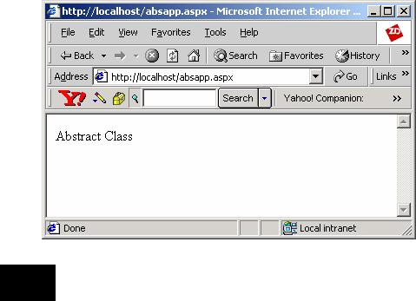

Exercise : 3

//indcomp.cs namespace indcomp

{

public class IndexerClass

{

int [] a = new int[100]; public int this [int index]

{

get

{

if (index < 0 || index >= 100) return 0;
else

return a[index];

}

set

{

if (!(index < 0 || index >= 100)) a[index] = value;
}

}

}

}
//indapp.aspx
<%@ Import Namespace=”indcomp” %>
52
Lab Solutions

<html>

<script language=”C#” runat=”server”>

public void Page_Load(Object sender, EventArgs E)

{

IndexerClass b = new IndexerClass(); b[2] = 30;
b[6] = 35; b[4]=40; b[7]=10;

for (int i=0; i<=10; i++)

{

Response.Write(“Indexer Element at “+ i+ “is “ + b[i]); Response.Write(“<br>”);
}

}

</script>

</html>
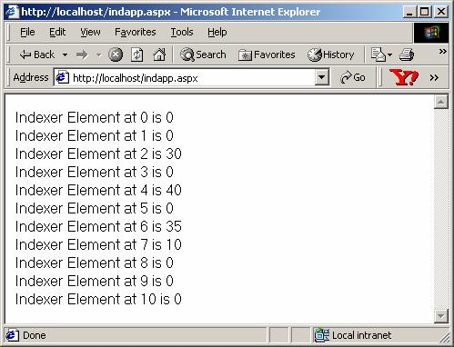

₅₃

