Traffic Light Controller Project Report
Logisim Design + Verilog Implementation

Course: COMP2001 Digital Design
Prepared by:
232010020041 Esma Begüm Demir
232010020021 Eda Eylül Özdemir
232010020025 Sudenaz Kuş
Date: 17 January 2026
Department: Computer Engineering
University: Konya Gıda ve Tarım Üniversitesi
Instructor: Prof. Dr. Kasım Öztoprak



1. Introduction
This report describes the design and Verilog implementation of a traffic light controller. The system is modelled as a finite state machine (FSM) and verified using a fast 1 Hz testbench. A Logisim-based schematic is used as the reference design for the control logic and output decoding.

2. Project Scope and Assumptions
- Four directions are controlled: East, West, North, South.
- Exactly one direction is granted right-of-way at a time; other directions remain red.
- Each direction has three lamps: Red, Yellow, Green.
- Operation is divided into phases: PRE (yellow), GREEN, POST (yellow).
- After reset, the controller outputs an all-red “boot” step for safe initialization.

3. System Overview
The controller consists of (i) an FSM for direction and phase sequencing, (ii) a seconds counter within each phase, and (iii) a combinational output decoder that drives the lamps according to the current FSM state.

3.1 Timing Parameters
Parameter | Meaning | Value (s)
T_YEL | Yellow duration (PRE and POST) | 2
T_MAIN_G | Green duration for main road (E, W) | 20
T_SIDE_G | Green duration for side road (N, S) | 15

4. Finite State Machine Design
The FSM is defined by two state registers: dir_state (which direction is active) and phase_state (which phase is active). A third register sec_in_phase counts elapsed seconds inside the current phase. The phase duration depends on the phase and on whether the active direction is a main road (E/W) or side road (N/S).

4.1 State Encoding
Signal | Encoding | Description
dir_state | 0=E, 1=W, 2=N, 3=S | Active direction sequence
phase_state | 0=PRE, 1=GREEN, 2=POST | Phase within a direction

4.2 Transition Logic
On each rising edge of clk_1hz, sec_in_phase is compared with (phase_dur - 1). When the phase completes, the FSM advances PRE -> GREEN -> POST -> PRE, and after POST it also updates dir_state to the next direction (E -> W -> N -> S -> E).
- If phase_state == PRE and the PRE duration is complete, phase_state becomes GREEN.
- If phase_state == GREEN and green duration is complete, phase_state becomes POST.
- If phase_state == POST and the POST duration is complete, phase_state becomes PRE and dir_state advances to the next direction.

4.3 Safety Boot Step
After reset, boot is asserted. During boot, all lamps are forced to red. On the first clock edge after reset is released, boot is cleared and sec_in_phase is kept at 0 so that the PRE phase timing starts cleanly.

5. Output Decode (Lamp Driving)
Lamp outputs are driven combinationally from the FSM state. Defaults are all-red. If boot is inactive, only the currently selected direction is allowed to show yellow or green; the other three directions remain red.
- Output rules (RYG bit pattern):
- 100 = Red, 010 = Yellow, 001 = Green
- PRE and POST phases use Yellow for the active direction.
- GREEN phase uses Green for the active direction.

6. Logisim Schematic (Reference Design)
The following figures show the Logisim implementation used as the design reference. The schematic includes the counter logic, decoders, and output gating for each direction and phase.
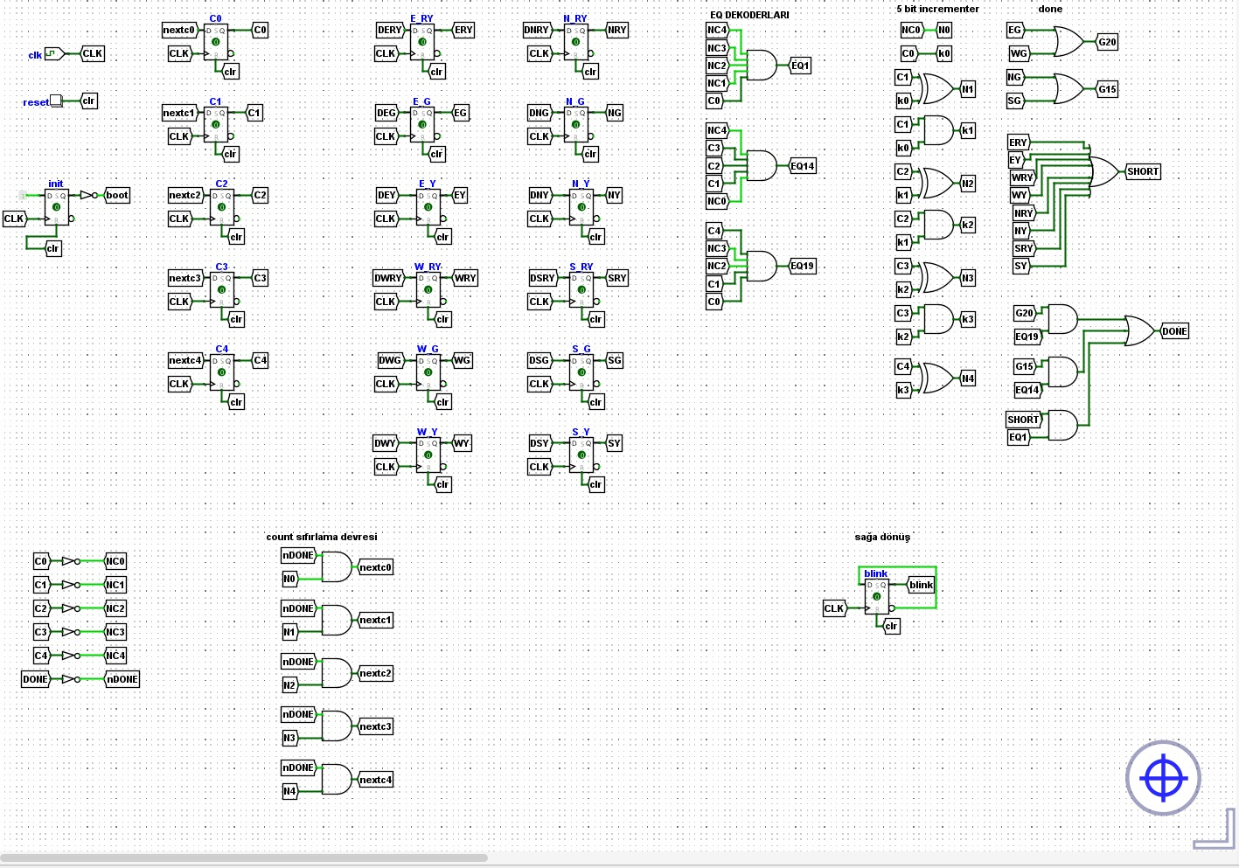
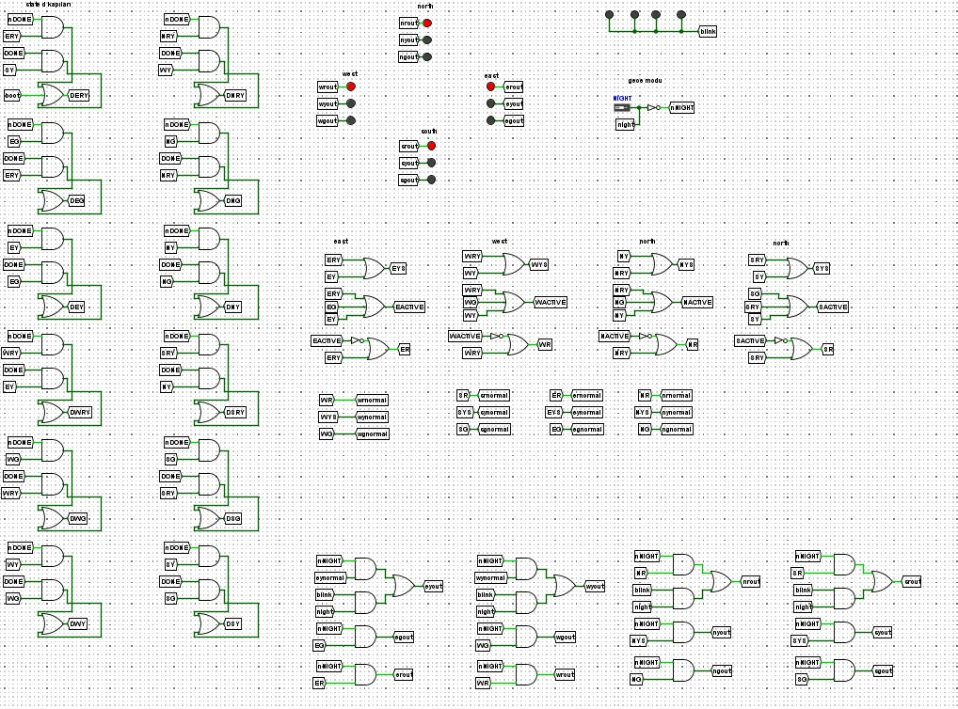

7. Verification and Simulation
A fast simulation testbench was created to validate state sequencing and lamp outputs. To reduce runtime, 1 second of real time is mapped to 10 ns in the simulator while preserving the logical 1 Hz behavior.

7.1 Testbench Strategy
- Key points:
- Generate a 1 Hz equivalent clock with 10 ns period (5 ns half-period).
- Hold reset for 2 clock ticks, then release.
- Print internal states and all lamp outputs on every clock edge.
- Run for 100 simulated seconds to observe multiple direction changes.

7.2 Example Output Trace
Below is an example excerpt of the expected trace (generated by an FSM-level reference simulation). It demonstrates: PRE (yellow) for East for 2 seconds, GREEN for 20 seconds, POST (yellow) for 2 seconds, and then switching to West.
tick=003 boot=0 dir=0 ph=0 sec=00 | E=010 W=100 N=100 S=100
tick=004 boot=0 dir=0 ph=0 sec=01 | E=010 W=100 N=100 S=100
tick=005 boot=0 dir=0 ph=1 sec=00 | E=001 W=100 N=100 S=100
...
tick=025 boot=0 dir=0 ph=2 sec=00 | E=010 W=100 N=100 S=100
tick=026 boot=0 dir=0 ph=2 sec=01 | E=010 W=100 N=100 S=100
tick=027 boot=0 dir=1 ph=0 sec=00 | E=100 W=010 N=100 S=100

8. Conclusion
The traffic controller was implemented as a compact FSM with parameterized phase durations. A safety boot step ensures an all-red output immediately after reset. The output decoding guarantees that only one direction receives permission (yellow/green) at any time. The provided testbench supports fast functional validation by scaling time while maintaining correct logical sequencing.

Appendix A - Verilog: traffic_controller_1hz
`timescale 1ns/1ps

module traffic_controller_1hz (
input wire clk_1hz,
input wire reset,

output reg e_r, output reg e_y, output reg e_g,
output reg w_r, output reg w_y, output reg w_g,
output reg n_r, output reg n_y, output reg n_g,
output reg s_r, output reg s_y, output reg s_g,

output reg [1:0] dir_state,
output reg [1:0] phase_state,
output reg [7:0] sec_in_phase
);

localparam [1:0] DIR_E = 2'd0, DIR_W = 2'd1, DIR_N = 2'd2, DIR_S = 2'd3;
localparam [1:0] PH_PRE = 2'd0, PH_G = 2'd1, PH_POST = 2'd2;

localparam integer T_YEL = 2;
localparam integer T_MAIN_G = 20;
localparam integer T_SIDE_G = 15;

reg boot; // <-- eklendi: ilk adımda sadece kırmızı için

function [7:0] green_dur;
input [1:0] d;
begin
if (d == DIR_E || d == DIR_W) green_dur = T_MAIN_G[7:0];
else green_dur = T_SIDE_G[7:0];
end
endfunction

function [7:0] phase_dur;
input [1:0] d;
input [1:0] ph;
begin
if (ph == PH_G) phase_dur = green_dur(d);
else phase_dur = T_YEL[7:0];
end
endfunction

function [1:0] next_dir;
input [1:0] d;
begin
case (d)
DIR_E: next_dir = DIR_W;
DIR_W: next_dir = DIR_N;
DIR_N: next_dir = DIR_S;
default: next_dir = DIR_E;
endcase
end
endfunction

// FSM
always @(posedge clk_1hz or posedge reset) begin
if (reset) begin
dir_state <= DIR_E;
phase_state <= PH_PRE;
sec_in_phase <= 8'd0;
boot <= 1'b1; // reset sonrası ilk adım kırmızı-only
end else begin
// İlk clock: sadece boot'u kapat, sayaç ilerlemesin (PRE süresi eksilmesin)
if (boot) begin
boot <= 1'b0;
sec_in_phase <= 8'd0;
end else begin
if (sec_in_phase == (phase_dur(dir_state, phase_state) - 1)) begin
sec_in_phase <= 8'd0;

if (phase_state == PH_PRE) begin
phase_state <= PH_G;
end else if (phase_state == PH_G) begin
phase_state <= PH_POST;
end else begin
phase_state <= PH_PRE;
dir_state <= next_dir(dir_state);
end
end else begin
sec_in_phase <= sec_in_phase + 1;
end
end
end
end

// Output decode
always @(*) begin
// default all red
e_r=1; e_y=0; e_g=0;
w_r=1; w_y=0; w_g=0;
n_r=1; n_y=0; n_g=0;
s_r=1; s_y=0; s_g=0;

// BOOT: ilk adım tamamen kırmızı (R=1,Y=0,G=0)
if (boot) begin
// zaten default all red
end else begin
case (dir_state)
DIR_E: begin
if (phase_state == PH_G) begin e_r=0; e_g=1; end
else /* PRE or POST */ begin e_r=0; e_y=1; end // <-- PRE artık sarı tek
end

DIR_W: begin
if (phase_state == PH_G) begin w_r=0; w_g=1; end
else begin w_r=0; w_y=1; end
end

DIR_N: begin
if (phase_state == PH_G) begin n_r=0; n_g=1; end
else begin n_r=0; n_y=1; end
end

default: begin // DIR_S
if (phase_state == PH_G) begin s_r=0; s_g=1; end
else begin s_r=0; s_y=1; end
end
endcase
end
end

endmodule

Appendix B - Verilog: tb_traffic_controller_1hz_fast
`timescale 1ns/1ps

module tb_traffic_controller_1hz_fast;

// "1 saniye"yi simde 10ns kabul ediyoruz
// 1Hz => period = 1s => burada 10ns
localparam integer SIM_SEC_NS = 10;
localparam integer HALF_PER_NS = SIM_SEC_NS/2; // 5ns

reg clk_1hz;
reg reset;

wire e_r,e_y,e_g, w_r,w_y,w_g, n_r,n_y,n_g, s_r,s_y,s_g;
wire [1:0] dir_state, phase_state;
wire [7:0] sec_in_phase;

traffic_controller_1hz dut (
.clk_1hz(clk_1hz),
.reset(reset),

.e_r(e_r), .e_y(e_y), .e_g(e_g),
.w_r(w_r), .w_y(w_y), .w_g(w_g),
.n_r(n_r), .n_y(n_y), .n_g(n_g),
.s_r(s_r), .s_y(s_y), .s_g(s_g),

.dir_state(dir_state),
.phase_state(phase_state),
.sec_in_phase(sec_in_phase)
);

// clock (simde hızlı)
initial begin
clk_1hz = 1'b0;
forever #HALF_PER_NS clk_1hz = ~clk_1hz;
end

// reset: 2 tick tut
initial begin
reset = 1'b1;
repeat (2) @(posedge clk_1hz);
reset = 1'b0;
end

// her "saniye" log
always @(posedge clk_1hz) begin
$display("t=%0t dir=%0d phase=%0d sec=%0d | E=%0d%0d%0d W=%0d%0d%0d N=%0d%0d%0d S=%0d%0d%0d",
$time, dir_state, phase_state, sec_in_phase,
e_r,e_y,e_g, w_r,w_y,w_g, n_r,n_y,n_g, s_r,s_y,s_g);
end

initial begin
@(negedge reset);

// 100 saniyelik çalışma = 100 posedge (simde 1000ns)
repeat (100) @(posedge clk_1hz);

$display("TB finished.");
$finish;
end

endmodule

