MALNAD COLLEGE OF ENGINEERING, HASSAN
(An Autonomous Institution affiliated to VTU, Belagavi)

24CS503(Computer Networks) Mini Project Synopsis On
"ARP MONITOR & ANOMALY DETECTOR"

Submitted in partial fulfillment of the requirements for the award of the degree of
“Bachelor of Engineering in Computer Science and Engineering”

Submitted by:
1.H B Sankalp 4MC24CS069
2.Kusuma K R 4MC25CS411

Under the guidance of:
Dr.Ananda Babu J
Prof and HOD


DEPARTMENT OF COMPUTER SCIENCE AND ENGINEERING
2026-2027
ARP MONITOR AND ANOMALY DETECTOR

1. Abstract
Address Resolution Protocol (ARP) maps an IP address to the MAC address of a device on a local network. Since these mappings may change, observing them over time can help in noticing unusual activity. The ARP Monitor & Anomaly Detector captures ARP packets using Scapy and Npcap, extracts the required IP and MAC details, and stores the observations in SQLite. When an existing IP is seen with a different MAC address, the system records the change as a potential anomaly. A Flask dashboard with Chart.js shows the monitored traffic, statistics, and detected events. Normal and abnormal test cases are also included to demonstrate the working of the system.
2.Introduction
Address Resolution Protocol (ARP) is used in a local network to find the MAC address associated with an IP address. This allows devices to deliver frames to the correct destination on the local network.
Because an IP–MAC association can change, keeping a record of ARP activity is useful for finding unexpected changes. Instead of checking the ARP table manually each time, the proposed system keeps previous observations for comparison.
The ARP Monitor & Anomaly Detector captures ARP packets, extracts IP and MAC information, stores the observed mappings, and checks new events against the stored history. A web dashboard is used to display the results.
The implementation uses Scapy and Npcap for packet capture, SQLite for storage, and Flask with Chart.js for the monitoring interface.
Two controlled cases are included for testing. The normal case keeps the same IP–MAC mapping, while the abnormal case changes the MAC address for an existing IP. This gives a simple way to demonstrate the detection logic in a controlled environment.
3. Problem Statement
Most ARP monitoring tools can show requests, replies, or the current ARP table, but they do not necessarily maintain a project-specific history and compare new mappings with older ones. Manual checking becomes difficult when many ARP events are generated. The proposed system combines packet capture, history, change detection, storage, and dashboard-based reporting in one workflow.
4. Existing System
ARP information can normally be viewed through packet-capture tools, network-analysis utilities, or the operating system ARP table. These tools are useful for checking individual packets and the mappings currently available on a device.
However, the information is mainly presented for observation and troubleshooting. The user may have to inspect packets or the ARP table and compare them with earlier observations to notice a changed mapping.
Traditional monitoring also may not keep every observed ARP event in one place. When a mapping changes, the administrator may need to compare current and earlier records manually. This becomes less convenient as the number of devices and ARP packets increases.
Another limitation is that packet capture, storage, analysis, and visualization may be handled by different utilities. There is no single interface in the basic setup that brings these functions together.
Limitations of Existing Systems
- ARP information may need to be inspected manually.
- Historical IP–MAC changes are not necessarily maintained in one dedicated database.
- Suspicious IP–MAC changes may require manual comparison.
- Basic monitoring does not provide an integrated anomaly database.
- Statistical analysis and visualization may require separate tools.
- There is no single project-specific dashboard that combines monitoring, detection, storage, and visualization.
- No centralized monitoring dashboard.
5. Proposed / New System
The proposed system brings ARP capture, mapping history, change detection, database storage, statistics, and visualization into one application. The aim is to make the monitoring process easier by comparing each new observation with the mappings already stored.
ARP request and reply packets are captured from the selected network interface using Npcap and Scapy. The system extracts the IP address, MAC address, ARP operation, and observation time from each relevant packet.
The new mapping is then checked against the previously stored mapping for the same IP address. If the IP is associated with a different MAC address, the event is marked as a potential anomaly.
The detected event is stored in SQLite along with the details needed for later checking.
- IP address
- Previous MAC address
- New MAC address
- Timestamp
- Severity
- Description of the detected change
Keeping the history makes it possible to compare current observations with earlier mappings instead of relying only on the current ARP table.
The Flask dashboard is the main interface for viewing the collected information. It shows total ARP events, unique IPs, unique MACs, and detected anomalies using tables and counters.
Chart.js is used for graphical views of ARP activity and anomaly-related information. The dashboard refreshes the displayed data so recent events can be seen without repeatedly reloading the page.
For testing, the project uses two controlled scenarios. In the normal case the IP–MAC mapping stays unchanged. In the abnormal case an existing IP is given a different MAC address, which allows the detection logic to be checked safely.
Complete workflow: ARP packet capture → packet processing → IP–MAC extraction → comparison with stored history → anomaly detection → SQLite storage → statistics → web dashboard.
6. Existing System vs Proposed System

The table below contrasts traditional network monitoring mechanisms with the proposed ARP Monitor & Anomaly Detector system:

Existing System | Proposed / New System
Observes ARP requests and replies | Continuously monitors ARP traffic
IP–MAC information is inspected manually | IP–MAC mappings are automatically recorded
Limited historical tracking | Maintains ARP history using SQLite
IP–MAC changes require manual comparison | Automatically detects IP–MAC changes
No dedicated anomaly database | Stores detected anomalies with details
Limited statistical analysis | Provides ARP and anomaly statistics
Visualization requires separate tools | Provides an integrated dashboard with charts
Manual monitoring is common | Dashboard updates automatically
No built-in simulation | Supports normal and abnormal simulations
Results are viewed using separate utilities | Centralized Flask-based monitoring interface

7. System / Network Architecture:
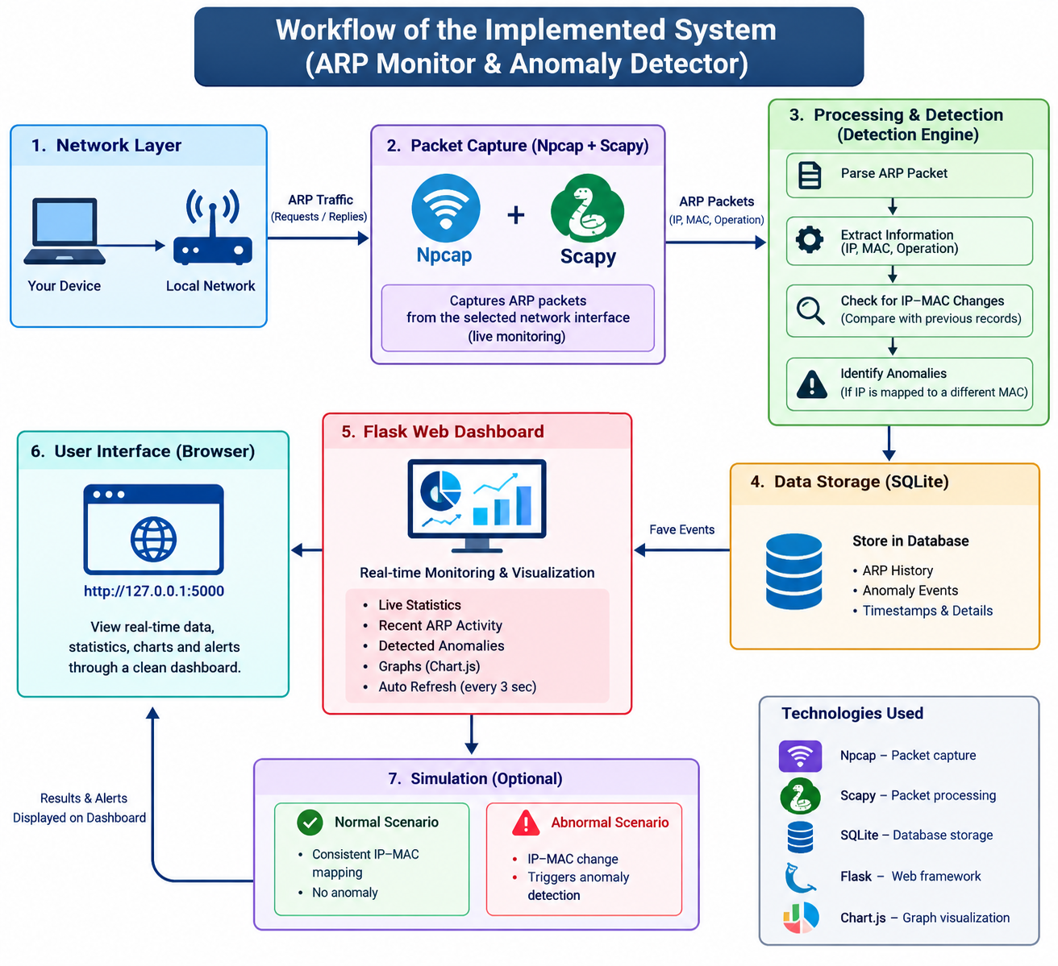

The system is divided into layers for capturing, processing, storing, and displaying ARP information. The flow starts with ARP traffic on the local network and ends with the results being shown in the browser.

Architecture Flow

1. Network Layer
The Network Layer represents the LAN where devices communicate using IP and MAC addresses. ARP requests and replies are generated when a device needs the MAC address related to an IP address.

2. Packet Capture Layer
The Packet Capture Layer obtains ARP packets from the active interface. Npcap provides access to the Windows network interface, and Scapy is used to capture and decode the packets.

3. Packet Processing Layer
After a packet is captured, the system extracts the information needed for monitoring, including the IP address, MAC address, operation type, and timestamp.

4. IP–MAC Mapping and Detection Layer
The detection component keeps earlier IP–MAC associations. When a new ARP event arrives, its mapping is compared with the stored value for the same IP. A different MAC address is recorded as a potential anomaly.

5. Data Storage Layer
SQLite provides persistent storage for ARP events, mappings, timestamps, anomaly records, severity, and descriptions. This history is used when new mappings are checked.

6. Statistics and Analysis Layer
The stored data is summarized into monitoring statistics such as total ARP events, unique IPs, unique MACs, normal events, and detected anomalies.
- Total ARP Events
- Unique IP Addresses
- Unique MAC Addresses
- Total Detected Anomalies
- Normal ARP Events
- Anomalous ARP Events
These values give a quick summary of the network activity observed by the monitor.

7. Web Application Layer
The Flask application connects the stored data with the browser interface. It reads ARP events, mappings, statistics, and anomaly records from SQLite and provides them to the dashboard.

8. Visualization Layer
Chart.js presents ARP activity and anomaly statistics as graphs. Tables are used when detailed event information needs to be viewed.

9. User Interface Layer
The user accesses the monitoring system through a web browser. The Flask application runs locally at:
http://127.0.0.1:5000
The dashboard gives a single view of current ARP traffic, statistics, stored history, and detected anomalies.

10. Simulation Layer
The project contains controlled scenarios for checking the anomaly-detection logic.
- Normal Scenario: The same IP continues to use the same MAC address, so the event is treated as normal.
- Abnormal Scenario: An existing IP is shown with a different MAC address, so the system records a potential anomaly.
The cases provide a controlled demonstration of the detection process without carrying out an actual network attack.
Overall Communication Flow
The system follows this sequence:
Local Network → ARP Traffic → Npcap + Scapy → Packet Processing → IP–MAC Extraction → Historical Comparison → Anomaly Detection → SQLite Database → Flask Application → Chart.js Visualization → Web Dashboard
The architecture combines packet capture, IP–MAC history, change detection, database storage, statistics, simulation, and a web dashboard in one monitoring flow.

8. Network Design and Implementation

The ARP Monitor & Anomaly Detector runs on a Local Area Network (LAN). It captures ARP traffic, tracks IP–MAC mappings, checks for changes, and presents the collected information through the Flask dashboard.

8.1 Network Type
The project uses a LAN with IPv4 and MAC addressing. During testing, the selected Wi-Fi interface had IP 172.23.245.26 and MAC 1c:c1:0c:ce:3a:29.
8.2 ARP Protocol
The monitor records ARP requests and replies, IP and MAC addresses, the operation type, and changes in IP–MAC mappings.
- ARP requests and replies
- IP and MAC addresses
- ARP operation type
- IP–MAC mapping changes
These ARP observations are used for monitoring and change detection.
8.3 Packet Capture
Npcap and Scapy are used to capture and process live ARP packets. The required IP, MAC, and operation information is extracted from the packets.
Example:
ARP Request
IP : 172.23.245.85
MAC : de:81:87:5f:61:e6

ARP Reply
IP : 172.23.245.26
MAC : 1c:c1:0c:ce:3a:29
8.4 IP–MAC Change Detection
Each new IP–MAC mapping is checked against the previously stored value for that IP address.
New ARP Packet
↓
Extract IP + MAC
↓
Compare with Previous Mapping
↓
Same → Normal Event
Different → Potential Anomaly
When the same IP address is found with a different MAC address, the change is recorded as a potential anomaly.
8.5 Database Storage
SQLite stores ARP events, IP–MAC mappings, timestamps, anomaly records, severity, and descriptions. The stored records provide history for later comparison.
8.6 Client–Server Communication
The Flask application handles local communication between the browser, database, and monitoring interface:
Web Browser
↓
Flask Server
↓
SQLite Database
↓
Monitoring Data
↓
Web Dashboard
The dashboard is available locally at http://127.0.0.1:5000.http://127.0.0.1:5000
8.7 Statistics and Visualization
The dashboard displays important statistics such as:
- Total ARP Events
- Unique IPs
- Unique MACs
- Detected Anomalies
Chart.js displays ARP activity and normal/anomalous events. The dashboard refreshes the information shown to the user.
8.8 Simulation
Two controlled cases are used:
- Normal: The IP–MAC mapping remains consistent, so no anomaly is recorded.
- Abnormal: The MAC address for an existing IP changes, so a potential anomaly is generated.
The implementation brings packet capture, IP–MAC tracking, change detection, storage, statistics, and visualization into one system.

9. Results / Expected Results
The implemented system was tested on the selected Wi-Fi interface. The main observations from the testing are:
- ARP packets were captured using Npcap and Scapy.
- ARP requests and replies were captured from the selected Wi-Fi interface.
- IP addresses, MAC addresses, and ARP operation types were extracted from the captured packets.
- Different ARP events generated on the local network were processed by the system.
- Observed IP–MAC mappings were kept for comparison.
- New mappings were compared with the previously recorded mappings.
- A change in an existing IP–MAC association was treated as a potential anomaly.
- The previous and new MAC addresses were recorded for detected changes.
- SQLite stored the ARP events, mappings, timestamps, and anomaly details.
- The Flask dashboard provided a central interface for viewing the monitored activity.
- The dashboard showed Total ARP Events, Unique IPs, Unique MACs, and detected anomalies.
- Chart.js was used to display ARP activity and monitoring statistics.
- The dashboard updated the displayed monitoring information automatically.
- Normal and abnormal simulation cases were used to demonstrate unchanged and changed IP–MAC mappings.
- The complete flow from packet capture to dashboard visualization was demonstrated.
Overall Result
Testing on the active Wi-Fi interface showed that the system could capture ARP requests and replies and keep track of the corresponding mappings. The dashboard brought the monitoring information and detected changes together for easier viewing.
10. Conclusion
The ARP Monitor & Anomaly Detector provides a practical way to observe ARP activity on a local network and keep track of IP–MAC changes. It combines packet capture, historical storage, change detection, and visualization in one system.
Npcap and Scapy handle ARP packet capture and processing, while SQLite stores the observed history. When an existing IP is seen with a different MAC address, the system records the change as a potential anomaly.
The Flask dashboard provides the monitoring view, including ARP event counts, unique IPs and MACs, anomaly information, and Chart.js graphs.
The controlled normal and abnormal cases make the detection process easy to demonstrate. The project can be extended later with improved anomaly classification, alerting, and additional network-analysis features.
11. OUTPUT
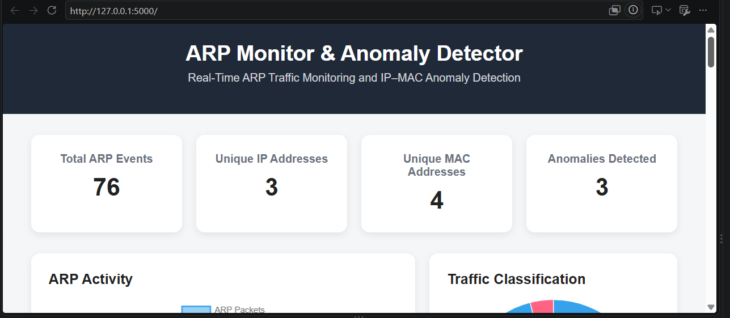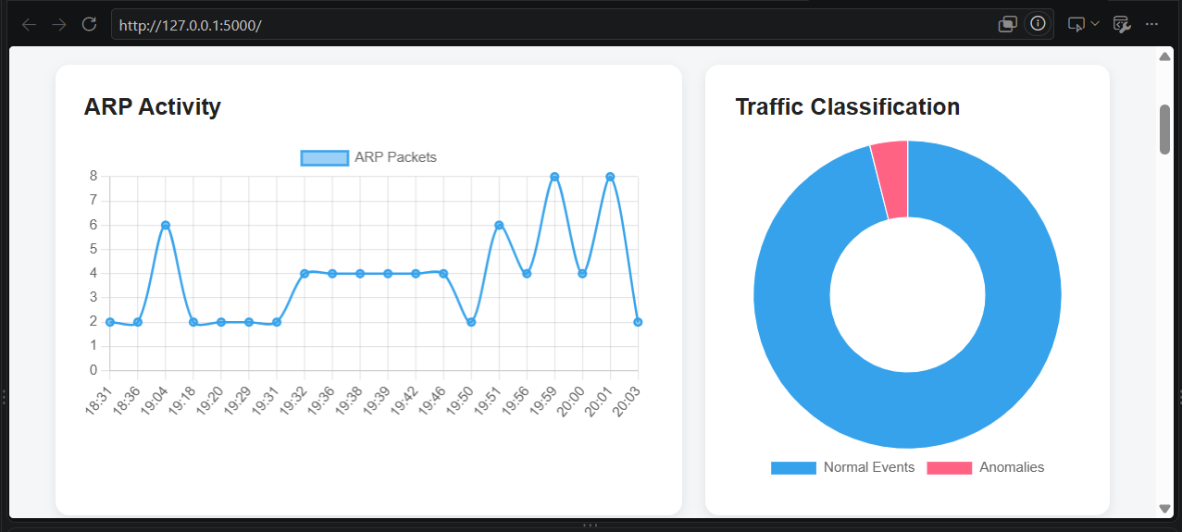
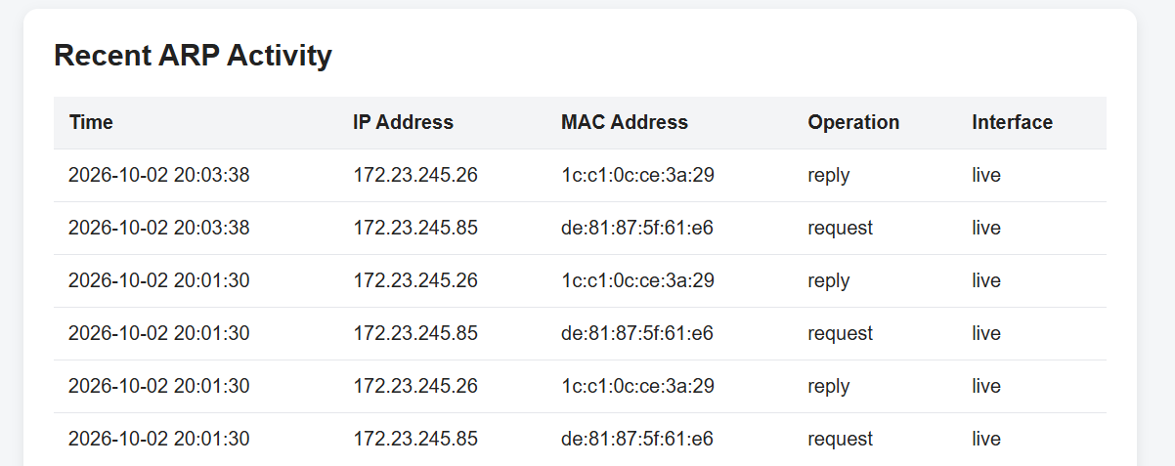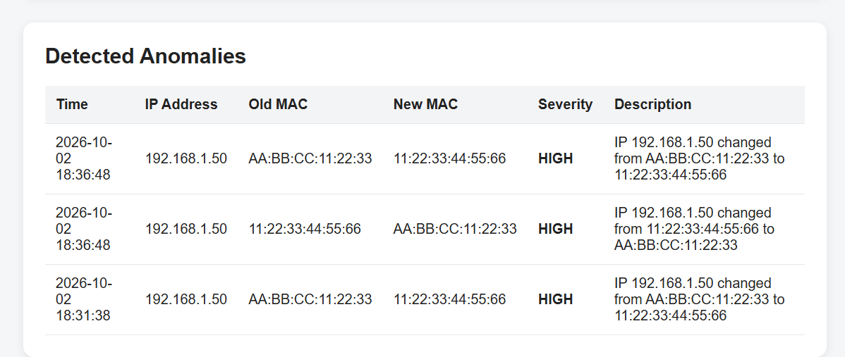

12.GIT REPOSITORY:
https://github.com/kusuma-kr/ARP-Monitor-Anomaly-Detector.git

