AI ASSISTED CODING

LAB:14.1

ROLLNO:2403A52096

BATCH:04

TASK1:

PROMPT: Create a responsive web page with a header, main content, and footer using HTML and CSS. Ensure it adapts to desktop, tablet, and mobile screens.

CODE:

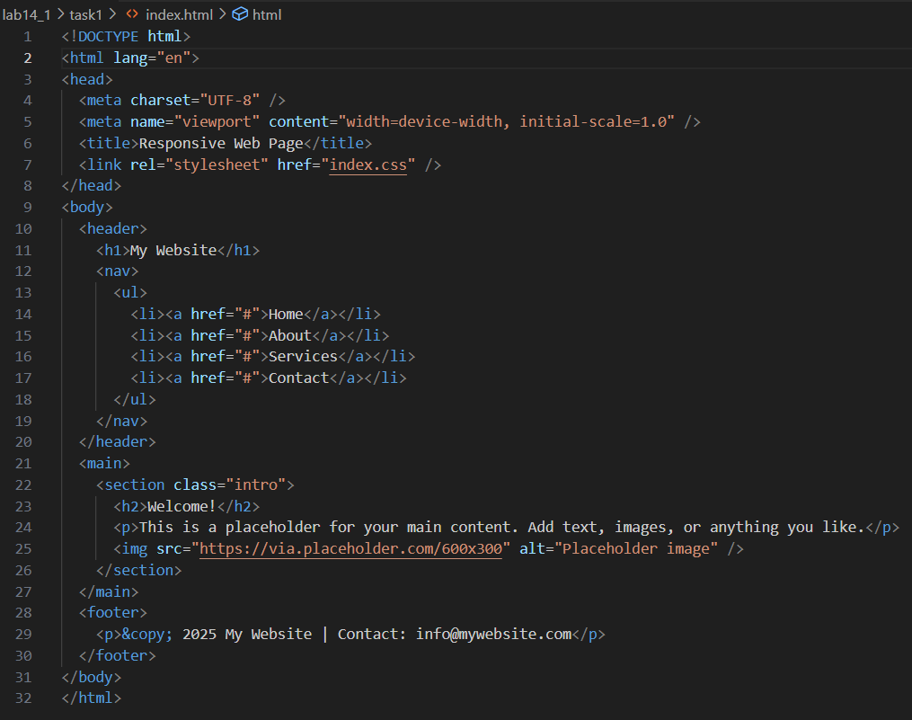

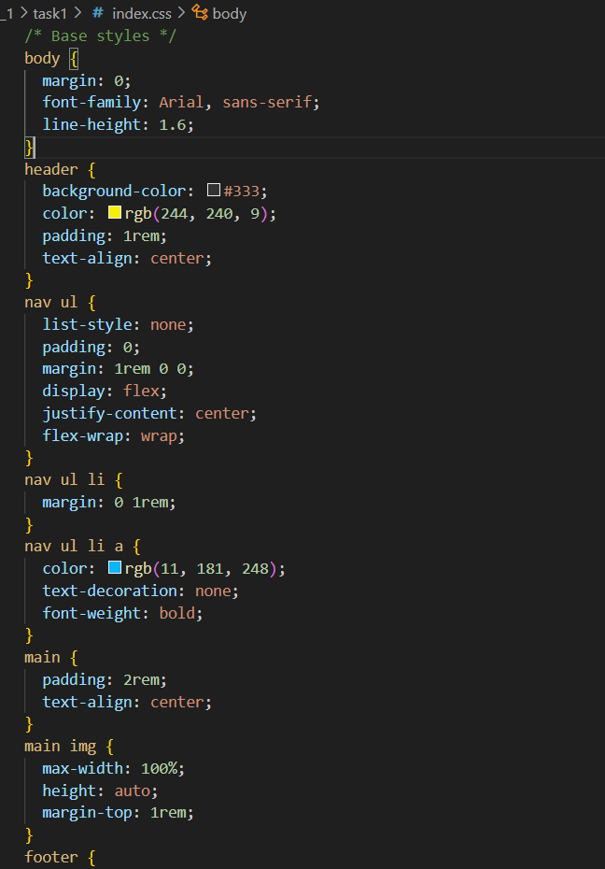

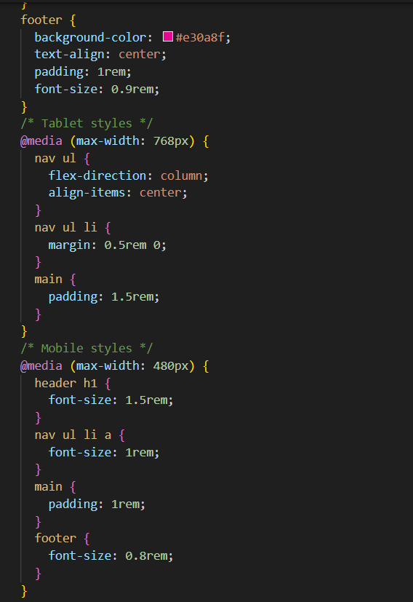

OUTPUT:

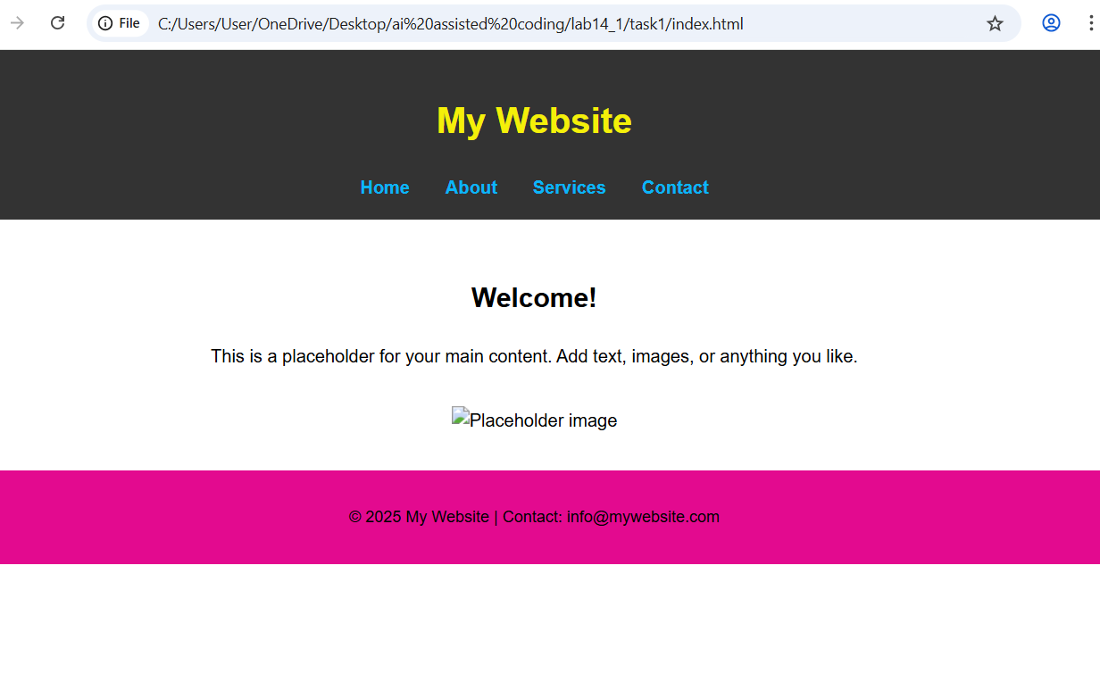

OBSERVATION:

A responsive web page was created with a header containing navigation links, a main section with placeholder text and an image, and a footer with copyright/contact information. The layout adapts smoothly to different screen sizes (desktop, tablet, mobile) using responsive CSS. The design is clean and visually organized, meeting all requirements.

TASK2:

PROMPT: Create a web page with a button. Use JavaScript so that clicking the button displays an alert message (e.g., “Button clicked!”). Ensure the code is clean and well-commented.

CODE:

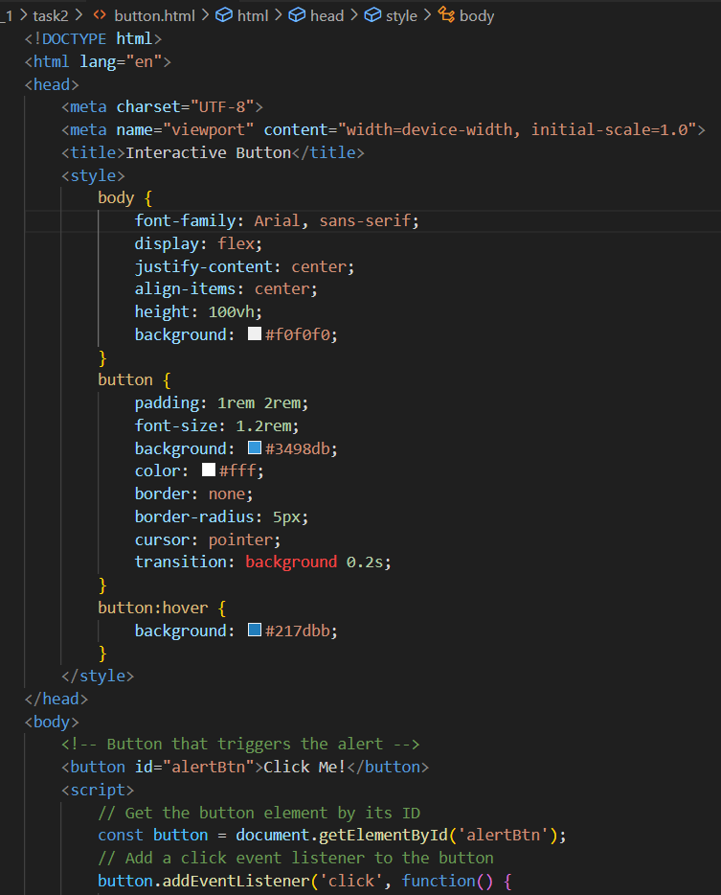

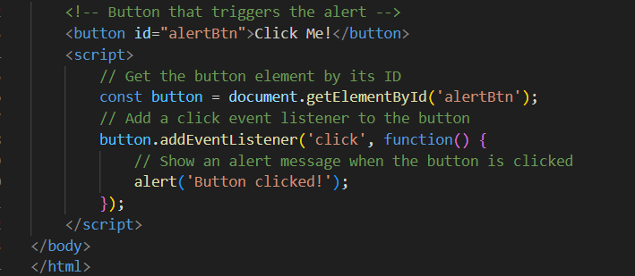

OUTPUT:

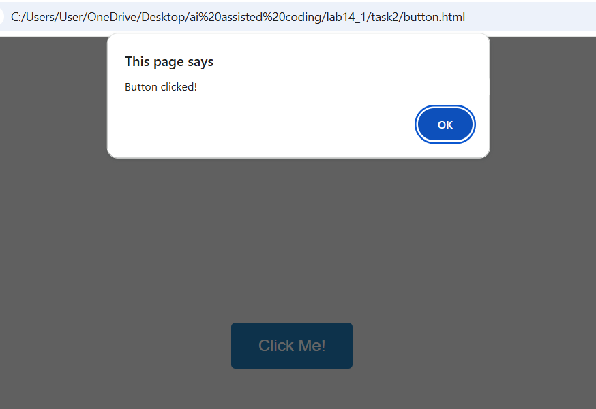

OBSERVATION: A web page was created with a button. When the button is clicked, a pop-up alert message appears as expected. The code is clean and includes comments for clarity.

TASK3:

PROMPT: Design a contact form with Name, Email, and Message fields. Use JavaScript to validate that all fields are filled and the email is in a valid format. Show inline error messages for invalid input, and display “Form submitted successfully” when the form is valid.

CODE:

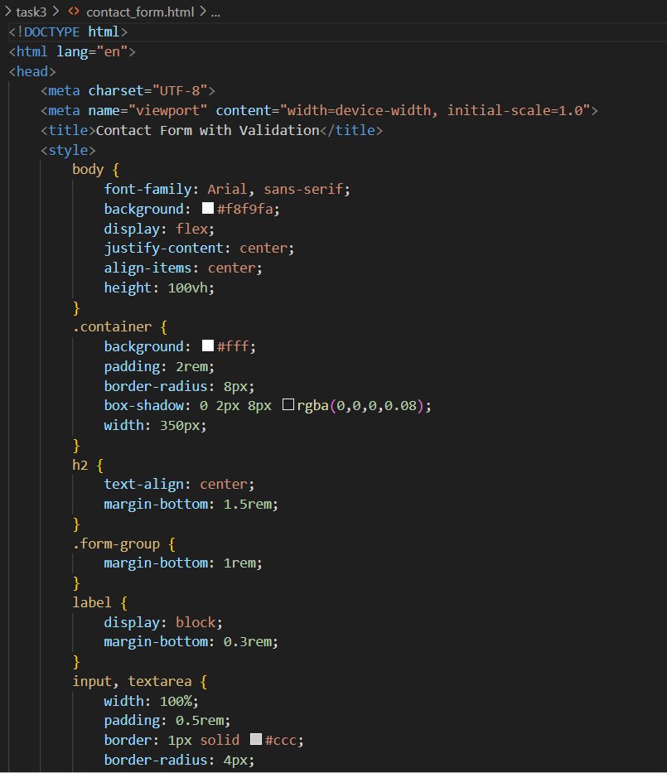

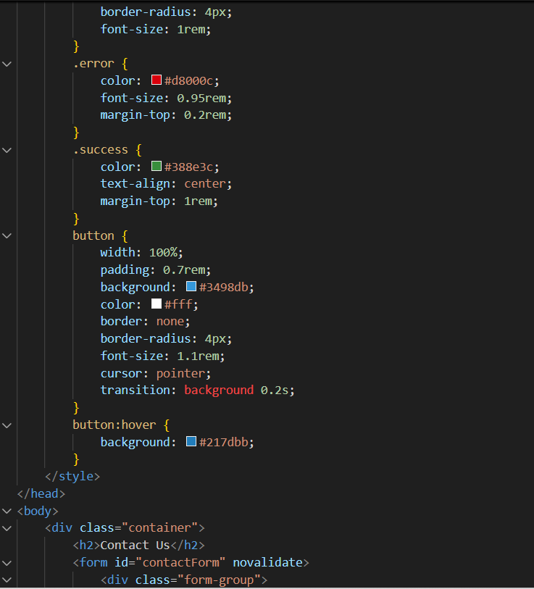

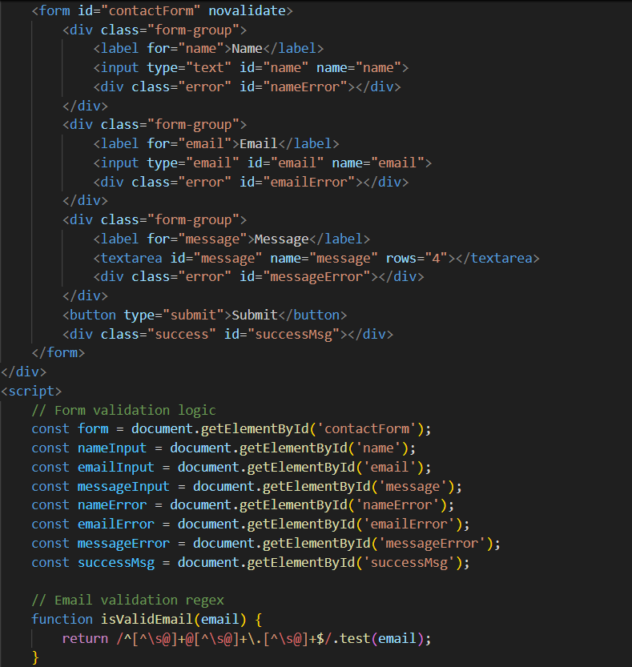

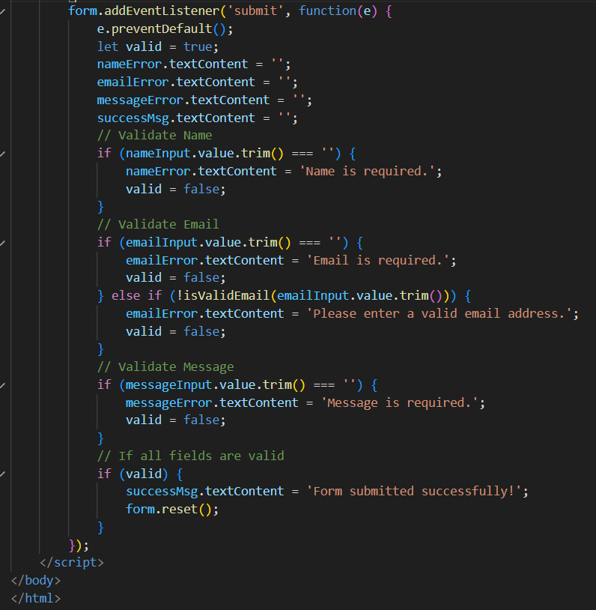

OUTPUT:

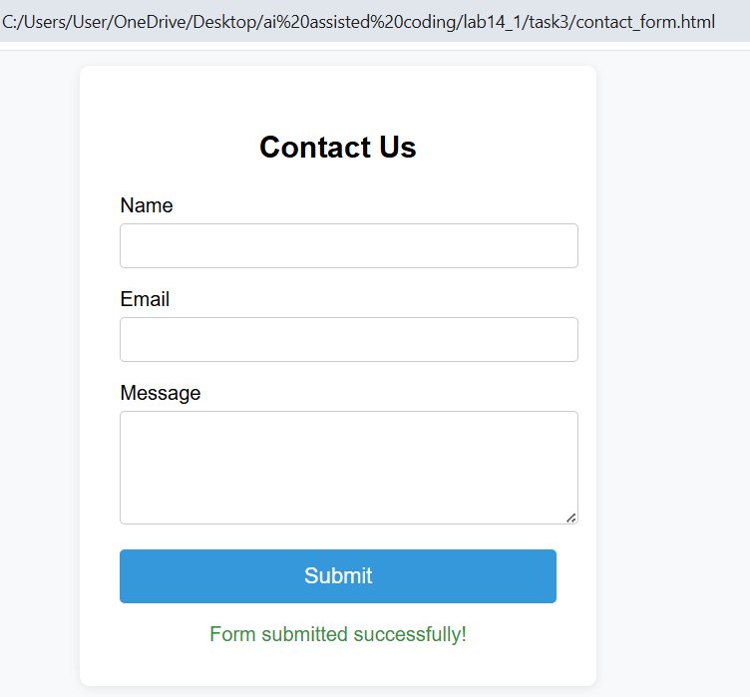

OBSERVATION: A functional contact form was created. Submitting with empty or invalid fields shows clear inline error messages. When all inputs are valid, a success message is displayed. The validation works as expected.

TASK4:

PROMPT: Create a web page with a list of items (e.g., product names). Use JavaScript to dynamically add a new item to the list when the “Add Item” button is clicked, and remove the last item when the “Remove Item” button is clicked. Updates should occur without reloading the page.

CODE:

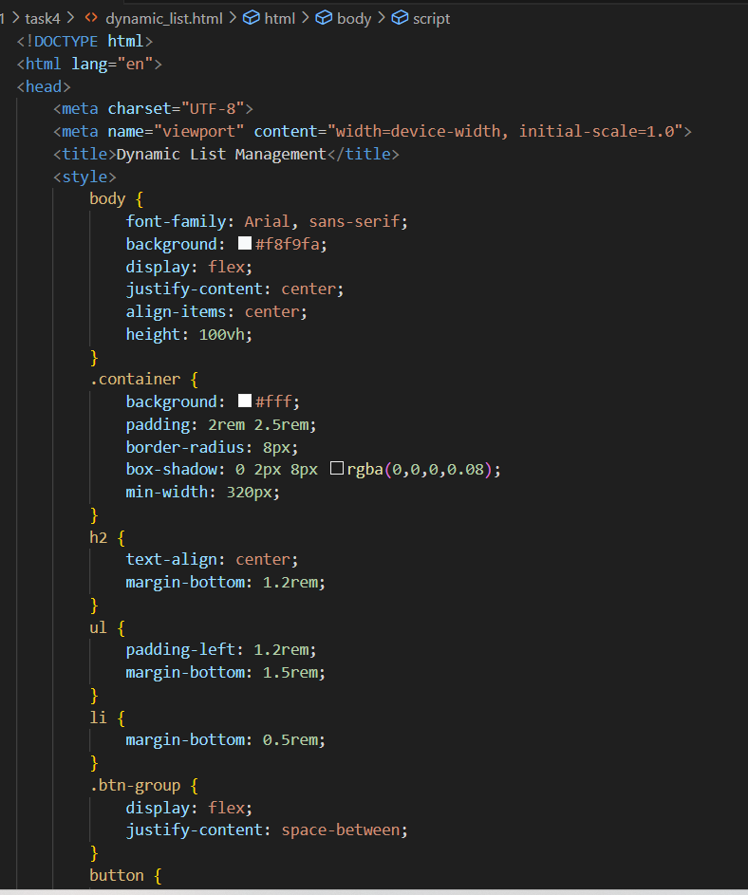

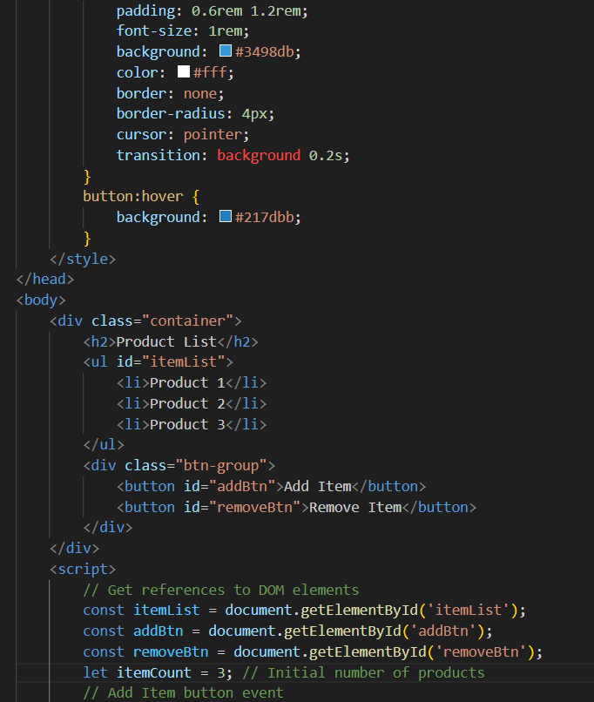

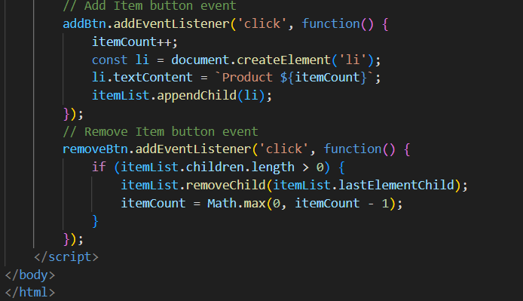

OUTPUT:

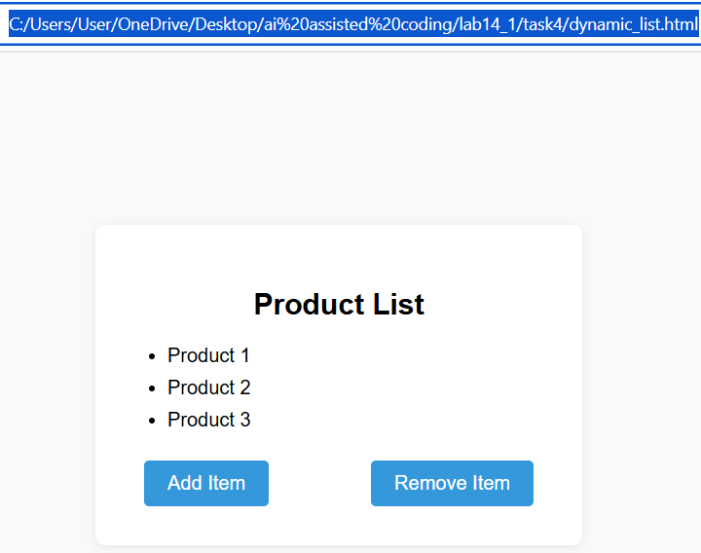

OBSERVATION: A web page was created with a product list and two buttons. Clicking “Add Item” adds a new product to the list, and “Remove Item” deletes the last product. All changes happen instantly without reloading the page, as expected.

TASK5:

PROMPT:Create a web page with a button labeled “Open Modal.” When clicked, a styled modal popup with a semi-transparent overlay should appear. The modal must have a close (“X”) button and should also close when the overlay area is clicked.

CODE:

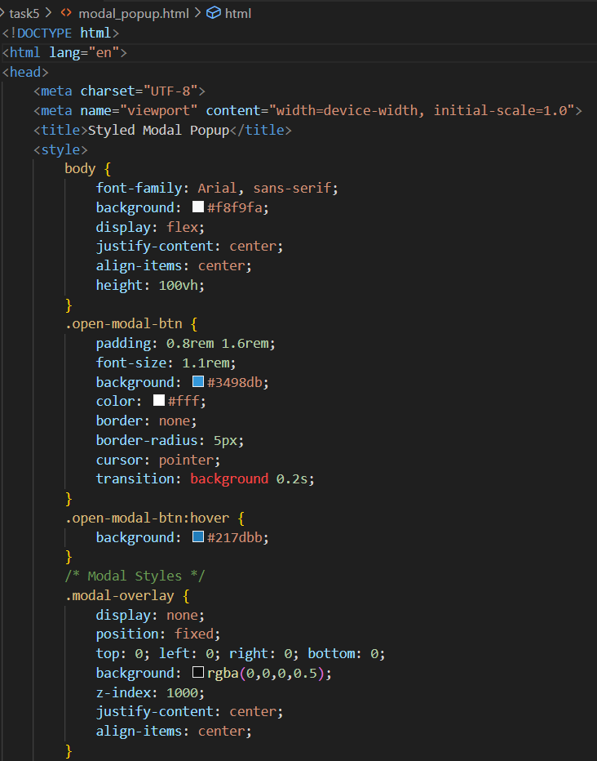

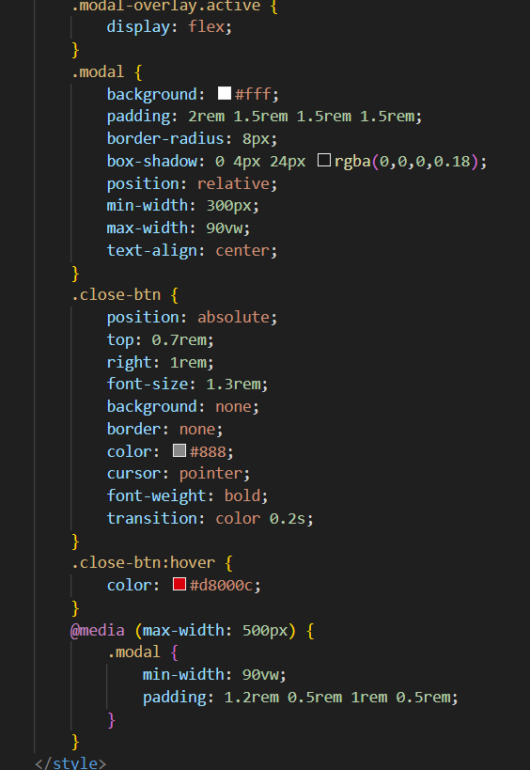

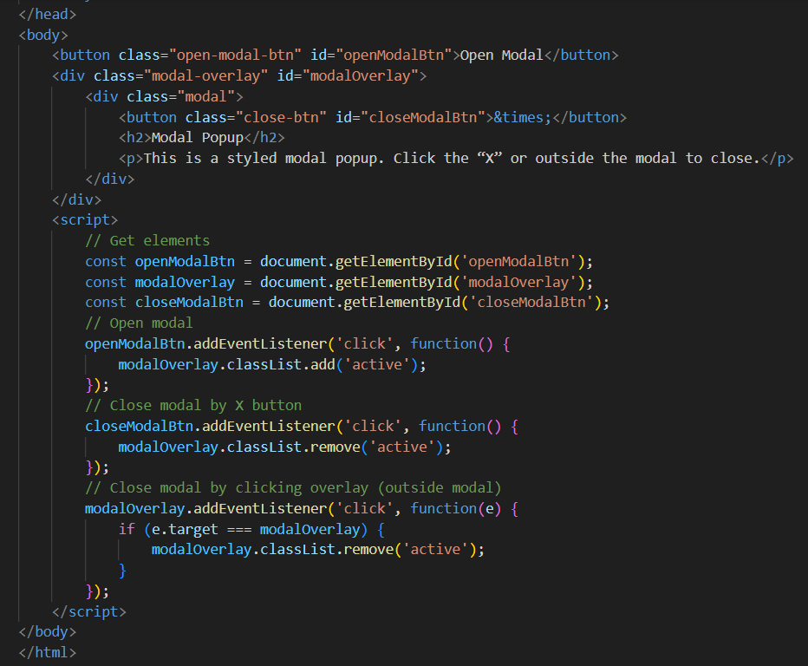

OUTPUT:

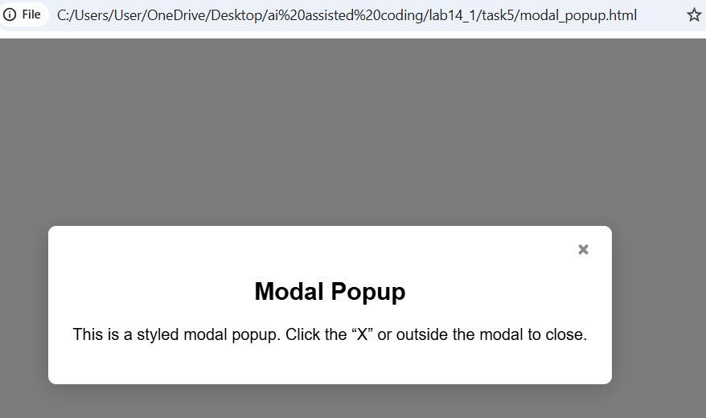

OBSERVATION:A web page was created with an “Open Modal” button. Clicking it displays a modal popup with content and a semi-transparent overlay. The modal can be closed by clicking the “X” button or the overlay area, as required.