AI ASSISTED CODING

LAB:8.4

ROLLNO:2403A52096

BATCH:04

TASK-1:

PROMPT: input:3 and output:9.write a python code that gives square of a number and satisfies the given test case.

CODE:

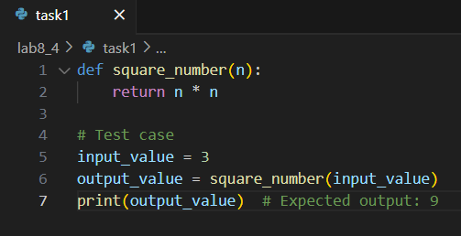

OUTPUT:



OBSERVATION:

This code defines a function to return the square of a number and prints the square of 3, which is 9.

TASK2:

PROMPT: INPUT:user@example.com and write a python code to satisfy the given input.

CODE:

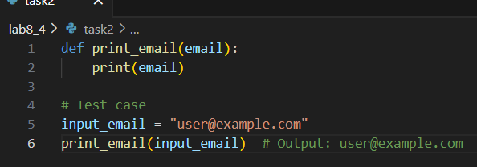

OUTPUT:

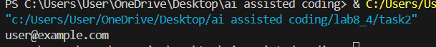

OBSERVATION:

This code defines a function print_email(email) that prints the given email address.

It sets input_email to "user@example.com" and calls print_email(input_email), which outputs the email to the console.

TASK3:

PROMPT: input:a=3,b=10,c=5 and max=b and write a python code to get max of three numbers and satisfies the input.

CODE:

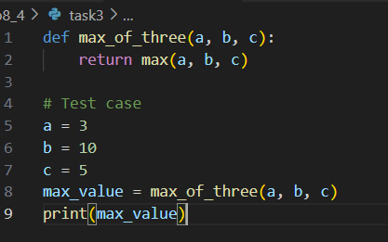

OUTPUT:

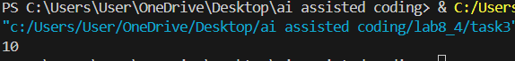

OBSERVATION:

This code defines a function max_of_three(a, b, c) that returns the largest of three numbers using Python’s built-in max() function.

It sets a = 3, b = 10, and c = 5, then finds and prints the maximum value, which is 10.

TASK4:

PROMPT: INPUT:add_item-apples,remove_item grapes,total_price and write a python code to satisfy the given inputs.

CODE:

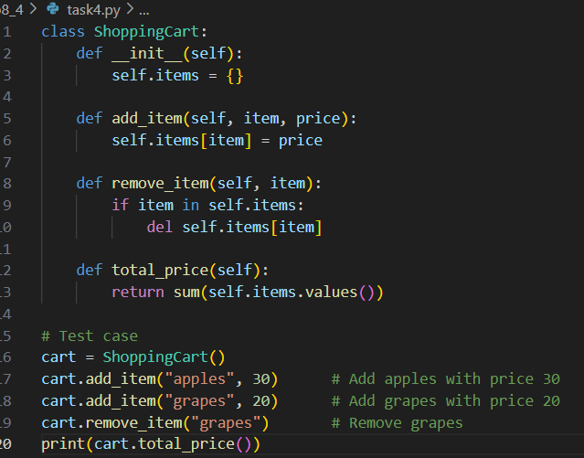

OUTPUT:



OBSERVATION: This code creates a shopping cart, adds apples and grapes, removes grapes, and prints the total price (30).

TASK5:

PROMPT: INPUT:121,OUTPUT:PALINDROME AND WRITE A PYTHON CODE THAT SATISFIES THE TESTCASE.

CODE:

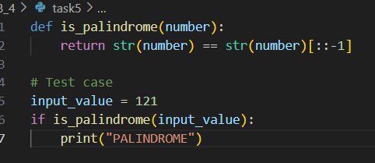

OUTPUT:

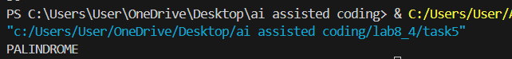

OBSERVATION:

This code defines a function is_palindrome(number) that checks if a number reads the same forwards and backwards by converting it to a string and comparing it to its reverse.

It tests the function with 121, and prints "PALINDROME" if the number is a palindrome.