AI ASSISTED CODING
LAB:15.4
ROLLNO:2403A52096
BATCH:04
TASK1:
PROMPT: Generate Python code to set up a basic Flask backend with one endpoint. The endpoint should be / and return a JSON response: {"message": "Welcome to AI-assisted API"}. The server should run locally on port 5000 with debug mode enabled.
CODE:
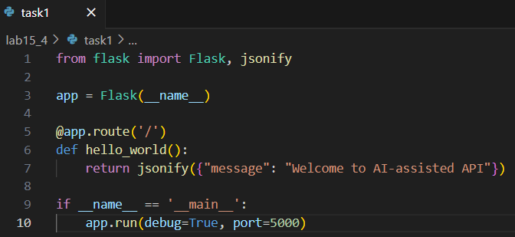
OUTPUT:
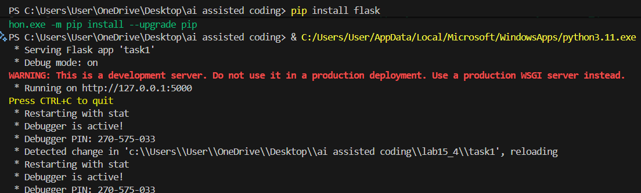
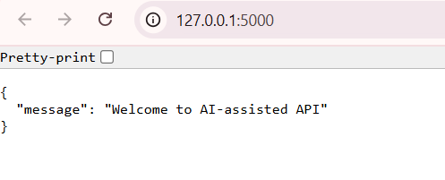
OBSERVATION:
Defines a minimal Flask app with GET / returning {"message":"Welcome to AI-assisted API"}. Runs locally on 127.0.0.1:5000 with debug=True.Requires Flask (pip install flask). Note: disable debug in production and change host to 0.0.0.0 to expose external.
TASK2:
PROMPT: Create a Flask backend with two endpoints:
- GET /items → returns a JSON list of items (initially empty).2. POST /items → accepts JSON payload like {"name":"Book","price":200}, adds it to the list, and returns {"message": "Item added", "item": {...}} with status code 201.Use request.get_json () to parse incoming data and jsonify() for responses. Include a global items list to store data in memory. Enable debug mode and run on localhost.
CODE:
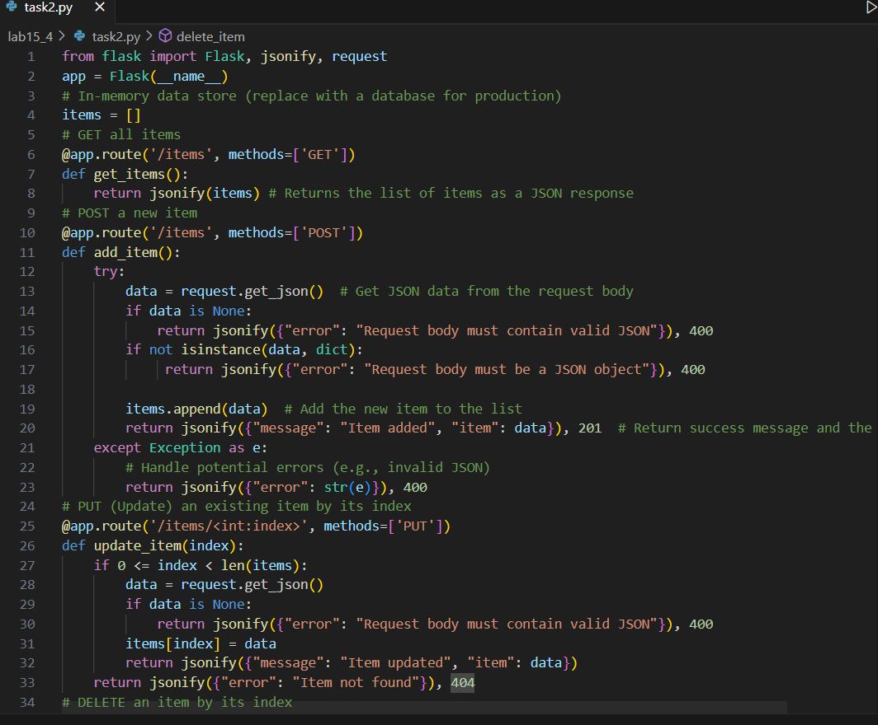
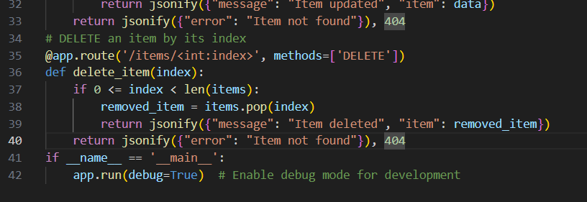
OUTPUT:
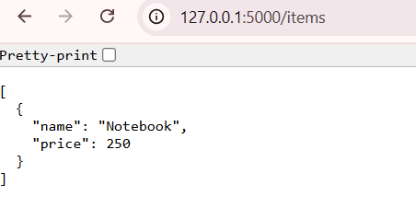
OBSERVATION:
This is a functional, straightforward Flask application that correctly implements a basic CRUD API.
The main weakness is using the list index to identify items for updates and deletions (/items/<int:index>). This is not a stable approach for an API, because if you delete an item, the indices of all subsequent items will change, breaking any client references to them.
A more robust solution would be to assign a unique, persistent ID (like a UUID) to each item when it's created and use that ID in the URL to reference it (e.g., /items/<string:item_id>).
TASK3:
- PROMPT: "Create a minimal Python Flask server with one endpoint / that returns JSON {"message":"Welcome to AI-assisted API"}; run locally on port 5000 with debug=True."
- "Add a PUT endpoint PUT /items/<int:index> that updates an existing item by index (404 if not found) and returns {"message":"Item updated","item":...}."
CODE:
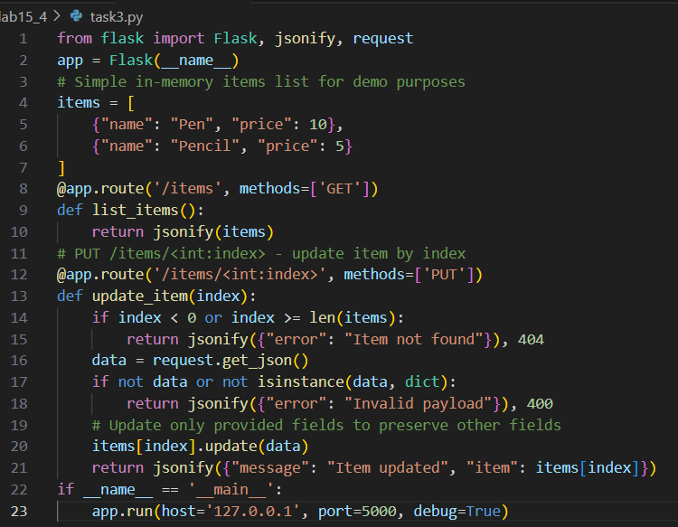
OUTPUT:
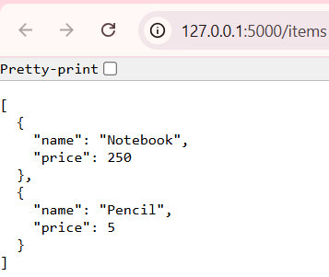
OBSERVATION:
- Created files: lab15_4/task1/app.py, lab15_4/task1/requirements.txt, lab15_4/task1/README.md.
- Added task3.py with an in-memory items list, GET /items, and PUT /items/<int:index> that updates fields and returns the updated item.
- Expected runtime: server at http://127.0.0.1:5000/ and PUT /items/0 with {"name":"Notebook","price":250} returns {"message":"Item updated","item":{"name":"Notebook","price":250}}.
- Note: dependency install was not completed in-session (pip install was cancelled) and the last local run of task3.py exited with code 1 — you may need to install Flask (pip install -r lab15_4/task1/requirements.txt) or fix local edits before running.
TASK4:
PROMPT: Start the server: run Python on task4.py using the full path (quote the script path because of spaces).
Observe: Flask prints "Running on http://127.0.0.1:5000" and the process stays running.
Test endpoint: send an HTTP GET to http://127.0.0.1:5000/items.
Observe: you receive JSON with the Notebook item (and the Flask terminal logs a 200 GET).
CODE:
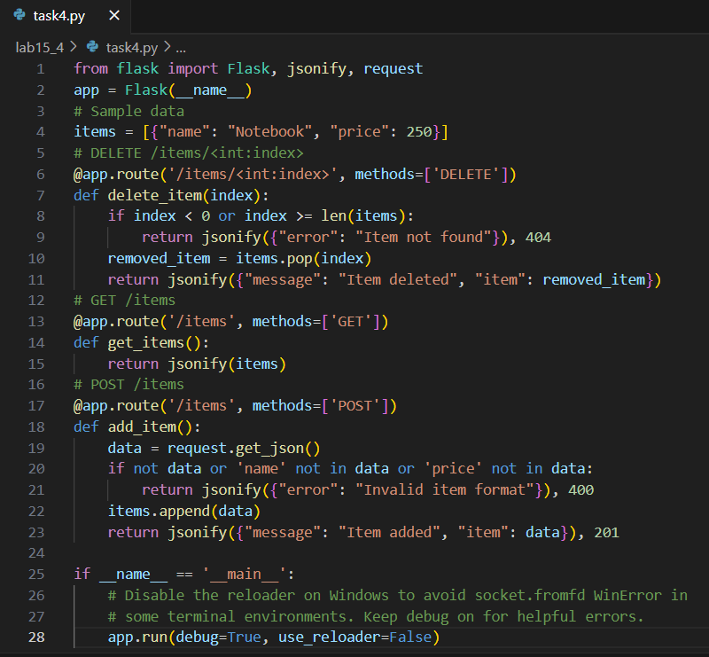
OUTPUT:
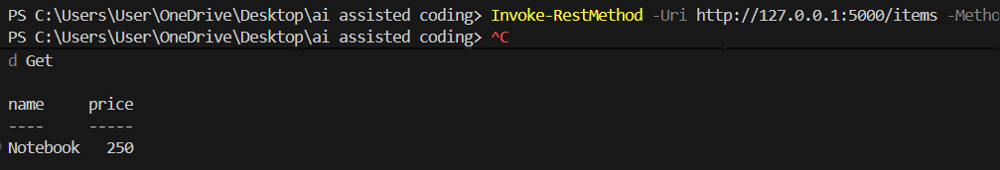
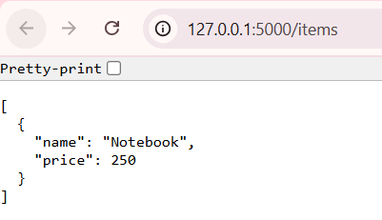
OBSERVATION:
- Start server: shows "Running on http://127.0.0.1:5000" and stays running.
- GET /items: returns JSON array with the Notebook item (HTTP 200).
- POST /items: returns HTTP 201 with the added item.
- DELETE /items/<index>: returns HTTP 200 with deleted item (or 404 if index invalid).
- Failure sign: a stack trace with "socket.fromfd" / "dup" / "WinError 10038" (reloader/socket issue).
TASK5:
PROMPT:
- Start server:
python3.11.exe "c:/Users/User/OneDrive/Desktop/ai assisted coding/lab15_4/task5.py"
- GET items:
Invoke-RestMethod -Uri http://127.0.0.1:5000/items -Method Get
- POST item:
Invoke-RestMethod -Uri http://127.0.0.1:5000/items -Method Post -ContentType 'application/json' -Body '{"name":"Pen","price":5}'
- DELETE item (index 0):
Invoke-RestMethod -Uri http://127.0.0.1:5000/items/0 -Method Delete
- Docs (browser or PowerShell):
Open http://127.0.0.1:5000/docs (or Invoke-RestMethod -Uri http://127.0.0.1:5000/docs -Method Get)
CODE:
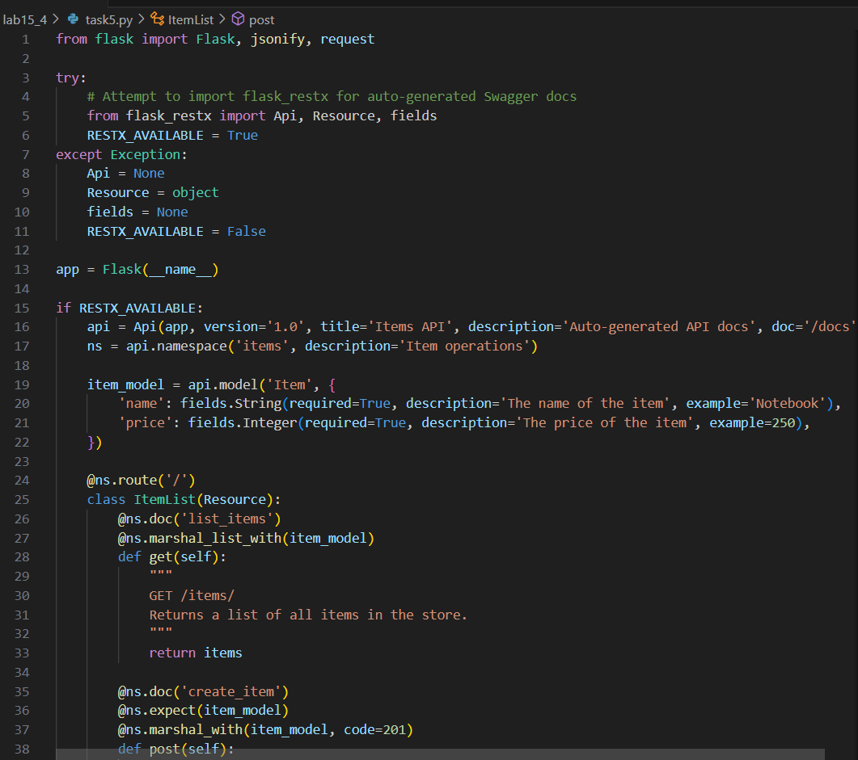
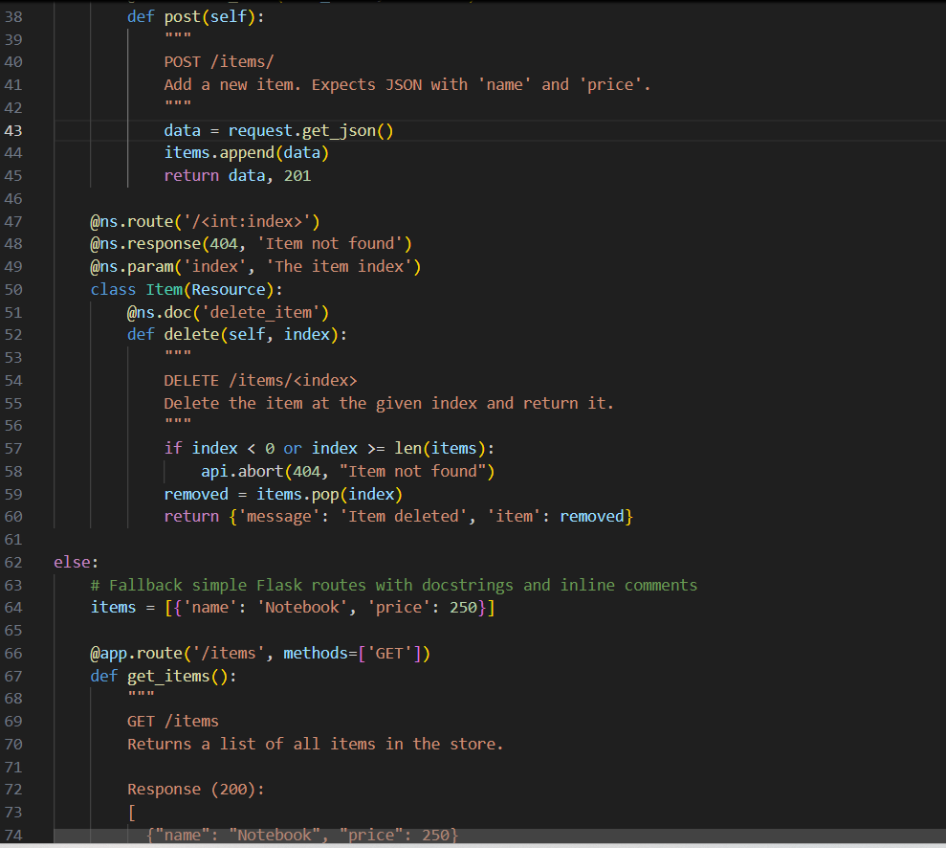
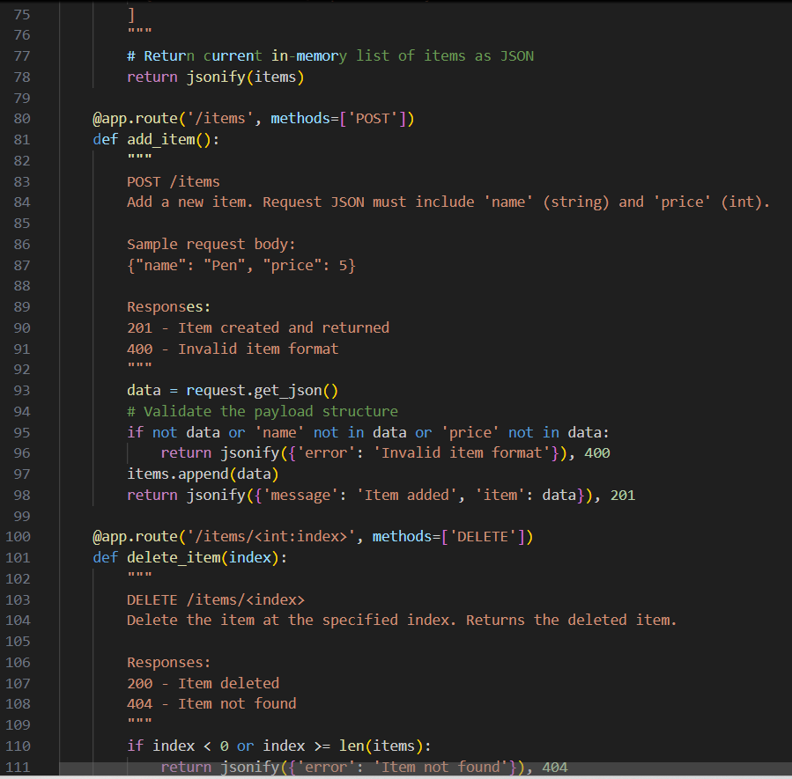
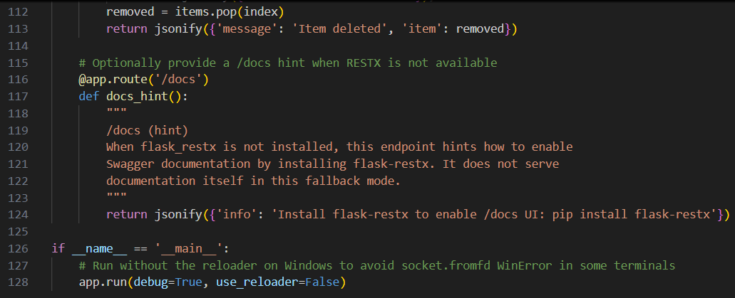

OUTPUT:
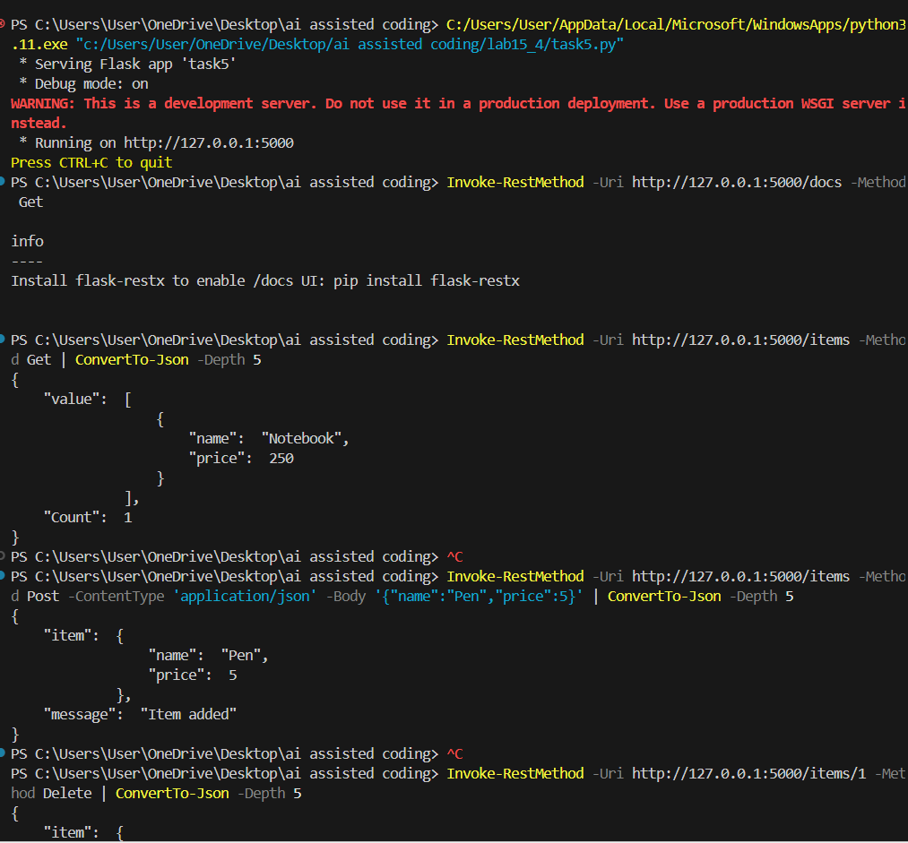
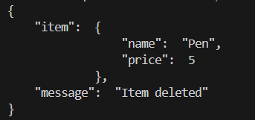
- OBSERVATION: Start server: prints "Serving Flask app 'task5'", "Running on http://127.0.0.1:5000" and stays running.
- GET /items: returns JSON array (initially contains Notebook) and server logs GET 200.
- POST /items: returns 201 with {"message":"Item added","item":{...}}; subsequent GET includes the new item.
- DELETE /items/0: returns 200 with {"message":"Item deleted","item":{...}} (404 if index invalid).
- /docs: shows Swagger UI if flask-restx is installed; otherwise returns a JSON hint telling how to install it.

