**SDM College of Engineering and Technology**

Dhavalagiri , Dharwad-580002. Karnataka State. India.

Email: [principal@sdmcet.ac.in](mailto:principal@sdmcet.ac.in), [cse.sdmcet@gmail.com](mailto:cse.sdmcet@gmail.com)

Ph: 0836-2447465/ 2448327 Fax: 0836-2464638 Website: sdmcet.ac.in

**Department**

**of**

**COMPUTER SCIENCE AND ENGINEERING**

**ASSIGNMENT-1**

**[18UCSE508- ADVANCED OBJECT ORIENTED PROGRAMMING ]**

**Course Teacher: Prof. Indira R Umarji**



**2022- 2023**

Submitted

By

**Ms. Kusuma Reddy**

**2SD20CS049**

**5th Semester B division**

**Q1. Write a Java program to perform the following operations:**

**a) Read a line of text**

**b) Search for a sub-string SDMCET (case insensitive search)**

**c) If found, then print success message**

**d) Otherwise throw an exception SubStringNotFoundException with appropriate message**

**package** program1;

**import** java.util.Scanner;

**public** **class** program1 {

**public** **static** **void** main(String[] args) **throws** Exception {

Scanner sc=**new** Scanner(System.***in***);

System.***out***.println("enter the text");

String str=sc.next();

String substr="SDMCET";

**boolean** b=str.toLowerCase().contains(substr.toLowerCase());

**if**(!b)

**throw** **new** SubStringNotFoundException();

**else**

System.***out***.println("Substring found");

}

**package** program1;

**public** **class** SubStringNotFoundException **extends** Exception{

**public** String toString() {

**return** " SubString not found";

}

}

}

OUTPUT

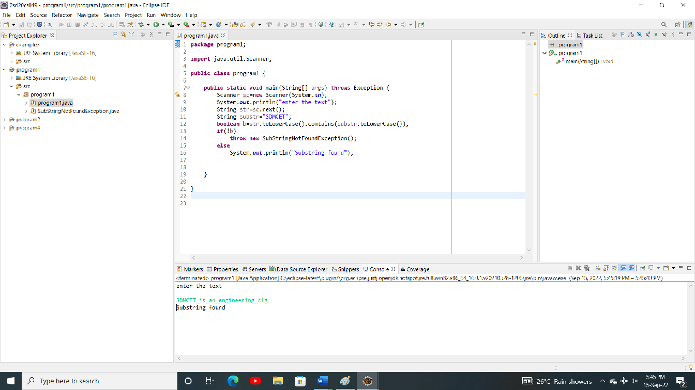

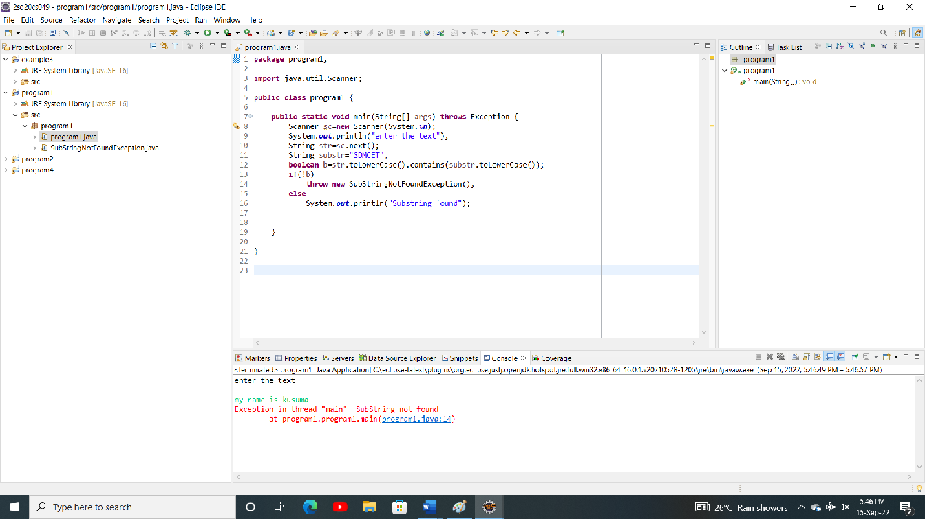

**Q2.Write a Java program to generate and handle any three built-in exceptions and display appropriate**

**error messages.**

**package** program2;

**public** **class** program2 {

**public** **static** **void** main(String[] args) {

**try** {

**int** a=10,b=0;

**int** res=a/b;

System.***out***.println(res);

}**catch**(ArithmeticException ae) {

System.***out***.println(ae);

}

**try** {

String str=**null**;

System.***out***.println(str.charAt(0));

}**catch**(NullPointerException ne) {

System.***out***.println(ne);

}

**try** {

**int**[] A= **new** **int**[2];

A[0]=10;

A[1]=20;

A[2]=30;

}**catch**(ArrayIndexOutOfBoundsException aie) {

System.***out***.println(aie);

}

}

}

OUTPUT:

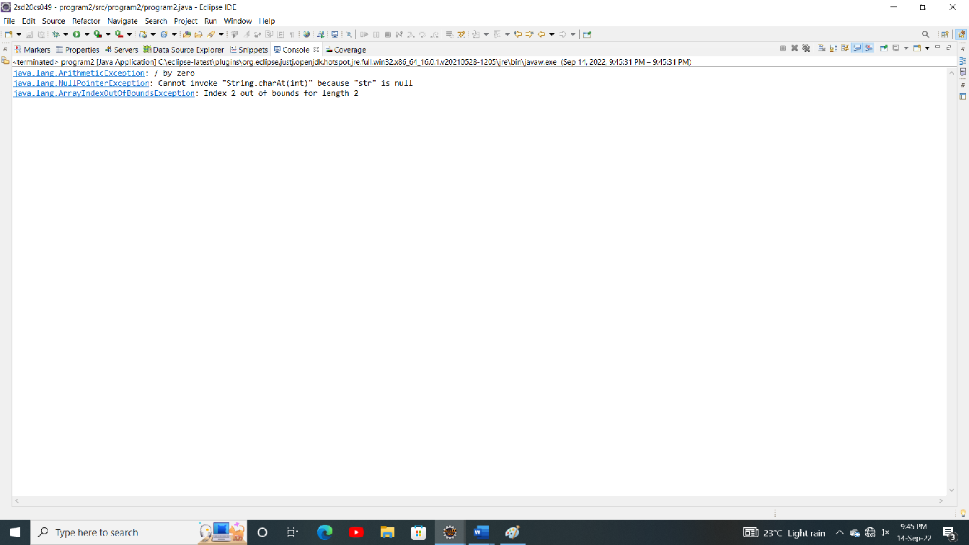

**Q3.Write a Java program to perform the following operations:**

**a) Create a file named Alphabets.txt and insert appropriate data into it**

**b) Read the file and copy all the consonants into another file named Consonants.txt**

**c) If vowel is encountered, throw an exception VowelNotAllowedException and continue until**

**end of file**

**package** program4;

**import** java.io.FileInputStream;

**import** java.io.FileOutputStream;

**public** **class** program4 {

**public** **static** **void** main(String[] args) **throws** Exception {

FileInputStream fis = **new** FileInputStream("C:\\eclipse-latest\\2sd20cs049\\program4\\src\\Alphabets.txt");

FileOutputStream fos = **new** FileOutputStream("C:\\eclipse-latest\\2sd20cs049\\program4\\src\\Consonants.txt");

**int** c;

**while**((c=fis.read())!=-1) {

**try** {

**if**(c=='a'|| c=='e' || c=='i'|| c=='o'|| c=='u'|| c=='A'|| c=='E' || c=='I' ||c=='O'|| c=='U') {

**throw** **new** VowelNotAllowedException();

}

fos.write(c);

}**catch**(Exception e) {

System.***out***.println(e);

}

}

}

}

**package** program4;

**public** **class** VowelNotAllowedException **extends** Exception {

**public** String toString() {

**return** "vowels not allowed";

}

}

OUTPUT:

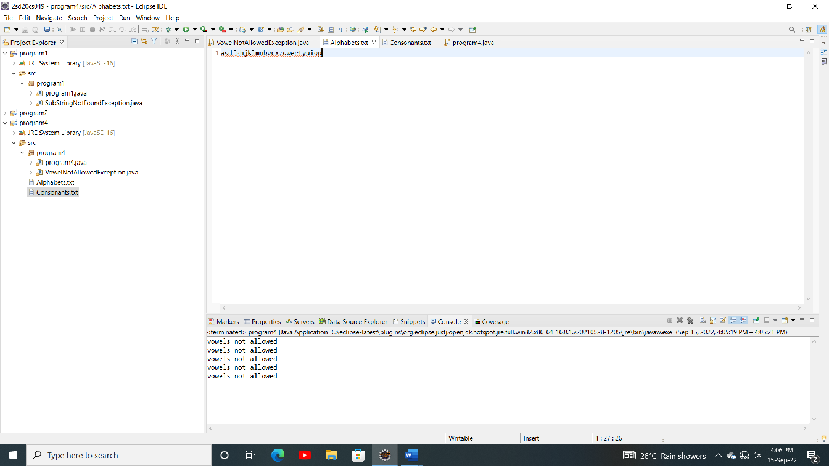

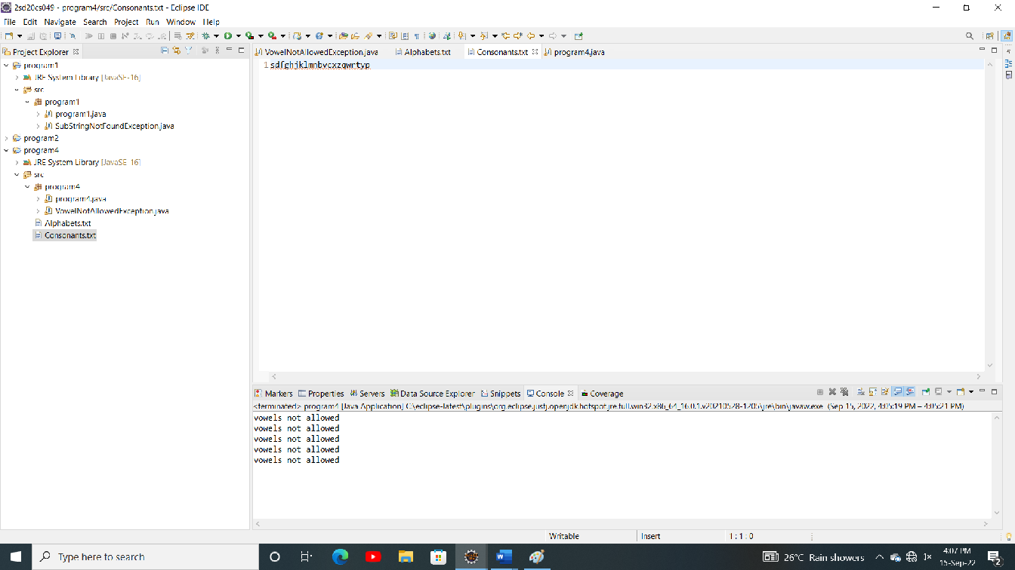

**Q4.Write a Java program to read an integer and check whether the number is prime or not. If negative**

**number is entered, throw an exception NegativeNumberNotAllowedException and if entered**

**number is not prime, then throw NumberNotPrimeException**.

**package** example3;

**import** java.util.Scanner;

**public** **class** example3 {

**public** **static** **void** main(String[] args) **throws** Exception {

Scanner sc=**new** Scanner(System.***in***);

System.***out***.println("enetr an integer");

**int** n=sc.nextInt();

**if**(n<0) {

**throw** **new** NegativeNumberNotAllowedException();

}

**for**(**int** i=2;i<n;i++) {

**if**(n%i==0) {

**throw** **new** NumberNotPrimeException();

}

}

}

}

**package** example3;

**public** **class** NegativeNumberNotAllowedException **extends** Exception {

**public** String toString() {

**return** "negative number not allowed";

}

}

**package** example3;

**public** **class** NumberNotPrimeException **extends** Exception {

**public** String toString() {

**return** "number not prime";

}

}

OUTPUT:

