ABSTRACT

ABOUT THE PROJECT:

Malaria prediction recognisation - Malaria is one of the major public health problems in India. Early prediction of a Malaria outbreak is the key for control of malaria morbidity, mortality as well as reducing the risk of transmission of malaria in the community and can help policymakers, health providers, medical officers, ministry of health and other health organizations to better target medical resources to areas of greatest need. Here developed model “Malaria outbreak prediction Model using Machine Learning” can help as an early warning tool to identify potential outbreaks of Malaria. In this study two popular data mining classification algorithms Support Vector Machine (SVM) and Artificial Neural Network (ANN) are used for Malaria prediction using a large dataset.

Signs and symptoms

A malaria infection is generally characterized by the following signs and symptoms:
- Fever
- Chills
- Headache
- Nausea and vomiting
- Muscle pain and fatigue
Other signs and symptoms may include:
- Sweating
- Chest or abdominal pain
- Cough

Malaria is a life-threatening disease caused by parasites that are transmitted to people through the bites of infected female Anopheles mosquitoes. It is preventable and curable. Malaria causes symptoms that typically include fever, tiredness, vomiting, and headaches. In severe cases it can cause yellow skin, seizures, coma, or death

INDEX

1. INTRODUCTION………………………………………………..7

  - Objective of Research……………………………………8

1.2 Problem Statement……………………………………..…8

2. REVIEW OF LITERATURE…………………………….….….8

2.1 Software requirements……………………………….…..9

2.2 Hardware requirements.…………………………………..9

3. DATA COLLECTION………………………………………......10

4. METHODOLOGY……………………………………………….11

4.1. Statistical techniques and data visualization…….….……12

4.2. Data modeling using supervised ML techniques…….…..13

5. FINDINGS AND SUGGESTIONS………………………….…..14

6. CONCLUSION…………………………………………………...15

- Survival Analysis of Chronic Kidney Disease

1. Introduction:

Early detection of preventable diseases is important for better disease management and more efficient health-care resource allocation. Our project focuses on to ease the medical processes of detecting the chronic kidney disease by providing a platform or a website where the users can enter their medical values to predict their disease.

Machine Learning is a growing field concerned with the study of enormous and several variable data having computational methods, algorithms and techniques for analysis and prediction. Machine learning delivers methodologies , approaches that can help resolving analytic and predictive In Medical Science’s viewpoint, Machine Learning techniques have showed success in prediction and diagnosis of numerous critical diseases.

Due to complexity and vagueness of data engendered by healthcare transactions, it is impossible to analyze them with traditional tools. In order to make the decision-making process easier and more trustable, machine learning techniques are provided to transmute these data into useful information and makes it feasible to get useful results and patterns and trends out of these huge amounts of data.

Machine Learning has been widely used in many areas. One of these areas which is using it even more and more as an essential tool is healthcare management. All agents in a healthcare industry can significantly benefit Data mining applications. Different machine learning classification algorithm for diagnosis of chronic kidney disease is discussed.
Various classification techniques that are used are: Random Forest Classifier, Decision Tree, KNN Classifier.

We have used Python version-3 for our project purpose. Python is an interpreted, high-level, general-purpose programming language. It can be used to handle big data and perform complex mathematics. Python community has developed many modules to help programmers implement machine learning. It has syntax that allows developers to write programs with fewer lines than some other programming languages.

We have even built a web UI that uses tools such as Node-RED and IBM Watson Studio. Using the machine learning service of IBM cloud with features for training and deploying the machine learning models, we have integrated and deployed our model. Next, We have built our own Web UI using Node -Red of WatsonStudio.

1.1 Objective of Research:

Chronic Kidney Disease prediction is one of the most central problems in medical decision making because it is one of the leading cause of death.
The aim of this work is to reduce the diagnosis time and to improve the diagnosis accuracy through classification algorithms . Machine Learning techniques have showed success in prediction and diagnosis of numerous critical diseases. So, We tried to provide a user interface that uses our ML model so that an individual just by sitting at their homes could know if his/her symptoms would lead to Kidney disease or not.
Our project model analyzes the symptoms provided by the user as input and gives the probability of the disease as an output.

We have also developed a web UI based on our algorithm helps in prediction of chronic kidney disease, providing a user friendly interface and making it more approachable to individuals.

1.2.Problem Statement:

In Medical Science’s viewpoint, Machine Learning techniques have showed success in prediction and diagnosis of numerous critical diseases. Chronic Kidney Disease prediction is one of the most central problems in medical decision making because it is one of the leading cause of death.
We, through this project, are trying to take the advantage of available technologies to develop prediction models for Chronic Kidney disease. We have compared the performance of three classifiers in the prediction of Random Forest Classifier ,Decision Tree Classifier, KNN classifier.

2.Review of Literature:

- DSVGK Kaladhar, Krishna Apparao Rayavarapu and Varahalarao Vadlapudi et al applied machine learning techniques to predict kidney stones by using C4.5, Random forest (93%), Support Vector Machines (SVM), Logistic, NN and Naive Bayes machine learning algorithms which becomes useful in automating the treatment of kidney stones diseases
- Vijayarani, S., Dhayanand, M. S., & Phil, M. (2015). Kidney disease prediction using svm and ann
- S. Ramya and Dr. N. Radha, “Diagnosis of Chronic Kidney Disease Using Machine Learning Algorithms”, International Journal of Innovative Research in Computer and Communication Engineering, Volume 4, Issue 1, January 2016, pp 813- 820
- SA, S. (2013). Intelligent heart disease prediction system using data mining techniques. International Journal
of Healthcare & Biomedical Research, 1, 94-101.
- Chapman, P., Clinton, J., Kerber, R. Khabeza, T., Reinartz, T., Shearer, C., Wirth, R.: “CRISP-DM 1.0: Step by step data mining guide”, SPSS, 1-78, 2000.

2.1 SOFTWARE REQUIREMENTS

Operating System : Windows 10.

Technology : ASP.NET

Softwares : Anaconda, jupyter

2.2 HARDWARE REQUIREMENTS

Hardware :

RAM : 4 GB

3.Data Collection:

Chronic Kidney Disease Data
For study and analysis, I used the dataset from the UCI Machine Learning Repository named Chronic Kidney Disease. The dataset contains data of 400 sample from the southern part of India with their ages ranging between 2-90 years. There are in total fifteen features,
Most of which are clinical in nature and the rest are physiological.Table 1.summarizes various parameters. As a part of data pre-processing, missing values and outliers are imputed with mean value of that feature for continuous data and attribute model value for categorical data. Nominal data are converted to numerical values. For example, Nominal values ‘Normal’ are labelled “1” and ‘Abnormal’ are labelled “0”.
values ‘Normal’ are labelled “1” and ‘Abnormal’ are labelled “0”.
values ‘Normal’ are labelled “1” and ‘Abnormal’ are labelled “0”.
Table 1 Feature

Features for chronic kidney disease used in experiment:
S.No | Attribute | Description
1. | age | Age(numerical)
2. | bp | Blood Pressure(numerical)
3. | Al | Albumin(nominal)
4. | Su | Sugar(nominal)
5. | Rbc | Red Blood Cells(nominal)
6. | bgr | Blood Glucose Random(numerical)
7. | sc | Serum Creatinine (numerical)
8. | hemo | Haemoglobin (numerical)
9. | pcv | Packed Cell Volume (numerical)
10. | wc | White Blood Cell Count (numerical)
11. | rc | Red Blood Cell Count (numerical)
12. | htn | Hypertension (nominal)
13. | appet | Appetite (nominal)
14. | pe | Pedal Edema (nominal)
15. | ane | Anemia (nominal)
16. | classification -(ckd,notckd) | Class (nominal)

4.Methodology:

values ‘Normal’ are labelled “1” and ‘Abnormal’ are labelled “0”.

This section describes the proposed methodology for data mining from CKD dataset. The very first and important step is preprocessing and cleaning the data.
Cleaning process is the process of filling the missing values based on either there are categorical or nominal data. This process also involves replacing unknown values (like '?','\t43' as we have in our data).Also, we identified three numerical columns of our data to be in String format. So , we tried convert it into numerical format as we can only process the numerical data.
For identifying the columns with null values, we show in fig1

fig1. null values in dataset
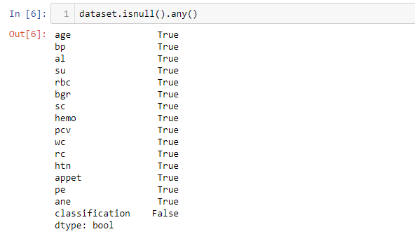
In columns of categorical data, we replaced with mode value
dataset['age'].fillna((dataset['age'].mean()),inplace=True)
dataset['bp'].fillna((dataset['bp'].mean()),inplace=True)
dataset['al'].fillna((dataset['al'].mode().iloc[0]),inplace=True)
dataset['su'].fillna((dataset['su'].mean()),inplace=True)
dataset['rbc'].fillna((dataset['rbc'].mode().iloc[0]),inplace=True)
dataset['bgr'].fillna((dataset['bgr'].mean()),inplace=True)
dataset['sc'].fillna((dataset['sc'].mean()),inplace=True)
dataset['hemo'].fillna((dataset['hemo'].mean()),inplace=True)
dataset['pcv'].fillna((dataset['pcv'].mode().iloc[0]),inplace=True)
dataset['wc'].fillna((dataset['wc'].mode().iloc[0]),inplace=True)
dataset['rc'].fillna((dataset['rc'].mode().iloc[0]),inplace=True)
dataset['htn'].fillna((dataset['htn'].mode().iloc[0]),inplace=True)
dataset['appet'].fillna((dataset['appet'].mode().iloc[0]),inplace=True)
dataset['pe'].fillna((dataset['pe'].mode().iloc[0]),inplace=True)
dataset['ane'].fillna((dataset['ane'].mode().iloc[0]),inplace=True)
In columns of numerical data, we replaced the null values with mean values.
fig2: After replacing null values
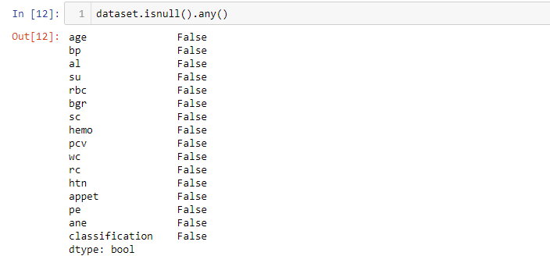

4.1. Statistical techniques and data visualization

BAR GRAPH:
Fig3: BAR GRAPH
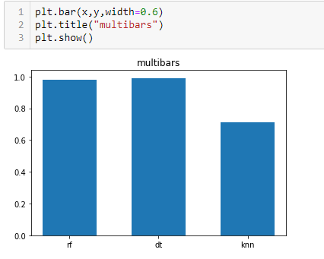
We can observe (from fig3) that the Highest accuracy is obtained in case of Decision Tree Classifier

4.2. Data modelling using Supervised ML techniques
We know that our target variable 'classification' is a binary variable(categorical variable).For prediction task of chronic kidney disease we separately applied three machine learning algorithms namely: like Random Forest Classifier ,Decision Tree Classifier, KNN classifier .
Data Preparation:
Dividing the given data into input array and output(target) variable. Then using train_test_split method to split the data into training data(70%) and testing data(30%).
#x is input features and y is target variable
from sklearn.model_selection import train_test_split
x_train,x_test,y_train,y_test=train_test_split(x,y,test_size=0.2,random_state=0)

- Model-1 Random Forest Classifier:
Python implementation:
from sklearn.ensemble import RandomForestClassifier
RFclassifier=RandomForestClassifier(n_estimators=30,criterion='gini',random_state=0)
RFclassifier.fit(x_train,y_train)
y_RFpredict=RFclassifier.predict(x_test)
y_RFpredict
y_test

- Model-2 Decision Tree Classifier:
Decision Trees are a type of Supervised Machine Learning (that is you explain what the input is and what the corresponding output is in the training data) where the data is continuously split according to a certain parameter.
Python implementation:
#inplaces of entropy we can change name into "gini" so that we can calculate another method for decision
from sklearn.tree import DecisionTreeClassifier
DTclassifier=DecisionTreeClassifier(criterion='entropy',random_state=0)
DTclassifier.fit(x_train,y_train)
y_DTpredict=DTclassifier.predict(x_test)
y_DTpredict
y_test

- Model-3 KNN Classifier:
K-Nearest Neighbors is one of the most basic yet essential classification algorithms in Machine Learning. It belongs to the supervised learning domain and finds intense application in pattern recognition, data mining and intrusion detection.

Python Implementation :
from sklearn.neighbors import KNeighborsClassifier
classifier=KNeighborsClassifier(n_neighbors=5,metric='minkowski',p=2)
classifier.fit(x_train,y_train)
y_predict=classifier.predict(x_test)
y_predict
y_test

- Findings and Suggestions:

Findings :
Table of accuracy of different classifier models used:
S.No | Model | Accuracy | AUC
1. | Random Forest | 0.975 | 0.9807692307692308
2. | Decision Tree | 0.9875 | 0.9903846153846153
3. | KNN classifier | 0.6875 | 0.7101648351648351
The highest accuracy is obtained in case of Decision Tree Classifier with 98% accuracy .It seems to fit the training dataset, but has poor fit with new datasets i.e, Over fitting . Overfitting happens when a model learns the detail and noise in the training data to the extent that it negatively impacts the performance of the model on new data. This means that the noise or random fluctuations in the training data is picked up and learned as concepts by the model. The problem is that these concepts do not apply to new data and negatively impact the models ability to generalize.
After Random Classifier the highest accurate model is Decision Tree with 98.75%.Also the plottings of attributes effect on the output seems to be a sigmoid curve. So finally it is observed that the Decision Tree model is better model for Chronic Kidney Disease Prediction.

Suggestions:
1. The size of the dataset used in this research is still quite small. A large dataset would definitely give better results.
2. Also, If we work on even more large sets and try to reduce the over fitting problem with random forest , we can have a more accurate prediction model.

- Conclusion:

Accurate prediction of chronic kidney disease is one of the emerging topics in medical diagnosis. Early detection of preventable diseases is important for better disease management. So, with the objective to find the better model for chronic kidney disease, We have compared the performance of three classifiers in the prediction of chronic kidney disease. The experimental results of our proposed method have demonstrated that Decision Tree has produced superior prediction performance in terms of classification accuracy for our considered dataset, with accuracy 98.75% . Thus finally it is observed that Decision Tree is better algorithm for chronic kidney diagnosis

Web based application:

We incorporated a responsive web based frontend for better and easier experience for users. They could easily enter the values of the parameters and can see the predicted output .
The web based tool is made using Watson Studio's Node Red as shown in fig3.

Fig3. Node-Red model of the web based UI
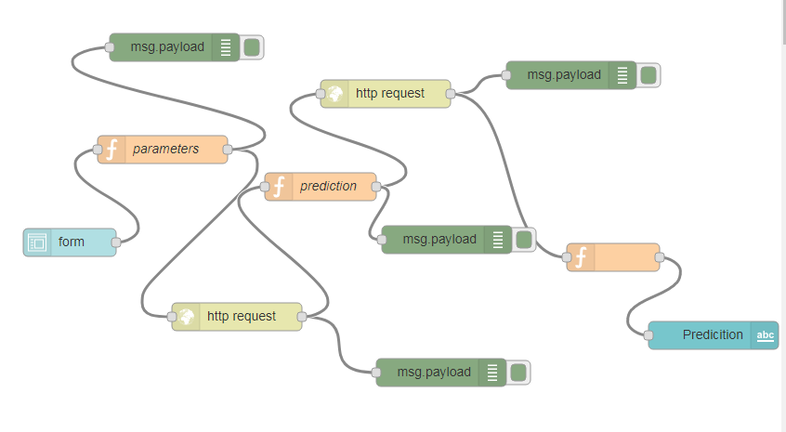

Our model is integrated to it using the Machine learning Service .The UI is highly responsive .The UI of prediction is fig 4.
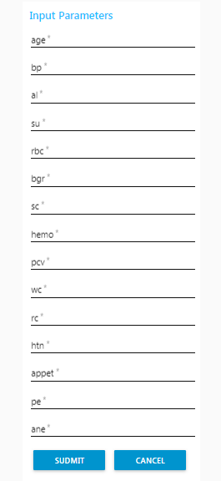

Future Work:

The experimental results of our proposed method have demonstrated that Decision Tree has produced superior prediction performance in terms of classification accuracy,but may be overifitted for our data set. It was also observed that few classifiers have yielded poor classification accuracy. This problem will be investigated in our future study by
(i) Exploring all possible combination of various different types of input features and different machine learning techniques.
(ii) By dealing with various factors that affects prediction performance , for improving the prediction accuracy and finally identifying the exact cause and improve the diagnosis accuracy through classification algorithms.
In future,I am also planning to develop a web tool which will be helpful in prediction of all the huge chronic diseases , which reduces the diagnosis time of diseases.

