ENTERPRISE SALES ANALYTICS DATA PLATFORM (ESADP)
Sprint 0 — Project Initiation & Architecture
UC19: Building a Unified Sales Performance & Revenue Analytics Platform
Enterprise Data Engineering Capstone Project

Submitted by
Hitashri M (26MML1024)
Kusuma Sree (26MML1021)
Krishnaveni M (26MML1008)

Client: ABC Global Retail Ltd.
Methodology: Agile Scrum (3 Sprints)

Table of Contents
1. Project Charter 3
2. Business Requirement Document (BRD) 3
3. Solution Architecture 6
4. Git Repository Structure 7
5. Sprint Backlog (Product Backlog) 8
6. Process Overview — End to End 8
7. Expected Final Output 9

1. Project Charter
Field | Content
Project Name | Enterprise Sales Analytics Data Platform (ESADP)
Sponsor | VP of Sales & Revenue, ABC Global Retail Ltd. (fictional)
Project Goal | Integrate sales, customer, product, dealer, pricing, and inventory data from independent enterprise systems into a governed PostgreSQL warehouse with executive Power BI reporting
Duration | 3 Sprints
Methodology | Agile Scrum
Team | Hitashri M (26MML1024), Kusuma Sree (26MML1021), Krishnaveni M (26MML1008)
Success Criteria | An end-to-end pipeline — raw multi-format sources to staging to warehouse to dashboard — with documented lineage and data quality
Real-World Data Basis | Olist Brazilian E-Commerce dataset (8 sources) + Olist Marketing Funnel dataset (1 source) + self-generated Inventory dataset anchored to real product IDs (1 source) — 10 integrated systems total

2. Business Requirement Document (BRD)

2.1 Business Context
ABC Global Retail Ltd. sells through retail stores, e-commerce, distributors, dealers, and corporate channels across multiple countries. Point of Sale, Sales Order Management, CRM, ERP, Product Catalog, Pricing, Inventory, Marketing, and Dealer Management systems all operate independently today, leaving no single view of sales performance, revenue trend, inventory position, or customer behaviour across the business.

2.2 Stakeholders
Stakeholder | Role | Pain Point / Need
VP, Sales & Revenue | Executive Sponsor | No unified view of sales performance across channels
Regional Sales Manager | Business User (Sales Order Mgmt) | Cannot compare regional performance without manually pulling reports from each system
CRM / Customer Insights Lead | Business User (CRM) | No consolidated view of customer purchase behavior
Merchandising / Product Lead | Business User (Product Catalog) | Cannot identify underperforming products or categories without manual joins
Dealer / Partner Manager | Business User (Dealer Mgmt) | No consolidated view of seller performance across the marketplace
Finance / Pricing Analyst | Business User (Pricing / ERP) | Cannot reconcile payment and pricing data against sales volume
Inventory Planner | Business User (Inventory Mgmt) | No visibility into stock position relative to sales demand
Marketing Analyst | Business User (Marketing Campaign) | No unified view of lead-to-deal conversion performance
Data Engineering Team | Technical Owner | Needs a governed staging and warehouse layer to build reporting on
IT / Data Governance | Compliance | Needs lineage, audit logs, and a data dictionary for audit readiness

2.3 Business Objectives
- Consolidate sales order, customer, product, dealer, pricing, marketing, and inventory data into one warehouse.
- Provide sales leadership a single, trusted view of revenue and regional performance.
- Enable merchandising to evaluate product and category performance without manual joins.
- Enable the dealer and partner team to compare seller performance.
- Give inventory planning a data-backed view of stock position alongside sales trend.
- Enable marketing to track lead-to-deal conversion performance alongside sales outcomes.
- Provide governance so every number on the executive dashboard is traceable back to its source.

2.4 Source Inventory — Data Sources and Format Mapping
All ten enterprise systems named in the use case are represented using real, publicly available data. The table below maps each system to its underlying dataset and the file format it is preserved or converted into for ingestion.
# | Data Source | Dataset Used | Format Preserved As
1 | Sales Order Management | olist_orders_dataset.csv | CSV (native)
2 | Point of Sale (POS) | olist_order_items_dataset.csv | SQL (converted)
3 | CRM | olist_customers_dataset.csv | JSON (converted)
4 | E-Commerce Platform | Same transactional core as #1/#2, documented not re-ingested | JSON (converted)
5 | ERP | olist_order_payments_dataset.csv | XML (converted)
6 | Dealer Management | olist_sellers_dataset.csv | XML (converted)
7 | Product Catalog | olist_products_dataset.csv + product_category_name_translation.csv | Excel (converted)
8 | Pricing Management | price / freight_value extracted from olist_order_items_dataset.csv | Excel (converted)
9 | Inventory Management | Self-generated (generate_inventory_data.py, anchored to real product_ids) | SQL (native)
10 | Marketing Campaign | olist_marketing_qualified_leads_dataset.csv + olist_closed_deals_dataset.csv | CSV (native)

2.5 Data Dictionary
The data dictionary is the field-level reference that maps every column landing in the Bronze staging tables back to its source system, data type, and business meaning. It is compiled in full during Sprint 1 (PB-07) as each of the ten sources is ingested and staged. The excerpt below illustrates the structure of that dictionary using a representative sample of fields drawn from different source systems; the complete field-level dictionary covering all staged columns is maintained as a Sprint 1 governance artifact.
Source System | Field Name | Data Type | Description | Sample Value
Sales Order Management | order_id | VARCHAR | Unique identifier for a customer order | e481f51...9dc
Sales Order Management | order_purchase_timestamp | TIMESTAMP | Date and time the order was placed | 2018-01-25 14:22:31
CRM | customer_id | VARCHAR | Unique identifier for a customer record | 3f5c8a2...e17
Product Catalog | product_category_name | VARCHAR | Product category assigned by the seller | beleza_saude
Pricing Management | price | NUMERIC(10,2) | Unit price of the item at time of sale | 89.90
Dealer Management | seller_id | VARCHAR | Unique identifier for a marketplace seller / dealer | 3442f80...b23
Inventory Management | stock_quantity | INTEGER | Self-generated on-hand quantity anchored to product_id | 145
Marketing Campaign | mql_id | VARCHAR | Unique identifier for a marketing-qualified lead | dc4802a...f6b

3. Solution Architecture

3.1 High-Level Architecture Diagram
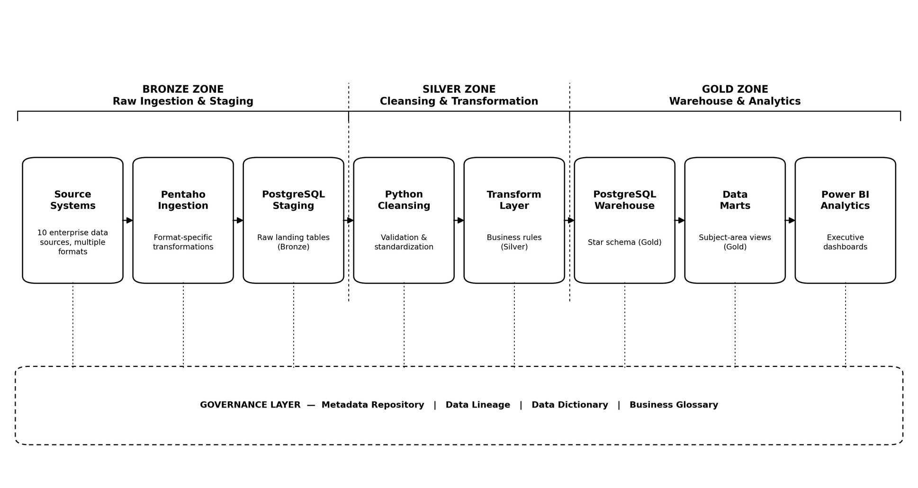
Figure 1. ESADP End-to-End Data Architecture (Medallion Design: Bronze – Silver – Gold)
The platform follows a medallion architecture. The Bronze zone ingests and stages raw data exactly as received from each of the ten source systems. The Silver zone cleanses, validates, and standardizes that data. The Gold zone holds the curated star-schema warehouse, subject-area data marts, and the executive analytics layer. A governance layer — metadata, lineage, data dictionary, and glossary — runs parallel to all three zones.

3.2 Role of PostgreSQL
PostgreSQL serves two distinct roles in this architecture. First, as the staging layer: a raw landing zone where each source system lands in its own staging table, structurally unmodified from source, keeping ingestion (Sprint 1) and cleansing (Sprint 2) as separate, auditable steps. Second, as the warehouse layer: the analytics-ready store, held in a separate schema of the same database, holding the star schema (fact and dimension tables) that Power BI connects to directly.
Using one relational engine for both staging and warehouse keeps the platform's scope appropriate for this project while still requiring genuine schema design, indexing, and SQL query-writing — the core skills this sprint is assessing. In short, PostgreSQL functions as both the inbox (staging) and the filing system (warehouse): everything upstream of it is format conversion, and everything downstream of it is reporting.

3.3 Layer Responsibilities
Layer | Tool | Responsibility
Source (Bronze) | 10 real-world enterprise data sources | Real data standing in for ABC's enterprise systems
Ingestion (Bronze) | Pentaho (Spoon) | Format-specific extraction into staging; logging and exception handling
Staging (Bronze) | PostgreSQL | Raw landing zone, no transformation logic
Cleansing (Silver) | Python (Pandas) | Validation, standardization, data quality checks
Transformation (Silver) | Python / SQL | Business rules, deduplication, conformance
Warehouse (Gold) | PostgreSQL (Star Schema) | Curated, analytics-ready facts and dimensions
Data Marts (Gold) | PostgreSQL | Subject-area views for reporting
Analytics (Gold) | Power BI | Executive-facing dashboards
Governance | Metadata / Lineage / Markdown | Data dictionary, lineage, glossary — parallel to all layers

4. Git Repository Structure
ESADP/
├── docs/
├── config/
├── datasets/
│ ├── bronze/
│ │ ├── ingestion/
│ │ └── staging/
│ ├── silver/
│ │ ├── cleansing/
│ │ ├── validation/
│ │ └── transformations/
│ └── gold/
│ ├── warehouse/
│ ├── datamarts/
│ └── analytics/
├── pentaho/
│ ├── transformations/
│ └── jobs/
├── python/
├── sql/
├── metadata/
├── lineage/
├── dashboards/
├── deployment/
├── tests/
└── README.md
The repository will be initialised and maintained collaboratively by the team throughout the project, with all three members contributing commits ahead of each submission milestone.

5. Sprint Backlog (Product Backlog)
ID | User Story | Sprint
PB-01 | Scaffold the Git repository using the medallion folder structure (bronze / silver / gold) so all members commit consistently | 0
PB-02 | Draft and finalize the Business Requirement Document to lock project scope before development starts | 0
PB-03 | Design the solution architecture, covering every medallion layer and the role of PostgreSQL | 0
PB-04 | Build the sprint backlog to plan and track work across all three sprints | 0
PB-05 | Export each of the 10 source systems into its designated format (CSV, Excel, JSON, XML, SQL) | 1
PB-06 | Build Pentaho transformations converting each format and loading it into PostgreSQL Bronze staging tables | 1
PB-07 | Compile a complete data dictionary covering every staged field | 1
PB-08 | Implement logging and exception handling on every ingestion pipeline | 1
PB-09 | Maintain incremental Git commit history showing ingestion progress | 1

6. Process Overview — End to End
- Real datasets (Olist e-commerce, Olist marketing funnel, and the self-generated inventory dataset) are identified and mapped to the ten enterprise systems defined in Section 2.4.
- Each source is exported or converted into its designated format: CSV, Excel, JSON, XML, or SQL.
- Pentaho transformations ingest each format and load the data, unmodified, into matching PostgreSQL Bronze staging tables.
- Python scripts cleanse and validate the staged data for quality issues — duplicates, missing values, inconsistent categories — in the Silver zone.
- A star schema is designed, and the PostgreSQL Gold warehouse and data marts are populated from the Silver-layer data.
- Governance documentation — data dictionary, lineage, source-to-target mapping, glossary — is maintained alongside every layer.
- Power BI connects to the Gold layer and builds executive dashboards.
- The full pipeline is orchestrated through Pentaho Jobs, validated through reconciliation checks, and released through a tagged Git commit.

7. Expected Final Output
The project's deliverable is a working, documented data pipeline rather than a report alone. This includes: a populated PostgreSQL warehouse (star schema) queryable via SQL; a set of Pentaho transformation and job files reproducing the full ingestion and load process from raw source files; a Power BI dashboard connected to the warehouse, reporting on sales, revenue, customer, dealer, and inventory metrics; and a complete governance document set — data dictionary, source-to-target mapping, lineage diagram, and glossary — allowing any reviewer to trace a dashboard figure back to its original source file.
Every design decision made in later sprints should be traceable to a scope or architecture decision documented here in Sprint 0.

