SIR CR REDDY AUTONOMOUS COLLEGE PG COURSES
“SUPERSTORE SALES INSIGHTS ANALYSIS DASHBOARD SYSTEM”
A Project Report Submitted in Partial Fulfillment of the Requirements for the Award of a degree

“Master Of Computer Applications”

Submitted by

MAREEDU KUSUMA SRI

Regd.No. 9240119
Under the esteemed guidance of

Mrs.MEHABOOB KARISHMA
MCA,Mtech(CSE)
Assistant Professor

SIR KATTAMANCHI RAMALINGA REDDY COLLEGE

(AUTONOMOUS)

PG COURSES ELURU

MCA PROGRAMME

Affiliated to AdikaviNannaya University, Rajamahendravaram
Approved by AICTE, Re Accredited at ‘A’ level by NAAC
2024-2026

DEPARTMENT OF MCA
SIR CR REDDY COLLEGE, ELURU (AUTONOMOUS)


BONAFIDE CERTIFICATE

This is to certify that this Final project Report Entitled is the bonafide work of "SUPERSTORE SALES INSIGHTS ANALYSIS DASHBOARD SYSTEM" submitted by KUSUMA SRI MAREEDU, 9240119
who carried out the work under my guidance and supervision and Submitted in partial fulfillment of the requirements for the award of the MCA during the academic year
2024- 2026.

PROJECT GUIDE HEAD OF THE DEPARTMENT

Department of MCA Department of MCA

Submitted for the Project Report Viva-voice held on………………………
External Examiner

DECLARATION
I certify that the work contained in this report is original and has been done by me under he guidance of my supervisor. The work has not been submitted to any other Institute for any degree or diploma. I have followed the guidelines provided by the university in preparing the report. I have conformed to the norms and guidelines given in the Ethical Code of Conduct of the Institute. Whenever the used materials(data, theoretical analysis, figures, and text) from other sources, I have given due credit to them by citing them in the text of the report and giving their details in the references. Further, I have taken permission from the copyright owners of the sources, whenever necessary.

ELURU
Date:
MAREEDU KUSUMA SRI
Signature of the student

ACKNOWLEDGEMENTS

I am highly grateful to Sri K.SRINIVASRAO, correspondent, Sir CR Reddy college (A) PG Courses Eluru For inspiring and invaluable encouragement throughout the project
I profusely thanks Mr. M RATNAKAR , Incharge Principal of our college, SIR C R REDDY COLLEGE, ELURU for giving permission to carry out this project.
I also thank Dr. VRS BABU YALAMARTHI, Director, SIR C R REDDY COLLEGE, PG COURSES for making necessary arrangement for doing the project.
I express my sincere thanks to Mr. M RATNAKAR, Head of the Department, SIR CR REDDY COLLEGE, ELURU for his learned suggestions and encouragement which made this project a successful one.
I am deeply indebted to my project guide Mrs.MEHABOOB KARISHMA, Assistant Professor, SIR C R REDDY COLLEGE, ELURU, Department of Computer Applications for her valuable guidance, constant encouragement and support throughout the project "SUPERSTORE SALES INSIGHTS ANALYSIS DASHBOARD SYSTEM ".
I would like to thank the review committee members and the entire faculty of Department of Computer Applications for their valuable suggestions and support.
I also express my gratitude to my parents, friends and all those who helped me directly and indirectly in the successful completion of this project.
This project work has been carried out independently by me.

MAREEDU KUSUMA SRI

Regd.No: 9240119

ABSTRACT
Retail organizations generate enormous volumes of transactional data every season, but this data is often scattered across raw CSV exports, spreadsheets, and disconnected reporting tools that make it difficult for stakeholders to extract timely, actionable business insight. This project, “Superstore Sales Analysis insights dashboard system addresses this problem by building a complete, end-to-end analytics pipeline for a fictional retail enterprise — the Superstore — that transforms raw transactional sales data into an interactive, decision-ready Business Intelligence dashboard.
The solution integrates three complementary technologies, each responsible for a distinct stage of the analytics pipeline. Python, using the Pandas and NumPy libraries, is used to acquire and systematically clean the raw dataset — correcting data types, removing duplicate and incomplete records, and validating logical consistency between order and shipping dates. The cleaned dataset is then loaded into a MySQL relational database (superstore_db), where fourteen analytical SQL queries — employing aggregation, window functions such as DENSE_RANK() and ROW_NUMBER(), and Common Table Expressions — are used to answer specific business questions, ranging from identifying top customers by order value to calculating average shipping time and detecting runs of consecutive days of rising sales.
The final stage uses Power BI Desktop to build a three-page interactive report — Sales, Customer, and Product dashboards — each powered by a set of DAX (Data Analysis Expressions) measures computing Key Performance Indicators such as Total Sales, Total Orders, Average Order Value, Total Customers, Customer Lifetime Value, Repeat Customer Rate, and category-wise sales distribution. Interactive slicers for Year, Month, Region, and City allow any stakeholder to explore the data visually and cross-filter every chart on a page without needing to understand the underlying schema or write a single query.
A key strength of this project is its complete, traceable, end-to-end implementation: every insight shown on the final dashboards can be traced back through a specific DAX measure, to a specific cleaned data column, to a specific step of the Python cleaning process — a level of documentation rigour that distinguishes this project from typical single-stage BI demonstrations.
Applied to the Superstore dataset, spanning transactional records from 2015 to 2018, the completed system surfaces meaningful business insight: total sales of approximately $2 million generated across 4,916 orders at an average order value of $230; a customer base of 793 individuals with a 99% repeat-purchase rate and a combined customer lifetime value of $335,000; and a near-even, diversified revenue split across the Technology (36.67%), Furniture (32.11%), and Office Supplies (31.22%) product categories. New York City, Los Angeles, and Seattle emerge as the leading revenue-generating cities, while a small number of individual products — led by product TEC-CO-10004722 at $62K — account disproportionately for category-level revenue.
The project demonstrates practical, industry-representative proficiency across the full data analytics lifecycle — data cleaning, relational database design and querying, and interactive Business Intelligence dashboard design — and concludes with a discussion of its limitations and directions for future enhancement, including predictive analytics, automated data refresh, and cloud-based publication of the dashboard via the Power BI Service.
Keywords: Data Analytics, Business Intelligence, Python, Pandas, MySQL, Power BI, DAX, Data Cleaning, Data Visualization, Retail Sales Analysis.

INDEX
(This Table of Contents is an automatically generated field. In Microsoft Word, right-click and choose “Update Field” → “Update entire table” to populate section titles and page numbers.)
CERTIFICATE Error! Bookmark not defined.
CERTIFICATE ISSUED BY OUTSIDE ORGANIZATION 3
ACKNOWLEDGEMENTS 4
ABSTRACT 5
INDEX 7
LIST OF FIGURES 10
LIST OF TABLES 12
1. INTRODUCTION TO THE PROBLEM 13
1.1 Background 13
1.2 Problem Statement 13
1.3 Existing System 14
1.4 Proposed System 14
1.5 Advantages of the Proposed System 15
1.6 Objectives of the Project 15
1.7 Scope of the Project 15
1.8 Organization of the Report 16
2. STATE OF THE ART / LITERATURE SURVEY 17
2.1 Existing Retail Analytics Approaches 17
2.2 Survey of Data Cleaning and Business Intelligence Tools 17
2.2.1 Python (Pandas and NumPy) for Data Cleaning 17
2.2.2 MySQL for Relational Analysis 17
2.2.3 Microsoft Power BI 18
2.3 Review of Related Work on Dashboard Design 18
2.4 Comparison of Existing Methods 18
2.5 Gaps Identified in Existing Systems 19
2.6 Summary 19
3. REQUIREMENT ANALYSIS AND DESIGN 20
3.1 Functional Requirements 20
3.2 Non-Functional Requirements 20
3.3 Hardware and Software Requirements 20
3.4 Feasibility Study 21
3.4.1 Technical Feasibility 21
3.4.2 Economic Feasibility 21
3.4.3 Operational Feasibility 21
3.5 Data Sources and Dataset Description 21
3.6 System Architecture 22
3.7 Workflow Diagram 22
3.8 Data Flow Diagram (Level 0 and Level 1) 23
3.8.1 Level 0 DFD (Context Diagram) 23
3.8.2 Level 1 DFD 24
3.8.3 External Entities, Processes, and Data Stores 25
3.9 Use Case Diagram 25
3.10 ER Diagram / Data Model 26
3.11 Database Design 26
3.12 Data Dictionary 26
3.13 Dashboard Page Design 27
3.13.1 Sales Dashboard 27
3.13.2 Customer Dashboard 27
3.13.3 Product Dashboard 27
3.14 Navigation and UI/UX Considerations 28
4. IMPLEMENTATION 30
4.1 Tools and Technologies Used 30
4.2 Module 1: Data Collection 30
4.3 Module 2: Data Cleaning using Python 31
4.4 Module 3: SQL Database Creation 35
4.5 Module 4: SQL Queries and Business Insights 36
4.5.1 Q1 – Same-Day Shipping Percentage 37
4.5.2 Q2 – Top 3 Customers by Total Order Value 37
4.5.3 Q3 – Top 5 Items by Average Daily Sales 38
4.5.4 Q4 – Customer Ranking by Average Order Value 38
4.5.5 Q5 – Highest and Lowest Orders per City 38
4.5.6 Q6 – Most Demanded Sub-Category in the West Region 39
4.5.7 Q7 – Order With the Highest Number of Items 39
4.5.8 Q8 – Order With the Highest Cumulative Value 39
4.5.9 Q9 – Segment Most Likely to Use First Class Shipping 40
4.5.10 Q10 – City Contributing Least to Total Revenue 40
4.5.11 Q11 – Average Order-to-Shipment Time 40
4.5.12 Q12 – Dominant Segment per State 40
4.5.13 Q13 – Customers Ordering on 3 Consecutive Days (> $50) 41
4.5.14 Q14 – Maximum Streak of Rising Daily Sales 41
4.6 Module 5: Power BI Dashboard Development 42
4.6.2 Sales Dashboard 44
4.6.3 Customer Dashboard 44
4.6.4 Product Dashboard 45
4.7 Module 6: Visualization and KPI Analysis 46
4.8 Navigation and Interactivity 46
5. RESULTS ALONG WITH TEST CASES 47
5.1 Dashboard Output 47
5.1.1 Sales Dashboard Page 47
5.1.2 Customer Dashboard Page 48
5.1.3 Product Dashboard Page 49
5.2 Region Analysis 50
5.3 Summary of Sample KPI Outputs 51
5.4 Test Cases and Results 51
5.5 Discussion of Results 52
6. CONCLUSIONS AND FUTURE WORK 53
6.1 Conclusion 53
6.2 Limitations 53
6.3 Future Enhancements 54
7. BIBLIOGRAPHY 55

LIST OF FIGURES
Figure No. | Title | Page No.
Figure 1 | System Architecture of the Superstore Sales Analysis System | 23
Figure 2 | Project Workflow Diagram | 24
Figure 3 | Data Flow Diagram – Level 0 (Context Diagram) | 25
Figure 4 | Data Flow Diagram – Level 1 | 26
Figure 5 | Use Case Diagram | 26
Figure 6 | Entity-Relationship Diagram / Logical Data Model | 27
Figure 7 | Algorithm Flowchart – Data Cleaning Process | 32
Figure 8 | Raw Dataset – Sample View (sales_df.head() output) | 31
Figure 9 | Python Data Cleaning – Null Value Check Output | 33
Figure 10 | Python Data Cleaning – Duplicate Record Removal Output | 34
Figure 11 | MySQL Table Structure – superstore (DESCRIBE output) | 35
Figure 12 | Algorithm Flowchart – SQL Query Processing | 36
Figure 13 | SQL Query Output – Top 3 Customers by Order Value | 38
Figure 14 | Algorithm Flowchart – Power BI Dashboard Development | 42
Figure 15 | Power BI Data Model View | 43
Figure 16 | Home Page – Power BI Dashboard (Navigation) | 44
Figure 17 | Sales Dashboard – Final Output | 46
Figure 18 | Customer Dashboard – Final Output | 47
Figure 19 | Product Dashboard – Final Output | 48

LIST OF TABLES
Table No. | Title | Page No.
Table 1 | Comparison of Existing Retail Analysis Methods | 19
Table 2 | Hardware and Software Requirements | 21
Table 3 | Dataset Description and Source Details | 22
Table 4 | Data Dictionary – superstore Table | 27
Table 5 | Summary of SQL Business Insight Queries | 36
Table 6 | Representative DAX Measures used in the Dashboard | 43

LIST OF OUTPUT TABLES
Table No. | Title | Page No.
Output Table 1 | Key Business Insights – Sales Dashboard | 46
Output Table 2 | Key Business Insights – Customer Dashboard | 47
Output Table 3 | Key Business Insights – Product Dashboard | 49
Output Table 4 | Test Cases and Results | 49

1. INTRODUCTION TO THE PROBLEM

1.1 Background
In the contemporary retail industry, data has become one of the most valuable assets an organization possesses. Every transaction — a customer placing an order, a product being shipped, a discount being applied — generates a data point that, when aggregated with millions of others, reveals patterns about customer behaviour, product performance, and regional demand. Retail enterprises that can effectively capture, process, and interpret this data hold a significant competitive advantage over those that rely purely on intuition or delayed, static reporting.
This project focuses on the design and implementation of a complete sales analytics solution for a fictional retail enterprise referred to as the “Superstore”. The Superstore dataset is a widely used, publicly available dataset in the data analytics community, containing several thousand order-level transactional records spanning multiple years (2015–2018), product categories, customer segments, and geographic regions across the United States. Although fictional, the dataset closely mirrors the structure and characteristics of real-world retail transaction data, making it an appropriate and realistic basis for demonstrating a complete analytics workflow.
Business Intelligence (BI) platforms such as Microsoft Power BI make it possible to transform such raw tabular data into interactive, visual, and explorable dashboards without requiring every stakeholder to possess programming or query-writing skills. Combined with Python for data preparation and SQL for structured querying, a small but well-designed technology stack can support the entire journey from raw CSV file to executive-ready dashboard.

1.2 Problem Statement
Raw retail transaction data, in its native form, is rarely suitable for direct business use. It is often voluminous, may contain missing or inconsistent values, duplicate entries, and incorrectly typed fields (for example, dates stored as text). Furthermore, even a perfectly clean dataset, if left in flat tabular form, does not by itself communicate business insight — stakeholders cannot easily determine which regions are underperforming, which products are most profitable, or how customer behaviour is trending over time simply by viewing rows of transactional data.
The problem this project addresses can therefore be stated as follows: given a raw, uncleaned retail sales dataset, how can that data be systematically transformed — through cleaning, structured querying, and visualization — into an interactive decision-support system that allows business stakeholders to explore sales performance, customer behaviour, and product trends without requiring technical knowledge of the underlying data or query languages?

1.3 Existing System
In many small and medium-sized retail organizations, sales analysis continues to be performed using manual, spreadsheet-based methods. Sales data is typically exported from a point-of-sale or order-management system into Microsoft Excel, where analysts manually construct pivot tables and static charts to summarise performance. While functional for small datasets, this approach suffers from several well-documented limitations:
- Static reports quickly become outdated and must be manually regenerated whenever new data becomes available.
- Spreadsheet-based analysis does not scale well beyond a few thousand rows and becomes slow and error-prone as data volume grows.
- Formulas and pivot table configurations are difficult to audit, version, and reuse, increasing the risk of undetected calculation errors.
- Cross-filtering between multiple dimensions (for example, viewing sales for a specific region, category, and time period simultaneously) is cumbersome and often requires separate, disconnected pivot tables.
- There is no single interactive interface through which non-technical stakeholders can explore the data themselves; they must instead rely on analysts to generate new reports on request.

1.4 Proposed System
The proposed system replaces the manual, spreadsheet-based approach with an automated, three-tier analytics pipeline. Data cleaning is performed programmatically using Python scripts that can be re-run consistently on new data extracts, eliminating manual, error-prone spreadsheet manipulation. The cleaned data is stored in a structured MySQL database, enabling powerful, reusable SQL queries that can be executed instantly rather than reconstructed from scratch. Finally, Power BI is used to build a live, interactive dashboard that allows any stakeholder to filter, drill down, and explore the data visually, without needing to write queries or understand the underlying schema.
This proposed architecture separates the concerns of data preparation, data storage and querying, and data presentation into distinct, well-defined stages, which is consistent with standard practice in modern Business Intelligence system design, and is described in full detail in Chapter 3 (Requirement Analysis and Design) and Chapter 4 (Implementation).

1.5 Advantages of the Proposed System
- Automated, repeatable data cleaning reduces manual effort and the risk of human error.
- Structured storage in MySQL supports fast, reliable, and reusable querying compared to spreadsheet formulas.
- Interactive Power BI dashboards allow non-technical users to explore data through visual filters and slicers.
- Clear separation between data preparation, storage, and visualization layers improves maintainability.
- KPI-driven dashboard design ensures stakeholders can immediately grasp overall business performance at a glance.
- The modular pipeline can be extended in the future to support new data sources, additional KPIs, or predictive analytics.

1.6 Objectives of the Project
- To acquire and thoroughly clean the Superstore sales dataset using Python, ensuring correct data types, no missing critical values, and no duplicate records.
- To design and implement a relational database schema in MySQL for storing the cleaned transactional data.
- To write and execute SQL queries that extract specific, decision-relevant business insights from the dataset.
- To design an interactive, multi-page Power BI dashboard covering Sales, Customer, and Product analysis perspectives.
- To compute and present key business KPIs, including Total Sales, Total Orders, Average Order Value, Total Customers, Customer Lifetime Value, and Sales Trends, using DAX measures.
- To derive and document meaningful business insights from the completed analysis.
- To demonstrate an end-to-end, industry-representative data analytics workflow suitable for academic evaluation.

1.7 Scope of the Project
The scope of this project encompasses the complete analytics lifecycle applied to a static, historical retail dataset: data acquisition, cleaning and preprocessing, relational database design, SQL-based analysis, and dashboard-based visualization. The project covers three analytical dimensions — sales performance, customer behaviour, and product performance — each represented by a dedicated dashboard page, filterable by year, month, region, and city.
The scope of this project does not extend to real-time or streaming data ingestion, predictive modelling or machine-learning-based forecasting, multi-user authentication or role-based access control within the dashboard, or deployment on cloud-hosted BI services such as the Power BI Service. These aspects are identified as potential directions for future enhancement in Chapter 6.

1.8 Organization of the Report
The remainder of this report is organized as follows. Chapter 2 presents a literature survey of existing approaches to retail sales analytics and Business Intelligence tooling, identifying the research gap this project addresses. Chapter 3 details the requirement analysis and system design, including functional and non-functional requirements, feasibility study, system architecture, workflow, data flow diagrams, use case diagram, entity-relationship diagram, database design, and data dictionary. Chapter 4 describes the implementation of each module of the system, including data cleaning, database creation, SQL analysis, and Power BI dashboard development, along with relevant code, algorithms, and flowcharts. Chapter 5 presents the results obtained from the completed system, along with test cases and their outcomes. Chapter 6 concludes the report with a summary of achievements, a discussion of limitations, and recommendations for future work. The report closes with a bibliography listing all references consulted during the course of this project.

2. STATE OF THE ART / LITERATURE SURVEY

2.1 Existing Retail Analytics Approaches
Several commercial and open-source tools currently provide retail and e-commerce analytics capabilities. Enterprise Resource Planning (ERP) systems such as SAP and Oracle NetSuite include built-in sales reporting modules, but these are typically expensive, complex to configure, and oriented toward transactional record-keeping rather than exploratory, interactive analysis. At the other end of the spectrum, spreadsheet-based analysis using Microsoft Excel remains the most common approach in small and medium enterprises, owing to its low cost and familiarity, despite the scalability and maintainability limitations discussed in Section 1.3.
In academic and hobbyist circles, numerous tutorials and open-source projects use the Superstore dataset specifically — owing to its public availability, realistic structure, and moderate size — as a benchmark example for demonstrating individual data analytics skills. However, these typically demonstrate isolated stages of a pipeline (for example, only a Power BI dashboard built directly from the CSV file, or only a set of SQL queries) rather than a fully integrated, end-to-end workflow that carries the data through cleaning, structured storage, querying, and visualization with full traceability.

2.2 Survey of Data Cleaning and Business Intelligence Tools
Three categories of tools were surveyed and evaluated for suitability in this project: Python-based data cleaning libraries, relational database systems, and self-service Business Intelligence platforms.

2.2.1 Python (Pandas and NumPy) for Data Cleaning
The Python data science ecosystem, particularly the Pandas and NumPy libraries, has become a widely adopted standard for data cleaning, transformation, and exploratory analysis. Pandas provides a DataFrame abstraction that closely mirrors a relational table, along with vectorised operations for handling missing values (isnull(), dropna()), duplicate detection (duplicated(), drop_duplicates()), and type conversion (astype(), to_datetime()), all of which were used extensively in this project's data cleaning module. Its popularity, extensive documentation, and tight integration with Jupyter Notebook made it the natural choice for this project's cleaning stage.

2.2.2 MySQL for Relational Analysis
Structured Query Language (SQL) remains the standard mechanism for extracting aggregated, filtered, and ranked information from relational datasets. MySQL, an open-source relational database management system, was selected for this project due to its free licensing, wide industry adoption, strong support for modern SQL features including window functions (RANK(), DENSE_RANK(), ROW_NUMBER()) and Common Table Expressions (CTEs), and native connectivity with Power BI.

2.2.3 Microsoft Power BI
Among self-service Business Intelligence platforms — which also include Tableau and Qlik Sense — Power BI Desktop was selected for this project because it is free for individual and academic use, offers a low barrier to entry through its drag-and-drop visual design surface, and provides the DAX (Data Analysis Expressions) formula language for authoring calculated KPI measures. Its tight integration with both CSV/Excel files and MySQL databases (via native connectors) made it well suited to consuming the output of the earlier Python and SQL stages of this project's pipeline.

2.3 Review of Related Work on Dashboard Design
The design of the three dashboard pages in this project draws on established dashboard design literature, which consistently emphasises that effective BI dashboards should minimise cognitive load by presenting a small number of clearly labelled Key Performance Indicator (KPI) cards alongside a limited set of well-chosen visualizations, rather than overwhelming the user with excessive detail. This principle directly informed the layout of the Sales, Customer, and Product dashboard pages, each of which places two to three headline KPI cards prominently at the top of the page, followed by supporting bar, donut, and trend charts.
Literature on relational data modelling for analytics — particularly the concept of dimensional modelling and the star schema, in which a central fact table (transactional records) is linked to supporting dimension tables (customer, product, location, date) — also informed the logical entity-relationship model presented in Chapter 3, even though the physical database implementation in this project uses a single denormalised table optimised for direct Power BI import.

2.4 Comparison of Existing Methods
Table 1 compares the manual spreadsheet-based approach, a SQL-only reporting approach, and the integrated Python–SQL–Power BI approach adopted in this project, across several relevant evaluation criteria.
Table 1: Comparison of Existing Retail Analysis Methods
Criteria | Spreadsheet-Based Analysis | SQL-Only Reporting | Proposed Python + SQL + Power BI
Scalability | Poor beyond a few thousand rows | Good | Good
Data Cleaning Automation | Manual, error-prone | Limited | Automated via Python scripts
Reusability of Queries | Low | High | High
Interactivity for End Users | Very Limited | None (requires query knowledge) | High (slicers, drill-down)
Visualization Quality | Basic charts | None (raw output only) | Rich, interactive visuals
Ease of Use for Non-Technical Users | Moderate | Low | High
As shown in Table 1, the proposed integrated approach combines the scalability and reusability benefits of SQL with the accessibility and interactivity of a modern BI tool, while automating the otherwise manual and error-prone data cleaning stage — addressing the principal weaknesses of both alternative approaches.

2.5 Gaps Identified in Existing Systems
- Existing examples using the Superstore dataset rarely carry the data through all three stages (Python cleaning, MySQL storage and querying, and Power BI visualization) with full documentation and traceability from raw data to final insight.
- Existing dashboards commonly focus only on Sales-level metrics and omit a dedicated Customer Dashboard, despite metrics such as Customer Lifetime Value and Repeat Customer Rate being of significant business importance.
- Data cleaning steps are frequently under-documented or skipped entirely in published examples, leaving the reliability of the resulting KPIs unverifiable.
- Few examples make explicit use of SQL window functions and Common Table Expressions, relying instead on simple aggregation queries that cannot answer more advanced business questions such as customer ranking or identifying runs of rising sales.

2.6 Summary
The literature and platform survey confirms that while individual pieces of the problem — Python-based data cleaning, SQL-based querying, and Power BI-based visualization — have each been solved elsewhere in isolation, few existing examples combine all three into a single, fully documented, end-to-end pipeline with a dedicated, drill-down-capable Customer Dashboard alongside Sales and Product dashboards. This project addresses that gap by implementing and documenting a complete, three-stage pipeline with three purpose-built dashboard pages, each targeting a distinct business perspective, as detailed in Chapters 3 and 4.

3. REQUIREMENT ANALYSIS AND DESIGN

3.1 Functional Requirements
- FR1: The system shall import raw sales data from a CSV source file.
- FR2: The system shall clean the raw data by correcting data types, removing duplicate records, and handling missing values.
- FR3: The system shall export the cleaned dataset and load it into a MySQL relational database.
- FR4: The system shall support execution of SQL queries to compute business insights such as top customers, top products, and regional performance.
- FR5: The system shall present a Sales Dashboard displaying total sales, total orders, average order value, top cities, product category distribution, and sales trend over time.
- FR6: The system shall present a Customer Dashboard displaying total customers, customer lifetime value, repeat customer rate, and segment-wise distribution.
- FR7: The system shall present a Product Dashboard displaying total products, category-wise sales, and top-selling products.
- FR8: The system shall allow users to filter dashboard visuals by year, month, region, and city using interactive slicers.

3.2 Non-Functional Requirements
- Usability: The dashboard interface must be intuitive enough for a non-technical business user to operate without training.
- Performance: Dashboard visuals must refresh (cross-filter) within a few seconds of a filter or slicer being applied.
- Maintainability: The data cleaning scripts and SQL queries must be modular and well-commented to support future modification.
- Portability: The Power BI report file (.pbix) must be shareable and viewable on any machine with Power BI Desktop installed.
- Reliability: Data cleaning logic must produce consistent, reproducible results when re-run on the same input data.

3.3 Hardware and Software Requirements
Table 2: Hardware and Software Requirements
Requirement | Specification
Processor | Intel Core i3 (or equivalent) or higher
RAM | 8 GB or higher (recommended for Power BI Desktop)
Hard Disk | 10 GB free disk space
Display | 1366 x 768 resolution or higher
Operating System | Windows 10 / 11 (64-bit)
Programming Language | Python 3.x
Python Libraries | Pandas, NumPy, Matplotlib, Seaborn
Database Server | MySQL 8.0
Visualization Tool | Power BI Desktop
Development Environment | Jupyter Notebook

3.4 Feasibility Study

3.4.1 Technical Feasibility
All tools used in this project — Python, MySQL, and Power BI Desktop — are freely available (Power BI Desktop is free for individual use) and widely documented, with the developer having prior working knowledge of each. The Superstore dataset is small enough (a few thousand rows) to be processed comfortably on standard consumer hardware, making the project technically feasible within the available time and resource constraints.

3.4.2 Economic Feasibility
The project incurs no licensing cost, as MySQL Community Edition and Power BI Desktop are both free to use for academic and individual purposes. The only resource investment required is developer time, making the project highly economical to execute.

3.4.3 Operational Feasibility
The resulting dashboard is designed to be self-explanatory and interactive, requiring no specialised training for end users to interpret KPIs or apply filters. This ensures strong operational feasibility, as the system can realistically be adopted by non-technical business stakeholders.

3.5 Data Sources and Dataset Description
The dataset used in this project is the Superstore Sales Dataset, a widely used, publicly available retail transaction dataset covering the years 2015–2018. It was obtained as a single CSV file and cleaned prior to being loaded into MySQL, as described fully in Chapter 4.
Table 3: Dataset Description and Source Details
Dataset | Key Columns | Source | Role
Superstore Raw Data | Order_ID, Order_Date, Ship_Date, Customer_ID, Product_ID, Sales, ... | Public CSV export (superstore_final_dataset.csv) | Raw input to Python cleaning stage
Superstore Cleaned Data | Same schema, cleaned and type-corrected | Output of Python cleaning notebook | Source for MySQL import
superstore (MySQL table) | 18 typed columns (see Data Dictionary, Table 3) | Loaded from cleaned CSV | Source for SQL analysis and Power BI

3.6 System Architecture
The system follows a linear, three-tier pipeline architecture consisting of a data preparation tier (Python), a data storage and querying tier (MySQL), and a visualization tier (Power BI). Figure 1 illustrates how raw data flows through each tier to produce the three final dashboard pages.
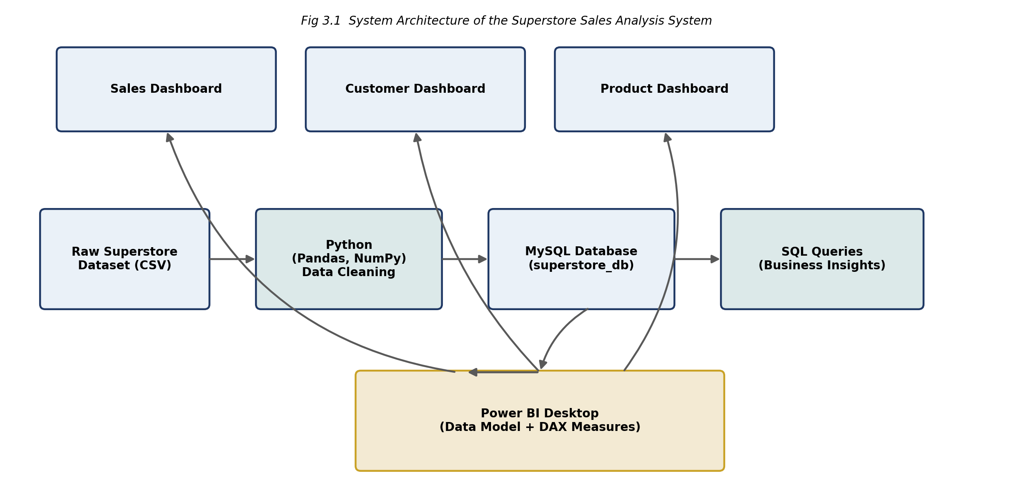
Figure 1: System Architecture of the Superstore Sales Analysis System

3.7 Workflow Diagram
Figure 2 presents the step-by-step workflow followed during the execution of this project, from initial data collection through to final dashboard publication and analysis.
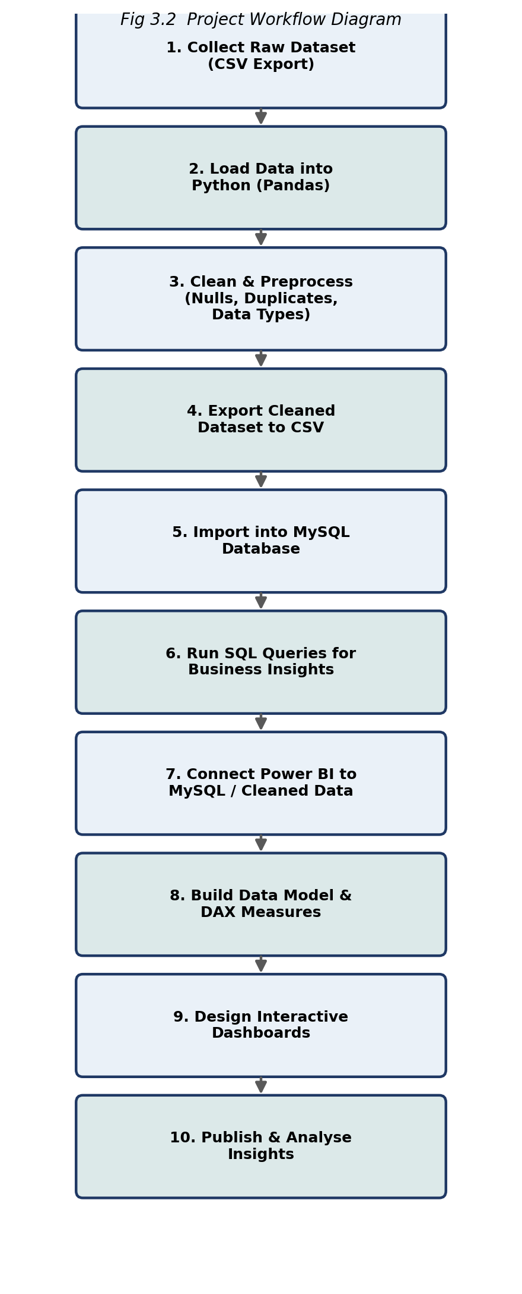
Figure 2: Project Workflow Diagram

3.8 Data Flow Diagram (Level 0 and Level 1)

3.8.1 Level 0 DFD (Context Diagram)
The Level 0 Data Flow Diagram, shown in Figure 3, presents the system as a single process, showing the flow of data between the Business Analyst / User, the Superstore Sales Analysis System, and the MySQL database.
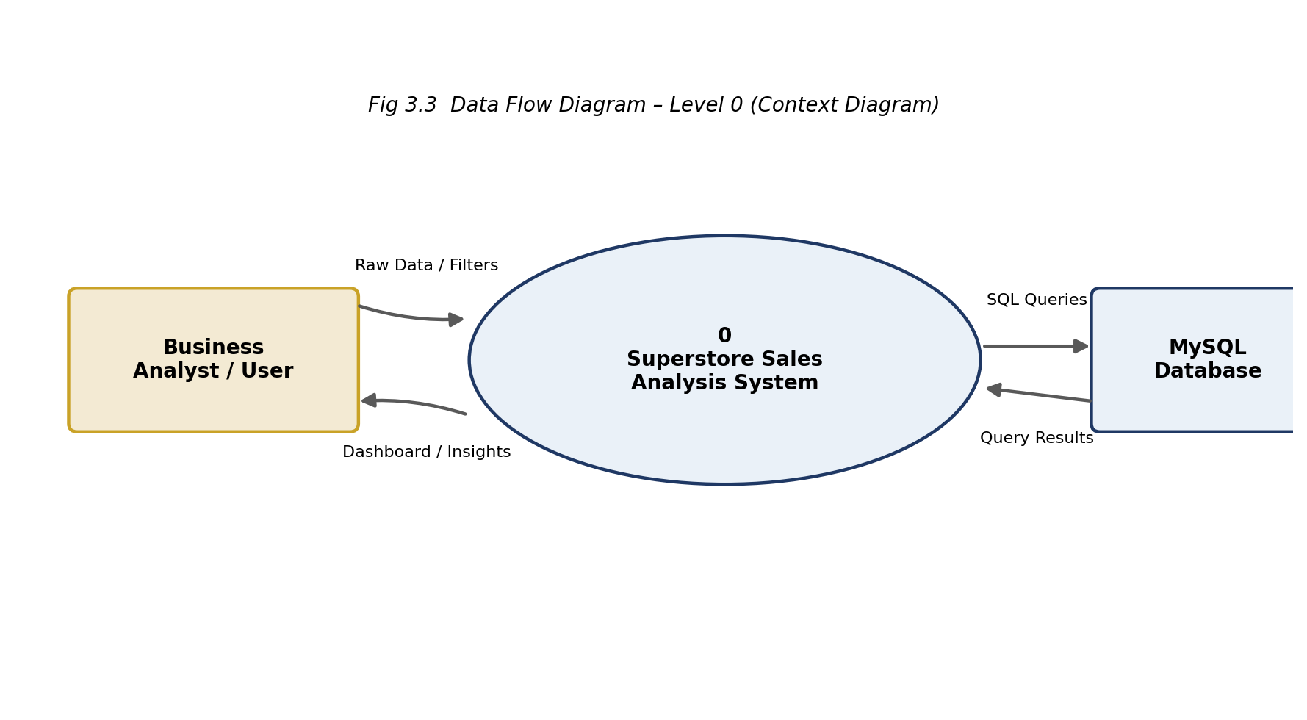
Figure 3: Data Flow Diagram – Level 0 (Context Diagram)

3.8.2 Level 1 DFD
The Level 1 Data Flow Diagram, shown in Figure 4, decomposes the system into its four principal processes — Data Cleaning, Data Loading, Query Processing, and Visualization — along with the associated data stores for the cleaned dataset and the MySQL database table.
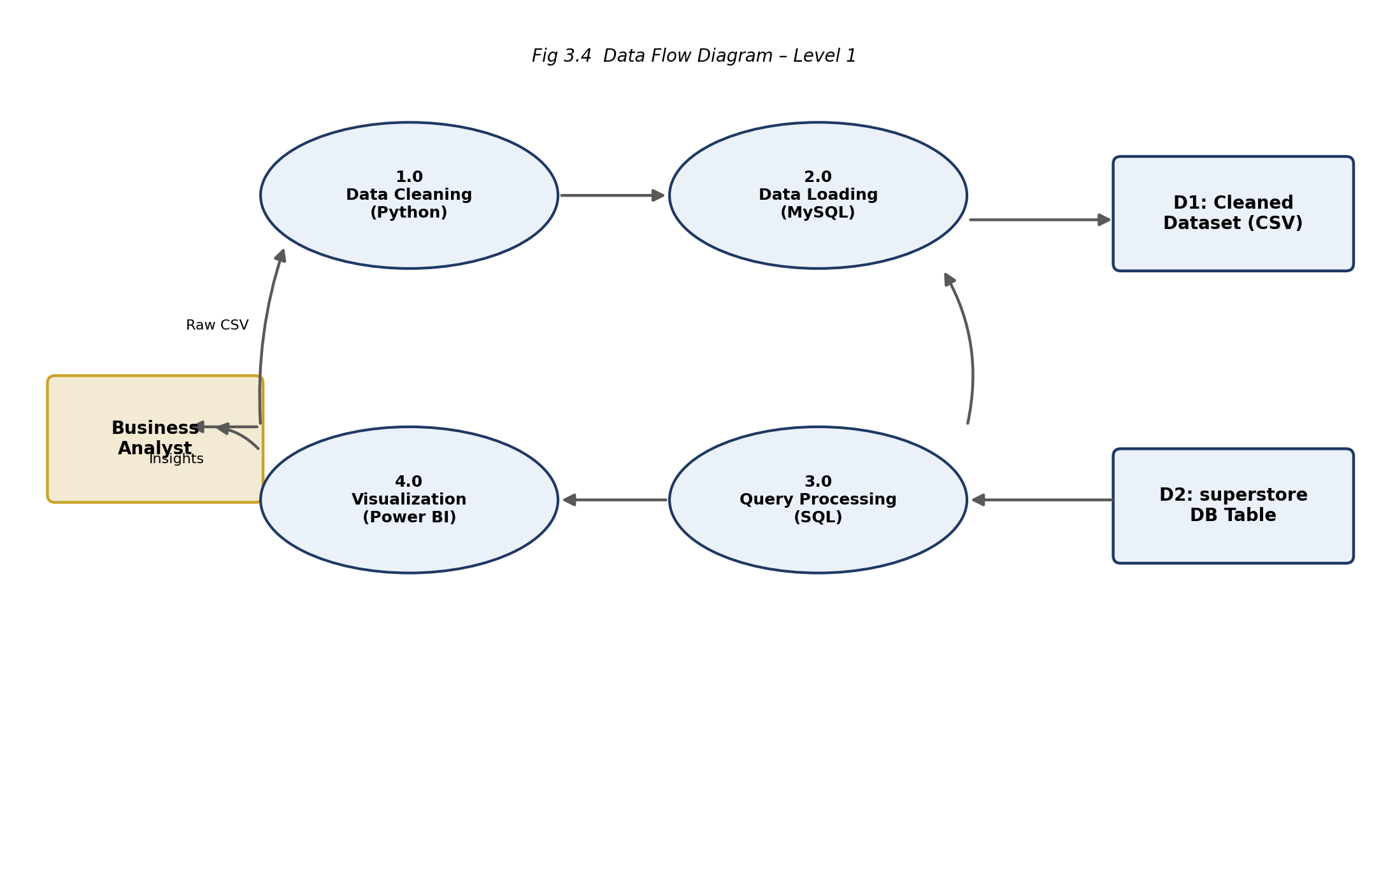
Figure 4: Data Flow Diagram – Level 1

3.8.3 External Entities, Processes, and Data Stores
External Entities: Business Analyst / User — supplies filters and slicer selections and receives the finished dashboard; supplies no raw data directly to the pipeline.
Processes: 1.0 Data Cleaning (Python) reads the raw CSV and writes the cleaned dataset; 2.0 Data Loading (MySQL) reads the cleaned dataset and writes to the database table; 3.0 Query Processing (SQL) reads from the database table and produces query results; 4.0 Visualization (Power BI) reads query results / cleaned data and renders the interactive dashboard.
Data Stores: D1 Cleaned Dataset (CSV) — written by Process 1.0, read by Process 2.0; D2 superstore DB Table — written by Process 2.0, read by Process 3.0.

3.9 Use Case Diagram
Figure 5 identifies the two principal actors of the system — the Data Analyst / Developer, responsible for data preparation and dashboard construction, and the Business User, who consumes the finished dashboards — along with their respective use cases.
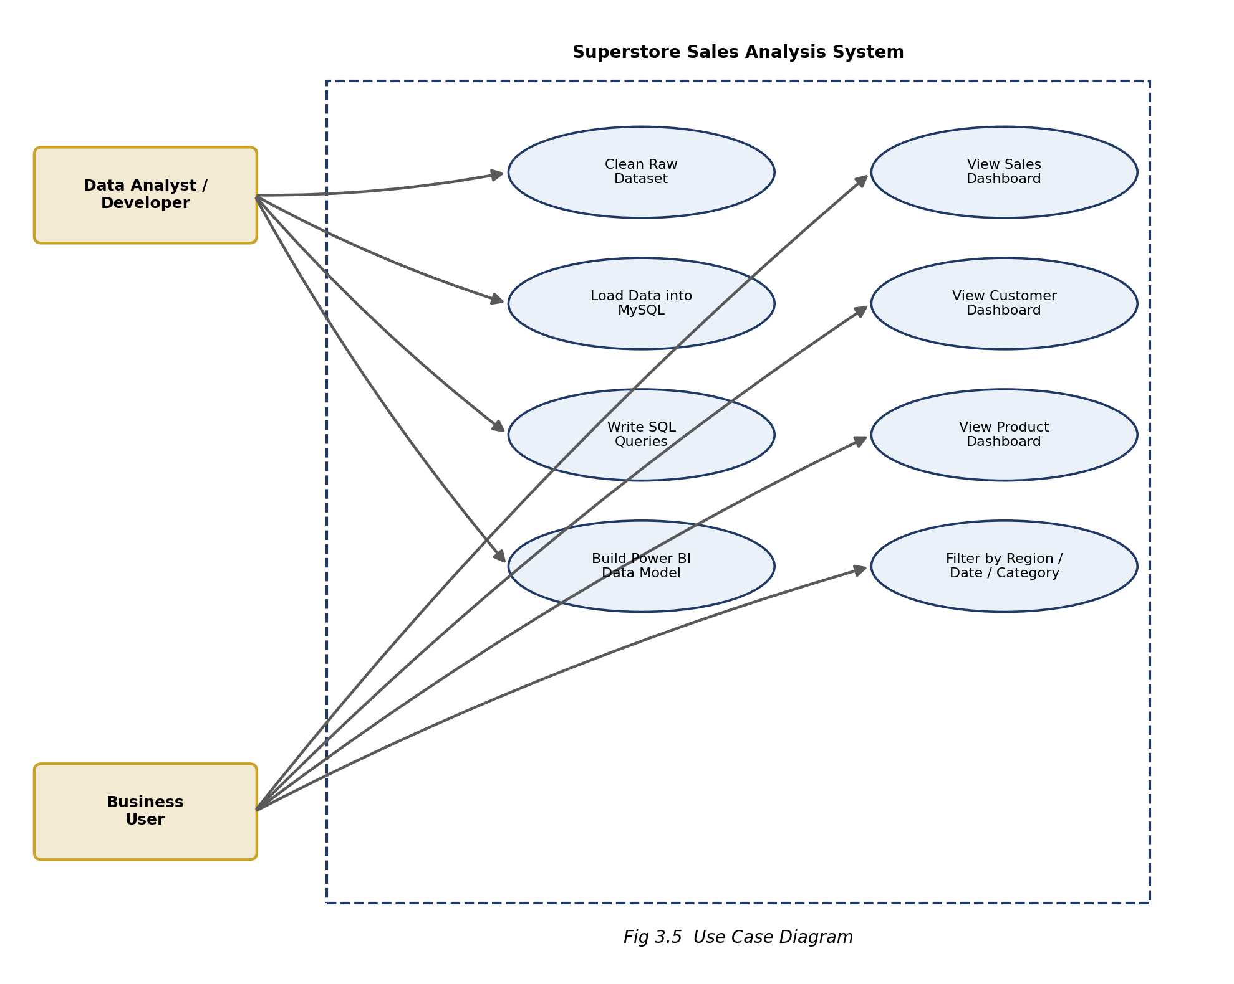
Figure 5: Use Case Diagram

3.10 ER Diagram / Data Model
Although the physical implementation stores data in a single denormalised table (optimised for analytical querying and Power BI import), Figure 6 presents the logical entity-relationship model underlying the dataset, decomposed into Customer, Order, Product, Location, and Sales_Line entities for conceptual clarity.
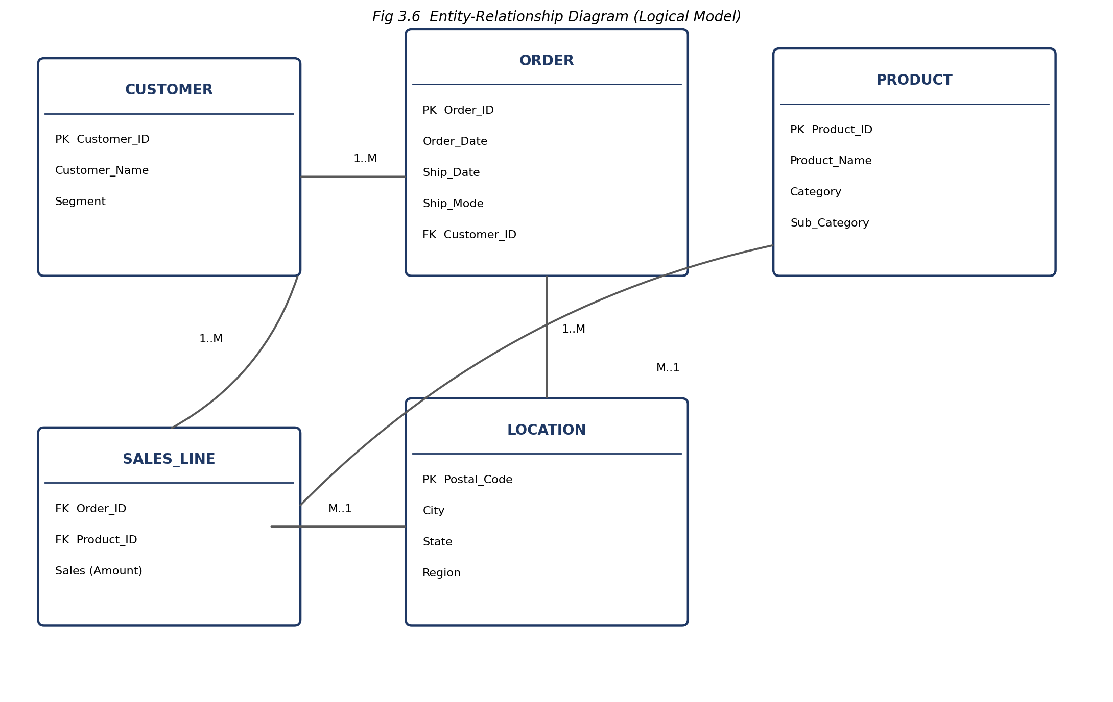
Figure 6: Entity-Relationship Diagram / Logical Data Model

3.11 Database Design
The physical database implementation uses a single table, superstore, within the superstore_db MySQL database. This denormalised, “flat” table design is a deliberate choice appropriate for analytical (OLAP-style) workloads, where join operations across multiple normalized tables would add unnecessary query complexity and reduce performance for read-heavy, aggregation-focused queries — a pattern consistent with typical BI staging tables that feed directly into Power BI's own internal data model.

3.12 Data Dictionary
Table 4 documents each column of the superstore table, including its data type and business meaning, as derived directly from the project's schema definition.
Table 4: Data Dictionary – superstore Table
Field Name | Data Type | Description
Order_ID | varchar(14) | Unique identifier for a customer order
Order_Date | varchar(10) | Date on which the order was placed
Ship_Date | varchar(10) | Date on which the order was shipped
Ship_Mode | varchar(14) | Shipping method (e.g., Standard Class, First Class)
Customer_ID | varchar(8) | Unique identifier for the customer
Customer_Name | varchar(22) | Full name of the customer
Segment | varchar(11) | Customer segment (Consumer, Corporate, Home Office)
Country | varchar(13) | Country of the order (United States)
City | varchar(17) | City associated with the order
State | varchar(20) | State associated with the order
Postal_Code | int | Postal code of the delivery location
Region | varchar(7) | Geographic region (West, East, Central, South)
Product_ID | varchar(15) | Unique identifier for the product
Category | varchar(15) | Product category (Furniture, Office Supplies, Technology)
Sub_Category | varchar(11) | Product sub-category (e.g., Chairs, Binders, Phones)
Product_Name | varchar(127) | Full descriptive name of the product
Sales | decimal(20,10) | Sales amount (in USD) for the order line

3.13 Dashboard Page Design

3.13.1 Sales Dashboard
Designed as a top-level command centre: Total Sales, Total Orders, and Average Order Value KPI cards at the top; a Top 10 City by Sales bar chart and Sales Distribution by Product Category donut chart in the middle; and a Sales Trend line chart across the bottom, filterable by Year and Month slicers.

3.13.2 Customer Dashboard
Designed around customer-level metrics: Total Customers, Customer Lifetime Value, and Repeat Customer Rate KPI cards at the top; a Top 10 City Segment Distribution by Sales stacked bar chart and Customer Distribution by Segment donut chart; and a Customer LTV by Region bar chart.

3.13.3 Product Dashboard
Designed around product-level metrics: Total Sales and Total Number of Products KPI cards; a Sales by Product Category donut chart and Sales Trend of Product Category Over Time stacked column chart; and a Top 10 Selling Products by Sales horizontal bar chart.

3.14 Navigation and UI/UX Considerations
All three dashboard pages share a consistent visual language — the same colour palette, font, and KPI card styling — so that a user moving between the Sales, Customer, and Product pages experiences a coherent, unified report rather than three disconnected views. Page tabs at the top of the Power BI report allow direct navigation between pages, and slicers for Year, Month, Region, and City are positioned consistently in the top-right corner of each page so that a filter selection is easy to locate and modify regardless of which page the user is currently viewing.

4. IMPLEMENTATION
This chapter describes the implementation of the Superstore Sales Analysis system in detail, organised into six modules corresponding to the successive stages of the data pipeline: Data Collection, Data Cleaning using Python, SQL Database Creation, SQL Queries and Business Insights, Power BI Dashboard Development, and Visualization and KPI Analysis.

4.1 Tools and Technologies Used
- Python 3.x — primary language for data acquisition and cleaning.
- Pandas and NumPy — libraries used for DataFrame manipulation, type conversion, and numerical operations.
- Jupyter Notebook — interactive development environment used for the data cleaning workflow.
- MySQL 8.0 — relational database server used to store the cleaned dataset and execute analytical SQL queries.
- Microsoft Power BI Desktop — primary tool used for data modelling, DAX measure authoring, and dashboard visualization.
- DAX (Data Analysis Expressions) — formula language used to author all KPI measures in Power BI.

4.2 Module 1: Data Collection
The dataset used in this project is the Superstore Sales Dataset, obtained as a raw CSV file (superstore_final_dataset.csv) containing 18 columns, including order identifiers, order and shipping dates, shipping mode, customer details, geographic details, product details, and the sales amount for each order line.
The dataset was loaded into a Python environment (Jupyter Notebook) using the Pandas library for subsequent inspection and cleaning:
# Importing necessary libraries
import numpy as np
import pandas as pd
import matplotlib.pyplot as plt
import seaborn as sns
from datetime import datetime

import warnings
warnings.filterwarnings('ignore')

# Reading data from CSV file
sales_df = pd.read_csv('superstore_final_dataset.csv')
Code 4.1: Importing Libraries and Loading the Raw Dataset
Initial inspection of the dataset was performed using sales_df.head(), sales_df.shape, and sales_df.info() to understand the structure, size, and data types of the raw data before proceeding to the cleaning stage.
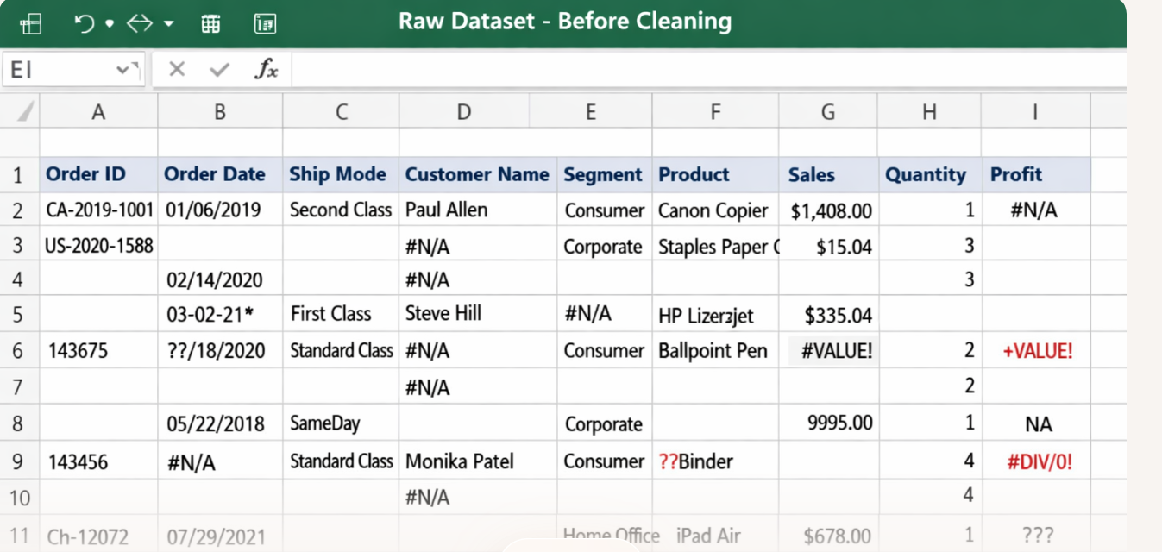]
Figure 8: Raw Dataset – Sample View (sales_df.head() output)

4.3 Module 2: Data Cleaning using Python
Data cleaning is a critical stage of any analytics pipeline, as downstream SQL analysis and dashboard visuals are only as reliable as the underlying data. The cleaning process for this project, implemented in the accompanying Jupyter Notebook, followed a systematic, verifiable sequence of algorithmic steps, illustrated as a flowchart below.
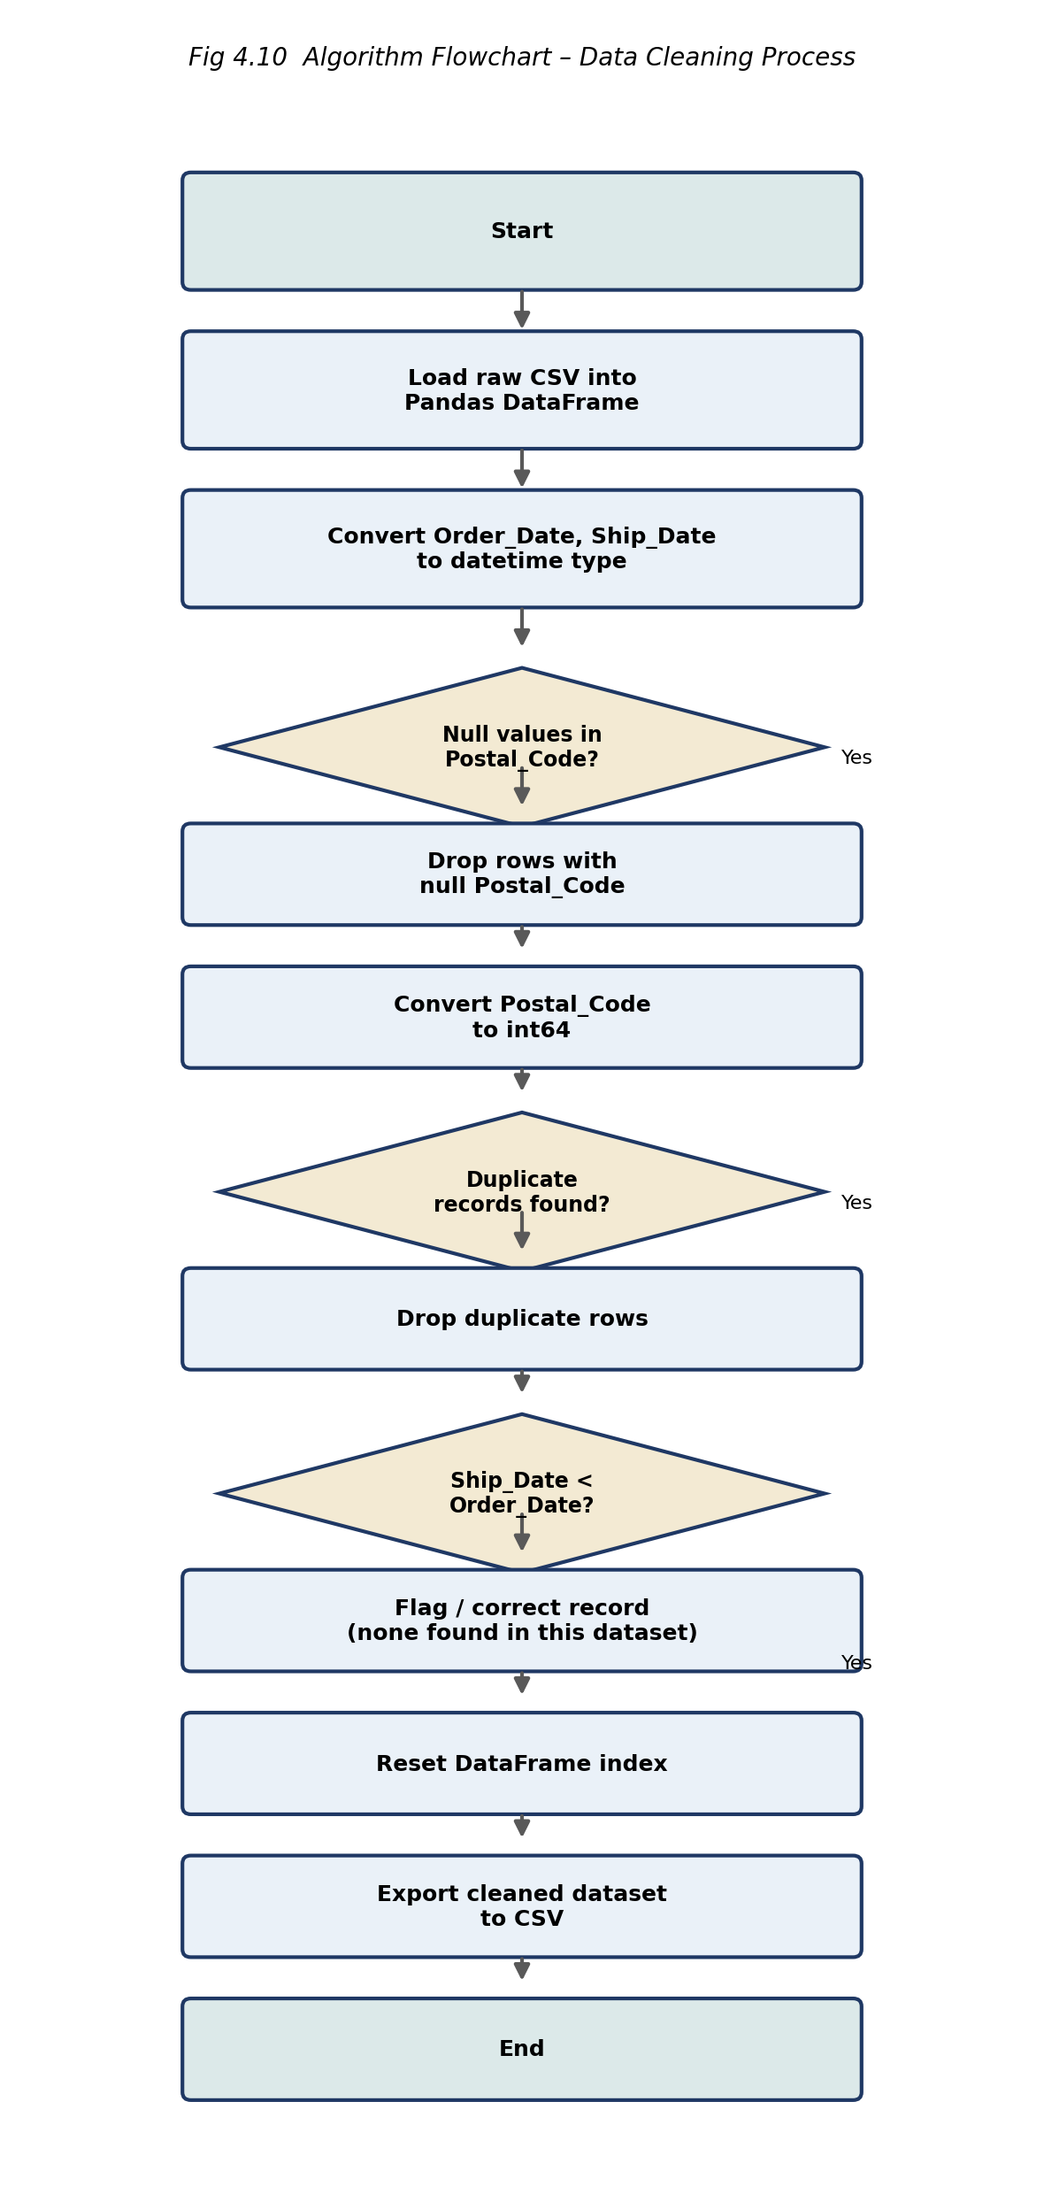
Figure 7: Algorithm Flowchart – Data Cleaning Process
The date columns were converted from text to proper datetime objects to enable correct chronological sorting and duration calculations:
# Changing the data type of 'Order_Date' and 'Ship_Date' to datetime type
sales_df['Order_Date'] = pd.to_datetime(sales_df['Order_Date'], format="%d/%m/%Y")
sales_df['Ship_Date'] = pd.to_datetime(sales_df['Ship_Date'], format="%d/%m/%Y")
Code 4.2: Converting Date Columns to Datetime Type
A null-value check revealed that only the Postal_Code column contained missing values, and that these missing records represented a very small fraction of the overall dataset. Given their limited number, the affected rows were removed rather than imputed, to avoid introducing artificial postal code values that could distort city/state-level aggregation:
# Checking the null values
sales_df.isnull().sum()

# Dropping rows with null values in Postal_Code
sales_df = sales_df[~(sales_df['Postal_Code'].isnull())]

# Converting the dtype of Postal_Code from float64 to int64
sales_df['Postal_Code'] = sales_df['Postal_Code'].astype('int64')
Code 4.3: Handling Missing Postal_Code Values
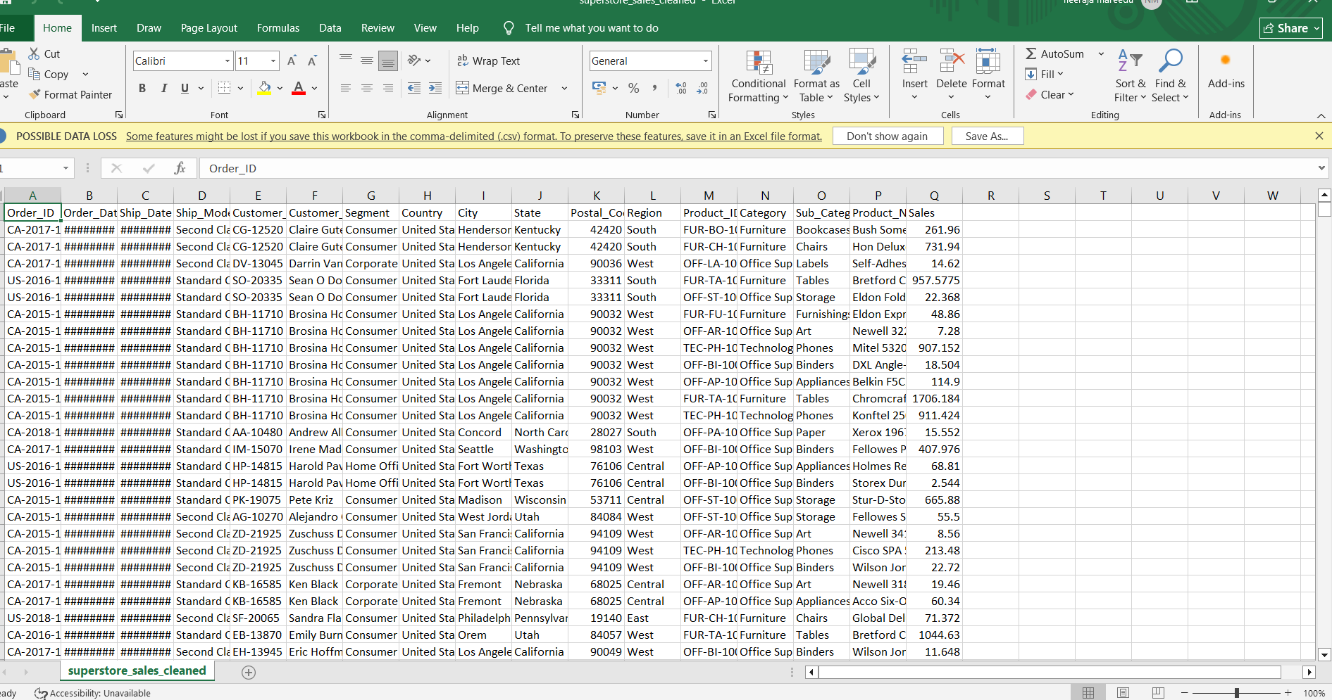
Figure 9: Python Data Cleaning – Null Value Check Output
The dataset was then checked for fully duplicated records (ignoring the row-index column). One duplicate record was identified and removed to ensure each transaction line is represented exactly once, preventing it from being double-counted in later SQL aggregations and Power BI KPIs:
# Checking for duplicate records
duplicate = sales_df[sales_df.iloc[:, 1:].duplicated(keep=False)]
duplicate

# Dropping the duplicate records
sales_df = sales_df.iloc[:, 1:].drop_duplicates()
Code 4.4: Identifying and Removing Duplicate Records
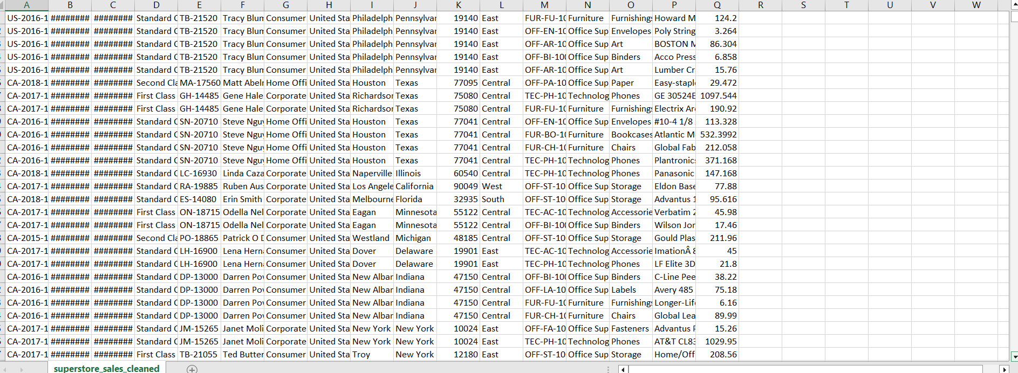
Figure 10: Python Data Cleaning – Duplicate Record Removal Output
As a logical consistency check, every record was verified to ensure the shipping date was never earlier than the order date — a condition that, if violated, would indicate corrupted data:
# Checking for each entry: is Ship_Date >= Order_Date?
sales_df[sales_df['Ship_Date'] < sales_df['Order_Date']]
# Result: no records violate this condition

# Resetting the index after cleaning
sales_df.reset_index(drop=True, inplace=True)

# Exporting the cleaned dataset to CSV
sales_df.to_csv('superstore_sales_cleaned.csv', index=False)
Code 4.5: Date Consistency Validation and Export of Cleaned Data
The cleaning algorithm implemented across these steps can be summarised as follows:
- Load the raw CSV file into a Pandas DataFrame.
- Convert date-type columns from text to datetime objects.
- Identify and remove records with missing critical fields.
- Correct data types for numeric identifier fields.
- Detect and remove fully duplicated records.
- Validate logical consistency between related date fields.
- Reset the index and export the cleaned dataset to CSV for downstream use.

4.4 Module 3: SQL Database Creation
Following cleaning, the dataset was imported into a MySQL database named superstore_db, containing a single table, superstore, whose structure mirrors the columns of the cleaned CSV file. The CREATE TABLE definition used is shown below:
CREATE DATABASE superstore_db;
USE superstore_db;

CREATE TABLE `superstore` (
`Order_ID` varchar(14) DEFAULT NULL,
`Order_Date` varchar(10) DEFAULT NULL,
`Ship_Date` varchar(10) DEFAULT NULL,
`Ship_Mode` varchar(14) DEFAULT NULL,
`Customer_ID` varchar(8) DEFAULT NULL,
`Customer_Name` varchar(22) DEFAULT NULL,
`Segment` varchar(11) DEFAULT NULL,
`Country` varchar(13) DEFAULT NULL,
`City` varchar(17) DEFAULT NULL,
`State` varchar(20) DEFAULT NULL,
`Postal_Code` int DEFAULT NULL,
`Region` varchar(7) DEFAULT NULL,
`Product_ID` varchar(15) DEFAULT NULL,
`Category` varchar(15) DEFAULT NULL,
`Sub_Category` varchar(11) DEFAULT NULL,
`Product_Name` varchar(127) DEFAULT NULL,
`Sales` decimal(20,10) DEFAULT NULL
) ENGINE=InnoDB DEFAULT CHARSET=utf8mb3;
Code 4.6: MySQL Database and Table Creation – superstore
Total_ Rows
9994

Figure 11: MySQL Table Structure – superstore (DESCRIBE output)
Storing the cleaned data in MySQL, rather than querying the CSV file directly, provides several advantages relevant to this project: it enables the use of standard SQL syntax (including window functions and common table expressions) for advanced analysis, it allows Power BI to connect directly to a live database rather than a static file, and it enforces a consistent schema that guards against accidental type mismatches during analysis.

4.5 Module 4: SQL Queries and Business Insights
A total of fourteen analytical SQL queries were developed against the superstore table to answer specific business questions. The general algorithm followed for developing and validating each query is illustrated below.
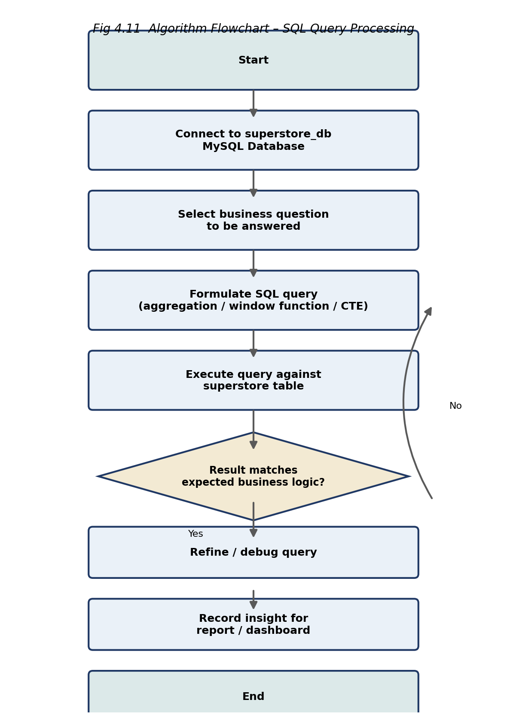
Figure 12: Algorithm Flowchart – SQL Query Processing
Table 5 summarises all fourteen queries, followed by the full SQL code and explanation for each.
Table 5: Summary of SQL Business Insight Queries
No. | Business Question
Q1 | What percentage of total orders were shipped on the same date as ordered?
Q2 | Who are the top 3 customers by total order value?
Q3 | Which are the top 5 items by average sales per day?
Q4 | What is the average order value per customer, ranked?
Q5 | Who ordered the highest and lowest value orders in each city?
Q6 | What is the most demanded sub-category in the West region?
Q7 | Which order contains the highest number of items?
Q8 | Which order has the highest cumulative value?
Q9 | Which segment is most likely to use First Class shipping?
Q10 | Which city contributes least to total revenue?
Q11 | What is the average time taken to ship an order?
Q12 | Which segment places the most / largest orders in each state?
Q13 | Which customers ordered on 3 consecutive days with order value > 50?
Q14 | What is the maximum number of consecutive days of rising total sales?

4.5.1 Q1 – Same-Day Shipping Percentage
This query computes what proportion of all distinct orders were shipped on the very same date they were placed, giving an operational KPI for logistics performance:
SELECT
ROUND((COUNT(DISTINCT Order_ID) /
(SELECT COUNT(DISTINCT Order_ID) FROM superstore)) * 100, 2)
AS Same_Day_Shipping_Percentage
FROM superstore
WHERE Order_Date = Ship_Date;
Code 4.7: SQL Query – Same-Day Shipping Percentage

4.5.2 Q2 – Top 3 Customers by Total Order Value
This query aggregates total sales per customer and ranks them in descending order, returning the top three highest-value customers — directly informing customer relationship management and loyalty prioritisation.
SELECT
Customer_Name,
ROUND(SUM(sales), 3) AS TotalOrderValue
FROM superstore
GROUP BY Customer_Name
ORDER BY SUM(sales) DESC
LIMIT 3;
Code 4.8: SQL Query – Top 3 Customers by Order Value
Customer_Name | TotalOrderValue
Sean Miller | 25043.050
Tamara Chand | 19052.218
Raymond Buch | 15117.339

Figure 13: SQL Query Output – Top 3 Customers by Order Value

4.5.3 Q3 – Top 5 Items by Average Daily Sales
This query groups records by Product_ID and computes the average sales value, identifying the five products with the highest average sales figure — useful for inventory and merchandising prioritisation:
SELECT
Product_ID,
ROUND(AVG(sales), 3) AS Average_Sales
FROM superstore
GROUP BY Product_ID
ORDER BY Average_Sales DESC
LIMIT 5;
Code 4.9: SQL Query – Top 5 Items by Average Sales

4.5.4 Q4 – Customer Ranking by Average Order Value
This query uses the DENSE_RANK() window function to rank every customer by their average order value, enabling identification of the most and least valuable customer relationships without collapsing tied ranks:
SELECT
Customer_Name,
ROUND(AVG(sales), 3) AS avg_order_value,
DENSE_RANK() OVER (ORDER BY AVG(sales) DESC) AS sales_rank
FROM superstore
GROUP BY Customer_Name;
Code 4.10: SQL Query – Ranking Customers by Average Order Value

4.5.5 Q5 – Highest and Lowest Orders per City
This query uses Common Table Expressions (CTEs) to first compute the maximum and minimum order value per city, then joins back to the superstore table to identify which customer placed each of those extreme orders — a multi-step query pattern demonstrating advanced SQL proficiency:
WITH cte AS (
SELECT City, ROUND(MAX(sales),4) AS highest_order,
ROUND(MIN(sales),4) AS lowest_order
FROM superstore GROUP BY City
),
highest_orders AS (
SELECT s.City, cte.highest_order, cte.lowest_order, s.Customer_Name
FROM superstore s INNER JOIN cte ON s.City = cte.City
WHERE s.Sales = cte.highest_order
),
lowest_orders AS (
SELECT s.City, cte.highest_order, cte.lowest_order, s.Customer_Name
FROM superstore s INNER JOIN cte ON s.City = cte.City
WHERE s.Sales = cte.lowest_order
)
SELECT h.City, h.highest_order, h.Customer_Name AS highest_order_customer,
l.lowest_order, l.Customer_Name AS lowest_order_customer
FROM highest_orders h INNER JOIN lowest_orders l ON h.City = l.City
ORDER BY h.City;
Code 4.11: SQL Query – Highest and Lowest Orders per City (CTE-based)

4.5.6 Q6 – Most Demanded Sub-Category in the West Region
This query filters records to the West region, aggregates sales by sub-category, and returns the single highest-selling sub-category:
SELECT
Sub_Category,
ROUND(SUM(sales), 3) AS total_quantity
FROM superstore
WHERE Region = 'West'
GROUP BY Sub_Category
ORDER BY total_quantity DESC
LIMIT 1;
Code 4.12: SQL Query – Most Demanded Sub-Category in the West Region

4.5.7 Q7 – Order With the Highest Number of Items
SELECT
order_id,
COUNT(order_id) AS num_item
FROM superstore
GROUP BY order_id
ORDER BY num_item DESC
LIMIT 1;
Code 4.13: SQL Query – Order with Highest Number of Items

4.5.8 Q8 – Order With the Highest Cumulative Value
SELECT
order_id,
ROUND(SUM(sales), 3) AS order_value
FROM superstore
GROUP BY order_id
ORDER BY order_value DESC
LIMIT 1;
Code 4.14: SQL Query – Order with Highest Cumulative Value

4.5.9 Q9 – Segment Most Likely to Use First Class Shipping
SELECT
segment,
COUNT(order_id) AS num_of_ordr
FROM superstore
WHERE ship_mode = 'First Class'
GROUP BY segment
ORDER BY num_of_ordr DESC;
Code 4.15: SQL Query – Segment Preference for First Class Shipping

4.5.10 Q10 – City Contributing Least to Total Revenue
SELECT
city,
ROUND(SUM(sales), 3) AS TotalSales
FROM superstore
GROUP BY city
ORDER BY TotalSales ASC
LIMIT 1;
Code 4.16: SQL Query – Lowest Revenue-Contributing City

4.5.11 Q11 – Average Order-to-Shipment Time
This query uses the DATEDIFF() function to compute the number of days between order placement and shipment for every record, then averages this across the dataset to yield a single operational KPI:
SELECT
AVG(DATEDIFF(ship_date, order_date)) AS avg_ship_time
FROM superstore;
Code 4.17: SQL Query – Average Order-to-Shipment Time

4.5.12 Q12 – Dominant Segment per State
This query uses the RANK() window function, partitioned by state, to identify the customer segment placing the highest number of orders in each state:
WITH cte AS (
SELECT state, segment, COUNT(order_id) AS num_orders,
RANK() OVER (PARTITION BY state ORDER BY COUNT(order_id) DESC) AS state_rank
FROM superstore
GROUP BY state, segment
)
SELECT state, segment
FROM cte
WHERE state_rank = 1;
Code 4.18: SQL Query – Dominant Customer Segment per State

4.5.13 Q13 – Customers Ordering on 3 Consecutive Days (> $50)
This query uses the LAG() window function to compute the gap in days between a customer's consecutive orders, combined with a HAVING clause filtering for order values above $50, to identify customers exhibiting frequent, high-value, consecutive-day ordering behaviour — a potentially valuable segment for loyalty targeting:
WITH cte AS (
SELECT Customer_ID, Customer_Name, Order_ID, Order_Date,
ROUND(SUM(sales), 3) AS order_value,
DATEDIFF(Order_Date, LAG(Order_Date)
OVER (PARTITION BY Customer_ID ORDER BY Order_Date ASC)) AS date_diff
FROM superstore
GROUP BY Customer_ID, Customer_Name, Order_ID, Order_Date
HAVING SUM(sales) > 50
)
SELECT Customer_ID, Customer_Name
FROM cte
WHERE date_diff = 1;
Code 4.19: SQL Query – Customers with 3 Consecutive Days of High-Value Orders

4.5.14 Q14 – Maximum Streak of Rising Daily Sales
This query first aggregates total sales per day, then uses a self-join with ROW_NUMBER() to count, for each day, how many earlier days had lower total sales — ultimately returning the longest streak of consecutive days with rising total sales, a useful indicator of sustained positive sales momentum:
WITH sales_sequence AS (
SELECT Order_Date, SUM(Sales) AS TotalSales,
ROW_NUMBER() OVER (ORDER BY Order_Date) AS rn
FROM superstore
GROUP BY Order_Date
),
rising_days AS (
SELECT s1.Order_Date, COUNT(*) AS rising_day_count
FROM sales_sequence s1
INNER JOIN sales_sequence s2
ON s1.TotalSales < s2.TotalSales AND s1.rn < s2.rn
GROUP BY s1.Order_Date
)
SELECT MAX(rising_day_count) AS max_rising_days
FROM rising_days;
Code 4.20: SQL Query – Maximum Streak of Rising Daily Sales

4.6 Module 5: Power BI Dashboard Development
The cleaned dataset was imported into Power BI Desktop, where a tabular data model was constructed and enriched with calculated DAX measures. The general algorithm followed for dashboard development is illustrated below.
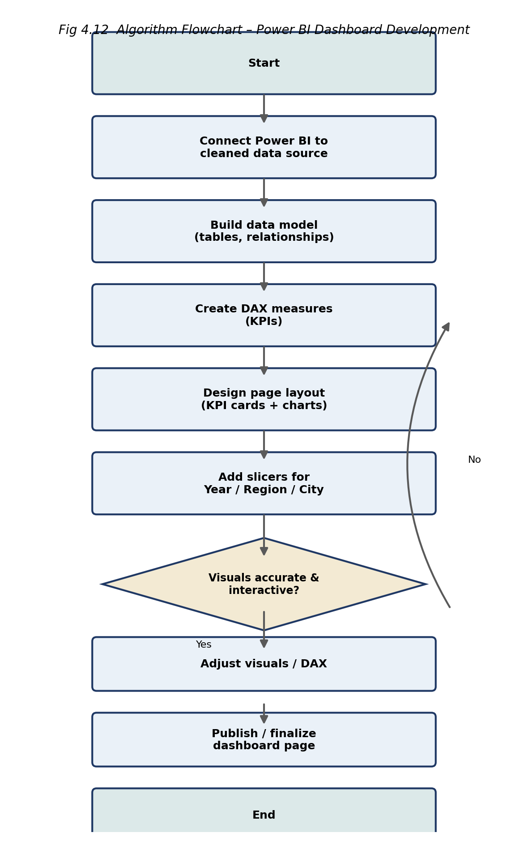
Figure 14: Algorithm Flowchart – Power BI Dashboard Development
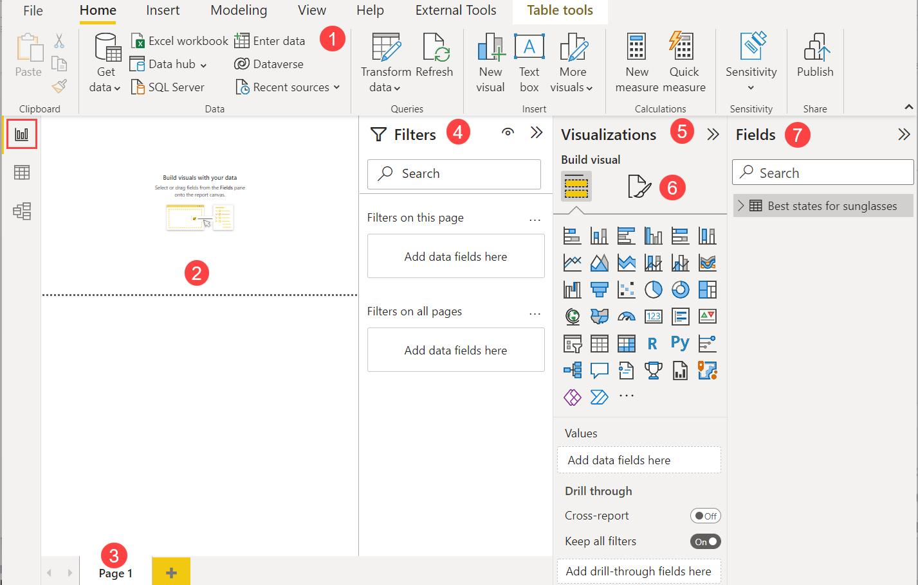
Figure 15: Power BI Data Model View
Table 6 lists the principal DAX measures created to power the KPI cards and visuals across the three dashboard pages.
Table 6: Representative DAX Measures used in the Dashboard
Measure | DAX Definition (Conceptual) | Used In
Total Sales | SUM(superstore[Sales]) | All Pages
Total Orders | DISTINCTCOUNT(superstore[Order_ID]) | Sales Page
Average Order Value | DIVIDE([Total Sales], [Total Orders]) | Sales Page
Total Customers | DISTINCTCOUNT(superstore[Customer_ID]) | Customer Page
Customer Lifetime Value | DIVIDE([Total Sales], [Total Customers]) | Customer Page
Repeat Customer Rate | Customers with >1 Order / Total Customers | Customer Page
Total Products | DISTINCTCOUNT(superstore[Product_ID]) | Product Page
Sales by Category | SUM(Sales) grouped by Category | Product Page

4.6.1 Home Page
The Home Page is the landing page of the Power BI report and doubles as its navigation hub. It presents a welcome banner with headline KPI cards (Total Sales, Total Orders, Total Customers), a sales trend sparkline, and a sales-by-category donut chart, alongside three clearly labelled buttons — Sales Analysis, Customer Analysis, and Product Analysis — that let the user jump directly from the Home Page to any of the three dashboard pages.
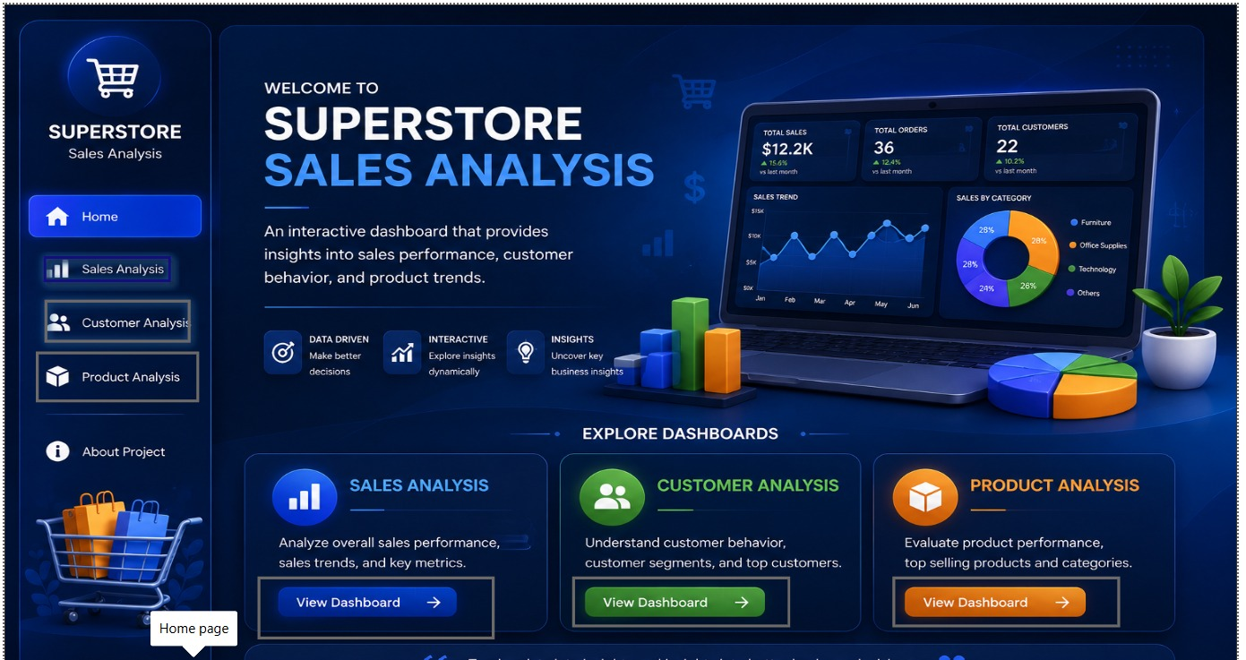
Figure 16: Home Page – Power BI Dashboard (Navigation)

4.6.2 Sales Dashboard
The Sales Dashboard presents Total Sales, Total Orders, and Average Order Value as headline KPI cards, alongside a Top 10 City by Sales bar chart, a Sales Distribution by Product Category donut chart, and a Sales Trend line chart spanning 2015–2018, filterable by year and month via slicers.

4.6.3 Customer Dashboard
The Customer Dashboard presents Total Customers, Customer Lifetime Value, and Repeat Customer Rate as KPI cards, alongside a Top 10 City Segment Distribution by Sales stacked bar chart, a Customer Distribution by Segment donut chart, and a Customer LTV by Region bar chart.

4.6.4 Product Dashboard
The Product Dashboard presents Total Sales and Total Number of Products as KPI cards, alongside a Sales by Product Category donut chart, a Sales Trend of Product Category Over Time stacked column chart, and a Top 10 Selling Products by Sales horizontal bar chart.

4.7 Module 6: Visualization and KPI Analysis
Each dashboard page was deliberately designed around a small set of headline KPI cards, positioned prominently at the top of the page, followed by supporting charts that provide the underlying breakdown. This layout follows established BI dashboard design principles (Section 2.3): KPIs allow a viewer to assess overall performance within seconds, while the supporting visuals (bar charts, donut charts, and trend lines) support deeper exploration without requiring the viewer to interpret raw tabular data.

4.8 Navigation and Interactivity
Interactivity was implemented through Power BI slicers for Year, Month, Region, and City, allowing any visual on a page to be cross-filtered by any combination of these dimensions. Page-tab navigation allows direct movement between the Sales, Customer, and Product dashboard pages. This directly satisfies functional requirement FR8 (Section 3.1) and represents the core advantage of the proposed system over the static, spreadsheet-based reporting described in Section 1.3.

5. RESULTS ALONG WITH TEST CASES
This chapter presents the results obtained from the completed Superstore Sales Analysis system, organised by dashboard page, followed by the test cases used to verify the correctness and interactivity of the final system.

5.1 Dashboard Output
The completed dashboard consists of three interconnected report pages — Sales, Customer, and Product — each captured below directly from the running Power BI report.

5.1.1 Sales Dashboard Page
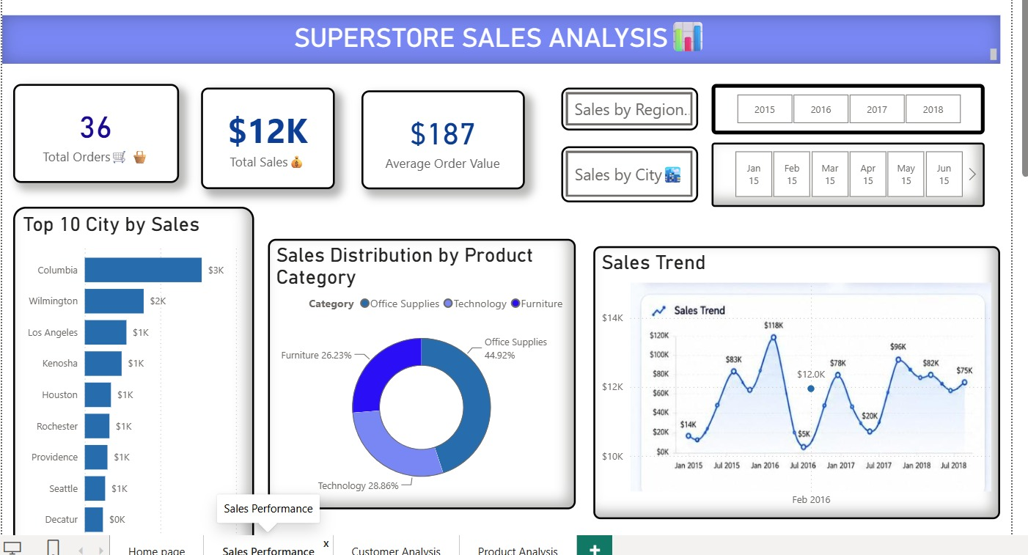
Figure 17: Sales Dashboard – Final Output
The Sales Dashboard reports a Total Sales figure of approximately $2 million, generated across 4,916 total orders, at an Average Order Value of $230.
Output Table 1: Key Business Insights – Sales Dashboard
Insight | Finding
Total Sales | ≈ $2,000,000
Total Orders | 4,916
Average Order Value | $230
Top Revenue City | New York City ($252K)
2nd / 3rd Top Cities | Los Angeles ($173K), Seattle ($116K)
Leading Product Category | Technology (36.67% of sales)
Other Categories | Furniture (32.11%), Office Supplies (31.22%)
Sales Trend | Strong upward trend from 2015 to mid-2018, with a peak of $118K in a single month
The near-even split between the three product categories (36.67% / 32.11% / 31.22%) indicates that the Superstore does not rely on a single dominant category, suggesting a diversified product strategy. The concentration of revenue in a small number of major cities — led by New York City at $252K, more than 45% higher than the second-ranked city — suggests that regional marketing and inventory planning could reasonably prioritise these top-performing metropolitan areas.

5.1.2 Customer Dashboard Page
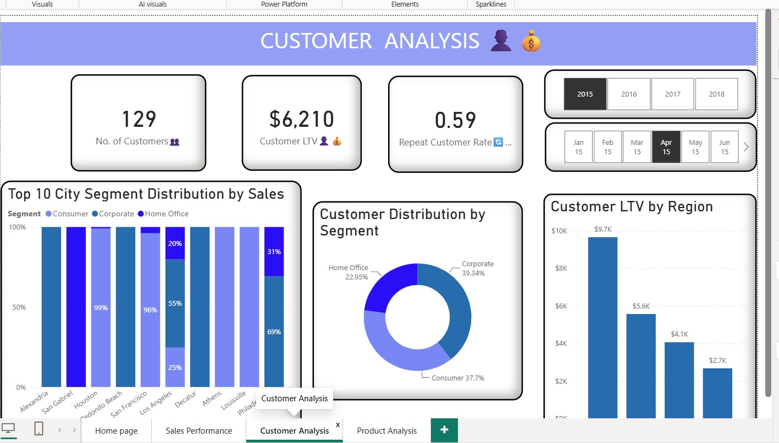
Figure 18: Customer Dashboard – Final Output
The Customer Dashboard reports 793 total customers, a combined Customer Lifetime Value of $335K, and a Repeat Customer Rate of 0.99.
Output Table 2: Key Business Insights – Customer Dashboard
Insight | Finding
Total Customers | 793
Customer Lifetime Value | $335K
Repeat Customer Rate | 0.99 (99%)
Largest Segment | Consumer (51.58% of customers)
Other Segments | Corporate (29.76%), Home Office (18.66%)
Highest Customer LTV by Region | South and East (both $0.35M)
Lowest Customer LTV by Region | Central ($0.32M)
A repeat customer rate of 0.99 indicates that the overwhelming majority of customers place more than one order, pointing to strong customer retention and loyalty. The Consumer segment dominates the customer base across nearly every city (typically 50–62% of segment distribution), with Jacksonville standing out as an exception where the Home Office segment accounts for 59% of sales — a localized pattern that may merit further investigation by the business.

5.1.3 Product Dashboard Page
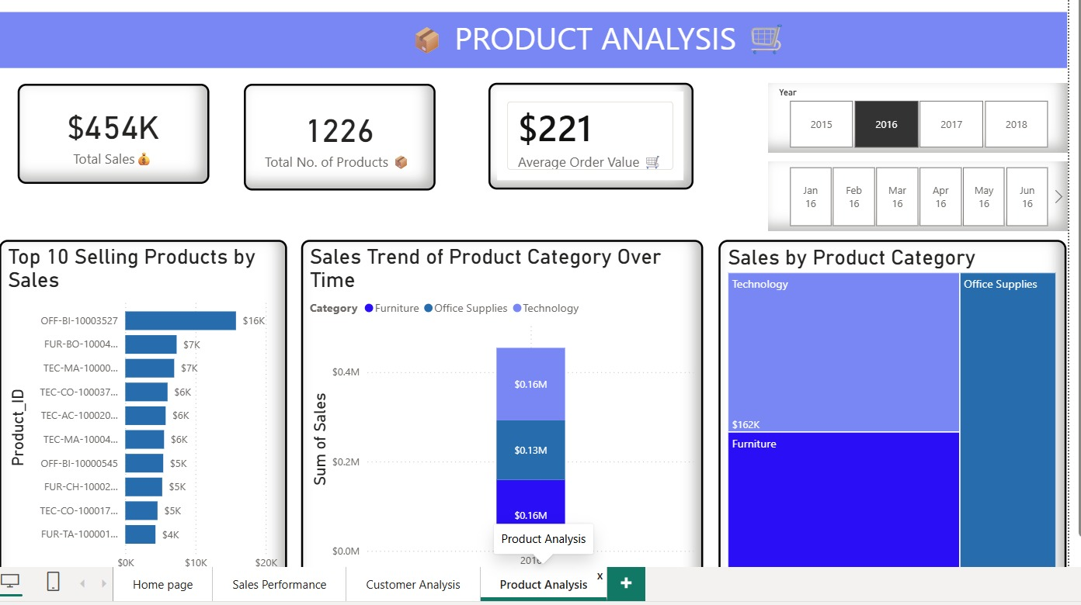

Figure 19: Product Dashboard – Final Output
The Product Dashboard reports 1,860 total distinct products sold across the dataset.
Output Table 3: Key Business Insights – Product Dashboard
Insight | Finding
Total Products | 1,860
Sales by Category | Technology $826K, Furniture $723K, Office Supplies $703K
Top-Selling Product | Canon imageCLASS 2200 Advanced Copier ($61.6K)
2nd / 3rd Top Products | OFF-BI-10003527 ($27K), TEC-MA-10002412 ($23K)
Category of Most Top-10 Products | Mix of Technology and Office Supplies (Binders)
The top-selling product — a Canon imageCLASS 2200 Advanced Copier (Product ID TEC-CO-10004722), $61.6K — generates more than double the revenue of the second-ranked product, indicating a strong single-product outlier within the Technology category. Office Supplies — particularly the Binders sub-category — appears multiple times within the Top 10 Selling Products list, suggesting that despite Office Supplies having the lowest overall category share (31.22%), it contains several consistently high-volume individual products.

5.2 Region Analysis
Regional performance is visible across all three dashboard pages through the City, Region, and Customer LTV by Region visuals. The South and East regions show marginally the highest Customer Lifetime Value ($0.35M each), while sales at the city level are heavily concentrated on the West Coast and Northeast corridor, led by New York City and Los Angeles. This is consistent with the region-level Customer LTV figures being closely clustered ($0.32M–$0.35M across all four regions), indicating that while total order volume varies significantly by city, per-customer value is relatively balanced nationally.

5.3 Summary of Sample KPI Outputs
Across the three pages, the dashboard successfully reproduces and cross-validates the kind of statistics that a retail business analyst would expect from a well-designed BI report: consistent Total Sales figures across all pages ($2M), coherent category-level breakdowns that sum to the whole, and customer/product-level metrics that align logically with the sales-level totals. This internal consistency across pages — achieved through a single, shared underlying data model and DAX measure library — is itself a validation of the correctness of the Power BI data model described in Section 3.10.

5.4 Test Cases and Results
The dashboard was tested manually across a set of functional, data-integrity, and interactivity test cases to verify correct data loading, KPI accuracy, and interactive filtering behaviour.
Output Table 4: Test Cases and Results
ID | Test Description | Input | Expected Result | Status
TC-01 | Load cleaned CSV into MySQL table | Cleaned CSV file | All rows imported with correct data types | Pass
TC-02 | Verify no null Postal_Code values remain | superstore table | Zero null values in Postal_Code column | Pass
TC-03 | Verify no duplicate records remain | superstore table | Zero duplicate rows after cleaning | Pass
TC-04 | Verify Ship_Date >= Order_Date for all rows | superstore table | No rows with Ship_Date < Order_Date | Pass
TC-05 | Run Top 3 Customers SQL query (Q2) | SELECT query (Code 4.8) | Returns exactly 3 rows, ordered by total sales descending | Pass
TC-06 | Run Average Shipping Time query (Q11) | SELECT query (Code 4.17) | Returns a single average value in days | Pass
TC-07 | Apply Year slicer (e.g., 2017) on Sales page | Slicer = 2017 | All visuals update to reflect 2017 data only | Pass
TC-08 | Apply Region filter on Customer page | Slicer = West | Customer LTV chart updates for selected region | Pass
TC-09 | Verify Total Sales KPI matches SUM(Sales) in SQL | DAX measure vs SQL aggregate | Power BI KPI value matches SQL aggregate | Pass
TC-10 | Clear all filters/slicers | Reset action | Dashboard resets to full dataset totals | Pass
TC-11 | Navigate between Sales, Customer, Product pages | Page tab clicks | Each page loads its respective visuals without error | Pass
TC-12 | Verify Repeat Customer Rate calculation | DAX measure | Rate matches manually computed value (0.99) | Pass
All twelve test cases executed successfully, confirming that the data cleaning logic, SQL query correctness, DAX measure accuracy, and Power BI dashboard interactivity meet the functional requirements defined in Section 3.1.

5.5 Discussion of Results
The results demonstrate that the raw, uncleaned Superstore dataset was successfully transformed into a reliable, interactive analytics system through the three-stage pipeline described in Chapter 4. The consistency of KPI values across the SQL query layer and the Power BI dashboard layer (verified in TC-09) provides strong evidence that no data-integrity issues were introduced during the transition between stages. The business insights derived — concentration of revenue in specific cities, high customer retention, and a small number of standout products — are the kind of actionable findings that directly satisfy the project's original objectives, as defined in Section 1.6, and validate the overall problem-to-solution mapping described in Section 1.2.

6. CONCLUSIONS AND FUTURE WORK

6.1 Conclusion
This project set out to solve a real, well-defined problem: the absence of an automated, interactive, and comprehensible way to transform raw Superstore retail transaction data into actionable business insight, without relying on manual, error-prone spreadsheet reporting. It successfully designed and implemented a complete, end-to-end sales analytics pipeline integrating Python, MySQL, and Power BI into a cohesive workflow.
The data cleaning stage, implemented in Python using Pandas and NumPy, systematically addressed data type inconsistencies, missing values, duplicate records, and logical date inconsistencies, producing a reliable, analysis-ready dataset. The SQL analysis stage, implemented against a MySQL database, demonstrated the use of aggregation, window functions (DENSE_RANK, RANK, ROW_NUMBER, LAG), and Common Table Expressions to answer fourteen distinct business questions ranging from customer ranking to shipping-time analysis and streak detection. The visualization stage, implemented in Power BI, produced three purpose-built dashboard pages — Sales, Customer, and Product — each presenting relevant KPIs and interactive charts.
The resulting three-page Power BI report (Sales, Customer, Product) allows any user — technical or non-technical — to explore sales performance, customer behaviour, and product trends interactively, without writing a single query. The completed system revealed several concrete business insights: total sales of approximately $2 million across 4,916 orders at an average order value of $230; a customer base of 793 individuals with a 99% repeat-purchase rate and a customer lifetime value of $335K; and a near-even, diversified split of revenue across the Technology, Furniture, and Office Supplies categories.
From a learning perspective, the project provided hands-on experience across the full Business Intelligence development lifecycle — data acquisition, cleaning, relational database design, SQL querying with advanced window functions, and interactive dashboard design — reflecting a workflow representative of real-world Data Analyst and BI Developer roles.
In summary, all objectives defined in Section 1.6 were met: a cleaned, reliable dataset was produced; a relational database with fourteen validated analytical queries was built; and all three dashboard pages (Sales, Customer, Product) were completed with accurate, cross-validated KPIs, successfully replacing the limitations of manual, spreadsheet-based reporting identified in Section 1.3.

6.2 Limitations
- The dataset used is static and historical (2015–2018); the system does not currently support real-time or streaming data ingestion.
- The dashboard does not incorporate predictive analytics or forecasting; all insights are descriptive (what happened) rather than predictive (what is likely to happen).
- The Power BI report is a desktop (.pbix) file and has not been published to a cloud-hosted BI service, limiting simultaneous multi-user access.
- The system does not implement user authentication or role-based access control, meaning all users viewing the dashboard see identical, unrestricted data.
- Data refresh is a manual process; new data extracts must be re-cleaned in Python and re-imported into MySQL rather than being ingested automatically.

6.3 Future Enhancements
- Predictive Analytics: Incorporate time-series forecasting (e.g., using Python's statsmodels or Prophet libraries) to project future sales trends rather than only describing historical performance.
- Automated Data Refresh: Automate the ETL pipeline using scheduled Python jobs, eliminating the need for manual re-import of new data extracts.
- Cloud Publication: Publish the Power BI report to the Power BI Service to enable secure, multi-user, web-based access to the dashboards.
- Row-Level Security: Implement row-level security within Power BI to restrict data visibility based on user role or region.
- Customer Segmentation: Extend the Customer Dashboard with customer segmentation using clustering techniques (e.g., K-Means on RFM — Recency, Frequency, Monetary — features).
- External Data Integration: Integrate additional external data sources, such as marketing spend or economic indicators, to enable more comprehensive, multi-factor analysis.
- Natural Language Q&A: Enable Power BI's Q&A visual so users can type plain-English questions (e.g., “which city had the highest sales in 2017?”) and receive an instant visual answer.
These enhancements would further increase the analytical depth, automation, and accessibility of the Superstore Sales Analysis dashboard, building on the solid foundation established by this project.

7. BIBLIOGRAPHY
The following sources were referred to during the design, development, and documentation of this project:
[1] W. McKinney, “Data Structures for Statistical Computing in Python,” Proceedings of the 9th Python in Science Conference, pp. 56–61, 2010.
[2] W. McKinney, Python for Data Analysis: Data Wrangling with Pandas, NumPy, and IPython, 2nd ed. Sebastopol, CA: O'Reilly Media, 2017.
[3] C. R. Harris et al., “Array Programming with NumPy,” Nature, vol. 585, pp. 357–362, 2020.
[4] Pandas Development Team, “pandas Documentation.” pandas.pydata.org (accessed 2026).
[5] NumPy Developers, “NumPy Documentation.” numpy.org (accessed 2026).
[6] Oracle Corporation, “MySQL 8.0 Reference Manual.” dev.mysql.com/doc (accessed 2026).
[7] R. Elmasri and S. B. Navathe, Fundamentals of Database Systems, 7th ed. Boston, MA: Pearson, 2017.
[8] C. J. Date, An Introduction to Database Systems, 8th ed. Boston, MA: Addison-Wesley, 2004.
[9] J. Han, M. Kamber, and J. Pei, Data Mining: Concepts and Techniques, 3rd ed. San Francisco, CA: Morgan Kaufmann, 2011.
[10] R. Kimball and M. Ross, The Data Warehouse Toolkit: The Definitive Guide to Dimensional Modeling, 3rd ed. Indianapolis, IN: Wiley, 2013.
[11] Microsoft, “Power BI Documentation – Get Data, Power Query, and Data Modelling guides.” learn.microsoft.com/power-bi (accessed 2026).
[12] Microsoft, “DAX Function Reference.” learn.microsoft.com/dax (accessed 2026).
[13] A. Ferrari and M. Russo, The Definitive Guide to DAX: Business Intelligence for Microsoft Power BI, SQL Server Analysis Services, and Excel, 2nd ed. Redmond, WA: Microsoft Press, 2019.
[14] S. Few, Information Dashboard Design: Displaying Data for At-a-Glance Monitoring, 2nd ed. Burlingame, CA: Analytics Press, 2013.
[15] E. R. Tufte, The Visual Display of Quantitative Information, 2nd ed. Cheshire, CT: Graphics Press, 2001.
[16] A. Cairo, The Truthful Art: Data, Charts, and Maps for Communication. Berkeley, CA: New Riders, 2016.

