Patient Health Monitoring Pipeline Using AWS
I have mentioned the whole AWS Healthcare ETL project step-by-step as below:

AWS Services Used
• Amazon S3
• AWS Glue Crawler
• AWS Glue Data Catalog
• AWS Glue ETL Job
• IAM Role

Architecture Flow
CSV Files → Amazon S3 → Glue Crawler → Glue Catalog → Glue ETL Job → Processed Parquet Output

Step 1 – Create S3 Bucket
Open AWS Console → Search S3 → Create Bucket.
Example Bucket Name: patient-health-monitoring-kusum
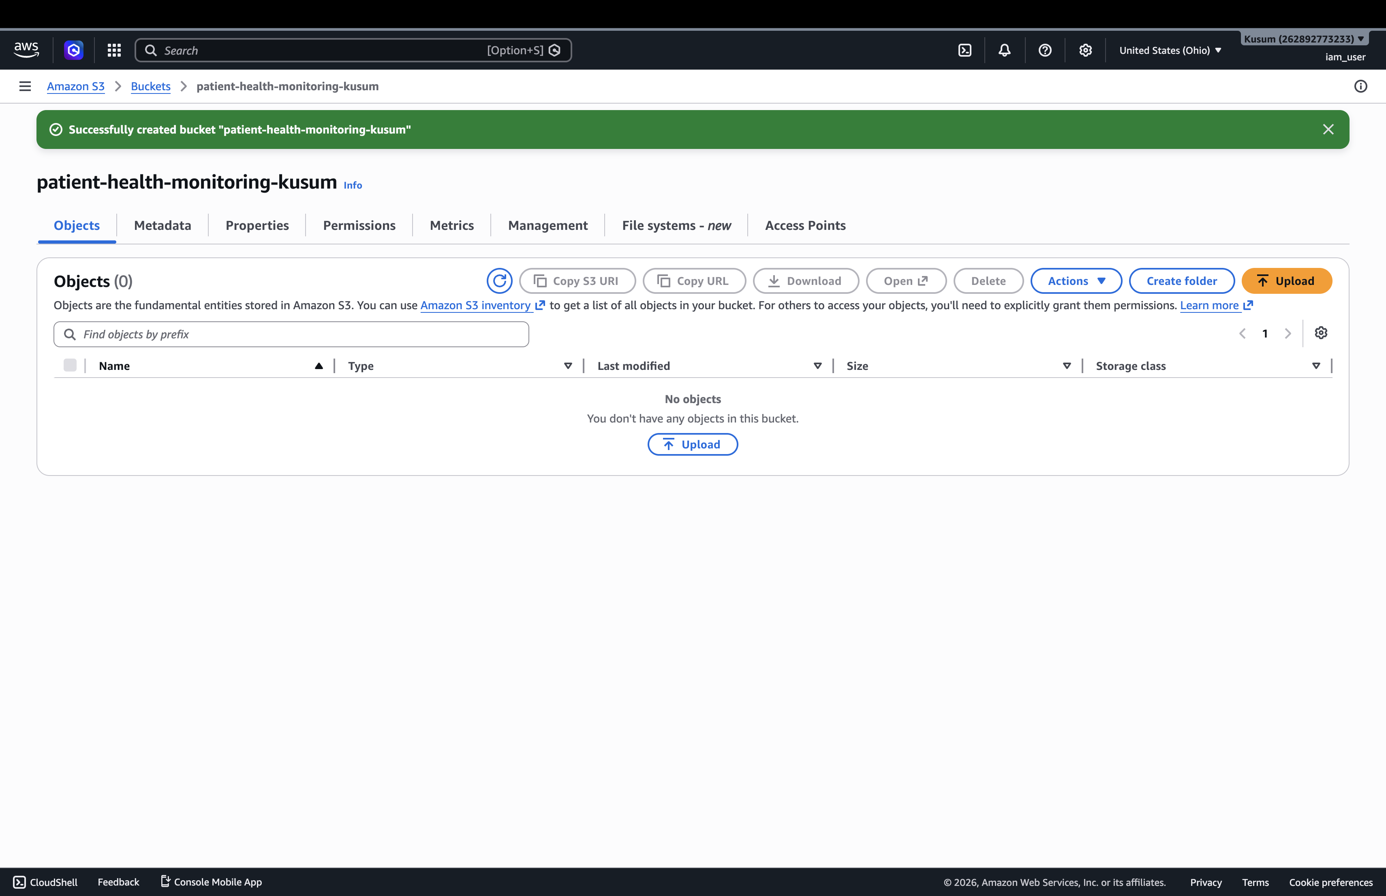

Step 2 – Create Folder Structure
Create these folders:
raw/vitals/
raw/patients/
raw/devices/
processed/reports/
rejected/
scripts/
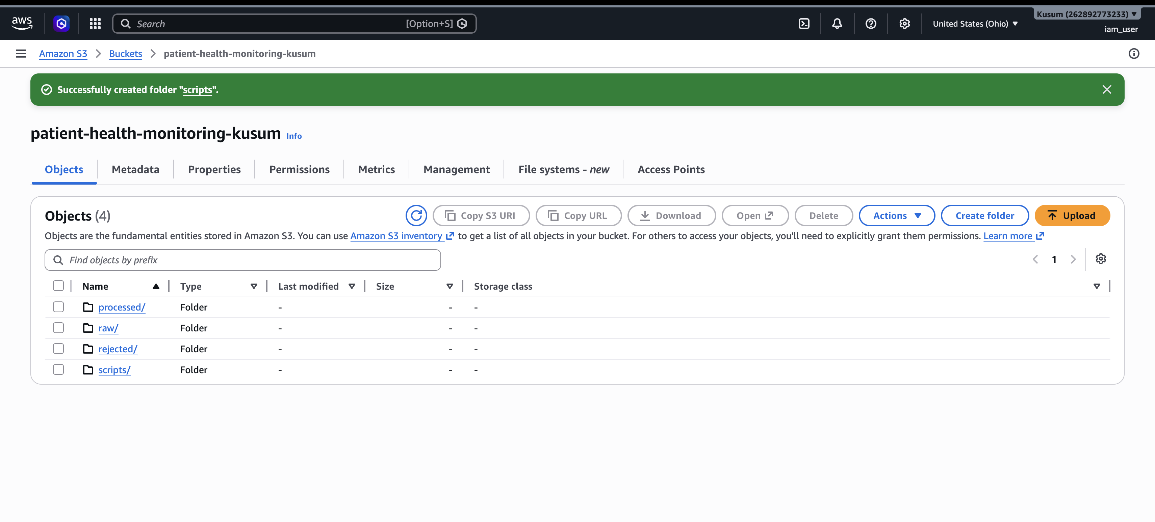

Step 3 – Create CSV Files
Create:
1. patient_vitals.csv
2. patient_details.csv
3. device_logs.csv
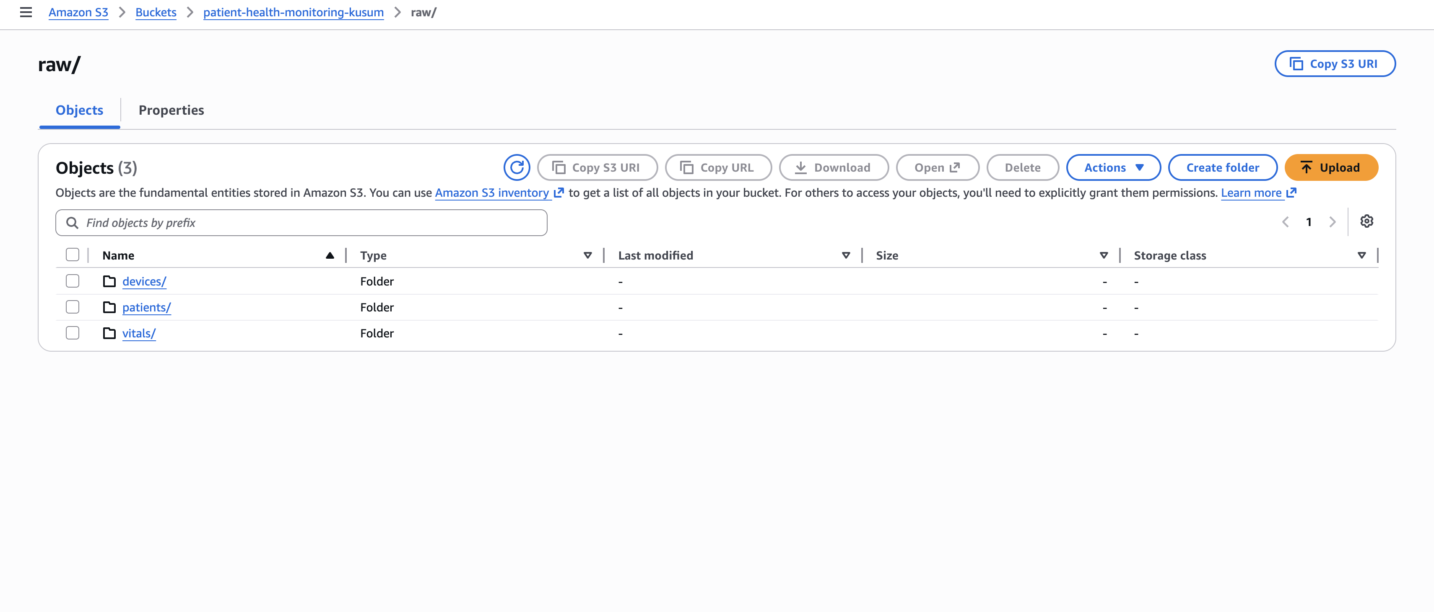

Step 4 – Upload Files
Upload files into correct S3 folders:
patient_vitals.csv → raw/vitals/
patient_details.csv → raw/patients/
device_logs.csv → raw/devices/


Step 5 – Create IAM Role
Open IAM → Roles → Create Role.
Choose AWS Service → Glue.
Attach:
AmazonS3FullAccess
AWSGlueConsoleFullAccess
Role Name: GlueHealthcareRole
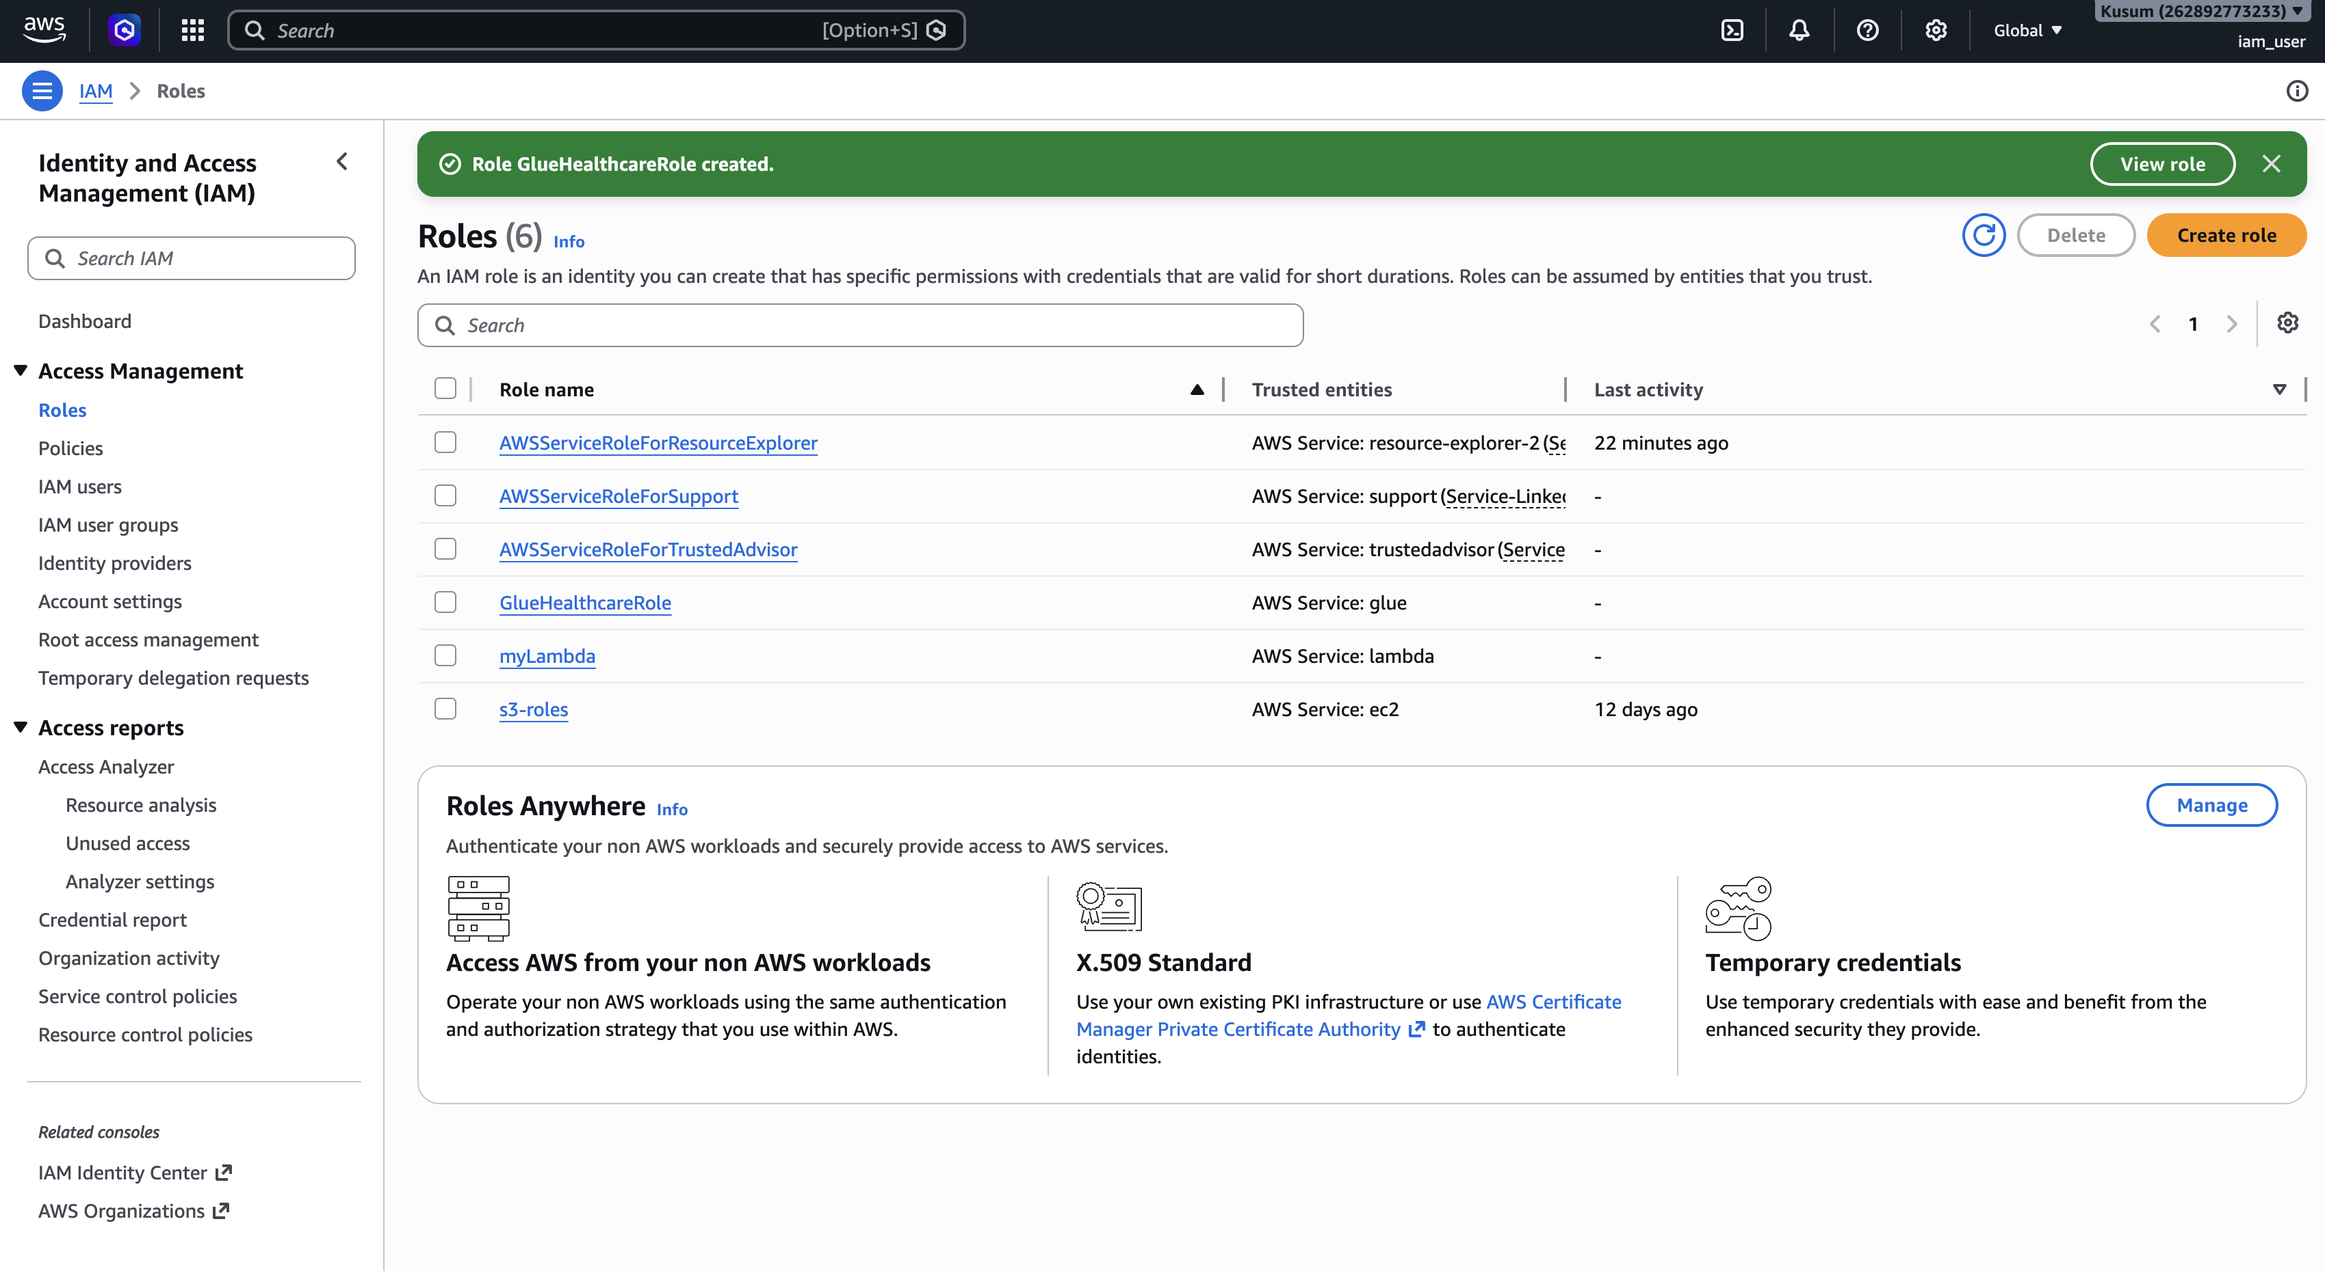

Step 6 – Create Glue Database
Open AWS Glue → Data Catalog → Databases → Add Database.
Database Name: healthcare_db
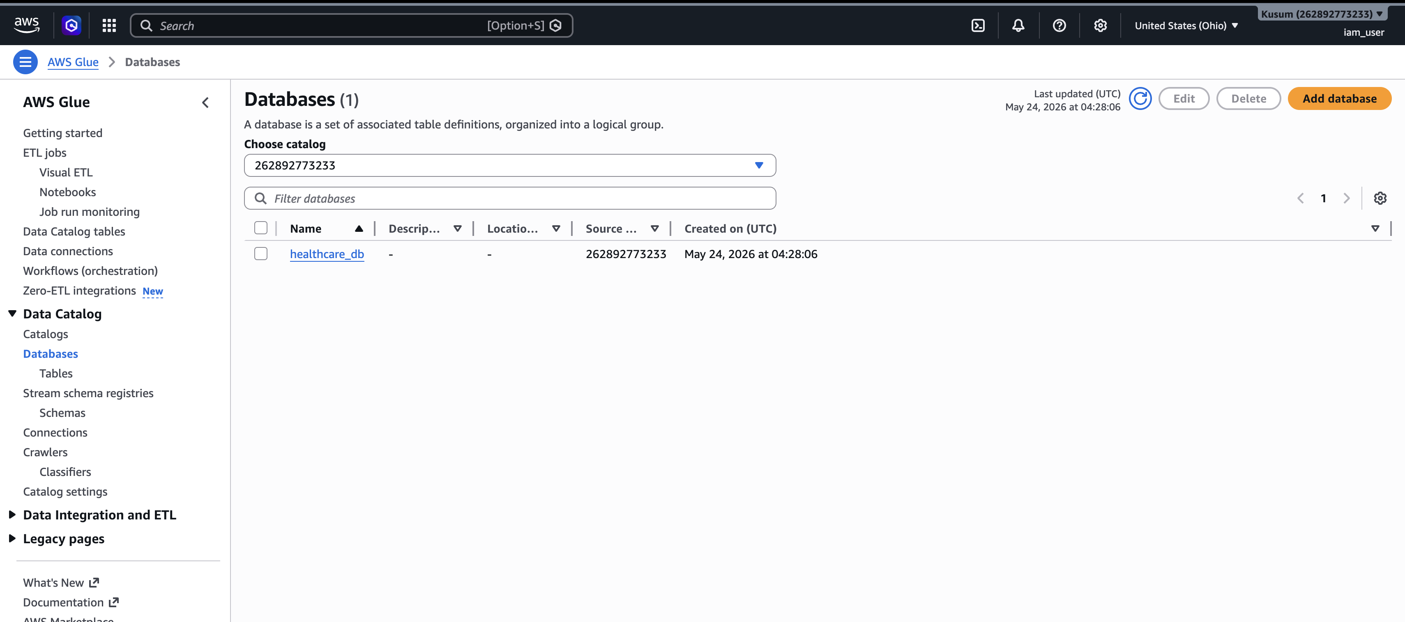

Step 7 – Create Glue Crawler
Open AWS Glue → Crawlers → Create crawler.
Add these S3 paths:
s3://patient-health-monitoring-kusum/raw/vitals/
s3://patient-health-monitoring-kusum/raw/patients/
s3://patient-health-monitoring-kusum/raw/devices/
Choose healthcare_db and run crawler.
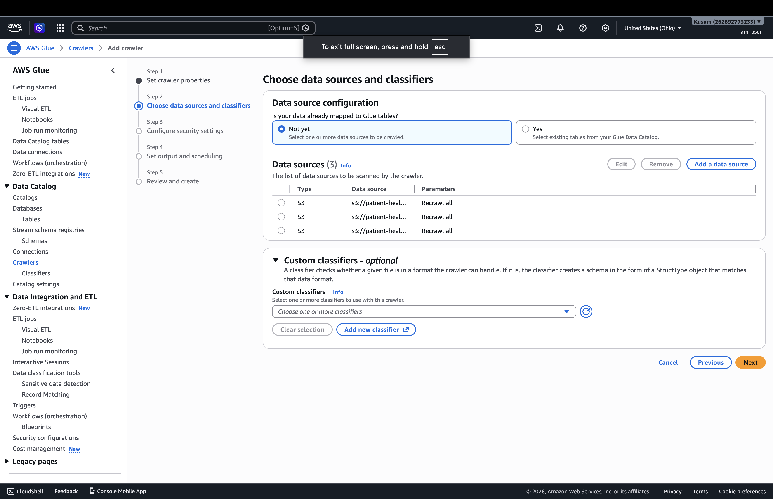
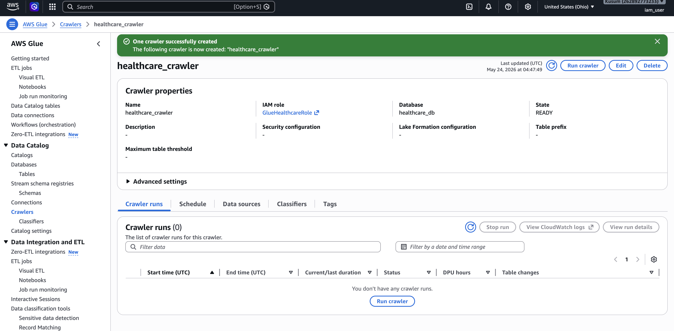

Expected Glue Tables
patient_vitals
patient_details
device_logs
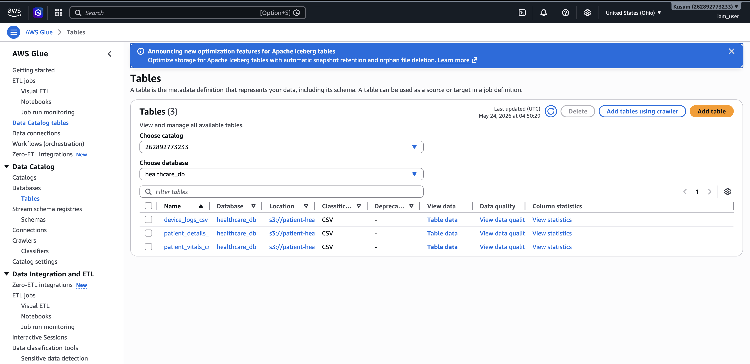

Step 8 – Create Glue ETL Job
Open AWS Glue → ETL Jobs → Script Editor.
Choose Spark and Python.
Paste PySpark ETL code.
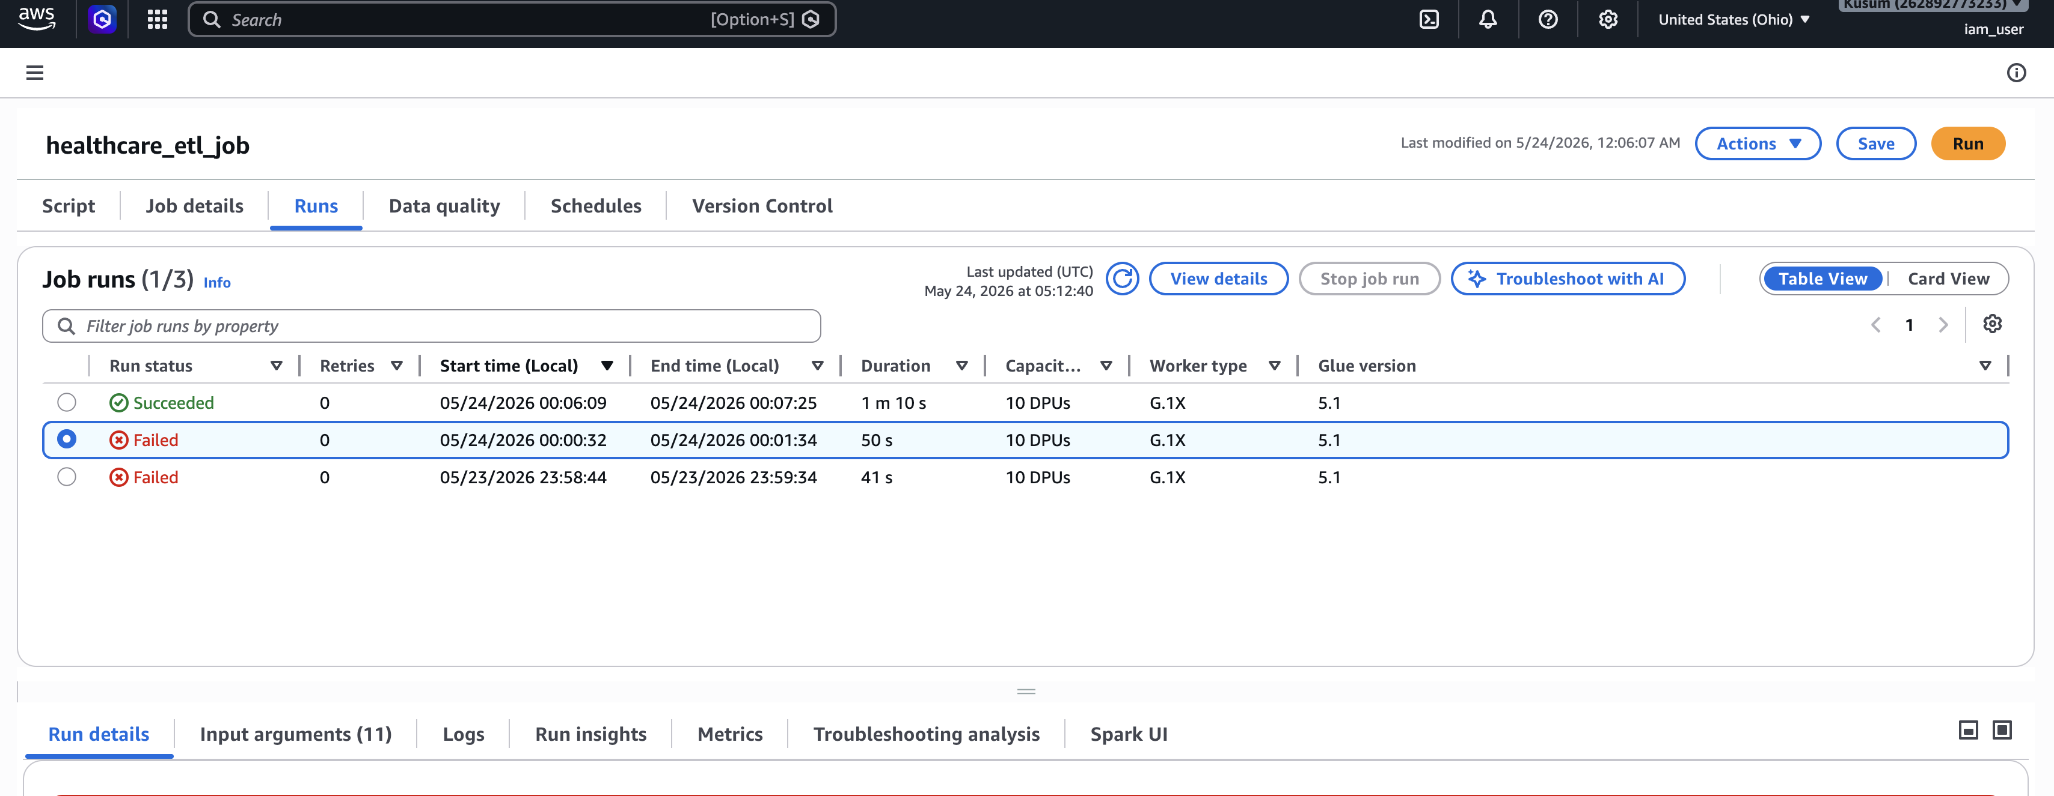

Simple Working ETL Code
import sys
from awsglue.context import GlueContext
from awsglue.job import Job
from awsglue.utils import getResolvedOptions
from pyspark.context import SparkContext
from pyspark.sql.functions import col, when, to_timestamp, to_date, hour
args = getResolvedOptions(sys.argv, ["JOB_NAME"])
sc = SparkContext()
glueContext = GlueContext(sc)
spark = glueContext.spark_session
job = Job(glueContext)
job.init(args["JOB_NAME"], args)
bucket_name = "patient-health-monitoring-kusum"
vitals_df = spark.read.option("header", True).option("inferSchema", True).csv(
f"s3://{bucket_name}/raw/vitals/"
)
patients_df = spark.read.option("header", True).option("inferSchema", True).csv(
f"s3://{bucket_name}/raw/patients/"
)
devices_df = spark.read.option("header", True).option("inferSchema", True).csv(
f"s3://{bucket_name}/raw/devices/"
)
vitals_df = vitals_df.dropDuplicates(["patient_id", "timestamp"])
valid_df = vitals_df.filter(
col("patient_id").isNotNull() &
col("heart_rate").isNotNull() &
col("oxygen_level").isNotNull() &
col("temperature").isNotNull()
)
valid_df = valid_df.withColumn("timestamp", to_timestamp(col("timestamp"))) .withColumn("monitoring_date", to_date(col("timestamp"))) .withColumn("monitoring_hour", hour(col("timestamp")))
valid_df = valid_df.withColumn(
"health_status",
when(col("oxygen_level") < 90, "Critical")
.when(col("temperature") > 100, "Fever")
.when(col("heart_rate") > 100, "High Risk")
.otherwise("Normal")
)
final_df = valid_df.join(patients_df, "patient_id", "left") .join(devices_df, "patient_id", "left")
final_df.write.mode("overwrite").parquet(
f"s3://{bucket_name}/processed/reports/"
)
job.commit()

Step 9 – Run Job
Click Save → Run.
Wait until status changes to Succeeded.
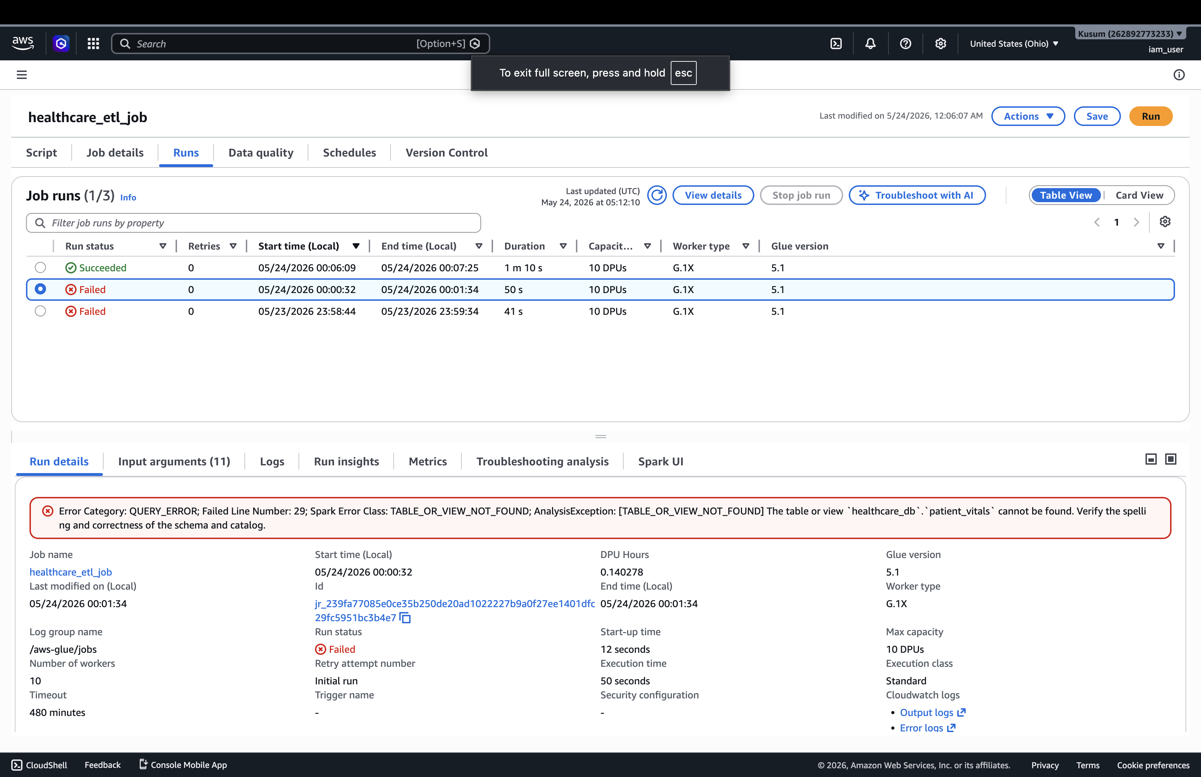

Step 10 – Verify Output
Open S3 bucket.
Check processed/reports/ and rejected/ folders.
You should see parquet files.
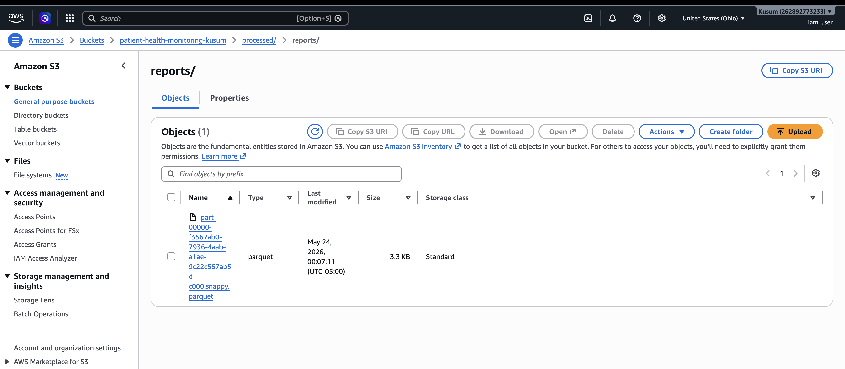

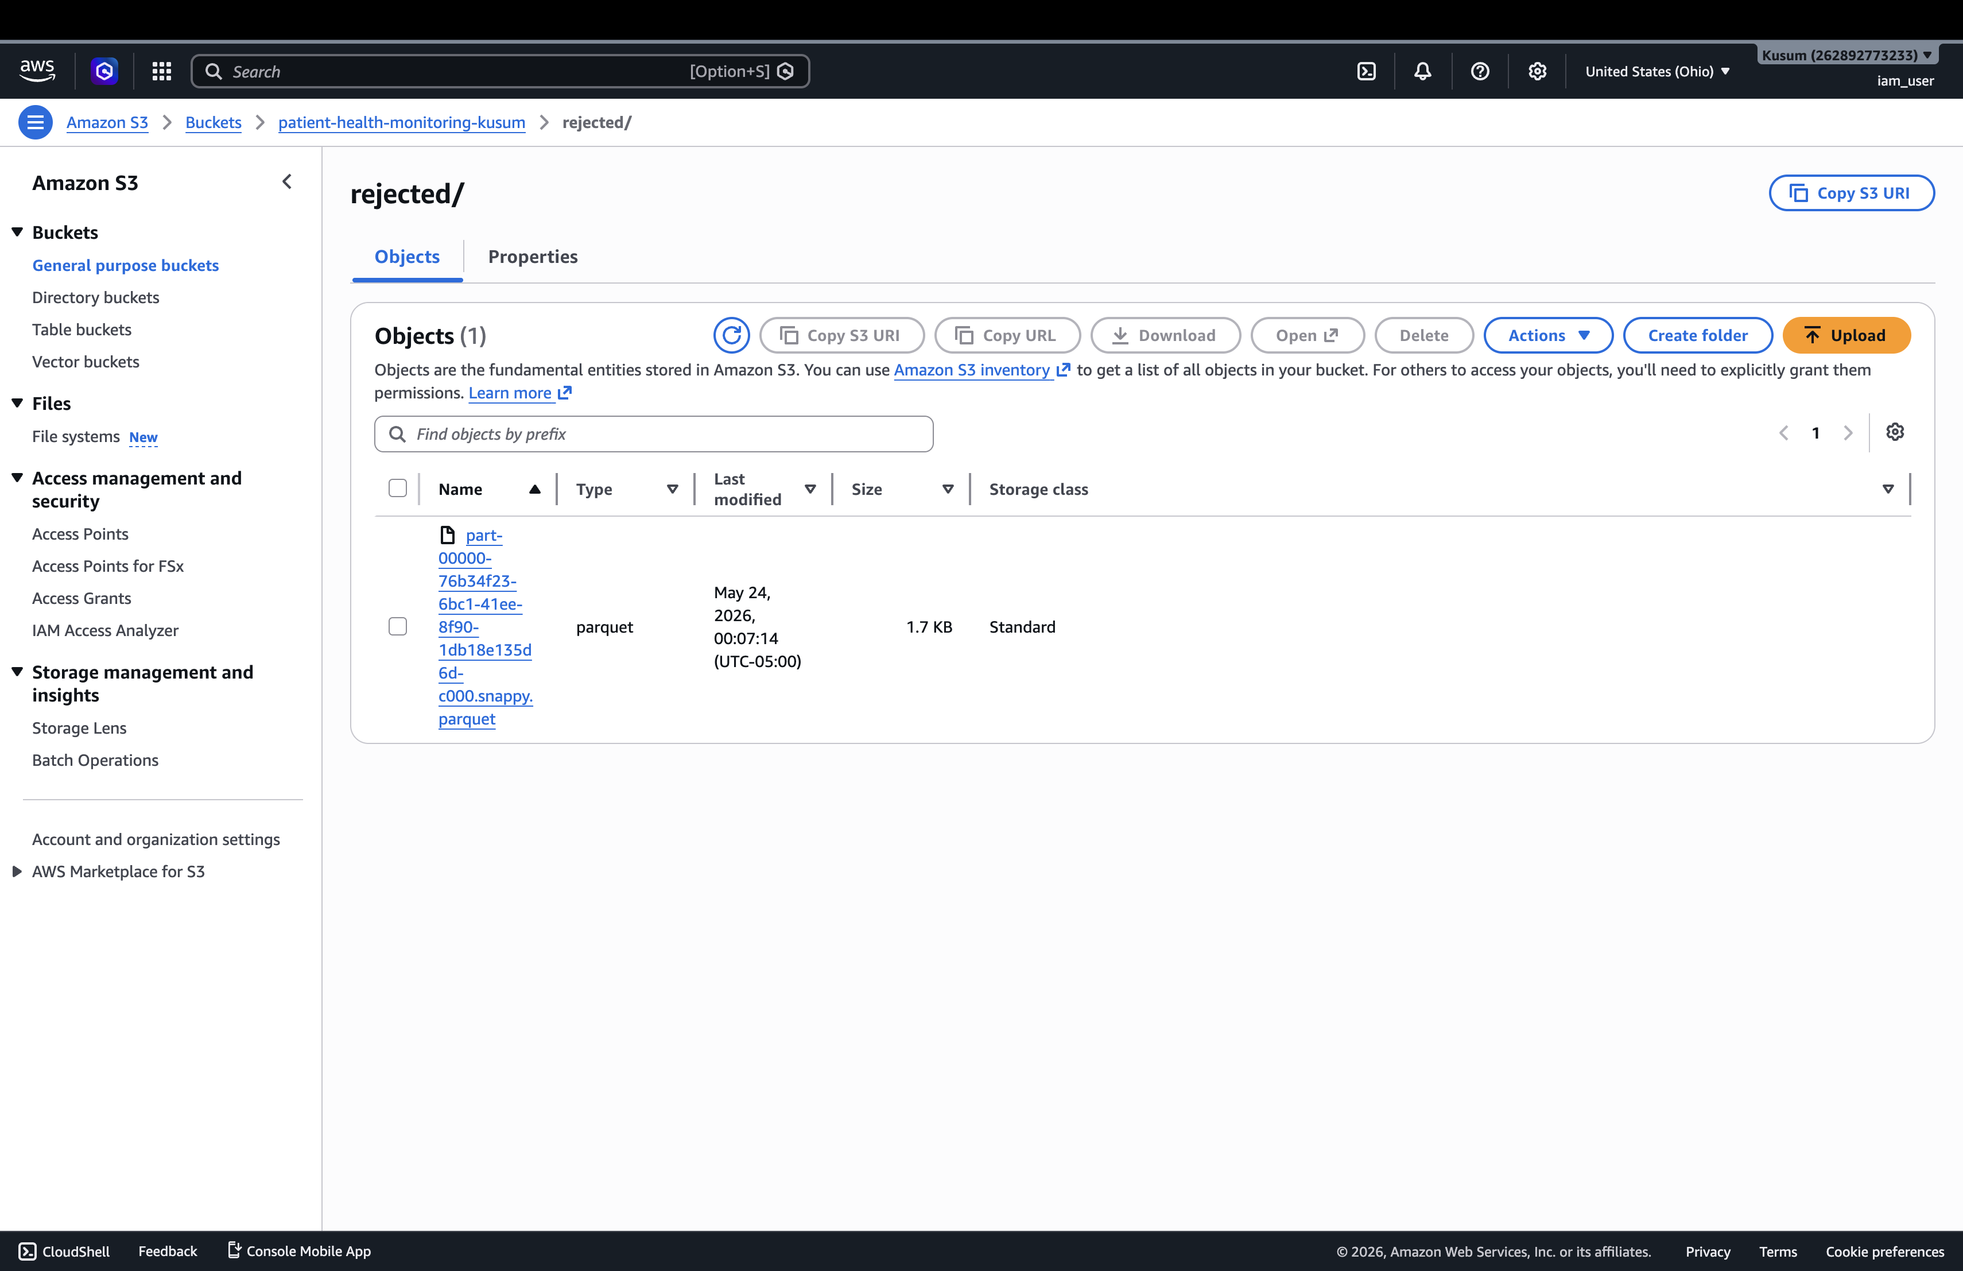

@Kusum Katwal

