PROJECT - E-COMMERCE SALES AND ANALYSIS

Summary Report - Data Cleaning & Interactive Dashboard
Author: Kusum S | Tools: Excel + Python + Power BI | 50K Rows

1. Introduction
This project cleaned a 50,000-row messy e-commerce dataset and built an interactive dashboard. I used Excel for initial exploration, Python for advanced cleaning, and Power BI for visualization.

2. Tools Used
Excel: Initial exploration, filters, unique values, formula check.
Python: Pandas, NumPy, OpenPyXL - fixed pricing, discount, profit logic.
Power BI: DAX measures, slicers, dark-theme dashboard.

3. How I Cleaned Dataset
Step 1 Excel: Opened messy file, found random UnitPrice for same product, incorrect Profit.
Step 2 Python Product Master: Fixed price with 40% margin - Table 2000/2800, Laptop 30000/42000 etc.
Step 3 Calculations: Total Purchase=Purchase*Qty, Total amount=Sales*Qty, Grand Total=Total amount*(1-Discount%), Profit=Grand Total-Purchase.
Step 4 Export clean file for Power BI.

4. Power BI Dashboard
DAX: Total Sales=SUM(Grand Total), Total Profit=SUM(Profit), Profit Margin=DIVIDE(Profit,Sales)*100
Page1: KPI cards 1.52bn/276K/243M/50K, Sales by Product donut, Profit by Category bar, Profit by City h-bar, Sales by Payment donut, Quantity vs Profit scatter, Sales by Year line.
Page2: Profit by Product bar, India Map, Sales by Month line, Quantity by Product h-bar.

5. Dashboard Screenshots

Page 1 - Executive Overview
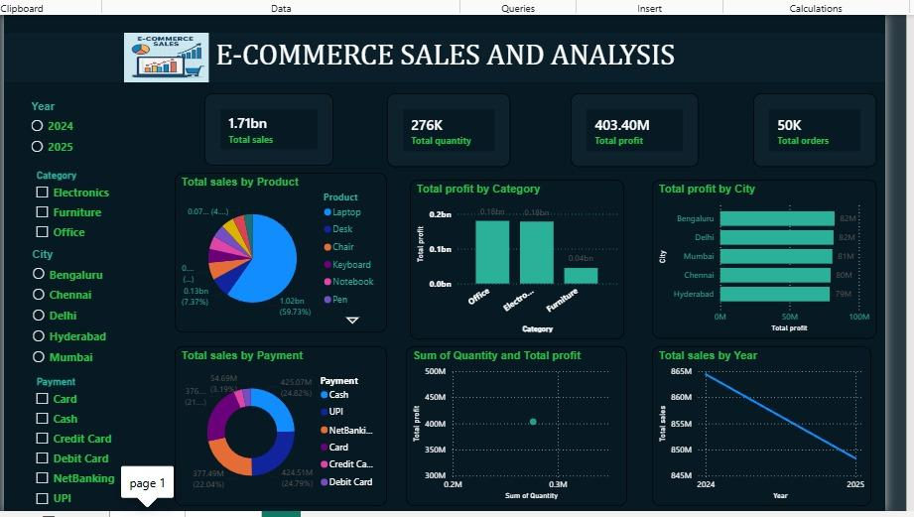

Page 2 - Product & Regional
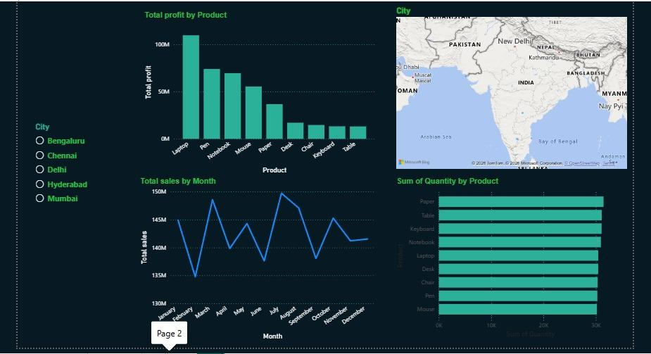

6. Insights
Laptop 71% sales, Electronics 77% profit, City balanced, 2024>2025 2.3% decline.
Author: Kusum S | Excel + Python + Power BI

