Done by Kuanysh Zhunussov
Laboratory work #1
E-shop

I. E-shop is a system for electronic commerce, analogy of physical buying products or services. Mostly used web browser for client interact via Internet. Aim of e-shop is to provide user-friendly UI for shopping and fast and integrity data communication with database in order to quickly respond from seller. So, it has functionalities as browsing through catalog, login, make an order, add to cart, data management, admin panel, cms, etc.

II. One-layer architecture
It's not good to use this type of architecture in e-shop, but it's possible. So, we have a monitor to display info and computer with presentation, business logic, database modules in one. It could be a computer which located in some shop, so everybody should buy goods directly from the computer.
Two-layer architecture
It's a client-server architecture. So in client application the code is written for saving the data in SQL server database (browsing, ordering, etc.). Client sends the request to server and it process the request and send back with data. The main problem of this architecture type is the server cannot respond multiple requests at same time, as a result it causes data integrity issue.
Three-layer architecture
It's a client-server architecture where three modules: user interface, business process and data access/storage developed as independent modules.
Presentation layer – contains UI part (web forms, images, etc.). Displays data, modifies/inserts data, provides all user interaction.
Business logic layer – e.g C# classes. Receives requests from client, responds to client requests, communicates with the database, applies business logic.
Data management layer – Database. Manages data interaction, enforce data integrity, does all that DB stuff.
The main advantage – easy to modify each layer separately without affecting other layers. Main disadvantage – implementation becomes more difficult.

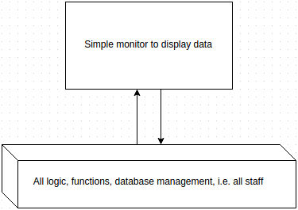
III. One-layer

Two-layer
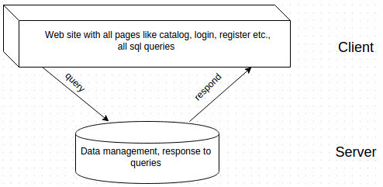
Three-layer
