CERQ-MTC/GEN/1812-0015-0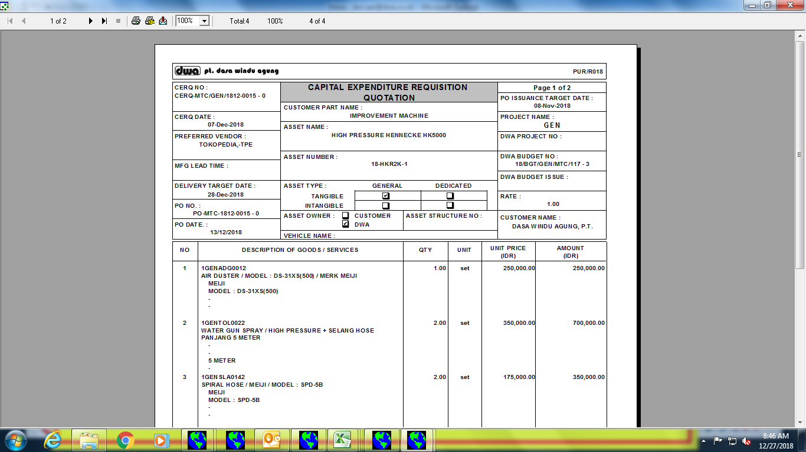

**Qty : Water Gun Spray = 2**

CER-MTC/GEN/1812-0115-0

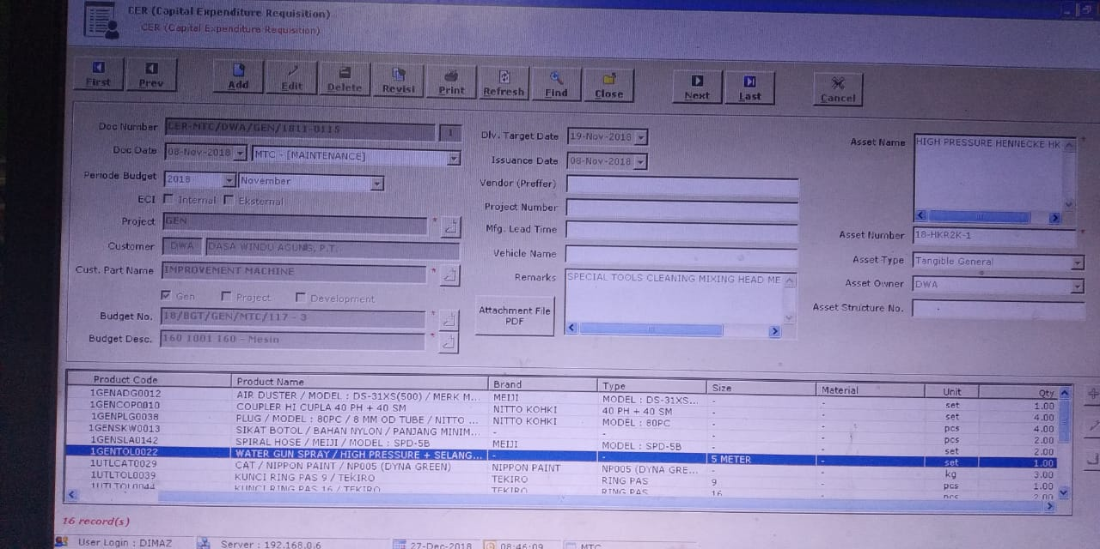

**Qty : Water Gun Spray = 1**

***Yang Benar QTY di CER, Water Gun Spray = 1***