Action Potential Generation

Kutay Uğurlu 2232841

May 29, 2021

# Abstract

The purpose of the report is to examine the cell behavior in terms of its electrical behavior, or ac- tion potentials in a narrower sense. The observed behavior is described mathematically by Hodgkin and Huxley. The work described here implements the proposed system of equation and investigates the relevant parameters by conducting several ex- periments via simulation. Finally, observations made and conclusions reached are presented.

# Introduction

This report consists of 4 Parts: Theory, Results, Discussion and Appendix. In the theory part, the Voltage Clamp experiment and its results are pre- sented to establish a background for the following parts where the simulation procedure is described and results are discussed. In the Results part, some sample outputs of the simulation are shared. The relevant explanations and comments are left to the discussion part. The simulation program is pre- sented in the Appendix section.

# Theory

This section introduces the Hodgkin Huxley Ex- periments with a brief history section, description of the experiment and the mathematical model.

## History

Hodgkin and Huxley published their studies in a series of five papers in 1952.[1]

* + The first paper investigated how the neuron functions and explained the procedure in the following studies.
  + The second paper studied the effect of sodium concentration changes on the membrane po- tential and action potential phenomenon.
  + The third paper examined the immediate con- ductance changes’ effect on action potential.
  + The fourth paper investigated the sodium in- activation process.
  + The fifth and the final paper was the pa- per where Hodgkin and Huxley combined the previous experiments outcomes and formula- tions to establish a mathematical model for the whole process of action potential genera- tion.

## Voltage Clamp experiment

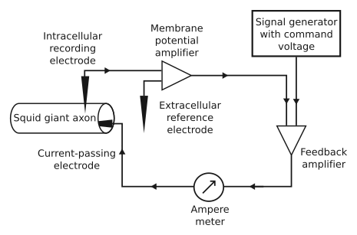

Figure 1: Voltage Clamp Experiment Setup [2]

Voltage Clamp technique is a method to measure the ionic currents to cell membrane. In the exper- iment, the giant squid axon is placed in a saline solution. The membrane voltage, *Vm* is measured

by an amplifier using an internal recording elec- trode and a reference electrode placed in saline so- lution, modelling extracellular fluid. This signal is fed to voltage clamp amplifier, which produces cur- rent proportional to the difference *Vm Vcommand*. The resultant current is fed to the axon via the current passing electrode. This circuit works as a feedback amplifier and equates *Vm* and *Vcommand*.

*−*

## Mathematical Model

The experiments result in three equations mod- elling the channel conductances discovered via curve fitting:

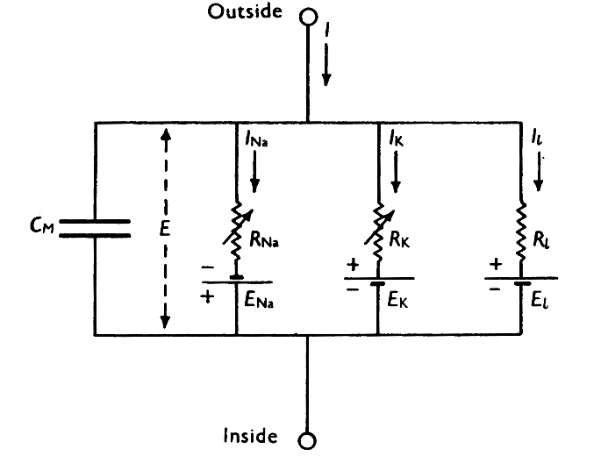

Figure 2: Membrane Equivalent Circuit [3]

*∂t* = *αn*(1 *− n*) *− βnn* (1)

*∂n*

*∂t* = *αm*(1 *− m*) *− βmm* (2)

*∂m*

*∂t* = *αh*(1 *− h*) *− βhh* (3)

*∂h*

For any time, according to Figure 2 and the Kirch- hoff’s Current Law following should be satisfied:

* + *INa* = *gNa*(*Vmembrane − ENa*)
  + *IK* = *gK* (*Vmembrane − EK*)

where *α* and *β* variables are functions of *vm* in the following manner:

* *IL*

= *gL*

(*Vmembrane*

* *EL*)

*α* = 0*.*1 *−* 0*.*01*vm*

*n*

*e*1*−*0*.*1*vm −* 1

*e−vm/*80

(4)

* + *IC* = *Imembrane −* (*INa* + *IK* + *IL*)

## Simulation

The pseudo code for the Action Potential Genera-

*βn* =

(5)

8

tion Simulation Algorithm is as follows:

*α* = 2*.*5 *−* 0*.*01*vm*

*m*

*e*2*.*5*−*0*.*1*vm −* 1

(6)

* + The time domain is discretized with small step size of *dt*.

*βm* = 4*e−vm/*18 (7)

*αh* = 0*.*07*e−vm/*20 (8)

1

* + For any time, first conductances are calculated and then currents are calculated according to these using the current *vm* value.
  + ∆*vm* =  *IC·dt* is calculated.

*Cmembrane*

*βh* = *e*3*−*0*.*1*vm* + 1 (9)

* + With *vm*

*i*+1 = *vm*

*i* + ∆*vm*

, new *α*, *β*, and

The instantaneous channel conductances are given by the following formulas:

*gNa* = *gN*¯ *a · m*3 *· h gK* = *g*¯*K · n*4

*gL* = *g*¯*L*

*m, n, h* are calculated.

* + Next iteration is run with the new parameters.

The algorithm is implemented in MATLAB pro- gramming environment and presented to the user as a Graphical User Interface Application via MATLAB GUI Designer Tool.

# Results

In this section the results corresponding to the dif- ferent excitation stimulus designs are presented all together including the currents, channel conduc- tances and membrane voltage, with the regarding observations. The relevant explanations and com- ments are left to the discussion section.

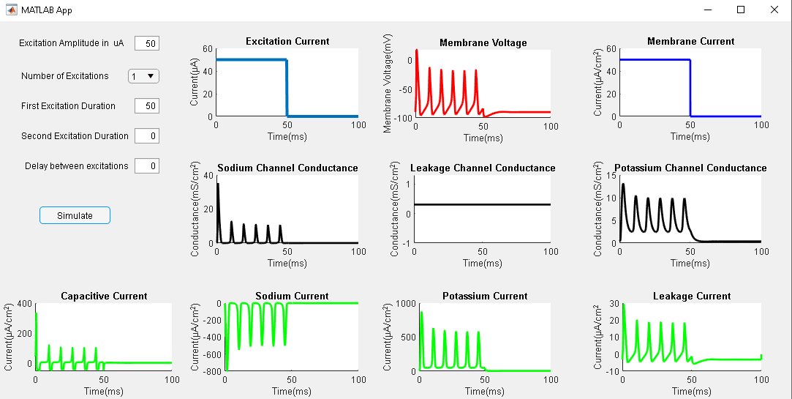

* + During rest, *i.e.* there is no excitation stim- ulus, the membrane potential remains at rest voltage of *Vrest* = 90*mV* and there is no cur- rent flowing through the membrane.
  + Potassium and Leakage Channel currents are observed to be positive, whereas sodium chan- nel current are observed to be negative.

*−*

* + The magnitude of the action potential gets smaller after the first excitation.

The following examples will touch on the different observations when excitation duration and magni- tude changes.

Figure 3: Results Corresponding to excitation of

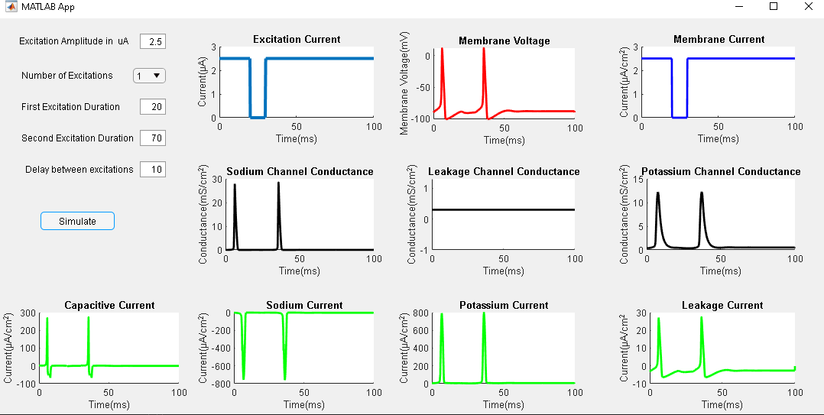

50*µA*

It is possible to see in Figure 3 that, an ampli- tude of 50*µA* is enough to trigger multiple Action Potentials when the stimulus is on for a period of time. The following observations can also be made for the next results to be shared:

* + Excitation Current is equal to the membrane current.
  + During action potential the K and Na chan- nel conductances tend to increase, whereas the Leakage channel (which is also used to model the Chlorine conductance), is constant during the whole process regardless of the presence of the stimulation current.
  + Capacitive current *IC* has the shape of*∂Vm* , with a scaling factor of membrane capacitance *Cm*. The capacitive current is observed be positive during the rise of action potential **(Depolarization phase)**, and it is observed to be negative during the fall of action poten- tial **(Repolarization Phase)**.

*∂t*

Figure 4: Results Corresponding to excitation of

* 1. *µA*

Different from Figure 3, it is possible to observe in Figure 4 that an excitation of magnitude 2.5*µA* was not able to trigger multiple consecutive ac- tion potentials. Instead, the membrane voltage re- mained at *Vrest* around -90 mV.

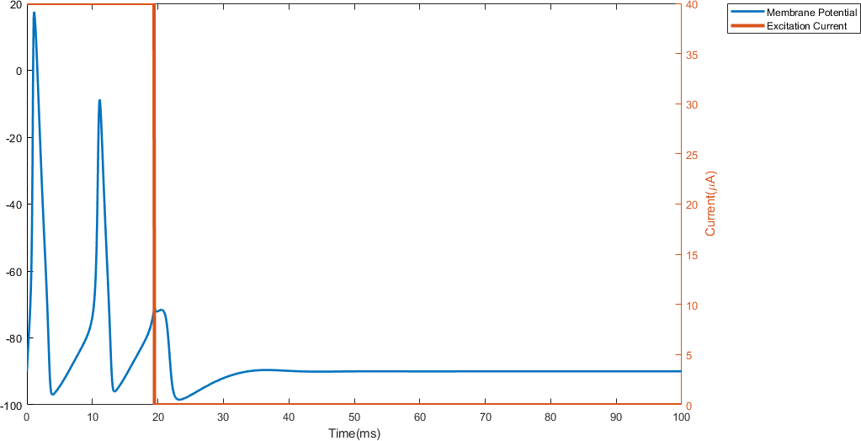 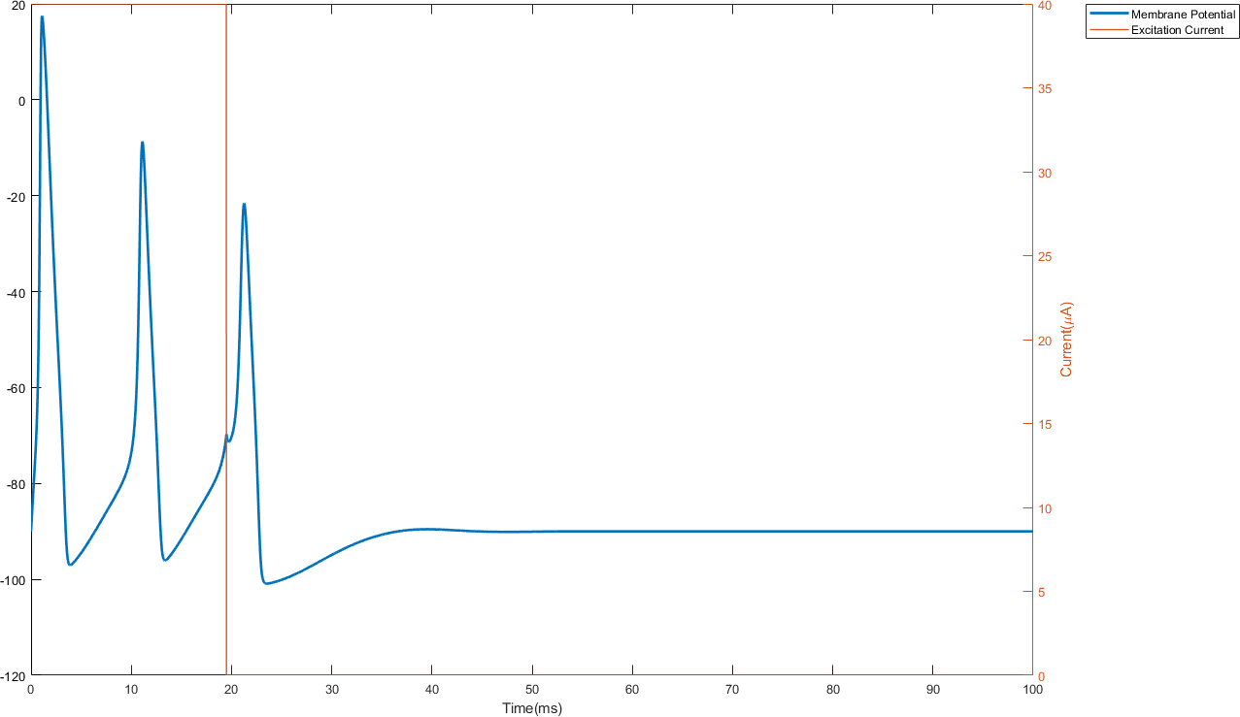

* + 1. Stimulation Time = 19.48ms (b) Stimulation Time = 19.5ms

Figure 5: Action Potential and Activation Threshold

Results indicated by Figure 5 may be used to investigate the action potential threshold of the implemented Hodgkin-Huxley model.

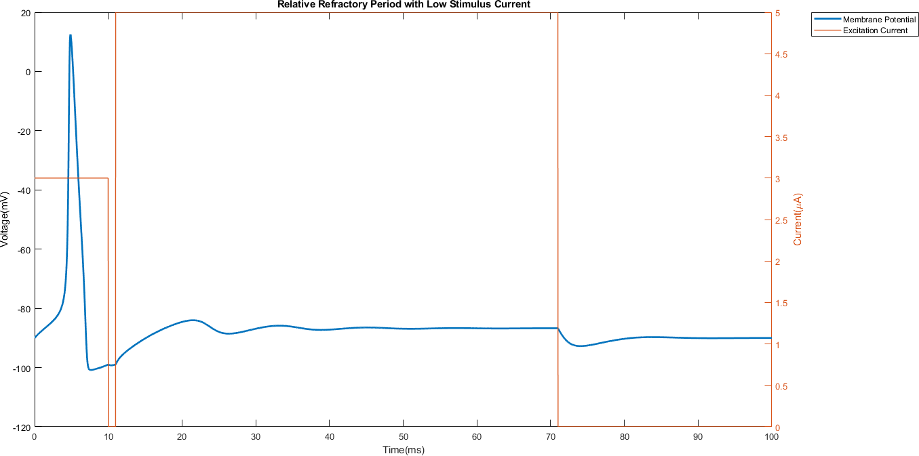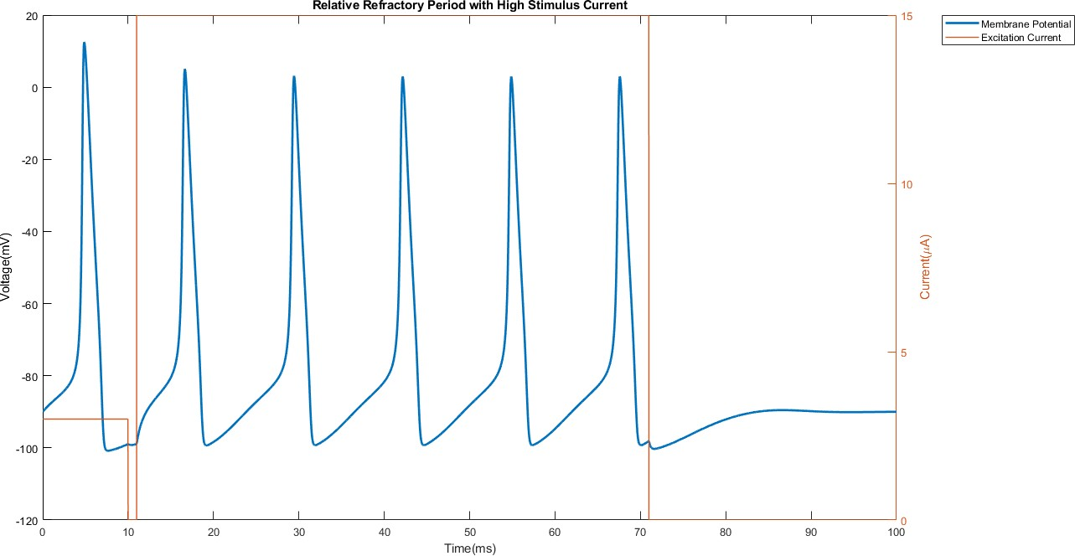

(a) Refractory Period with Low Stimulus (b) Refractory Period with High Stimulus

Figure 6: Refractory Period with High Stimulus

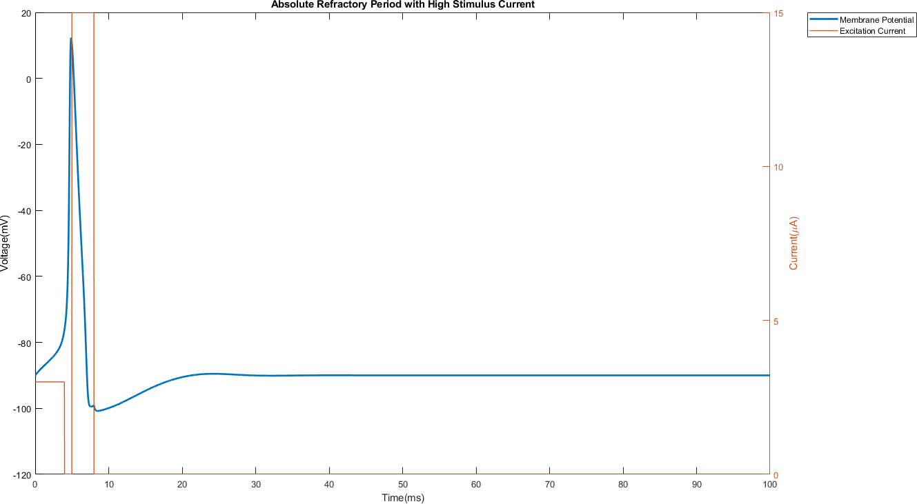

Figure 7: Absolute Refractory Period.

Figure 6 and 7 accurately summarize the difference between Relative and Absolute Refractory periods in terms re-excitability of the cell, based on the observation if the cell membrane potential reacts to stimulation or not.

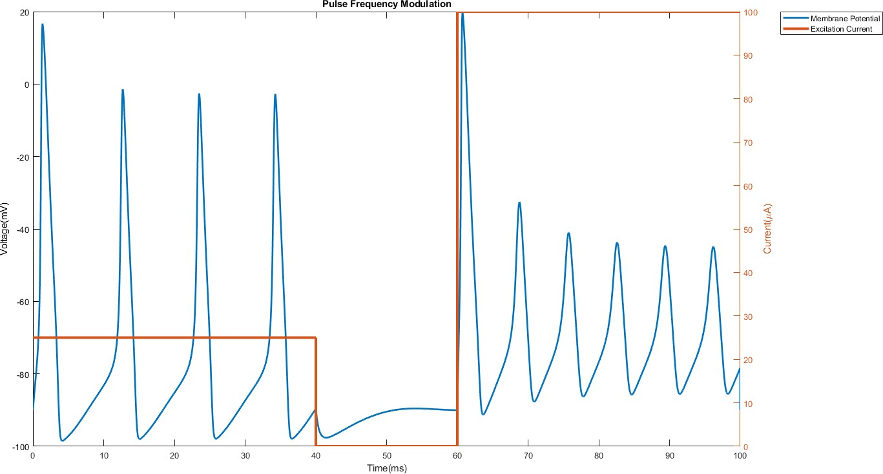

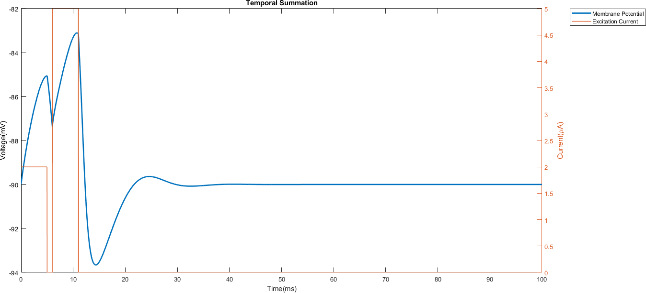 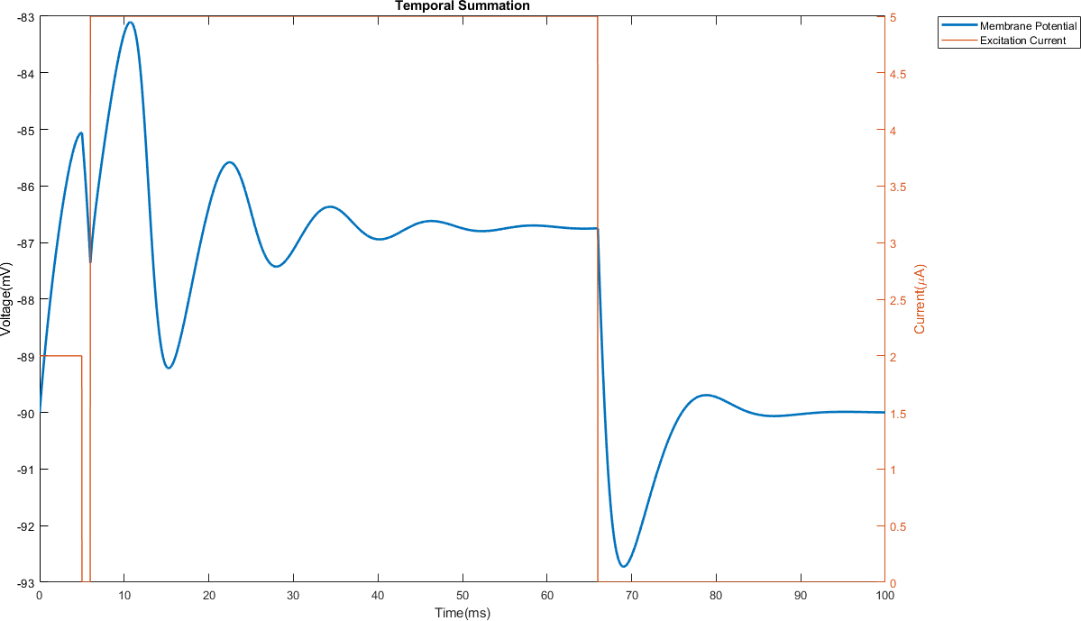

(a) Temporal summation: Short stimulus (b) Temporal summation: Long stimulus

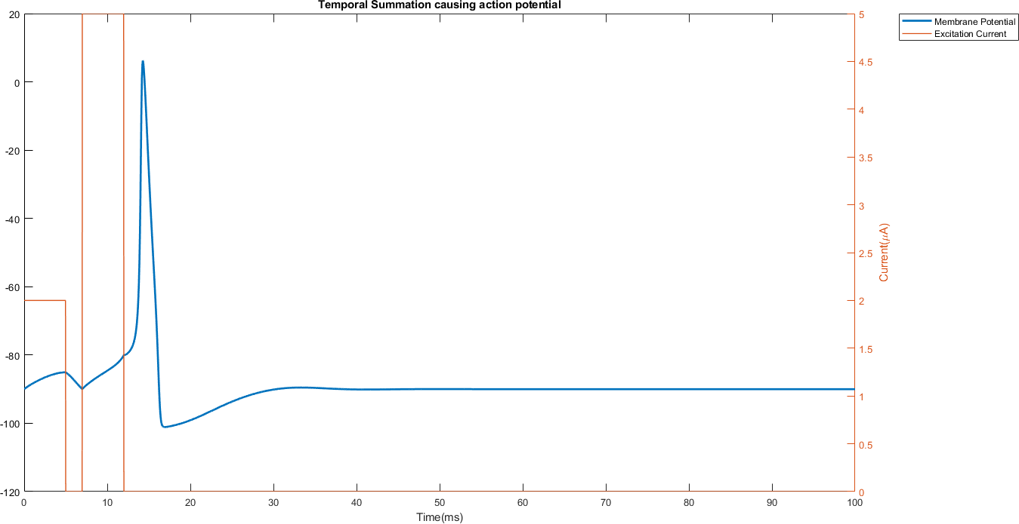Figure 8: An example Temporal Summation behavior

Figure 9: Consecutive Excitations cause temporal summation and action potential eventually.

Figure 10: Different excitations causing action potentials to occur in different frequencies.

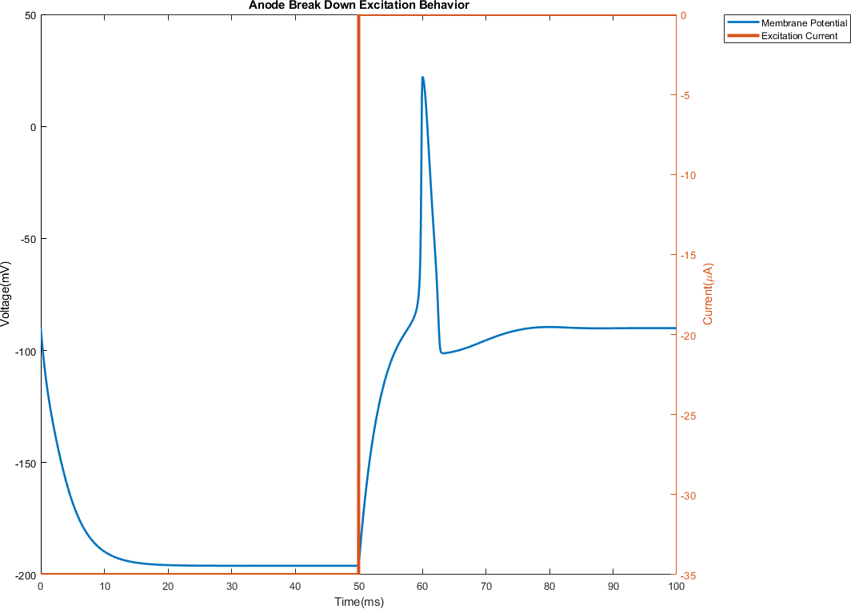

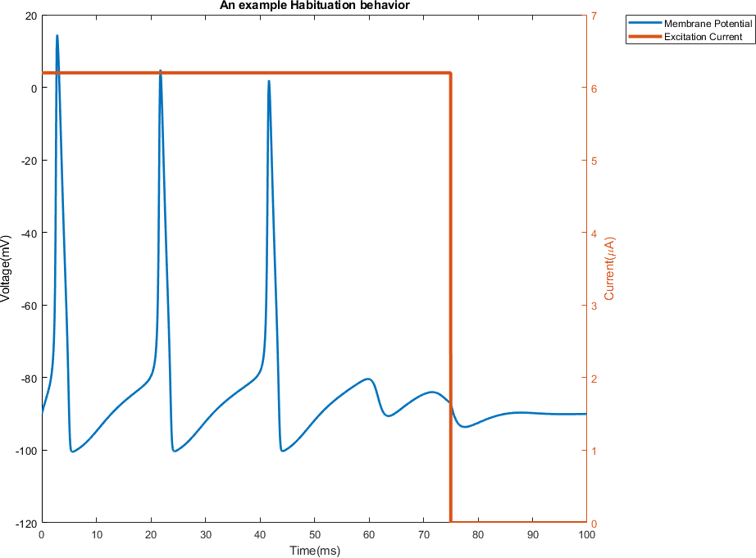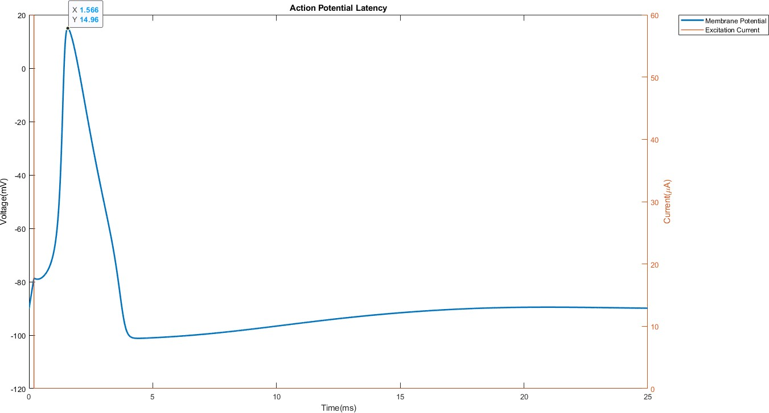Figure 11: Habituation Behavior

Figure 12: The latency between stimulus pulse and action potential.

Figure 13: Anode Breakdown excitation fires an action potential.

# Discussions

## Action Potential Threshold

The action potential threshold is defined as the voltage where the action potential cannot be stopped from occurring. In Figure 5, it is possi- ble to observe that the last increase in the mem- brane potential did not result in an action poten- tial generation. However, when stimulation time is increased to 0.02 ms more, the membrane poten- tial reaches around -80mV and the cell ignites an action potential, regardless of the presence of the stimulation.

## Relative Refractory Period

Refractory periods define the time segments where the cell lacks the capability of being re-excited tem- porarily. In the relative refractory period, the cells are not able to ignite action potential, unless they are excited with **abnormally high stimulus cur- rent**. In Figure 6, first a stimulus is applied to ignite an action potential, then in the hyperpolar- ization phase a stimulus of 5*µA* is applied again, causing almost no change in the membrane volt- age behavior. However, when this stimulation is repeated with three-fold increase in the second ex- citation, it is observed that this excitation was able to fire four consecutive action potentials. This con-

## Temporal Summation

The temporal summation behavior results from the successive excitations while the cell membrane voltage still is sub-threshold. In 8, two short con- secutive pulses are applied. The cell membrane voltage gets increases under the threshold, and it returns to its resting value once the excitation is over. Figure 8 b illustrates a longer second stimu- lus current duration and in this case, the cell mem- brane voltage can be observed to fluctuate around some value under the threshold. Once the excita- tion is cut, *Vmembrane* gets decreased to its resting value with some overshooting(hyperpolarization). Lastly, 9, illustrates a temporal summation behav- ior resulting in action potential. With the two ex- citation pulses, the membrane voltage was able to reach the action potential threshold.

## Pulse Frequency Modulation

The term **Pulse Frequency Modulation** is used to describe the changing spectral behavior of ac- tion potentials under excitations of different mag- nitude. *Figure 10* accurately illustrates this behav- ior. Although the 25*µA* excitation causes 4 action potential generations, 100*µA* stimulation results in 6 action potential generations, both in 40 millisec- onds of stimulation duration. This behavior can be explained by the following relations:

cludes that the hyperpolarization phase, where the second pulse was applied, is in the relative refrac- tory period.

*IC* = *Imembrane −* (*IK* + *INa* + *IL*)

= *Istimulation −* (*IK* + *INa* + *IL*)

(10)

## Absolute Refractory Period

∆*Vm*

= *IC · dt CMembrane*

(11)

Unlike relative refractory periods, the cells are not able to get stimulated with a stimulus in the ab- solute refractory period. This behavior is demon- strated in Figure 7. Although an abnormally high stimulus (See the relative refractory case.) is ap- plied to the cell membrane, the cell did not respond to the stimulation. Hence, one can conclude this stimulus is applied during the **Absolute Refrac- tory Period**, which is repolarization phase of the action potential cycle in this case.

Eqn. 11 implies that a higher stimulation current will result in a higher capacitive current, *IC*. Eqn. 10 tells us that a higher capacitive current will re- sult in a higher change in membrane potential in the same amount of time. Combining this infor- mation, one may conclude that, a higher stimulus current causes the subthreshold voltage to reach action potential threshold faster, and results in a faster action potential. Hence, we observe more action potentials generated with the higher excita- tion current in the same period of time.

## Habituation and Accommodation

Habituation behavior is characterized by the in- creased action potential threshold of the cell mem- brane when it is under continuous excitation. The scenario in Figure 11 describes this phenomenon accurately. In this scenario, the cell is excited by a stimulus of 6*.*25*µA* for a duration of 75 millisec- onds. At first, the cell fires 3 action potentials. However, although the subthreshold membrane be- havior looks quite similar, at the end of the fourth subthreshold voltage increase did not result in ac- tion potential. This can be explained by the in- creased action potential threshold when the cell is exposed to continuous excitation.

## Latency

The latency is described by the time difference be- tween the beginning of the excitation pulse and beginning of the action potential. In the exper- iment, whose results can be seen in 12, the cell was subjected to a 60*µA* excitation in a duration of 0.1 milliseconds. At the end of the excitation, there was an action potential. The latency can be observed to be around 0.2 milliseconds. This time is spent for membrane to reach action poten- tial threshold. In the electrical network equivalent, this time corresponds to the time required for the capacitor in the RC network to reach a potential of *Vthreshold − Vrest*.

## Anode Breakdown Excitation

In this experiment, the cell membrane is excited with a current in the reverse direction, character- ized by a negative amplitude, for a period of time, which can be seen in Figure 13. With this stimula- tion, the membrane voltage goes below the resting potential in an exponentially decaying characteris- tic and converges to some value around -200 mV. When the excitation is cut, the cell membrane in- creases towards the resting potential. However, the decreasing speed of increase in the potential is not enough to make membrane potential con- verge to the resting potential, so an overshoot oc- curs. Since the overshoot is larger than 10mV, the value required to reach action potential threshold from the resting potential, the cell generates an action potential. After action potential, the usual cell behavior is observed with the hyperpolariza- tion phase and convergence to resting potential.

# Appendix

## Simulation Code

1 f u n c t i o n [ time , V_membrane , I_d , I_C, I_Na , I_K, I_L , g_Na, g_K, g_L] = HHSimulate ( num_exc , durations , delay , amplitude , i f _p l o t )

2 %% Hyperparams

3 simulation_time_in_samples = 1 e5 ;

4 dt = 1 e −3;

5

6 %% Constants

7 % Current w i l l be in microamperes , time w i l l be in msec , hence c a p a c i ta n c e must

8 % be in Farads

9

10 C_m = 1 ;

11 % mV %

12 E_Na = −115; %Sodium nernst i s p o s i t i v e

13 E_K = 1 2 ;

14 E_l = − 10 .613 ;

15 % mS

16 g_na_bar = 120 ;

17 g_k_bar = 3 6 ;

18 g_l_bar = 0 . 3 ;

19

20 % Resting r e f e r e n c e d Nernst p o t e n t i a l c o r r e c t i o n s

21 V_rest = −90;

22 E_Na = V_rest − E_Na;

23 E_l = V_rest − E_l ;

24 E_K = V_rest − E_K;

25

26 %% Vector I n i t i a l i z a t i o n s

27 vm = z e r o s ( 1 , simulation_time_in_samples ) ;

28 Delta_vm = z e r o s ( s i z e (vm) ) ;

29

30 %% Desing s t i m u l a t i o n

31 i f i s c h a r ( num_exc)

32 num_exc = s tr 2 d o u b l e ( num_exc) ;

33 end

34 e xc i ta t i o n _c u r r e n t = amplitude ; %uA

35 I_d = z e r o s ( s i z e (vm) ) ;

36 i f num_exc == 1

37 duration_in_sample = d u r a t i o n s ( 1 ) / dt ;

38 I_d ( 1 : duration_in_sample ) = e xc i ta t i o n _c u r r e n t ( 1 ) ;

39 e l s e

40 duration1_in_sample = d u r a t i o n s ( 1 ) / dt ;

41 duration2_in_sample = d u r a t i o n s ( 2 ) / dt ;

42 delay_in_sample = delay / dt ;

43 I_d ( 1 : duration1_in_sample ) = e xc i ta t i o n _c u r r e n t ( 1 ) ;

44 I_d ( duration1_in_sample+delay_in_sample : duration1_in_sample+ delay_in_sample+duration2_in_sample ) = e xc i ta t i o n _c u r r e n t ( 1 ) ;

45 i f l ength ( e xc i ta t i o n _c u r r e n t ) == 2

46 I_d ( duration1_in_sample+delay_in_sample : duration1_in_sample+ delay_in_sample+duration2_in_sample ) = e xc i ta t i o n _c u r r e n t ( 2 ) ;

47 end

48 end

49

50

51

52 % Currents

53 I_Na = z e r o s ( s i z e (vm) ) ;

54 I_K = z e r o s ( s i z e (vm) ) ;

55 I_L = z e r o s ( s i z e (vm) ) ;

56 I_C = z e r o s ( s i z e (vm) ) ;

57 I_total = z e r o s ( s i z e (vm) ) ;

58

59 [ a_mi , b_mi , a_hi , b_hi , mi , tau_m , hi , tau_h ] = calculate_na_params ( 0 ) ;

60 [ a_ni , b_ni , ni , tau_n ] = calculate_k_params ( 0 ) ;

61

62 n = ni ∗ ones ( s i z e (vm) ) ;

63 m = mi∗ ones ( s i z e (vm) ) ;

64 h = hi ∗ ones ( s i z e (vm) ) ;

65

66 % Channel Conductances

67 g_Na = g_na_bar∗mi^3∗ hi ∗ ones ( s i z e (vm) ) ;

68 g_K = g_k_bar∗ ni ^4∗ ones ( s i z e (vm) ) ;

69 g_L = g_l_bar∗ ones ( s i z e (vm) ) ;

70

71 a_n = a_ni∗ ones ( s i z e (vm) ) ;

72 a_m = a_mi∗ ones ( s i z e (vm) ) ;

73 a_h = a_hi∗ ones ( s i z e (vm) ) ;

74 b_n = b_ni∗ ones ( s i z e (vm) ) ;

75 b_h = b_hi∗ ones ( s i z e (vm) ) ;

76 b_m = b_mi∗ ones ( s i z e (vm) ) ;

77

78 %% Define V_membrane

79

80 V_membrane = V_rest∗ ones ( s i z e (vm) ) ;

81

82

83 %% Action p o t e n t i a l

84 f o r i = 1 : simulation_time_in_samples −1

85

86 V_membrane( i ) = vm( i ) + V_rest ;

87

88 % Ca l c u l a te conductances

89 g_Na( i ) = g_na_bar∗m( i ) ^3∗h ( i ) ;

90 g_K( i ) = g_k_bar∗n ( i ) ^ 4 ;

91 g_L( i ) = g_l_bar ; % does not change

92

93 % Ca l c u l a te c u r r e n ts

94 I_Na( i ) = g_Na( i ) ∗ ( V_membrane( i )−E_Na) ;

95 I_K( i ) = g_K( i ) ∗ ( V_membrane( i )−E_K) ;

96 I_L( i ) = g_L( i ) ∗ ( V_membrane( i )−E_l) ;

97 I_C( i ) = I_d ( i ) − ( I_Na( i ) + I_K( i ) + I_L( i ) ) ;

98 I_total ( i ) = I_d ( i ) ;

99

100 % update vm

101 Delta_vm ( i ) = dt ∗ I_C( i ) / C_m;

102 vm( i +1) = vm( i ) + Delta_vm ( i ) ;

103

104 % c a l c u l a t e params

105 [a_m( i ) ,b_m( i ) ,a_h( i ) ,b_h( i ) , ~ , mi , ~ , hi ] = calculate_na_params (vm( i ) ) ;

106 [ a_n( i ) ,b_n( i ) , ni , ~ ] = calculate_k_params (vm( i ) ) ;

107

108 % s e t m, n , h

109 m( i +1) = m( i ) + dt ∗ (a_m( i ) ∗( 1 − m( i ) ) − b_m( i ) ∗m( i ) ) ;

110 n ( i +1) = n ( i ) + dt ∗ ( a_n( i ) ∗( 1 − n ( i ) ) − b_n( i ) ∗n ( i ) ) ;

111 h ( i +1) = h ( i ) + dt ∗ ( a_h( i ) ∗( 1 − h ( i ) ) − b_h( i ) ∗h ( i ) ) ;

112

113 end

114 time = [ 1 : simulation_time_in_samples ] ∗ dt ;

115 i f i f _p l o t == 1

116 % f i g u r e

117 p l o t ( time , V_membrane , ’ LineWidth ’ , 2 )

118 y l a b e l ( ’ Voltage (mV) ’ )

119 hold on

120 yyaxis r i g h t

121 p l o t ( time , I_d , ’ LineWidth ’ , 3 )

122 y l a b e l ( ’ Current ({\mu}A) ’ )

123 x l a b e l ( ’ Time ( ms) ’ )

124 l egend ( ’ Membrane Po te n t i a l ’ , ’ Exc i ta t i o n Current ’ , ’ Location ’ , ’ n o r th e a s to u t s i d e ’ )

125 end

126

127 end

# References

1. A. F. Huxley A. L. Hodgkin. “A quantitative description of membrane current and its application to conduction and excitation in nerve”. In: *The Journal of Physiology* 117.4 (1952), pp. 500–544.
2. Biomodels. *Hodgkin and Huxley (1952), Membrane Current in the Giant Squid Axon*. [Online; accessed May 16, 2021]. url: [https://www.ebi.ac.uk/biomodels-static/ModelMonth/2006-09/Hodgkin1.](https://www.ebi.ac.uk/biomodels-static/ModelMonth/2006-09/Hodgkin1.png) [png](https://www.ebi.ac.uk/biomodels-static/ModelMonth/2006-09/Hodgkin1.png).
3. Swarthmore. *Membrane Equivalent Circuit*. [Online; accessed May 16, 2021]. 2004. url: [https://www.](https://www.swarthmore.edu/NatSci/echeeve1/Ref/HH/Circuit.GIF) [swarthmore.edu/NatSci/echeeve1/Ref/HH/Circuit.GIF](https://www.swarthmore.edu/NatSci/echeeve1/Ref/HH/Circuit.GIF).