══════════════════════════════════════════════════════════════
DEPARTMENT OF COMPUTER SCIENCE & ENGINEERING
LABORATORY OBSERVATION
══════════════════════════════════════════════════════════════
Student Name: K SUHAS VARMA
Roll No: A24126552091
Branch & Sec: CSM-B
Date of Execution: 02 / 08 / 2026
Course Name: Full Stack Web Development
Course Code: 23CM4121

────────────────────────────────────────────────────────────────
EXPERIMENT NO: 2
────────────────────────────────────────────────────────────────

1. TITLE OF THE EXPERIMENT:
Implementation of HTML5 Canvas Graphics and CSS3 Styling Concepts

2. MAPPED OUTCOMES:
• Course Outcome (CO): CO1
• Program Outcomes (POs): PO1, PO2, PO3, PO4, PO5

3. AIM:
To design and implement a modern, responsive webpage titled "My Styled Webpage" demonstrating CSS3 styling properties and HTML5 Canvas.
4. ALGORITHM / DESIGN:
Algorithm: Design of My Styled Webpage
Step 1: Document Structure & CSS3 Reset — Initialize HTML5 template with <meta name="viewport"> and set up global reset (margin: 0, padding: 0, box-sizing: border-box). Apply a linear gradient background and Flexbox layout to <body>.

Step 2: Header & Navigation Bar — Create <header> with text shadows and deep background color. Add <nav> using horizontal Flexbox layout with anchor links featuring smooth CSS hover background-color transitions.

Step 3: HTML5 Canvas Section (Part A) — Add a <canvas> element inside a centered container card. Use JavaScript (getContext('2d')) to draw a filled rectangle (fillRect), a colored circular arc (arc, fill), a horizontal line (moveTo, lineTo), and custom centered text (fillText).

Step 4: Responsive Cards Grid (Part B) — Implement a CSS Grid container (repeat(auto-fit, minmax(280px, 1fr))) to display three content <article> cards. Apply border-radius, box-shadow, and smooth hover elevation effects (transform: translateY) to cards and interactive buttons.

Step 5: Footer & Closing — Add a <footer> with copyright information and a styled top border, then close all HTML tags.
5. TEST CASES & EXECUTION DATA:
────────────────────────────────────────────────────────────────
Test Cases (Validation & UI Verification)
- TC-01: Input: Load the webpage in a modern web browser
Expected: Background displays a smooth diagonal linear gradient and header renders with drop shadows | Status: Passed

- TC-02: Input: Hover cursor over navigation bar links
Expected: Background smoothly transitions to #1abc9c with white text | Status: Passed

- TC-03: Input: Execute JavaScript Canvas API rendering script
Expected: Canvas displays a green filled rectangle, orange filled circle, red horizontal line, and centered text ("Suhas") | Status: Passed

- TC-04: Input: Hover cursor over individual content cards
Expected: Card elevates vertically (translateY(-5px)) with expanded shadow depth | Status: Passed

- TC-05: Input: Hover cursor over ".btn" action buttons
Expected: Button background darkens and scales smoothly | Status: Passed

- TC-06: Input: Resize browser viewport across different screen widths
Expected: CSS Grid automatically reflows content cards into single or multi-column layouts responsively | Status: Passed
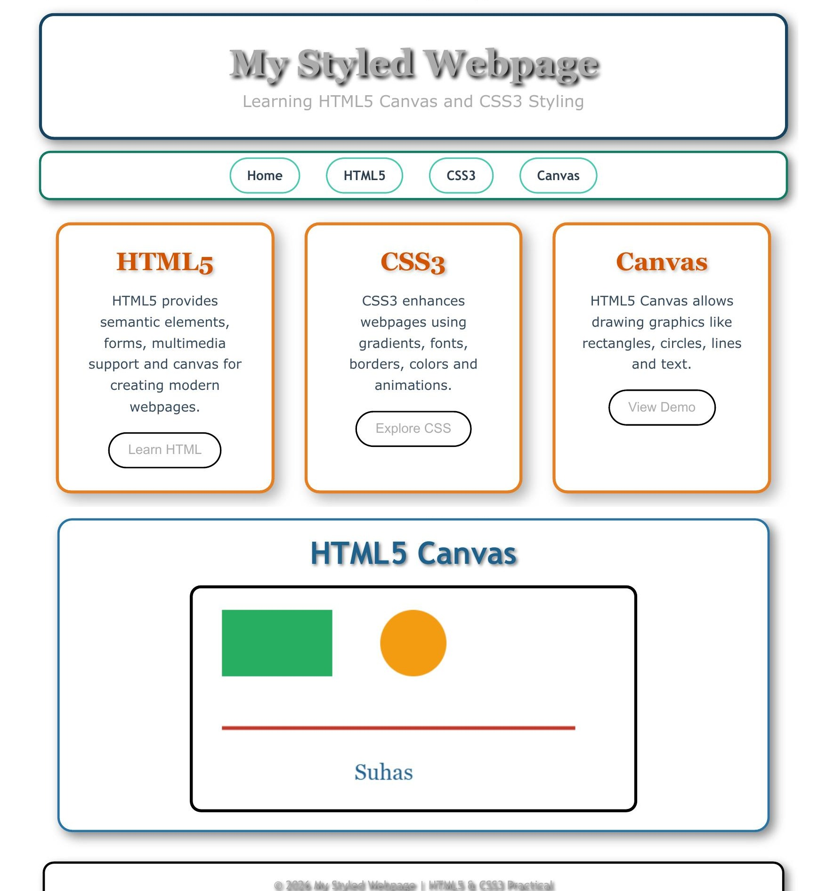
────────────────────────────────────────────────────────────────
6. OUTPUT PROOF:

Github Link:
https://github.com/kutcherlapatisuhasvarma24/FS_LAB/tree/e4a3cb0ffd8e271a29d398159202ea1f6224db73/FS_LAB/lab_obv/Task_2
7. LEARNING OUTCOME / RESULT: Successfully implemented and verified the styling and graphics script. Learned how to enhance static web pages with modern CSS3 visual techniques (CSS Grid, Flexbox, transitions, pseudo-classes, gradients) and dynamically render 2D geometric shapes and text using the HTML5 <canvas> API and JavaScript context.

══════════════════════════════════════════════════════════════
RUBRIC EVALUATION (Faculty Use Only)
══════════════════════════════════════════════════════════════

1. Design & Logic (5 Marks):
2. Execution & Output (5 Marks):
3. Viva & Record (5 Marks):
────────────────────────────────────────────────────────────────
TOTAL MARKS: [ / 15 ]
Faculty Signature: _______________

