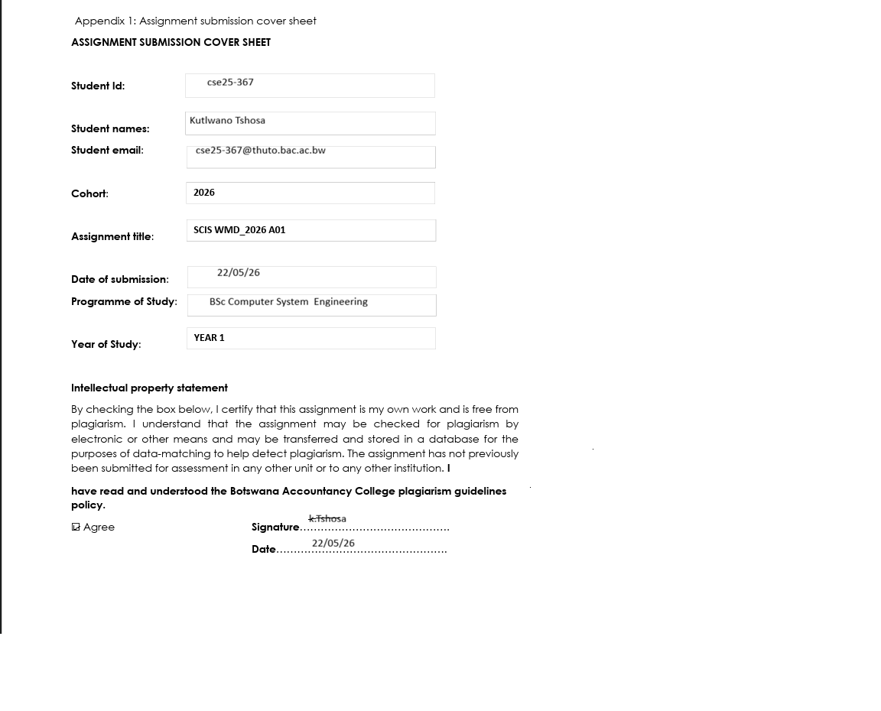

SpeedWave Internet - Technical Specification, Architectural Design, and Site Documentation
Website specification
SpeedWave is a high-performance digital storefront representing Gaborone's leading unlimited fiber provider. Built as a responsive, multi-page web platform, the site communicates brand prestige, highlights package offerings, and facilitates active engagement. The website consists of seven interconnected core pages:
- index.html (Home): Features a showcase, live speed test connection simulator, and dynamic monthly/annual pricing toggles.
- htmls/residential.html (Residential): Offers tiered home packages (Basic, Popular, Pro) with discount toggle hooks.
- htmls/business.html (Business): Showcases high-end symmetric solutions and includes an interactive staff count plan recommendation tool.
- htmls/check.html (Check Coverage): Integrates a multi-step diagnostic availability form.
- htmls/payment.html (Secure Payment): Includes a mock transactional authorization module and dynamic query param pre-loader.
- htmls/support.html (Customer Support): Houses a 24/7 technical hotline and a dynamic multi-topic troubleshooting wizard.
- htmls/about.html (About Us): Highlights company core values and includes animated statistic trackers (uptime, active users, latency) triggered on load.

Target market
SpeedWave Internet targets three main market segments in Gaborone:
- Suburban Households: Families seeking stable, unlimited bandwidth for multi-screen 4K streaming, remote education, and home entertainment.
- Remote Professionals & Gamers: Power users requiring ultra-low latency, symmetric speeds, and zero bandwidth capping for gaming, content creation, and stable virtual conferencing.
- Gaborone Business Enterprises: SMEs and corporate entities requiring symmetric high-bandwidth lines, dedicated static IPs, strict Service Level Agreements (SLAs), and 24/7 proactive technical service.
Demography
The demographic profile covers residential and enterprise clients in Gaborone:
- Geography: Residents, cafes, shops, and offices located in Gaborone and neighbouring extensions.
- Age & Occupation: Young adults, tech-savvy parents, gamers, digital creators, and business executives aged 18 to 60.
- Enterprise Size: Small startup hubs (1-15 staff) up to large corporate headquarters (50+ staff).
workflow
The user workflow represents the sequential navigation of a customer from discovery to payment:
1. Site Discovery: User lands on Home Page to browse features and runs the live speed test simulator.
2. Coverage Check: User navigates to Check Coverage and inputs their Gaborone address.
3. Plan Recommendation: Business clients use the recommendation tool to highlight the appropriate card.
4. Transaction: User selects a plan, fills payment details, and undergoes secure authorization to generate an invoice receipt.
5. Tech Support: Existing clients resolve connectivity issues using the troubleshooting wizard or request field visits.
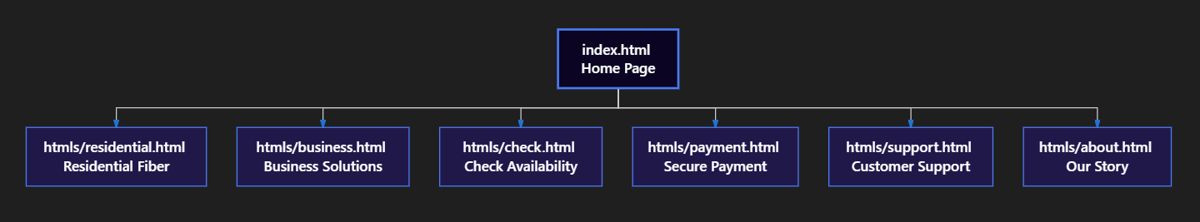
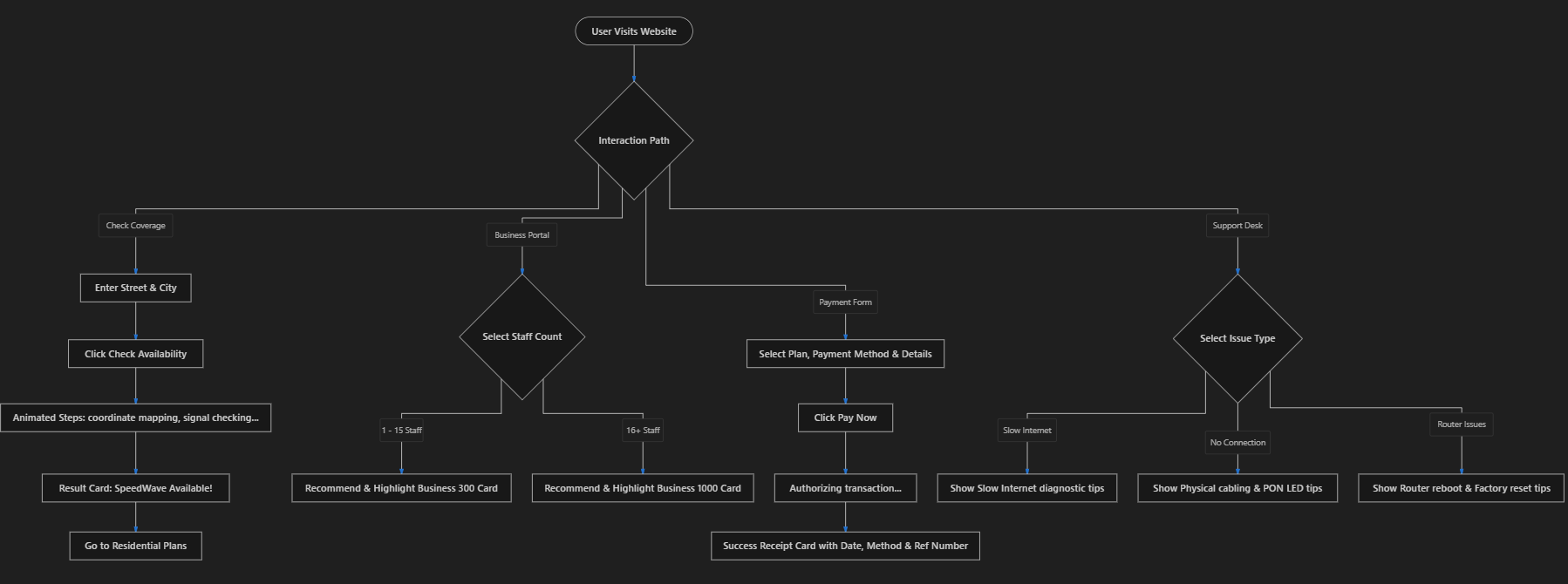
Diagram Description: The Site Map illustrates the flat navigation layout allowing one-click transitions from index.html. The Interaction Flowchart shows the client-side JavaScript logic managing coverage loading steps, staff choice highlights, payment processing, and troubleshooting updates.
Design and Wireframe
The design focuses on modern tech-brand layouts. It uses deep dark blues for premium background blocks, crisp white containers for high-contrast reading, and symmetric grids to balance columns. Low-fidelity wireframes illustrate the skeletal alignment, elements structure, and image placements before presentation styling:
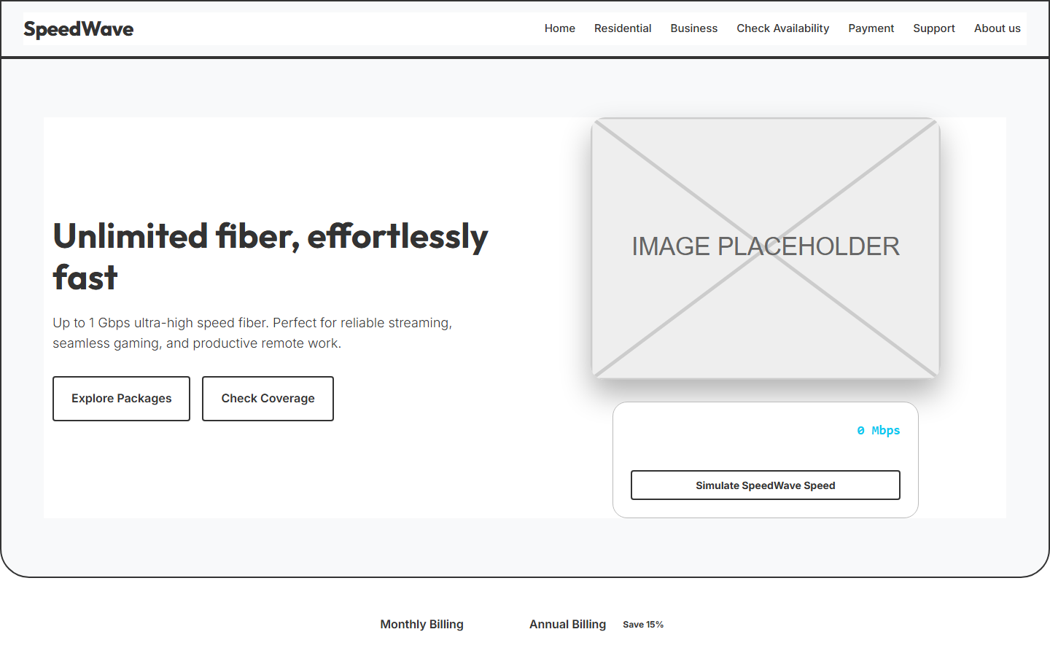
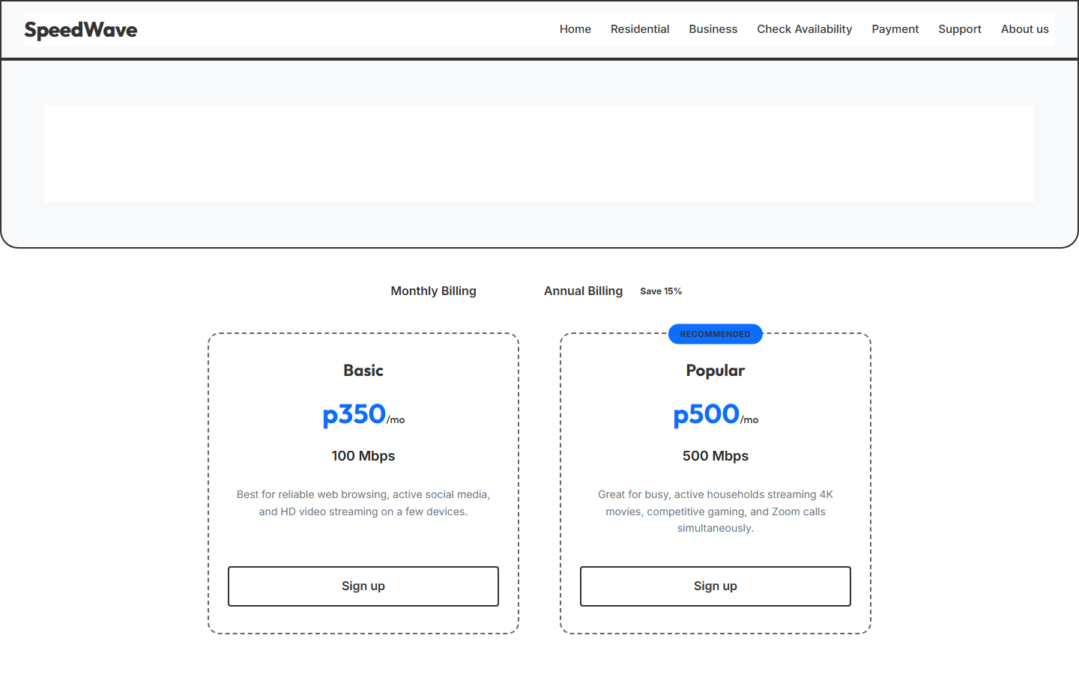
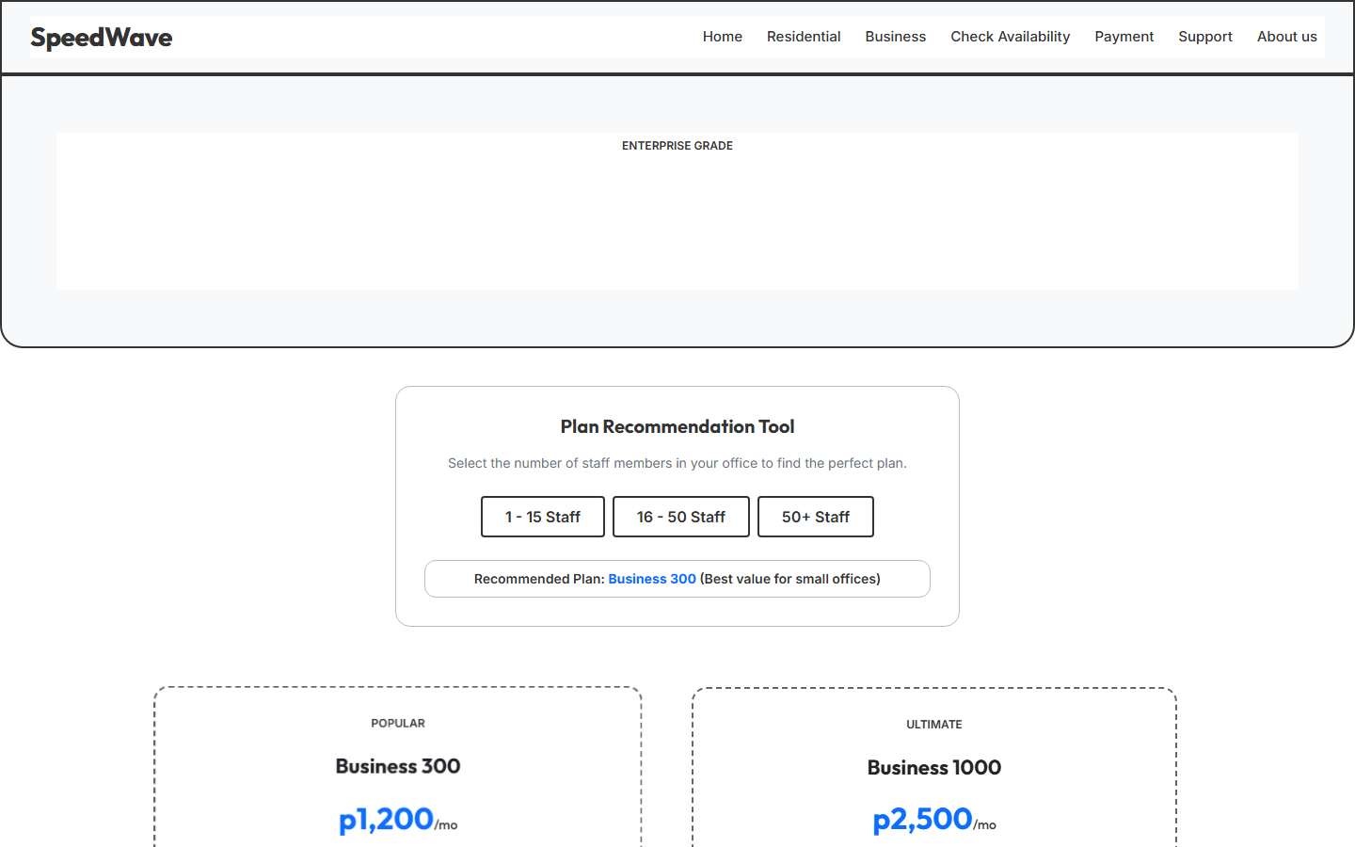
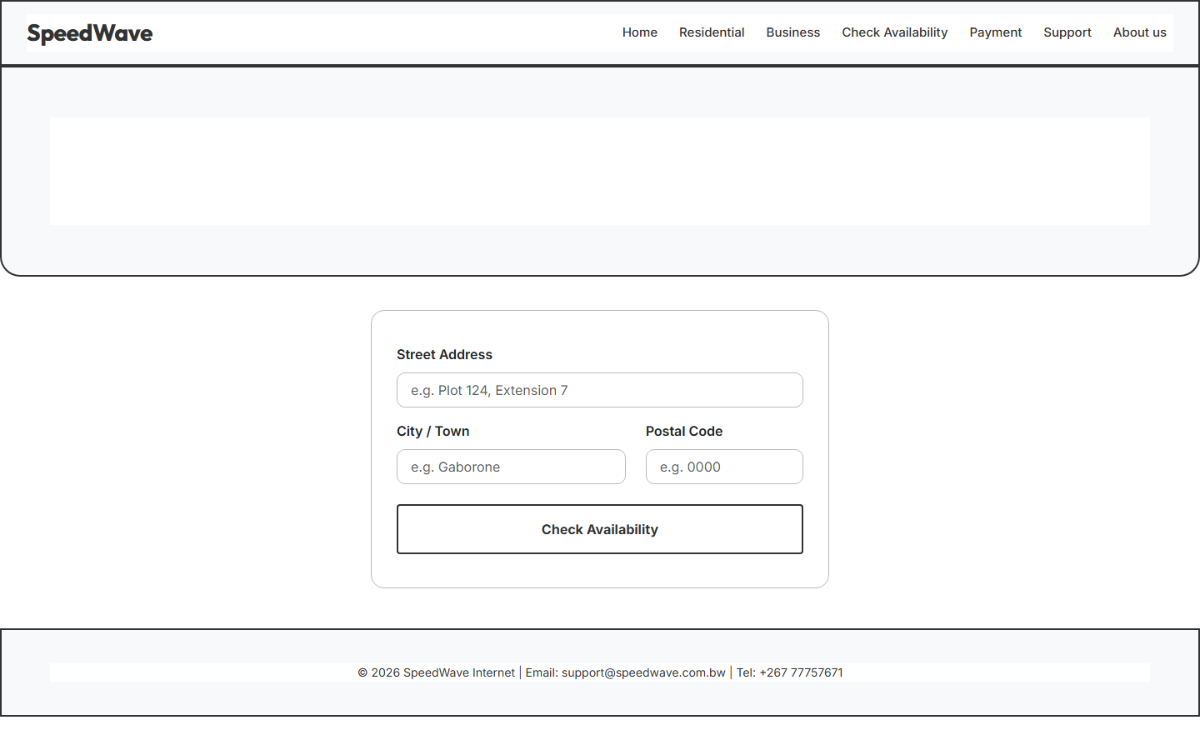
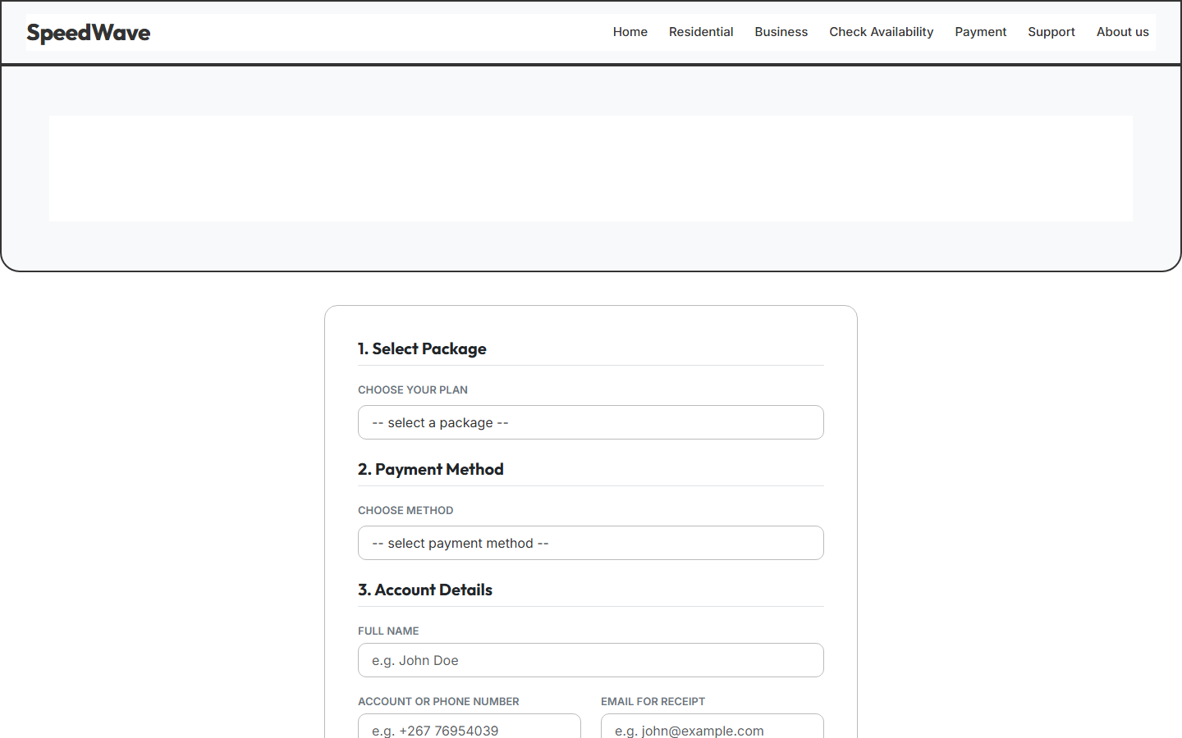
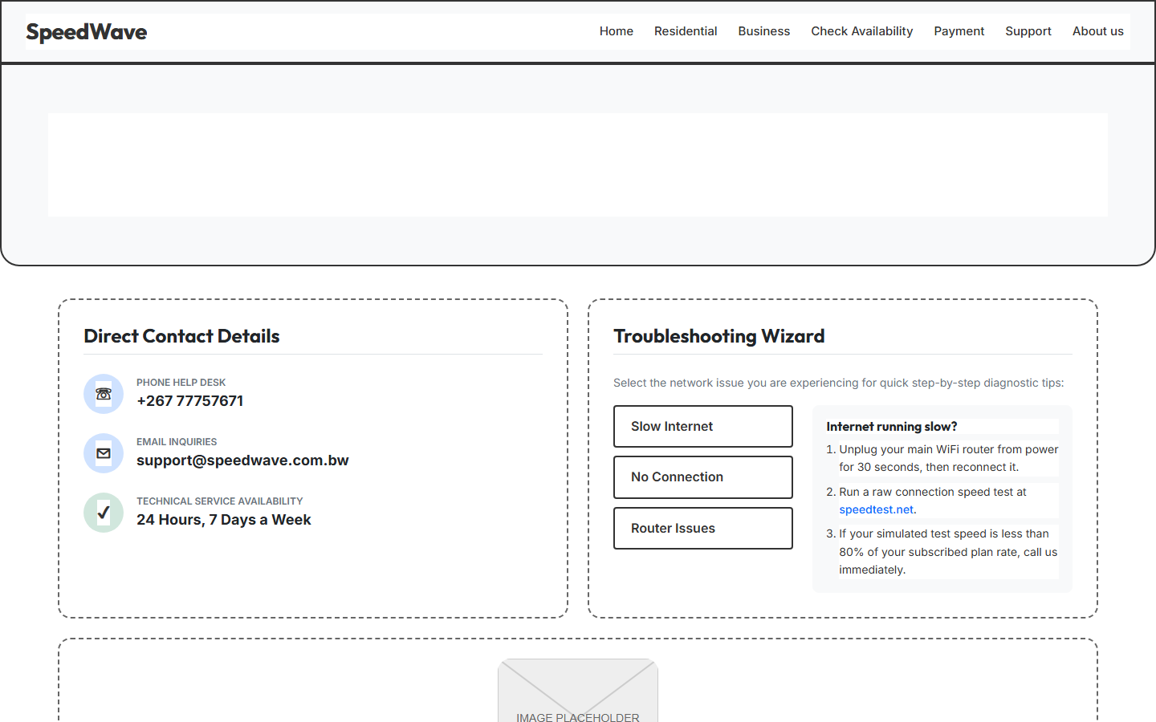
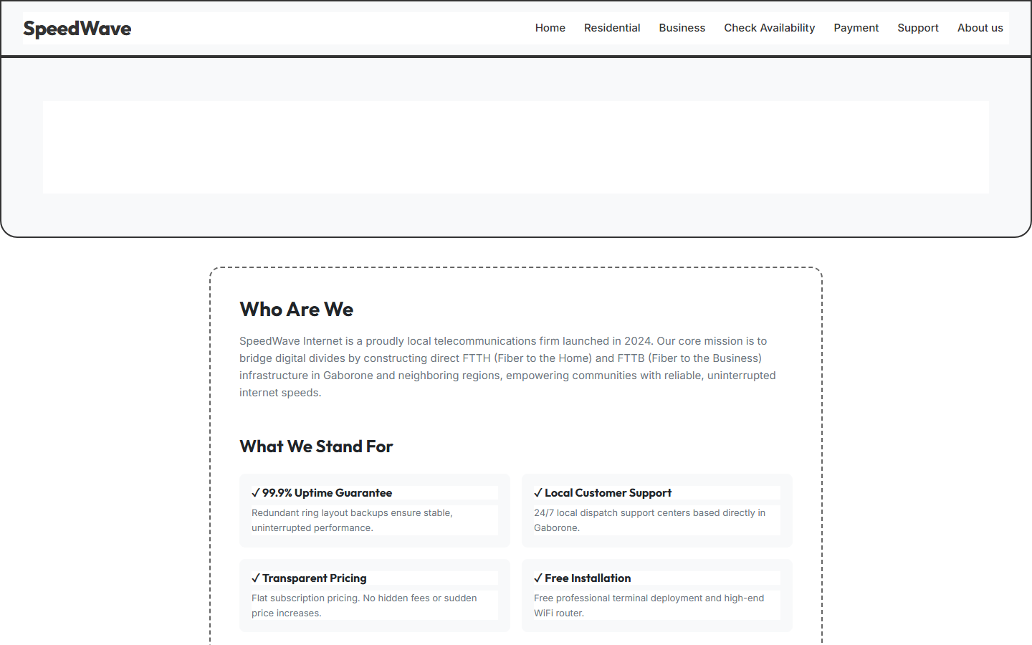
Wireframe Layouts: The wireframes highlight structural outlines: a fixed top navigation banner, a large hero showcase with action anchors, three-column pricing grids, dual-column contact details, and centred modular forms with outline buttons.

Html 5-layer snippets from the code and explanation
The HTML5 structural architecture leverages clean semantic elements. The sticky-top navigation header represents a shared, reusable layout that stays fixed during page scrolling, ensuring consistent brand visibility and quick accessibility.
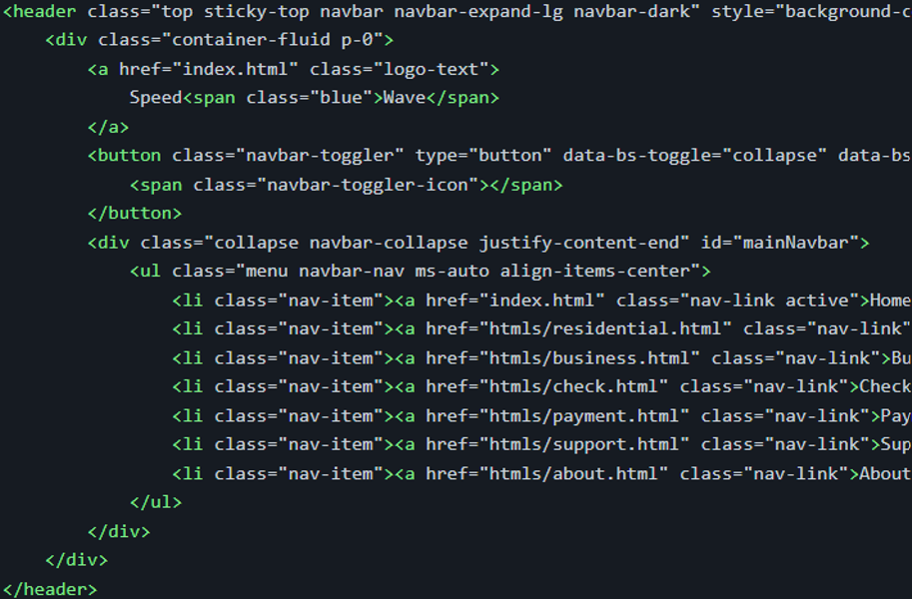
HTML5 Implementation: The structural layer integrates a Bootstrap-based responsive header (.top). It encapsulates the brand-logo, an interactive navbar-toggler button for smaller viewports, and a list of structural nav-links. The semantic layout ensures that screen readers and search engines index the website navigation.
CSS snippet from the code and explanation
The visual presentation utilizes standard, custom CSS classes to achieve micro-animations that make the site feel responsive and premium.
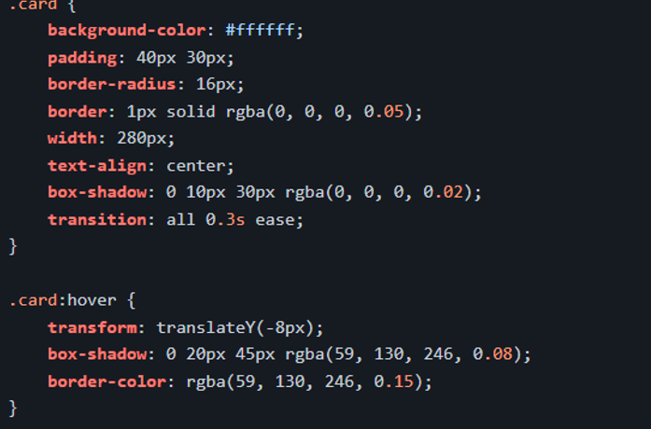
CSS3 Implementation: The card class uses absolute transitions (all 0.3s ease) to control translation speeds. When hovered, the card rises vertically by 8px (transform: translateY(-8px)), displays a warm hover shadow (rgba(59, 130, 246, 0.08)), and highlights its border in accent blue to provide interactive visual feedback.
Bootstrap snippets from the code and explanation
Bootstrap v5.3.3 classes are used to establish fluid, mobile-first columns, layout spacing, and badges.
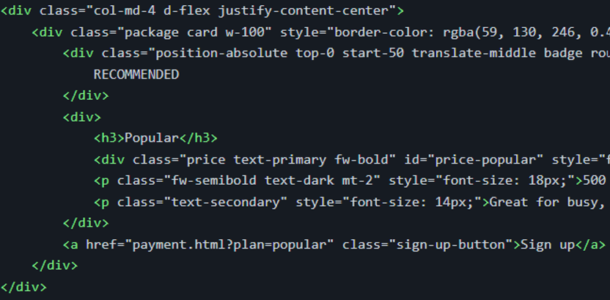
Bootstrap Implementation: The grid system employs the responsive flex wrapper class (col-md-4 d-flex) to distribute pricing cards equally. It utilizes absolute positioning utility wrappers (position-absolute top-0 start-50 translate-middle) to center high-contrast visual badges (bg-primary rounded-pill) dynamically above the popular plan.

JavaScript snippets from the code and explanation
JavaScript handles local state changes, connection simulation, plan highlights, and dynamic loaders asynchronously.
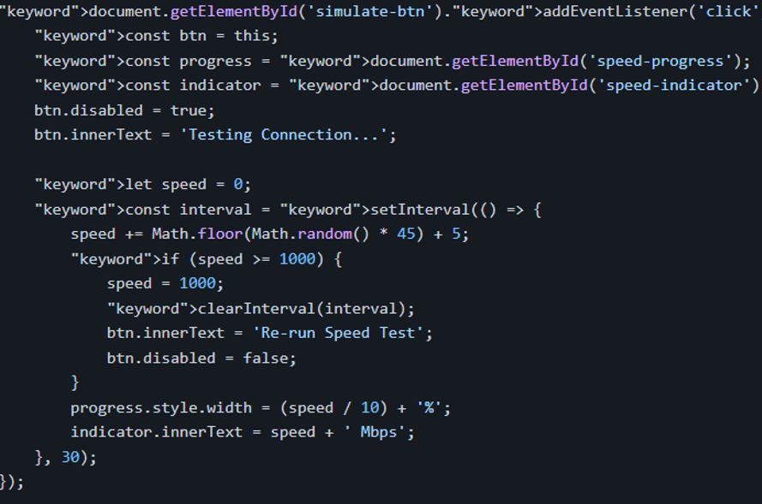
JavaScript Implementation: The connection speed test uses an event listener to intercept simulated clicks. It disables the button to prevent double-clicks, triggers an interval loop (setInterval) that increments speeds by random rates every 30ms, shifts the progress bar width accordingly, and updates the text indicator dynamically until it hits the 1 Gbps limit.
Quality testing
SpeedWave underwent comprehensive responsive tests across standard mobile (375x812), tablet (768x1024), and desktop (1440x900) resolutions. Layout components, forms, and buttons scale smoothly:
Laptop Testing:
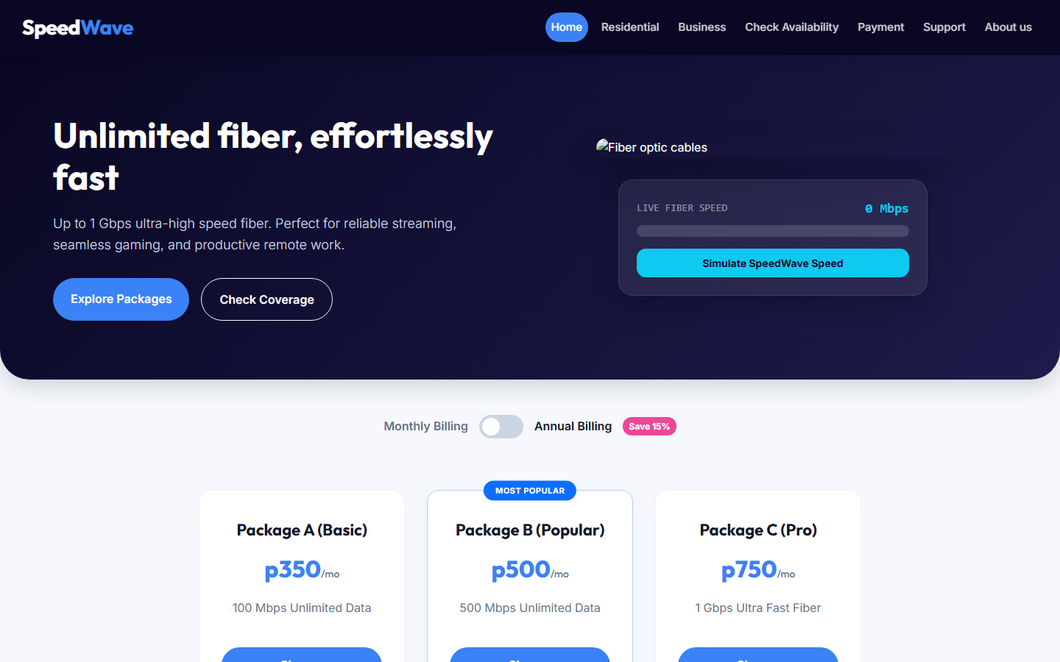
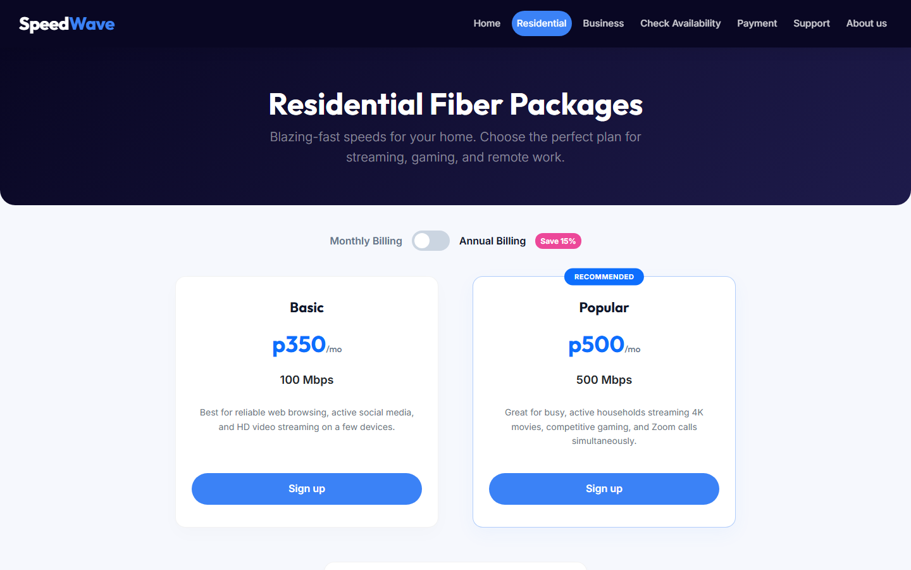
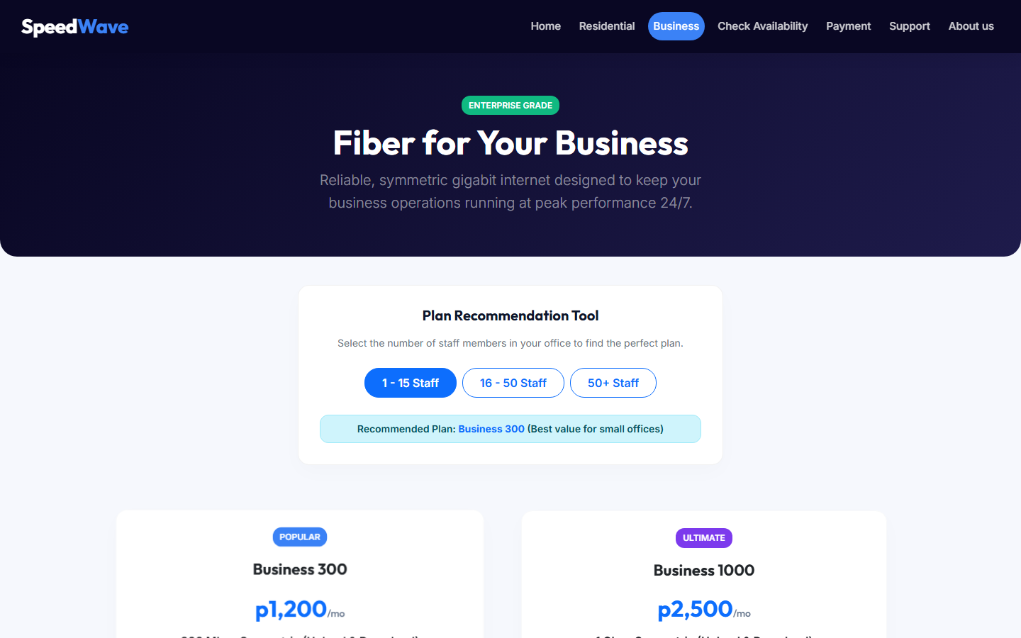
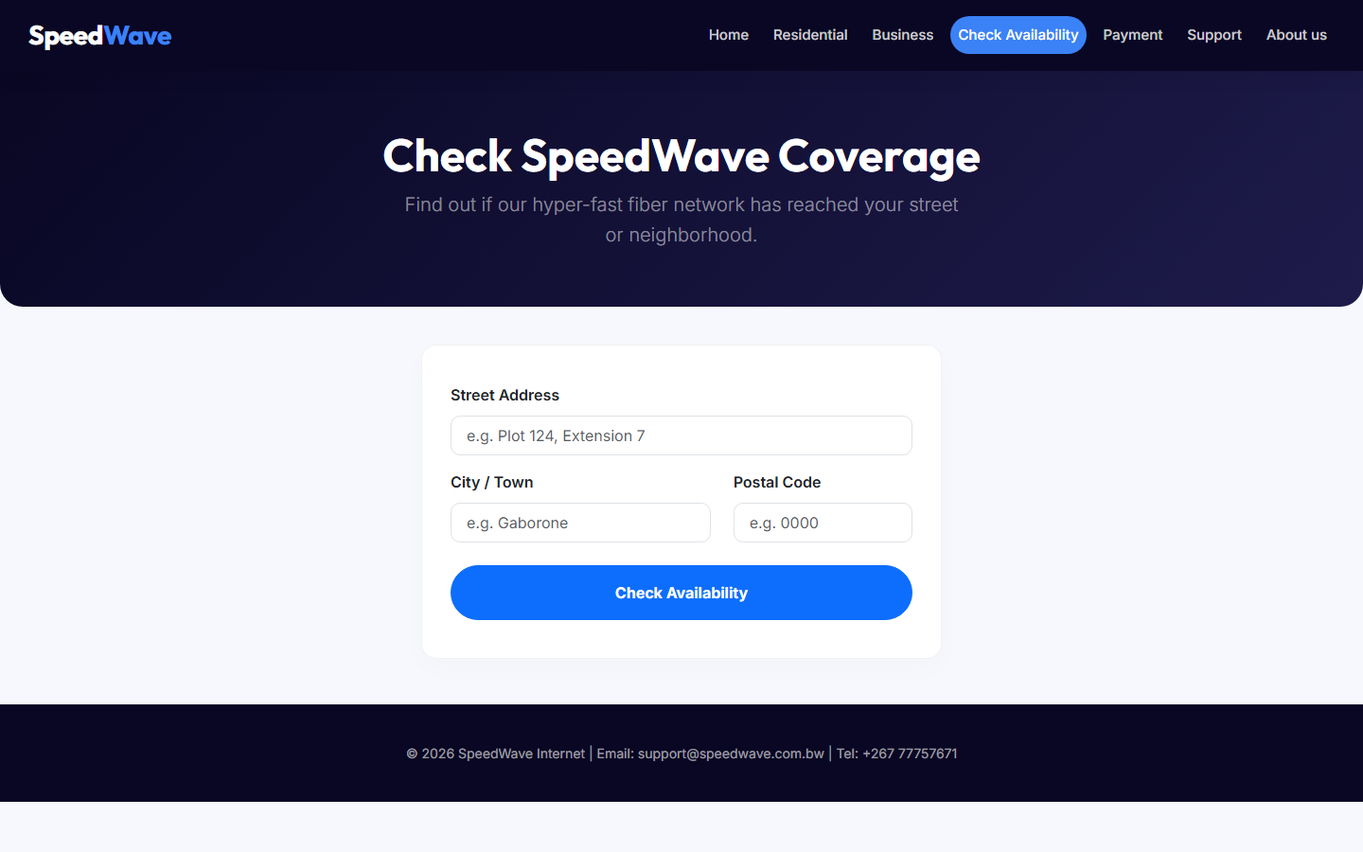
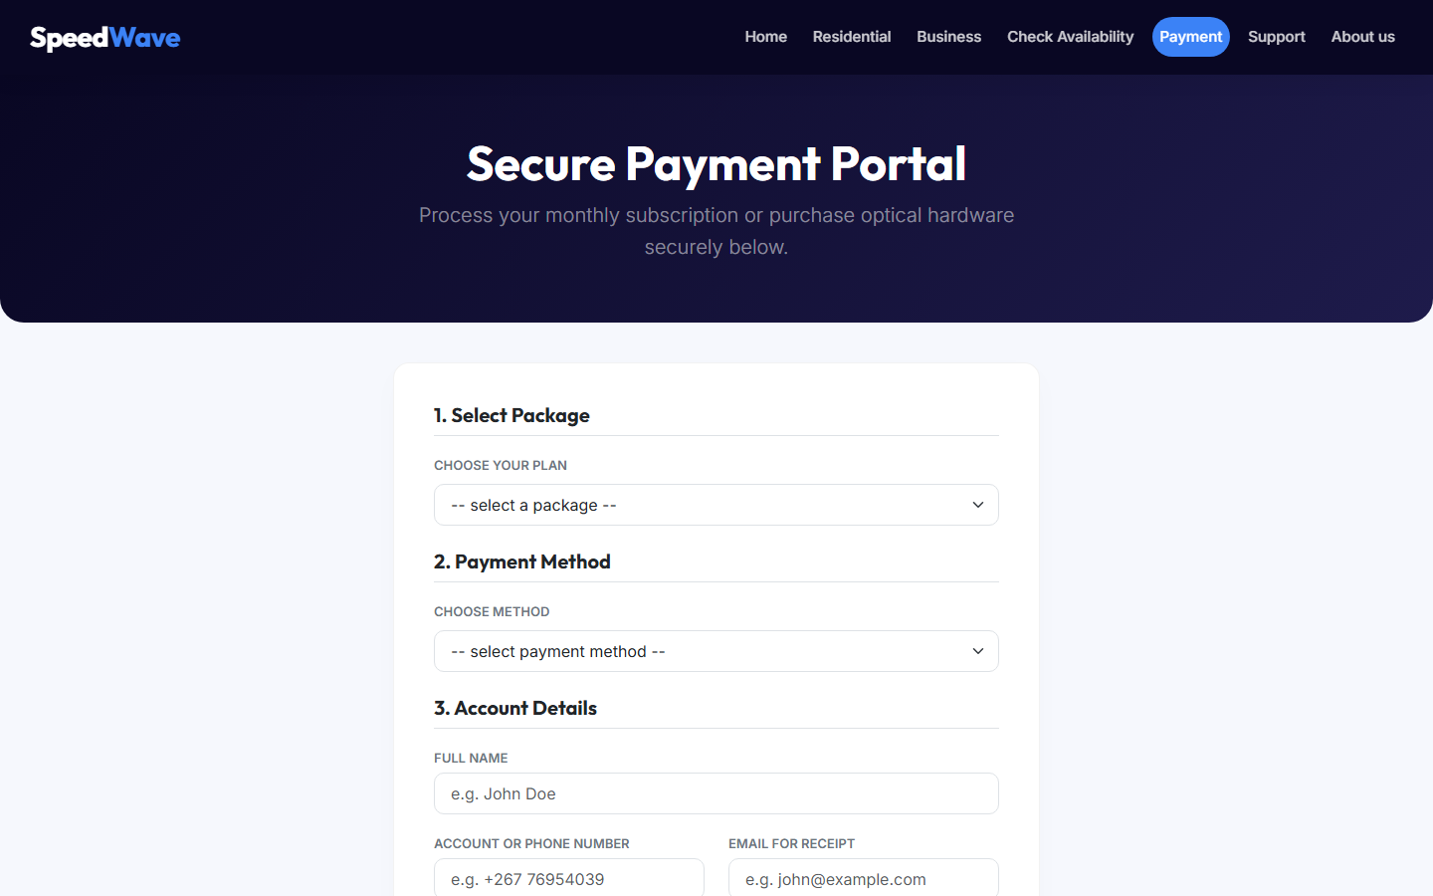
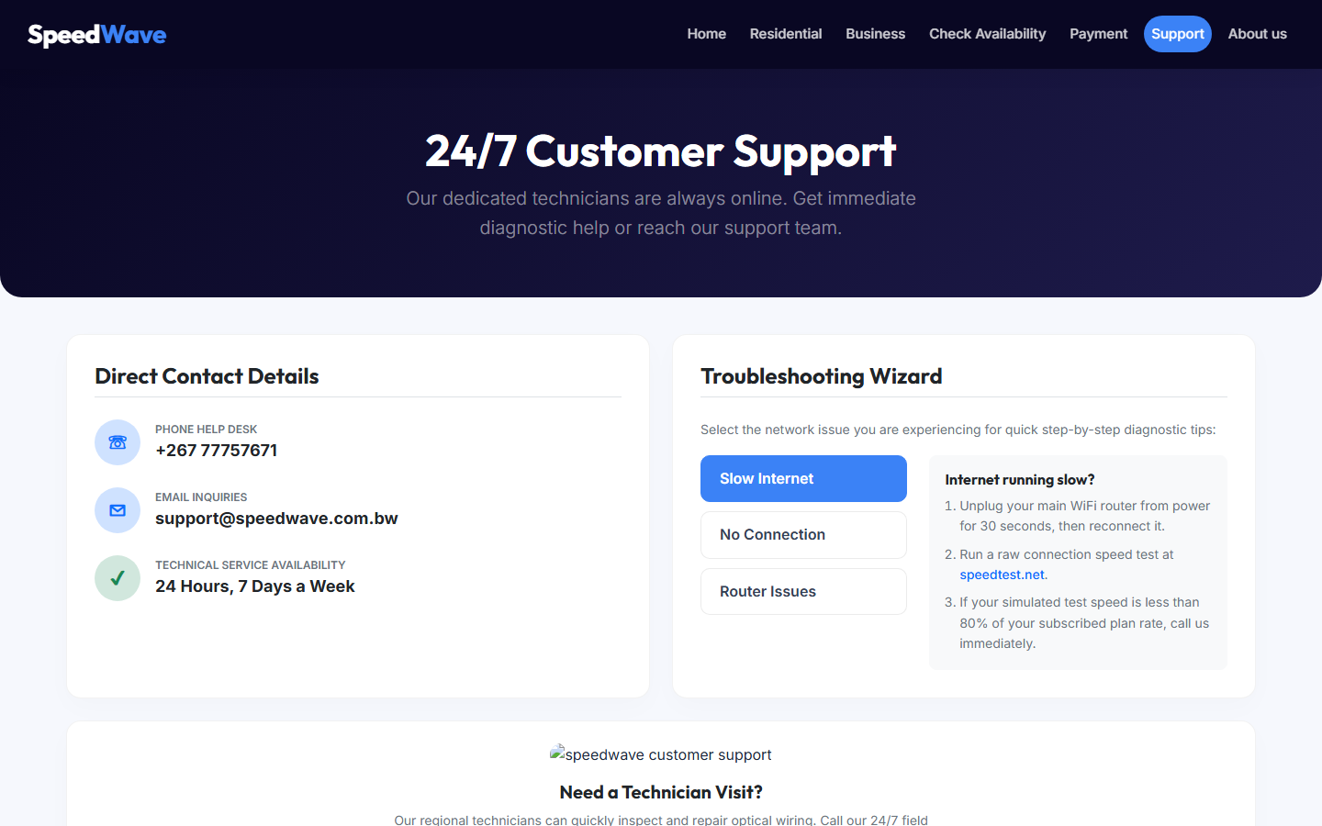
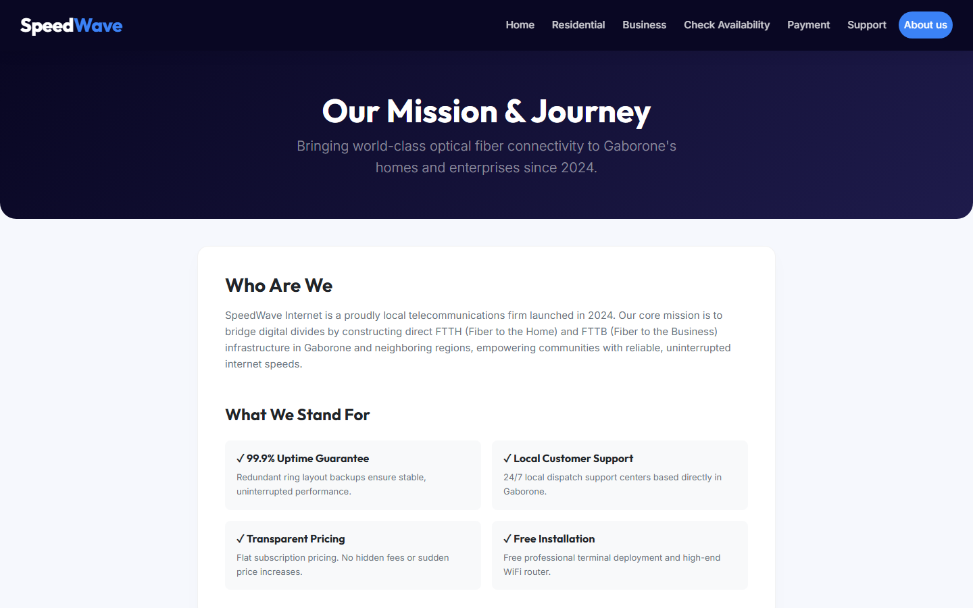
Smartphone Testing:
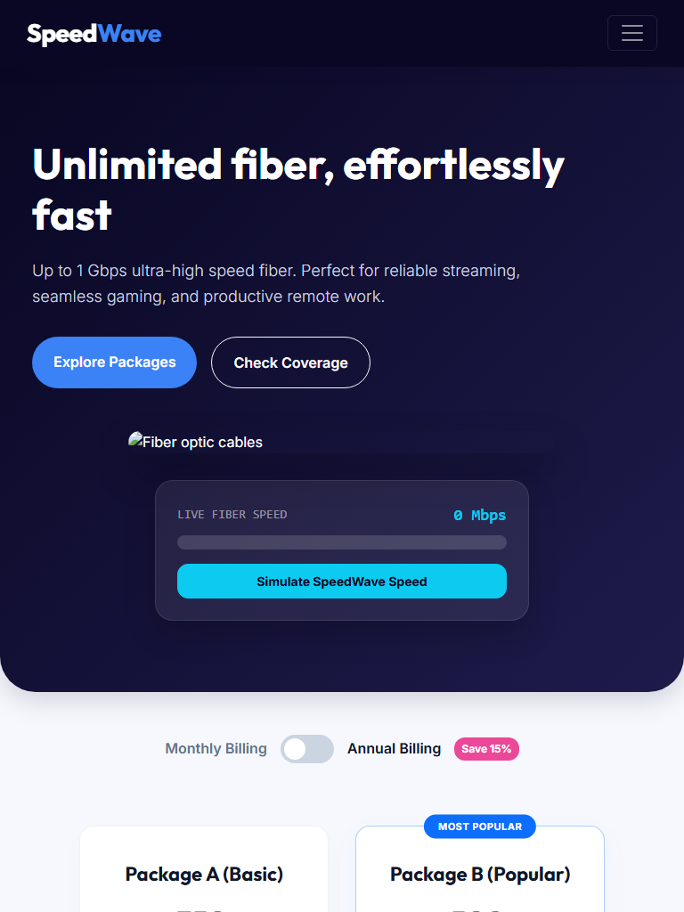
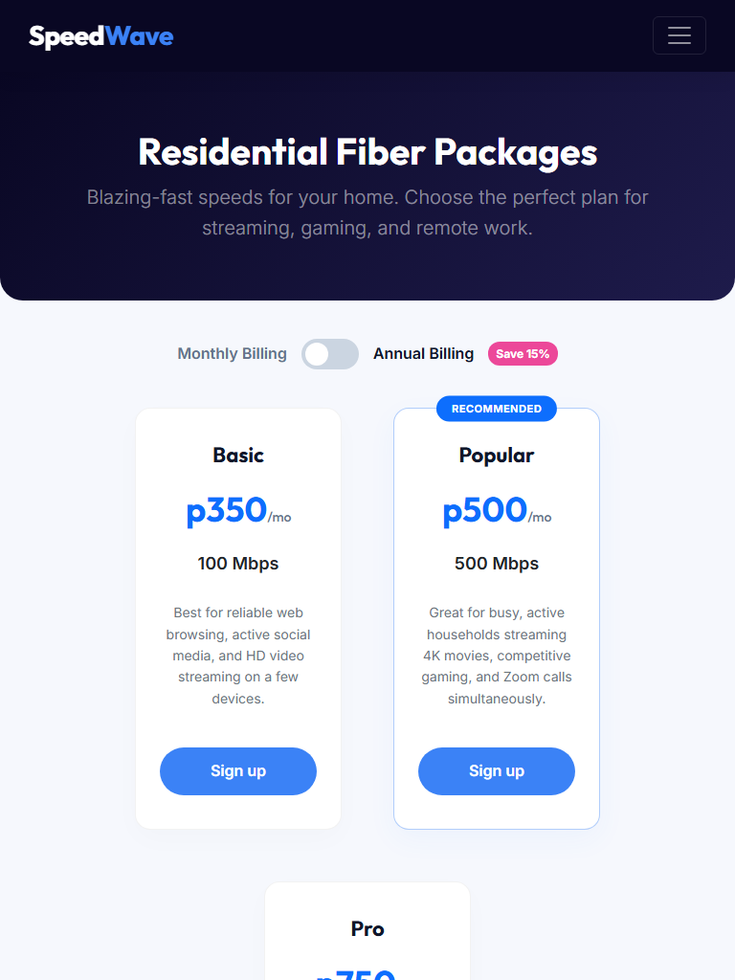
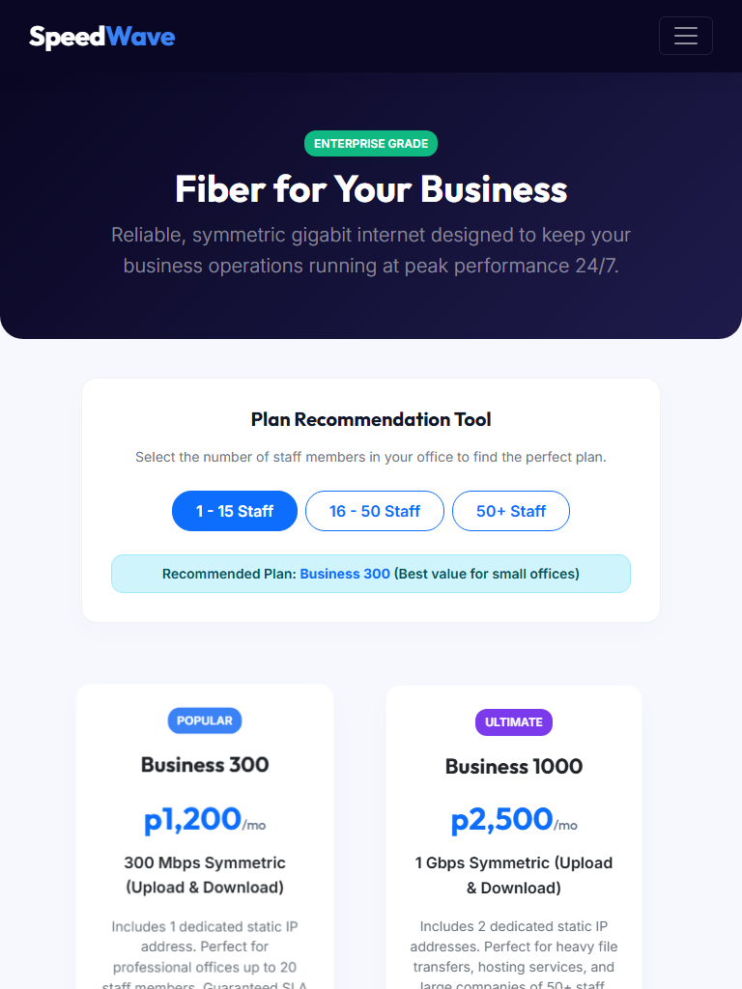
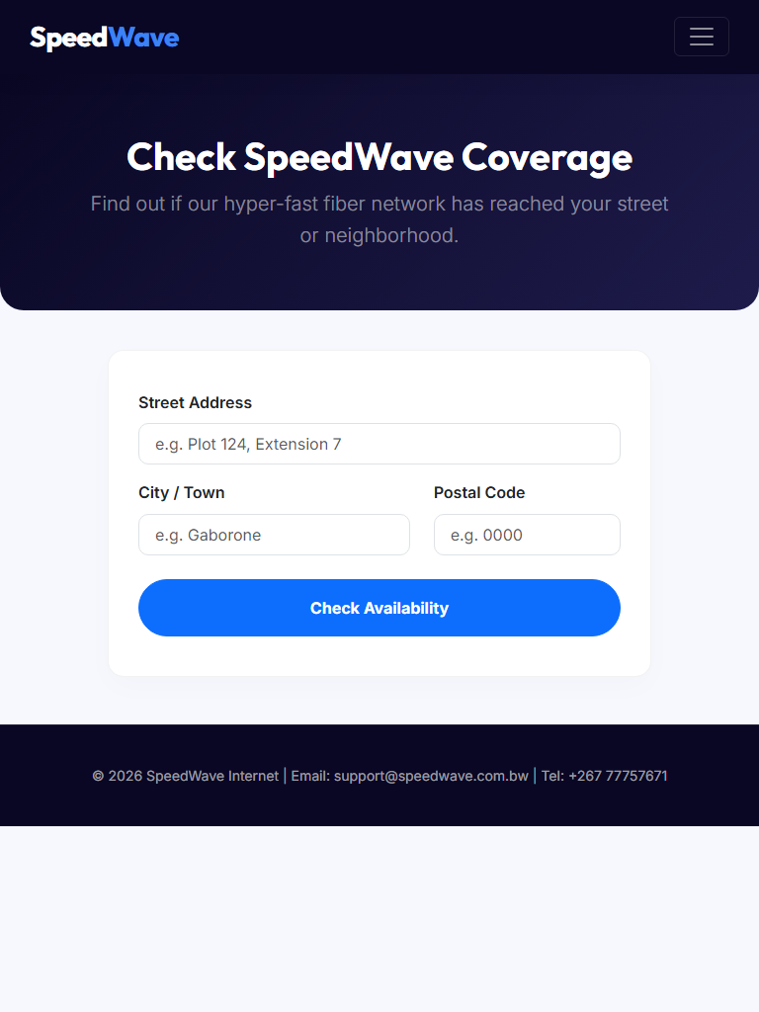
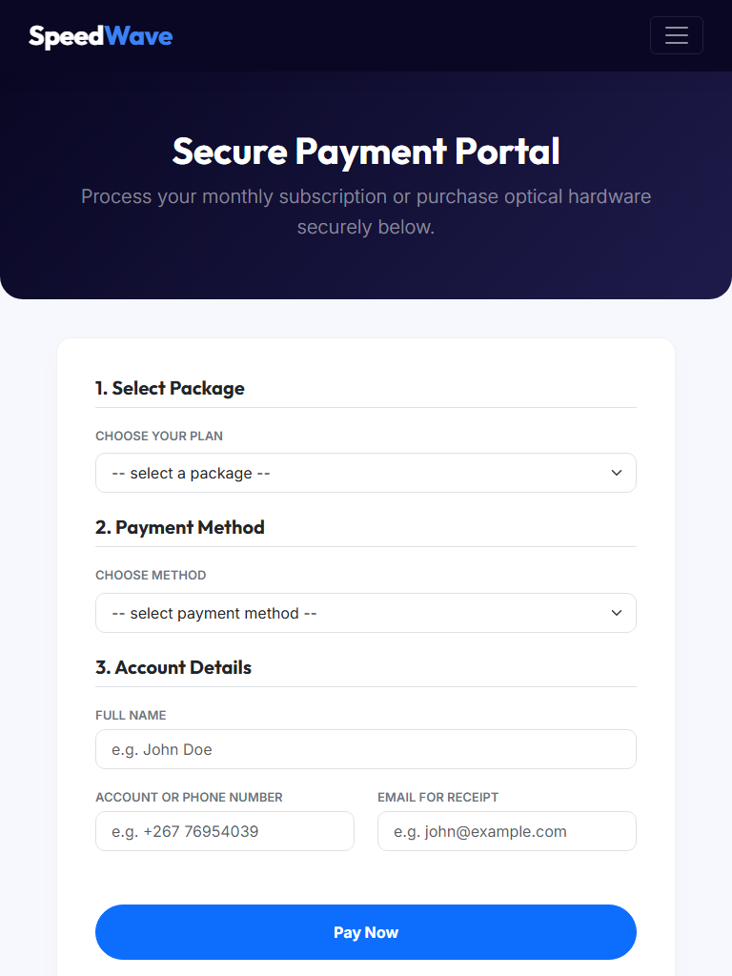
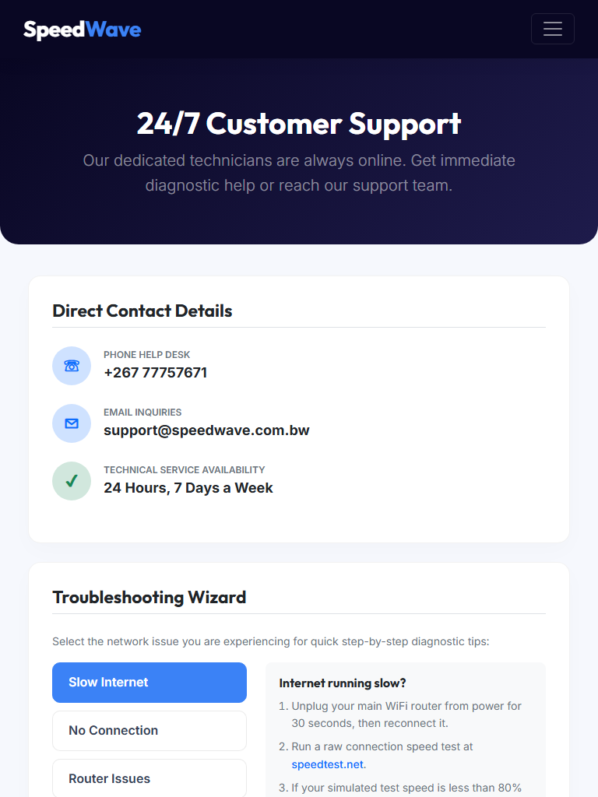
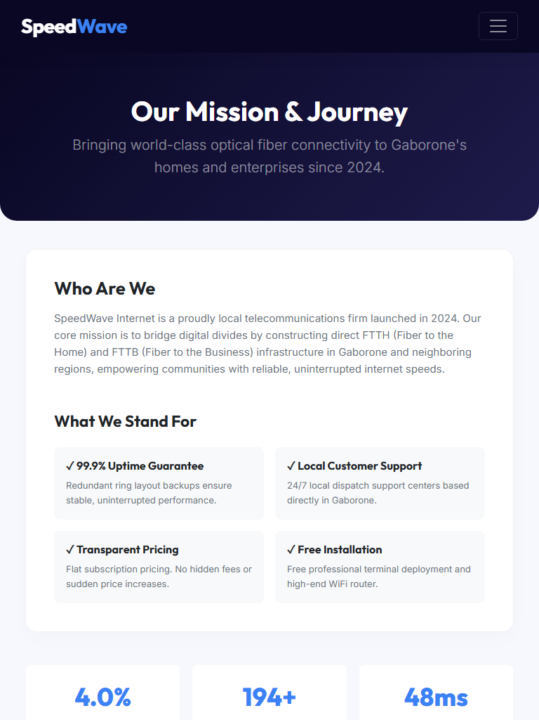
publishing and promotion
SpeedWave is optimized for direct web publishing and local promotion channels:
- Production Publishing: Hosted on GitHub Pages
- Search Engine Optimization: Custom meta descriptions, descriptive viewport parameters, and clean semantic heading tags enable high visibility on search engines.
- Promotion: Marketed locally via Gaborone community social channels Facebook, WhatsApp Business and word of mouth
Problem encountered issues you faced during the development
Three core issues were encountered and resolved during local development:
- Simulated Interval Clears: The connection speed simulator initially stacked intervals if the button was clicked multiple times. This was resolved by disabling the click button and updating the button text to "Testing Connection." during runs.
- Mobile Menu Offsets: On smaller tablets and mobile screens, elements in the sticky header shifted. This was resolved by integrating custom media queries to hide standard lists off-canvas and toggle an active mobile overlay using a hamburger icon switch.
Future improvements
To scale SpeedWave's features, we propose three technical upgrades:
- Mobile Money: Integrate local payments (Orange Money, FNB ewallet, Myzaka) to support direct
- Direct Chat Live Portal: Embed a client-side live chat bubble linking users directly to Gaborone technicians for instantaneous troubleshooting support.

