Arduino Based 6x6x6 LED Audio Visualizer

**Vaidas Karnickas** (바이다스 카르니츠카스) **2012161176**

**Simonas Jokubauskas** (시모나스 조쿠바우스카스) **2012161175**

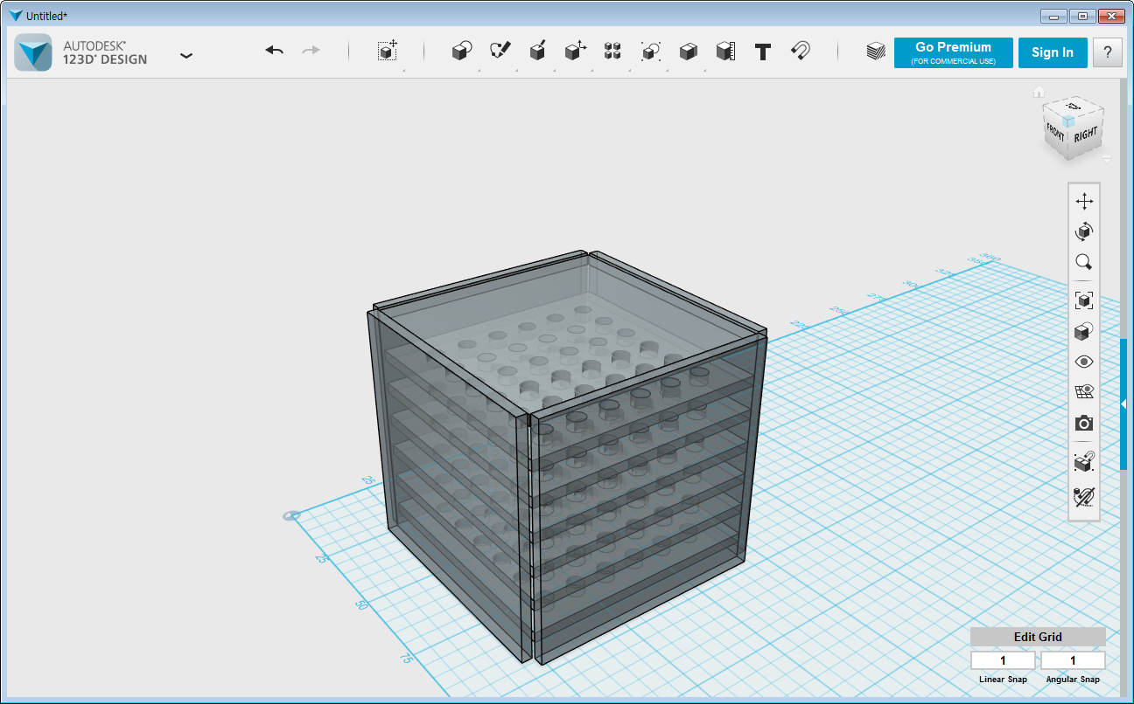

After putting the LED’s into the enclosure proposed above made out of acrylics we can start making test functions on how the audio could be visualized.

Proposed and a pretty common way to approach the problem could be by utilizing four files:  
**LEDs**.**h**: Contains all pins definitions, and arrays containing pins for swift iterations.

**DisplayBasics**.**pde**: Contains a few basic "shapes" in the cube, for use in patterns.

**Patterns**.**pde**: Contains patterns which the cube can display. Each is documented in the code, this would also be the place where we could add patterns specific to audio.

**LEDCubePCB**.**pde**: setup() and loop() functions.

Audio visualization can be completed by utilizing and changing parts of the Piccolo repository by PaintYourDragon on GitHub.

Codes are attached for convenience.