Arduino Based 4x4x4 LED Audio Visualizer

**Vaidas Karnickas** (바이다스 카르니츠카스) **2012161176**

**Simonas Jokubauskas** (시모나스 조쿠바우스카스) **2012161175**

We want to make an arduino based and driven 4x4x4 LED array (later on mentioned as cube) to complete a variety a tasks, of which one would be audio visualization depending on the input.

We can achieve controling each LED as a single unit by introducing a new data type (using struct parameter in the programing environment) to represent a single point on the cube – which I called “xyz”. It consists of just two integers: “xz”, and “y”. With this structure, I could then also represent a direction, indicated below in our special (xz,y) coordinate system.

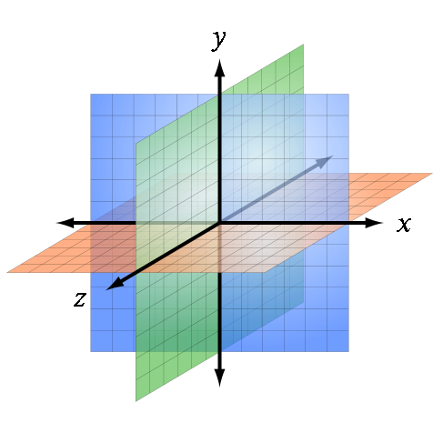

Our proposed idea would consist of the following:

* 64, 3.3V, 20mA LED’s
* 64 100 ohm resistors
* Arduino board
* Breadboard or a PCB
* Preferably a project box/enclosure



We would expect our final project to look like the image posted above. With a variety of functions implemented into the design.