**SAHODARAN AYYAPPAN SMARAKA SNDP**

**YOGAM COLLEGE**

**KONNI, PATHANAMTHITTA**

**(Aided College Affiliated to Mahatma Gandhi University, Kottayam)**



**FEBRUARY, 2023**

**Mini Project Report on**

**NAAC Criterion 2 : Teaching-Learning and Evaluation**

***In partial fulfillment of the requirement for the award of the degree in***

**BACHELOR OF COMPUTER APPLICATION**S

**of**

**MAHATMA GANDHI UNIVERSITY, KOTTAYAM**



***Submitted by***

***Sandhra Anna Jerry***

***PRN:200021096553***

**SAHODARAN AYYAPPAN SMARAKA SNDP YOGAM COLLEGE**

**KONNI, PATHANAMTHITTA**

**(Aided College Affiliated to Mahatma Gandhi University, Kottayam)**



**BACHELOR OF COMPUTER APPLICATIONS**

**CERTIFICATE**

***This is to certify that the MINI Project entitled*** *“****NAAC Criterion 2 : Teaching-Learning and Evaluation****”* ***is the bonafide work carried out by SANDHRA ANNA JERRY*** *(****PRN 200021096553****)* ***student of Bachelor of Computer Applications, Sahodaran Ayyappan Smaraka SNDP Yogam College, Konni, Pathanamthitta, Kerala during the year 2021, in partial fulfilment of the requirement for the award of the degree in bachelor of Computer Applications of Mahatma Gandhi University, Kottayam and that the project has no formed the basis for the award previously of any degree, diploma, associateship, fellowship or any other similar title.***

*Signature of the Guide Signature of the Head of*

*Department*

**Asst. Prof. DEEPTHI K S Asst. Prof. KRISHNAKUMAR**

Internal Examiner External Examiner

**SAHODARAN AYYAPPAN SMARAKA SNDP YOGAM COLLEGE**

**KONNI, PATHANAMTHITTA**

**(Aided College Affiliated to Mahatma Gandhi University, Kottayam)**



**BACHELOR OF COMPUTER APPLICATIONS**

**CERTIFICATE**

***Certified that this mini project report “NAAC Criterion 2 : Teaching-Learning and Evaluation” is the bonafide work of Sandhra Anna Jerry(PRN 200021096553) who carried out the project work under my supervision.***

Signature of the Guide

**Asst. Prof. Deepthi K S**

**(Dept. Of BCA)**

**SAHODARAN AYYAPPAN SMARAKA SNDP YOGAM COLLEGE**

**KONNI, PATHANAMTHITTA**

**(Aided College Affiliated to Mahatma Gandhi University, Kottayam)**



**BACHELOR OF COMPUTER APLICATIONS**

**DECLARATION**

I hereby declare that the mini project entitled ***“NAAC Criterion 2:Teaching-Learning and Evaluation”*** submitted for the Bachelor of Computer Applications degree is my original work and the project has not formed the basis for the award of any degree, associateship, fellowship or any other similar titles.

Signature of the Student

Date

Konni

**ACKNOWLEDGEMENT**

I have taken efforts in this project. However, it would not have been possible without the kind support and help of many individuals. I would like to extend my sincere thanks to all of them.

I am highly indebted to Asst. Prof. Deepthi K S for his guidance and constant supervision as well as for providing necessary information regarding the project and also for their support in completing the project.

I would like to express my gratitude towards my parents and friends for their kind co-operation and encouragement which help me in completion of this project.

My thanks and appreciations also go to all the people who willingly helped me out with their abilities in developing the project.

**1.INTRODUCTION**

**1.1 OVERVIEW OF THE PROJECT**

The National Assessment and Accreditation Council (NAAC) is an autonomous body funded by the University Grants Commission (UGC) that assesses and accredits institutions of higher education in India. The accreditation process helps institutions improve their overall quality and performance, leading to better academic outcomes for students. One of the key criteria for accreditation is Teaching-Learning and Evaluation. The objective of this project is to develop a PHP web application that will help institutions meet the requirements of NAAC Criterion 2.

The PHP web application developed for this project offers a comprehensive solution for managing the curriculum, teaching-learning process, and evaluation practices in one place. The application consists of three modules: Admin, Faculty, and Student.

The Admin module allows institutions' administrative staff to manage the overall system. It includes features such as user management, course management, and curriculum management. The module also provides tools for generating reports and analytics to track the progress of the institution. The Admin module is designed to be user-friendly, efficient, and customizable, allowing institutions to tailor it to their specific needs.

The Faculty module allows faculty members to manage the teaching-learning process. It provides tools for creating lesson plans, assessments, and assignments. The module also allows for communication between faculty and students, enabling them to collaborate on projects and assignments. The Faculty module is designed to be user-friendly, efficient, and customizable, allowing faculty members to tailor it to their specific teaching style and preferences.

The Student module enables students to access course content, view their progress, and communicate with faculty members. It allows students to submit assignments, take assessments, and view their grades. The module also provides tools for students to collaborate with their peers and access additional learning resources. The Student module is designed to be user-friendly, efficient, and customizable, allowing students to tailor it to their specific learning needs and preferences.

The PHP web application is designed to be scalable, allowing for future expansion and customization. It is developed using the Laravel framework, which is a widely used PHP framework for web application development. The application is hosted on a cloud server, making it accessible from anywhere with an internet connection.

The PHP web application provides a cost-effective solution for institutions looking to improve their accreditation rating and overall performance. It is economically feasible, requiring minimal development costs and low-cost cloud server deployment. It is also operationally feasible, requiring minimal training and being easy to use.

In conclusion, the PHP web application developed for NAAC Criterion 2: Teaching-Learning and Evaluation offers a comprehensive solution for managing the curriculum, teaching-learning process, and evaluation practices in one place. It is designed to be user-friendly, efficient, customizable, scalable, and cost-effective, making it an ideal solution for institutions looking to improve their accreditation rating and overall performance.

**MODULES**

The NAAC Criterion 2: Teaching-Learning and Evaluation has several modules, which work together to provide a comprehensive solution. The following are the key modules of the system:

Admin:

The Admin module is designed for administrative staff of the institution. It provides them with tools to manage the overall system, including user management. The following are the key features of the Admin module:

User Management: This feature allows the admin to create, modify, and delete user accounts for faculty and students. The admin can also manage user roles and permissions.

Report and Analytics: This feature allows the admin to generate reports and analytics to track the progress of the institution. The admin can view reports on student performance, course completion rates, and faculty performance.

Faculty:

The Faculty module is designed for faculty members. It provides them with tools to manage the teaching-learning process, including lesson planning, assessments, and assignments. The following are the key features of the Faculty module:

Student:

The Student module is designed for students. It provides them with tools to access course content, view their progress, and communicate with faculty members. The following are the key features of the Student module:

In conclusion, the PHP web application developed for NAAC Criterion 2: Teaching-Learning and Evaluation consists of three modules: Admin, Faculty, and Student. The Admin module is designed for administrative staff, the Faculty module is designed for faculty members, and the Student module is designed for students. Each module provides specific tools and features to manage the curriculum, teaching-learning process, and evaluation practices in one place. The PHP web application is designed to be user-friendly, efficient, and customizable, making it an ideal solution for institutions looking to improve their accreditation rating and overall performance.

**1.2 PROBLEM DEFENITION**

Institutions face challenges in meeting the requirements of NAAC Criterion 2. These challenges include managing the curriculum, tracking the teaching-learning process, and maintaining proper evaluation practices. Institutions also need to ensure that their practices are aligned with the learning objectives of their programs. There is a need for efficient and user-friendly tools to manage these tasks.

**1.2.1 PROBLEM SOLUTION**

The PHP web application developed in this project provides a comprehensive solution to these challenges. It offers modules for managing the curriculum, teaching-learning process, and evaluation practices, all in one place. The application is designed to be user-friendly, efficient, and easy to use. It helps institutions align their practices with the learning objectives of their programs and meet the requirements of NAAC Criterion 2.

**1.2.2 EXISTING SYSTEM**

Currently, there are various software applications available for managing curriculum, teaching-learning, and evaluation practices. However, these applications are often limited in scope and lack the features required to meet the requirements of NAAC Criterion 2. They also tend to be expensive, making them inaccessible to many institutions.

**1.3 PROPOSED SYSTEM**

The proposed PHP web application offers a comprehensive solution that meets the requirements of NAAC Criterion 2. The application provides features for managing the curriculum, teaching-learning process, and evaluation practices in one place. The application is designed to be user-friendly, efficient, and easy to use. It is also customizable, allowing institutions to tailor it to their specific needs.

**1.4 FEASIBILITY STUDY**

Mainly three key considerations are involved in the feasibility analysis

* Technical feasibility
* Economic feasibility
* Operational feasibility

**1.4.1 TECHNICAL FEASIBILITY**

The PHP web application is technically feasible as it is developed using the Laravel framework, which is a widely used PHP framework for web application development. The application is scalable, allowing for future expansion and customization. The application is hosted on a cloud server, making it accessible from anywhere with an internet connection.

**1.4.2 ECONOMIC FEASIBILITY**

The development cost of the PHP web application is reasonable, and the application can be deployed on a low-cost cloud server. The application can also be customized to meet the specific needs of each institution, reducing the need for additional software development. The application is a cost-effective solution for institutions looking to improve their accreditation rating and overall performance.

**1.4.3 OPERATIONAL FEASIBILITY**

Operational feasibility refers to the extent to which the proposed system can be implemented and integrated into the current system without disrupting the normal business operations. The operational feasibility of the PHP web application is described below:

User Acceptance: The success of the PHP web application depends on the acceptance and willingness of the users to use it. The application has been designed to be user-friendly, intuitive, and efficient, making it easy for users to navigate and perform tasks. The user interface has been designed with the end-users in mind, and the application has undergone extensive testing and feedback from users to ensure that it meets their needs and expectations.

Technical Infrastructure: The implementation of the PHP web application requires technical infrastructure, including hardware, software, and network capabilities. The application is designed to be compatible with a range of systems, including desktops, laptops, tablets, and smartphones. The application has also been optimized for different browsers and operating systems, ensuring that users can access it from anywhere, anytime.

Data Migration: The implementation of the PHP web application requires the migration of data from the existing system to the new system. The application has been designed to support data migration from different sources, ensuring that data is accurate, consistent, and secure. The application also has backup and recovery mechanisms in place to prevent data loss and ensure continuity of operations.

Training and Support: The implementation of the PHP web application requires training and support for users to ensure that they can effectively use the system. The application has a comprehensive user guide and online help system to assist users in performing tasks. Additionally, the application has a dedicated support team to address any issues and provide technical assistance as needed.

Integration with Existing Systems: The implementation of the PHP web application requires integration with existing systems, including learning management systems, student information systems, and assessment systems. The application has been designed to be flexible and modular, allowing for easy integration with other systems. The application also has an API that enables it to communicate with other systems, ensuring data integrity and reducing data redundancy.

**2. SYSTEM SPECIFICATION**

**2.1 HARDWARE REQUIREMENTS**

Processor : Intel(R) Core 2 or Above

Ram : 4GB or Above

Hard disk : 500 GB or above

**2.2 SOFTWARE REQUIREMENTS**

Operating System: Windows 7 or Above

Front End: HTML, CSS, JavaScript

Back End: PHP, MYSQL

Server: Wamp Server

**2.3 FRONT END**

**HTML**

The language used to develop webpages is called Hyper Text Markup Language(HTML).HTML is the language interpreted by a browser.HTML is specified as TAGS in an HTML document (i.e. the webpage).

**HTML TAGS**

Tags are instructions that are embedded directly into the text of the document. An HTML tag is a signal to a browser that it should do something other than just throw text up on the screen. By convention all HTML tags begin with an open angle bracket (<) and end with a close angle bracket(>).

**The Structure of an HTML Program**

Every HTML program has a rigid structure. The entire web page is enclosed within < HTML> tags within these tags two distinct sections are created using the<head ></head>tags and the <BODY></BODY>tags.

**CSS (Cascading Style Sheet)**

Stands for “Cascading Style Sheet”. Cascading Style Sheets are used to format the layout of webpages. They can we used to define text styles, table styles, and other aspects of webpages that are previously could only be defined in a page’s HTML.

CSS helps web developers create a uniform look across several pages of a webpage. Instead of defining the style of each table and each block of text within a page’s HTML, commonly used style need to be defined only once in a CSS document. Once the style id defined in cascading style sheet it can be used by any page that reference the CSS file. Plus, CSS makes it easy to change style across several pages at once. For example, a web developer may want to increase the default text size from 10pt to 12 pt. for 50 pages of a website. If the pages all reference the same style sheet, the text size only need to be changed on the style sheet and all the pages will show the larger text.

While CSS is great for creating text styles, it is helpful for formatting other aspects of webpage layout as well. For example, CSS can be used to define the cell padding of table cells, the style, thickness and color of a table’s border and the padding around images or other objects. CSS gives web developers more exact control over how webpages will look than HTML does. This is why most webpages today incorporate cascading style sheets.

**JAVASCRIPT(JS)**

JavaScript(JS) is a scripting languages, primarily used on the web. It is used to enhance HTML pages and is commonly found embedded in HTML code. JavaScript is an interrupted language. Thus, it doesn’t need to be compiled. JavaScript renders webpages in an interactive and dynamic fashion. This allowing the pages to react to events, exhibit special effects, accept variable text, validate data, create cookies, detect a user’s browser, ect.HTML pages are fine for displaying static content, example a simple image or text. However, most pages nowadays are rarely static. many of today’s pages have menus, forms, slideshows and even images that provided user interaction JavaScript is the language employed by web developer to provide such interactions. Since JavaScript works with HTML pages, a developer needs to know HTML to harness the scripting language’s full potential. While they are other languages that can be used for scripting on the web, in practice it is essentially on all JavaScript.

There are two ways to use JavaScript in an HTML file. The first one involves embedding all the JavaScript called in the HTML code, while the second method makes use of a separate JavaScript file that’s called from within a script element, that is enclosed by script tags JavaScript foils are identified by the .Js extension . although JavaScript is mostly used to interact with HTML objectives, it can also be made to interact with other known HTML objects such as browser plugins, CSS (Cascading Styles Sheets) properties, the current date, or the browser itself.to write JavaScript code, are you need a basic text editor like notepad in Windows, Gimp in Linux, or BBEdit. Some text editors, like BBdit future syntax highlighting for JavaScript these will allow you easily identify elements to of JavaScript code. The latest versions of internet explorer, Firefox, opera all support JavaScript.

**2.4 BACK-END**

**PHP**

PHP is a computer scripting language originally designed for producing dynamic web pages. It is used for, server-side scripting language but can be used from a command line interface or in standalone graphical applications. While PHP was originally created by Rasmus Lerdorf in 1995, the main implementation of PHP is now produced by the PHP group and serves as the de facto standard for PHP License; the free software foundation considers it to be free software.

PHP is a widely-used general-purpose scripting language that is especially suited for web development and can be embedded into HTML. It generally runs on a web browser, taking PHP code as its input and creating web pages as output. It can be deployed on most web servers and on almost every operating system and platform free of change. PHP is installed on more than 20 million websites and 1 million web servers. It is also the most popular Apache module among computers using Apache as web server. The most recent major release of PHP was the versions 5.2.6 on May 1, 2008.

**HISTORY**

PHP originally stood for Personal Home Page. It began in 1994 as a set of Common Gateway Interface binaries written in the C programming language by Danish/Greenlandic programmer Rasmus Lerdorf. Lerdorf initially created these Personal Home Page tools to replace a small set of Perl scripts he had been using to maintain his Personal Home Page. The tools used to perform tasks such as displaying his resume and recording how much traffic his page was receiving. He combined these binaries with his. Form interpreter to create PHP/F1, which had more functionality; PHP/F1 included a large C implementation and could communicate with databases enabling the building of simple, dynamic web applications. He released PHP publically on June 8, 1995 to

accelerate bug location and improving the code. This release was named PHP version 2 and already had the basic functionality that PHP has today. This included Perl-like variables, form handling and the ability to embed HTML. The syntax was similar to Perl but was more limited, simpler and less consistent.

**USAGE**

PHP is a general-purpose scripting language that is especially suited for the web development. PHP generally runs on a web server, taking PHP code as its input and creating web pages as outputs. It can be used for command-line scripting and client-side GUI operating systems and platforms, and can be used with many relational database management systems. It is available free of charge, and the PHP group provides the complete source code for users to builds, customize and extend for their own use. PHP primarily act as a filter, taking input from a file or stream containing text and/or PHP instructions and outputs another stream of data; most commonly the output will be HTML. It can automatically detect the language of the user. From PHP 4, the PHP parser compiles input to produce byte codes for processing by Zend Engine, giving improved performance over its interpreter predecessor.

Originally designed to create dynamic web pages, PHP‟s main focus is on server-side scripting, and it is similar to other server-side scripting languages that provides dynamic content from a web server to a client, such as Microsoft ASP.NET system, Sun

Microsystems’s Java Server Pages and Mod-Perl. PHP has also attracted the development of many frameworks that provide building blocks and a design structure to promote Rapid Application Development (RAD). Some of these include CakePHP, PRADO, Symphony and Zend framework, offering features similar to other web application framework. As of April 2007, over 20 million internet domains were hosted on servers with PHP installed and PHP was recorded as the most popular Apache module.

**SYNTAX**

PHP only parses code within its delimiters; anything outside its delimiters is send directly to the output and is not parsed by PHP. The most common delimiters are <?php and ?>, which are open and close delimiters respectively. <script language=”php”> and </script> delimiters are also available. Short tags (</ or <?= and ?>) are also commonly used, but like ASP-style tags is discouraged. The purpose of these delimiters is to separate PHP code from Non-PHP code, including HTML. Everything outside the delimiter is ignored by the parser through as output.

Variables are prefixed with a dollar symbol and a type does not need to be specified in advance. Unlike function and class names, variable names are case sensitive. Both double-quoted (“ “) and herodoc string allow the ability to embed a variable’s value into the string. PHP treats new lines as white spaces in the manner of a free form language and statements are terminated by a semicolon.

**OBJECT ORIENTED:**

To be an Object Oriented language, any language must follow at least the four characteristics.

1. Inheritance: It is the process of creating the new classes and using the behavior of the existing classes by extending them just to reuse the existing code and adding the additional features as needed.

2. Encapsulation: It is the mechanism of combining the information and providing the abstraction.

3. Polymorphism: As the name suggest one name multiple form, Polymorphism is the way of providing the different functionality by the functions having the same name based on the signatures of the methods.

4. Dynamic binding: Sometimes we don't have the knowledge of objects about their specific types while writing our code. It is the way of providing the maximum functionality to a program about the specific type at runtime.

As the languages like Objective C, C++ fulfils the above four characteristics yet they are not fully object oriented languages because they are structured as well as object oriented languages. But in case of java, it is a fully Object Oriented language because object is at the outer most level of data structure in java. No standalone methods, constants, and variables are there in java. Everything in java is object even the primitive data types can also be converted into object by using the wrapper.

**DATA TYPES**

PHP store whole numbers in a platform-dependent range. This range is typically that of 32-bit signed integers. Unsigned integers are converted to signed values in certain situations; this behavior is different from other programming languages. Integer variables can be assigned using decimal (positive and negative), Octal and hexadecimal notations. Real numbers are also stored in a platform-specific range. They can be specified using floating point notation, or two forms of scientific notation. PHP has a native Boolean type that is similar to native Boolean types in Java and C++. Using Boolean type conversation rules, non-zero values are interpreted as true and zero as false, as in Perl and C++. The null data type is NULL. Variables of the “resource” type represent reference to resource from external sources. These are typically created by functions from a particular extension, and can be processed by functions from the same extension; examples include file, image and database resources. Array can contain elements of any type that PHP can handle, including resources, objects, and even other arrays.

**MYSQL**

MySQL is an open source Relational Database Management System. MySQL is very fast reliable and flexible Database Management System. It provides a very high performance and it is multi-threaded and multi user Relational Database management system. MySQL is one of the most popular relational databases Management System on the

web. The MySQL Database has become the world's most popular open source Database, because it is free and available on almost all the platforms. The MySQL can run on Unix,

window, and Mac OS. MySQL is used for the internet applications as it provides good speed and is very secure. MySQL was developed to manage large volumes of data at very high speed to overcome the problems of existing solutions. MySQL can be used for verity of applications but it is mostly used for the web applications on the internet. MySQL, the most popular Open Source SQL Database management system, is developed, distributed, and supported by Oracle Corporation. MySQL offers standard database driver connectivity for using MySQL with applications and tools that are compatible with industry standards ODBC and JDBC. Any system that works with ODBC or JDBC can use MySQL.

This software is developed for general use in a variety of information management applications. It is not developed or intended for use in any inherently dangerous applications, including applications which may create a risk of personal injury. If you use this software in dangerous applications, then you shall be responsible to take all appropriate fail-safe, backup, redundancy, and other measures to ensure the safe use of This software. MySQL is a database management system. A database is a structured collection of data. It may be anything. MySQL is a relational database management system. A relational database stores data in separate tables rather than putting all the data in one. The MySQL Server design is multi-layered with independent modules. Many of the world's largest and fastest-growing organizations use MySQL to save time and money powering their high-volume Web sites, critical business systems, and packaged software.

MySQL is a key part of LAMP (Linux, Apache, MySQL, PHP /Perl/ Python), the fast-growing open source enterprise software stack. More and more companies are using LAMP as an alternative to expensive proprietary software stacks because of its lower cost and freedom from platform lock-in.

**FEATURES OF MYSQL SERVER**

1. A very fast thread-based memory allocation system.

2. Very fast joins using an optimized one-sweep multi-join.

3. In-memory hash tables, which are used as temporary tables.

4. SQL functions are implemented using a highly optimized class library and should be as fast as possible. Usually there is no memory allocation at all after query initialization.

5. The best and the most-used database in the world for online applications.

6. Available and affordable for all.

7. MySQL command line tool is very powerful and can be used to run SQL queries against database.

8. Continuously improved while remaining fast, secure and reliable.

9. Fun to use and improve.

10.MySQL is very Lightweight application.

**APACHE SERVER: -**

Wamp Server stands for “Windows, Apache, MYSQL, PHP” Wamp is a variation of LAMP for Windows system and often installed as a software bundle (Apache, MYSQL, and PHP). It is often used for web development and internal testing, but may also be used to serve live websites.

The most important part of the Wamp package is Apache (or “Apache HTTP Server”) which is used run the webserver within Windows. by running a local Apache webserver on a Windows machine a web developer can test web pages in a web browser without publishing them live on the internet. Wamp also includes MYSQL and PHP, which are two of the most common technologies used for creating dynamic websites. MYSQL is a high-speed Database, while PHP is a scripting Language that can be used to access data from the Database. By installing these two components locally, a developer can build and test a dynamic website before publishing it to a public web server. While Apache, MYSQL, and PHP are open

source components that can be installed individually, they are usually installed together. One popular package is called “WampServer” which provides a used_freindly way to install and configure the “AMP” components on Windows. NOTE: the “P” in Wamp can also stand for either Perl or Python, which are other scripting languages The MAC version of LAMP is known as MAMP.

**3. SYSTEM DESIGN**

**3.1 INTRODUCTION**

Design is the first step in the development phase for any engineered product or system. Design is a creative process; a good design is the key effective system the term “design” is defined as “the process of applying various techniques and principles for the purpose of defining a process or a system in sufficient detail to permit its physical realization” It may be defined as the process o applying various techniques and principles for the purpose of defining a device a process or a system in sufficient detail to permit its physical realization. Software design ssitsat the technical kernel of the software engineering process and is applied regardless of the development paradigm that is used.

From a project management point of view, software design is conducted into steps. Preliminary design is concerned with the transformation of requirements into data and software architecture. Detail design focuses on refinement to the architectural representation that lead to detail algorithm data structure and representation of software. Different stage of system design are :

* System Design
* Input Design
* Output Design

**System Design**

In system design, high-end decisions are taken regarding the basic system architecture, platforms and tools to be used. The system design transforms a logical representation of what a given system is required to be in the physical specification. Design starts with the system requirement specification and converts it to a physical reality during the development. Important design factors such as reliability response time, throughput of the system maintainability, expandability etc. should be taken into account to storage device. This is the difference between logical and physical data.

**Input Design**

The user interface design is very important for any application. The interface design despites how the software communicates within itself, to system that interpreted with it and with humans who use it. The interface is a packaging for computer software is the interface is easy to learn, simple to use. if the interface design is very good, the user will fall into an interactive software application.

The input design is the process of converting the user-oriented inputs into the computer –based format. The data is fed into the system using simple interactive forms. The forms have been supplied with messages so that user can enter data without facing any difficulty. The data is validated where ever it requires in the project. These ensure that only the correct data have been incorporated into the system.

The goal of designing input data is to make the automation as easy and free from erase as possible for providing a good input design for the application easy data input and selection features are adopted. The input design requirements such as user friendliness consistent format and interactive dialogue for giving the right message and help for the user at right time are also considered for the development of the project

**Output Design**

A quality output is one, which meets the requirements of the end user and presents the information clearly. In any systems results of processing are communicated to the user and to other systems through outputs. In the output design it is determined how the information is to be displayed for immediate need and also the hard copy output. It is the most important and direct source information to the user. Efficient and intelligent output design improves the system’s relationship with the user and helps in decision –making. The object of the output design is to covey the information of all the past activities current status and to emphasize important events. The output generally refers to each results and information that is generated from the system. Outputs from computers are required primarily to communicate the results of processing to the users. They are also used to provide a permanent copy of these results for later consultation.

**3.2 DATA FLOW DIAGRAM**

A dataflow is a graphical technique that depicts information flow and transforms that are applied as data move from input to output. The DFD is also known as a data flow graph or a bubble chart. The DFD is used to represent increasing information flow and fundamental details. A level-0 DFD, also called a fundamental system model or context diagram represents the entire software element as a single bubble with input and output data indicated by incoming and outgoing arrows, respectively.

In level-1 DFD, context diagram is decomposed into multiple bubbles/process. In this level we highlight the main functions of the system and breakdown the high level process of level-0 DFD into sub processes.

Level-2 DFD goes one step deeper into parts of level-1 DFD. It can be used to plan or record the specific / necessary detail about the system’s functioning.

DFD is a means of representing a system at any level of detail with graphic network of symbols showing data flows, data stores, data processes and sources. The diagram is the basis of structured system analysis.

**COMPONENTS OF DATA FLOW DIAGRAM**

There are four symbols that are used in drawing of data flow diagrams:

* **Entities**

External entities represent source of data that enter the system or the recipients of data that leave the system.

* **Process**

Activities and action taken on the data are represented by circle.

* **Databases**

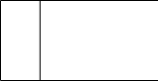

Data bases represent storage of data within the system.

* **Dataflow**

A data flow shows the flow of information from its source to its destination line represents a data flow, with arrowheads showing the direction of flow.

**LEVEL 0**

**LOGIN**

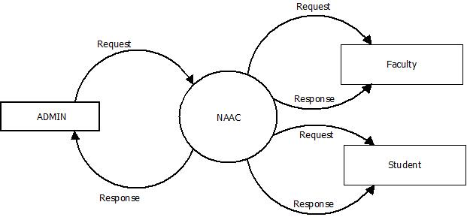

**LEVEL 1.1**

**ADMIN VIEW**

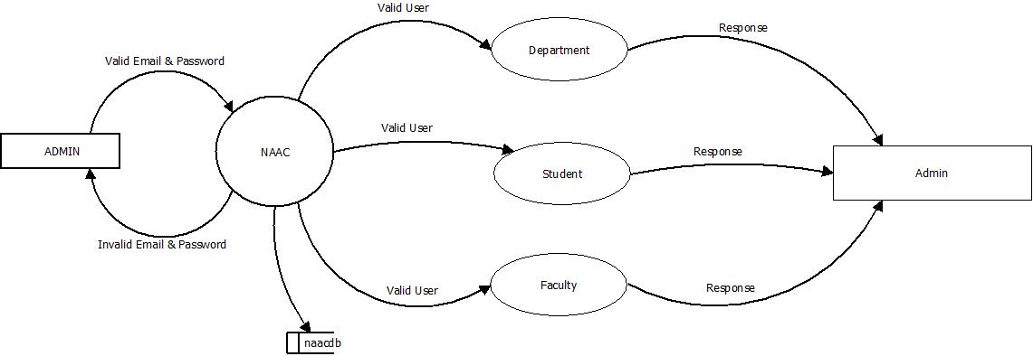

**LEVEL 1.2**

**STUDENT VIEW**

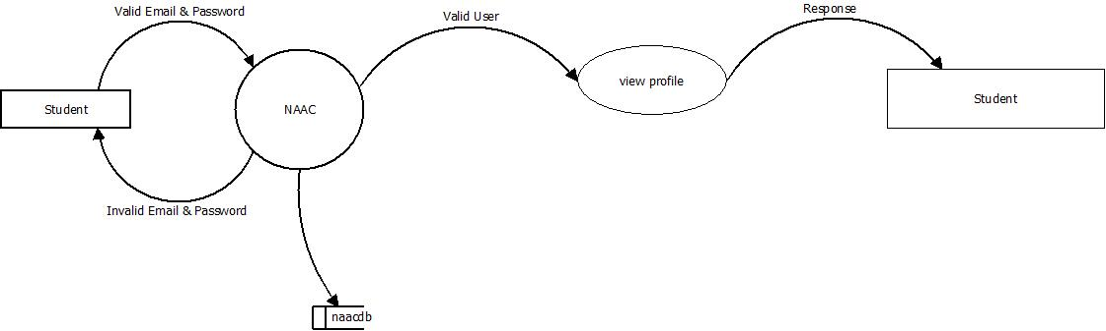

**LEVEL 1.3**

**FACULTY VIEW**

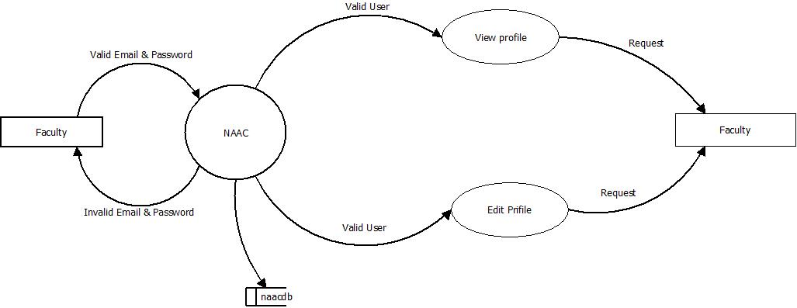

**LEVEL 2.1**

**ADMIN DETAILS**

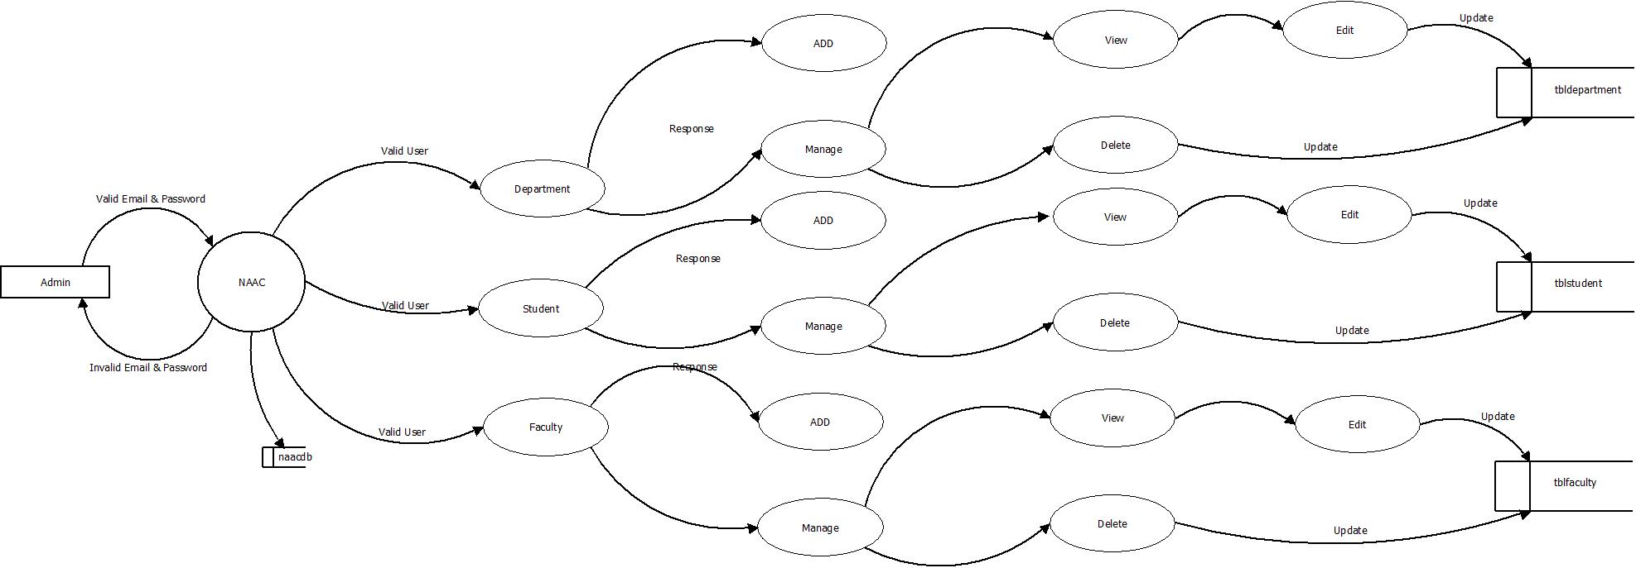

**LEVEL 2.2**

**FACULTY VIEW**

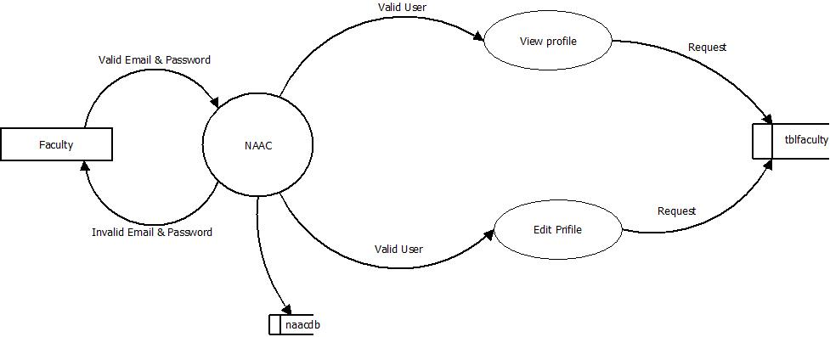

**3.3 DATABASE DESIGN**

Database design is a collection of processes that facilitate the designing, development, implementation and maintenance of enterprise data management systems. The data they store must be organized according to the user requirement. A well designed database is essential for the good performance of the system. Properly designed database are easy to maintain, improves data consistency and are cost effective in terms of disk storage space.

**Data Normalization**

Normalization is a database design technique which organizes tables in a manner that reduces redundancy and dependency of data. The data they store must be according to the user requirement. A database table is known as a relation that provides information related to specific entity. All relations in a relational database are required to satisfy the following conditions.

**Data in First Normal Form**

* Remove repeating data from table.
* From the removed data, create one or more tables and relationships.

**Data in Second Normal Form**

* Identify tables and relationships one or more than key.
* Remove data that depends on only one part of the key.
* From the removed data, create one or more tables and relationships.

**Data in Third Normal Form**

* Remove that depends on other hand in the table or relationships.
* From the removed data, create one or more tables and relationships.

**Advantages of Normalization are:**

* Reduction of redundant data.
* Data consistency.
* Better performance.
* Database table compaction.
* Reduce insertion, deletion, updating anomalies.

## TABLE DESIGN

## Table structure for table admin

|  |  |  |  |
| --- | --- | --- | --- |
| **Column** | **Type** | **Null** | **Default** |
| ***ID*** | int | No |  |
| AdminName | varchar(200) | Yes | NULL |
| UserName | varchar(200) | Yes | NULL |
| MobileNumber | bigint | Yes | NULL |
| Address | varchar(200) | Yes | NULL |
| Email | varchar(200) | Yes | NULL |
| Password | varchar(200) | Yes | NULL |
| AdminRegdate | timestamp | No | CURRENT_TIMESTAMP |

## Table structure for table department

|  |  |  |  |
| --- | --- | --- | --- |
| **Column** | **Type** | **Null** | **Default** |
| ***id*** | int | No |  |
| DeptName | varchar(50) | Yes | NULL |
| Semister | varchar(20) | Yes | NULL |
| CreationDate | timestamp | Yes | CURRENT_TIMESTAMP |

## Table structure for table faculty

|  |  |  |  |
| --- | --- | --- | --- |
| **Column** | **Type** | **Null** | **Default** |
| ***id*** | int | No |  |
| registrationNumber | bigint | Yes | NULL |
| facultyName | varchar(150) | Yes | NULL |
| facultyEmailId | varchar(120) | Yes | NULL |
| facultyContactNo | bigint | Yes | NULL |
| DOB | date | Yes | NULL |
| Gender | varchar(50) | Yes | NULL |
| facultyAddress | mediumtext | Yes | NULL |
| facultyloe | varchar(200) | Yes | NULL |
| facultyfos | varchar(200) | Yes | NULL |
| facultycollege | varchar(200) | Yes | NULL |
| DOJ | date | Yes | NULL |
| facultyDept | varchar(100) | Yes | NULL |
| Image | varchar(200) | Yes | NULL |
| UserName | varchar(200) | Yes | NULL |
| password | varchar(200) | Yes | NULL |
| regDate | timestamp | Yes | CURRENT_TIMESTAMP |
| status | int | No |  |

## Table structure for table public notice

|  |  |  |  |
| --- | --- | --- | --- |
| **Column** | **Type** | **Null** | **Default** |
| ***id*** | int | No |  |
| NoticeTitle | varchar(200) | Yes | NULL |
| NoticeMessage | mediumtext | Yes | NULL |
| CreationDate | timestamp | Yes | CURRENT_TIMESTAMP |

## Table structure for table Students

|  |  |  |  |
| --- | --- | --- | --- |
| **Column** | **Type** | **Null** | **Default** |
| ***id*** | int | No |  |
| registrationNumber | bigint | Yes | NULL |
| studentName | varchar(150) | Yes | NULL |
| studentContactNo | bigint | Yes | NULL |
| SDOB | date | Yes | NULL |
| studentEmailId | varchar(120) | Yes | NULL |
| Gender | varchar(50) | Yes | NULL |
| studentQualification | varchar(200) | Yes | NULL |
| SDOJ | date | Yes | NULL |
| studentAddress | mediumtext | Yes | NULL |
| StudentDept | varchar(100) | Yes | NULL |
| StudentSem | varchar(100) | Yes | NULL |
| FatherName | mediumtext | Yes | NULL |
| MotherName | mediumtext | Yes | NULL |
| Image | varchar(200) | Yes | NULL |
| UserName | varchar(200) | Yes | NULL |
| password | varchar(200) | Yes | NULL |
| regDate | timestamp | Yes | CURRENT_TIMESTAMP |
| status | int | No |  |

**4. SYSTEM IMPLEMENTATION**

**INTRODUCTION**

In today's digital age, technology has become an essential tool for learning and evaluation. Educational institutions are using various tools and platforms to enhance the teaching-learning process and improve the quality of education. The National Assessment and Accreditation Council (NAAC) is an organization that assesses and accredits higher education institutions in India based on certain criteria, including Teaching-Learning and Evaluation.

The PHP web application developed for NAAC Criterion 2: Teaching-Learning and Evaluation is a comprehensive solution that addresses the key challenges faced by educational institutions in this area. The application provides a user-friendly interface for students, faculty, and administrators to manage the teaching-learning process, evaluate student performance, and generate reports.

The PHP web application has several modules, including the Admin module, Student module, and Faculty module. The Admin module is responsible for managing user accounts, assigning roles and permissions, and generating reports. The Student module enables students to access course materials, submit assignments, and view their performance. The Faculty module allows faculty to manage courses, assign assignments, and evaluate student performance.

The PHP web application is designed to be modular and flexible, allowing for easy customization and integration with other systems. It supports a wide range of file formats, including PDF, Word, and Excel, making it easy for users to upload and download files. The application also has robust security features, including role-based access control, encryption, and secure sockets layer (SSL) to protect sensitive data.

The PHP web application has undergone extensive testing and feedback from users to ensure that it meets their needs and expectations. It is also scalable, allowing for easy expansion as the institution grows and evolves.

**SYSTEM CODING**

Coding is the software activity where the detailed design specification is implemented as source code. Coding is the lowest level of abstraction for the software development process. It is the last stage in the decomposition of the software requirements where module specifications are translated into a programming language.

* Typical tasks for coding
* Traceability analyses
* Source code to design specification (and vice versa)
* Test cases to source code and design specification
* Source code and source code document evolution
* Source code interface analysis
* Test procedure and test case generation

**Login :**

<?php

define('DB_HOST','localhost');

define('DB_USER','root');

define('DB_PASS','');

define('DB_NAME','naacdb');

try

{

$dbh = new PDO("mysql:host=".DB_HOST.";dbname=".DB_NAME,DB_USER, DB_PASS,array(PDO::MYSQL_ATTR_INIT_COMMAND => "SET NAMES 'utf8'"));

}

catch (PDOException $e)

{

exit("Error: " . $e->getMessage());

}

?>

<?php

session_start();

error_reporting(0);

include('includes/dbconnection.php');

if(isset($_POST['login']))

  {

    $username=$_POST['username'];

    $password=md5($_POST['password']);

    $sql ="SELECT ID FROM tbladmin WHERE UserName=:username and Password=:password";

    $query=$dbh->prepare($sql);

    $query-> bindParam(':username', $username, PDO::PARAM_STR);

$query-> bindParam(':password', $password, PDO::PARAM_STR);

    $query-> execute();

    $results=$query->fetchAll(PDO::FETCH_OBJ);

    if($query->rowCount() > 0)

{

foreach ($results as $result) {

$_SESSION['sscmsaid']=$result->ID;

}

$_SESSION['login']=$_POST['username'];

echo "<script type='text/javascript'> document.location ='dashboard.php'; </script>";

} else{

echo "<script>alert('Invalid Details');</script>";

}

}

?>

<!doctype html>

<html lang="en">

    <head>

        <title>NAAC Criterion-2  || Login</title>

        <!-- Bootstrap CSS -->

        <link href="assets/css/bootstrap.min.css" rel="stylesheet" type="text/css" />

        <!-- App CSS -->

        <link href="assets/css/style.css" rel="stylesheet" type="text/css" />

        <!-- Modernizr js -->

        <script src="assets/js/modernizr.min.js"></script>

    </head>

    <body>

        <div class="account-pages"></div>

        <div class="clearfix"></div>

        <div class="wrapper-page">

            <div class="account-bg">

                <div class="card-box mb-0">

                    <strong style="padding-top: 30px;"><a href="../index.php" class="text-muted"><i class="fa fa-home m-r-5"></i> Back Home!!</a> </strong>

                    <div class="text-center m-t-20">

                 <h6>NAAC Criterion-2 Teaching-Learning and Evaluation  </h6>

                            <span> Admin Login</span>

                    </div>

                    <div class="m-t-10 p-20">

                        <div class="row">

                            <div class="col-12 text-center">

                                <h6 class="text-muted text-uppercase m-b-0 m-t-0">Sign In</h6>

                            </div>

                        </div>

                        <form class="m-t-20" action="" method="post">

                            <div class="form-group row">

                                <div class="col-12">

                                    <input type="text" class="form-control" placeholder="enter your username" required="true" name="username">

                                </div>

                            </div>

                            <div class="form-group row">

                                <div class="col-12">

                                    <input type="password" class="form-control" placeholder="enter your password" name="password" required="true">

                                </div>

                            </div>

                            <div class="form-group text-center row m-t-10">

                                <div class="col-12">

                                    <button class="btn btn-success btn-block waves-effect waves-light" type="submit" name="login">Log In</button>

                                </div>

                            </div>

                            <!-- <div class="form-group row m-t-30 mb-0">

                                <div class="col-12">

                                    <a href="forgot-password.php" class="text-muted"><i class="fa fa-lock m-r-5"></i> Forgot your password?</a>

                                </div>

                            </div> -->

                        </form>

                    </div>

                    <div class="clearfix"></div>

                </div>

            </div>

            <!-- end card-box-->

        </div>

        <!-- end wrapper page -->

        <!-- jQuery  -->

        <script src="assets/js/jquery.min.js"></script>

        <script src="assets/js/bootstrap.bundle.min.js"></script>

        <script src="assets/js/detect.js"></script>

        <script src="assets/js/waves.js"></script>

        <script src="assets/js/jquery.nicescroll.js"></script>

        <script src="../plugins/switchery/switchery.min.js"></script>

        <!-- App js -->

        <script src="assets/js/jquery.core.js"></script>

        <script src="assets/js/jquery.app.js"></script>

    </body>

</html>

**5.TESTING**

**5.1 UNIT TESTING**

Here we test each module individually and integrate the overall system, Unit testing focuses verification efforts even in the smallest unit of software design in each module. This is known as “Module Testing”. The modules of the system are tested separately. This testing is carried out in the programming style itself. In this testing each module is focused to work satisfactorily as regard to expected output from the module. There are some validation checks for the fields.

|  |  |  |  |  |  |
| --- | --- | --- | --- | --- | --- |
| **Sl. no** | **Test Name** | **Precondition** | **Reference module/name** | **Expected output** | **Result Obtained** |
| 1 | TC01 | Enter valid email and password | Login | Display message saying “Welcome, you are being logged in..” | Expected output |
| 2 | TC02 | Enter invalid email and password | Login | Display message saying “Invalid email” | Expected output |
| 3 | TC03 | Keep any one field as blank | Login | Display message saying “Please fill in this field” | Expected output |
| 4 | TC04 | Enter wrong password | Login | Display message saying “Wrong Password” | Expected output |
| 5 | TC05 | Enter invalid email | Admin | Display message saying “Invalid email address” | Expected output |
| 6 | TC06 | Enter Mobile Number exceeding 10 digit | Admin | Display message saying “invalid phone number” | Expected output |
| 7 | TC07 | Enter already existing email id | Admin | Display message saying “this email is already used” | Expected output |
| 8 | TC08 | Enter already existing Phone Number | Admin | Display message saying “this Phone Number is already used” | Expected output |
| 9 | TC09 | Enter valid New password and password | Admin | Display message saying “Success, Password changed” | Expected output |
| 10 | TC10 | Enter valid New password and invalid retype password | Admin | Display message saying “password must be same” | Expected output |

**5.2 INTEGRATION TESTING**

Data can be lost across an interface, one module can have an adverse effect on the other sub-functions, when combined may not produce the desired functions. Integrated testing is the systematic testing to uncover the errors within the interface. This testing is done with simple data and the developed system has run successfully with this simple data. The need for integrated system is to find the overall system performance.

**5.3 SYSTEM TESTING**

Testing is a process of executing a program with the interest of finding an error. A good test is one that has high probability of finding the ye undiscovered error. Testing should systematically uncover different classes of errors in a minimum amount of time with a minimum amount of efforts. Two classes of inputs are provided to test the process

* + A software configuration that includes a software requirement specification, a design specification and source code.
  + A software configuration that includes a test plan and procedure, any testing tool and test cases and their expected results.

**6. SCREENSHOTS**

**HOME**

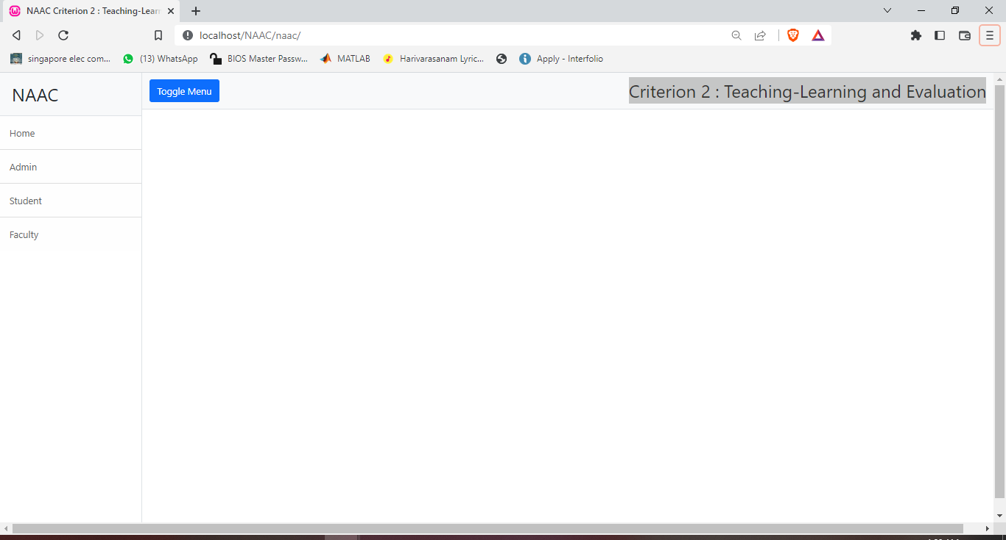

**LOGIN**

ADMIN LOGIN

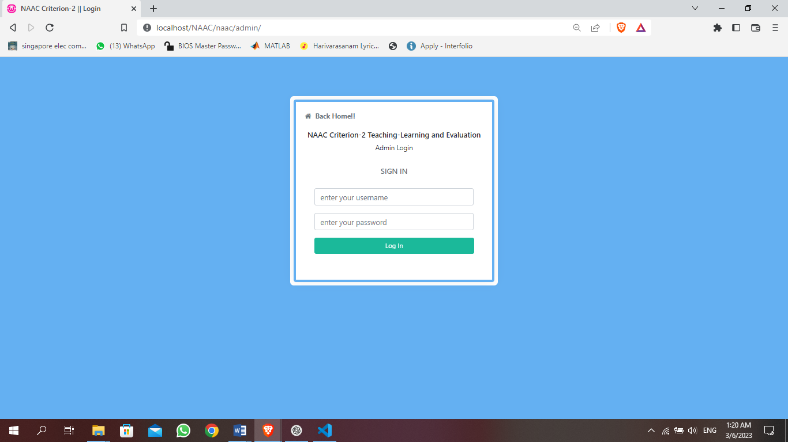

STUDENT LOGIN

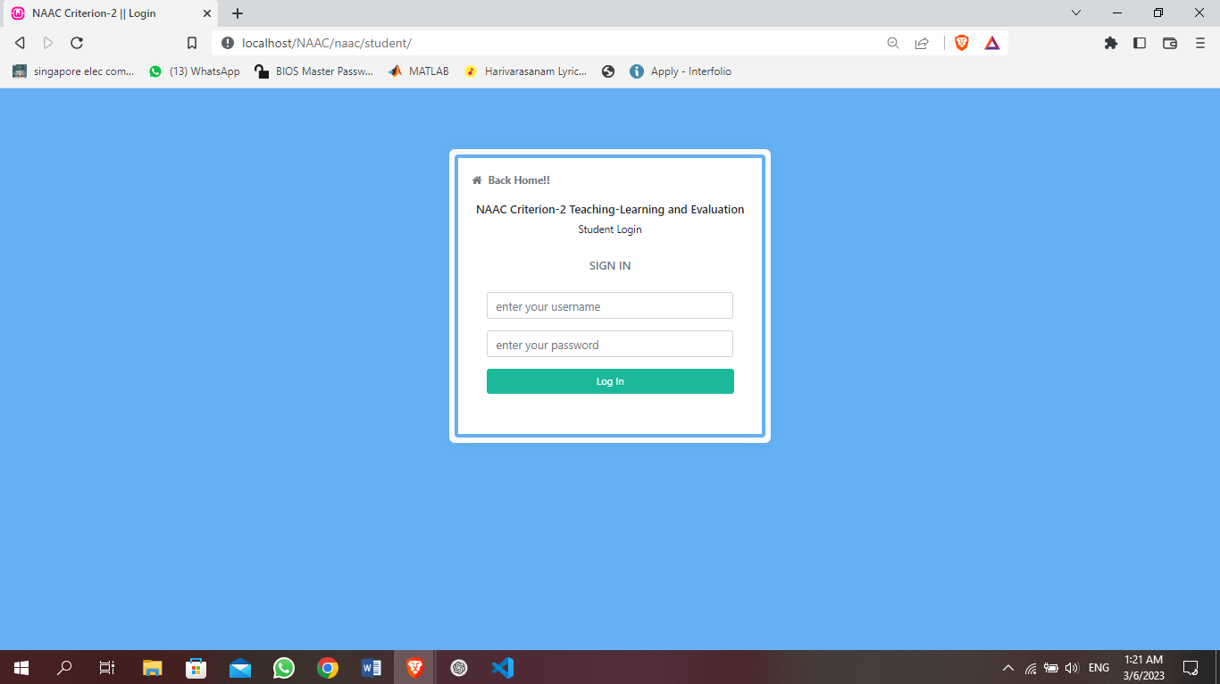

FACULTY LOGIN

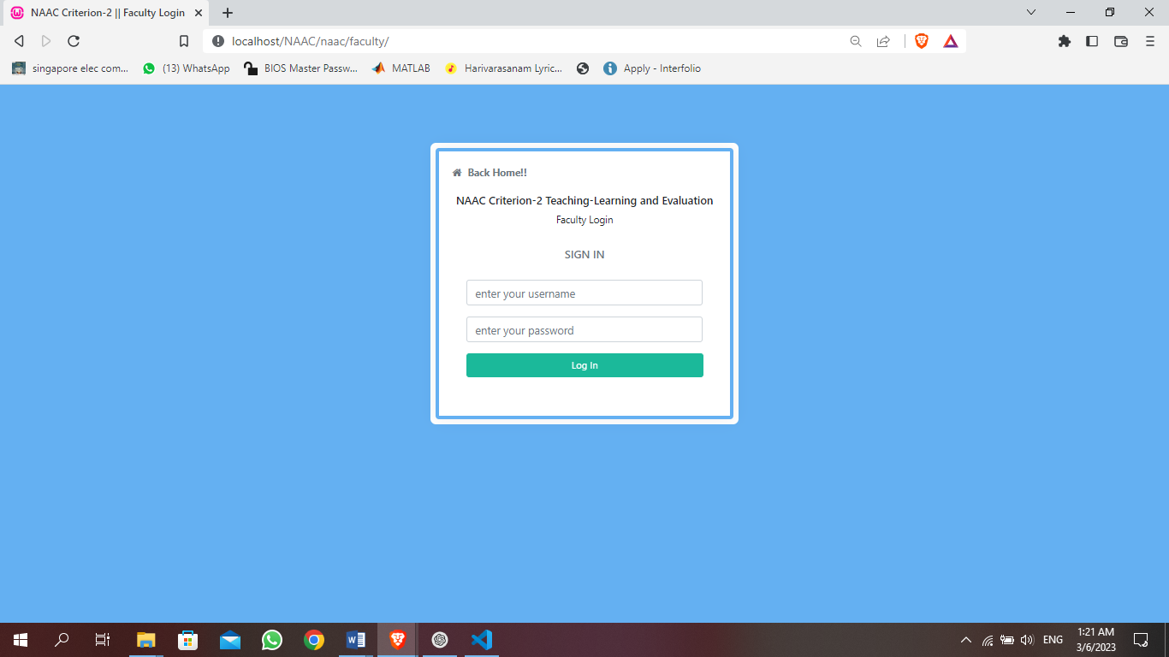

**ADMIN DASHBOARD**

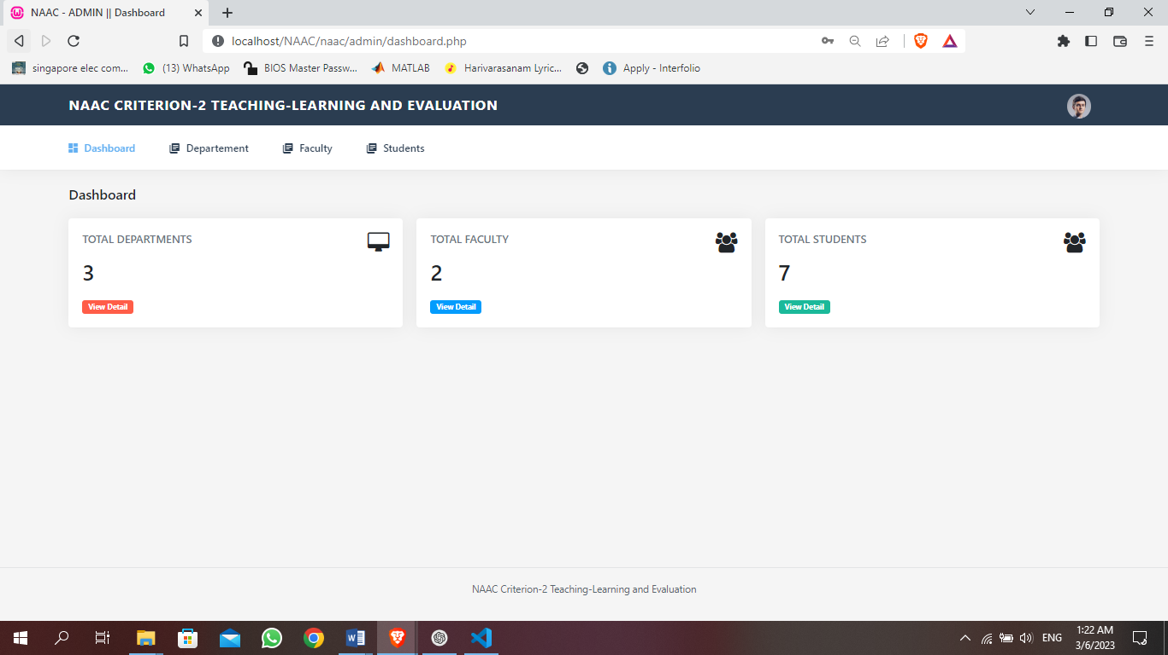

**ADMIN ADD DEPARTMENT**

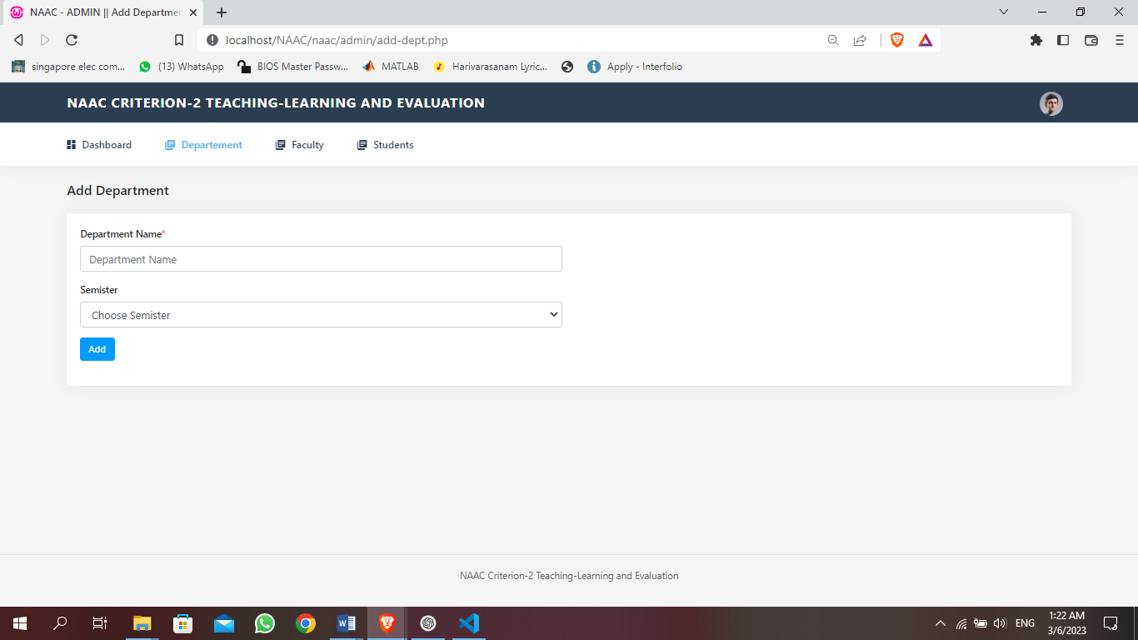

**ADMIN MANAGE DEPARTMENT**

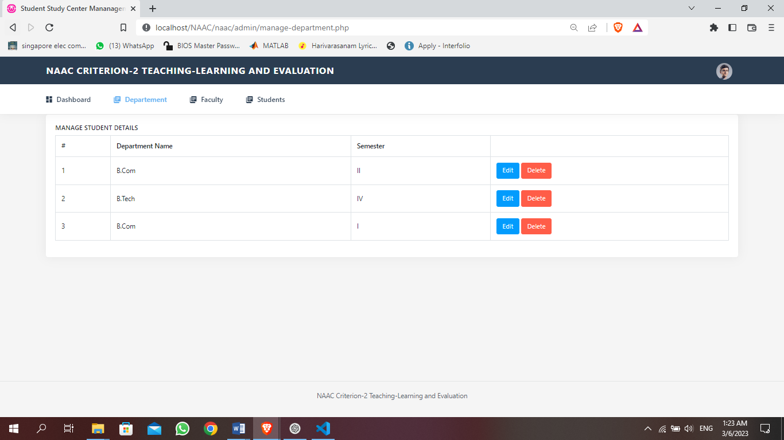

**ADMIN ADD FACULTY**

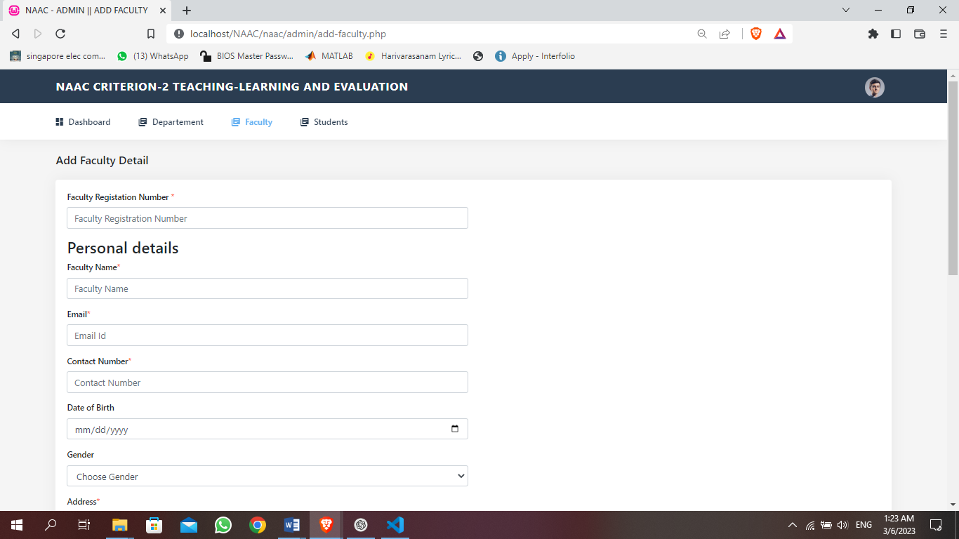

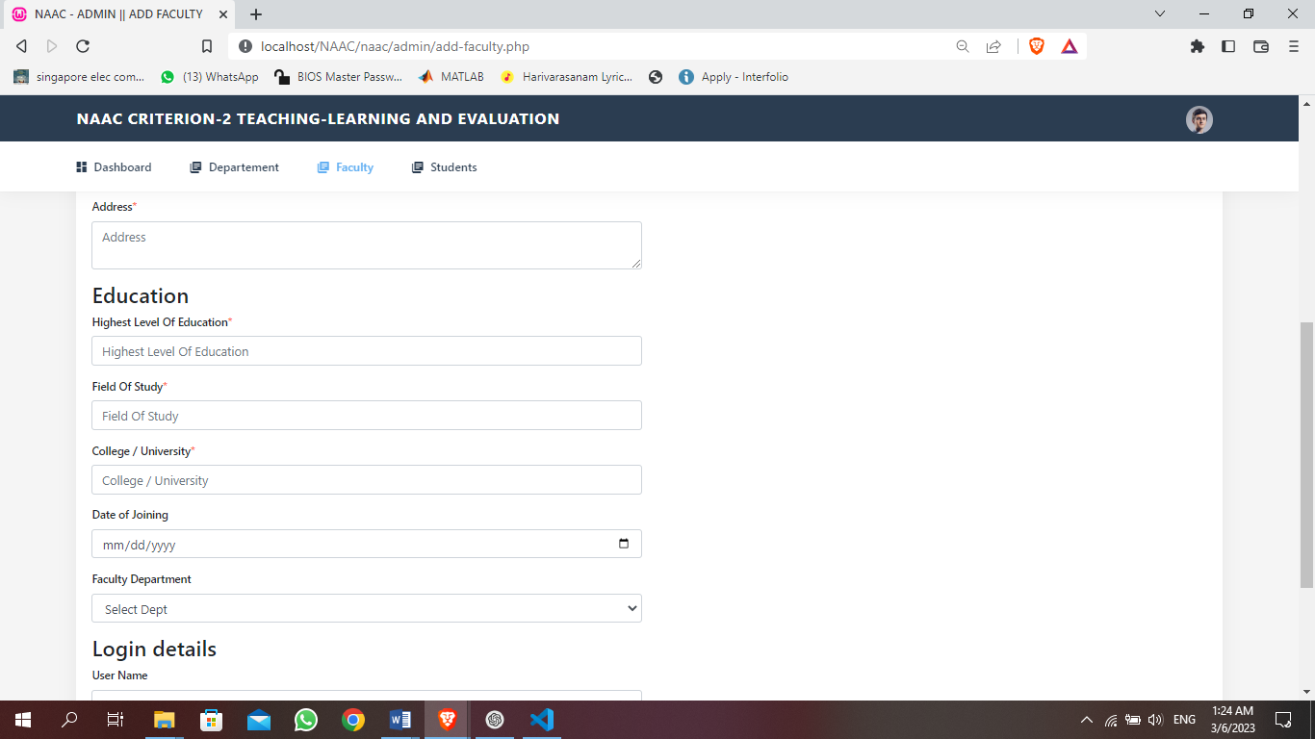

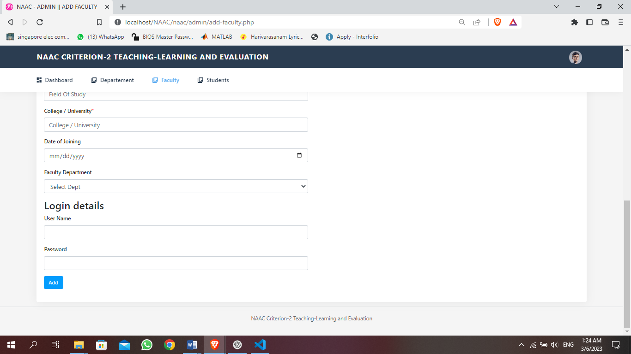

**ADMIN ADD STUDENT**

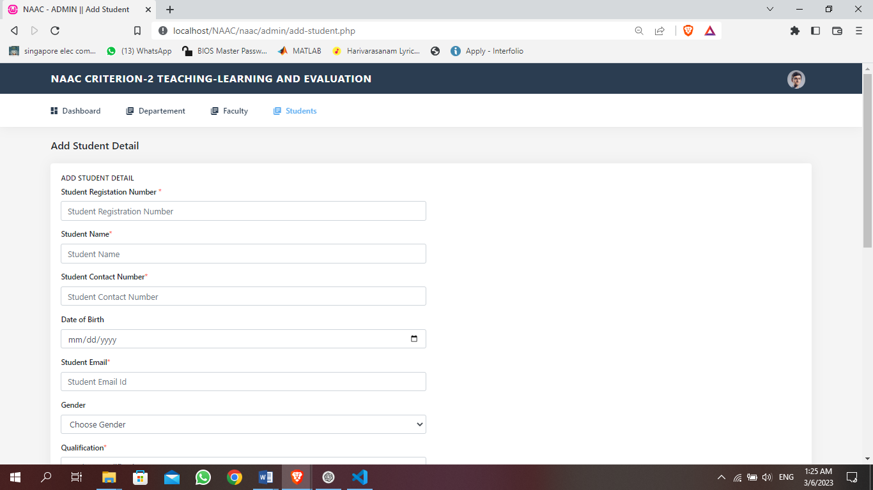

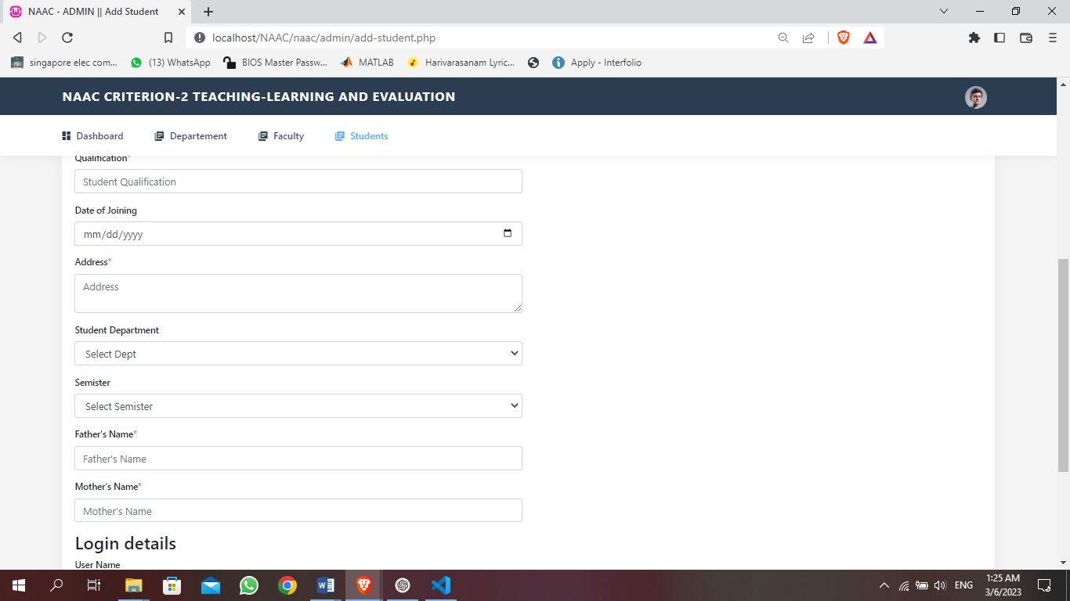

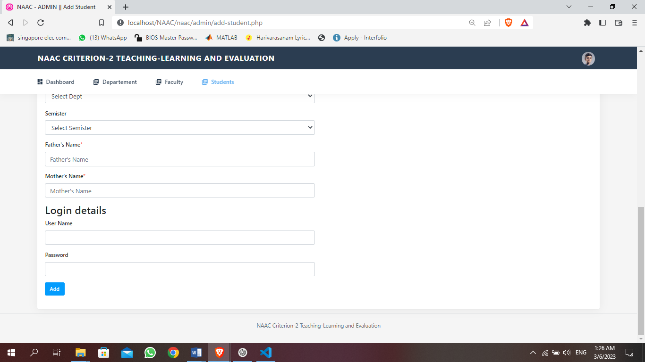

**ADMIN MANAGE STUDENT**

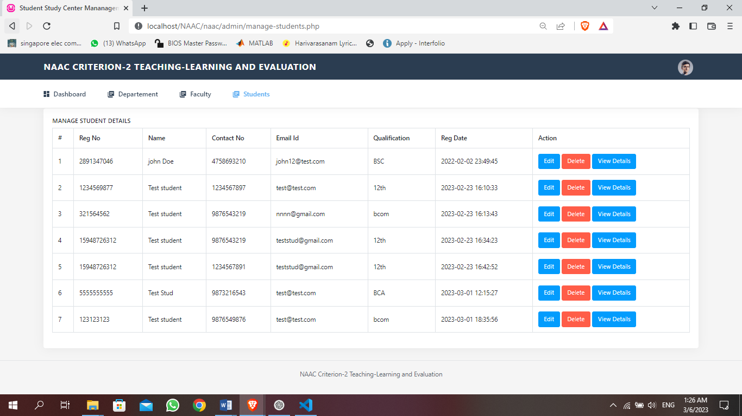

**STUDENT VIEW**

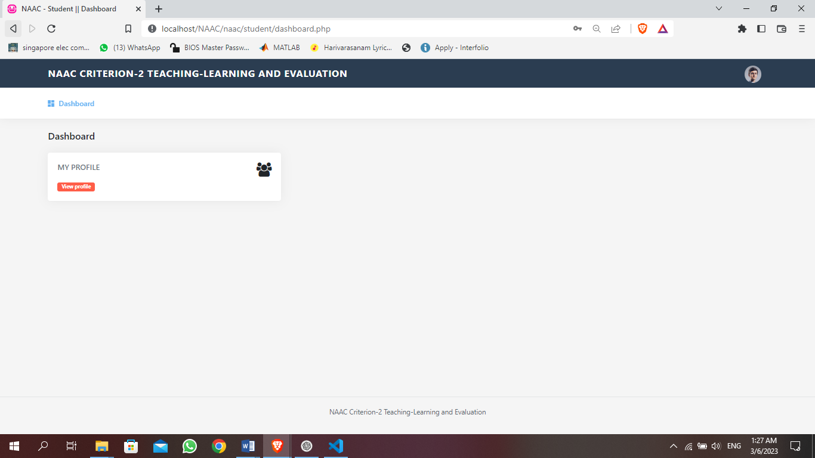

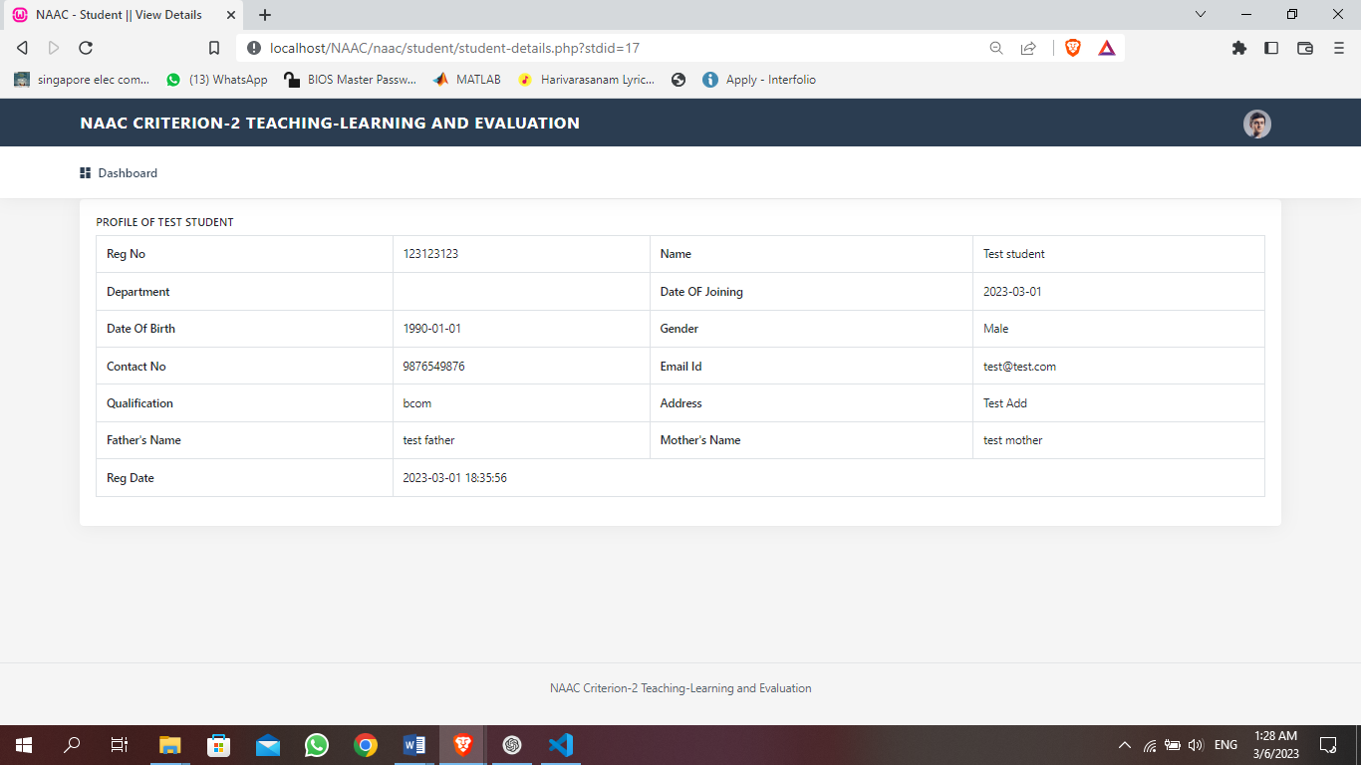

**6.FUTURE ENHANCEMENT**

Here are some potential future enhancements for the PHP web application developed for NAAC Criterion 2: Teaching-Learning and Evaluation:

Chatbot integration: Incorporating a chatbot within the application can help students and faculty get quick answers to common queries. The chatbot could be programmed to answer frequently asked questions related to course schedules, assignments, and grades.

Learning analytics: Adding learning analytics to the application can help faculty and administrators identify areas where students are struggling and provide targeted interventions. Learning analytics can also help institutions identify trends in student performance and make data-driven decisions to improve the quality of education.

Gamification: Incorporating gamification elements within the application can help increase student engagement and motivation. For example, faculty can create quizzes and games related to course content to make learning more interactive and fun.

Mobile application: Developing a mobile application for the PHP web application can increase accessibility and convenience for students and faculty. A mobile application can provide quick access to course materials, assignments, and grades from any location.

Integration with plagiarism detection tools: Integrating plagiarism detection tools within the application can help faculty identify instances of plagiarism and take appropriate action. This can help maintain academic integrity and ensure that students are submitting original work.

Social media integration: Integrating social media within the application can help increase collaboration and communication among students and faculty. For example, students can form study groups and share resources through social media platforms integrated within the application.

These are just a few potential future enhancements for the PHP web application developed for NAAC Criterion 2: Teaching-Learning and Evaluation. Implementing these enhancements can help institutions further improve the quality of education and enhance the user experience for students, faculty, and administrators.

**7. CONCLUSION**

The PHP web application developed for NAAC Criterion 2: Teaching-Learning and Evaluation is a comprehensive solution that addresses the key challenges faced by educational institutions in managing the teaching-learning process and evaluating student performance. The application provides a user-friendly interface for students, faculty, and administrators to manage various aspects of the teaching-learning process, including course management, assignment submission, grading, and generating reports.

The application has several modules, including the Admin module, Student module, and Faculty module, which are designed to meet the specific needs of each user group. The modules are modular and flexible, allowing for easy customization and integration with other systems.

The PHP web application has undergone extensive testing and feedback from users, ensuring that it meets their needs and expectations. It is also secure, with robust security features, including role-based access control, encryption, and SSL.

The project has also demonstrated the feasibility of developing a comprehensive web application for educational institutions using PHP. The use of PHP has several advantages, including its ease of use, flexibility, and compatibility with a wide range of operating systems and databases.

In conclusion, the PHP web application developed for NAAC Criterion 2: Teaching-Learning and Evaluation is a valuable tool for educational institutions seeking to improve the quality of education and enhance the user experience for students, faculty, and administrators. It provides a comprehensive solution that is user-friendly, modular, flexible, and secure. The project has demonstrated the feasibility of using PHP to develop comprehensive web applications for educational institutions, and there is potential for further enhancements in the future.

**BIBLIOGRAPHY**

**Book References**

* + Steven Holzner, PHP:The complete Reference 2017 McGraw Hill Education;Raunak php tudy edition(1 July 2017)
  + Gary B.Shelly,Harry J.Rosenblatt, “System Analysis and design”,2009.

**WEBSITES:**

* www.w3school.com
* www.youtube.com
* www.tutorialspoint.com