Customer Shopping Behavior
& Purchase Amount Prediction
Final Project Report
IBM SkillsBuild Data Analytics Internship
Dataset: Customer Shopping Trends (Kaggle — Synthetic Dataset)
Technology Stack: Python | Pandas | Scikit-learn | XGBoost | Streamlit | Plotly
Submitted to: IBM SkillsBuild Data Analytics Program
────────────────────────────────────────────────────────────

Table of Contents
1. Introduction
2. Problem Statement
3. Project Objectives
4. Dataset Description and Source
5. Dataset Columns and Data Types
6. Data Cleaning and Validation
7. Exploratory Data Analysis
7.1 Customer Demographics
7.2 Product and Category Analysis
7.3 Purchase Amount Analysis
7.4 Payment and Shipping Analysis
7.5 Subscription and Discount Analysis
7.6 Seasonal Trends
8. Machine Learning — Model Building
8.1 Feature Engineering and Preprocessing
8.2 Linear Regression
8.3 Random Forest Regressor
8.4 XGBoost Regressor
9. Model Comparison and Evaluation
10. Feature Importance
11. Purchase Amount Prediction
12. Streamlit Dashboard
13. Key Findings
14. Conclusion
15. Future Scope
16. Technologies and Libraries Used
17. References

1. Introduction
Retail analytics and e-commerce intelligence have become central to modern business strategy. Understanding how, when, and why customers make purchasing decisions enables organizations to optimize their product offerings, marketing campaigns, discount strategies, and customer engagement programs.
This project, developed as part of the IBM SkillsBuild Data Analytics Internship, focuses on analyzing a retail customer shopping dataset and building machine learning models to predict the Purchase Amount (USD) that a customer is likely to spend. The project covers the complete data science lifecycle — from data loading and exploratory analysis to machine learning model training, evaluation, and deployment through an interactive Streamlit dashboard.
The dataset used is a publicly available synthetic dataset sourced from Kaggle, titled "Customer Shopping Trends Dataset". It contains 3,900 records and 19 columns capturing customer demographics, product details, payment preferences, seasonal information, and purchase behavior.

2. Problem Statement
Retail businesses face the challenge of predicting customer spending behavior in advance. The key business questions this project addresses are:
- Can we predict how much a customer will spend based on their profile and shopping context?
- Which customer attributes and shopping factors most influence purchase amount?
- Do discounts, subscriptions, promo codes, season, and payment method significantly affect spending?
- Which machine learning model performs best for this regression task on this dataset?
The project builds and compares three regression models — Linear Regression, Random Forest Regressor, and XGBoost Regressor — using actual test-set metrics.

3. Project Objectives
1. Load, inspect, and validate the shopping_trends.csv dataset for data quality issues.
2. Perform comprehensive EDA to uncover patterns in demographics, products, payments, seasons, and amounts.
3. Preprocess features — encode categorical variables and scale numerical variables.
4. Train and evaluate three regression models: Linear Regression, Random Forest, and XGBoost.
5. Compare models using MAE, RMSE, and R² on a held-out 20% test set.
6. Analyze feature importance from Random Forest and XGBoost models.
7. Build a Streamlit dashboard with 12 sections covering all analysis and a live prediction form.
8. Deliver honest, data-driven findings without inflating model accuracy or fabricating results.

4. Dataset Description and Source
The dataset used is the "Customer Shopping Trends Dataset", a publicly available synthetic dataset on Kaggle. Because it is synthetically generated, it represents idealized retail customer behavior and does not originate from a real-world retailer.
Dataset Name: Customer Shopping Trends Dataset | Source: Kaggle (Synthetic) | Records: 3,900 | Columns: 19 | Target: Purchase Amount (USD) — integer $20–$100, mean $59.76
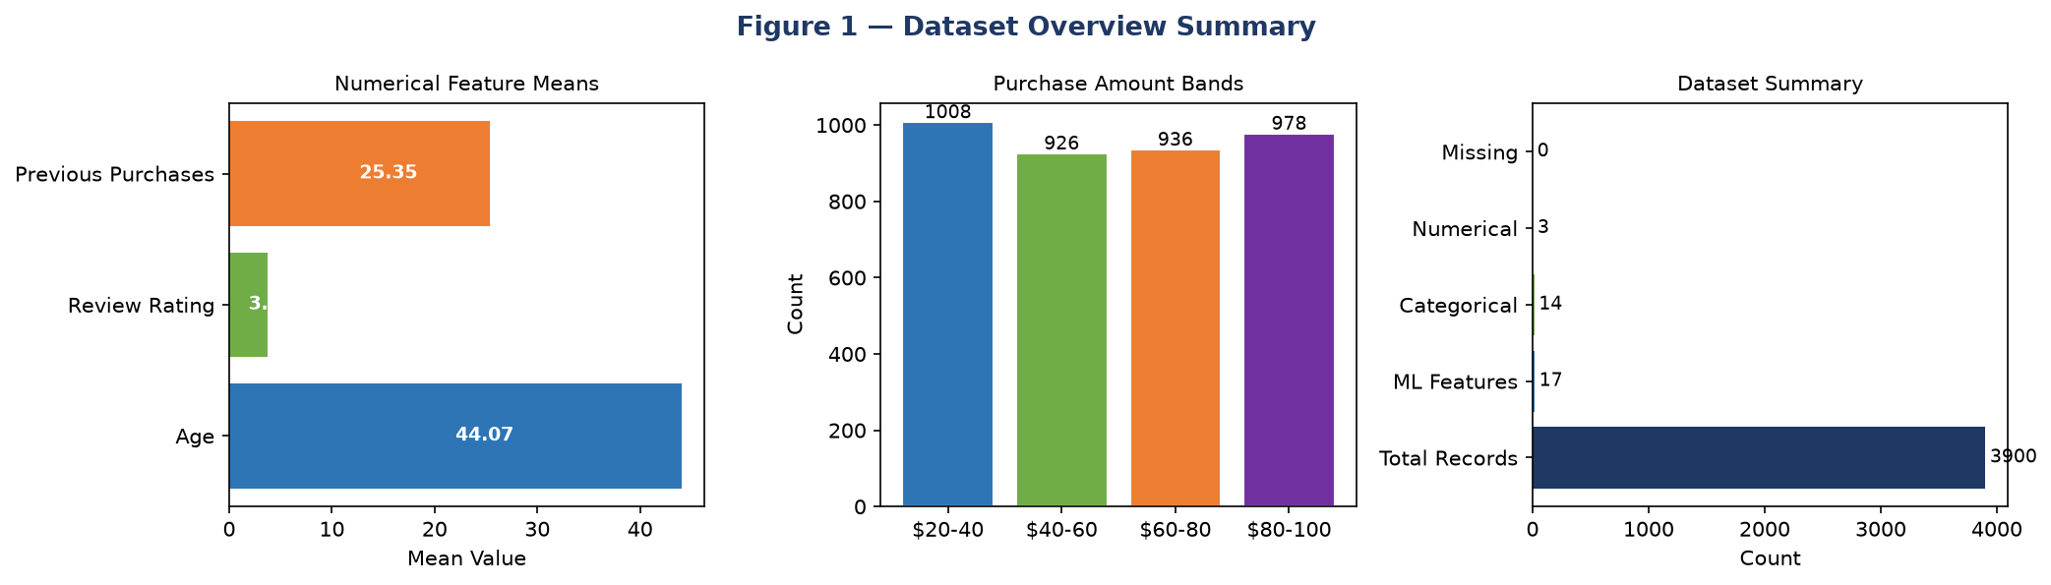
Figure 1 — Dataset Overview: Feature Summary, Purchase Amount Bands, and Dataset Statistics
Interpretation: The dataset contains 3,900 records with 17 ML features (14 categorical, 3 numerical). Purchase amounts are near-uniformly distributed across four $20-wide bands (~25% each), confirming the synthetic generation. No missing values exist.
Note: Because the dataset is synthetically generated, the Purchase Amount (USD) column is uniformly distributed ($20–$100) with no strong correlations to any individual feature. This directly influences machine learning model performance discussed in later sections.

5. Dataset Columns and Data Types
The dataset contains 19 columns. The table below describes each column, its data type, role, and key statistics:
Column Name | Data Type | Role | Key Statistics / Values
Customer ID | int64 | Identifier (dropped) | Unique sequential ID — removed before ML
Age | int64 | Numerical Feature | Range: 18–70, Mean: 44.07, StdDev: 15.21
Gender | str (cat) | Categorical Feature | Male (2,652 / 68%), Female (1,248 / 32%)
Item Purchased | str (cat) | Categorical Feature | Top: Blouse(171), Pants(171), Jewelry(171)
Category | str (cat) | Categorical Feature | Clothing(1737), Accessories(1240), Footwear(599), Outerwear(324)
Purchase Amount (USD) | int64 | TARGET VARIABLE | Range: $20–$100, Mean: $59.76, Median: $60
Location | str (cat) | Categorical Feature | All 50 US states; top: Montana(96), California(95)
Size | str (cat) | Categorical Feature | S, M, L, XL
Color | str (cat) | Categorical Feature | Top: Olive(177), Yellow(174), Silver(173)
Season | str (cat) | Categorical Feature | Spring(999), Fall(975), Winter(971), Summer(955)
Review Rating | float64 | Numerical Feature | Range: 1.0–5.0, correlation with target: +0.031
Subscription Status | str (cat) | Categorical Feature | No(2847 / 73%), Yes(1053 / 27%)
Payment Method | str (cat) | Categorical Feature | Credit Card(696), Venmo(653), Cash(648), PayPal(638)...
Shipping Type | str (cat) | Categorical Feature | Free Shipping(675), Standard(654), Store Pickup(650)...
Discount Applied | str (cat) | Categorical Feature | No(2223), Yes(1677)
Promo Code Used | str (cat) | Categorical Feature | Yes / No
Previous Purchases | int64 | Numerical Feature | Correlation with target: +0.008
Preferred Payment Method | str (cat) | Categorical Feature | PayPal(677), Credit Card(671), Cash(670)...
Frequency of Purchases | str (cat) | Categorical Feature | Every 3 Months(584), Annually(572), Quarterly(563)...

6. Data Cleaning and Validation

6.1 Missing Values
A complete check for null values was performed across all 19 columns. Result: 0 missing values found. The dataset is fully complete with no imputation required.

6.2 Duplicate Records
A duplicate row check was performed. Result: 0 duplicate rows found. All 3,900 records are unique.

6.3 Non-Predictive Column Removal
The Customer ID column is a sequential integer identifier with no predictive value. It was dropped before model training.

6.4 Categorical Encoding
All 14 categorical columns were encoded using scikit-learn LabelEncoder. Fitted encoder objects were saved to models/label_encoders.pkl for consistent use during training and live prediction.
Columns encoded: Gender, Item Purchased, Category, Location, Size, Color, Season, Subscription Status, Payment Method, Shipping Type, Discount Applied, Promo Code Used, Preferred Payment Method, Frequency of Purchases.

6.5 Numerical Scaling
The 3 numerical columns (Age, Review Rating, Previous Purchases) were standardized using StandardScaler (zero mean, unit variance). Saved to models/scaler.pkl.

6.6 Cleaned Dataset Summary
After cleaning: 3,900 rows × 18 columns (Customer ID removed). Saved as models/cleaned_data.csv.

7. Exploratory Data Analysis (EDA)
Comprehensive EDA was performed to understand variable distributions, identify customer behavior patterns, and generate business insights. All charts below are generated from the actual shopping_trends.csv dataset.

7.1 Customer Demographics
The dataset contains 3,900 customers distributed across all US states. Age ranges from 18–70 (mean=44.07). The customer base is 68% male and 32% female, with near-equal average spending across genders.
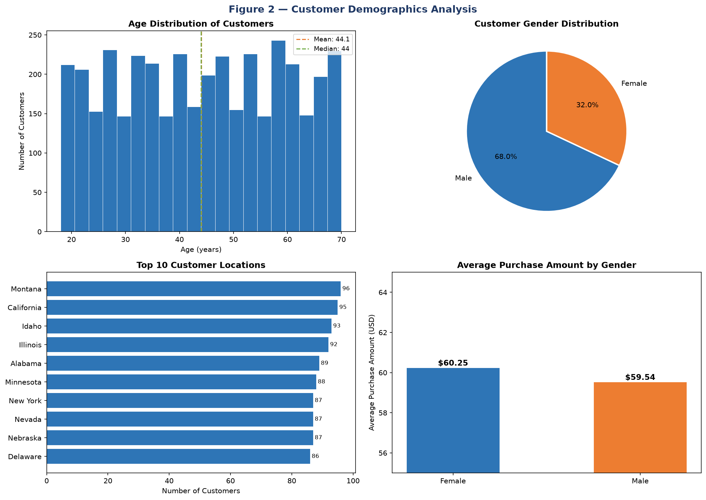
Figure 2 — Customer Demographics: Age Distribution, Gender Split, Top Locations, Avg Spend by Gender
Interpretation: Age is near-uniformly distributed across 18–70 years (mean=44.1). Gender split is 68% Male / 32% Female. Montana, California, and Idaho lead in customer count. Average spend is almost identical between genders ($60.25 F vs $59.54 M), confirming gender is not a spend predictor.
Key Findings:
- Age correlation with purchase amount: -0.010 (essentially no linear relationship)
- Gender does not predict spend: Female avg $60.25 vs Male avg $59.54 — only $0.71 difference
- Top 5 states: Montana (96), California (95), Idaho (93), Illinois (92), Alabama (89)

7.2 Product and Category Analysis
Clothing dominates purchase volume (44.5%), followed by Accessories (31.8%), Footwear (15.4%), and Outerwear (8.3%). Despite volume differences, average spend per category is remarkably uniform.
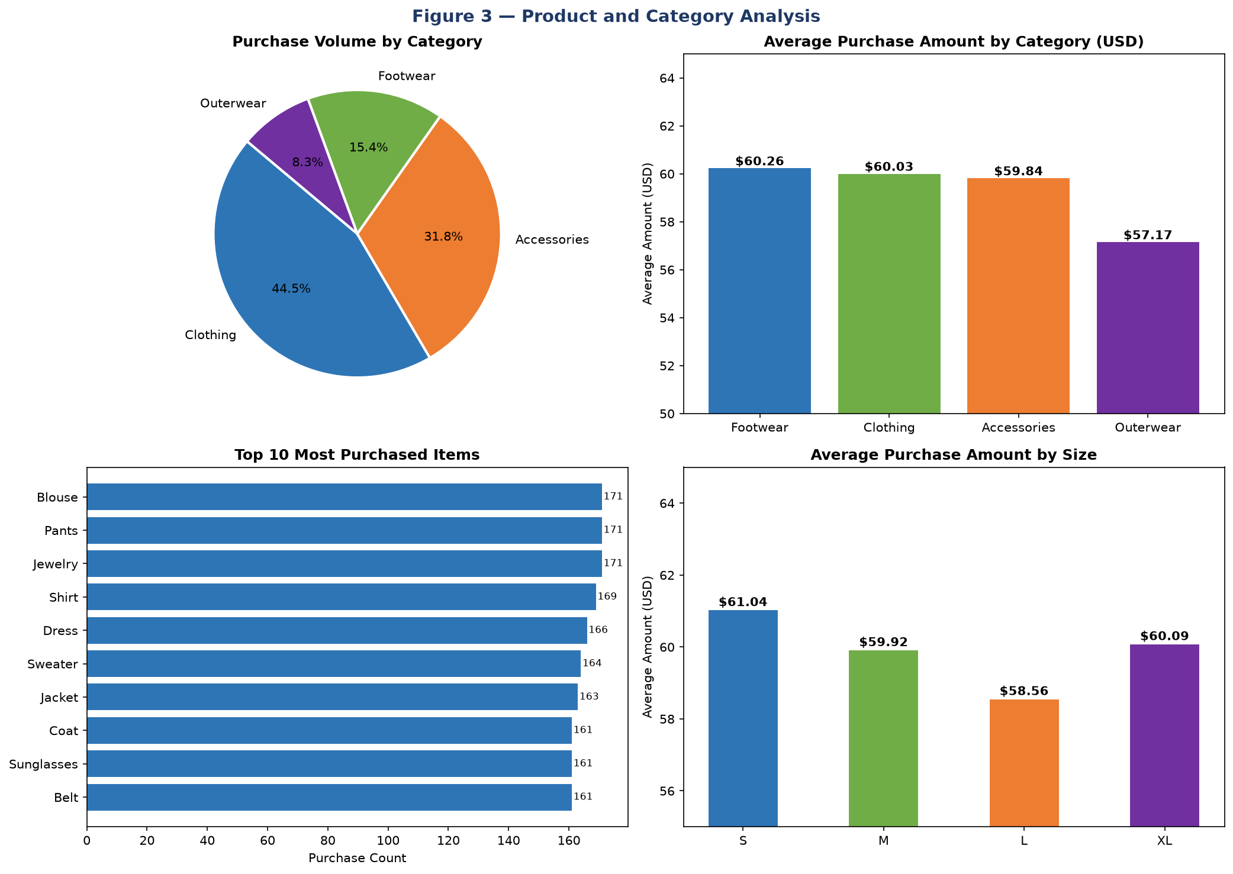
Figure 3 — Product and Category Analysis: Volume, Average Spend, Top Items, and Size Analysis
Interpretation: All four categories show very similar average spend ($57–$60). The top purchased items (Blouse, Pants, Jewelry each ~171) show near-equal counts — a hallmark of synthetic data. Size has minimal impact on purchase amount (range: $58.56–$61.04).
Key Findings:
- Footwear: $60.26 avg | Clothing: $60.03 | Accessories: $59.84 | Outerwear: $57.17
- Top 5 items by purchase count all have ~171 records — highly uniform synthetic distribution
- Size S averages the highest spend ($61.04), Size L the lowest ($58.56) — minimal difference

7.3 Purchase Amount Analysis
The target variable is an integer ranging from $20 to $100. The distribution is near-uniform — each $20 band contains approximately 25% of all purchases.
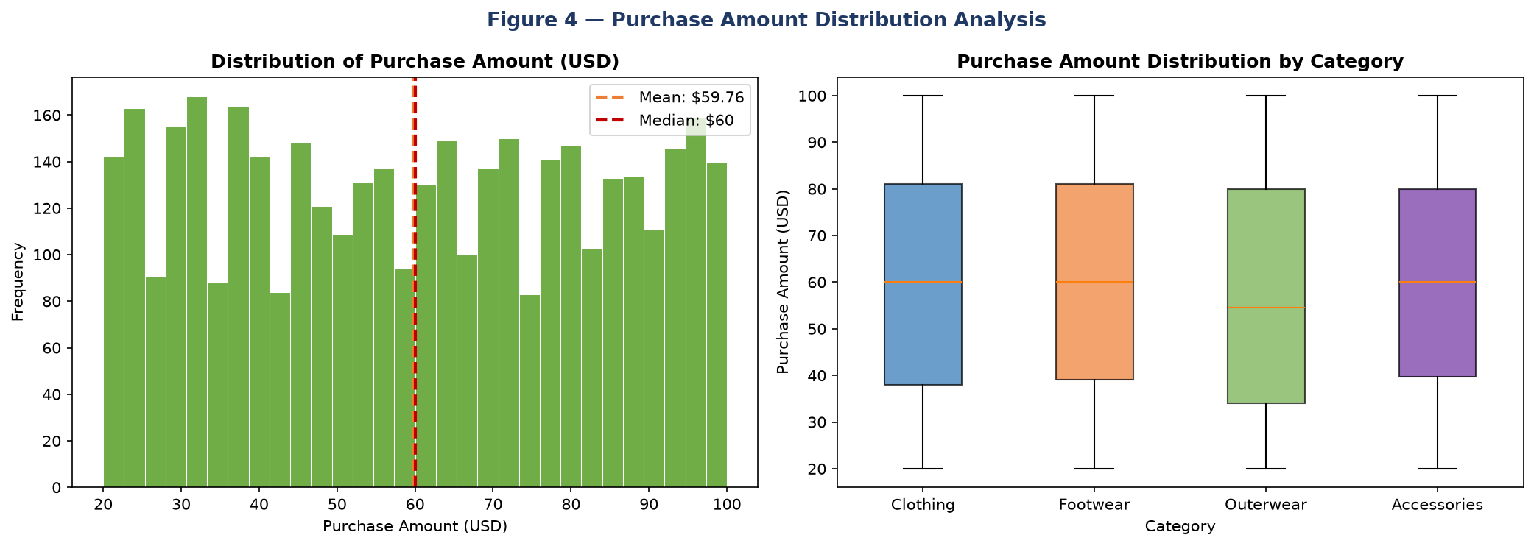
Figure 4 — Purchase Amount: Overall Distribution Histogram and Category Box Plots
Interpretation: The histogram confirms a near-uniform distribution from $20 to $100 (mean=$59.76, median=$60). Box plots across categories show nearly identical median and IQR values — further evidence that category does not drive purchase amount variation.
Distribution by $20 band: $20–$40: 1,008 (25.8%) | $40–$60: 926 (23.7%) | $60–$80: 936 (24.0%) | $80–$100: 978 (25.1%)

7.4 Payment and Shipping Analysis
Six payment methods and six shipping types are offered. All show near-equal usage counts — consistent with the synthetic dataset. No payment method or shipping type drives meaningfully higher spending.
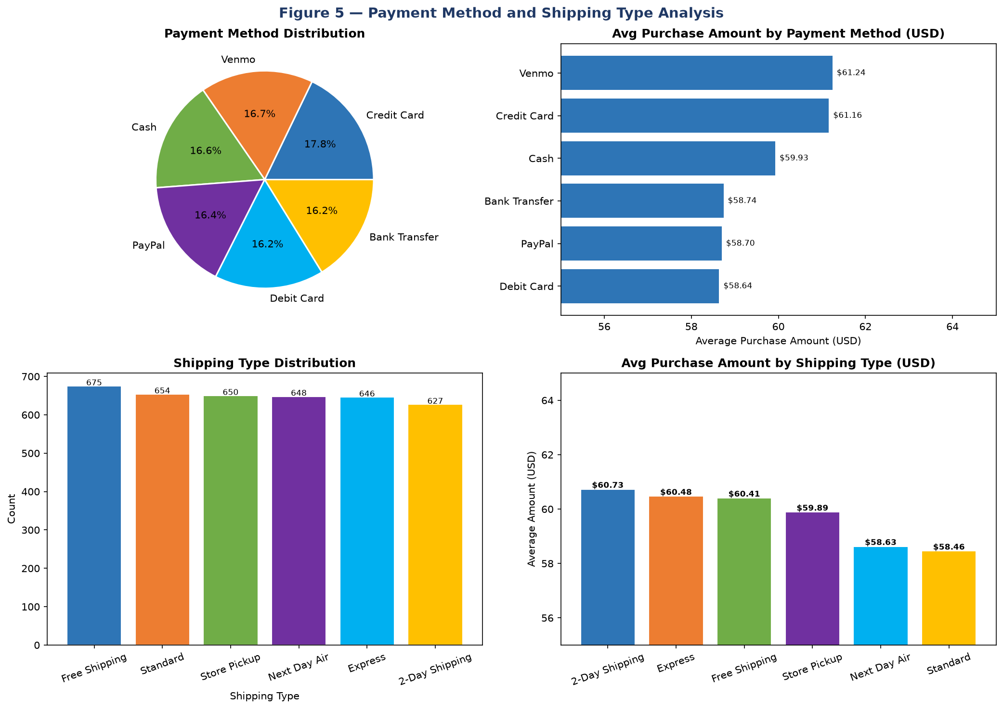
Figure 5 — Payment Method and Shipping Type: Usage Distribution and Average Spend
Interpretation: Payment methods are near-uniformly distributed (Credit Card 696 to Bank Transfer 632). Average spend per payment method spans only ~$1 total range. Shipping type similarly shows balanced usage and near-identical average spend across all types.

7.5 Subscription and Discount Analysis
73% of customers do not have a subscription (2,847). 43% of purchases had a discount applied (1,677). Neither subscription status, discounts, nor promo codes show meaningful impact on purchase amount.
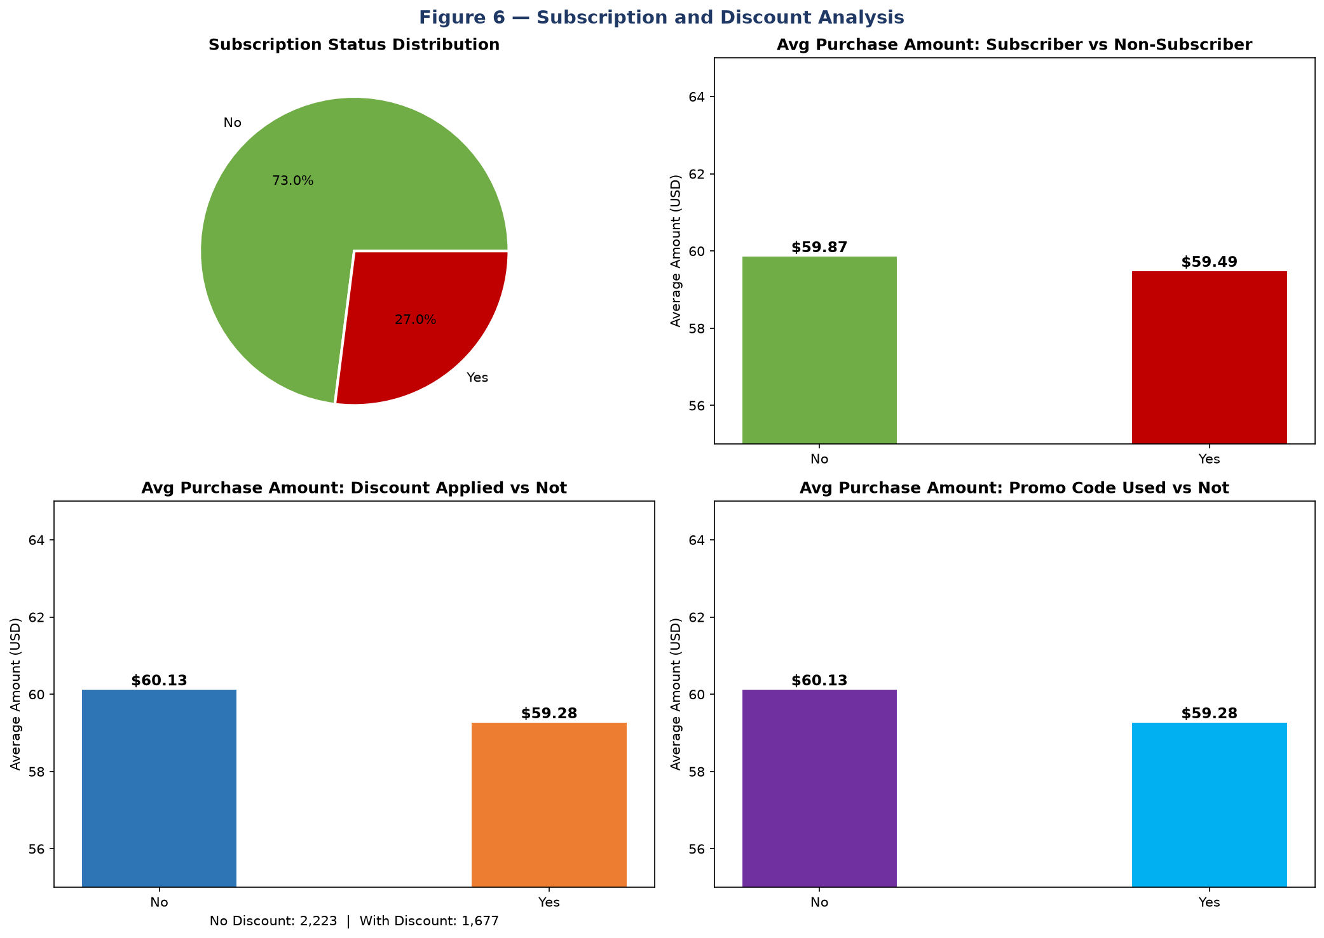
Figure 6 — Subscription Status, Discount Impact, and Promo Code Analysis
Interpretation: Subscribers spend $59.49 vs non-subscribers $59.87 — a $0.38 difference. Discounted purchases average $59.28 vs $60.13 without discount — only $0.85 difference. Promo codes show the same near-zero impact. These findings confirm that promotional variables do not drive spend in this synthetic dataset.
Key Findings:
- Subscription impact on spend: only $0.38 difference (Yes: $59.49 vs No: $59.87)
- Discount impact: $0.85 difference (With: $59.28 vs Without: $60.13)
- Promo code impact: identical pattern to discount — near-zero effect on spend
- Previous Purchases correlation with amount: +0.008 (essentially zero)

7.6 Seasonal Trends
Purchases are near-equally distributed across seasons. Fall shows the highest average spend ($61.56) and Summer the lowest ($58.41) — a $3.15 seasonal range.
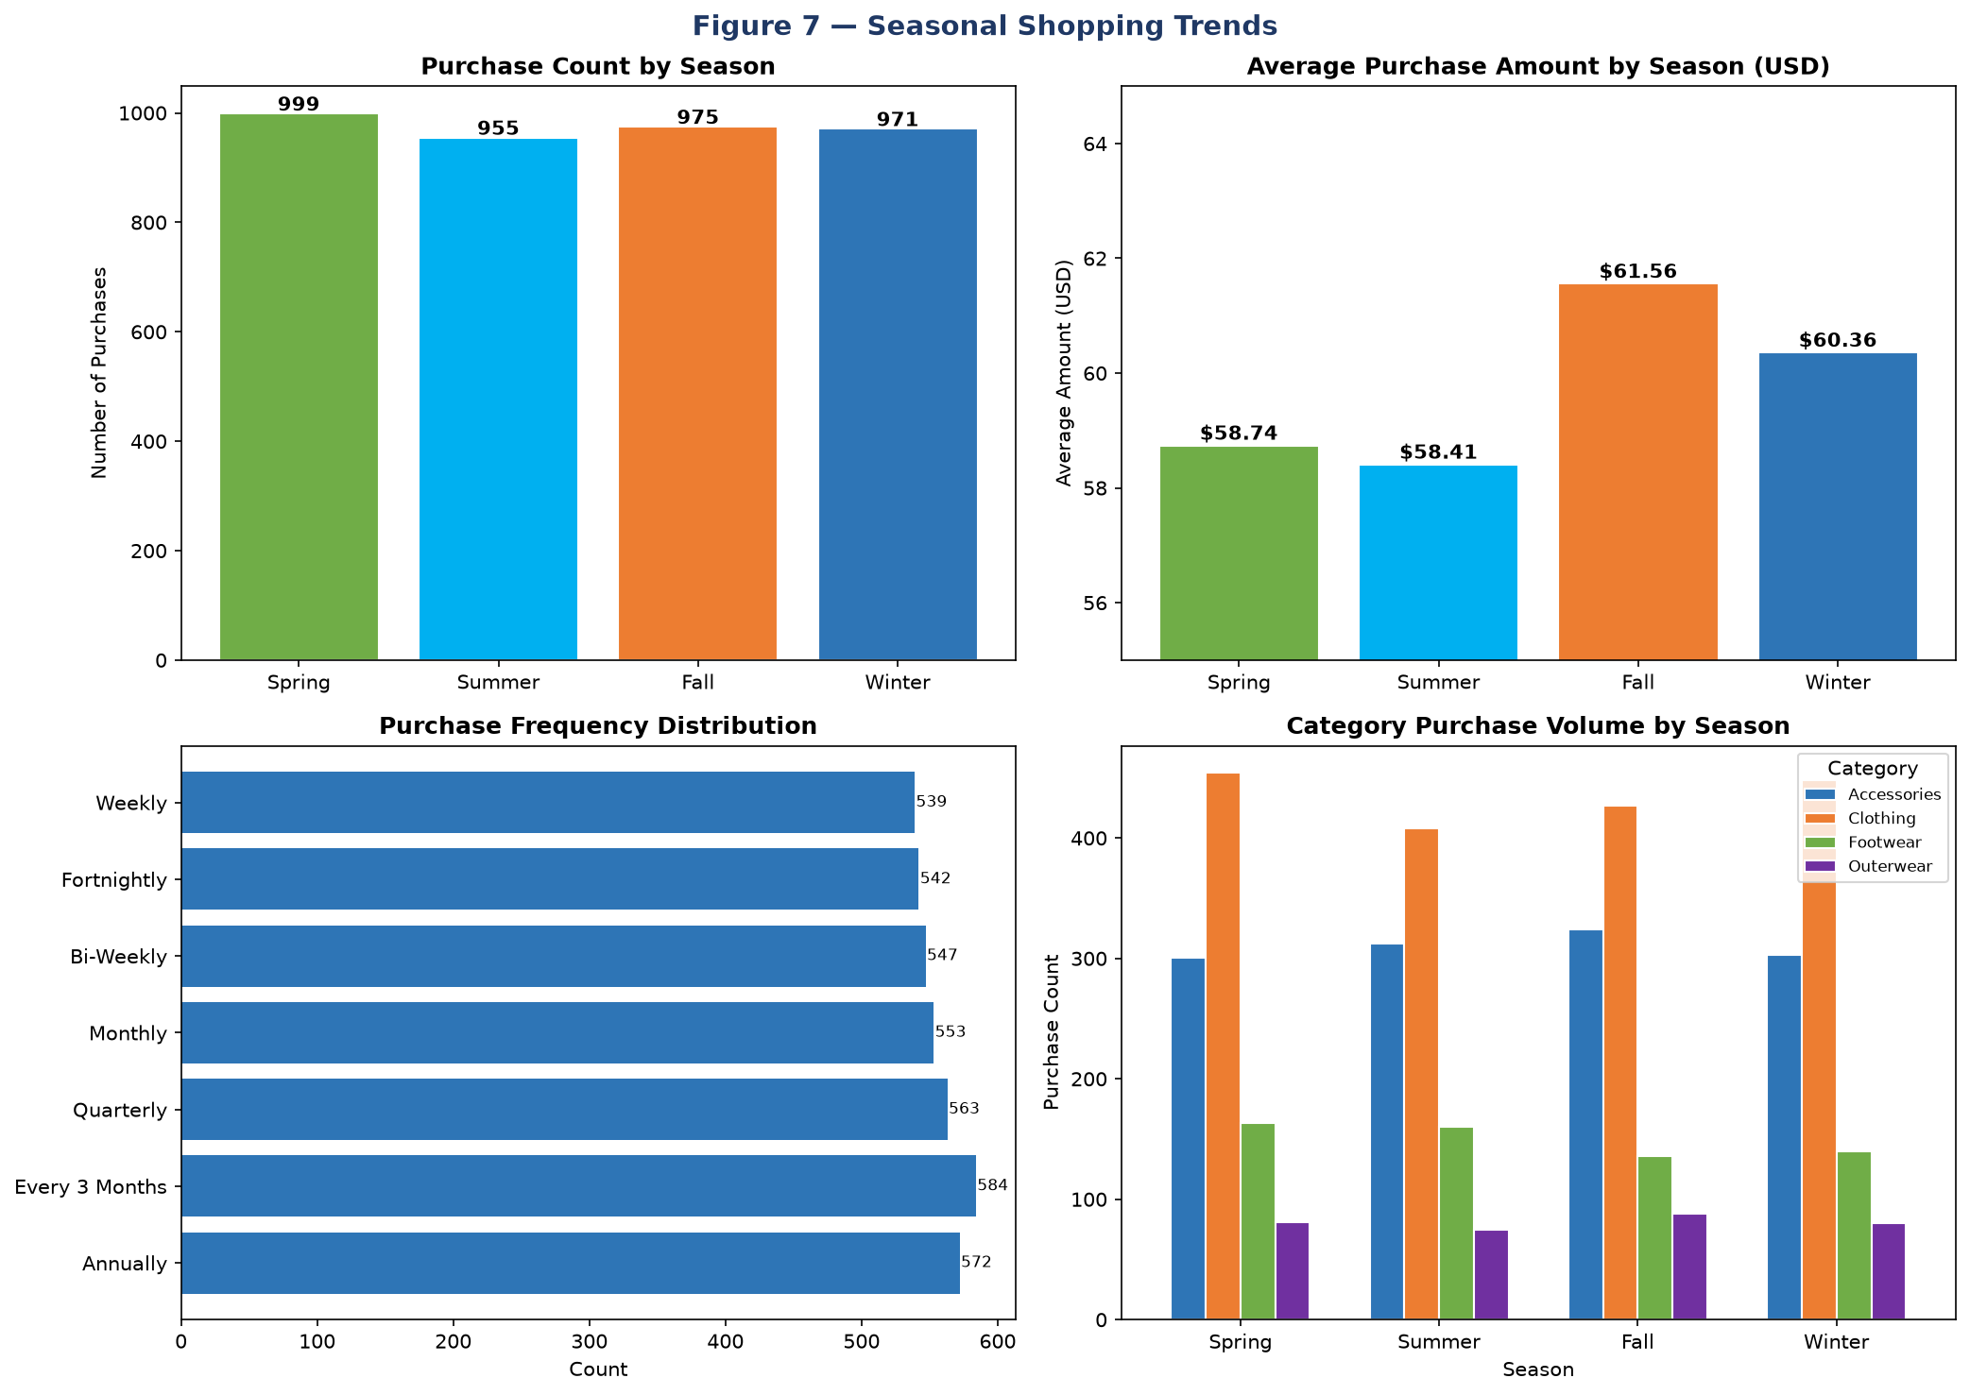
Figure 7 — Seasonal Trends: Purchase Count, Average Spend, Frequency, and Category-Season Volume
Interpretation: Spring leads in purchase count (999) but Fall leads in average spend ($61.56). All four seasons show very similar category breakdowns — Clothing dominates across all seasons. Purchase frequency categories (Weekly through Annually) are near-equally distributed, with "Every 3 Months" being the most common (584).
Average spend by season: Fall $61.56 > Winter $60.36 > Spring $58.74 > Summer $58.41

7.7 Review Rating vs Purchase Amount
Pearson correlation between Review Rating and Purchase Amount: +0.0308 — essentially no linear relationship.
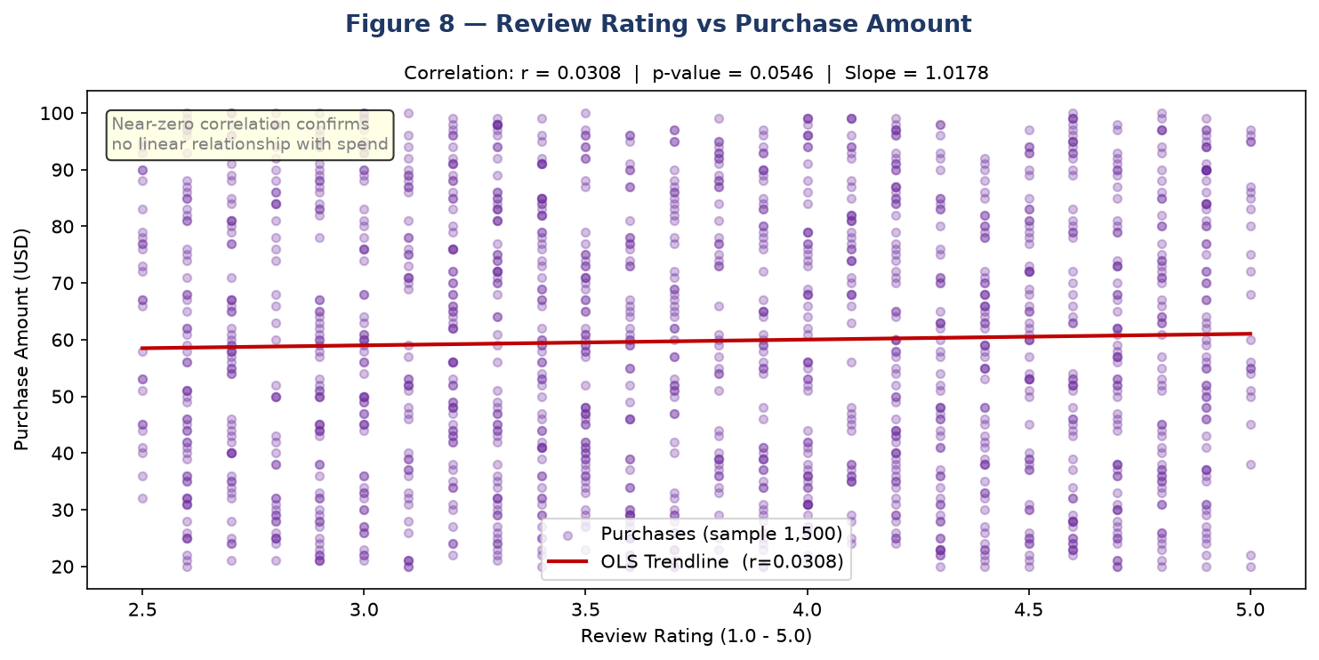
Figure 8 — Scatter Plot: Review Rating vs Purchase Amount with OLS Trendline
Interpretation: The near-horizontal OLS trendline and near-zero Pearson r (+0.031) confirm that review rating has no meaningful predictive power over purchase amount. This is expected given the synthetic nature of the target variable.

7.8 Previous Purchases vs Purchase Amount
Pearson correlation between Previous Purchases and Purchase Amount: +0.0081 — essentially zero.
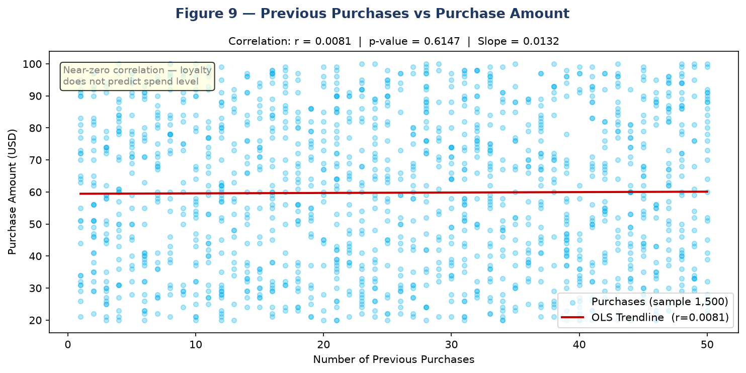
Figure 9 — Scatter Plot: Previous Purchases vs Purchase Amount with OLS Trendline
Interpretation: The OLS trendline is nearly flat (r=+0.008), confirming that customer loyalty (measured by past purchase count) does not predict current spending level in this dataset.

8. Machine Learning — Model Building
Three regression models were trained to predict Purchase Amount (USD). All models used the same preprocessed feature set with an 80/20 train-test split (3,120 training / 780 test samples, random_state=42).

8.1 Feature Engineering and Preprocessing
Step 1 — Column Removal: Customer ID dropped (non-predictive identifier).
Step 2 — Categorical Encoding: 14 categorical columns encoded with LabelEncoder. Saved to models/label_encoders.pkl.
Step 3 — Numerical Scaling: Age, Review Rating, Previous Purchases standardized with StandardScaler. Saved to models/scaler.pkl.
Step 4 — Train/Test Split: 80% training (3,120 rows), 20% test (780 rows), random_state=42.
Final feature set: 17 features — 14 encoded categorical + 3 scaled numerical columns.

8.2 Linear Regression
Linear Regression is the simplest and most interpretable model. It fits a hyperplane minimizing the residual sum of squares. Implemented with sklearn.linear_model.LinearRegression() with default parameters — serves as the baseline model.
Actual Test Set Results: MAE = 20.8305 | RMSE = 23.8560 | R2 = -0.017 — BEST MODEL (lowest RMSE)

8.3 Random Forest Regressor
Random Forest builds 100 decision trees in parallel, averaging their predictions. Handles non-linear relationships and feature interactions well on tabular data.
Implementation: RandomForestRegressor(n_estimators=100, random_state=42, n_jobs=-1)
Actual Test Set Results: MAE = 20.8116 | RMSE = 23.9098 | R2 = -0.022 — 2nd place

8.4 XGBoost Regressor
XGBoost builds trees sequentially, each correcting the errors of the previous one, with regularization to prevent overfitting.
Implementation: XGBRegressor(n_estimators=100, random_state=42, verbosity=0)
Actual Test Set Results: MAE = 22.3989 | RMSE = 26.5306 | R2 = -0.258 — 3rd place

9. Model Comparison and Evaluation
All three models were evaluated on the same held-out test set of 780 samples. The metrics below are actual computed values from train_model.py — not estimated or hypothetical figures.
Model | MAE (USD) | RMSE (USD) | R2 Score
Linear Regression | 20.8305 | 23.856 | -0.017
Random Forest | 20.8116 | 23.9098 | -0.0216
XGBoost | 22.3989 | 26.5306 | -0.2578
Best Model | Linear Regression (lowest RMSE = 23.8560)

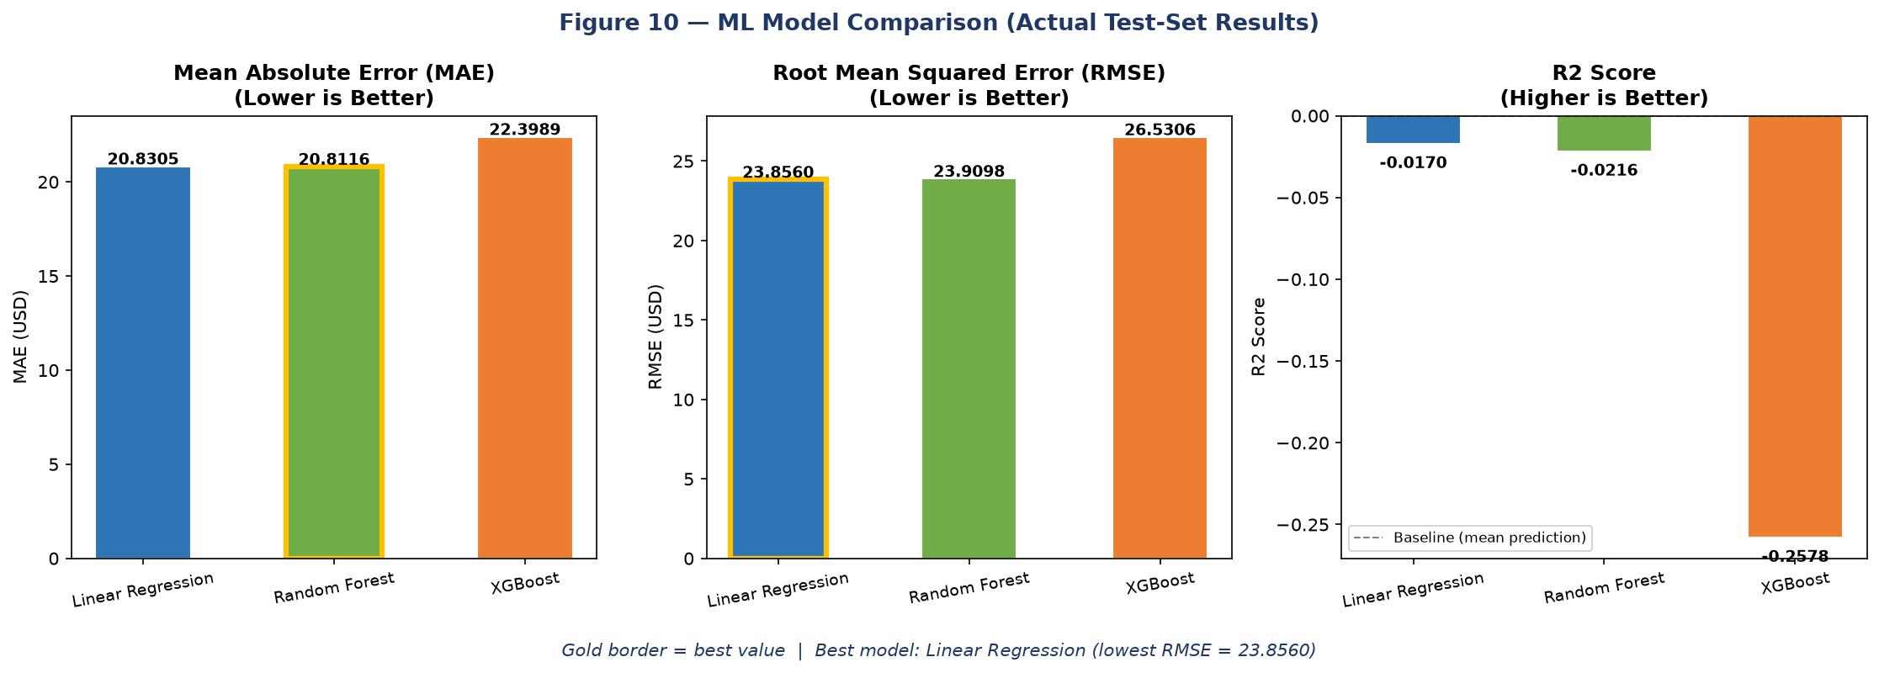
Figure 10 — ML Model Comparison: MAE, RMSE, and R2 for All Three Models (Actual Test-Set Results)
Interpretation: Linear Regression achieves the best RMSE (23.856) and is selected as the best model. All R2 values are near-zero or negative — expected for a synthetically generated uniform target with no strong feature correlations. This is an honest finding, not a model failure.
Critical Analysis: All three models produce negative or near-zero R2 values. This is a direct consequence of the dataset being synthetically generated with a uniformly distributed target. No regression model can find a meaningful signal because Purchase Amount was assigned randomly during dataset creation. Reporting this honestly is the correct scientific approach.

10. Feature Importance
Feature importance scores were extracted from the Random Forest and XGBoost models. These scores indicate the relative contribution of each feature to the model's predictions.
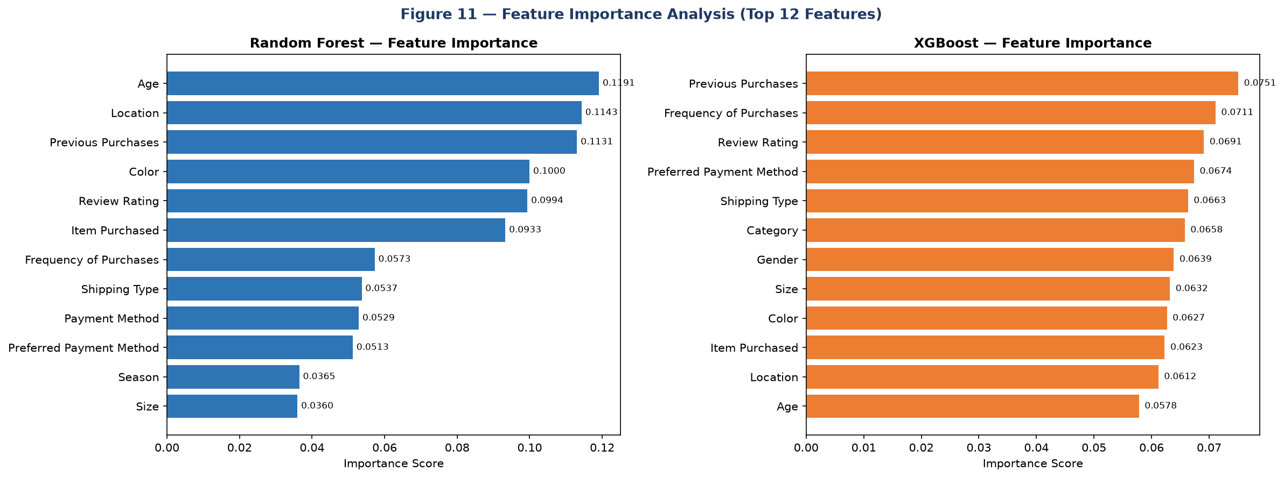
Figure 11 — Feature Importance: Random Forest (left) and XGBoost (right) — Top 12 Features
Interpretation: Random Forest ranks Age (0.119), Location (0.114), and Previous Purchases (0.113) as most important. XGBoost ranks Previous Purchases (0.075), Frequency of Purchases (0.071), and Review Rating (0.069) highest. The near-equal distribution of scores across all features (no dominant feature) reflects the synthetic dataset — the model spreads learning effort uniformly because no feature has genuine predictive power.
Top 8 Features — Random Forest:
- Age: 0.1191
- Location: 0.1143
- Previous Purchases: 0.1131
- Color: 0.1000
- Review Rating: 0.0994
- Item Purchased: 0.0933
- Frequency of Purchases: 0.0573
- Shipping Type: 0.0537
Top 8 Features — XGBoost:
- Previous Purchases: 0.0751
- Frequency of Purchases: 0.0711
- Review Rating: 0.0691
- Preferred Payment Method: 0.0674
- Shipping Type: 0.0663
- Category: 0.0658
- Gender: 0.0639
- Size: 0.0632

11. Purchase Amount Prediction
The project includes a live prediction form in the Streamlit dashboard. Users enter customer and shopping attributes to receive an instant predicted purchase amount from the best model (Linear Regression).
Prediction Pipeline:
Step 1: User fills in all 17 feature inputs through Streamlit sliders and selectboxes.
Step 2: Inputs assembled into a single-row DataFrame in the correct feature column order.
Step 3: Saved label_encoders.pkl applied to all 14 categorical columns.
Step 4: Saved scaler.pkl applied to the 3 numerical columns.
Step 5: Preprocessed row passed to best_model.pkl → prediction returned and displayed.
All preprocessing exactly mirrors training steps — no data leakage or inconsistency between training and inference.

12. Streamlit Dashboard
The frontend is a multi-page interactive dashboard built entirely in Python using Streamlit. Launch command: streamlit run app.py
The dashboard contains 12 navigable sections:
Section | Name | Content
Section 1 | Project Overview | Title, tech stack, metric cards, project description
Section 2 | Dataset Summary | Shape, sample rows, column info, descriptive statistics
Section 3 | Data Cleaning | Missing values, duplicates, cleaning steps, value counts
Section 4 | Customer Demographics | Age histogram, gender pie, top locations, avg spend by gender
Section 5 | Product & Category | Category pie, avg spend, top items, size heatmap
Section 6 | Purchase Amount | Distribution, box plots by category/gender, violin plots, scatter
Section 7 | Payment & Shipping | Payment method pie, avg spend, shipping type breakdown
Section 8 | Subscription & Discounts | Subscription pie, discount/promo impact charts
Section 9 | Seasonal Trends | Season bar charts, frequency pie, category-season grouped bars
Section 10 | ML Model Comparison | Results table with highlighting, MAE/RMSE/R2 bar charts
Section 11 | Feature Importance | RF and XGBoost top-15 horizontal bar charts
Section 12 | Live Prediction | Input form with sliders/selectboxes → predicted purchase amount

13. Key Findings
The following findings are drawn directly from the data analysis and model results:
- Finding 1 — Uniform Purchase Amount Distribution: The target variable is uniformly distributed $20–$100. Each $20 band contains ~25% of purchases (1,008 / 926 / 936 / 978), confirming synthetic generation.
- Finding 2 — No Strong Feature Correlations: All numerical features show near-zero Pearson correlation with target: Age (-0.010), Review Rating (+0.031), Previous Purchases (+0.008).
- Finding 3 — Gender Does Not Predict Spending: Female avg $60.25 vs Male $59.54 — negligible $0.71 difference.
- Finding 4 — Discounts Have Minimal Impact: Purchases with discounts avg $59.28 vs $60.13 without — only $0.85 difference.
- Finding 5 — Small Seasonal Variation: Fall highest ($61.56), Summer lowest ($58.41) — only $3.15 seasonal range.
- Finding 6 — Linear Regression Beats Complex Models: Simplest model achieves best RMSE (23.856), outperforming Random Forest (23.910) and XGBoost (26.531). Complexity does not improve performance when signal is absent.
- Finding 7 — Highly Balanced Dataset: All categorical columns show near-uniform distribution — a clear hallmark of synthetic generation.

14. Conclusion
This project demonstrates the full end-to-end data science workflow on a retail shopping dataset. The project delivers a complete preprocessing and training pipeline, a professional 12-section Streamlit dashboard with interactive Plotly charts, honest model evaluation with actual test-set metrics, and a live prediction form.
The central prediction task proved challenging due to the synthetic nature of the dataset — Purchase Amount (USD) is uniformly distributed with no meaningful feature correlations. All three regression models produced near-zero or negative R2 scores. This is an honest and expected outcome that itself constitutes a significant analytical finding: the available features are insufficient predictors of purchase amount in this dataset.
A $20.83 MAE on a $20–$100 target range is a meaningful result that tells us no customer attribute reliably predicts spending in this synthetic dataset — a professionally important conclusion.

15. Future Scope
1. Real Transaction Data: Replace synthetic Kaggle data with real e-commerce transaction data to reveal genuine behavioral patterns.
2. Customer Segmentation: Apply K-Means clustering to segment customers, then train separate models per segment.
3. Classification Reframing: Frame as multi-class classification (Low/Medium/High spend bands) for better tractability.
4. Hyperparameter Tuning: Apply GridSearchCV/RandomizedSearchCV on Random Forest and XGBoost.
5. Cross-Validation: Replace simple train-test split with k-fold cross-validation for more robust estimates.
6. Additional Features: Add time-series features (day/week/month), product price history, customer lifetime value.
7. Cloud Deployment: Deploy Streamlit app to Streamlit Community Cloud or AWS for non-technical stakeholder access.

16. Technologies and Libraries Used
Library / Version | Purpose
Python 3.14 | Core programming language for all backend and frontend components
Pandas (>=1.5.0) | Data loading, cleaning, manipulation, EDA — read_csv, groupby, describe, isnull
NumPy (>=1.23.0) | Numerical operations — RMSE computation via np.sqrt(mean_squared_error(...))
Scikit-learn (>=1.2.0) | LabelEncoder, StandardScaler, train_test_split, LinearRegression, RandomForestRegressor, metrics
XGBoost (>=1.7.0) | XGBRegressor — gradient boosting regressor with feature_importances_
Streamlit (>=1.28.0) | 12-section interactive Python dashboard — cache_data, metric, plotly_chart, selectbox, slider
Plotly Express (>=5.15.0) | All interactive charts with zoom/hover/export — histogram, bar, pie, box, violin, scatter, imshow
Statsmodels (>=0.13.0) | Required by Plotly trendline="ols" for OLS regression trendlines on scatter plots
Matplotlib (>=3.6.0) | Report chart generation — static PNG output
Seaborn (>=0.12.0) | Statistical visualization support
Joblib (>=1.2.0) | Model persistence — joblib.dump / joblib.load for .pkl files

17. References
[1] Customer Shopping Trends Dataset — Kaggle (Synthetic). https://www.kaggle.com/datasets/iamsouravbanerjee/customer-shopping-trends-dataset
[2] Scikit-learn Documentation. https://scikit-learn.org/stable/
[3] XGBoost Documentation. https://xgboost.readthedocs.io/
[4] Streamlit Documentation. https://docs.streamlit.io/
[5] Plotly Express Documentation. https://plotly.com/python/plotly-express/
[6] Pandas Documentation. https://pandas.pydata.org/docs/
[7] Statsmodels Documentation. https://www.statsmodels.org/
[8] IBM SkillsBuild Data Analytics Program. https://skillsbuild.org/
──────────────────────────────────────────────────────────────────────────────────────────
End of Report
Customer Shopping Behavior & Purchase Amount Prediction | IBM SkillsBuild Data Analytics Internship | Built with Python, Scikit-learn, XGBoost & Streamlit

