**Output for will stay subscribed:**

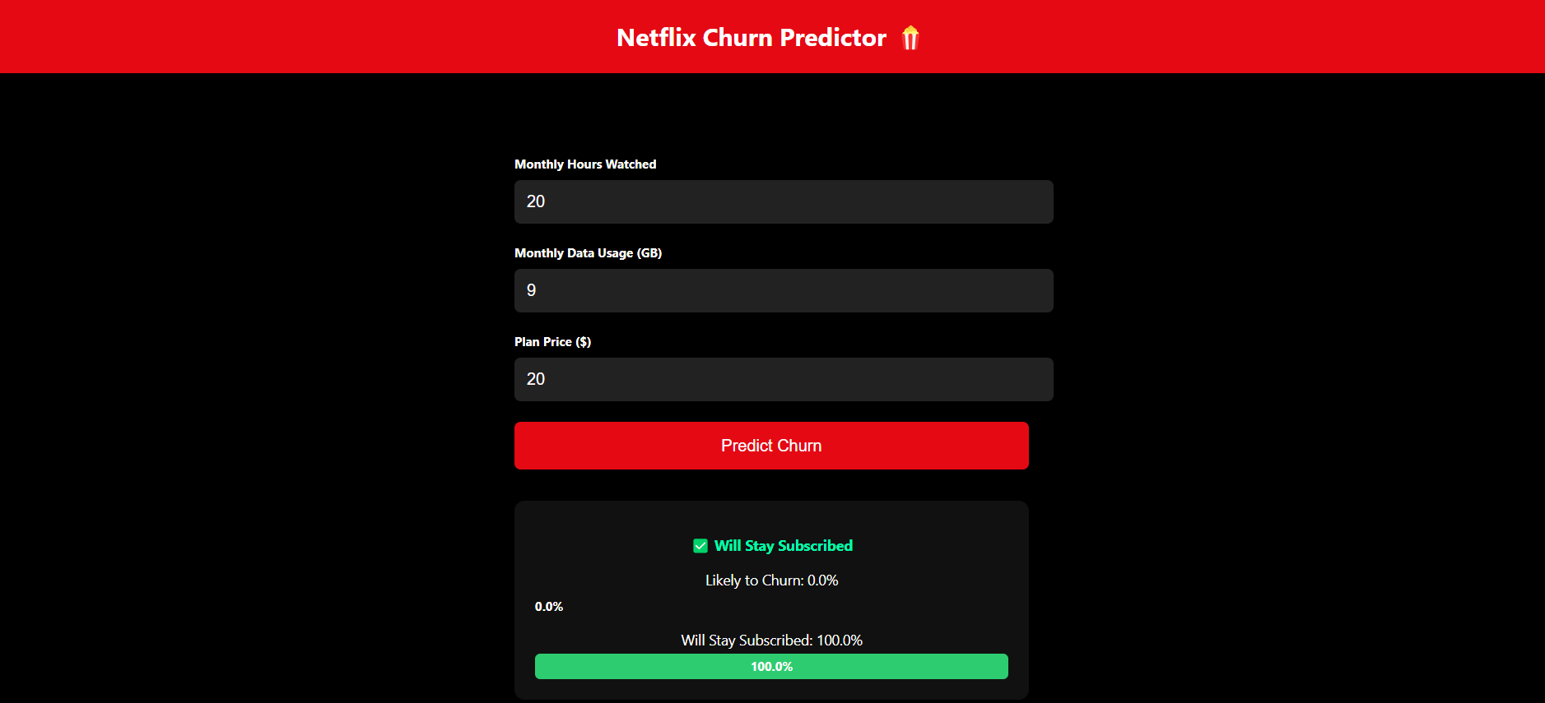

**Output for likely to churn:**

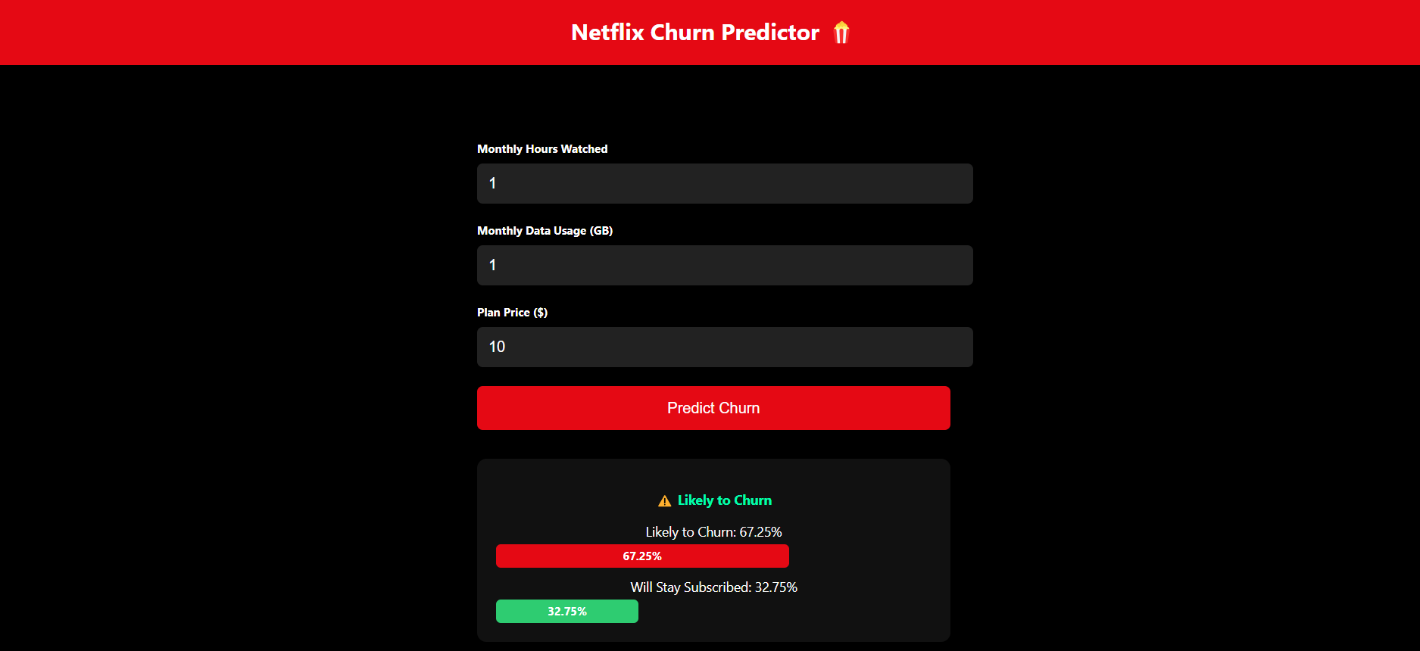

**Link**:https://www.kaggle.com/datasets/shubh0799/churn-modelling