BLUESTOCK FINTECH
Mutual Fund Analytics Platform
End-to-End Data Engineering, ETL Pipeline & Interactive Dashboard
Capstone Project Report
Prepared by: Intern / Data Analyst — Bluestock Fintech
Domain: Mutual Fund / Fintech
Date: June 2026

1. Executive Summary
This report documents the end-to-end build of a Mutual Fund Analytics Platform for Bluestock Fintech, covering ETL pipeline design, relational database modelling, exploratory data analysis, fund performance and risk metrics, an interactive Power BI dashboard, and advanced investor analytics. The project draws on ten datasets spanning 40 real mutual fund schemes, approximately 87,000 transaction-level rows, and over four years of NAV history anchored to genuine AMFI India data.
The platform was built on a PostgreSQL relational database following a star schema design (2 dimension tables, 9 fact tables), populated through a Python ETL pipeline, and explored through Jupyter notebooks covering exploratory data analysis, fund performance analytics, and advanced risk analytics including Value-at-Risk, rolling Sharpe ratios, investor cohort behaviour, and sector concentration. The final deliverable includes a 4-page interactive Power BI dashboard covering industry-level trends, fund performance comparison, investor demographics, and SIP/market trend analysis.

Key Outcomes
- A fully normalised PostgreSQL database with 11 tables and approximately 89,000 rows loaded with zero data-quality issues.
- A 10-chart exploratory data analysis notebook covering NAV trends, AUM growth, SIP inflows, investor demographics, and sector allocation.
- Computed risk-adjusted performance metrics (Sharpe, Sortino, Alpha, Beta, Maximum Drawdown, VaR, CVaR) for all 40 schemes.
- A 4-page interactive Power BI dashboard with slicers, KPI cards, and drill-down visuals across all required business areas.
- Advanced analytics covering investor cohort behaviour, SIP continuation risk, a simple fund recommendation engine, and sector concentration analysis.

2. Problem Statement
Despite the rapid growth of India's mutual fund industry — which as of December 2025 manages over Rs. 81 lakh crore in assets under management across 1,908 schemes and 26.12 crore investor folios — individual investors and financial advisors continue to face challenges in making data-driven fund selection decisions. This stems from data fragmentation across multiple AMFI publication formats, the absence of unified risk-adjusted comparison tools, limited benchmark tracking, and a lack of visibility into investor behaviour patterns.
This project addresses five concrete problems identified in the project brief:
- Data Fragmentation — NAV, AUM, SIP flow, and portfolio holdings data exist in disconnected formats across the AMFI website. Solved by consolidating all sources into a single PostgreSQL database via an automated ETL pipeline.
- Performance Comparison Gap — investors cannot easily compare funds on a risk-adjusted basis. Solved by computing and visualising Sharpe, Sortino, Alpha, and Beta for all 40 schemes in one dashboard.
- No Benchmark Tracking — most retail investors do not know if their fund is outperforming its benchmark. Addressed by joining NAV data with benchmark index prices for direct comparison.
- Investor Behaviour Blind Spot — limited visibility into how demographics and geography influence SIP behaviour. Addressed through dedicated investor analytics covering age group, city tier, gender, and transaction type.
- Slow Reporting — static monthly PDF reports are slow to produce. Solved with a refreshable, self-service Power BI dashboard connected directly to the live database.

3. Data Sources & Datasets
All datasets are derived from publicly available sources, primarily AMFI India, the mfapi.in REST API, and NSE/BSE published index data. NAV values are anchored to real historical values sourced from mfapi.in, while investor transaction data is synthetically generated using realistic demographic and geographic distributions observed in the Indian mutual fund market.

Dataset Inventory
# | Dataset | Rows | Description
01 | fund_master.csv | 40 | Master list of 40 real mutual fund schemes
02 | nav_history.csv | 46,000 | Daily NAV, Jan 2022 to May 2026
03 | aum_by_fund_house.csv | 90 | Quarterly AUM by fund house, 2022–2025
04 | monthly_sip_inflows.csv | 48 | Month-wise SIP inflow and account statistics
05 | category_inflows.csv | 144 | Net inflows by fund category, FY 2024-25
06 | industry_folio_count.csv | 21 | Total mutual fund folios by category
07 | scheme_performance.csv | 40 | Returns, Sharpe, Sortino, Alpha, Beta, Max Drawdown
08 | investor_transactions.csv | 32,778 | SIP, Lumpsum, and Redemption transactions
09 | portfolio_holdings.csv | 322 | Top equity holdings by fund and sector
10 | benchmark_indices.csv | 8,050 | Daily closing values for 7 benchmark indices

4. System Architecture & ETL Pipeline
The platform follows a standard data engineering pipeline: Extract, Transform, Load, Analyse, and Visualise. Raw CSV data is ingested via Python and Pandas, validated and transformed, then loaded into a PostgreSQL relational database designed as a star schema.

Database Schema
The schema consists of two dimension tables (dim_fund, dim_date) and nine fact tables (fact_nav, fact_transactions, fact_performance, fact_portfolio, fact_aum, fact_sip_industry, fact_category_inflows, fact_folio_count, fact_benchmark), totalling approximately 89,000 rows. Every fact table is indexed on its foreign keys and date columns to support fast dashboard query performance.

Table | Type | Approx. Rows | Grain
dim_fund | Dimension | 40 | One row per scheme
dim_date | Dimension | 1,826 | One row per calendar day, 2022–2026
fact_nav | Fact | 46,000 | Fund × Trading Day
fact_transactions | Fact | 32,778 | One row per transaction
fact_performance | Fact | 40 | One row per fund (snapshot)
fact_portfolio | Fact | 322 | Fund × Stock Holding
fact_aum | Fact | 90 | Fund House × Quarter
fact_sip_industry | Fact | 48 | One row per month
fact_category_inflows | Fact | 144 | Month × Category
fact_folio_count | Fact | 21 | One row per quarter
fact_benchmark | Fact | 8,050 | Index × Trading Day

Technology Stack
- Python 3, Pandas, NumPy — ETL, data cleaning, and metric computation
- PostgreSQL — production relational database, accessed via pgAdmin and SQLAlchemy
- Power BI Desktop — interactive dashboard development
- Jupyter / Kaggle Notebooks — exploratory and advanced analytics
- Matplotlib, Seaborn, Plotly — static and interactive chart generation

5. Exploratory Data Analysis
Exploratory analysis was performed across all ten datasets to understand NAV trends, AUM growth, SIP inflow patterns, investor demographics, and sector concentration. The following charts summarise the key findings.

5.1 NAV Trend — All 40 Schemes
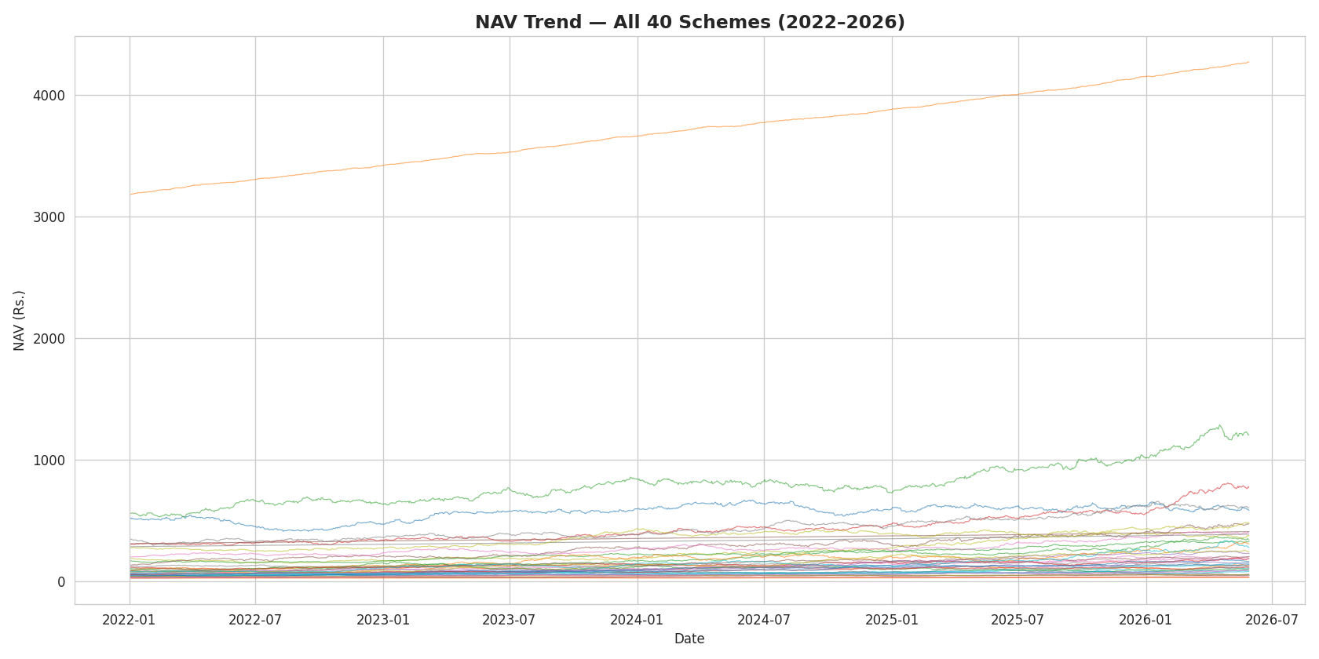
Figure 1. Daily NAV trend for all 40 schemes, 2022–2026.

5.2 AUM Growth by Fund House
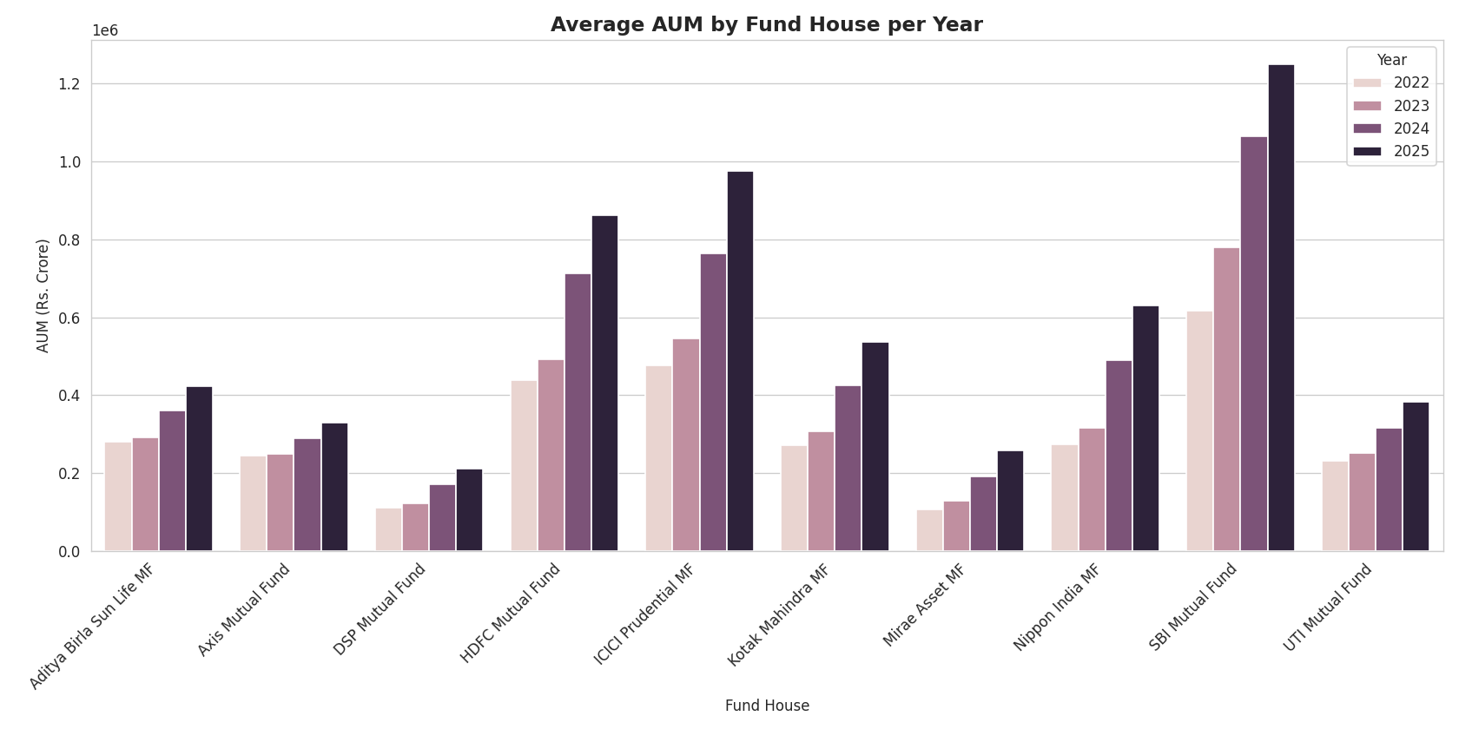
Figure 2. Average AUM by fund house, by year.

5.3 Category-wise Inflow Heatmap
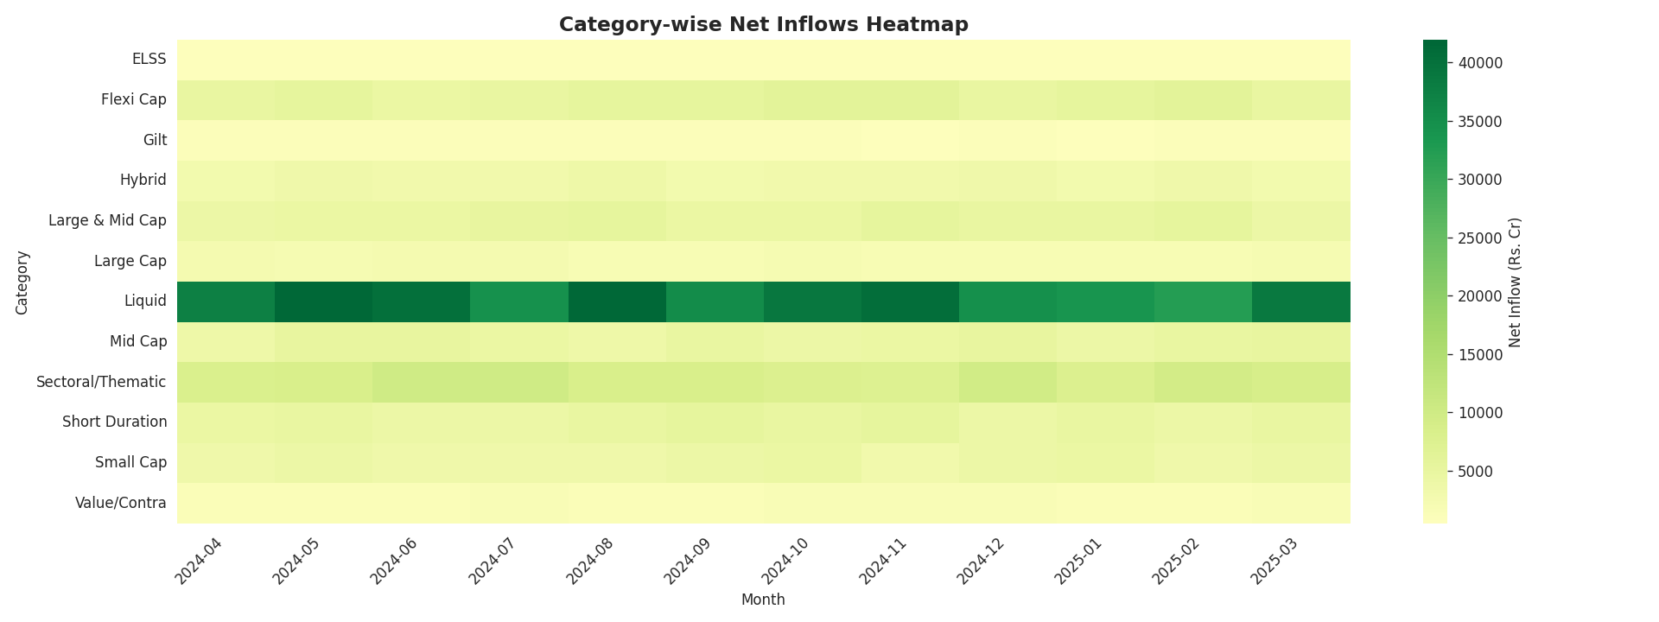
Figure 3. Net inflows by fund category and month. Liquid funds show the strongest and most consistent inflows.

5.4 Investor Demographics
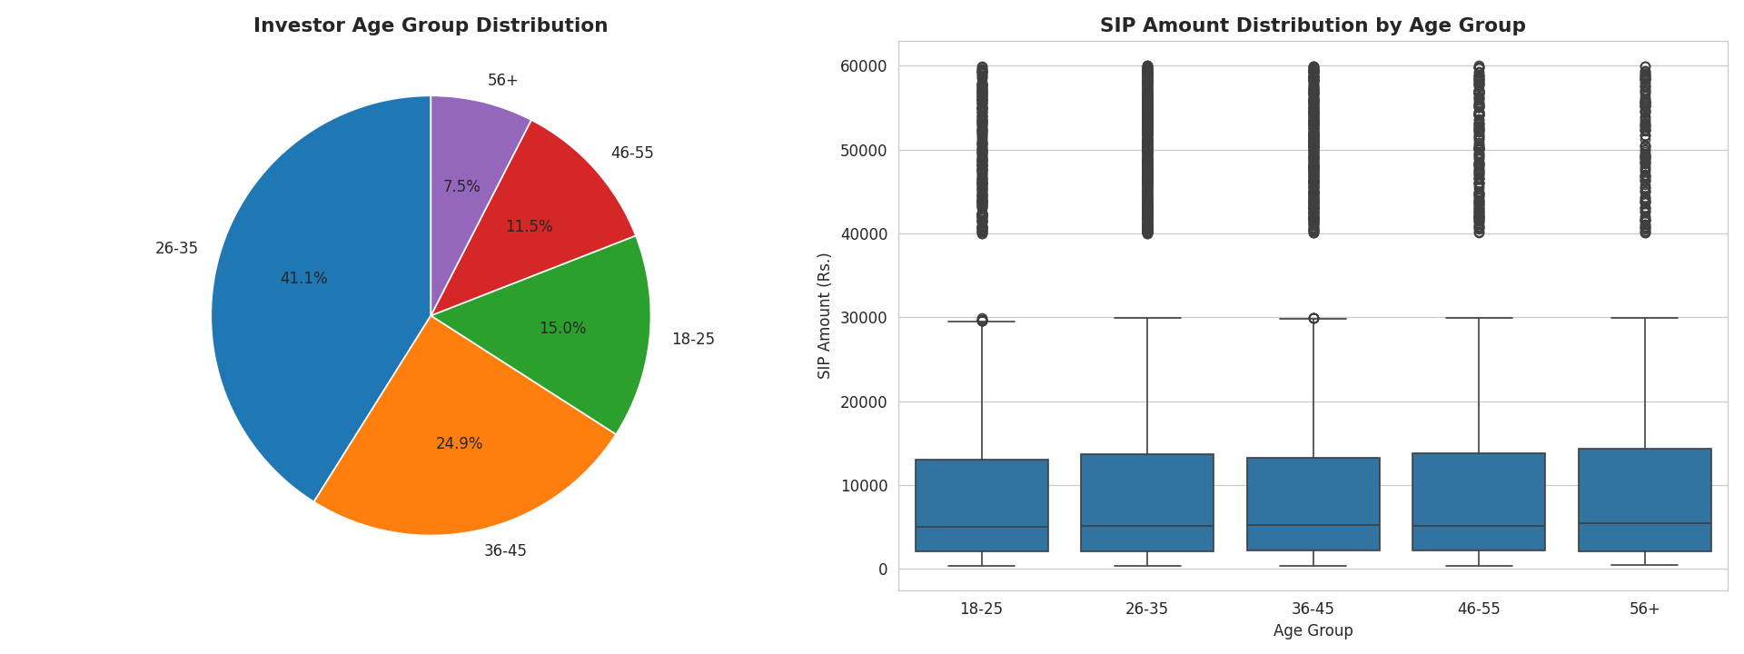
Figure 4. Investor age group distribution and SIP amount by age group.

5.5 Geographic Distribution
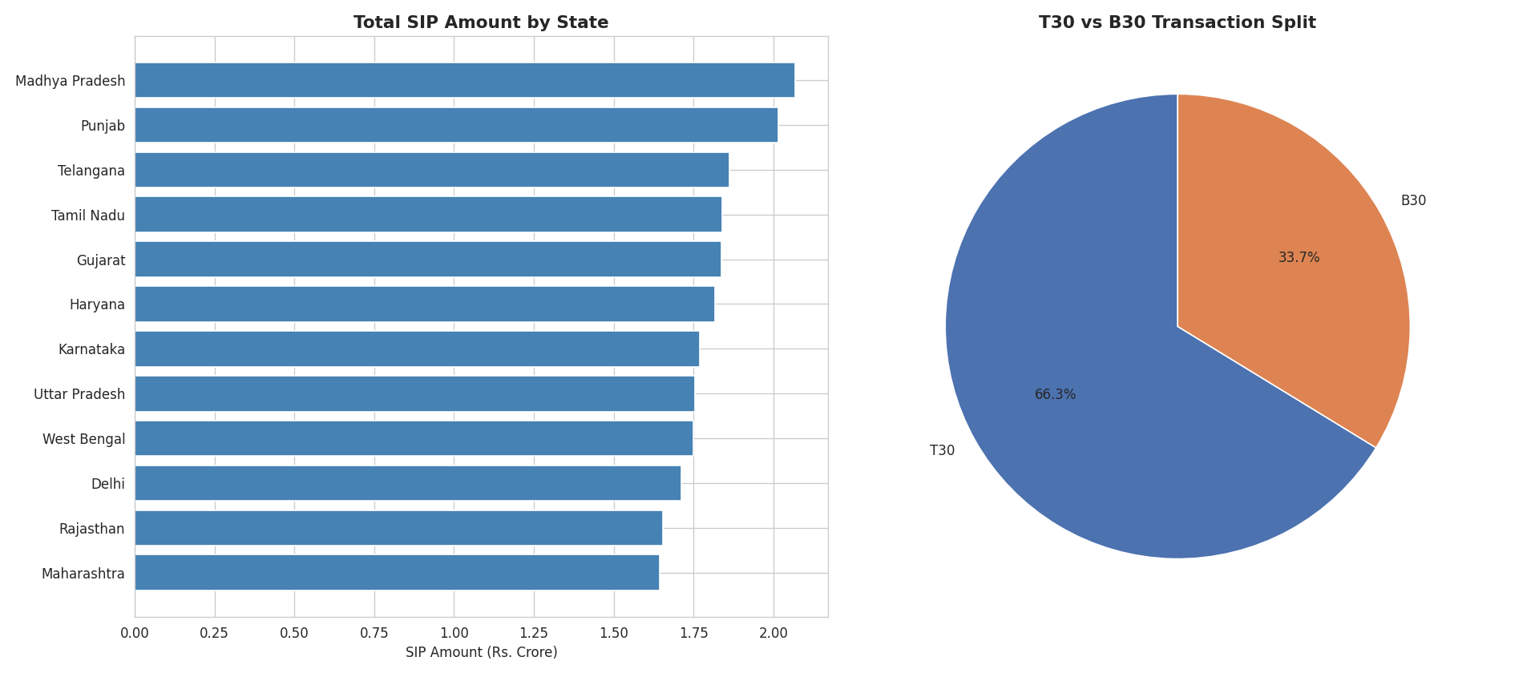
Figure 5. SIP amount by state and T30/B30 city tier split.

5.6 NAV Return Correlation Matrix
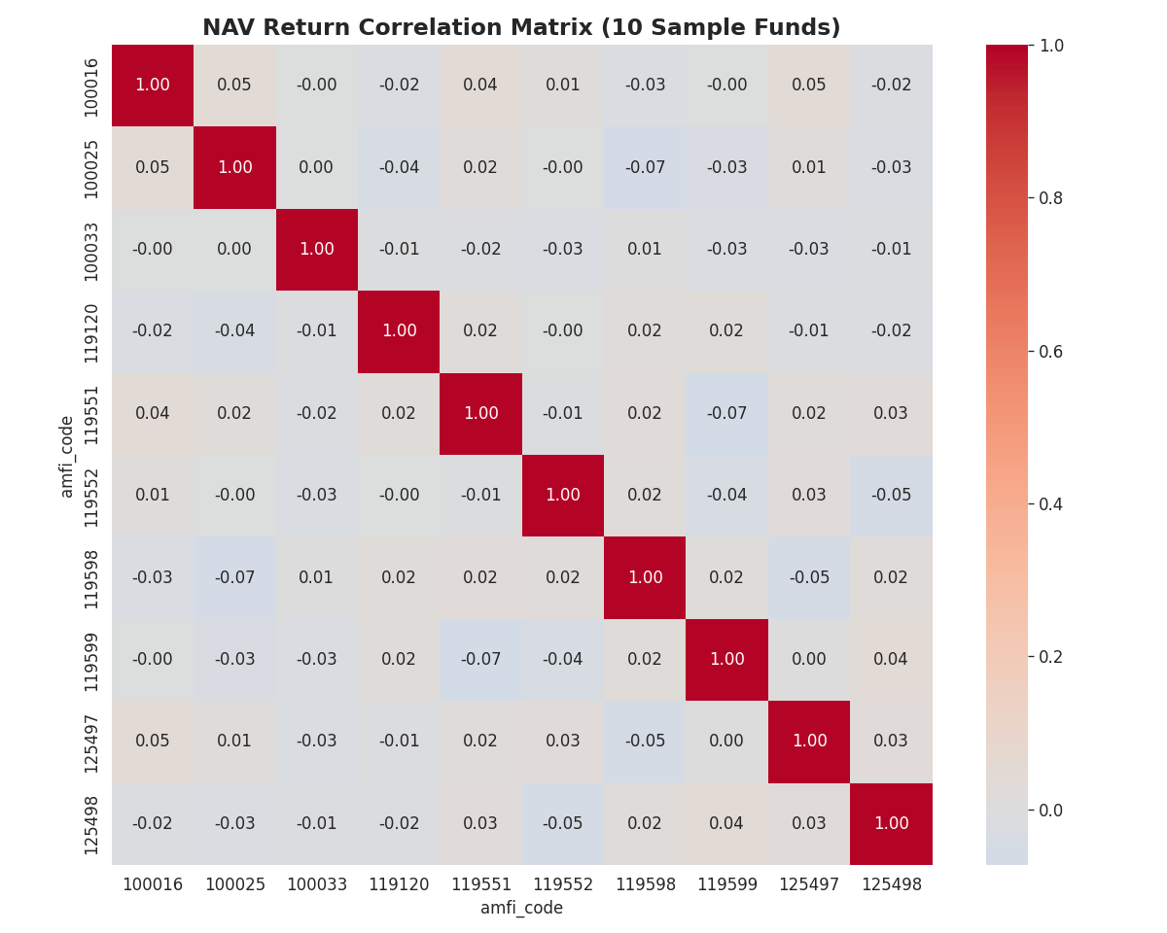
Figure 6. Pairwise correlation of daily NAV returns across 10 sample funds.

5.7 Sector Allocation
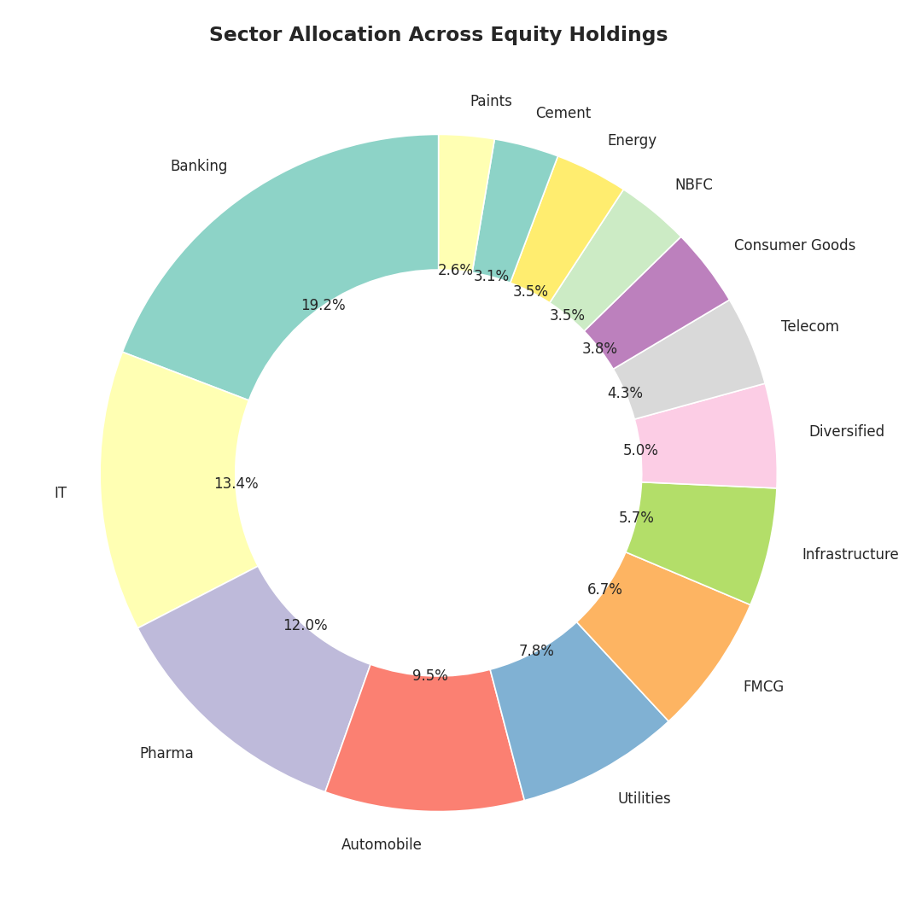
Figure 7. Sector weight distribution across equity fund holdings.

Key EDA Findings
- NAV trends across all 40 schemes show broad upward momentum from 2022 to 2026, with visible volatility clusters around known market correction periods.
- AUM growth is concentrated among a handful of large fund houses, consistent with industry consolidation trends — SBI Mutual Fund leads on average AUM.
- Liquid funds show the largest and most consistent net inflows across the observed period, ahead of more volatile equity categories.
- The 26–35 and 36–45 age groups contribute the largest share of SIP volume.
- Geographic contribution remains skewed toward established T30 cities, though B30 representation is non-trivial at roughly one-third of transactions.
- Sector allocation in equity holdings is concentrated in a few dominant sectors, particularly Banking and Financial Services.

6. Fund Performance Analytics
Risk-adjusted performance metrics were computed for all 40 schemes directly from NAV history, including annualised returns, Sharpe ratio, Sortino ratio, Alpha, Beta, and Maximum Drawdown. The risk-free rate used throughout is 6.5%, approximating the RBI repo rate at the time of this project.

Methodology
- Daily returns computed as (NAV_t / NAV_t-1) − 1, annualised using a 252 trading-day convention.
- Sharpe Ratio = (portfolio return − risk-free rate) / standard deviation of returns, annualised with √252.
- Sortino Ratio follows the same logic as Sharpe but penalises only downside volatility.
- Alpha and Beta computed via OLS regression of fund returns against the Nifty 100 benchmark.
- Maximum Drawdown computed as the minimum of (NAV / running maximum NAV − 1) across the observation period.
These metrics, together with expense ratio and AUM, feed directly into the Fund Performance page of the Power BI dashboard, where they are presented as a sortable scorecard table and a Risk-vs-Return bubble chart (bubble size proportional to AUM).

7. Interactive Dashboard
The dashboard was built in Power BI Desktop, connected directly to the live PostgreSQL database. It consists of four pages, each with dedicated KPI cards and interactive slicers for Fund House, Category, Year, Age Group, and City Tier as appropriate to the page's focus area.

7.1 Industry Overview
Provides headline KPIs (total schemes, total AUM, SIP inflows) alongside AUM growth by year and by fund house.
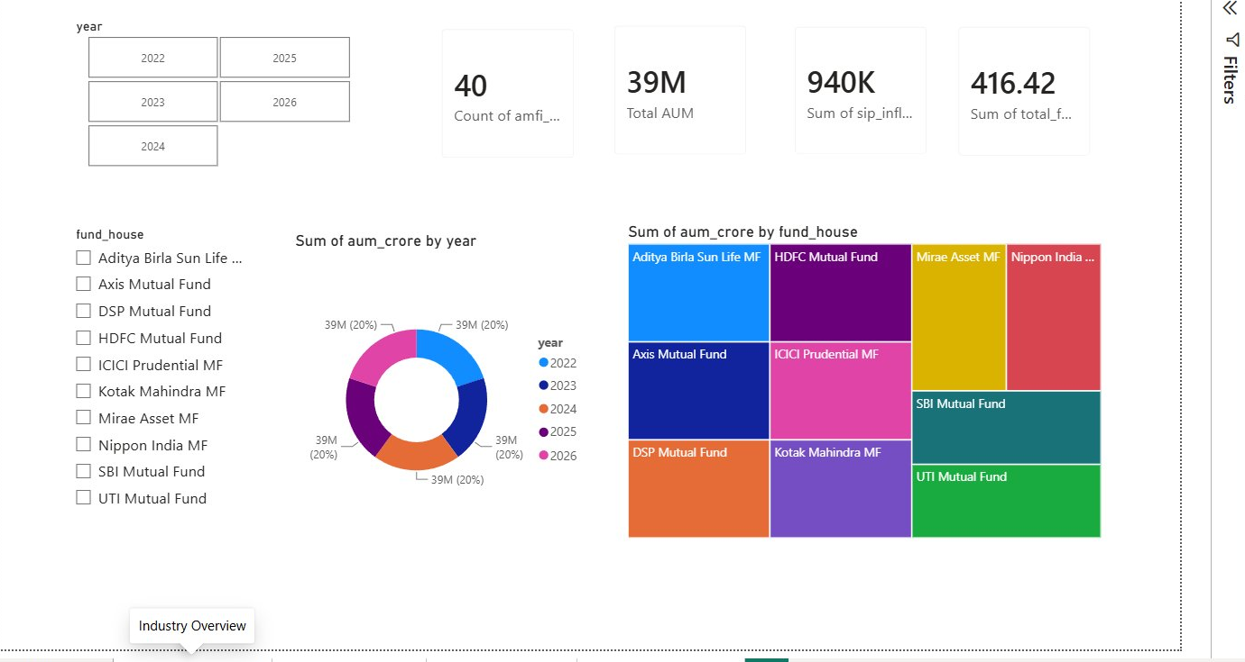
Figure 8. Industry Overview dashboard page.

7.2 Fund Performance
Presents a Risk-vs-Return bubble chart (bubble size = AUM), a sortable fund scorecard table with Sharpe, Alpha, expense ratio and drawdown, and supporting KPI cards for best Sharpe, average 3-year return, and highest Alpha.
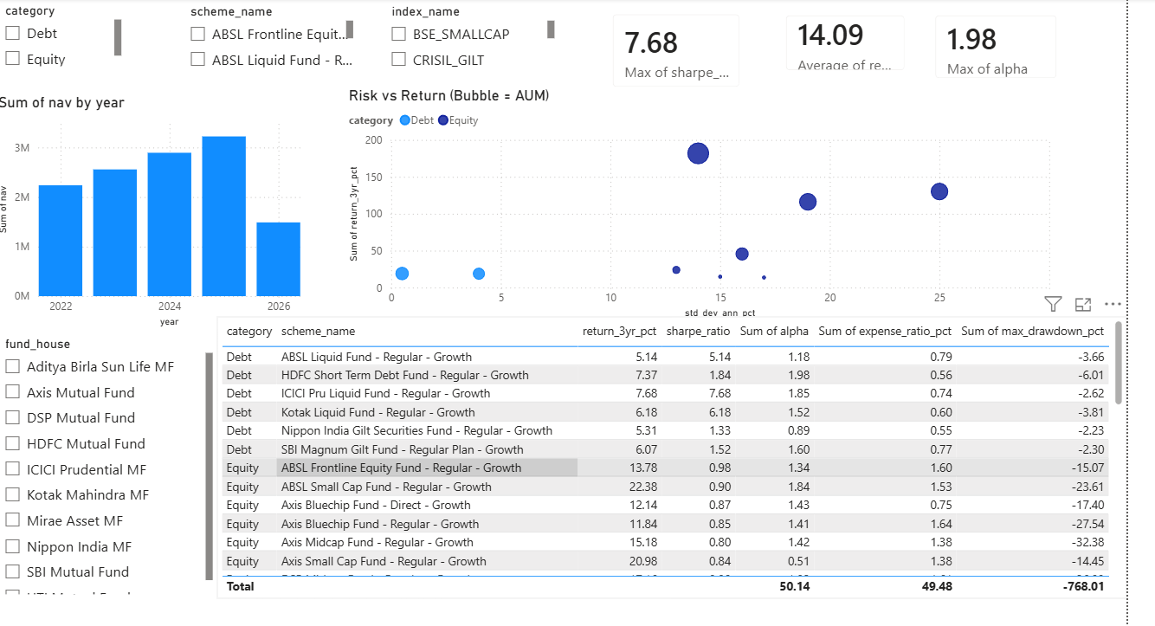
Figure 9. Fund Performance dashboard page.

7.3 Investor Analytics
Breaks down investor transaction volume by city, age group, and transaction type, supported by city-tier and age-group slicers and KPI cards for total investors and transaction volume.
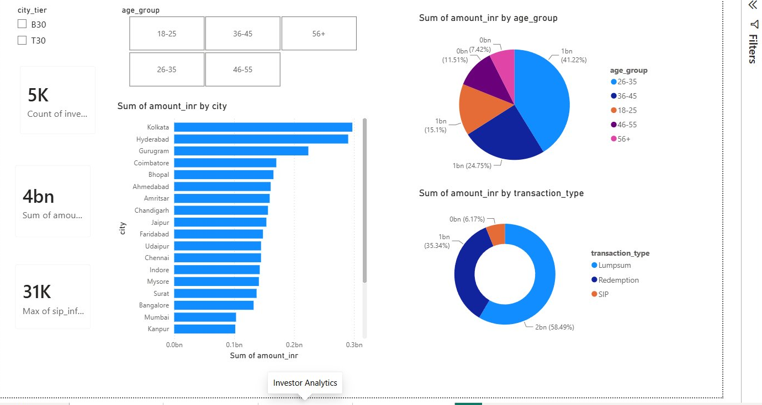
Figure 10. Investor Analytics dashboard page.

7.4 SIP & Market Trends
Combines a dual-axis SIP Inflow vs Nifty 50 chart, a category-wise net inflow matrix by month, and a Top 5 Categories by Net Inflow chart, with year and benchmark index slicers.
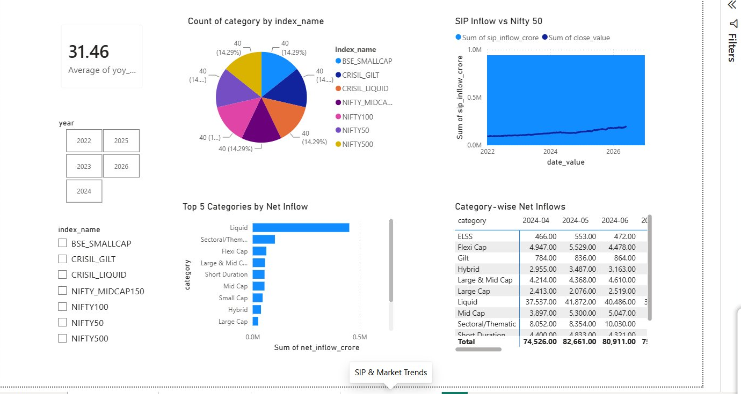
Figure 11. SIP & Market Trends dashboard page.

.8. Advanced Analytics & Risk Metrics
Beyond standard performance metrics, additional risk and behavioural analytics were performed to surface deeper insights into tail risk, time-varying risk-adjusted performance, investor cohort behaviour, SIP continuation patterns, and portfolio sector concentration.

8.1 Historical VaR and CVaR
Historical Value-at-Risk (95% confidence) and Conditional VaR were computed per fund from the empirical distribution of daily returns. Small Cap and Mid Cap schemes consistently show the worst tail-risk profiles, consistent with their higher underlying volatility.
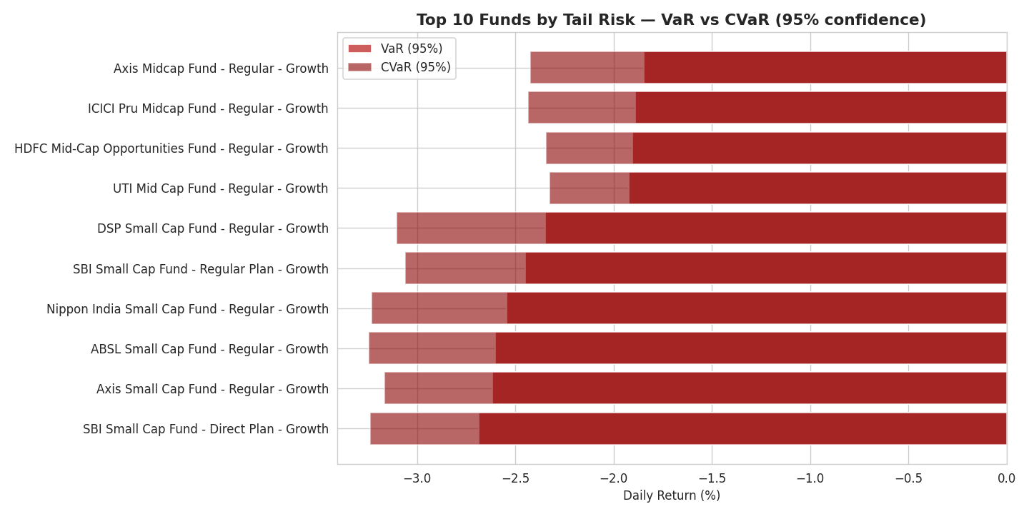
Figure 12. Top 10 funds by tail risk — VaR vs CVaR at 95% confidence.

8.2 Rolling 90-Day Sharpe Ratio
Rolling Sharpe ratios were computed for five sample funds to illustrate that risk-adjusted performance varies meaningfully over time rather than remaining static, which has implications for relying on any single point-in-time Sharpe figure during fund selection.
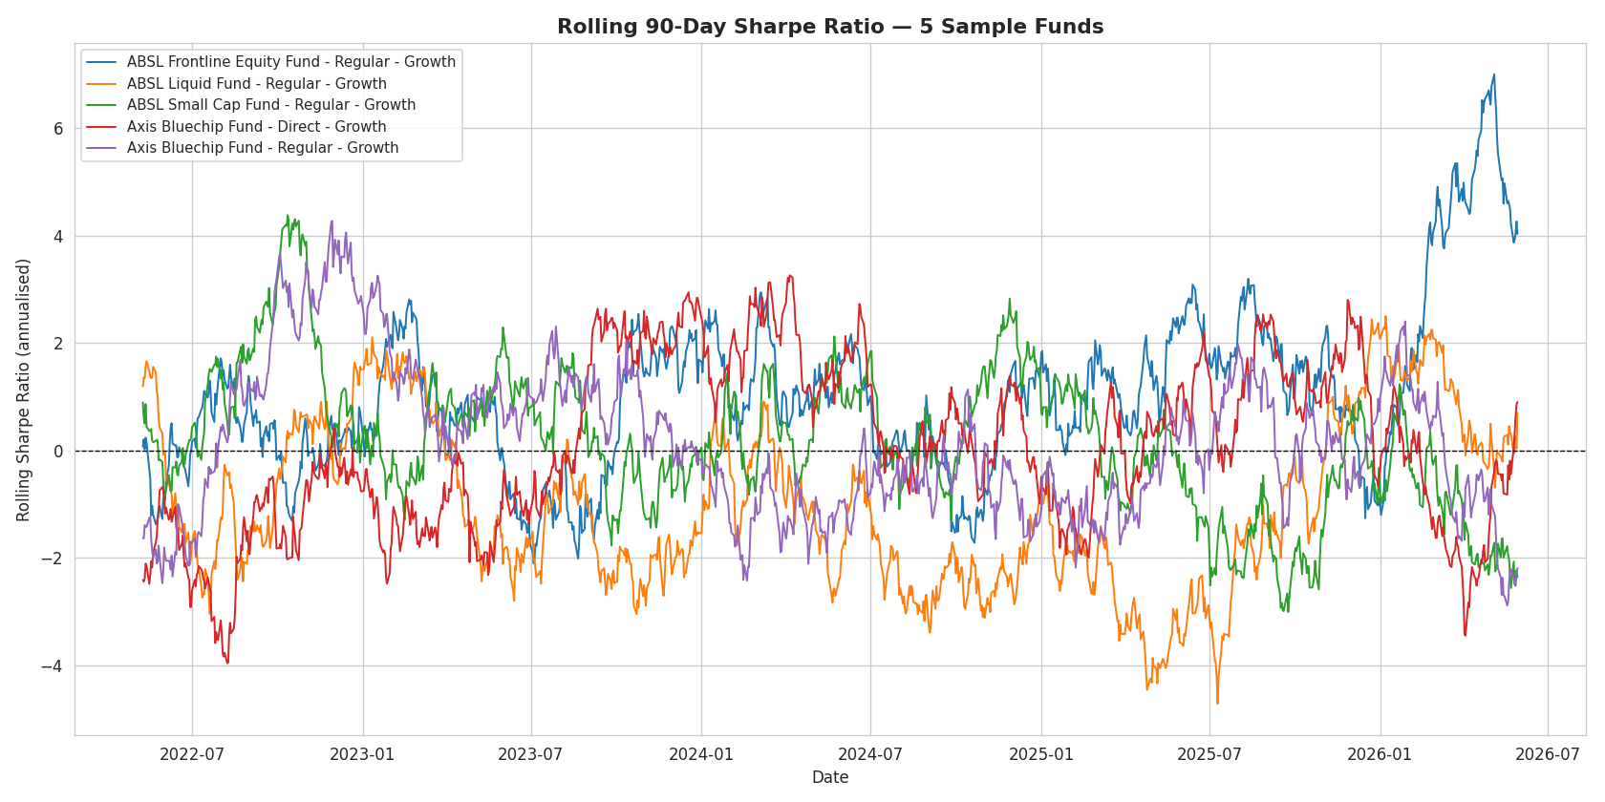
Figure 13. Rolling 90-day Sharpe ratio for 5 sample funds.

8.3 Investor Cohort Analysis
Investors were grouped by the year of their first transaction. The dataset's transaction history spans 2024 and 2025, yielding two cohorts. The 2025 cohort shows a higher average SIP amount, though this cohort is considerably smaller in size and the comparison should be treated as indicative rather than conclusive given the limited sample.
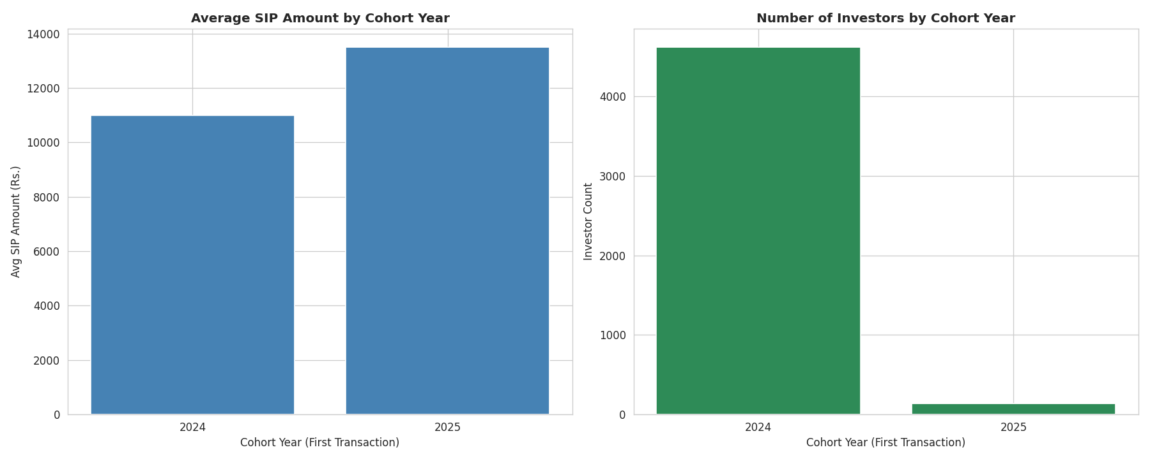
Figure 14. Average SIP amount and investor count by cohort year.

8.4 SIP Continuation Analysis
Among investors with six or more SIP transactions, the average gap between consecutive contributions was computed and flagged as at-risk where this average exceeded 35 days. The dataset's median SIP gap is approximately 60 days rather than a strict monthly cadence, which results in a high proportion of investors crossing this threshold; the underlying logic and threshold follow the project specification, with this dataset characteristic noted for context when interpreting the at-risk percentage.
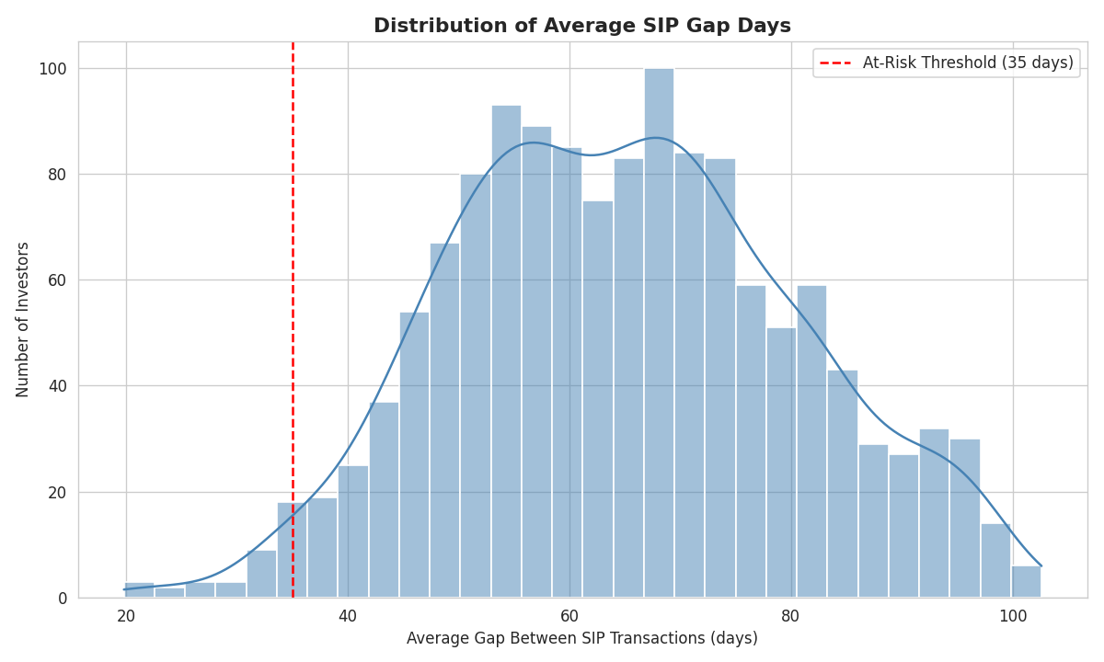
Figure 15. Distribution of average SIP gap days, with the 35-day at-risk threshold marked.

8.5 Sector Concentration (HHI)
The Herfindahl-Hirschman Index was computed for each equity fund's sector allocation to quantify concentration risk independent of category labels alone. Higher HHI values indicate a portfolio concentrated in fewer sectors.
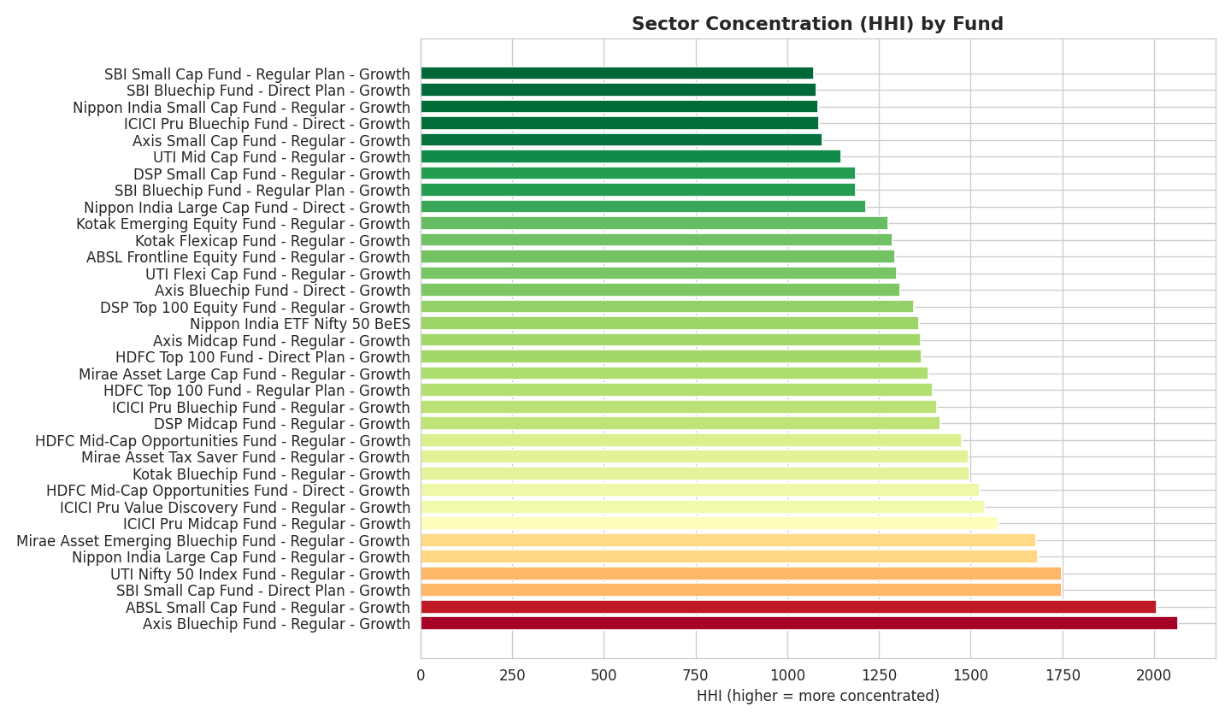
Figure 16. Sector concentration (HHI) across equity funds.

\

8.6 Fund Recommendation Logic
A simple rule-based recommender was implemented that maps an investor's stated risk appetite (Low, Moderate, High) to the dataset's five SEBI risk grades, then ranks matching funds by Sharpe ratio. For Low risk appetite, Liquid and Debt funds dominate the top recommendations; for Moderate, Large Cap equity funds lead; for High, Mid Cap and Small Cap funds surface as the top-ranked options — consistent with expected real-world risk hierarchies.

9. Limitations
- Investor transaction data is synthetically generated and, while based on realistic demographic and geographic distributions, does not reflect actual AMFI-reported investor-level behaviour.
- The SIP continuity at-risk threshold (35 days) was applied as specified in the project brief; however, the dataset's actual median SIP gap (~60 days) is wider than a strict monthly cadence, which inflates the at-risk percentage relative to what a genuinely monthly-SIP dataset would show.
- Cohort analysis is limited to two years (2024–2025) due to the date range of the provided transaction data, restricting the depth of longitudinal behavioural trends that could be observed.
- Portfolio holdings data covers only the 34 equity-oriented schemes; debt and liquid schemes do not carry equity sector exposure and are excluded from the HHI analysis.
- All metrics are computed as of the dataset's snapshot dates and do not reflect live, continuously refreshed market data.

10. Conclusion
This project delivers a complete, end-to-end Mutual Fund Analytics Platform spanning data engineering, relational database design, exploratory and advanced analytics, and an interactive business intelligence dashboard. The platform consolidates fragmented AMFI data into a single, queryable PostgreSQL database; surfaces risk-adjusted fund performance through computed Sharpe, Sortino, Alpha, Beta, VaR, and CVaR metrics; and provides stakeholders with a self-service, slicer-driven Power BI dashboard covering industry trends, fund performance, investor behaviour, and SIP market dynamics. The accompanying advanced analytics — cohort behaviour, SIP continuation risk, sector concentration, and a simple fund recommender — extend the platform beyond static reporting toward the kind of proactive, data-driven insight Bluestock Fintech set out to build.

