AWS Multi-Region Highly Available Web Application
with Disaster Recovery
Project Documentation
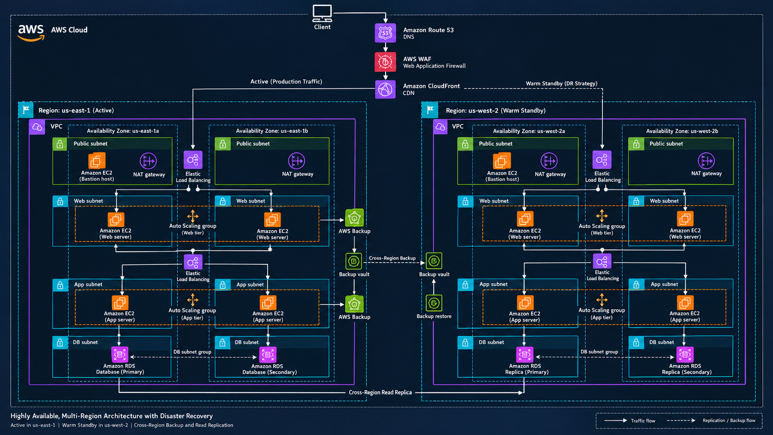

1. Project Overview
This project implements a highly available, multi-tier AWS web application architecture with a warm-standby disaster recovery environment. The primary production environment runs in us-east-1 and the secondary environment is maintained in us-west-2.

2. Objectives
The main objectives are high availability, horizontal scaling, secure traffic handling, database redundancy, cross-region backup, and rapid disaster recovery.

3. Architecture Flow
Client → Amazon Route 53 → AWS WAF → Amazon CloudFront → Elastic Load Balancer → Web Tier → Application Tier → Amazon RDS.

4. Primary Region
The us-east-1 region contains a VPC spanning two Availability Zones. Each AZ contains public, web, application, and database subnets. EC2 instances provide the bastion, web, and application tiers. Auto Scaling Groups and Elastic Load Balancers provide availability and scalability.

5. DR Region
The us-west-2 region is configured as a warm standby environment. It contains the required network, compute, load-balancing, and database components needed to support recovery during a primary-region failure.

6. AWS Services
Amazon Route 53: DNS and routing. AWS WAF: web application protection. Amazon CloudFront: CDN. Amazon VPC: network isolation. EC2: compute. Elastic Load Balancing: traffic distribution. Auto Scaling: capacity management. NAT Gateway: outbound access. Amazon RDS: relational database. AWS Backup: backup and recovery.

7. High Availability
High availability is achieved using multiple Availability Zones, load balancers, Auto Scaling Groups, redundant EC2 instances, and database redundancy. If an instance fails, Auto Scaling can replace it; if an AZ fails, traffic can be served from healthy resources in another AZ.

8. Disaster Recovery
The design follows a warm-standby DR strategy. Backups are copied across regions, backup vaults are maintained for recovery, and cross-region database protection is used to reduce recovery time and data loss.

9. Security
Security should follow least privilege. Web traffic is protected by AWS WAF, workloads are separated into subnets, administrative access is restricted, IAM roles are used instead of embedded credentials, and data and backups should be encrypted.

10. Scaling
Web and application EC2 instances are managed by Auto Scaling Groups. Capacity can increase when demand rises and decrease when demand falls. Load balancers distribute requests only to healthy instances.

11. Failure Scenarios
EC2 failure: Auto Scaling replaces the instance. AZ failure: the load balancer routes traffic to healthy resources. Database failure: the configured RDS redundancy/replication strategy supports recovery. Regional failure: DR procedures can redirect traffic to the warm-standby region and restore/promote required data.

12. Project Outcome
The completed architecture demonstrates practical AWS skills in networking, compute, load balancing, auto scaling, DNS, security, databases, backup, and cross-region disaster recovery.

13. Suggested GitHub Repository Structure
aws-multi-region-dr-project/
├── README.md
├── .gitignore
├── docs/
│ └── project-documentation.md
└── images/
└── aws-architecture.png

14. GitHub Description
Highly available AWS multi-region web application architecture with warm-standby disaster recovery, Auto Scaling, Elastic Load Balancing, RDS replication, AWS Backup, Route 53, WAF, and CloudFront.

