United International University
Department of Electrical & Electronics Engineering

Assignment – 01
Keypad-Controlled Serial Terminals with UART Communication

Submitted to
Mr. Kazi Abrar Mahmud
Lecturer, Dept. of EEE, UIU
Course Title : Microprocessor & Interfacing
Course Code : EEE 3403
Section : A

Submitted by

Muktadir Hasan sun : 0212230006

Halima Begam Lamia: 021222040

Nabila : 021222041

Objective:
The goal of this project is to design and configure a microcontroller-based system where
keypad inputs are transmitted between two STM32 microcontrollers using UART
communication. One STM32 acts as the transmitter by reading keypress values from a
4×3 keypad, while the other STM32 receives the data and displays it on a virtual
terminal. The system also sends a confirmation message back to ensure successful data
transmission.
Abstract:
This project demonstrates how UART serial communication can be used to transfer
keypad-entered data between two microcontrollers. The transmitting STM32 captures
numeric input from a keypad following a defined start and end sequence and sends it to
the receiving STM32. The received data is displayed on a virtual terminal, and an
acknowledgment is sent back to the transmitter. The complete system is simulated using
Proteus.
Introduction:
Microcontroller-based embedded systems are incredibly popular for tasks involving
automation and control. Our project connects two STM32 microcontrollers via UART
to exchange keypad data. This setup is common in access control, serial terminals, and
human-machine interfaces, showing how serial communication works in the real world.
Component List:
● STM32F103C8T6 (BLUE PILL) microcontrollers (2 units)
● 4x3 matrix keypad
● USB to TTL converter (for serial terminal)
● Proteus software (for simulation)
● Jumper wires and breadboard (for hardware)

Working Process:
➔ When a key is pressed on the 4×3 keypad, the first microcontroller (Key-uC)
detects and identifies the pressed key.
➔ Keypress input starts with ‘*’ and ends with ‘#’. The Key-uC stores only the
numeric values entered between these two symbols.
➔ After detecting the ‘#’ key, the first microcontroller transmits the collected
numeric data to the second microcontroller through the UART transmit pin (PA9),
and the second microcontroller receives the data via the UART receive pin (PA10).
➔ The second microcontroller (Screen-uC) processes the received data and displays
the message “Received = [data]” on the virtual terminal using UART communication.
➔ After successfully displaying the data, the second microcontroller sends a
confirmation message back to the first microcontroller through its transmit pin (PA9),
which is received by the first microcontroller via it’s receive pin (PA10).
➔ This confirmation ensures that the data has been successfully transmitted and
received between both microcontrollers.
GPIO Structure:
First Microcontroller (Key-uC):
● Keypad Rows: PB3–PB6 (inputs with pull-up)
● Keypad Columns: PB13–PB15 (outputs with no pull-up and no pull-down)
● UART1: TX (PA9) →, RX (PA10)
● UART2: TX (PA2)→, RX (PA3)
Second Microcontroller (Screen-uC):
● UART1: TX (PA9) →, RX (PA10)
● UART3: TX (PB10) →, RX (PB11)

First Microcontroller Code :
GPIO_TypeDef* row_ports [4] = {GPIOB,GPIOB,GPIOB,GPIOB};
uint16_t row_pins[4] = {GPIO_PIN_3,GPIO_PIN_4,GPIO_PIN_5,GPIO_PIN_6};
GPIO_TypeDef* column_ports[3] = {GPIOB,GPIOB,GPIOB};
uint16_t column_pins [3]= {GPIO_PIN_13,GPIO_PIN_14,GPIO_PIN_15};
UART_HandleTypeDef huart1;
UART_HandleTypeDef huart2;
char numberBuffer[20];
uint8_t numIdx = 0;
uint8_t collecting = 0;
uint8_t RX1_Char;
uint8_t RX_Message[50];
uint8_t idx = 0;
void SystemClock_Config(void);
static void MX_GPIO_Init(void);
static void MX_USART1_UART_Init(void);
static void MX_USART2_UART_Init(void);
uint16_t scanKeypad()
{
for(int col=0;col<3;col++)
{
HAL_GPIO_WritePin(column_ports[col],column_pins[col],GPIO_PIN_RESET);
for(int row=0;row<4;row++)
{
if(HAL_GPIO_ReadPin(row_ports[row],row_pins[row]) == GPIO_PIN_RESET)
{
HAL_Delay(50);
while(HAL_GPIO_ReadPin(row_ports[row],row_pins[row])==GPIO_PIN_RESET);
HAL_GPIO_WritePin(column_ports[col],column_pins[col],GPIO_PIN_SET);
return col+row*3;
}
}
HAL_GPIO_WritePin(column_ports[col],column_pins[col],GPIO_PIN_SET);
}
return 0xFF;
}
void HAL_UART_RxCpltCallback(UART_HandleTypeDef *huart)
{
if(huart->Instance == USART1)
{
RX_Message[idx++] = RX1_Char;
if(RX1_Char == '\n')
{
RX_Message[idx] = '\0';
HAL_UART_Transmit(&huart2, RX_Message, idx, HAL_MAX_DELAY);
idx = 0;
}
HAL_UART_Receive_IT(&huart1, &RX1_Char, 1);
}
}
int main(void)
{
HAL_Init();
SystemClock_Config();
MX_GPIO_Init();
MX_USART1_UART_Init();
MX_USART2_UART_Init();
HAL_UART_Receive_IT(&huart1, &RX1_Char, 1);
while (1)
{
uint16_t button = scanKeypad();
if (button != 0xFF)
{
char key;
if (button <= 8)
key = '1' + button;
else if (button == 9)
key = '*';
else if (button == 10)
key = '0';
else if (button == 11)
key = '#';
if (key == '*')
{
collecting = 1;
numIdx = 0;
memset(numberBuffer, 0, sizeof(numberBuffer));
}
else if (key == '#' && collecting)
{
numberBuffer[numIdx++] = '\n';
HAL_UART_Transmit(&huart1,
(uint8_t*)numberBuffer,
numIdx,
HAL_MAX_DELAY);
collecting = 0;
}
else if (collecting && key >= '0' && key <= '9' && numIdx < sizeof(numberBuffer)-2)
{
numberBuffer[numIdx++] = key;
}
HAL_Delay(200);
}
}
}

Code Explanation (First Microcontroller – Key-uC):
● Scans the 4×3 keypad by driving column pins and reading row pins to detect the
pressed key.
● Converts the detected key index into the corresponding character (0–9, *, #) based
on keypad mapping.
● Starts collecting numeric input when the * key is pressed and stores the entered
digits in a buffer.
● Stops data collection when the # key is pressed and transmits the collected numeric
data to the second microcontroller via UART1.
● Receives acknowledgment messages from the second microcontroller using UART1
interrupt.
● Forwards the received confirmation message to the serial monitor using UART2 for
display.
Second Microcontroller Code :
UART_HandleTypeDef huart1;
UART_HandleTypeDef huart3;
uint8_t RX1_Char;
uint8_t RX_Buffer[50];
uint8_t rxIndex = 0;
void SystemClock_Config(void);
static void MX_GPIO_Init(void);
static void MX_USART1_UART_Init(void);
static void MX_USART3_UART_Init(void);
void HAL_UART_RxCpltCallback(UART_HandleTypeDef *huart)
{
if (huart->Instance == USART1)
{
if (RX1_Char != '\n')
{
if (rxIndex < sizeof(RX_Buffer) - 1)
{
RX_Buffer[rxIndex++] = RX1_Char;
}
}
else
{
RX_Buffer[rxIndex] = '\0';
char displayMsg[80];
strcpy(displayMsg, "Received = ");
strcat(displayMsg, RX_Buffer);
strcat(displayMsg, "\r\n");
HAL_UART_Transmit(&huart3,
(uint8_t*)displayMsg,
strlen(displayMsg),
HAL_MAX_DELAY);
char confirm[] = "Data received\r\n";
HAL_UART_Transmit(&huart1,
(uint8_t*)confirm,
strlen(confirm),
HAL_MAX_DELAY);
rxIndex = 0;
}
HAL_UART_Receive_IT(&huart1, &RX1_Char, 1);
}
}
int main(void)
{
HAL_Init();
SystemClock_Config();
MX_GPIO_Init();
MX_USART1_UART_Init();
MX_USART3_UART_Init();
HAL_UART_Receive_IT(&huart1, &RX1_Char, 1);
while (1)
{
/* USER CODE END WHILE */
/* USER CODE BEGIN 3 */
}
/* USER CODE END 3 */
}
Simulation Implementation:
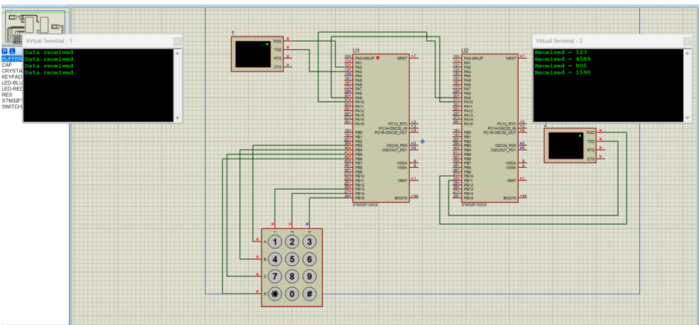

Code Explanation (Second Microcontroller – Screen-uC):
● Receives serial data from the first microcontroller through UART1 using interrupt
based communication.
● Stores incoming characters in a buffer until a newline character (\n) is received.
● After receiving the complete data, formats the message as “Received = [data]”.

● Transmits the formatted message to the virtual terminal using UART3 for display.
● Sends a confirmation message back to the first microcontroller through UART1 to
acknowledge successful data reception.
● Resets the receive buffer and index to prepare for the next data transmission.
Conclusion:
The project successfully implemented a UART-based communication system between
two STM32 microcontrollers. Keypad-entered numeric data was transmitted from one
microcontroller and displayed on a virtual terminal by the other, with acknowledgment
feedback sent in return. This project enhanced our understanding of keypad interfacing,
UART communication, and embedded system simulation using Proteus and
STM32CubeIDE.

