<https://www.planetfitness.com/community/articles/beginner-lower-body-workout-youve-been-looking>

**Day 1,3: Lower Body**

**Box Squat: 3 sets of 10-20 repetitions**

**Beginner:** Advanced:

<https://jettslife.jetts.com.au/home/5-reasons-you-should-box-squat>

<https://origympersonaltrainercourses.co.uk/blog/box-squats>

<https://gympion.com/blog/what-is-a-box-squat>

**Lunges: 3 rounds of 10-20 repetitions, each side**

<https://www.womenshealthmag.com/fitness/a20697201/single-leg-squat-start-with-stationary-lunge>

Beginner: Advanced:

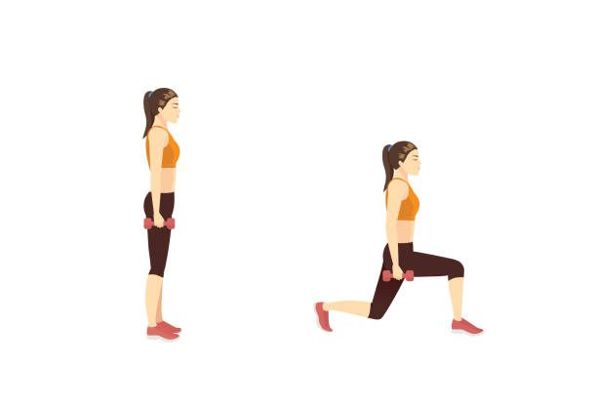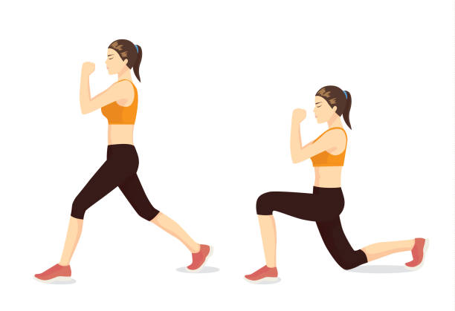

Lunges Dumbbell lunges

**Leg Raise: 3 rounds of 10-20 repetitions**

Beginners Advanced

<https://www.pixtastock.com/illustration/50620849>

<https://www.istockphoto.com/illustrations/calf-raise-exercise>

**Glutes: 3 rounds of 10-20 repetitions**

<https://gabbyabigaill.com/7-minute-booty-workout-using-glute-bridges-only/>

Beginner Advanced

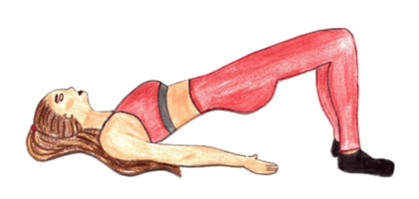

Glute Bridge Glute Bridge with leg lift

**Day 2,4: Upper Body**

**Push ups: 3 rounds of 30 seconds, 10 seconds rest between each round**

Beginner Advanced

<https://www.istockphoto.com/search/2/image?mediatype=illustration&phrase=push+ups>

<https://darebee.com/workouts/upperbody-workout.html>

**Arms: 3 rounds of 30 seconds, 10 seconds rest between each round**

**Beginner Advanced**

Arm scissors Triceps extension

**Shoulders: 3 rounds of 30 seconds, 10 seconds rest between each round**

Beginners Advanced

Shoulder taps Shoulder press

<https://darebee.com/workouts/upper-body-workout.html>

**Arms: 3 rounds of 30 seconds, 10 seconds rest between each round**

Beginners Advanced

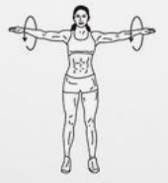

Raised arm circles

Lateral raises

<https://darebee.com/workouts/toned-arms-workout.html>

<https://darebee.com/workouts/bulk-order-workout.html>

**Day 5 Cardio Full Body**

**Jacks: 3 rounds of 40 seconds, 10 seconds rest between each round**

Beginner Advanced

Jumping Jacks

Step out Jacks

<https://darebee.com/workouts/this-girl-workout.html>

<https://www.sheknows.com/health-and-wellness/articles/1115547/jumping-jack-variations/>

**Thighs: 3 rounds of 40 seconds each**

**Beginner Advanced**

High knee run

March steps

<https://darebee.com/workouts/total-burn-workout.html>

**Squats: 4 rounds of 20 seconds each, 10 seconds rest between rounds**

Beginners Advanced

Jump Squats

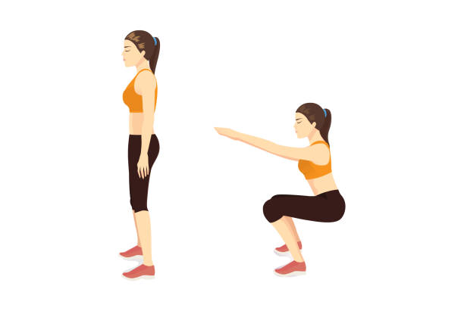

Squats

<https://www.istockphoto.com/search/2/image?mediatype=illustration&phrase=squat+jump>

<https://www.istockphoto.com/search/2/image?mediatype=illustration&phrase=squat>

**Chest: : 3 rounds of 15 seconds each, 5 seconds rest between rounds**

Beginner: Advanced

Chest expansions Raised Arm circles

<https://workoutlabs.com/fit/wkt/SXzh5nd/>

<https://darebee.com/workouts/cardio-mill-workout.html>