GENERAL UNION OF VIETNAM LABOR UNION

**TON DUC THANG UNIVERSITY**

**FACULTY OF INFORMATION TECHNOLOGY**



**WEB SEARCH FOR JOBS**

*Instructor*: **Phạm Văn Huy**

*Student*: **Bùi Quốc Huy-518H0625**

**Vũ Quang Huy – 518H0199**

**Trần Hoàng Cung-518H0602**

School Year  **: K22**

**HO CHI MINH CITY, 2020 YEAR**

**THANK YOU**

Here I would like to represent to say a few words. Our group( include Quoc Huy, Quang Huy, Hoang Cung) would like to thank you for helping us gain more knowledge about web programming to be able to complete this final exam.

**PROJECT IS COMPLETED**

**AT TON DUC THANG UNIVERSITY**

I assure you that this is our own project and theguidance of instructor Pham Van Huy ;. The research contents and results in this topic are honest and have not been published in any previous forms. The figures in the tables serving the analysis, comments and assessments were collected by the author himself from different sources specified in the references.

In addition, the project also uses a number of comments, assessments as well as data of other authors, other organizations and agencies that have cited and annotated the origin.

If any fraud is detected, I am fully responsible for the content of my project. Ton Duc Thang University is not related to copyright and copyright infringement caused by me during the implementation process (if any).

*Ho Chi Minh City, July 2, 2020*

*Author*

*(sign and clearly state full name)*

*Bùi Quốc Huy*

*Vũ Quang Huy*

*Trần Hoàng Cung*

**TABLE OF CONTENTS**

**Chapter 1: + The reason to choose a topic………………………….**

**+ Open source to build………………………………….**

**+ Website content……………………………………….**

**Chapter 2: + Necessary business requirements…………………….**

**+Analyze the design of database corresponding to the corresponding business………………………………………………**

**Chapter 3: Introducing the finished product………………………**

**Chapter 4: General conclusions and references……………………**

* **Chapter 1:**
* **The reason to choose a topic:** Today the unemployment rate is rising rapidly. Many people are still confused as to what jobs to choose to suit their abilities. It is difficult for employers to find the right people for their business requirements. So a job search website is created so that people can solve these problems for both job seekers and employers.
* **Open source to build: Laravel**
* **Concept:** Laravel is a free and open source PHP framework developed by Taylor Otwell and aims to support the development of model-view-controller (MVC) web applications. Key features of Laravel include easy-to-understand syntax, a modular packaging system and dependency management, various ways to access relational databases, and many other utilities. each other supports deployment into application maintenance.
* **Advantages of Laravel:**

+ Use the latest features of PHP

+ Integrate with mail service

+ Support common backend cache

+ Reverse Routing

+ IoC container

+ Eloquent ORM

* **Disadvantages of Laravel:**

+ Does not support the payment feature

+ Lack of continuity between versions

+ Usually does not provide abundance for mobile applications

* **General assessment:** Laravel is the strongest competitor in the PHP ecosystem simply because it includes the features needed to build modern web applications. Therefore, it is a clear and efficient framework, with simple syntax that builds great applications.
* **Website content:** Website helps people logging in can find information and find jobs that suit the ability of each person. Help people send jobs online to companies, save their time and for everyone.
* **Chapter 2:**
* **Necessary business requirements :** Professional skills are divided into 3 main subjects
* **Admin** **:** + Log in

+ Web management on articles, users, web content.

* **Company** **:** + Sign up, Log in

+ Post recruitment posts

+ Get cv file sent from the article

* **Student :** + Sign up, login

+ Search articles: about skills, about the workplace, ...

+ View recruitment information.

+ Submit cv file to Company.

* **Analyze the design of database corresponding to the corresponding business :**
* **Data design(**Illustration**)**

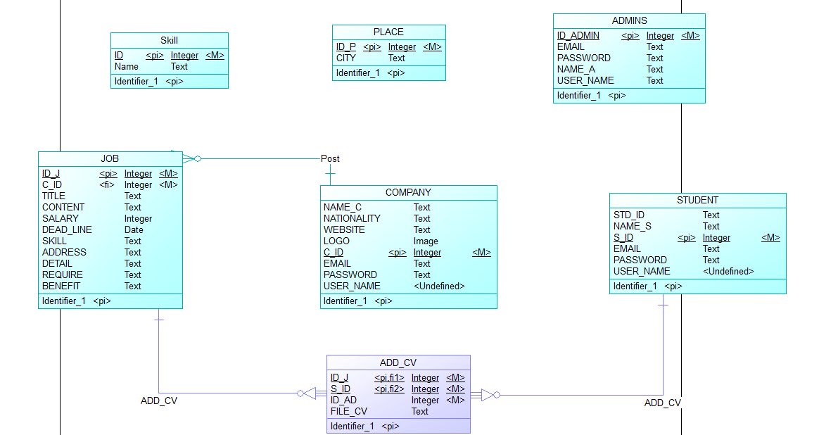

* **Skill table: +** The task of storing the programming skills used for applying.

**+** For example: PHP, Laravel, Java, ...

* **Place table:** + Stores all posted job locations.

+ For example: Da Nang, Saigon, Hanoi, ...

* **ADMIN:** +The site administrator contains the following information: email, password, name, user_name (account)

+Web content editing function: Adjust operation to add and delete user corrections including Company and User.

* **COMPANY:** + Store company information, and view the company as a login account

+ The information of the Company includes: Company name, Country, Link Website, Logo, email, password, user_name (account)

+ A company is allowed to post many articles.

* **STUDENT:** +Where to store student data include: Name, student_id, email, password, username.
* **JOB:**  + The company's recruiting post includes the following information: title, content, salary, skills, address, details, requirements, benefits.

+ Each article represents a Company.

* **ADD_CV:** + Each student can recruiment to multiple articles and each article can be recruimented by many students+ Each time you submit an application, information for the article and information will be saved and there must be an accompanying cv file for the application.
* **Chapter 3: Introducing the finished product**
* **Chapter 4: General conclusions and references**