GYM MANAGEMENT SYSTEM
CIA 3 – Software Application Development using OOP & Database
Submitted By:
Megh Bari
App ID: 2410232

INDEX
1. Introduction
2. Problem Statement
3. Objectives
4. System Design
5. Features of Application
6. OOP Concepts Used
7. Database Design
8. Tools & Technologies Used
9. Screenshots
10. Conclusion
11. References

1. Introduction
The Gym Management System is a comprehensive desktop-based application developed using Java and MySQL to automate and streamline gym operations. In modern fitness centers, manual management of member records, trainer assignments, and workout plans can lead to inefficiencies, redundancy, and data inconsistency. This system addresses these challenges by providing a centralized and structured platform for managing all gym-related data.
The application is designed using Object-Oriented Programming (OOP) principles to ensure modularity, scalability, and maintainability. It integrates Java Swing for building an interactive graphical user interface and JDBC for seamless database connectivity with MySQL. The system enables efficient handling of member information, trainer data, and workout assignments while ensuring data persistence and integrity.
Additionally, the project incorporates a layered architecture separating the user interface, business logic, and data access components. This enhances code readability and maintainability. The system also includes role-based access control, allowing different users such as Admin, Trainer, and Member to interact with the application according to their permissions.

2. Problem Statement
In traditional gym management systems, most operations such as maintaining member records, assigning trainers, and tracking workout plans are handled manually or through unstructured digital tools. This leads to several challenges including data redundancy, lack of proper record maintenance, difficulty in searching and updating information, and increased chances of human error.
There is a need for a centralized and efficient system that can manage all gym-related data in an organized and structured manner. The system should allow users to perform operations such as adding, updating, deleting, and searching records with ease, while ensuring data consistency and integrity.
The objective of this project is to design and develop a Gym Management System using Java that demonstrates the effective application of Object-Oriented Programming (OOP) concepts and database connectivity using JDBC. The system must support full CRUD operations and ensure persistent storage of data using a relational database.
Additionally, the application should provide a user-friendly interface and incorporate real-world features such as role-based access control and input validation to enhance usability and reliability.

3. Objectives
The primary objectives of this project are as follows:

1. Implementation of CRUD Operations
To develop a system that allows users to Create, Read, Update, and Delete records efficiently using Java and JDBC, ensuring proper interaction with the database.

2. Application of Object-Oriented Programming Concepts
To implement core OOP principles such as encapsulation, inheritance, abstraction, and polymorphism in the system design, thereby promoting modularity and code reusability.

3. Database Integration
To establish a connection between the Java application and a relational database (MySQL) using JDBC, enabling persistent storage and retrieval of data.

4. Development of a User-Friendly Interface
To design and implement a graphical user interface using Java Swing that allows users to interact with the system easily and efficiently.

5. Implementation of Layered Architecture
To structure the application into multiple layers (Presentation, Business Logic, DAO, and Database) to improve maintainability, scalability, and separation of concerns.

6. Incorporation of Real-World Features
To enhance the application by including features such as role-based login system, input validation, and data filtering/search functionality.

7. Ensuring Data Integrity and Security
To ensure that all user inputs are validated and that database operations maintain data consistency through the use of constraints such as primary keys and foreign keys

4. System Design
The Gym Management System follows a layered architecture to ensure separation of concerns and improve system maintainability. The architecture is divided into four primary layers:

Presentation Layer
This layer consists of the Graphical User Interface (GUI) implemented using Java Swing. It allows users to interact with the system through forms, buttons, and tables. The main interface (GymUI) enables users to perform operations such as adding members, viewing records, and assigning workouts.

Business Logic Layer
This layer contains the core logic of the application, including validation, role-based access control, and data processing. It ensures that user inputs are validated before being passed to the database layer.

Data Access Layer (DAO)
The DAO layer acts as an intermediary between the application and the database. It encapsulates all database-related operations such as inserting, retrieving, updating, and deleting records. In this project, the TrainerDAO class is implemented to demonstrate DAO functionality.

Database Layer
This layer consists of a MySQL relational database that stores all application data. It includes structured tables for members, trainers, and workouts, with proper relationships established using primary and foreign keys.
This layered architecture improves modularity, reduces code dependency, and enhances scalability.

5. Features of Application

Member Management
The system allows users to perform complete CRUD operations on member data. Users can add new members, view all members in a tabular format, update existing records, delete members, and search for specific members based on their name. This functionality ensures efficient handling of gym member data.

Trainer Management
The application enables management of trainer information, including adding new trainers and viewing trainer details. Each trainer has a specialization, which helps in assigning appropriate workout plans to members.

Workout Assignment
The system supports assigning workout plans to members and linking them with trainers. This feature establishes a relationship between members and trainers, ensuring that each member receives personalized training.

Role-Based Access Control
A login system is implemented that allows users to select roles such as Admin, Trainer, or Member. Based on the selected role, access to different functionalities is restricted. This enhances system security and demonstrates real-world application behavior.

Input Validation
The application includes validation mechanisms to ensure that user inputs are correct before storing them in the database. For example, age must be numeric and phone numbers must follow a specific format.

6. OOP Concepts Used
The project extensively uses Object-Oriented Programming principles to ensure modular and reusable code.

Encapsulation
Encapsulation is implemented by declaring class variables as private and accessing them through public getter and setter methods. This ensures data security and controlled access.

Inheritance
Inheritance is implemented using a base abstract class User, from which Member and Trainer classes inherit common properties such as name, age, and phone. This reduces code duplication and promotes reusability.

Abstraction
Abstraction is achieved through the use of an abstract class User, which defines a common structure and abstract methods. The implementation details are provided in the child classes.

Polymorphism
Polymorphism is demonstrated through method overriding, where the displayRole() method is implemented differently in Member and Trainer classes.

Method Overloading
Method overloading is used by defining multiple methods with the same name but different parameters, improving flexibility in method usage.

Collections
The project uses ArrayList to manage collections of objects dynamically, demonstrating efficient data handling.

7. Database Design
The application uses a MySQL relational database named gymdb. The database is designed with proper normalization and relationships to ensure data integrity.

Tables:

Members Table
- member_id (Primary Key)
- name
- age
- phone
- membership_type

Trainers Table
- trainer_id (Primary Key)
- name
- specialization

Workouts Table
- workout_id (Primary Key)
- member_id (Foreign Key)
- trainer_id (Foreign Key)
- plan

Relationships:
- A member can have multiple workouts.
- A trainer can be assigned to multiple members.
- Foreign keys ensure referential integrity between tables

8. Tools & Technologies Used
The development of this project involved the use of several tools and technologies:
- Java: Used as the primary programming language for application development.
- MySQL: Used as the relational database for storing application data.
- JDBC: Used to establish connectivity between Java application and MySQL database.
- Java Swing: Used to develop the graphical user interface.
- VS Code / IntelliJ IDEA: Used as the development environment.
- MySQL Workbench: Used for database design and query execution.

9. Screenshots
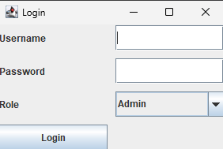
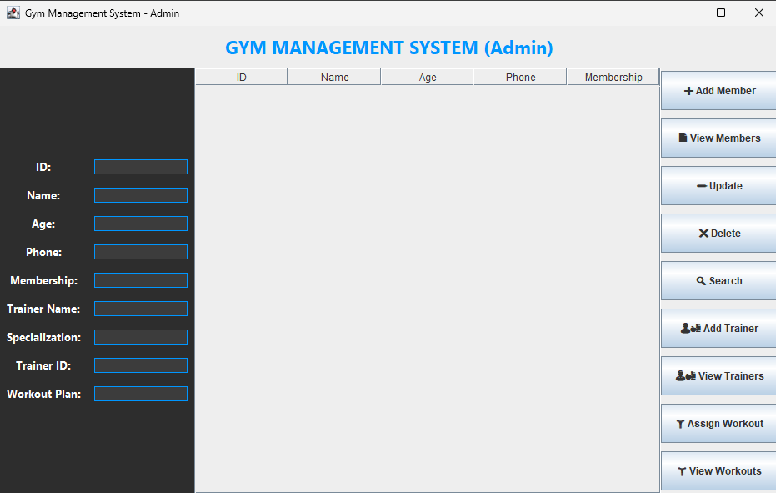
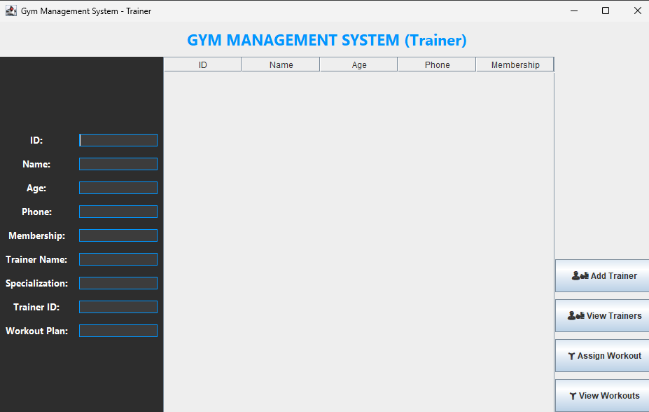
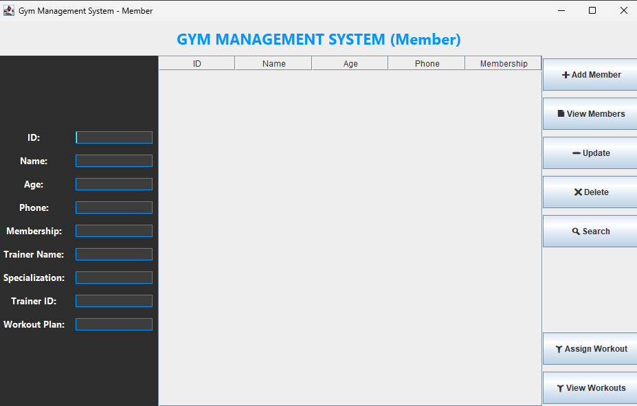
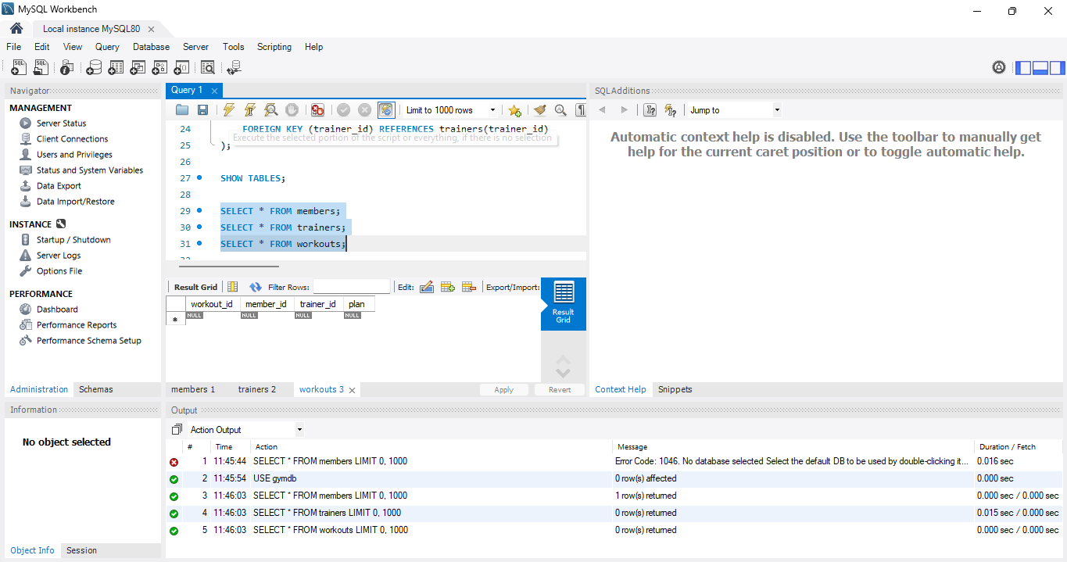

10. Conclusion
The Gym Management System successfully demonstrates the integration of Object-Oriented Programming concepts with database management using Java and MySQL. The application provides a user-friendly interface and supports efficient handling of gym operations through structured data management.
The use of layered architecture, DAO design pattern, and role-based access control enhances the scalability and maintainability of the system. The project not only fulfills all functional and technical requirements but also reflects real-world software development practices.
Overall, the system serves as a strong foundation for further enhancements such as advanced authentication, reporting features, and web-based deployment.

11. References
• Oracle. (2024). Java Documentation. https://docs.oracle.com
• MySQL. (2024). MySQL Reference Manual. https://dev.mysql.com
• JDBC API Documentation

