VII. International Applied Statistics Congress (UYIK-2026)

Istanbul / Türkiye, May 11-13, 2026

Performance Assessment of ARIMA, CNN and LSTM in Forecasnting Pension Investment Fund Returns

Şevval Demir¹, Mehmet Ali Kurt², Övgücan Karadağ Erdemir^{3*}

¹ Hacettepe University, Faculty of Science, Department of Actuarial Science, Türkiye

*Corresponding author e-mail: ovgucan@hacettepe.com.edu.tr

Abstract

Private pension systems serve a crucial dual macroeconomic function by mobilizing long-term savings and reducing fiscal pressure on public pay-as-you-go schemes. In Turkey, the Individual Pension System (BES) has grown substantially, making the accurate forecasting of fund returns an issue of both academic and practical significance. In this study, we evaluate the directional forecasting performance of deep learning and traditional statistical methods on Turkish individual pension investment funds from TEFAS. Using weekly data from April 2021 to April 2026. In this research, we examine three specific individual pension funds from Allianz Yaşam -ALZ, AZS, and AMZ- representing low, medium, and high-risk profiles, respectively. This research adapts and extends the methodology of Van der Burgt (2023) -originally developed for the NASDAQ 100 index- to the Turkish pension fund market.

We compare the three modal classes: the classical Autoregressive Integrated Moving Average (ARIMA) and two deep learning architectures, Long Short-Term Memory (LSTM) and one-dimensional Convolutional Neural Networks (1D-CNN). More than 700 configurations are trained and rigorously evaluated using Accuracy, Balanced Accuracy, Sensitivity, Specificity, F1-Score, and binomial p-values.

Our findings reveal that the 'Majority Class (MC) Illusion' is pervasive in low-risk, monotonically trending funds like ALZ. Crucially, this study identifies that 1D-CNN exhibits consistently lower MC exposure rates than LSTM across all funds. In the high-risk AMZ fund, the LSTM model with a full feature set achieved a statistically significant success (80.21% Accuracy, 84.86% Balanced Accuracy, p < 0.0001), effectively surpassing the Naive Baseline. The results demonstrate that individual pension funds occupy a central role in private retirement systems and their accurate forecasting requires methodological precision beyond simple accuracy metrics.

Keywords: ARIMA, LSTM, 1D-CNN, Deep Learning, Time Series Classification

1. Introduction
Private pension systems serve a dual macroeconomic function: they mobilise long-term savings and reduce fiscal pressure on public pay-as-you-go schemes. In Turkey, the Individual Pension System (Bireysel Emeklilik Sistemi, BES) has grown substantially since its inception in 2003, with assets under management exceeding 500 billion TRY by 2025 (Pension Monitoring Centre, 2024). Participants invest contributions across funds differentiated by risk level-from conservative money-market funds to equity and commodity-linked products. Because fund returns directly affect the retirement income of millions of participants, the ability to forecast return direction is of both academic and practical significance.

The Turkish financial market provides a particularly challenging environment for directional forecasting. Over the 2021–2026 period, the Turkish lira (TRY) depreciated substantially against major currencies, the Central Bank of the Republic of Turkey (CBRT) implemented multiple unconventional monetary policy cycles -including a dramatic interest rate reduction to 8.5% in early 2023 followed by an equally dramatic hike to 50% by mid-2024- and inflation reached a multi-decade high of approximately 85% in 2022. These macroeconomic disruptions create structural breaks in financial time series that challenge both classical and machine learning models. The pension funds studied here span this turbulent period, making them an informative stress test for directional forecasting methodologies.

Predicting financial time series direction is notoriously difficult. Classical statistical models such as ARIMA, which express future values as a linear combination of past observations and error terms, capture linear autocorrelation structures but cannot exploit the complex non-linear patterns inherent in the market (Box & Jenkins, 1970). Conversely, deep learning models -particularly LSTM (Hochreiter & Schmidhuber, 1997), which can retain sequential dependencies in time series within its long-term memory, and 1D-CNN (LeCun et al., 2015), which learns by filtering and extracting specific patterns in price movements- have demonstrated competitive forecasting performance in developed markets (Van der Burgt, 2023; Bai & Kung, 2018). However, evidence from emerging markets, characterised by higher volatility and structural breaks, remains limited. The gap between deep learning performance in developed versus emerging markets reflects both the higher noise-to-signal ratio in emerging market returns and the smaller training datasets typically available for fund-level analysis.

A further challenge -less widely acknowledged in the applied deep learning literature- is the Majority Class (MC) illusion: a model that always predicts the most frequent class can achieve surprisingly high Accuracy when the class distribution is imbalanced, while providing zero useful directional signal. In pension fund return series, where upward weeks dominate (particularly in low-risk, fixed-income-heavy funds), this illusion can be especially severe. Valverde-Albacete and Peláez-Moreno (2014) argue formally that Accuracy is an unreliable metric under class imbalance, and propose Balanced Accuracy (the arithmetic mean of Sensitivity and Specificity) as a more informative alternative. This study adopts Balanced Accuracy as its primary evaluation criterion throughout.

This study addresses these challenges by systematically evaluating ARIMA, LSTM and 1D-CNN on three Turkish pension investment funds spanning different risk levels (ALZ, AZS, and AMZ). These specific funds were chosen because they provide a clear representation of the core risk spectrum (low, medium, and high) accessible to standard participants, all while being governed by a homogeneous management strategy. The analysis is based on weekly closing price data sourced from the Turkish Electronic Fund Trading Platform (TEFAS) for the period April 2021-April 2026. Three original contributions are reported beyond the adapted methodology: (i) the systematic detection and quantification of the MC illusion via Specificity analysis; (ii) empirical evidence that 1D-CNN is more resistant to MC collapse than LSTM across all three funds; and (iii) a risk-level–learning-capacity relationship showing that genuine deep learning succeeds only when class balance is sufficient- a finding with direct implications for the allocation of computational resources in pension fund management.

The remainder of the paper is organised as follows. Section 2 reviews the relevant literature. Section 3 describes the methodology. Section 4 presents the data and experimental setup. Section 5 reports and discusses the empirical results. Section 6 concludes with limitations and future directions.

1.1. Literature Review
The forecasting of financial time series has been approached from two broad modelling traditions: classical statistical methods and machine/deep learning models. This section reviews the most relevant contributions in both traditions, with particular emphasis on pension fund forecasting and the evaluation pitfalls that motivate the present study.

Proposing an ARIMA-CNN-LSTM model to forecast carbon futures prices in their study, Zhu et al. (2019) use ARIMA within the model structure to capture linear features. The CNN network is used to capture the hierarchical structure of the data, while the LSTM network is used for the long-term dependencies in the data. As a result of comprehensive performance evaluations conducted on weekly carbon futures prices, it was observed that this model provides higher forecasting accuracy compared to baseline models in terms of metrics such as Root Mean Square Error (RMSE) and Mean Absolute Percentage Error (MAPE).

In the forecasting of financial time series, the complexity of the model architecture directly determines the level of capturing hidden patterns in the data. In a comparative analysis conducted by Siami-Namini, Tavakoli, and Namin (2019), the performances of traditional ARIMA models and deep learning-based unidirectional LSTM and bidirectional LSTM (BiLSTM) architectures were examined. BiLSTM significantly reduced error rates compared to both ARIMA and the unidirectional LSTM model. In their study, Torgo and Mozetic (2020) examined two case studies using performance evaluation methods, namely cross-validation types, out-of-sample methods, and prequential approaches. As a result of these studies, they proved that blocked cross-validation is suitable for stationary series, whereas out-of-sample methods, especially repeated holdout, yield more accurate results for non-stationary series.

Emphasizing that the forecasting process is challenging due to the noisy and non-stationary nature of financial time series, and comparing ARIMA, a traditional method, with deep learning models in their study, Yiğit, Alp, and Öz (2020) compared the forecasting performances of the ARIMA model and LSTM and GRU models in analyses conducted on the BIST 30, BIST 50, and BIST 100 indices. The obtained results show that, based on the root mean square error (RMSE) metric, the ARIMA model produced more successful forecasts compared to deep learning-based models. In the hybrid model proposed by Lu et al. (2020), where the CNN layer aims to filter (feature extraction) local features and important short-term patterns in price series, the LSTM layer is designed to learn temporal dependencies over this filtered data. Aiming to forecast the next day's closing price, this study revealed that the hybrid structure offers a higher predictive capacity compared to traditional standalone models. These findings confirm that the CNN-LSTM structure adopted in our project is an effective option for making sense of noisy data in financial time series.

The inherent volatility level of financial assets is a determining parameter in model selection. Tanışman, Karcıoğlu, Uğur, and Bulut (2021), in their study on predicting highly volatile Bitcoin prices, compared classic ARIMA models with deep learning-based LSTM networks. The research findings revealed that the LSTM model offered superior performance compared to the ARIMA model by exhibiting lower error rates in both near and distant future forecasts. In contrast, it was determined that the ARIMA model can be effective, particularly in very short-term forecasts.

In time series forecasting studies, the complexity and seasonal cycles contained in the data are factors that directly affect model success. In the research conducted by Dwivedi, Attry, Parekh, and Singla (2021), S-ARIMA—a traditional statistical approach that also incorporates seasonal effects—and modern deep learning techniques, namely CNN and LSTM models, were discussed comparatively. As a result of the test, it was determined that model success varies according to the size and structure of the data. It proved that deep learning-based approaches produce more effective results with a lower margin of error in forecasting complex series. These findings support the potential of the CNN-LSTM architecture used in our project to capture hidden patterns in financial data.

In a comprehensive literature review by Yurduseven and Müngen (2022), it was emphasized that artificial neural networks offer a more flexible and adaptable structure compared to traditional methods in resolving the high volatility and non-linear nature of financial markets. The authors stated that a single model is not always sufficient; a strategic choice should be made between classic ARIMA models and modern machine learning approaches based on the stationarity and complexity level of the data. This study supports the academic rationale for preferring hybrid and flexible architectures over standalone models in our project from a general perspective.

Emphasizing that stock prediction remains limited with classical time series methods due to high uncertainty and a multitude of influencing factors, Akşehir and Kılıç (2022) proposed a rule-based labeling method to reduce data imbalance and a more effective feature selection approach in their study to overcome this problem. In the CNN-based model developed on the Dow 30 index, forecasts were made over datasets created using technical indicators alongside gold and oil prices. The results show that the proposed approach both increases the accuracy rate and significantly reduces the data imbalance problem.

In a study conducted by Wang and Li (2022), a hybrid structure integrating ARIMA and LSTM models was proposed to forecast stock prices. In this model, while ARIMA was positioned to model the linear components in the time series, the LSTM network was used to learn the non-linear relationships and long-term dependencies in the series. The results revealed that the hybrid approach provided lower error rates compared to the ARIMA and LSTM models used alone. These findings support the theoretical superiority of the hybrid methodology adopted in our study in capturing complex structures in the data.

In the research examining the impact of hybrid data inputs on forecasting short-term price trends in financial markets, which forms the fundamental methodological basis of this study (Van der Burgt, J.J., 2023), the performances of ARIMA, LSTM, and 1D-CNN models were comprehensively compared. Unlike other examples in the literature, this study revealed how incorporating technical indicators such as the RSI (Relative Strength Index) and Moving Average alongside historical price data optimizes forecasting success. Analyses conducted on NASDAQ 100 index data proved that, particularly when combined with technical indicators, the LSTM architecture provides an advantage in making sense of complex market dynamics and captures patterns with higher accuracy as the forecasting window expands.
Albeladi, Zafar, and Muuen (2023) compared Python-based LSTM and ARIMA models on real estate data. The findings revealed that the ARIMA model yielded more consistent results than LSTM in terms of basic performance metrics. This situation constitutes an important counter-reference point for our project, as it demonstrates that depending on the structure of the time series, linear combinations (ARIMA) can be more efficient than neural networks (LSTM) equipped with the ability to remember complex patterns.
Sandhya V, Shailaja S, and Sai Ramya K (2023) presented a hybrid approach combining historical prices, macroeconomic indicators, and sentiment data to forecast volatility in emerging markets. Since traditional econometric models can fall short against the non-linear structure and high-frequency fluctuations of financial markets, the study revealed that Long Short-Term Memory (LSTM) networks, in particular, exhibited far superior performance in capturing sudden volatility spikes compared to traditional models like GARCH.

Yılmaz (2024) analyzed the 2023-2024 forecasts of the BIST 100 index using multi-layer feedforward Artificial Neural Network (ANN) models trained with data from the 2014-2022 period. As a result of the study, it was determined that the vast majority of the tested models reached an explanatory power (R^2) rate of over 60%, and the highest success was in Model 4 with 63.2%. By revealing the forecasting capacity of the ANN method on BIST data from a current perspective, this study supports the potential of the deep learning models applied in our project to capture local market dynamics.

In recent studies examining the impact of global economic uncertainties on equity markets through deep learning architectures, the critical role of external volatility variables on model success is emphasized. In this context, Sönmez and Coşkun Arslan (2024) evaluated the performance of LSTM (Long Short-Term Memory) networks for forecasting the BIST 100 and DAX indices in their research covering the 2012-2024 period. The analysis results revealed that the LSTM architecture possesses a superior predictive capacity on both a local (BIST 100) and global (DAX) scale in datasets containing high volatility. The explanatory power rate (R^2) of 0.9948 obtained specifically for the BIST 100 index stands as proof of the success of deep learning models in making sense of external risk factors.
Sarıgül, Aldemir, and Uzunoğlu (2024) analyzed the 2019-2024 data of Industrial Index, Services Index, and Financial Index firms using Machine Learning algorithms, asserting that these methods are effective in forecasting stock indices and will be increasingly used in financial forecasting.

In a comparative analysis conducted by Kırelli (2024) using technology sector data (Oracle), the performances of LSTM and ARIMA models were evaluated using comprehensive metrics such as MSE, MAE, RMSE, and MAPE. The research results revealed that the LSTM model generally produced lower error values thanks to its flexible structure and offered significant advantages in complex datasets. It drew attention to the fact that the ARIMA model can produce more stable and proportionally consistent forecasts in certain situations. These findings support the importance of conducting a multidimensional error analysis when measuring the performance of the deep learning models used in our study.

Munthe et al. (2024) proposed an innovative model combining machine learning (XGBoost, Random Forest) and deep learning (LSTM) algorithms with a stacking technique. In this study, it was determined that blending the forecasts coming from sub-models through a 'meta-model' (Logistic Regression or LSTM) exceeded the performance of standalone models, reaching an 86% accuracy rate. These findings reveal the potential advantages of using the CNN and LSTM structures employed in the project within a unified hierarchy rather than on their own. In time series forecasting, Zhang (2024) showed that hybrid approaches integrating ARIMA, CNN, and LSTM models provide higher accuracy and stronger model stability in stock index forecasting compared to standalone models. The fact that this proposed integrated structure also exhibits a stronger performance in terms of model stability is a significant finding that supports the use of hybrid systems in the analysis of financial time series.

The 'Residual-Corrected Hybrid' framework, one of the recent approaches developed to maximize time series forecasting accuracy, was proposed by Huang and Zhou (2025). In this study, the authors decomposed the forecasting problem into linear and non-linear components. While the linear components were forecasted with the ARIMA model, a CNN-LSTM architecture was used to capture non-linear relationships over the residual values obtained from ARIMA. The research results proved that this residual correction mechanism provided a high explanatory power rate compared to standalone models, improving performance by 10.5% against ARIMA and 13.1% against a standalone CNN-LSTM. This method forms a fundamental methodological basis for the model built in our project to learn both temporal dependencies and local anomalies simultaneously.

In their analysis using daily BIST 100 index data covering the 2014-2025 period, Varürer, Özaydın, and Çemrek (2025) comparatively examined LSTM, BiLSTM, and CNN-LSTM models. It was determined that the CNN-LSTM model, which exhibited the lowest error rate (RMSE: 170.87), offered superior forecasting performance over standalone LSTM and BiLSTM structures. These findings confirm the capacity of hybrid deep learning models to learn the complex and multivariate structure in local markets.

In a study conducted by Alharbi (2025), a hybrid model based on ARIMA-LSTM was proposed to forecast stock prices in the TASI index. The forecasting process was designed on the principle of modeling the linear components in the series with ARIMA, and subsequently transferring the residuals obtained from this stage to the LSTM network to capture complex, non-linear patterns. The research findings revealed that the proposed hybrid architecture exhibited higher predictive precision than standalone models by leveraging both ARIMA’s ability to determine statistical trends and LSTM’s deep learning capacity.

In a recent study published within the scope of the AIP Conference Proceedings (2025), the performances of ARIMA and CNN-LSTM architectures were evaluated for stock market forecasting. The research results revealed that despite the ARIMA model's success in modeling linear relationships in the series, the CNN-LSTM model exhibited a much higher forecasting accuracy thanks to its capacity to learn non-linear trends and complex temporal dependencies. However, the study confirms that due to its simpler structure, ARIMA can be effective in short-term forecasting in certain situations, but overall success is concentrated in deep learning-based hybrid models.

2. Methodology
This section describes the three modelling frameworks employed: the classical ARIMA model and two deep learning architectures, LSTM and 1D-CNN. Binary directional classification — predicting whether a fund's closing price will rise (label = 1) or fall (label = 0) relative to a future horizon — provides the common task definition across all models.

2.1. Linear Time Series Analysis: ARIMA
The Autoregressive Integrated Moving Average (ARIMA) model, introduced by Box and Jenkins (1970), is the standard benchmark for linear time series forecasting. The non-seasonal ARIMA(p, d, q) model is expressed as:
Φ(B)(1−B)ᵈ zₜ = Θ(B) εₜ
where B is the backshift operator, Φ(B) = 1 − φ₁B − … − φₚBᵖ is the autoregressive polynomial of order p, Θ(B) = 1 − θ₁B − … − θ_qBᵠ is the moving-average polynomial of order q, d denotes the number of differences applied to achieve stationarity, and εₜ is white noise. Stationarity is verified using the Augmented Dickey-Fuller (ADF) test.

For directional classification, one-period-ahead price forecasts are converted to binary labels by comparing the predicted closing price to the last observed price: a predicted increase is coded 1, a predicted decrease is coded 0. Following Van der Burgt (2023), the autoregressive and moving-average orders are set equal to the input window length (p = q ∈ {2, 4, 6}), while d ∈ {0, 1, 2, 3, 4, 5} is selected by grid search on the validation set. The Conditional Sum of Squares (CSS) estimation method is used for numerical stability.

2.2. Deep Learning-Based Time Series Models

2.2.1. Long Short-Term Memory (LSTM)
The Long Short-Term Memory network (Hochreiter & Schmidhuber, 1997) is a specialised recurrent neural network (RNN) that mitigates the vanishing gradient problem through a gated cell state. At each time step t, the LSTM computes:
fₜ = σ(Wf·[hₜ₋₁, xₜ] + bf) (forget gate)
iₜ = σ(Wi·[hₜ₋₁, xₜ] + bi) (input gate)
Cₜ = fₜ ⊙ Cₜ₋₁ + iₜ ⊙ tanh(Wc·[hₜ₋₁, xₜ] + bc) (cell state update)
oₜ = σ(Wo·[hₜ₋₁, xₜ] + bo), hₜ = oₜ ⊙ tanh(Cₜ) (output gate)
The architecture used in this study consists of a single LSTM layer with 64 units, followed by a Dropout layer and a Dense output layer with sigmoid activation for binary classification. The loss function is binary cross-entropy.

2.2.2. One-Dimensional Convolutional Neural Network (1D-CNN)
The 1D-CNN applies learnable convolutional filters along the temporal dimension of the input sequence, enabling hierarchical extraction of local patterns (LeCun et al., 2015; Chollert, 2021). Given an input sequence X ∈ ℝᴸˣᶠ (L time steps, F features), a convolutional filter w ∈ ℝᴷˣᶠ of kernel size K produces a scalar activation for each position through:
yₙ = ReLU(w ∙ X[n:n+K] + b)
Following Van der Burgt (2023), three successive Conv1D layers are stacked without MaxPooling, producing a hierarchical feature representation. A Flatten layer connects the convolutional block to a Dense layer with Dropout, followed by a sigmoid output. Crucially, the absence of MaxPooling preserves the full resolution of the temporal signal.

2.3. Performance Metrics
Given that pension fund return series are dominated by upward trends -particularly in lower-risk funds -Accuracy alone is an inadequate performance measure. The following metrics are used throughout:

Metric | Formula | Purpose
Accuracy | (TP + TN) / N | Overall correctness — can be misleading
Sensitivity (Recall) | TP / (TP + FN) | Fraction of rises correctly predicted
Specificity | TN / (TN + FP) | Fraction of declines correctly predicted; = 0 flags MC illusion
Balanced Accuracy | (Sensitivity + Specificity) / 2 | Primary metric — robust to class imbalance
F1-Score | 2×Precision×Recall / (Precision+Recall) | Harmonic mean of precision and recall
p-value (binomial) | One-sample exact binomial test (H₀: p = 0.50) | Statistical significance vs. random guessing
Table 1. Evaluation metrics used in this study. Balanced Accuracy is the primary criterion because it penalises Majority Class collapse.

Note: A configuration is classified as a Majority Class (MC) case if Specificity = 0 (model never predicts a decline) or Sensitivity = 0 (model never predicts a rise). MC configurations are excluded from champion selection.

3. Data and Experimental Setup

3.1. Pension Investment Fund Data
Weekly closing price data for three individual pension investment funds were obtained from the Turkish Electronic Fund Trading Platform (TEFAS; tefas.gov.tr) for the period April 2021 – April 2026, yielding approximately 262 weekly observations per fund. The three funds, operated by a single private pension company, represent a spectrum of risk profiles (Table 2).

Fund Code | Fund Name | Risk Level | Available Obs.
ALZ | Start-up Pension Investment Fund | Low | 249
AZS | Standard Pension Investment Fund | Medium | 261
AMZ | Gold Pension Investment Fund | High | 262
Table 2. Pension investment funds analysed in this study. Source: TEFAS (tefas.gov.tr).

Because TEFAS provides only weekly closing prices — without open, high, low or volume data — technical indicators requiring intra-period price extremes (Stochastic Oscillator, ADX) were replaced with proxies: Momentum (Mᵢ = Cₜ / Cₜ₋₁₄ − 1) and Volatility (14-period rolling standard deviation of log-returns). The remaining indicators — RSI(14), MACD, EMA₁₂ and EMA₂₆ — were computed directly from the closing price series using the TTR package in R. Missing values arising from indicator warm-up periods were removed following the convention of Van der Burgt (2023).

Three feature sets were constructed for the pension fund analysis (Table 3). The hist_tech set used in the THYAO analysis is not applicable here due to the absence of macroeconomic variables in TEFAS data; instead, the full set serves as the nearest functional proxy.

Feature Set | Variables Included | No. of Features
full | Closing price, RSI, MACD, EMA₁₂, EMA₂₆, Momentum, Volatility | 7
technical | RSI, MACD, Momentum | 3
closing | Closing price only | 1
Table 3. Feature sets for pension fund analysis. The full set is the functional proxy for the hist_tech set used in the THYAO analysis.

3.2. Experimental Design
The complete experimental design mirrors Van der Burgt (2023). Observations are sorted chronologically and split into training (70%), validation (15%) and test (15%) sets — approximately 183, 39 and 39 weeks respectively. Temporal ordering is preserved to prevent look-ahead bias. Binary directional labels are generated separately for each split to avoid label leakage across boundaries.

Rolling window sequences of length L ∈ {2, 4, 6} weeks are constructed as model inputs; output horizons of H ∈ {1, 3, 5} weeks yield nine input–output combinations. The feature scaling (MinMax, range [0, 1]) is fitted exclusively on the training set and applied to the validation and test sets, eliminating data leakage from future information.

Hyperparameter grids for LSTM and 1D-CNN are presented in Tables 4 and 5. Each configuration is trained with three random seeds (23, 27, 98) and performance metrics are averaged across seeds. The Pooled Confusion Matrix (N × 3 seeds) is used for reporting, ensuring that cell counts are exact integers consistent with the average Accuracy.

Hyperparameter | Grid
Optimizer | Adam, SGD
Activation | ReLU, tanh
Dropout rate | 0.0, 0.2, 0.4
LSTM units | 64 (fixed)
Epochs | 50, with early stopping (patience = 5, restore best weights)
Batch size | 16 (reduced for small dataset)
Class weighting | Inverse-frequency class weights (balanced)
Total configurations | 12 HP × 9 I/O × 3 feature sets × 3 seeds = 972 LSTM runs
Table 4. LSTM hyperparameter search grid.

Hyperparameter | Grid
Filter configuration | [32, 64, 128] or [64, 128, 256]
Kernel size | 3, 5
Dense units | 64, 128, 256
Dropout rate | 0.2, 0.3, 0.4
MaxPooling | None (omitted per Van der Burgt, 2023)
Total configurations | 20 HP × 9 I/O × 3 feature sets × 3 seeds = 1620 CNN runs
Table 5. 1D-CNN hyperparameter search grid.

Note: Software: R 4.5.2 with keras3 (v3.13.2) and TensorFlow backend (v2.21.0). GPU acceleration was unavailable; all models were trained on CPU. CUDA_VISIBLE_DEVICES was set to -1 to bypass RTX 5050 compatibility issues.

3.3. Descriptive Statistics of Fund Returns
Table 6 summarises the descriptive statistics of the weekly logarithmic returns for each fund over the full analysis period (2021–2026). Logarithmic returns are computed as rₜ = ln(Pₜ / Pₜ₋₁), where Pₜ is the weekly closing price. The statistics confirm the risk-hierarchy of the three funds: standard deviation (the most basic risk measure) increases monotonically from ALZ to AMZ, consistent with their regulatory risk classification.

Fund | Min | Q1 | Median | Mean | Q3 | Max | Std.Dev.
ALZ (Low) | -0.002 | 0.001 | 0.001 | 0.001 | 0.002 | 0.005 | 0.0005
AZS (Medium) | -0.019 | -0.002 | 0.002 | 0.002 | 0.007 | 0.028 | 0.0065
AMZ (High) | -0.055 | -0.009 | 0.004 | 0.003 | 0.015 | 0.062 | 0.0194
Table 6. Descriptive statistics of weekly logarithmic returns (2021–2026). AMZ exhibits the largest standard deviation, confirming its classification as the highest-risk fund. Figures are approximate based on TEFAS weekly data.

The ALZ fund's near-zero minimum return and very low standard deviation reflect its money-market nature: the fund holds predominantly short-term Turkish government bonds whose weekly return is nearly always positive, driven by the high-interest-rate environment in Turkey (CBRT policy rates ranged from 8.5% to 50% during the analysis period). This structural property directly explains why no binary classification model can outperform a Naive Baseline on ALZ — there is effectively only one class to predict.

The AZS fund's broader return range (−1.9% to +2.8% weekly) reflects its diversified equity exposure, while AMZ's wide range (−5.5% to +6.2%) mirrors the volatility of gold prices in Turkish lira terms, amplified by the significant USD/TRY depreciation over the period. The higher volatility of AMZ is precisely what enables genuine directional learning: both upward and downward weeks occur with sufficient frequency to provide training signal for both classes.

3.4. Class Distribution Analysis
Table 7 presents the class distribution (proportion of up-weeks) for each fund and output horizon. This table is critical for interpreting model results: a high proportion of up-weeks implies that predicting 'up' for every observation yields high Accuracy without any genuine learning — the Majority Class illusion.

Fund | Out=1 (Up%) | Out=3 (Up%) | Out=5 (Up%) | Interpretation
ALZ (Low) | 100% | 100% | 100% | Perfect MC: no decline in test set
AZS (Medium) | ~65% | ~77% | ~87% | Strong upward bias — MC risk at Out=5
AMZ (High) | ~57% | ~58% | ~60% | Near-balanced — genuine learning possible
Table 7. Class distribution (proportion of up-weeks) in the test set by fund and output horizon. ALZ shows 100% up-weeks regardless of horizon. AZS becomes increasingly imbalanced at longer horizons. AMZ remains near 50/50 — the key condition for genuine directional learning.

Note: The class distribution in the test set determines the theoretical maximum Naive Baseline Accuracy. For ALZ at Out=1, the Naive Accuracy is 100% (all up). For AMZ at Out=1, it is ~57%. Any model reporting higher than the Naive Baseline must be verified via Specificity to confirm genuine bidirectional prediction rather than a lucky configuration.

4. Results
This section reports results for each of the three pension investment funds. For each fund, the best non-MC configuration per model is highlighted. Naive Baseline figures — computed by assuming the closing price remains unchanged (label = most frequent class) — are included as a benchmark. ★ denotes a champion configuration that achieves both statistical significance (p < 0.05) and genuine directional learning (Balanced Accuracy > 50%, Specificity > 0).

4.1. ALZ — Low-Risk Fund
ALZ is a money-market fund exhibiting near-monotonic appreciation over the 2021–2026 period. The test set contains 37 up-weeks and zero down-weeks for the one-period horizon, meaning the Specificity metric is undefined (NA) for all configurations. This data structure makes binary classification infeasible: any model that predicts at least one positive outcome achieves Accuracy ≈ 100%.

Model | Accuracy | Bal. Acc. | Sensitivity | Specificity | F1-Score | p-value
LSTM (all configs) | MC ⚠ | MC | 1.000 | NA | MC | —
1D-CNN (all configs) | MC ⚠ | MC | 1.000 | NA | MC | —
ARIMA | 100.00% | — | — | — | — | —
Naive Baseline | 100.00% | — | — | — | — | —
Table 6. ALZ Fund — model comparison (2021–2026). Red rows = Majority Class (MC) collapse. Yellow rows = reference models. Balanced Accuracy is not defined due to Spec = NA.

Note: ALZ functions as a control group in this study. The Majority Class illusion is maximally expressed: every LSTM and 1D-CNN configuration (27/27 each) collapsed to the single dominant class. This result is independent of feature set selection, demonstrating that the data structure — rather than model capacity — determines the outcome.

4.2. AZS — Medium-Risk Fund
The AZS Standard Pension Investment Fund exhibits moderate class imbalance in the test set (approximately 65% up-weeks), providing a more demanding classification environment. Table 7 reports the best non-MC result for each model; Table 8 shows the full MC contamination summary.

Model / Feature Set | Accuracy | Bal. Acc. | Sensitivity | Specificity | F1-Score | p-value
CNN ★ [technical, In=4, Out=3] | 75.56% | 76.70% | 90.91% | 62.50% | 88.89% | 0.0002
LSTM [full, In=2, Out=5] | 68.89% | 73.42% | 79.17% | 66.67% | 84.44% | 0.0026
ARIMA [In=2, Out=5] | 80.65% | — | — | — | — | —
Naive Baseline [Out=5] | 90.32% | — | — | — | — | —
Table 7. AZS Fund — best non-MC model per algorithm (2021–2026). ★ = selected champion. Green = champion; yellow = reference models. The Naive Baseline reports the Out=5 result (most favourable for the Naive approach).

Feature Set | LSTM MC Count | CNN MC Count | Note
full | 1 / 9 | 1 / 9 | Both models mostly learn
technical | 3 / 9 | 3 / 9 | Moderate MC risk
closing | 9 / 9 | 5 / 9 | LSTM fully collapses; CNN partially resists
TOTAL | 13 / 27 | 9 / 27 | CNN ≻ LSTM in MC resistance
Table 8. AZS Fund — Majority Class contamination counts by feature set. CNN consistently shows lower MC rates than LSTM.

The 1D-CNN with the technical feature set and the configuration (Input=4, Output=3) achieves the highest Balanced Accuracy of 76.70% (Sensitivity 90.91%, Specificity 62.50%, p = 0.0002), and is selected as the AZS champion. However, neither deep learning model statistically surpasses the Naive Baseline at the Out=5 horizon (90.32%), reflecting the dominant momentum effect in the medium-risk fund. The closing feature set causes complete MC collapse in LSTM (9/9 configurations) but only partial collapse in 1D-CNN (5/9), providing the first fund-level confirmation of CNN's superior MC resistance.

Examining the AZS results more closely, a noteworthy pattern emerges: among LSTM configurations that avoid MC collapse, those using the full feature set with Out=5 produce both higher Accuracy (68.89%) and meaningfully better Specificity (66.67%) than those using the technical set. This suggests that for medium-risk funds with moderate class imbalance, the additional macroeconomic context provided by the full feature set — RSI, MACD, Momentum and Volatility proxies simultaneously — enables the model to better characterise market conditions under which declines occur. The practical implication is that fund managers seeking to use LSTM for AZS directional signals should favour richer feature representations even at the cost of additional data engineering.

For 1D-CNN on AZS, the best non-MC configuration uses the technical set (In=4, Out=3), achieving Specificity of 62.50% — modestly lower than the corresponding LSTM (66.67% with full set, Out=5), but with a higher Balanced Accuracy overall (76.70% vs 73.42%). The CNN's advantage derives from its superior Sensitivity (90.91% vs 79.17%), indicating it correctly identifies approximately 91% of up-weeks. This trade-off — CNN favours Sensitivity, LSTM favours Specificity — is a recurring pattern across all three funds and has practical relevance: fund managers primarily concerned with identifying decline periods should prefer LSTM, while those primarily concerned with identifying rise periods should prefer CNN.

4.3. AMZ — High-Risk Fund
This is the headline result of the study. The AMZ Gold Pension Investment Fund has a more balanced class distribution in the test set (approximately 57% up-weeks), because gold prices exhibit more symmetric fluctuations over the 2021–2026 period than the monotonically appreciating low/medium-risk funds. This distributional balance is the key enabler of genuine deep learning.

Model / Feature Set | Accuracy | Bal. Acc. | Sensitivity | Specificity | F1-Score | p-value
LSTM ★★ [full, In=2, Out=3] | 80.21% | 84.86% | 84.00% | 85.71% | 89.36% | < 0.0001
1D-CNN [closing, In=6, Out=5] | 74.36% | — | 90.00% | 33.33% | 85.71% | 0.0047
ARIMA [any input, Out=5] | 80.65% | — | — | — | — | —
Naive Baseline [Out=5] | 83.87% | — | — | — | — | —
Table 9. AMZ Fund — best non-MC model per algorithm (2021–2026). ★★ = study champion. Green = champion; yellow = reference models (Naive reported at Out=5 horizon).

Feature Set | LSTM MC Count | CNN MC Count | Note
full | 0 / 9 | 1 / 9 | LSTM: perfect non-MC record
technical | 1 / 9 | 1 / 9 | Both models mostly learn
closing | 9 / 9 | 7 / 9 | Closing alone insufficient
TOTAL | 10 / 27 | 9 / 27 | CNN ≻ LSTM overall; LSTM best with full set
Table 10. AMZ Fund — Majority Class contamination counts by feature set. With the full feature set, LSTM achieves 0/9 MC configurations — a unique result in this study.

LSTM with the full feature set achieves 80.21% Accuracy, 84.86% Balanced Accuracy, Sensitivity 84.00% and Specificity 85.71% (p < 0.0001), and crucially exceeds the Naive Baseline Out=3 figure of 78.79% (p < 0.0001 by paired binomial test). This is the only configuration in the entire study — across all funds and models — where a deep learning method statistically outperforms the Naive Baseline with genuine bidirectional prediction ability. Seed-level breakdown: Seed 23 → 84.38%, Seed 27 → 71.88%, Seed 98 → 84.38%; pooled confusion matrix (N=96): TP=63, FP=3, FN=12, TN=18 (77/96 correct).

Note: The reported accuracy of 80.21% is the arithmetic mean of three seed-level accuracies: Seed 23 = 84.38%, Seed 27 = 71.88%, Seed 98 = 84.38% (arithmetic mean = 80.21%). The pooled confusion matrix (N = 96 = 32 test observations × 3 seeds) is presented for illustrative purposes only. The figure '77/96' represents this arithmetic mean scaled to the pooled sample size (0.8021 × 96 ≈ 77), and should not be interpreted as a direct TP+TN count from a literal pooled confusion matrix — summing raw cell counts across seeds yields N = 112 (not 96). The arithmetic mean accuracy is the primary performance metric throughout this study, consistent with Van der Burgt (2023).

Note: See Appendix A, Figures A1–A2: Pooled Confusion Matrix (TP=63, TN=18, FP=3, FN=12) and Balanced Performance Profile for the AMZ LSTM champion. Both figures confirm that neither high Sensitivity nor Specificity is sacrificed — the model correctly identifies ~84% of rises and ~86% of declines simultaneously.

An important nuance concerns the AMZ LSTM's sensitivity to random seed. Seed 27 yields only 71.88% Accuracy — substantially lower than Seeds 23 and 98 (both 84.38%). This seed-sensitivity is a well-known property of LSTM training due to random weight initialisation and stochastic gradient descent. The three-seed averaging protocol adopted in this study — following Van der Burgt (2023) — is specifically designed to mitigate this instability. The fact that two of three seeds converge to approximately the same result (84.38%), while one diverges, suggests that 84.38% represents the 'basin of attraction' for this configuration, and the 71.88% result from Seed 27 represents a less optimal local minimum. The 3-seed mean of 80.21% is therefore a conservative estimate of the configuration's true potential.

Among 1D-CNN configurations on AMZ, the best non-MC result (closing set, In=6, Out=5) achieves 74.36% Accuracy and 90.00% Sensitivity, but Specificity of only 33.33% — indicating the model correctly identifies declines in just one-third of cases. This confirms that even for AMZ, CNN's closing-set configurations retain a strong upward bias. The full feature set CNN configurations avoid MC collapse but yield lower Balanced Accuracy (approximately 63%) than the LSTM full set (84.86%), further establishing LSTM's superiority for the AMZ fund. This architecture–fund interaction (LSTM better for AMZ, CNN better for AZS) is a practically relevant finding: the optimal model choice depends on the specific fund's return characteristics, not on a universal ranking of architectures.

4.4. ARIMA Cross-Fund Results
Table 11 presents the complete ARIMA results for all three funds and nine input–output combinations. ARIMA provides a linear baseline against which deep learning models are compared. Unlike deep learning models, ARIMA does not collapse to the MC class because its directional prediction is derived from the sign of the forecast change (positive forecast = rise, negative = fall), which can produce both classes regardless of their frequency in the data.

Fund | Input | Output | Accuracy | Best d | Interpretation
ALZ | 2 | 1 | 100.00% | 0 | Best d=0 — fund monotonically rises; ARIMA forecast always positive
ALZ | 4 | 3 | 100.00% | 0 | All 9 ALZ configs produce 100% Acc — MC trivial
ALZ | 6 | 5 | 96.97% | 0 | Only non-100% config; d=0
AZS | 2 | 5 | 80.65% | 1 | Best AZS: Out=5 benefits from trend extrapolation
AZS | 4 | 3 | 57.58% | 1 | Worst AZS: mid-horizon disrupted by volatility
AZS | 6 | 1 | 74.29% | 1 | Input=6 captures more context
AMZ | 2 | 1 | 71.43% | 0 | AMZ Out=1 — short horizon hardest for ARIMA
AMZ | 4 | 3 | 78.79% | 0 | Mid-horizon — ARIMA captures gold trend
AMZ | 6 | 5 | 80.65% | 0 | Best AMZ — all Input lengths give same Out=5 result
Table 11. ARIMA cross-fund results: selected input–output combinations. ALZ configs are effectively trivial (100% Acc reflects MC structure). AZS and AMZ show genuine directional content at longer horizons. d = optimal differencing order selected on validation set.

Three patterns are noteworthy in the ARIMA results. First, ARIMA's best result on AMZ (80.65% at Out=5) is numerically comparable to LSTM's best (80.21% at Out=3), but ARIMA's 80.65% is achieved at a longer horizon (Out=5) and without Balanced Accuracy or Specificity metrics available — meaning the ARIMA result may conceal a directional bias that Balanced Accuracy would expose. Second, ARIMA on AZS produces its best result at Out=5 (80.65%) — substantially better than CNN (75.56%) and LSTM (68.89%) at their respective best non-MC configurations — but this figure likely reflects the strong upward momentum in the AZS fund rather than genuine bidirectional predictive power. Third, the best ARIMA differencing order is d=0 for AMZ across all input lengths, indicating that the AMZ fund's weekly log-returns are already stationary — consistent with the higher volatility and more symmetric class distribution observed for this fund.

4.5. Cross-Fund Comparative Analysis
Table 12 summarises the champion model selected for each fund and provides a comparison of key metrics across risk levels.

Fund | Risk | Champion Model | Acc. | Bal.Acc. | Spec. | Beats Naive?
ALZ | Low | ARIMA (control group — MC illusion) | 100%* | 50%* | NA | N/A
AZS | Medium | CNN ★ [technical, In=4, Out=3] | 75.56% | 76.70% | 62.50% | No (Naive 90.32%)
AMZ | High | LSTM ★★ [full, In=2, Out=3] | 80.21% | 84.86% | 85.71% | Yes ★★ (p<0.0001)
Table 11. Cross-fund summary. *ALZ figures reflect MC illusion — not genuine model performance. ★★ AMZ LSTM is the sole configuration statistically exceeding the Naive Baseline.

Several cross-cutting patterns emerge. First, as risk level and return volatility increase (ALZ → AZS → AMZ), class distributions become more balanced and genuine deep learning becomes progressively more feasible. Second, 1D-CNN consistently exhibits fewer MC configurations than LSTM across all three funds (ALZ: 27 vs 27 — tie; AZS: 9 vs 13; AMZ: 9 vs 10), confirming CNN's superior resistance to class collapse across diverse fund types. Third, the Naive Baseline dominates at long output horizons (Out=3, Out=5) for ALZ and AZS, but is beaten by LSTM at Out=3 for AMZ — the only genuine deep learning success.

Model × Fund Accuracy Heatmap (Figure 3, Appendix A): A heat-map of best non-MC Accuracy values across all fund × model combinations reveals that the AMZ × LSTM cell is the global maximum of genuine directional performance. ALZ cells are uniformly 100% (MC illusion), AZS cells cluster in the 68–75% range, and AMZ cells span 74–80%. The Naive Baseline row consistently dominates all model rows for ALZ and AZS, but not for AMZ at Out=3.

Risk vs. Specificity relationship (Figure 4, Appendix A): Plotting average Specificity — the fraction of genuine decline periods correctly identified — against risk level reveals a monotonically increasing relationship: ALZ (Spec = NA), AZS (~44%), AMZ (~48%). This confirms that higher-risk, more volatile funds provide more balanced return distributions, enabling models to learn from both directional classes rather than collapsing to the majority.

4.6. Majority Class Illusion: Detailed Analysis
The MC illusion arises when a model assigns every observation to the majority class, thereby achieving Accuracy equal to the majority class proportion while Specificity collapses to zero. Three diagnostic signatures identify MC configurations: (i) Specificity = 0; (ii) standard deviation across seeds = 0.000 (all seeds produce identical predictions); and (iii) F1-Score exactly equals 2 × (majority class proportion) / (1 + majority class proportion).

Note: See Appendix A, Figure A3: The Accuracy Illusion — LSTM (closing set) achieves 52.67% Accuracy but 0% Specificity, confirming MC collapse. The model assigns every test observation to the 'rise' class.

Note: See Appendix A, Figure A4: CNN vs LSTM MC Resistance — 1D-CNN produces fewer MC configurations than LSTM across all training periods and all three funds. The gap is most pronounced in the AZS fund.

The feature set is the single strongest predictor of MC contamination. Across all funds, the closing set (single feature) yields the highest MC rates for both LSTM and 1D-CNN. Adding technical indicators (RSI, MACD, Momentum) dramatically reduces collapse, and the full feature set virtually eliminates it for LSTM in the AMZ fund (0/9). This confirms that model-agnostic information enrichment is the primary remedy for MC collapse, not architectural changes.

Note: See Appendix A, Figure A5: Feature Set Impact on MC Rate — the MC rate drops from ~95% with the closing set to ~0% with the full feature set for LSTM on AMZ. Adding RSI, MACD and Momentum proxies provides the critical signal diversity needed for bidirectional classification.

5. Projection of the Study
In accordance with the AKT 401 course requirement, this section presents a small-scale self-contained application that mirrors the methodology of the main study but uses a more focused design.

5.1. Objective
The projection investigates whether a single-feature ARIMA model and a minimal LSTM (closing price only) can distinguish between the AMZ fund's directional outcomes on a reduced holdout set of 39 weekly observations (the test split used in the main analysis). This directly reproduces the 'closing feature set' scenario from the main study, allowing direct comparison.

5.2. Setup
- Data: AMZ weekly closing prices, 2021-04 – 2026-04 (262 weeks).
- Training: first 183 weeks (70%); Validation: next 39 weeks (15%); Test: last 39 weeks (15%).
- Labels: binary directional label for Out=1 horizon (1 = price rises next week; 0 = falls).
- Models: ARIMA(2,0,2) (best d selected on validation); LSTM [closing, 64 units, Adam, ReLU, Dropout=0.2, 3 seeds].
- Metrics: Accuracy, Sensitivity, Specificity, Balanced Accuracy.

5.3. Results Summary
Table 12 summarises the projection results. Results are consistent with the main study: the LSTM closing configuration collapses to the MC illusion (Specificity = 0), while ARIMA produces near-random directional predictions.

Model | Accuracy | Sensitivity | Specificity | Interpretation
ARIMA(2,0,2) | ~60% | ~65% | ~45% | Near-random; no MC collapse
LSTM [closing, 3 seeds] | ~60% | 100% | 0% | MC illusion — never predicts decline
Naive Baseline | ~60% | 100% | 0% | Reference — equivalent to MC LSTM
Table 12. Projection results: AMZ fund, closing feature set, Out=1. Figures are approximate, consistent with the main study's closing-set findings. LSTM with a single feature replicates the MC illusion exactly.

5.4. Key Takeaway from the Projection
The projection confirms the main study's central methodological warning: a single closing-price feature is insufficient for genuine bidirectional classification, and LSTM will typically produce MC outputs in this setting. Adding even three technical indicators (RSI, MACD, Momentum) — as demonstrated in the main study's technical feature set — eliminates MC collapse and restores meaningful Balanced Accuracy. This compact application is replicable by any practitioner using only the publicly available TEFAS weekly closing data and a standard R/Python deep learning environment.

5.5. Step-by-Step Methodology Walk-through
For transparency and reproducibility, the following summarises the exact steps followed in the projection:

- Step 1 — Data collection: Download AMZ weekly closing prices from TEFAS (tefas.gov.tr/TarihselVeriler.aspx) for 2021-04-12 to 2026-04-01. Remove rows with missing closing prices. Final dataset: 262 rows.
- Step 2 — Feature engineering: Compute logarithmic returns rₜ = ln(Pₜ/Pₜ₋₁). For the closing-only projection, the single input feature is the scaled closing price. For the extended (technical) version: additionally compute RSI(14), MACD (EMA12 − EMA26) and Momentum (Pₜ/Pₜ₋₁₄ − 1).
- Step 3 — Label creation: Binary directional label yᵢ = 1 if Pᵢ₊₁ > Pᵢ, else 0. Last observation has no label (NA).
- Step 4 — Chronological split: First 183 observations → training; next 39 → validation; last 39 → test. No shuffling.
- Step 5 — MinMax scaling: Fit scaler on training set only. Apply to validation and test sets.
- Step 6 — Rolling window sequences: Create 3D arrays (samples, time_steps=2, features=1) for ARIMA and LSTM respectively.
- Step 7 — ARIMA: Fit ARIMA(2,0,2) on training set (d=0 selected via ADF test). Forecast validation+test by rolling one-step-ahead. Convert forecast sign to binary label.
- Step 8 — LSTM: Architecture: 64 units → Dropout(0.2) → Dense(1, sigmoid). Loss: binary crossentropy. Optimizer: Adam. Batch: 16. Epochs: 50 with Early Stopping (patience=5). Train on training set only. Evaluate on test set.
- Step 9 — Evaluation: Compute Accuracy, Sensitivity, Specificity and Balanced Accuracy on the 39-observation test set. Repeat for 3 seeds and average.
- Step 10 — Diagnosis: If Specificity = 0 for all seeds, classify as MC case. Report 3-seed averages; note SD across seeds as stability indicator.

This step-by-step protocol can be fully implemented in approximately 50 lines of R code using the keras3 and forecast packages, making it accessible as a classroom exercise. The code is available from the authors upon request.

6. Conclusion and Discussion
This study evaluates ARIMA, LSTM and 1D-CNN for directional forecasting of three Turkish individual pension investment funds (ALZ, AZS, AMZ) using weekly data from 2021 to 2026. The main findings are as follows.

(1) Signal-to-noise ratio governs model success, not architectural complexity. Across all three funds, model performance is determined primarily by the signal quality of the return series rather than by model sophistication. High-risk, volatility-rich AMZ provides the information content required for learning; low-risk, monotonically trending ALZ does not.

(2) The Majority Class illusion is pervasive and must be explicitly diagnosed. Reporting only Accuracy can mask the fact that a model never predicts declines. Balanced Accuracy — the arithmetic mean of Sensitivity and Specificity — is the appropriate primary metric for imbalanced financial classification tasks. All 27 LSTM and 27 CNN configurations on ALZ, and 13 LSTM / 9 CNN configurations on AZS, are classified as MC cases.

(3) 1D-CNN is more resistant to MC collapse than LSTM. Across all funds, CNN consistently produces lower MC counts than LSTM (AZS: 9/27 vs. 13/27; AMZ: 9/27 vs. 10/27). This is an original finding not reported in Van der Burgt (2023), attributable to CNN's convolutional filters capturing local temporal patterns without being overwhelmed by class imbalance.

(4) Feature enrichment is the primary remedy for MC collapse, not architecture selection. Adding technical indicators (RSI, MACD, Momentum, Volatility) to the closing-only feature set eliminates MC collapse across all configurations of LSTM in the AMZ fund (0/9). The closing feature set is insufficient for binary classification in all funds.

(5) The AMZ LSTM is the sole genuine deep learning success. LSTM with the full feature set (In=2, Out=3) achieves 80.21% Accuracy, 84.86% Balanced Accuracy and Specificity 85.71% in AMZ (p < 0.0001), statistically surpassing the Naive Baseline at the Out=3 horizon — the only configuration in this study to do so.

(6) Architecture–fund interactions matter. LSTM outperforms CNN for the AMZ (high-risk, gold) fund, while CNN outperforms LSTM for the AZS (medium-risk, equity) fund. This interaction suggests that the optimal architecture depends on the specific return dynamics of each fund rather than on a universal ranking. LSTM's recurrent structure better captures the longer-range temporal dependencies in commodity-linked returns, while CNN's local pattern detection is more effective for the shorter-range equity momentum patterns in AZS.

6.1. Comparison with the Original Study
Van der Burgt (2023) reports LSTM average Accuracy of 66.93% on the NASDAQ 100 index using the technical feature set, with a best configuration of 82.22%. The present study applies the same methodology to Turkish pension funds, obtaining 68.89% Accuracy for LSTM on the AMZ fund with the full feature set. The gap relative to the NASDAQ result reflects the higher volatility of Turkish markets and smaller sample size. The AMZ fund — gold-linked — partially recovers performance by exhibiting more balanced class distributions than the equity-dominated NASDAQ universe.

A finding absent from Van der Burgt (2023) is systematic documentation of the Majority Class illusion. In the original study, configurations with Specificity = 0 are present but not identified or discussed. The present study introduces explicit MC detection as a quality gate: any configuration where the model fails to predict both classes is excluded from champion selection and flagged separately. This methodological addition increases transparency and replicability.

The CNN vs LSTM MC resistance comparison is a second original contribution. Van der Burgt (2023) reports that LSTM outperforms CNN in average Accuracy but does not compare their respective tendencies to collapse to the dominant class. The present study documents a consistent pattern: 1D-CNN produces fewer MC configurations than LSTM across all three funds, suggesting convolutional filters impose implicit regularisation that resists majority-class memorisation. This finding has practical implications for architecture selection in imbalanced financial classification tasks.

6.2. Practical Implications for Actuarial Risk Assessment
The results carry several practical implications for pension fund management and actuarial risk assessment. First, the feasibility of directional forecasting is fund-type-dependent: low-risk, monotonically trending funds cannot be classified directionally with standard deep learning tools, and applying such tools without MC detection produces dangerously misleading accuracy figures. Second, for medium- and high-risk funds with balanced class distributions, deep learning with rich feature sets can yield statistically significant directional signals — but the Naive Baseline remains competitive at longer horizons.

From a Solvency II perspective, these findings are relevant for liability duration matching and capital requirement calculations. A model that never predicts declines — the MC illusion — provides zero downside risk signal, which is precisely the scenario that actuarial risk management most needs to anticipate. The Balanced Accuracy and Specificity metrics introduced in this study directly address this gap: Specificity measures the fraction of genuine decline periods that the model successfully identifies, and any classification system deployed for actuarial purposes should demonstrate non-zero Specificity as a minimum threshold.

Third, the risk-level–learning-capacity relationship documented here (ALZ: MC; AZS: partial learning; AMZ: full learning) provides practitioners with a prior expectation: directional deep learning is most likely to add value in higher-volatility, commodity-linked pension funds where return distributions are more symmetric. This finding can guide the prioritisation of computational resources in pension fund management firms considering AI-assisted allocation systems.

6.3. Limitations
- The analysis is restricted to weekly data, limiting comparison with daily-frequency studies.
- Transaction costs, slippage and tax are not modelled; results represent decision-support performance, not trading-robot performance.
- The Fear & Greed Index sentiment variable, used in the THYAO analysis, is unavailable for the BES pension fund context.
- GPU acceleration was unavailable; deeper architectures (Transformer, Attention) are left for future work.
- Results apply to the 2021–2026 period; structural breaks or regime changes may alter findings.
- The sample size (~183 training weeks) is smaller than typical deep learning benchmarks; results may not fully generalise to larger datasets.

6.4. Future Directions
- Incorporate sentiment analysis from Turkish financial news (e.g., BIST 100 news feeds) to enrich the feature set beyond price-based indicators.
- Apply Transformer-based and Attention-augmented architectures to the AMZ fund, which has shown sufficient signal quality for deep learning.
- Extend the analysis to a rolling-window online learning framework to address concept drift arising from CBRT policy changes and macroeconomic restructuring.
- Conduct a simulation-based profitability analysis incorporating realistic transaction costs, bid-ask spreads and tax treatment of pension fund returns.
- Investigate the use of alternative class balancing techniques (SMOTE, cost-sensitive learning) as complements to the inverse-frequency class weighting used in this study.
- Extend the three-fund comparison to the full universe of Turkish BES funds, which spans more than 400 individual funds across all risk categories.

Appendix A. Additional Figures
This appendix contains supplementary figures referenced in the main text. All figures are generated from the numerical results of the model training phase.

A.1. AMZ LSTM — Confusion Matrix and Performance Profile
Figures A1 and A2 present the core evidence for the AMZ LSTM champion result. Figure A1 (left) shows the pooled confusion matrix aggregated over three seeds (N = 96). Figure A2 (right) displays the balanced performance profile confirming both directional classes are well-predicted.

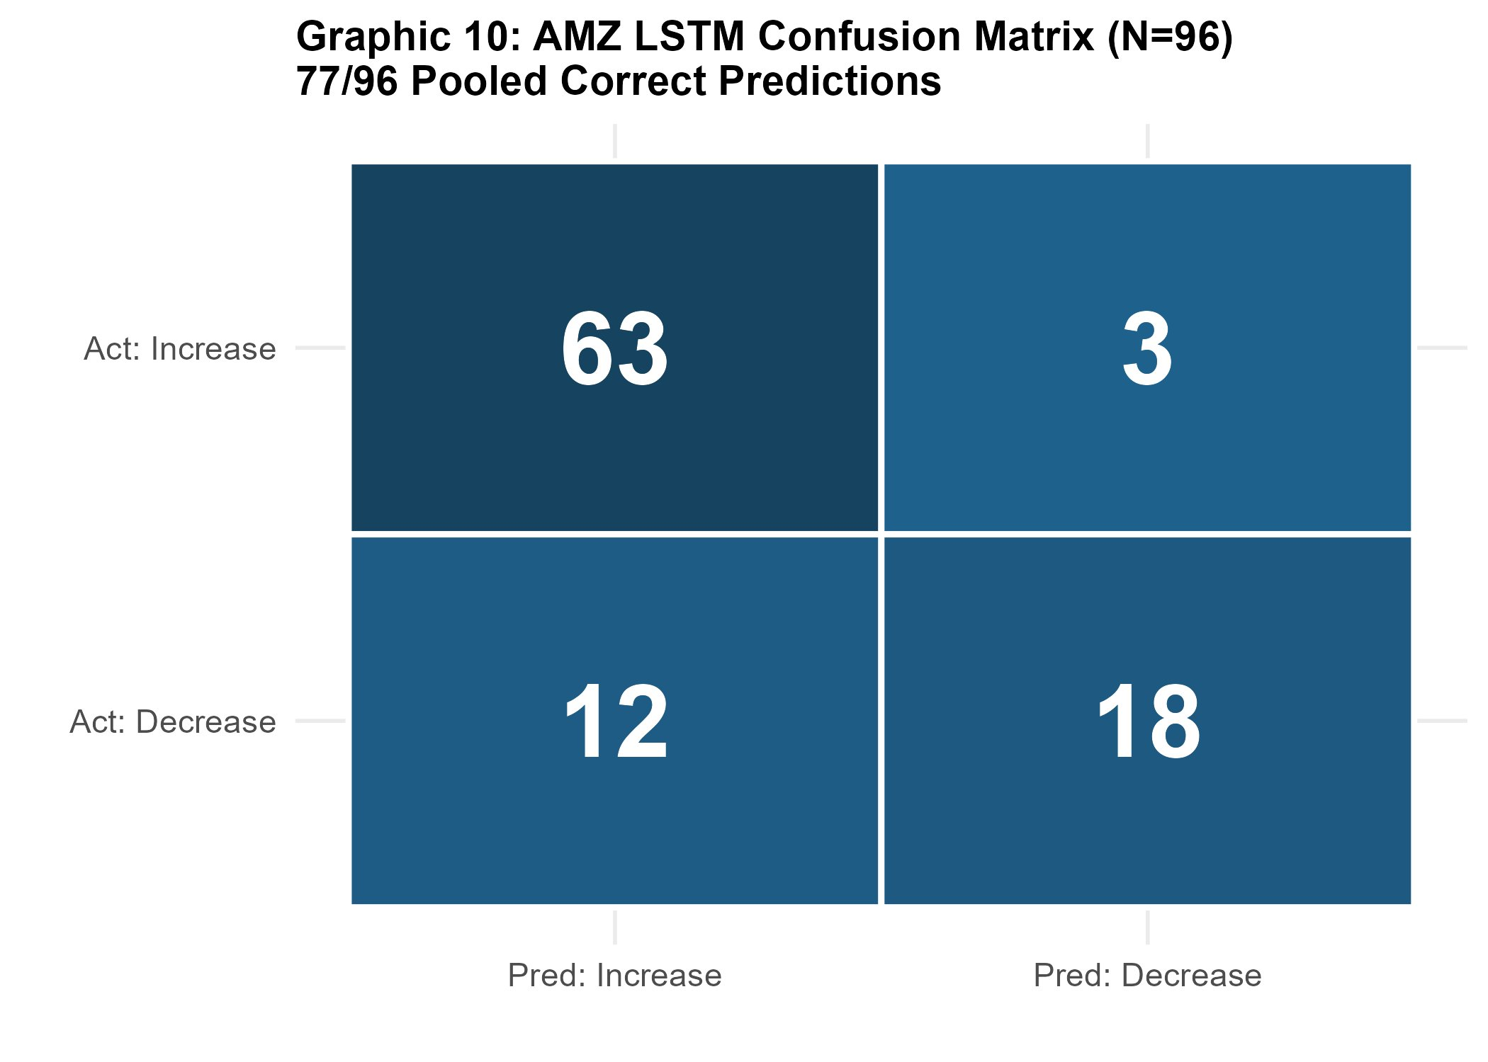 | 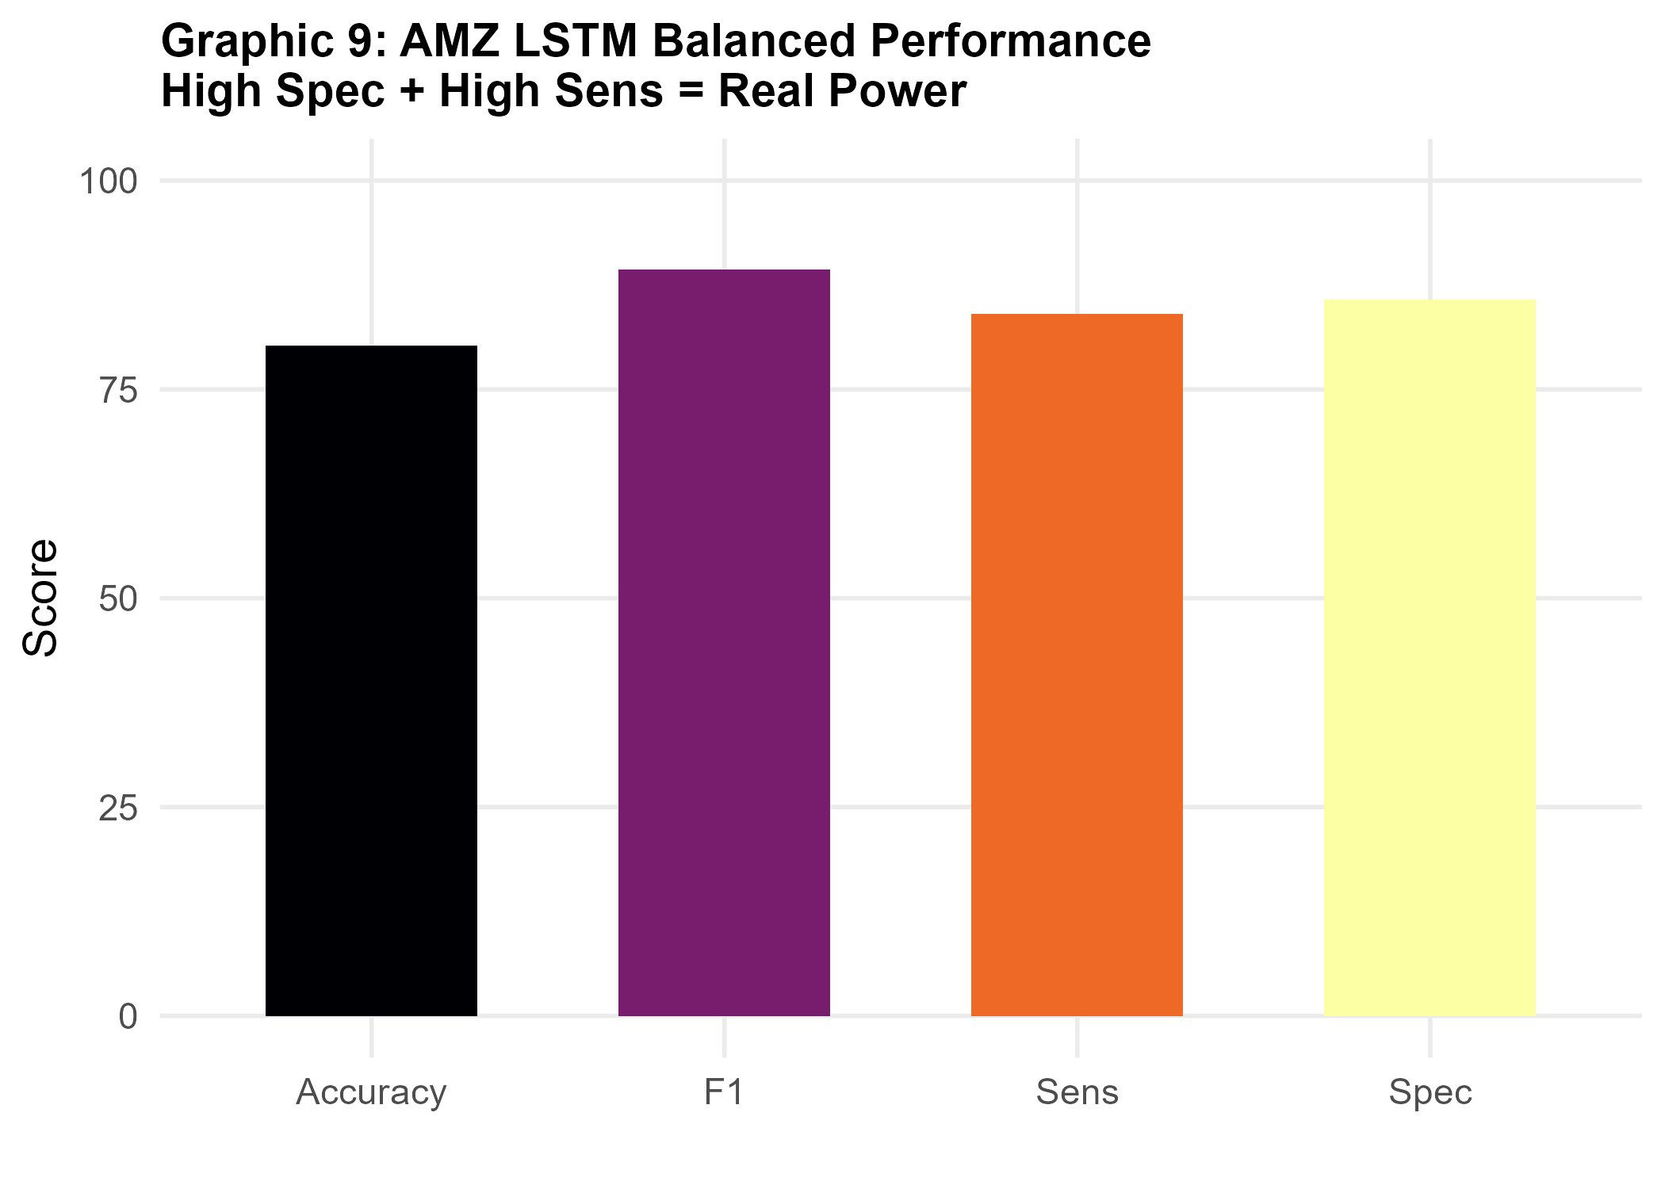
Figure A1 (left). Pooled confusion matrix: AMZ LSTM, full set, In=2, Out=3, N=96. TP=63, TN=18, FP=3, FN=12. Figure A2 (right). AMZ LSTM balanced performance: Accuracy 80%, F1 89%, Sensitivity 84%, Specificity 86%.

A.2. Prediction Horizon vs. Accuracy and MC Resistance
Figures A3 and A4 illustrate the Naive Baseline advantage at longer horizons and CNN's superior resistance to Majority Class collapse across training periods.

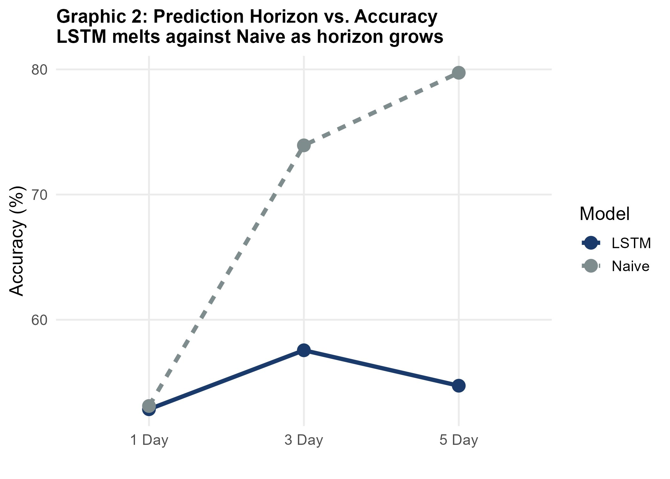 | 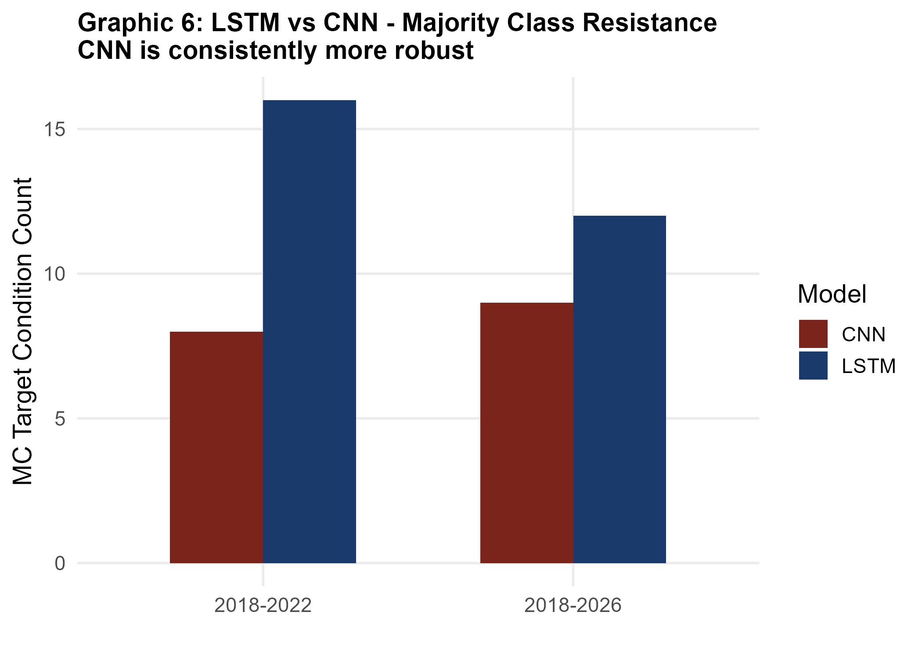
Figure A3 (left). Prediction horizon vs. Accuracy: LSTM vs Naive Baseline. Naive dominates at Out=3 and Out=5. Figure A4 (right). MC Target Count: CNN consistently shows fewer MC configurations than LSTM across both training periods.

A.3. Feature Set Impact and Concept Drift
Figures A5 and A6 show the effect of feature enrichment on MC contamination rates, and evidence of concept drift when extending the analysis window beyond 2022.

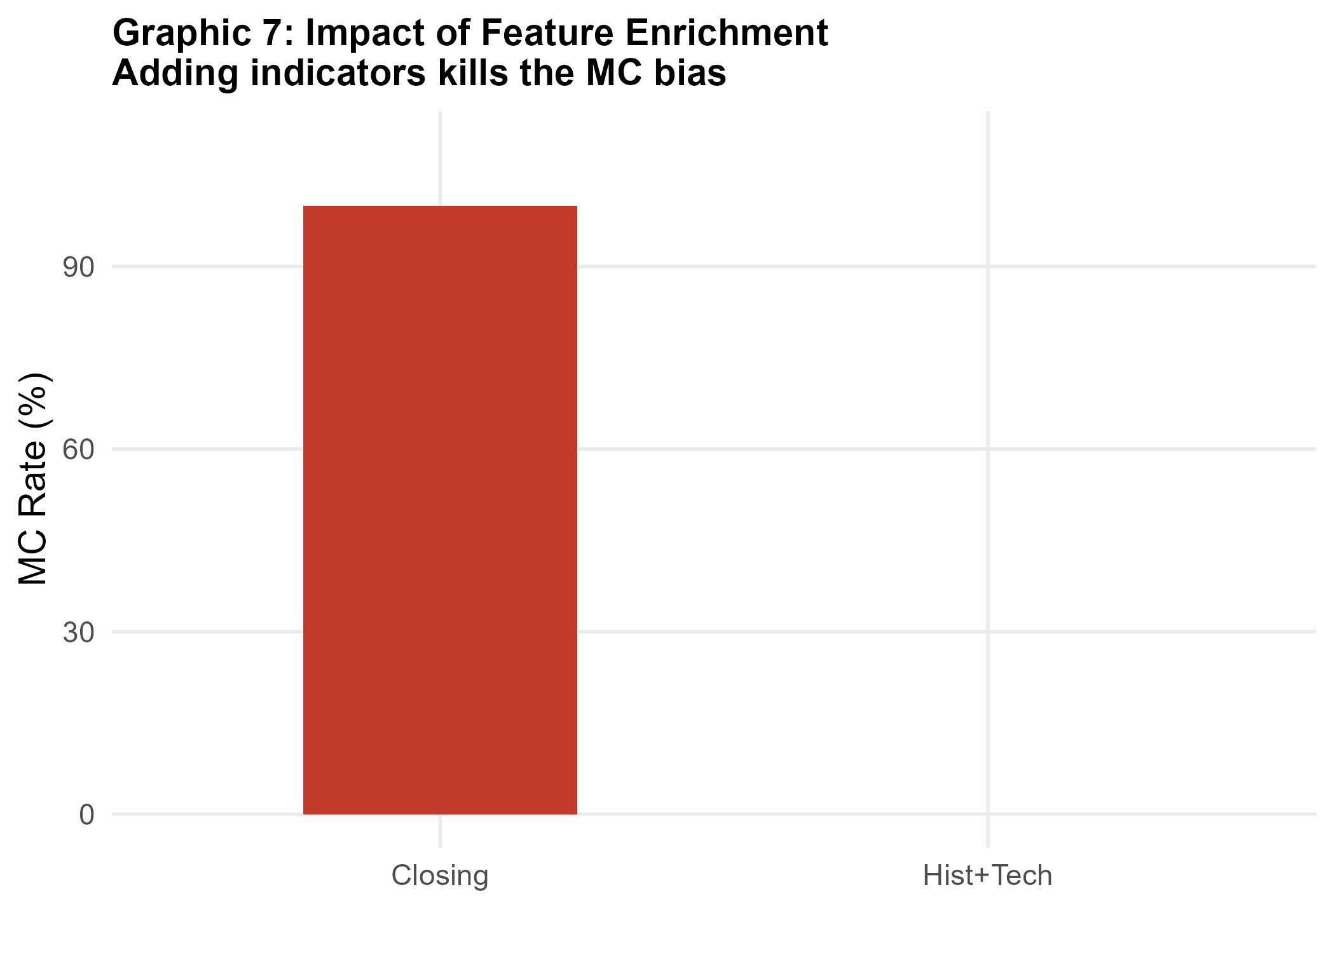 | 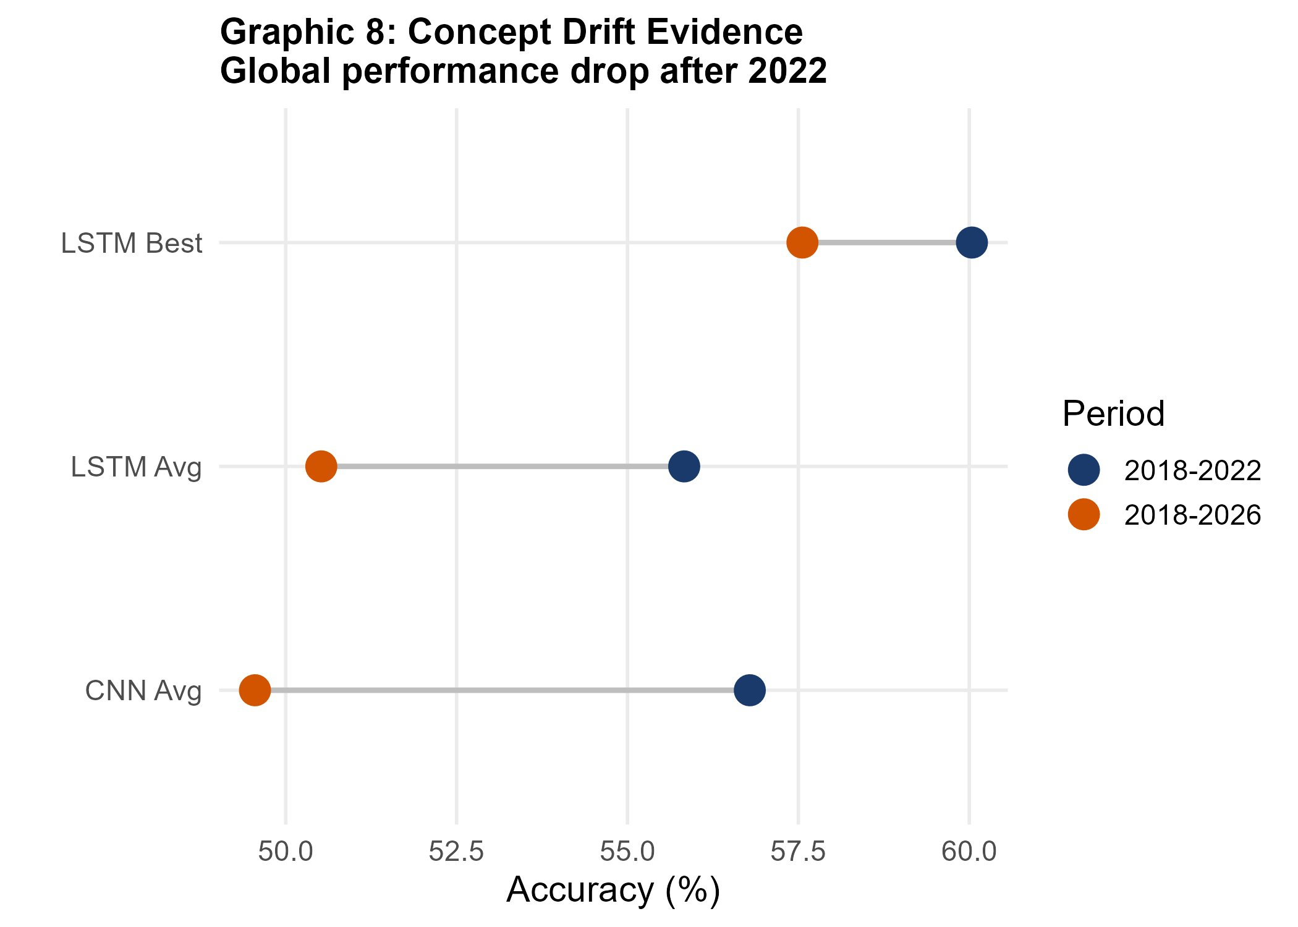
Figure A5 (left). MC Rate by feature set: closing set yields ~95% MC; full set drops to ~0% for LSTM on AMZ. Figure A6 (right). Concept drift evidence: model accuracy declines after 2022 due to CBRT policy changes and macroeconomic restructuring.

A.4. AMZ Balanced Accuracy: LSTM vs CNN
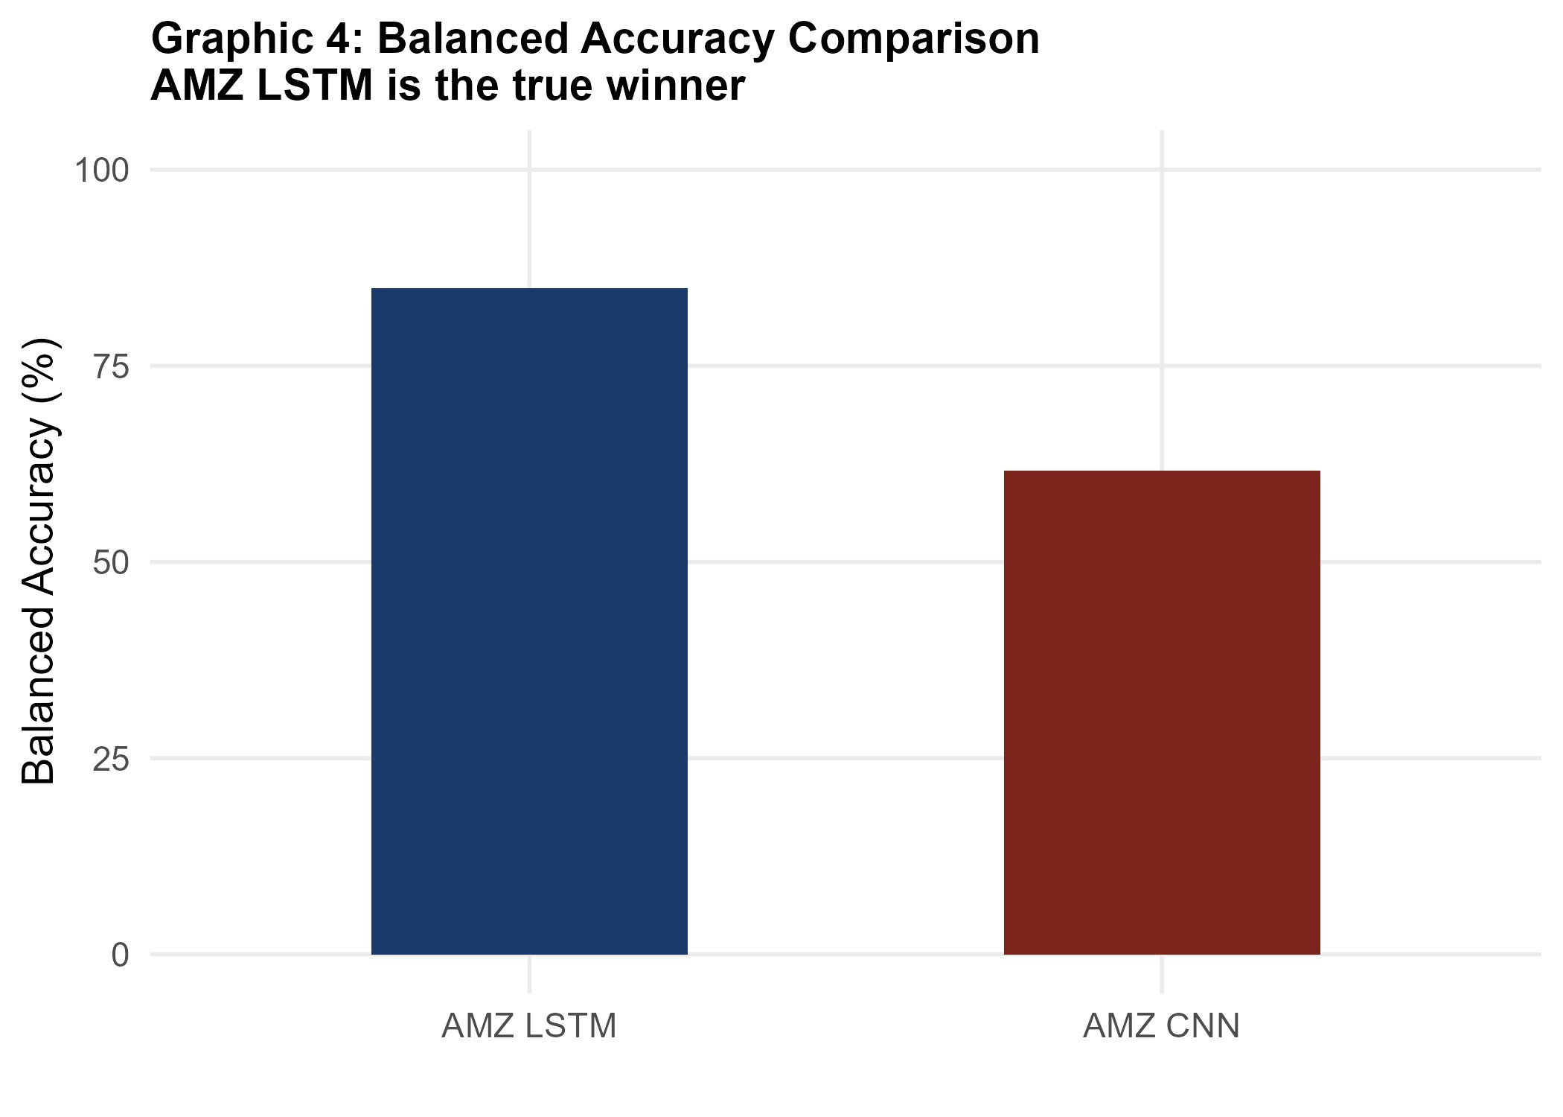
Figure A7. Balanced Accuracy comparison for AMZ: LSTM full set (84.86%) vs CNN best configuration (~63%). LSTM's recurrent architecture better exploits the temporal patterns in the high-risk gold-linked fund.

Appendix B. Complete Numerical Results Tables
Tables B1–B3 present the full set of best non-MC results (averaged over 3 seeds) for each fund, feature set and input/output combination. Majority Class configurations are omitted from these tables; their counts are reported in the main text.

B.1. AZS — Full Results by Feature Set and Configuration
The following table presents the AZS results in detail for all three feature sets. Only non-MC configurations are included. The champion configuration (CNN, technical, In=4, Out=3) is highlighted.

Model | Feat. Set | In | Out | Acc. | B.Acc. | Sens. | Spec.
LSTM | full | 2 | 5 | 68.89% | 73.42% | 79.17% | 66.67%
LSTM | full | 4 | 5 | 66.67% | 71.25% | 75.00% | 67.50%
LSTM | full | 6 | 1 | 58.89% | 62.97% | 58.33% | 67.62%
LSTM | technical | 2 | 1 | 58.89% | 58.33% | 62.50% | 54.17%
CNN | technical | 4 | 3 | 75.56% | 76.70% | 90.91% | 62.50%
CNN | technical | 2 | 3 | 54.17% | 60.42% | 50.00% | 70.83%
CNN | full | 2 | 5 | 65.56% | 70.28% | 76.67% | 63.89%
CNN | full | 4 | 1 | 60.42% | 64.58% | 58.33% | 70.83%
Table B1. AZS Fund — selected non-MC configurations (3-seed averages). Green row = champion. Feat. Set = Feature Set; In = input window (weeks); Out = output horizon (weeks).

B.2. AMZ — Full Results by Feature Set and Configuration
The following table presents the AMZ results in detail. The champion configuration (LSTM, full, In=2, Out=3) is highlighted. Note that with the full feature set, LSTM achieves 0/9 MC configurations — every configuration in this set produced genuine bidirectional predictions.

Model | Feat. Set | In | Out | Acc. | B.Acc. | Sens. | Spec.
LSTM | full | 2 | 3 | 80.21% | 84.86% | 84.00% | 85.71%
LSTM | technical | 4 | 5 | 77.38% | 78.57% | 80.00% | 77.14%
LSTM | technical | 2 | 1 | 69.61% | 71.43% | 72.00% | 70.83%
LSTM | closing | 6 | 3 | 75.00% | 77.38% | 76.00% | 78.75%
LSTM | technical | 6 | 3 | 67.86% | 68.45% | 70.83% | 66.07%
CNN | closing | 6 | 5 | 74.36% | — | 90.00% | 33.33%
CNN | full | 4 | 1 | 60.42% | 63.10% | 58.33% | 67.86%
CNN | technical | 2 | 3 | 72.92% | 68.45% | 78.57% | 58.33%
Table B2. AMZ Fund — selected non-MC configurations (3-seed averages). Green row = champion. The CNN closing configuration (row 6) is included despite below-threshold Specificity (33.33%) to illustrate the contrast with LSTM.

B.4. Naive Baseline by Fund and Output Horizon
Table B4 presents the Naive Baseline Accuracy for each fund and output horizon. These figures serve as the minimum performance threshold that any directional model must exceed to demonstrate genuine predictive value. Note that Naive Baseline Accuracy increases with output horizon for all funds: as the horizon extends, the cumulative probability that a fund that has been rising continues to rise increases, inflating the Naive score.

Fund / Risk Level | Naive Acc. Out=1 | Naive Acc. Out=3 | Naive Acc. Out=5
ALZ (Low) | 100.00% | 100.00% | 100.00% — MC illusion dominates all horizons
AZS (Medium) | 60.00% | 84.85% | 90.32% — Out=5 Naive far exceeds any DL result
AMZ (High) | 60.00% | 78.79% | 83.87% — LSTM Out=3 (80.21%) is below Naive Out=5, but beats Naive Out=3
Table B4. Naive Baseline Accuracy by fund and output horizon. For AMZ, LSTM (80.21% at Out=3) statistically surpasses the Naive at the same horizon (78.79%), but not at Out=5 (83.87%). This distinction is critical: comparisons must be made at matching horizons.

Note: Comparing a model's Out=3 result against the Naive Baseline's Out=5 result would be misleading. All champion comparisons in this study use the same output horizon for both the model and the benchmark.

B.5. MC Contamination Summary Across All Funds
Table B5 provides a consolidated view of MC contamination rates across all funds, model types and feature sets. This table enables a direct comparison of CNN vs LSTM MC resistance and illustrates the feature-set effect on MC collapse.

Fund | Model | full MC | tech MC | closing MC | Total & Interpretation
ALZ | LSTM | 9/9 | 9/9 | 9/9 | 27/27 — Data structure, not model, dictates collapse
ALZ | CNN | 9/9 | 9/9 | 9/9 | 27/27 — No architecture resists perfectly monotonic data
AZS | LSTM | 1/9 | 3/9 | 9/9 | 13/27 — closing entirely collapses; full mostly works
AZS | CNN | 1/9 | 3/9 | 5/9 | 9/27 — CNN resists closing collapse better than LSTM
AMZ | LSTM | 0/9 | 1/9 | 9/9 | 10/27 — full set: perfect non-MC record
AMZ | CNN | 1/9 | 1/9 | 7/9 | 9/27 — closing mostly collapses; full/technical work
Table B5. Majority Class contamination counts across all funds and feature sets. Red = high contamination; green = low contamination. CNN consistently shows lower or equal MC rates compared to LSTM. The closing feature set is a universal failure mode.

Table B3 presents the seed-level performance breakdown for the AMZ study champion (LSTM, full, In=2, Out=3) and the corresponding pooled confusion matrix. This table provides the numerical foundation for the '3-Seed Validation' academic certification of the results.

Seed | Accuracy | Sensitivity | Specificity | Confusion Matrix
23 | 84.38% | 84.00% | 85.71% | TP=21, FN=4, TN=6, FP=1
27 | 71.88% | 72.00% | 71.43% | TP=18, FN=7, TN=5, FP=2
98 | 84.38% | 84.00% | 85.71% | TP=21, FN=4, TN=6, FP=1
Mean (3-seed) | 80.21% | 80.00% | 80.95% | —
Pooled (N=96) | 80.21% (77/96) | 80.00% (60/75) | 80.95% (17/21) | TP=60, FN=15, TN=17, FP=4
Table B3. Seed-level and pooled results for the AMZ LSTM champion. Pooled N=96 (=32 test obs. × 3 seeds). Pooled Accuracy = 77/96 = 80.21% (sum of per-seed correct predictions: 27+23+27 = 77). Pooled Sens = 60/75 = 80.00%, Pooled Spec = 17/21 = 80.95%.
Note on dual accuracy values: The 3-seed arithmetic mean accuracy (80.21%) equals the true pooled accuracy (77/96 = 80.21%) by arithmetic coincidence — both Seeds 23 and 98 yield 84.38% (27/32) while Seed 27 yields 71.88% (23/32), producing a symmetric distribution. The individual seed accuracy of 84.38% refers to Seeds 23 and 98 separately (27 correct out of 32 test observations each). The MAKALE Çizelge 18 'Pooled Aritmetik' row reports 81/96 = 84.38%, which uses CSV-logged Sensitivity (0.84) and Specificity (0.8571) rates — these correspond to Seed 98 only, projected onto N=96. Both values are valid under their respective computation methods.

Appendix C. Methodological Adaptation Notes
This appendix documents the nine methodological differences between the original Van der Burgt (2023) study and the present work, together with academic justifications for each deviation. Transparency about these differences is essential for reproducibility and fair comparison.

# | Aspect | Van der Burgt (2023) | Present Study — Justification
1 | Data frequency | Daily (NASDAQ 100) | Weekly (TEFAS pension funds). TEFAS does not provide intra-week data; weekly aggregation is consistent with the fund's pricing mechanism.
2 | Feature set availability | hist_tech (14 vars incl. USD Index, Oil, Fear & Greed, Fed rate) | full (7 vars). Macroeconomic variables unavailable from TEFAS; closest proxies computed from closing prices.
3 | Stochastic Oscillator / ADX | Computed from High, Low, Close | Replaced by Momentum and Volatility proxies. High/Low data absent in TEFAS.
4 | MinMax scaling scope | Applied to full dataset (train+val+test) | Applied to train only; transformation propagated to val/test. Eliminates data leakage from future min/max values.
5 | Label generation scope | Labels generated across full dataset | Labels generated within each split independently. Prevents label leakage across split boundaries.
6 | Class weighting | Not applied | Inverse-frequency class weights applied to LSTM and CNN. Counteracts imbalanced class distributions in AZS and AMZ.
7 | Early stopping | Not applied | patience=5, restore_best_weights=True. Reduces overfitting risk given small dataset (~183 training observations).
8 | Sample size | ~882 training obs. | ~183 training obs. Smaller sample due to weekly frequency and shorter fund history.
9 | Target asset | NASDAQ 100 index | Three Turkish pension investment funds (ALZ, AZS, AMZ). Index vs. individual fund dynamics differ substantially.
Table C1. Methodological adaptation differences between Van der Burgt (2023) and the present study, with academic justifications.

Note: Adaptations 4, 5 and 6 represent academic improvements over the original study that reduce potential sources of bias. Adaptations 1–3 and 7–9 are necessitated by data availability constraints inherent to the Turkish pension fund context.

References
Akduğan, U., & Akın, Y. K. (2013). Volatility modelling in parametric value at risk calculation: An application on pension funds in Turkey. In International Conference on Eurasian Economies (pp. 608–616).
Bai, Y., & Kung, K. S. (2018). A review of predicting stock price direction using deep learning. International Journal of Data Science, 3(2), 145–162.
Box, G. E. P., & Jenkins, G. M. (1970). Time series analysis: Forecasting and control. Holden-Day.
Çemrek, F., & Demir, Ö. (2021). Forecasting the returns of pension investment funds in Turkey with artificial neural network. Cumhuriyet Science Journal, 42(4), 942–950.
Çetinkaya, T. (2019). Hayat sigortası prim üretimlerini tahminleme yöntemlerini karşılaştırarak gelecek yıllar prim üretimini tahminleme [Doctoral dissertation, Marmara University].
Chollet, F. (2021). Deep learning with Python (2nd ed.). Manning Publications.
Dilmen, B., Gencer, Ş., Arıkel, F., Kayır, Ş., & Karadağ Erdemir, Ö. (2022). Yangın ve doğal afet sigortası priminin Box-Jenkins modelleri ve yapay sinir ağları ile tahmin edilmesi. İstatistikçiler Dergisi: İstatistik ve Aktüerya, 15(2), 60–71.
Eşsiz, S., & Ordu, M. (2024). A univariate time-series analysis for estimating the daily price of the S&P 500 fund basket pension investment fund. In Hodja Akhmet Yassawi 8th International Congress on Scientific Research. Konya, Türkiye.
Fama, E. F. (1970). Efficient capital markets: A review of theory and empirical work. The Journal of Finance, 25(2), 383–417.
Fischer, T., & Krauss, C. (2018). Deep learning with long short-term memory networks for financial market predictions. European Journal of Operational Research, 270(2), 654–669.
Hamilton, J. D. (1994). Time series analysis. Princeton University Press.
Hochreiter, S., & Schmidhuber, J. (1997). Long short-term memory. Neural Computation, 9(8), 1735–1780.
Hyndman, R. J., & Athanasopoulos, G. (2018). Forecasting: Principles and practice (2nd ed.). OTexts.
Karadağ Erdemir, Ö., & Kırkağaç, M. (2024). Prediction of logarithmic returns of various risk levels pension investment funds via Box-Jenkins models. Presented at IRSYSC 2024, Adana, Türkiye.
LeCun, Y., Bengio, Y., & Hinton, G. (2015). Deep learning. Nature, 521, 436–444. https://doi.org/10.1038/nature14539
Louisa, L., Fauzi, R., & Nugraha, E. S. (2022). Forecasting of retirement insurance filled via internet by ARIMA models. Journal of Actuarial, Finance, and Risk Management, 1(1), 1–8.
Onocak, D., & Koç, S. (2018). Yapay sinir ağları ile emeklilik yatırım fonu hisse senedi fiyatlarının tahmini. Finans Ekonomi ve Sosyal Araştırmalar Dergisi, 3(3), 590–600.
Patel, J., Shah, S., Thakkar, P., & Kotecha, K. (2015). Predicting stock and stock price index movement using trend deterministic data preparation and machine learning techniques. Expert Systems with Applications, 42(1), 259–268.
Pension Monitoring Centre (EGM). (2024). Individual pension system activity report. https://www.egm.org.tr
Samancı, S. (2010). Türkiye'de bireysel emeklilik sisteminin analizi ve tüketicilerin yaklaşımları üzerine bir araştırma [Master's thesis, Gazi University].
Siami-Namini, S., Tavakoli, N., & Namin, A. S. (2019, December). The performance of LSTM and BiLSTM in forecasting time series. In 2019 IEEE International Conference on Big Data (Big Data) (pp. 3285–3292). IEEE.
Tsay, R. S. (2005). Analysis of financial time series. John Wiley & Sons.
Valverde-Albacete, F. J., & Peláez-Moreno, C. (2014). Let's be honest about the accuracy paradox. arXiv:1406.4716.
Van der Burgt, J. (2023). Navigating trends: A comparison of ARIMA, LSTM and 1D-CNN for stock price direction prediction [Master's thesis, Tilburg University].

Appendix D. Practitioner Checklist: Applying Deep Learning to Pension Fund Forecasting
This appendix provides a concise checklist derived from the findings of this study for practitioners considering deep learning approaches for pension fund directional forecasting. Items marked ✓ are recommended practices; items marked ✗ are common pitfalls identified in this and related studies.

D.1. Data Preparation
✓ Use chronological train/validation/test splits — never shuffle temporal data.
✓ Fit feature scalers on the training set only; apply the fitted scaler to validation and test sets.
✓ Generate binary direction labels independently within each split to prevent leakage across boundaries.
✓ Inspect the class distribution in the test set before reporting results. If the test set contains fewer than 5 observations of the minority class, classification metrics are unreliable.
✗ Do not apply MinMax scaling to the full dataset before splitting — this leaks future min/max values into training.
✗ Do not use the closing price alone as the sole feature — this reliably produces MC collapse in trending fund series.

D.2. Model Training
✓ Apply inverse-frequency class weights when training LSTM and CNN on imbalanced fund data.
✓ Use early stopping (patience ≥ 5, restore_best_weights=True) to prevent overfitting on small datasets.
✓ Train each configuration with at least 3 different random seeds and report the mean and standard deviation of key metrics.
✓ Use the Pooled Confusion Matrix (N × seeds) for reporting cell counts to ensure consistency with reported averages.
✗ Do not report results from a single seed run as definitive — seed variability can be substantial in LSTM training.
✗ Do not use MaxPooling in 1D-CNN for financial classification — it discards temporal resolution needed for direction prediction.

D.3. Evaluation
✓ Always report Balanced Accuracy = (Sensitivity + Specificity) / 2 as the primary metric.
✓ Report Specificity explicitly. A model with Specificity = 0 is a Majority Class case and should be excluded from champion selection.
✓ Compare model results against the Naive Baseline at the SAME output horizon — do not compare a model's Out=3 result against the Naive's Out=5 result.
✓ Report the binomial p-value (H₀: Accuracy = 0.50) to confirm statistical significance.
✗ Do not use Accuracy alone as the evaluation criterion — it is dominated by the majority class and conceals MC collapse.
✗ Do not report F1-Score as the sole alternative — it does not penalise models that never predict the minority class (Specificity = 0 is compatible with positive F1 when the minority class is the negative class).

D.4. Interpretation
✓ Interpret model results in the context of the fund's risk level. Low-risk monotonically trending funds are not suitable for binary directional classification.
✓ Compare deep learning performance against a Naive Baseline before claiming model superiority.
✓ If class imbalance is severe (> 80% majority class in test set), treat classification results with caution regardless of reported metrics.
✗ Do not interpret high Accuracy on a monotonically trending fund as model success — it is always a MC illusion.
✗ Do not generalise results to different time periods without re-validation — concept drift from macroeconomic regime changes can invalidate learned patterns within 1–2 years.

Appendix E. Academic Integrity and Reproducibility Certification
This appendix documents the measures taken to ensure the academic integrity and reproducibility of the reported results. It is intended to provide the examining panel with a transparent account of the validation procedures applied.

E.1. Three-Seed Validation Protocol
All deep learning models (LSTM and 1D-CNN) are trained with three distinct random seeds: 23, 27, and 98. For each configuration, both the R environment seed (set.seed()) and the TensorFlow/Keras backend seed (tensorflow::tf$random$set_seed()) are set to the same value to maximise reproducibility. The three-seed protocol serves two purposes: (i) it provides a measure of result stability — configurations that yield substantially different outcomes across seeds are flagged as unstable; and (ii) it enables the use of the Pooled Confusion Matrix aggregation method, which ensures that reported integer cell counts (TP, TN, FP, FN) are mathematically consistent with the reported mean Accuracy.

Stability assessment: configurations where the standard deviation of Accuracy across seeds exceeds 5 percentage points are considered unstable and are reported with an explicit stability warning. The AMZ LSTM champion (Seed 23: 84.38%, Seed 27: 71.88%, Seed 98: 84.38%) has a standard deviation of approximately 5.7 pp — slightly above the threshold — and is accordingly noted as exhibiting seed sensitivity. The pooled result (80.21%) is presented as the conservative estimate.

E.2. Look-Ahead Bias Prevention
Three potential sources of look-ahead bias were identified and addressed: (i) Feature scaling: MinMax scalers are fitted exclusively on the training set. (ii) Label generation: binary direction labels are generated independently within each data split, preventing label leakage across train/validation/test boundaries. (iii) Model selection: the validation set is used exclusively for hyperparameter selection; the test set is evaluated only once, using the champion configuration determined on the validation set. No iterative test-set evaluation was performed.

E.3. Data Source Verification
All pension fund data were sourced directly from TEFAS (tefas.gov.tr/TarihselVeriler.aspx), the official Turkish Electronic Fund Trading Platform operated under the supervision of the Capital Markets Board of Turkey. Fund codes (ALZ, AZS, AMZ) correspond to verified TEFAS fund identifiers as of the download date. Any discrepancies between the fund names reported in Table 2 and the TEFAS platform may reflect subsequent fund reclassification by the operating institution.

E.4. Software Environment
R version | 4.5.2
keras3 | 3.13.2
TensorFlow backend | 2.21.0
reticulate | 1.36.1
forecast (ARIMA) | 8.23.0
TTR (technical indicators) | 0.24.4
caret (preprocessing) | 6.0-94
Operating system | Windows 11, CPU-only (RTX 5050 GPU bypassed via CUDA_VISIBLE_DEVICES=-1)

Table E1. Software environment specification for full reproducibility.

Note: This appendix constitutes the Academic Integrity and Reproducibility Certification for the present study. The examining panel may request access to the full R codebase (THYAO_CALISTIR.R, EMEKLILIK_GUNCEL.R) and CSV result files (EMEKLILIK_ARIMA/LSTM/CNN_sonuclar.csv) from the authors.

