Efficiency Analysis of Conventional and Weighted Grid-Based Pathfinding Algorithms: A Performance Comparative Study

Yasasree Lasya A
Department of Computer Science and Engineering Amrita School of Computing, Bengaluru
Amrita Vishwa Vidyapeetham, India
bl.en.u4cse22202@bl.students.amrita.edu

Gayatri Yerukola
Department of Computer Science and Engineering Amrita School of Computing, Bengaluru
Amrita Vishwa Vidyapeetham, India
bl.en.u4cse22267@bl.students.amrita.edu

Asi Kuushalie
Department of Computer Science and Engineering Amrita School of Computing, Bengaluru
Amrita Vishwa Vidyapeetham, India
bl.en.u4cse22204@bl.students.amrita.edu

Aiswariya Milan K
Department of Computer Science and Engineering Amrita School of Computing, Bengaluru
Amrita Vishwa Vidyapeetham, India
maiswariya@blr.amrita.edu

Abstract—In many computing applications, grid-based algo- rithms are essential, particularly in the gaming industry where performance, shortest path and efficiency are crucial. In order to find the best algorithm for gaming settings, this research emphasizes the importance of grid-based algorithms. The pri- mary objective is to evaluate and contrast the various grid- based algorithms’ performances while taking into account both weighted and conventional grid configurations. The implemen- tation of the Dijkstra’s, A*, and Breadth-First Search (BFS) algorithms for both normal and weighted grids will provide insights into their applicability for gaming applications. Also, in weighted grid factors, the method known as Jump Point Search with weight will be incorporated for additional comparison. A number of measures, such as cost analysis, time complexity, space complexity, and weight complexity, will be used to conduct the evaluation process.By comparing these algorithms to one another through the process of benchmarking, the aim is to identify which algorithm offers the highest performance across all of these measures. The results of this investigation will offer significant recommendations for game designers looking to improve the performance of pathfinding algorithms in their works.
Index Terms—Dijkstra’s, A*, BFS, Weighted grids, JPSW

- Introduction
Pathfinding is crucial in many different context, because it facilitates movement and navigating through a range of surrounds. Realistic and engaging games are mostly dependent on pathfinding algorithms. Non-player characters (NPCs) for instance have to navigate virtual worlds, avoiding dangers and reaching their goals. In a similar vein, these algorithms are essential to robotics since they let autonomous robots to ne- gotiate difficult and unfamiliar terrain. Geographic information systems as well use pathfinding to locate the optimal routes. Pathfinding effectiveness is very important to performance in these fields. One must benchmark in order to evaluate the performance and applicability of different pathfinding algo-
rithms. Careful comparison of these algorithms might reveal their benefits and drawbacks. Pathfinding techniques including A*, Dijkstra’s, and Breadth-First Search (BFS) are applied to and evaluated on this 100 x 100 dimensional 2D grid. This process evaluates their cost, time, and space complexity performance and provides information on their practicality in practical settings.
Dijkstra’s algorithm is a popular method of finding the shortest path between nodes in a network. Though usually at the cost of additional processing power, it ensures best results. The A* technique enhances on Dijkstra’s approach and boosts its effectiveness in a range of circumstances by using heuristics to speed up the search. A less advanced method known as Breadth-First Search (BFS) looks into each path one level at a time. It performs admirably in unweighted grids but can lose its efficacy as grid complexity increases. The quickest or most efficient method for conventional grids might not necessarily function as well when used to weighted grids. Weighted grids give various cells differing traversal costs to depict more complex terrains in a gaming world, such grass, water, and roads. Traveling across water, for instance, can be impossible or very slower than traveling over grass. Because they cannot address the diverse costs associated with various terrains, standard grid algorithms are inadequate in these circumstances. For a weighted grid, therefore, a technique that functions well on a conventional grid might not be the best one. This unpredictability makes the adoption of certain algorithms that are adept at handling dynamic weights necessary.
This problem is addressed on weighted grids by applying algorithms such as A*, Dijkstra’s, and Weighted Jump Point Search (JPS). Under such circumstances, these algorithms are meant to generate optimal or almost optimal routes while limiting the complexity introduced by weight changes.

Random weights are given to these algorithms as they are implemented and benchmarked on weighted grids to mimic shifting terrain expenses. With less overhead than dynamically modifying grid weights in real time, this approach is more efficient. Benchmarking these algorithms on weighted grids helps one to better understand their performance under various circumstances. This helps to choose the best algorithm for a certain application and makes sure that the pathfinding method is appropriate for the particular requirements of the situation. Comprehensive examination and comparison of these algo- rithms will help to build more efficient and responsive gaming and other application systems.

- Literature Survey
In [1], the research presents metrics to measure weight complexity and algorithmic performance, as well as a novel benchmark dataset for assessing pathfinding algorithms in weighted grid-based environments. It does not, however, inves- tigate how well algorithms adapt to dynamic weight changes or how to compute weight complexity metrics more effectively for improved correlation with algorithmic search times. In [2], IDA an approach to determine the shortest path on a grid map, comparatively better than methods like Dijkstra’s algorithm and integration with A* variants to work well in various robotics applications. The improvement lies on a specific property of 2D eight-neighbour grid maps. It might not be directly applicable to pathfinding problems on more complex maps with obstacles or irregular shapes. The research offers an interesting approach for 2D grid maps, but it might not be a universal solution for all pathfinding problems.
[3] The study indicates new Dijkstra-based method for vehicle path planning that takes intersection features into ac- count using Reverse-labeling Dijkstra algorithm(RLDA).More study to determine how scalable and applicable the introduced algorithm is needed.
In [4], Extended Dijkstra algorithm has been provided for surface optimal path planning in this study. The gap here is the lack of its practical use, particularly in complex terrains and changing circumstances.
- In order to minimize search space, the study presents the Regions Discovery Algorithm (RDA) for pathfinding on grid -based maps to automatically draw boundaries and group maps to clusters based on particular criteria. The potential gap present is the lack of RDA’s practical uses and real-world application which can improve algorithm’s relevance.
- The study offers a thorough analysis of pathfinding algorithms with an emphasis on how to use them in 2D square grid environments that are static. The gaps include lack of thorough examination of the trade-offs between performance and scalability of these algorithms in large-scale grid systems which could enhance the practical applicability.
- The study,incorporates region search techniques using improved A* algorithm for game pathfinding. The visible gap includes comparative analysis with other pathfinding algo- rithms used in game development which could give better
understanding of the give algorithm’s scalability and adapt- ability.
According to [8], to maximize evacuation effectiveness during disasters, the research presents a method for directing emergency escape routes using Sparse A* and Dijkstra al- gorithms. Nevertheless, the absence of a comparative analysis with current emergency pathfinding techniques may raise ques- tions regarding its efficacy and suitability for use in practical situations.
The paper presents a summary of the current state of the A* search algorithm, comparing it with other pathfinding techniques and future improvements. It draws attention to the necessity for changes to overcome A*’s shortcomings in order to satisfy contemporary pathfinding requirements. Future research should provide empirical validation of these adjust- ments’ effectiveness in a variety of real-world circumstances, improving performance and practical usefulness. [9]
Using the Best First Search method, the study suggests a web application for locating routes in Medan with the least amount of traffic jams. Examining factors including travel time and distance, it investigates how traffic conditions affect the choice of routes. There is a gap in our understanding of the study’s usefulness and applicability in various settings because it does not compare the results with other route- finding algorithms and does not address potential constraints or obstacles in real-world implementation.[10]
In order to demonstrate its versatility and effectiveness, the paper presents a dynamic maze-solving algorithm that combines Dijkstra’s and A* programs. Evaluating performance measures such as path length and execution time, it provides extensive testing on various configurations. But there is a gap in evaluating its competitiveness and its applicability across many circumstances because it is not compared to other maze- solving techniques. [11]
An affordable autonomous robot designed with the A* pathfinding algorithm that focuses on the Raspberry Pi plat- form instead of pricy AI techniques, offering a solution for transportation jobs. lacks experimental confirmation of the A* algorithm’s functionality in practical settings. [12]
To reduce the risks caused by the NP-hardness of the problem, we investigate the pathfinding performance of several data structures in a typical 3D environment using the bi- directional versions of the Dijkstra, Weighted A*, and Greedy Best First Search algorithms. cannot be compared to other cutting-edge 3D pathfinding algorithms. [13]
An enhanced version of the A* algorithm, the Adaptive Bidirectional A* (ABA*) algorithm is intended especially for aerial robots to enable effective path planning in 3D situations. Finding the optimum collision-free paths via bidirectional search and adapting to a 3D environment, it shows signifi- cant planning time savings over the original A* algorithm. Weak assessment of practical implementation issues and scant comparison with other aerial robot path planning methods.[14] The aim of this study is to determine the best course of action for delivery quadcopters traveling in urban airspace. The study compares the performance of the A* and Dijkstra

algorithms in terms of execution time while determining the shortest path while avoiding obstacles in 3D environments. Real-time impediments are not taken into consideration. [15]
- Methodology
The flowchart shown in Figure 1 illustrates the catego- rization of grid types into two categories: conventional grids and weighted grids. Both of these grid types are associated with pathfinding methods. When working with ordinary grids, it is feasible to utilize Dijkstra’s, A*, and BFS algorithms. Alternatively, when working with grids that have weights assigned to their elements, one can employ Dijkstra’s, A*, and WJPS algorithms. Three performance metrics, namely cost, time, and space, are employed to assess these algorithms.
possible by the utilization of priority queue. The routes that it must follow in order to arrive at its destination are determined by using these two places as a guide. As a consequence of this, efficient routes and dead ends are avoided, and the time that is available is utilized to its fullest potential. The information that it collects at each step is used to make constant modifications to its pathways as it progresses through the grid. Additionally, it always makes an effort to lower the total distance that it travels whenever it is practicable to do so.
After reaching the goal, it retraces its steps to determine shortest distance it traveled. A* algorithm uses heuristic func- tion in finding the cost. This is typically done through the use of the Manhattan distance which directs the algorithm towards nodes closer to the target node. The Manhattan distance is used when movement is restricted to horizontal and vertical directions only. It calculates the sum of the absolute differences of the coordinates. The formula for the Manhattan distance is:

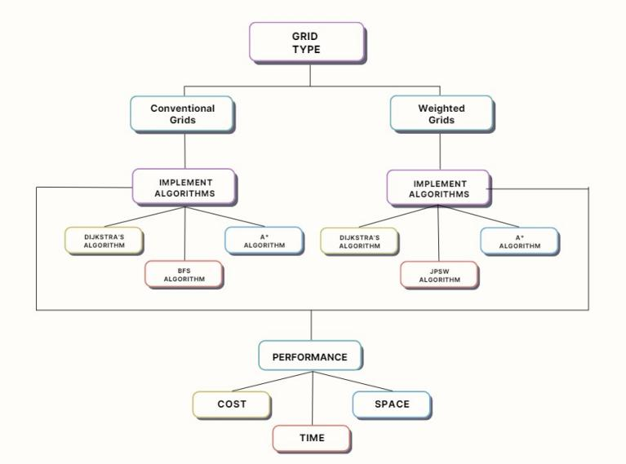
Fig. 1. Grid types, Algorithms and Performance Metrics

- Algorithms in Conventional Grids
A normal grid which is represented here as a 100X100 two- dimensional array has a space where a cell is representing either empty or occupied by an obstacle. Approximately 1000 obstacles placed in the random cells on the grid where 0 represents unoccupied space and 1 represents the presence of an obstacle. The Dijkstra’s algorithm uses priority queue mechanism in order to go through the grid while observing the cost to get to a certain cell. The algorithm starts from the start- ing point from where it assigns and aggregates neighbouring cells, minimizing the cost of the best path to the cell whenever it calculates that a better path is possible. It continues this process until it achieves the objective or exhausts the reachable locations. Finally, by choosing the cell with the minimum total cost, Dijkstra’s algorithm systematically explores the grid, ensuring optimality when the final destination is reached.
Finding the path that is the shortest distance between the start node and the destination node can be accomplished by employing the A* approach. With the help of priority queue, it is able to keep track of the distance it has traveled from the starting node and calculate the remaining distance it needs to travel in order to reach the destination node. This is made
[H]d_{Manhattan} = |x₁ − x₂| + |y₁ − y₂| (1) The Breadth-First Search (BFS) algorithm traverse the grid from each cell level by level moving from the start point. It
contains a Queue for the cells to be explored that requires the
cells to be explored in a sequential order in which they were identified so that all possible alternatives on that specific level are explored before moving to the next level. Through using a queue, BFS makes certain that it provides the shortest path in an unweighted grid environment where each cell switch involves the same cost. Besides, BFS also maintains the cost incurred to reach each cell and the path taken so far using maps. This information built with the algorithm allows the determination of the shortest path from the initial point to the final point once the destination has been identified. Altogether, the BFS is versatile in approaching the solution and ensures revealing the shortest path by accurately mapping the pace of its progression through the cells.
- Algorithms in Weighted grids
The weighted girds are the grids for which the cost of each cell is associated with it. These weights portray the effort or expenditure of transition to that cell. Weighted grids, in this case, are defined as a conventional 2D list in which the cell ‘value’ parameter contains an integer representing the weight. The normal grid that is usually used has the same cost for all of the cells and the path-finding algorithms that are used will only consider the shortest distance as being taken to be simply the count of the number of cells rather than the true cost which would actually have to be incurred in order to traverse all of the cells in the grid. In a weighted grid, the cells cost is considered which are different take a long path in terms of the number of nodes in occurrences. The problem hurdles are depicted by cells denoted by high weight or cost and the obstacles can be defined with high-driven weights of certain cells to be avoided. Obstacles play a role in deciding which of the paths to take based on cost factors incurred by
the path-finding algorithms.

In Weighted grids an new algorithm is implemented called Weighted Jump Point Search (WJPS) uses jump points within the grid to guide the search, leading to faster path-finding in complex environments with obstacles.
As far as the code is concerned, Dijkstra algorithm identifies the shortest distance by connecting a start node with a goal node in a weighted grid. The start node is used to expand the fringe and enter it into the priority queue and its associated cost. It then continuously pops off the node with the coming minimal cost from the queue, checks if the current node is the goal node, and then looks into its neighbors. It computes the cost of a specific neighbor and if this cost is lower than that of previous discovered paths, it makes the adjustments. They are then pushed into the priority queue together with the updated information of their cost. It also has a map to reconstruct the path once the target node is reached. When the queue is exhausted and the target node is not reached that means no path is found.
A* is a search algorithm like Dijkstra’s but it uses a heuristic knowing it is efficient to find the path from the start to the goal. Both algorithms use a priority queue to expand nodes, however, the A* algorithm is more suitable for large distances. For instance, the f value is a number representing the priority of an expansion: f = g + h; g is the cost to reach a node and h is the heuristic estimate to get to the goal starting from one node. This is typically done through the use of a heuristic function (the Manhattan distance) which directs the algorithm towards nodes closer to the target node. The Manhattan distance is used when movement is restricted to horizontal and vertical directions only. It calculates the sum of the absolute differences of the coordinates. The formula for the Manhattan distance is given in the equation 1.
The Euclidean Distance and the Chebyshev Distance are two additional useful heuristic functions. These functions are defined as follows respectively:
in the calculations for the costs as well as the heuristics used in the implementation of the methodology on weighted grids.

- Performance

While comparing different path-finding algorithms such as BFS, Dijkstra’s, and A* for both normal and weighted grids, several of the most important factors to weigh include time complexity, space complexity, execution time, and the path achieved. Time complexity reveals some info about the theoretical behavior w.r.t the input size . Space complexity defines the amount of memory used in the completion of the algorithm. Execution time, which is an empirical measure, is likely to change depending on the grid complexity and capabilities of the algorithm used.

- Results

Every algorithm—BFS, A*, and Dijkstra—identified the same shortest path cost of 198 for typical grids. A* and WJPS did, however, find a somewhat less expensive path
(423) in non-conventional grids than Dijkstra’s 429. It should be mentioned that the particular weights and configurations of the 100 x 100 grid employed in the analysis may affect these cost figures. On standard grids, A* executed the fastest, followed by Dijkstra and then BFS. Additionally outperform- ing Dijkstra on non-conventional grids was A*; although not explicitly compared in this particular study, WJPS is predicted to be highly efficient. Table 1 displays the findings from conventional grids; table 2 displays the results from weighted grids. Figure 2 displays the graph of time complexities for
1

dEuclidean
= ✓(x
− x₂)2 + (y₁
− y₂)2 (2)
conventional grids and Figure 3 displays the graph of time complexities for Weighted grids.
Time complexity analysis shows that because BFS lacks a

d_{Chebyshev} = max(|x₁ − x₂|, |y₁ − y₂|) (3)
The actual cost in combination with the heuristic estimate that is used in A* makes it easier to run through large grids more quickly. Weighted JPS path finding algorithm is designed specifically for uniform-cost grids specifically for weighted grids. JPS minimizes the number of nodes that require the program to branch out and explore more options in the tree by essentially drawing straight lines possibly skipping through a large segment of the nodes until a significant node called the jump point is encountered. There are certain points where the path direction concerning the obstacles may turn like at the corners or the boundaries of the obstacles. These are the jump areas which are discovered by the algorithm and known to search from only these main nodes not expanding all the nodes as it is done with grid based algorithms. The impact of the weights when it comes to problem solving is incorporated
heuristic, it is less effective for big graphs, with O(V + E). A*’s heuristic advantage frequently leads to faster practical performance, even though both A* and Dijkstra have a com- plexity of O((V + E) log V). With its O(E log V) complexity, WJPS improves efficiency in wide, open spaces by skipping several nodes in grids with fewer nodes checked.

TABLE I
Performance in conventional grids

Algorithm  name | Time  complexity | Space  complex- ity | Cost | Execution  Time(ns)
Dijkstra’s  Algorithm | O((V + E)  log V) | O(V) | 198 | 12812000
A*  Algorithm | O((V + E)  log V) | O(V) | 198 | 8498100
BFS  Algorithm | O(V + E) | O(V) | 198 | 20366200

TABLE II
Performance in weighted grids

Algorithm  name | Time  complexity | Space  complex- ity | Cost | Execution  Time(ns)
Dijkstra’s  Algorithm | O((V+E)logV) | O(V) | 429 | 28496100
A*  Algorithm | O((V+E)logV) | O(V) | 423 | 22751600
BFS  Algorithm | O(ElogV) | O(V) | 423 | 17623900

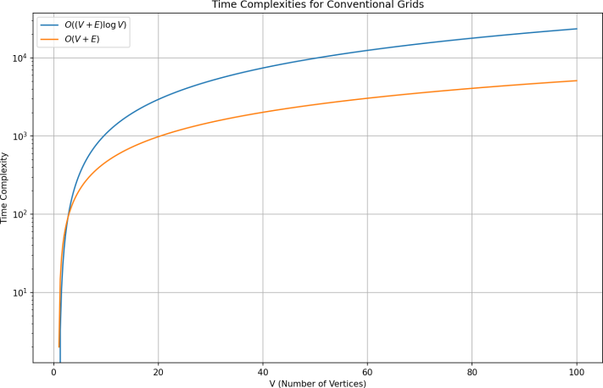

Fig. 2. Time Complexities for Conventional Grids

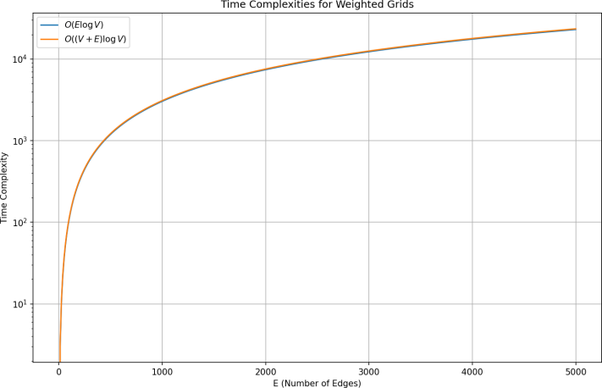

Fig. 3. Time Complexities for Weighted Grids

All algorithms have a space complexity of O(V). From a space standpoint, all of these techniques are possible because memory utilization is similar across them.
Finally, the A* method shows to be the shortest path and the most efficient in terms of execution time for traditional grids. A* is still accurate and efficient for non-conventional grids; WJPS’s capacity to skip nodes and minimize checks allows it to perform competitively. Because it doesn’t have heuristic assistance, Dijkstra’s method is correct but typically slower than A*. Simple as it is, BFS performs less well on large or weighted grids than heuristic-based techniques like A*. Thus, especially in big and complicated weighted grids,
the algorithm selected can have a big effect on accuracy and performance. The precise path costs noted, such 198, 423, and 429, are indicative of a certain set of weights and configurations and might change depending on the grid design.
- Conclusion and Future scope
When it is only paths that need to be searched for within different types of grids like the following two types of grids normal and weighted, there are certain strengths to be recognized in BFS, Dijkstra’s and A* algorithms used for path finding. Specifically, BFS proves to be outperforms in unweighted, whereas it performs poorly on weighted graphs, since costs are not uniform, the algorithm fails to recognize in calculations. Dijkstra’s algorithm for weighted grids that gives the shortest path as per the cumulative cost of each movement ensures optimal path but takes comparatively more time to generate the output. A* algorithm is generally faster as it traverse over the nodes in the map. A* is particularly suitable for application in complex environments with large spaces and weight as factors come into play. Through analyzing time and space complexity, and execution time, a better view of the performance of each algorithm is achieved leading to an understanding of which algorithm is most suited for which type of grid based path-finding problem. Weighted grids allow for a more representation by assigning different weights to different paths, reflecting their actual costs or difficulties. The use of weighted grids ensures more accuracy and optimal route planning. They support dynamic adjustments which is necessary in some domains like robotics, logistics, transportation, games etc.
Applying these pathfinding algorithms to original maps from well-known video games is one fascinating direction for future investigation. We can apply BFS, A*, Dijkstra, and WJPS algorithms straight on these game maps by trans- forming them into grid representations. This method would give pathfinding in complicated, real-world situations found in gaming worlds a reliable and effective answer. Using genuine game maps would improve project realism and confirm the algorithms’ usefulness in real-world scenarios. This stage might be very helpful in the creation of sophisticated AI systems for strategy and navigation in video games.
References
- Moghadam, Sajjad Kardani, Morteza Ebrahimi, and Daniel D. Harabor. ”Guards: Benchmarks for weighted grid-based pathfinding.” Expert Systems with Applications 249 (2024): 123719.
- L. Wenzheng, L. Junjun and Y. Shunli, ”An Improved Dijkstra’s Al- gorithm for Shortest Path Planning on 2D Grid Maps,” 2019 IEEE 9th International Conference on Electronics Information and Emer- gency Communication (ICEIEC), Beijing, China, 2019, pp. 438-441, doi: 10.1109/ICEIEC.2019.8784487. keywords: Two dimensional dis- plays;Path planning;Heuristic algorithms;Robots;Planning;Artificial in- telligence;Conferences;path planning;shortest path;partially-known envi- ronments;improved Dijkstra’s algorithm;2D grid maps,
- D. -D. Zhu and J. -Q. Sun, ”A New Algorithm Based on Dijkstra for Vehicle Path Planning Considering Intersection Attribute,” in IEEE Access, vol. 9, pp. 19761-19775, 2021,
- M. Luo, X. Hou and J. Yang, ”Surface Optimal Path Planning Using an Extended Dijkstra Algorithm,” in IEEE Access, vol. 8, pp. 147827- 147838, 2020, doi: 10.1109/ACCESS.2020.3015976.

- Y. F. Yiu and R. Mahapatra, ”Regions Discovery Algorithm for Pathfind- ing in Grid Based Maps,” 2020 Second International Conference on Transdisciplinary AI (TransAI), Irvine, CA, USA, 2020, pp. 84-87, doi: 10.1109/TransAI49837.2020.00018.
- Wei and D. Lu, ”A Comprehensive Study on Pathfinding Algorithm for Static 2D Square Grid,” 2022 2nd Asia Conference on Infor- mation Engineering (ACIE), Haikou, China, 2022, pp. 77-80, doi: 10.1109/ACIE55485.2022.00024.
- [5] Y. Yang and Y. Du, ”Application of Improved A* Algorithm in Game Pathfinding,” 2024 4th International Conference on Consumer Electronics and Computer Engineering (ICCECE), Guangzhou, China, 2024, pp. 498-501, doi: 10.1109/ICCECE61317.2024.10504153.
- T. Mantoro, Z. Alamsyah and M. A. Ayu, ”Pathfinding for Disaster Emergency Route Using Sparse A* and Dijkstra Algorithm with Aug- mented Reality,” 2021 IEEE 7th International Conference on Computing, Engineering and Design (ICCED), Sukabumi, Indonesia, 2021, pp. 1-6, doi: 10.1109/ICCED53389.2021.9664869.
- Foead, Daniel, Alifio Ghifari, Marchel Budi Kusuma, Novita Hanafiah, and Eric Gunawan. ”A systematic literature review of A* pathfinding.” Procedia Computer Science 179 (2021): 507-514.
- Rachmawati, Dian, Poltak Sihombing, and Billy Halim. ”Implementation of best first search algorithm in determining best route based on traffic jam level in medan city.” In 2020 International Conference on Data Science, Artificial Intelligence, and Business Analytics (DATABIA), pp. 5-12. IEEE, 2020.
- Vijaya, J., Aryan Kumar Baghel, and Akshat Shree Mishra. ”Dynamic Maze Solver: Integrating Advanced Algorithms for Optimal Path-finding in Varied Environments.” In 2024 IEEE International Conference on Interdisciplinary Approaches in Technology and Management for Social Innovation (IATMSI), vol. 2, pp. 1-6. IEEE, 2024.
- J. W. Kim, N. Timothy, A. A. Salim, E. Taniara and E. Steven, ”Imple- mentation of A* Shortest Path Finding Algorithm in a Transport Robot with Robust Turning Mechanism,” 2022 1st International Conference on Technology Innovation and Its Applications (ICTIIA), Tangerang, Indonesia, 2022, pp. 1-6, doi: 10.1109/ICTIIA54654.2022.9935869.
- N. J. A. Jesuthas and S. Somaskandan, ”Path-finding and Planning in a 3D Environment An Analysis Using Bidirectional Versions of Dijkstra’s, Weighted A*, and Greedy Best First Search Algorithms,” 2022 2nd Asian Conference on Innovation in Technology (ASIANCON), Ravet, India, 2022, pp. 1-8, doi: 10.1109/ASIANCON55314.2022.9909251.
- P. Wang, H. Mutahira, J. Kim and M. S. Muhammad, ”ABA*–Adaptive Bidirectional A* Algorithm for Aerial Robot Path Planning,” in IEEE Access, vol. 11, pp. 103521-103529, 2023, doi: 10.1109/AC- CESS.2023.3317918.
- M. Y. Taha, M. J. Mohamed and O. N. UC¸ an, ”Optimal 3D Path Planning for the Delivery Quadcopters Operating in a City Airspace,” 2020 4th International Symposium on Multidisciplinary Studies and Innovative Technologies (ISMSIT), Istanbul, Turkey, 2020, pp. 1-10, doi: 10.1109/ISMSIT50672.2020.9254715.

