WEEK-2
A.KUVIRA
Roll No: 2520030192

Step 1 — Create Database & Books Table
Created the librarybook database and the Books table with column-level constraints (PRIMARY KEY, NOT NULL, UNIQUE, CHECK on published_year). Inserted 3 sample records and verified with SELECT * FROM Books.
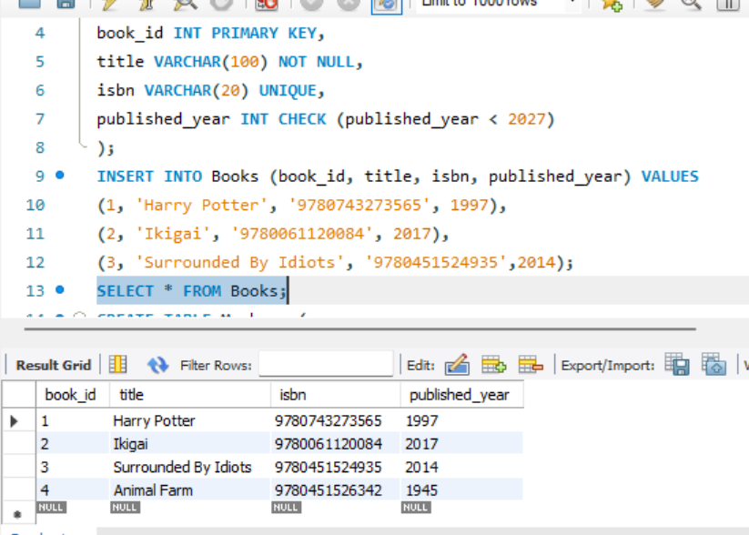

Step 2 — Create Members Table
Created the Members table (member_id, full_name, email) and inserted 3 sample members, then verified with SELECT * FROM Members.
